Low Level Design

Crime Analysis in Baton Rouge

|  |  |
| --- | --- |
| Written By | Prateek Jha |
| Document Version | 1.0 |
| Last Revised Date | 22nd May 2022 |

**Document Control**

### Change Record:

|  |  |  |  |
| --- | --- | --- | --- |
| **Version** | **Date** | **Author** | **Comments** |
| 1.0 | 22-May-  2022 | Prateek Jha | Introduction & Architecture defined, Architecture & Architecture Description appended and updated |
|  |  |  |  |
|  |  |  |  |
|  |  |  |  |
|  |  |  |  |
|  |  |  |  |

### Reviews:

|  |  |  |  |
| --- | --- | --- | --- |
| **Version** | **Date** | **Reviewer** | **Comments** |
|  |  |  |  |

### Approval Status:

|  |  |  |  |  |
| --- | --- | --- | --- | --- |
| **Version** | **Review**  **Date** | **Reviewed By** | **Approved By** | **Comments** |
|  |  |  |  |  |

Contents

1. Introduction 1
   1. What is Low-Level design document? 1
   2. Scope 1
2. Architecture 2
3. Architecture Description 3
   1. Data Description 3
   2. Web Scrapping 3
   3. Data Transformation 3
   4. Data Insertion into Database 3
   5. Export Data from Database 3
   6. Data Pre-processing 3
   7. Data Clustering 3
   8. Model Building 4
   9. Data from User 4
   10. Data Validation 4
   11. User Data Inserting into Database 4
   12. Data Clustering 4
   13. Model Call for Specific Cluster 4
   14. Recipe Recommendation & Saving Output in Database 4
   15. Deployment 4
4. Unit Test Cases 5

# Introduction

## What is Low-Level design document?

The goal of LLD or a low-level design document (LLDD) is to give the internal logical design of the actual program code for Crime Analysis report prepared for the given dataset. LLD describes the class diagrams with the methods and relations between classes and program specs. It describes the modules so that the programmer can directly code the program from the document.

## Scope

Low-level design (LLD) is a component-level design process that follows a step-by-step [refinement](https://en.wikipedia.org/wiki/Refinement_(computing)) process. This process can be used for designing data structures, required software architecture, source code and ultimately, performance of the final prodcut. Overall, the data organization may be defined during requirement analysis and then refined during data design work

# Architecture

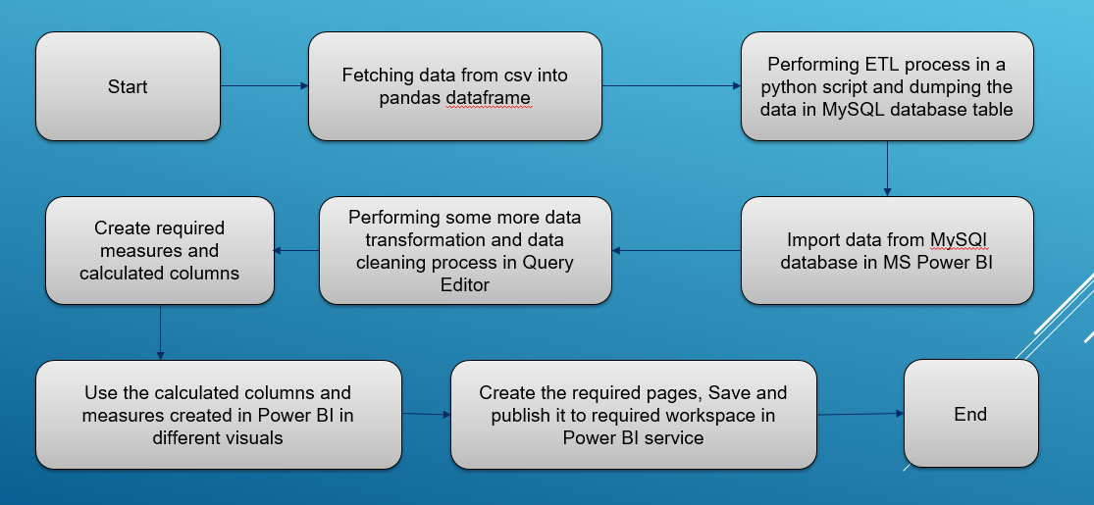

# Architecture Description

## Data Description

The dataset available for this report is present at this location: <https://www.kaggle.com/datasets/himanshupoddar/zomato-bangalore-restaurants>

Dataset contains very important information such as restaurant name, their ratings, cuisines they served, if they allow online orders or not, their location, approx. cost for 2 people and etc.

## Data Transformation

In the Transformation Process, we will be using a python script for loading data and making some minor conversions for easy use in Power Bi report construction

## Data Insertion into Database

1. Database Creation and connection - Create a database with name passed. If the database is already created, open the connection to the database.
2. Table creation in the database named “bangalorerestaurants”
3. Insertion data from the available pandas dataframe in the python script from the source file named “Zomato.csv”

## Data from User

The data provided has various informative columns such as restaurant name, their ratings, cuisines they served, if they allow online orders or not, their location, approx. cost for 2 people and etc.

## User Data Inserting into Database

Collecting the data from the user and storing it into the database. The database is in local instance of MySQL database.

## Deployment

Once the data is imported after cleaning and stored in Mysql source database table, we create reports with help of various insightful visuals using calculated columns and measures created in Power BI depending on the message we are trying to convey using the data and the most suitable visual.