**Power BI Questions**

* Can you map geographic data into Power BI reports?
* **Map** (Basic)
* Filled **Map**.
* ArcGIS **Maps**. Powered by Bing and uses active internet connection
* Shape **Map**.
* Power BI integrates with Bing Maps to find default coordinates for locations in a process known as geocoding.
* This integration means that users do not need to provide longitude and latitude coordinates.
* Explain the two gateways in Power BI.

Moving data from on premise DB to cloud database specifically for powerbi service or whatever is in your internal local machine/network. Acts as a bridge. If cloud to cloud , no need for gateway to migrate data . No need a paid powerBI license to use gateway. 2 types – personal mode and enterprise mode . Download latest edition of gateway from service portal. Choose either one of 2 at installation time.

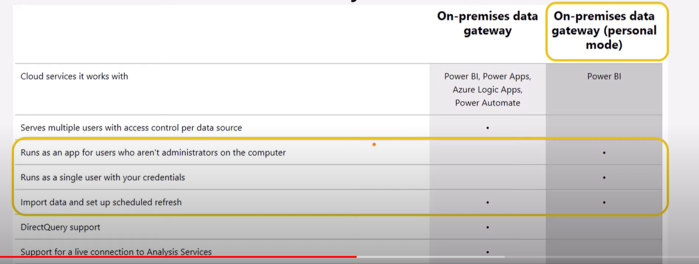

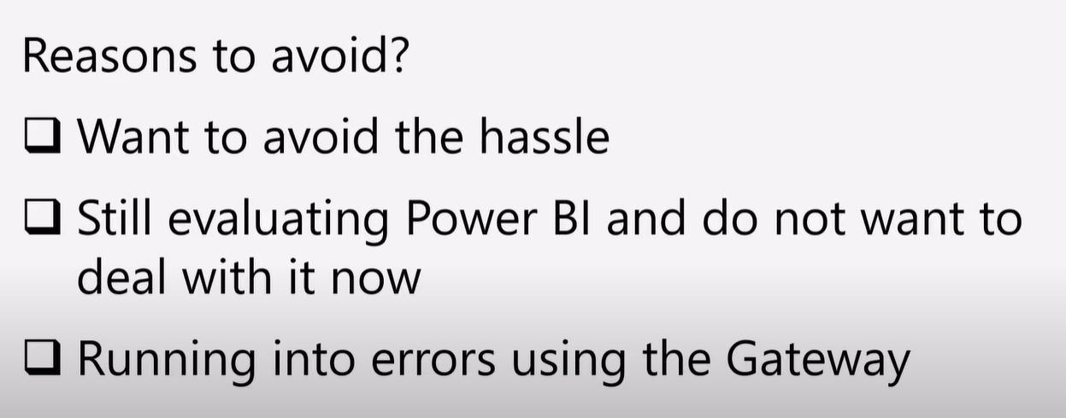

* How is the filter function used in DAX?

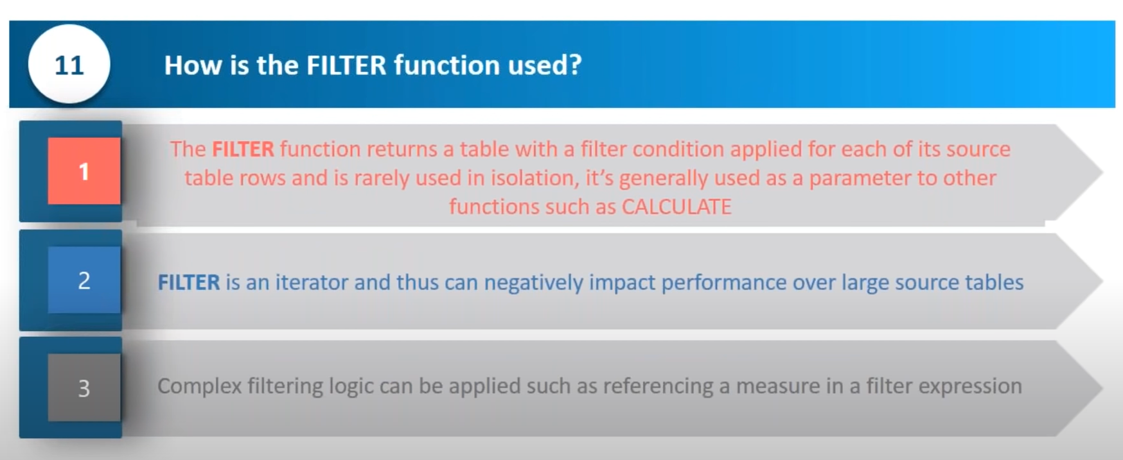

* Why would you apply general formatting to data in Power BI?

By formatting data, users can help Power BI categorize and identify data, making it much easier to work with.

* Name three of the most common data shaping techniques and explain how to use them.

Explain everything that we can do in power query editor such as new column , splitting into multiple columns, data type change, checking about the M code that is generated behind the scenes.

* What's z-order in Power BI, and why would you choose to use it?

Z-order is a design strategy that is used for arranging visuals over shapes. Also, z-order can be defined as an implementation method that can be applied when reports have multiple elements. Further, this can also be used to refresh the display after the order of items in a report is changed.

* [What are the versions of Power BI?](https://intellipaat.com/blog/interview-question/power-bi-interview-questions/#6)
* Power BI Desktop: The on-premise version for Windows 10
* Power BI Service: For publishing to the cloud
* Mobile Power BI: For mobile users
* [What is the purpose of the ‘Get Data’ icon in Power BI?](https://intellipaat.com/blog/interview-question/power-bi-interview-questions/#9)

When users click on the Get Data icon in Power BI, a drop-down menu appears and it shows all data sources from which data can be ingested.

* Synchronised Slicers

Select the slicer visual which we want to sync with other one and use appropriate visual level filters on it depending upon the need. Also can create a specific measure to do that.

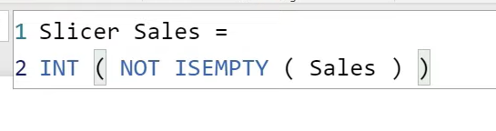

And apply this as selected as 1 for visual level filters.

* Can we have multiple custom relationships in Power BI?

No , only 1 active relationship at a time

* What leads to the advent of Self-service BI over Managed Enterprise BI?

There is no need of third-party vendors anymore and all associated constraints are eradicated.

Users could generate intuitive and actionable dashboards almost instantaneously without executing complex programming codes.

* Importance of Normalization of SQL Server.

**Normalization** is a database design technique that reduces data redundancy and eliminates undesirable characteristics like Insertion, Update and Deletion Anomalies. Normalization rules divides larger tables into smaller tables and links them using relationships. The purpose of Normalization in SQL is to eliminate redundant (repetitive) data and ensure data is stored logically.

* 1NF (First Normal Form)
* 2NF (Second Normal Form)
* 3NF (Third Normal Form)
* BCNF (Boyce-Codd Normal Form)

**in most practical applications, normalization achieves its best in 3rd Normal Form**.

;

* Database designing is critical to the successful implementation of a database management system that meets the data requirements of an enterprise system.
* Normalization Process in DBMS helps produce database systems that are cost-effective and have better security models.
* Functional dependencies are a very important component of the normalize data process
* Most database systems are normalized database up to the third normal forms.
* A primary key uniquely identifies are record in a Table and cannot be null
* A foreign key helps connect table and references a primary key
* What is denormalization in SQL?

**Denormalization** is a database optimization technique in which we add redundant data to one or more tables. This can help us avoid costly joins in a relational database. ... In a traditional normalized database, we store data in separate logical tables and attempt to minimize redundant data.

* Power Query.
* What do you know about Slowly Changing Dimension (SCD)concept in Data Warehousing?

Dimension attributes definitely do change over time to accommodate business requirements.

Type -1: overwrite the old value with new one and not trach historical data. Easy to implement and reflects latest data if no old data is not needed. No backup of history

Type -2 : Preserve the history by adding a new row for the new changed data along with old data. Different PK is maintained. Flag version is mentioned and given an incremental value or data a start and end date . No to be done in places where changes are structure is a possibility and increases DB side.

Type -3: Adding a new attribute to track current and previous values(partial history).

New column for new value and a date column to record the date for change.

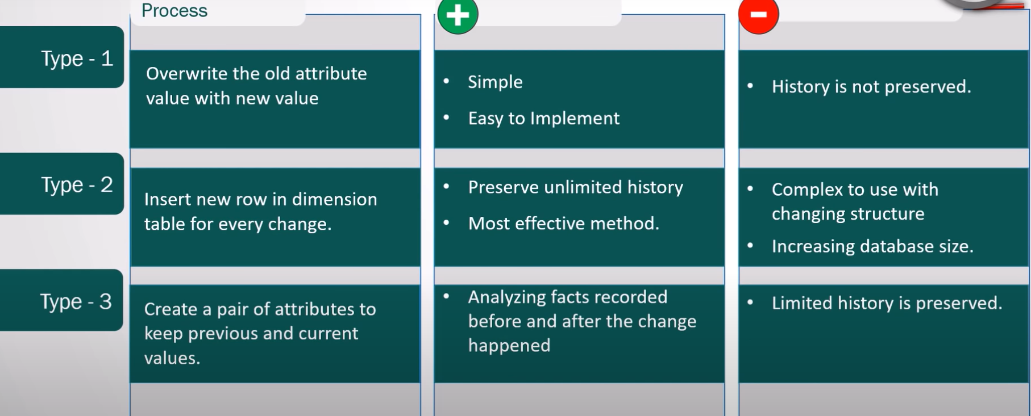

* How to query a SSAS Tabular model database using DAX functions?
* How do you write a DAX query?
* Diff b/w Fact table & Dimensions

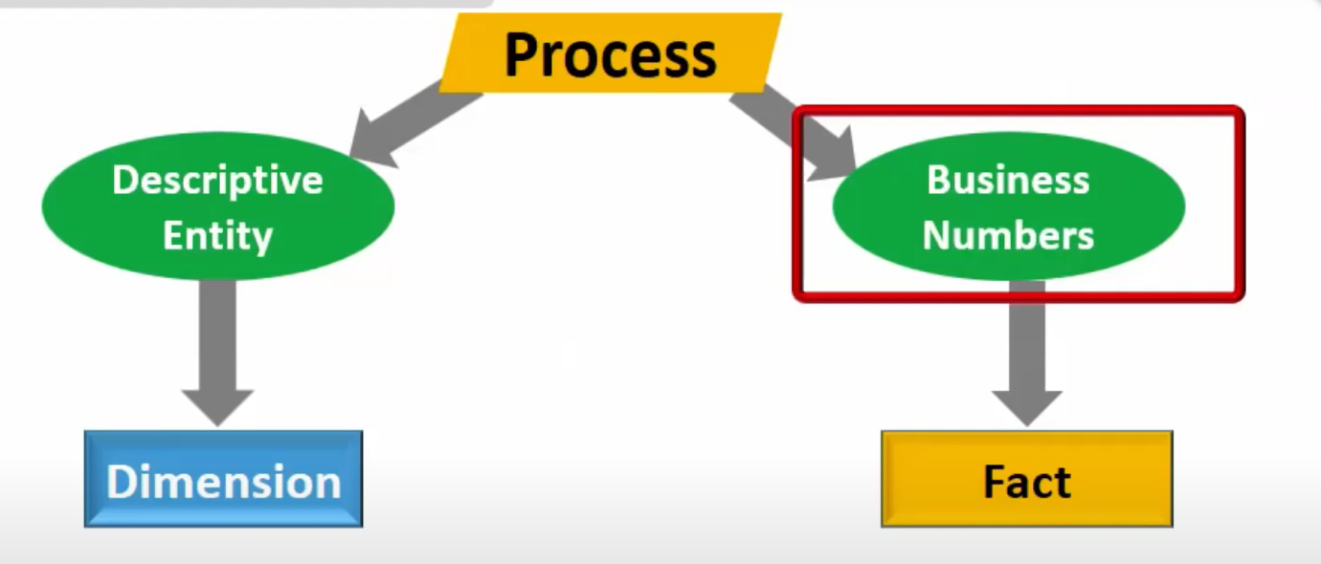

* **Fact tables**: The central table in a star schema of a data warehouse, a fact table stores quantitative information for analysis and is not normalized in most cases.
* **Dimension tables**: It is just another table in the star schema that is used to store attributes and dimensions that describe objects stored in a fact table.
* Diff b/w Sum & SUMX

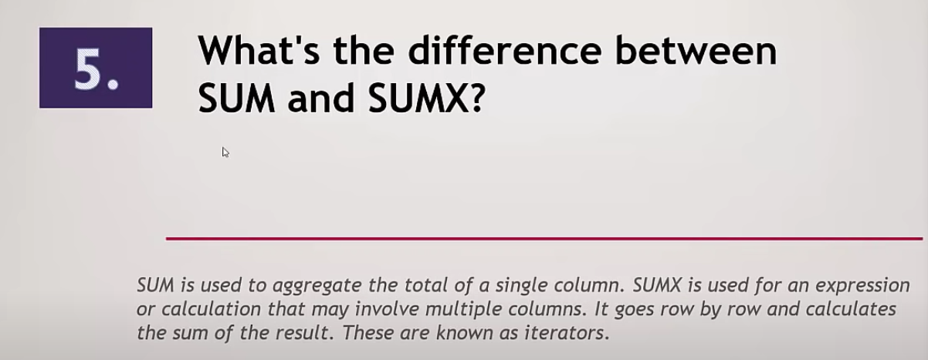

* Diff b/w Filters and Dashboard
* Diff b/w Reports & Dashboards
* Difference b/w Visual, Page, Report levels
* What is RLS

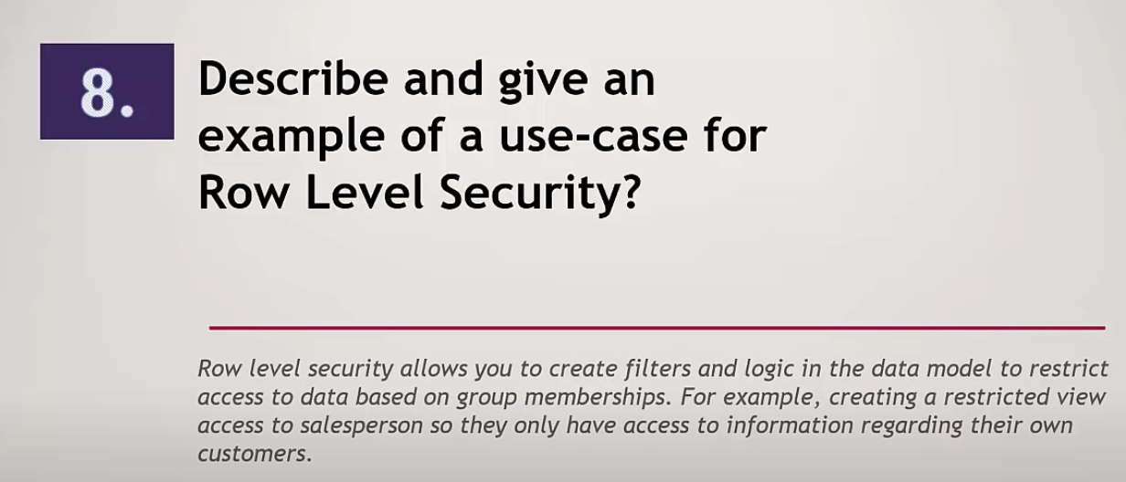

* What is PBI Service

**Power BI** is a collection of software services, apps, and connectors that work together to help you create, share, and consume business insights in the way that serves you and your business most effectively. The Microsoft Power BI service (app.powerbi.com), sometimes referred to as Power BI online, is the SaaS (Software as a Service) part of Power BI. In the Power BI service, dashboards help you keep a finger on the pulse of your business. Dashboards display tiles, which you can select to open reports for exploring further. Dashboards and reports connect to datasets that bring all of the relevant data together in one place.

* Stored Procedures?
* A stored procedure is a prepared SQL code that you can save, so the code can be reused over and over again.
* So if you have an SQL query that you write over and over again, save it as a stored procedure, and then just call it to execute it.
* You can also pass parameters to a stored procedure, so that the stored procedure can act based on the parameter value(s) that is passed.

CREATE PROCEDURE SelectAllCustomers @City nvarchar(30), @PostalCode nvarchar(10)  
AS  
SELECT * FROM Customers WHERE City = @City AND PostalCode = @PostalCode  
GO;

* Difference between Import & Direct

Import – creating a copy of all data in power bi , reports are extremely fast, 1 Gb max allowed on non premium account but that too for only 10 GB.

Direct query – go to data source main to fetch data and reports are little slow, doesnot allow more than 1 million rows, cannot connect to all data sources.

* What is Bookmark?

Bookmarks capture the currently configured view of a report page, including filters, slicers, and the state of visuals. When you select a bookmark, Power BI takes you back to that view. There are two types of bookmarks - those you create yourself and those created by report designers. Any Power BI user can create personal bookmarks. However, the ability to use bookmarks created by others requires a Power BI Pro or Premium license.

* Difference b/w PBI Gateways & Management Gateways
* Diff b/w Related & Relatedtable in Dax
* RELATED can only draw values from the One-Side to the Many-side. So, it looks up the values in the One-Side and it populates the Many-Side.
* For RELATEDTABLE it can look up values from the Many-Side and bringing it into the One-Side.
* Diff between where and having clause

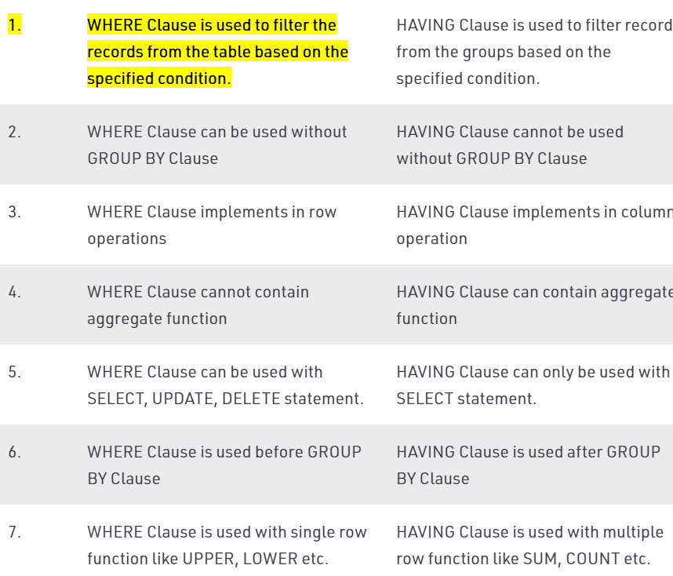

* Rank and dense rank

Simply put, RANK skips the number of positions after records with the same rank number. The ranking RANK_DENSE returns position numbers from 1 to 6 because it doesn’t skip records with the same rank number

* Diff sp and views
* View is simple showcasing data stored in the database tables whereas a stored procedure is a group of statements that can be executed.
* A view is faster as it displays data from the tables referenced whereas a store procedure executes sql statements
* A view is a simple way to save a complex SELECT in the database.
* A store procedure is used when simple SQL just isn't enough. Store procedures contain variables, loops and calls to other stored procedures. It's a programming language, not a query language.
* How to improve the performace of the query on daily basis ,then how you will over come on that issue

## **Reducing table size**

## **Making joins less complicated**

## **EXPLAIN**

* Rls
* Gate ways
* Shedule refresh
* Filters and types
* Custom visuals -- get from powerBI market and use them based on free / bought
* Ssis------
* Containers – sequence , for loop, for each loop container
* Packages
* project overview
* Best practices for PBI

**Limit the number of visuals in dashboards and reports**

**To improve Power BI report performance, remove unnecessary interactions between visuals.**

**Enable**[**Row-Level Security**](https://docs.microsoft.com/en-us/sql/relational-databases/security/row-level-security?view=sql-server-2017)**(RLS).**

**Limit complicated complex measures and aggregations in data models.**

**Import only necessary fields and tables instead of entire datasets.**

**Shorten numbers.**

* The trendline chart ,bar chart and bubble chart
* Rank function in sql – skips the rows specified inside order by within OVER()
* •Dense rank in sql – doesnot skip rows specified inside order by within OVER()
* Partition BY is used in OVER() for more granular level segregation
* •Rownum in sql -- ROW_NUMBER numbers all rows sequentially (for example 1, 2, 3, 4, 5).
* •Group by in sql – grouping some column values based on same values for all rows of some other column value
* •How to delete multiple duplicates in sql
* 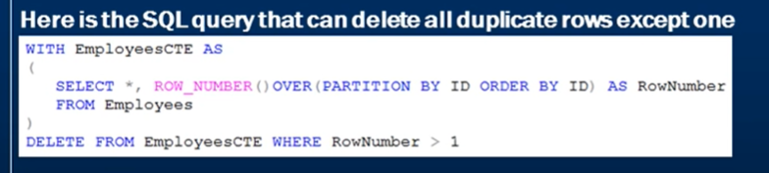
* •Bookmarks in power bi – present on powerbi service side which stores all filters, visuals and is shareable to others in organization and can be restored to default .
* •Selection in power bi – present in view tab – need to enable it manually to filter which visuals we want to see on reports and what not to see. Same is for bookmarks pane
* •Edit interactions in power bi – go to format option after selecting visual and click on circular symbol for limiting the interaction.
* **Sql:**
* Group by -- grouping some column values based on same values for all rows of some other column value
  + Union and union all – union doesnot allow duplicates from results of 2 subqueries but union all allows it. UNION first performs a sorting operation and eliminates of the records that are duplicated across all columns before finally returning the combined data set.
  + Rank
  + Sum
* The COUNT() function returns the number of rows that matches a specified criterion.
* The AVG() function returns the average value of a numeric column.
* The SUM() function returns the total sum of a numeric column.
* **Power bi:**
  + Maps
  + Bookmarks
  + Pie charts – distribution of marks , entity wise
  + Tree map -- Treemaps display hierarchical data as a set of nested rectangles. Each level of the hierarchy is represented by a colored rectangle (branch) containing smaller rectangles (leaves). Power BI bases the size of the space inside each rectangle on the measured value. The rectangles are arranged in size from top left (largest) to bottom right
  + RLS(row level security)
  + Linear chart -- A line chart is a series of data points that are represented by dots and connected by straight lines. A line chart may have one or many lines. Line charts have an X and a Y axis.
* Complex project, how it was created – explain about the project TA
* What is Composite model in power bi

A **model** that combines data from more than one DirectQuery source or that combines DirectQuery with import data is called a **composite model**. You can create relationships between tables as you always have, even when those tables come from different sources.

* What is outlier

**Outliers** are those data points that lie outside the overall pattern of distribution & the easiest way to detect **outliers** is though graphs. Box plots, Scatter plots can help detect them easily.

* Different charts and options
* Area **Charts**. The area **chart** depends on line **charts** to display quantitative graphical data. ...
* Line **Charts**. ...
* Bar **Charts**. ...
* Column **Charts**. ...
* Combo **Charts**. ...
* **Pie Charts**. ...
* Doughnut **Charts**. ...
* Gauge **Charts**.
* Using left join in alteryx
* Incremental loading
* Optimization
* Challenges of the project I worked on
* Rls
* Explain any complex dax query
* Triggers -- A trigger is a special type of stored procedure that automatically runs when an event occurs in the database server. DML triggers run when a user tries to modify data through a data manipulation language (DML) event. DML events are INSERT, UPDATE, or DELETE statements on a table or view. These triggers fire when any valid event fires, whether table rows are affected or not.
* OLAP Vs OLTP

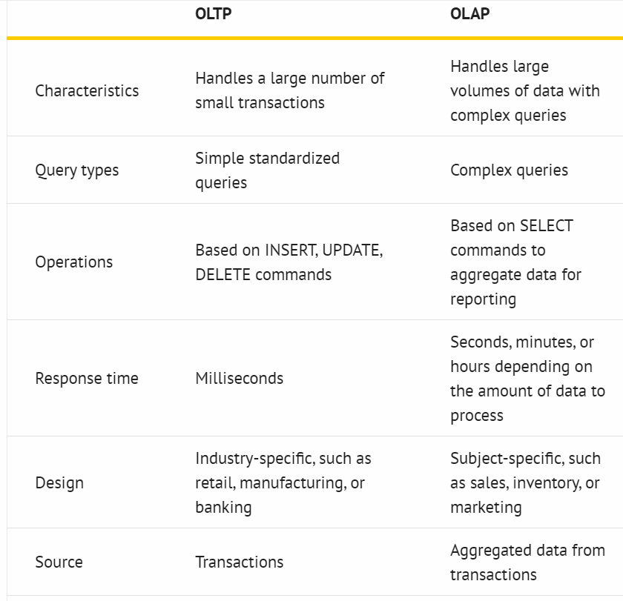

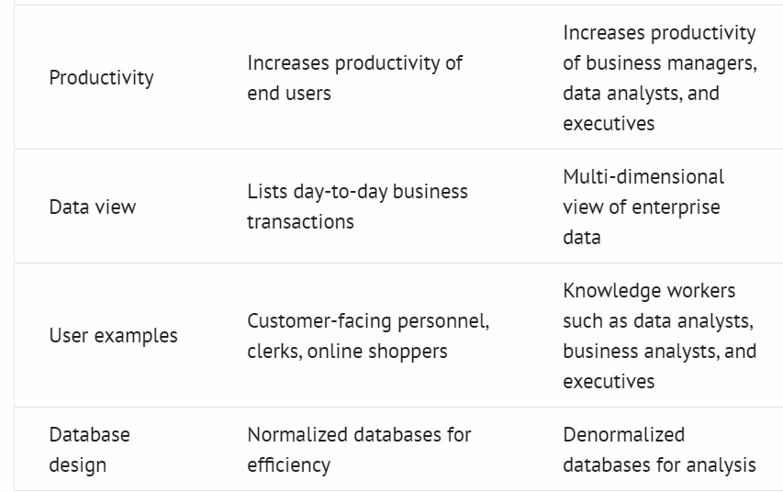

* Types of Indexes

A clustered index defines the order in which data is physically stored in a table. Table data can be sorted in only way, therefore, there can be only one clustered index per table. In SQL Server, the primary key constraint automatically creates a clustered index on that particular column.

A non-clustered index doesn’t sort the physical data inside the table. In fact, a non-clustered index is stored at one place and table data is stored in another place. This is similar to a textbook where the book content is located in one place and the index is located in another. This allows for more than one non-clustered index per table.

* Columns and measures differences
* Types of SCDs – 3 ..explanation given above
* Charts – given above
* Select all and all function
* Realtime scenarios
* Connectivity Modes
* DAX Functions
* Subscription and alert in power bi service. -- <https://docs.microsoft.com/en-us/power-bi/create-reports/service-set-data-alerts>
* Merge queries – increases columns volumne
* Append Queries – increases row volume
* Combine – consists of merge and append
* The Merge button is an equivalent of JOIN in SQL. It’s also similar to LOOKUP function in Excel, but behavior is different when multiple matches are found. Read more to find out.
* The Append button is an equivalent of UNION ALL in SQL
* how can mange more then 1gb data

if you don’t have relevant powerBI license premium, then you cannot import more than 1 GB data but with premiuim account you can got to 10 GB. Direct query option should not have more than 1 million rows on that option usage. Direct query has limited options to certain datasources as well. Import has no disadvantages compared to direct query.

* palyers score and name perticular year@number wise – use rownumber() , over() and partition by inside over()
* Scenario for bar graph
* 2 dimensions and a measure and she need to sort it by 3rd dimension without involving it in visual – use a lookup table, join it to a fact and sort in relational table view
* And which type of visual will be used in profit and sales – only KPI if you want to see direct nos with/without filters, we can use bar charts/area charts stacked/transparent ones
* Regarding my project
* Min – works with only numeric values and MINA – works with numeric, logical and text values,

Same works for MAX and MAXA.