**CORE MODULE 5**

**Business Data Analytics**

**PRACTICAL**

**Name : - Prateek Kumar**

**Registration No : - ADIT22AP00152**

**NSTI Name : - NSTI Noida**

**Course : - ADIT (IBM)**

**Date : - 23-10-2024**

**Module : - Core Module 5**

**Practical : - Business data analytics**

**Requirements/tools : -**

1. **Hardware: -** 
   * 1. **Working PC with Hard disk installed**
     2. **Internet connection**
2. **Software: -**
   * 1. **Browser for google collab**

**Question 1 :- What steps should I follow to establish an IBM Watson assistant and design a basic chatbot that welcomes user and inquires about their favourite food, while also integrating the chatbot with a simple web page or application to display its responses there?**

**solution**

**STEP1:- Go to the ibm cloud dashboard**

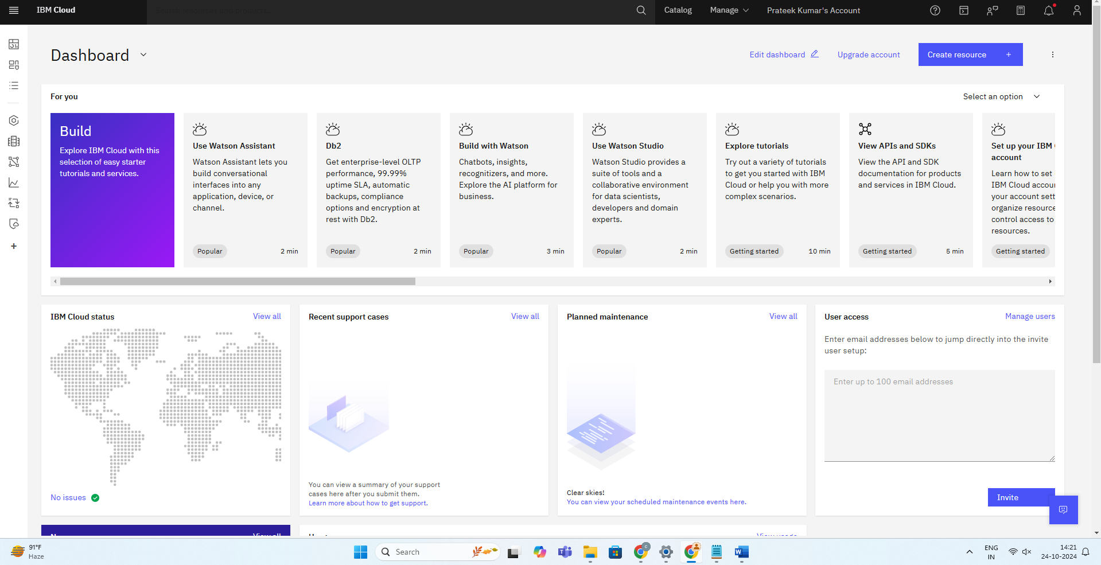

**STEP2:- in the navigation menu click on resource list**

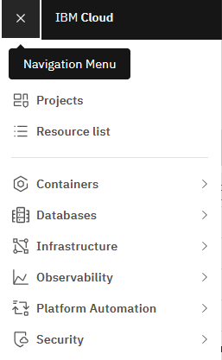

**STEP 3: - now click on create resource and search for watsonx Assistant**

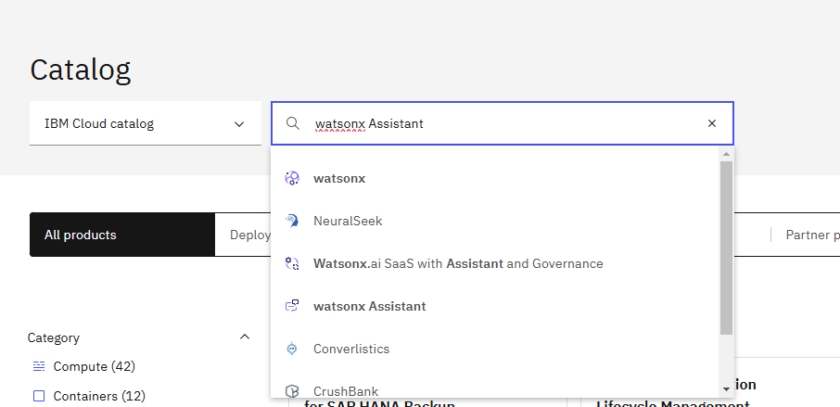

**STEP4:- now configure your assistant and click on create**

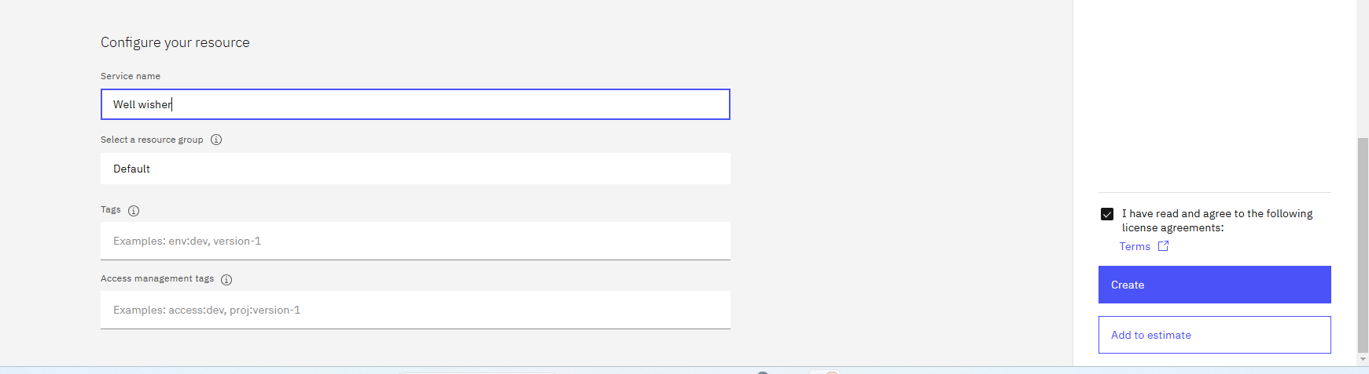

**STEP5:- now click on launch Watson assistant**

**STEP5:- now SET-UP your Watson assistant and click on next**

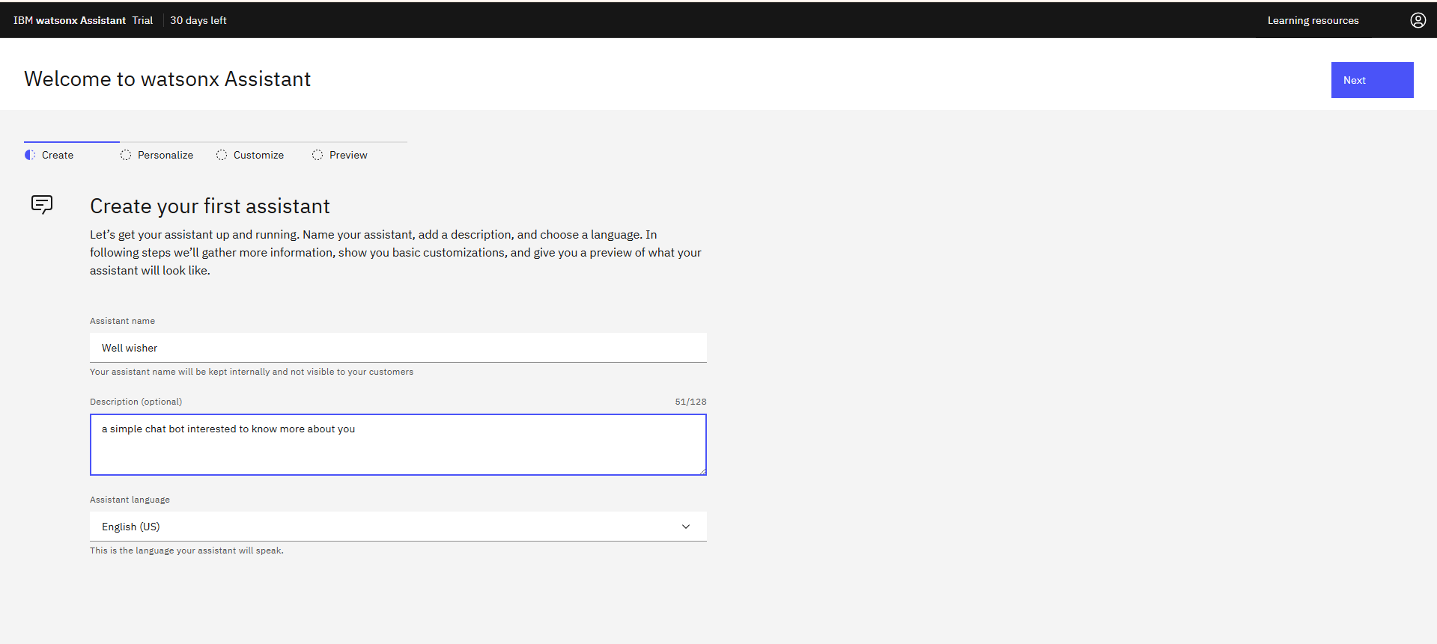

**STEP6:- personalize your assistant according to your needs**

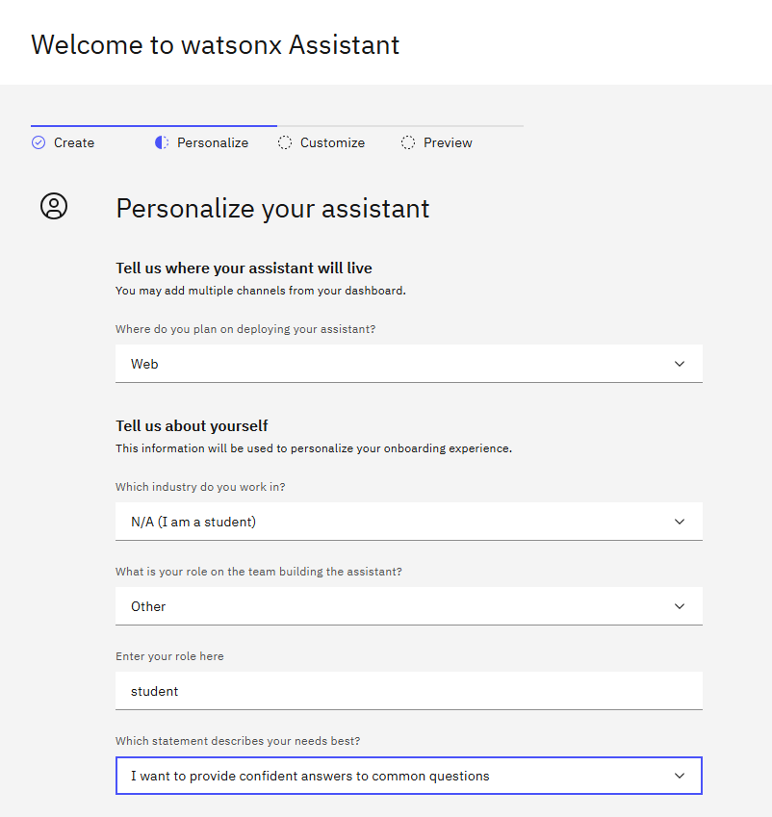

**STEP7: - click on next than customize its name and chat ui and logo than click on next**

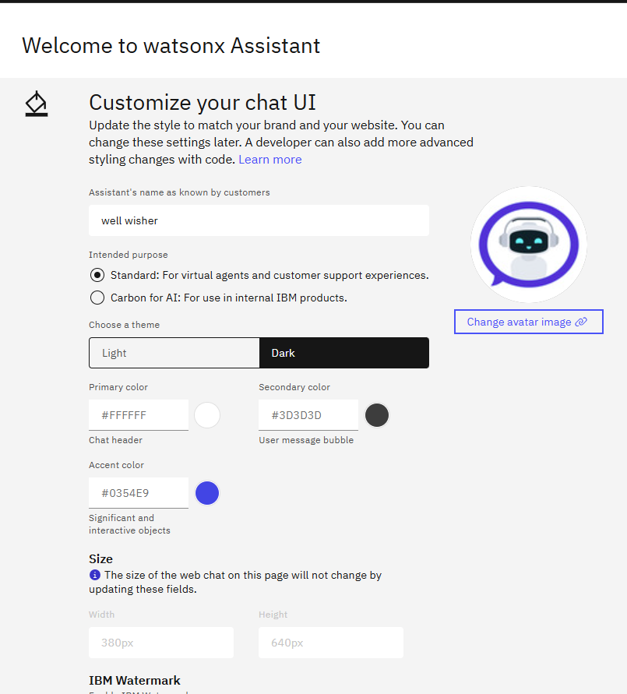

**STEP 8 : - now customize chatbot interactions**

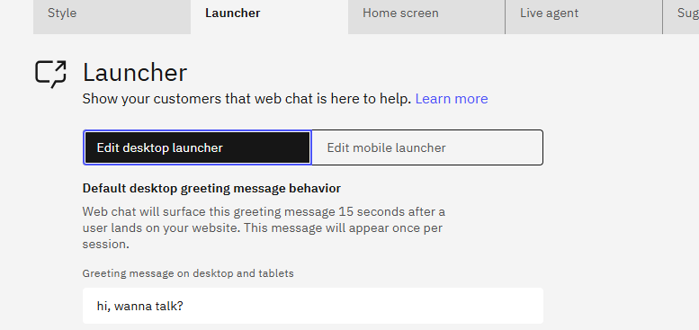

**Customize homescreen**

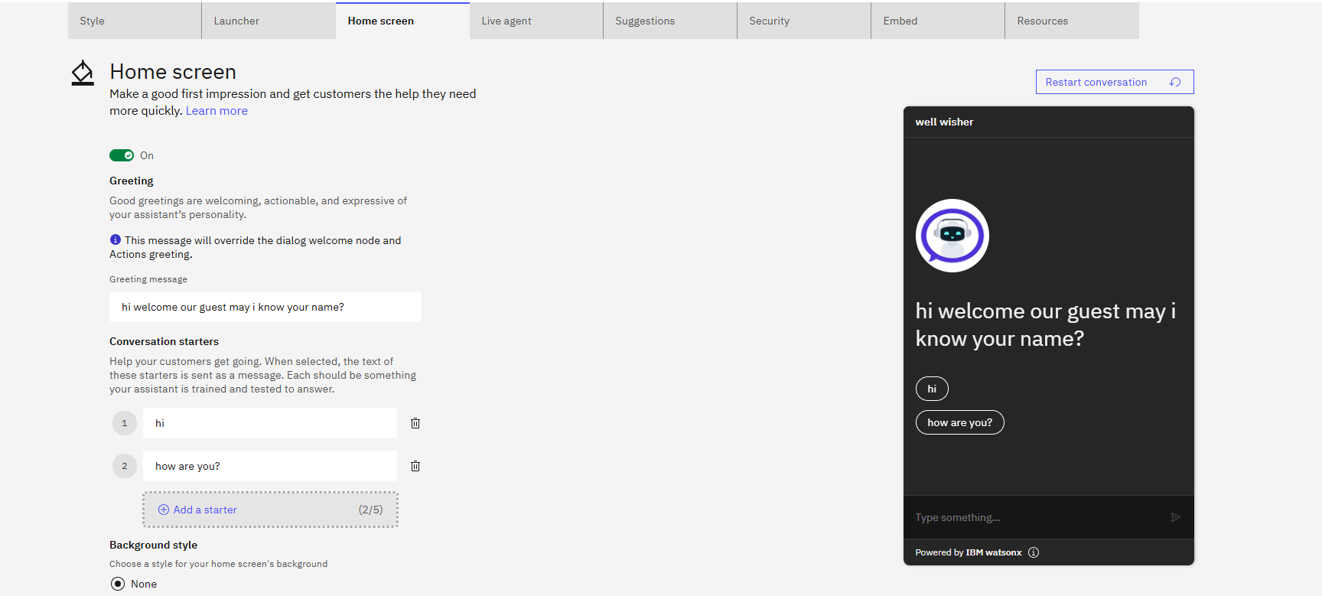

**STEP 9 : - now lets create our custom interactions click on actions**

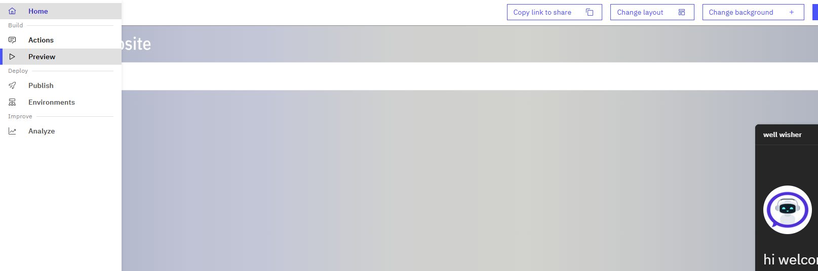

**STEP 10:- now click on created by you and create your first interactions**

**Click on start from scratch**

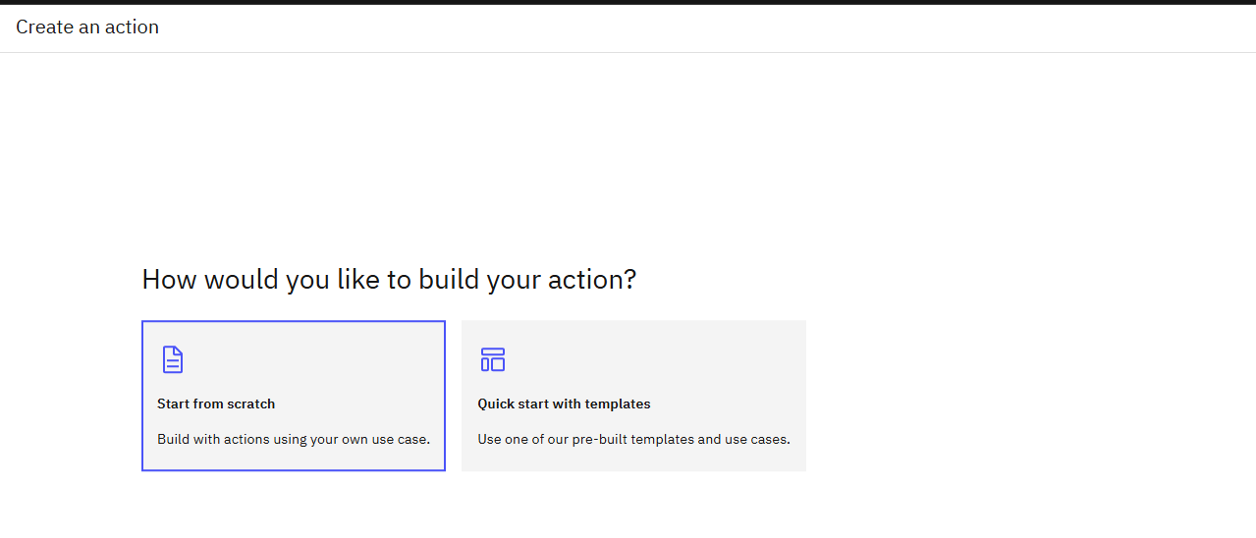

**STEP 10:-**

**welcome user name ask their name in first step**

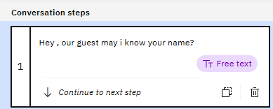

**Greet them with their name using condition that step1 is defined and show user name using action step variable**

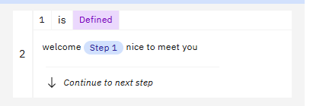

**In third step ask their food using their name**

**Now answer them accordingly**

**Now end the conversion using nice to meet you and their name**

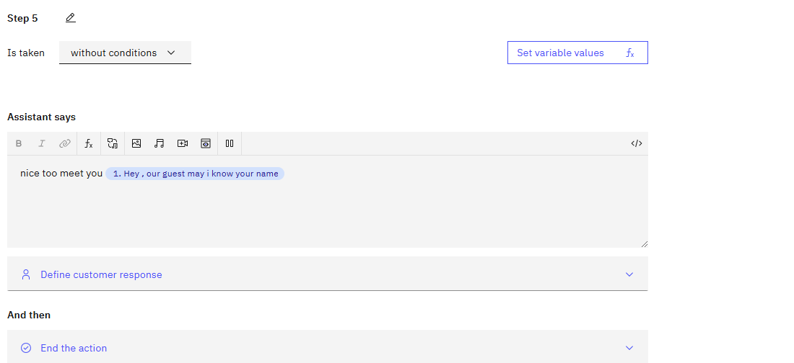

**STEP11:-now save everything and lets integrate it to our html page**

**Click on integration in the bottom left of sidebar**

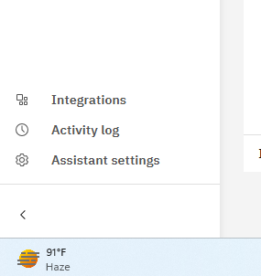

**Click on open**

**Click on confirm**

**Click on embed**

**Copy the script**

**STEP 12:- create a html file in your editor**

**Here is the complete code**

**<!DOCTYPE html>**

**<html lang="en">**

**<head>**

**<meta charset="UTF-8">**

**<meta name="viewport" content="width=device-width, initial-scale=1.0">**

**<title>chatbot</title>**

**<style>**

**\*{**

**background-color: black;**

**color: white;**

**}**

**</style>**

**</head>**

**<body>**

**<h1 style="text-align: center;">Welcome to ADIT</h1>**

**<script>**

**window.watsonAssistantChatOptions = {**

**integrationID: "c1b07741-8a52-4a91-ad70-7a8a7d56a8a4", // The ID of this integration.**

**region: "au-syd", // The region your integration is hosted in.**

**serviceInstanceID: "d48910fc-63a8-4b95-91da-fee116c5c71b", // The ID of your service instance.**

**onLoad: async (instance) => { await instance.render(); }**

**};**

**setTimeout(function(){**

**const t=document.createElement('script');**

**t.src="https://web-chat.global.assistant.watson.appdomain.cloud/versions/" + (window.watsonAssistantChatOptions.clientVersion || 'latest') + "/WatsonAssistantChatEntry.js";**

**document.head.appendChild(t);**

**});**

**</script>**

**</body>**

**</html>**

**Now lets run the html**

**Now we can see our chatbot icon has been appeared on bottom left click on it**

**Click on hi or how are you?**

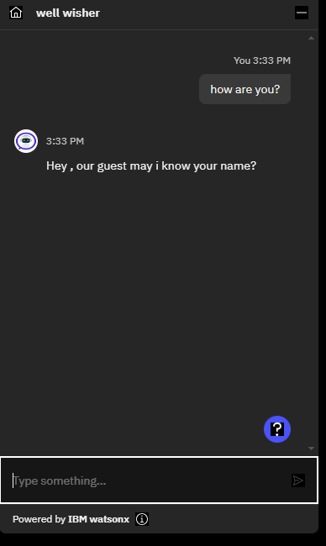**It will ask for your name enter your name than it will ask about favourite food**

**Enter name of your favourite food**

**It will say nice to meet you and the conversation will end**

**We finally created our chatbot**

**Question 3: - Create an instance of Cloudant database on IBM cloud and name it student DB.**

**Solution: -**

**STEP1:- Go to the ibm cloud dashboard**



**STEP 2 : - Search for Cloudant and click on it**

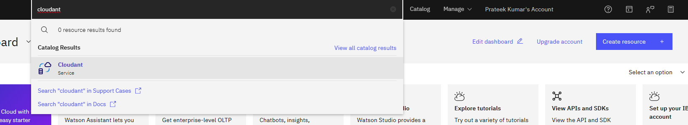

**STEP 3: - configure it and click on create**

**Our service will be created**

**STEP 4: - than click on the name of the service**

**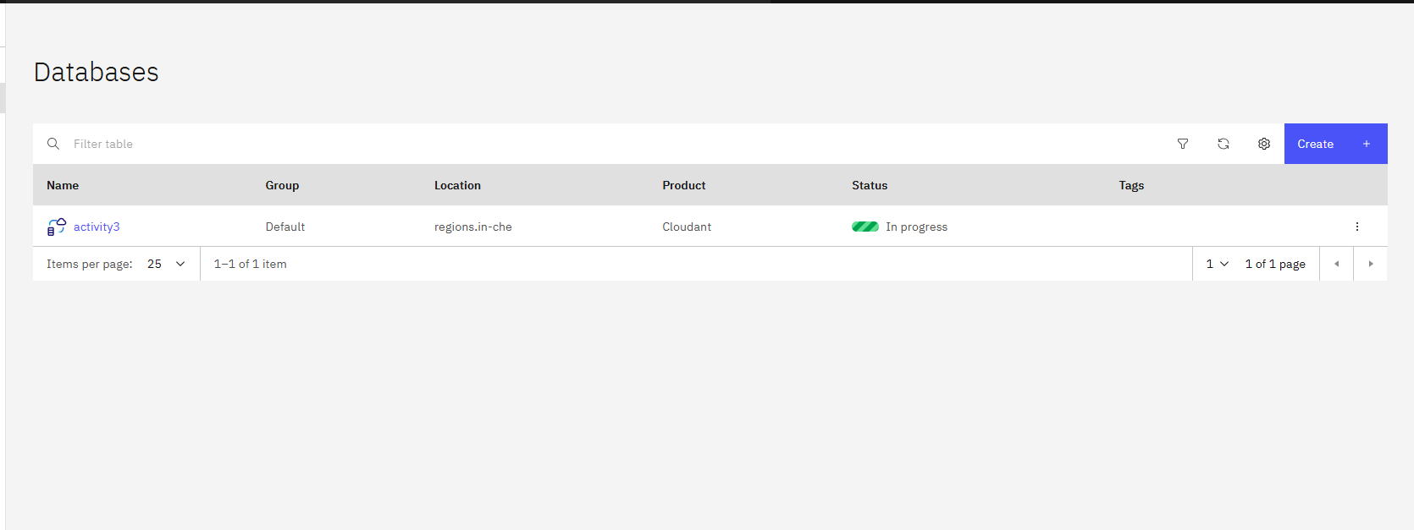  
STEP 4: - than click on launch dashboard**

**STEP 5:- in the dashboard create the database Student db**

**STEP 6: - Now we can see our database is successfully created**



