**CORE MODULE 1**

**Computer Hardware**

**PRACTICAL**

**Name : - Prateek Kumar**

**Registration No : - ADIT22AP00152**

**NSTI Name : - NSTI Noida**

**Course : - ADIT (IBM)**

**Date : - 18-10-2024**

**Module : - Core Module 1**

**Practical : - Computer Hardware**

**Requirements/tools : -**

1. **Hardware: -** 
   * 1. **PC with 8 GB ram and minimum 512 gb storage**
2. **Software: -**
   * 1. **Ms word**

**Question 3).** Create an invitation letter using mail merge for multiple invitees in Microsoft Word or Open Office.

**Solution: -**

**Step-1** Open the MS Word Document and save the file with the name Mail Merge.

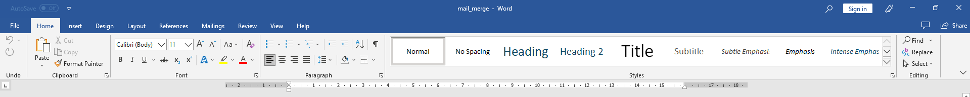

**Step-2** Click on the Mailings Tab in the Menu Bar.

**Step-3** Now click on Start Mail Merge.

**Step-4** Now click on Step-by-Step Mail Merge Wizard.

**Step-5** Now, select the type of document you'd like to create. Since we're tasked with creating an invitation letter, click on the 'Letters' option

**Step-6** Now we have to move further to the next step then click on **Next: Starting document.**

**Step 7**: Select Use the Current Document as your starting document.

**Step-8**: Click Next: Select Recipients to continue

**Step-9** Now, it's time to select the recipients for the invitation letter. If you already have a list created, click on Use an existing list. Alternatively, if you need to create a new list, click on Type a new list.

**Step-10** To create a new list of recipients, click on Create and make your own list.

**Step-11** Now click on Write your letter.

**Step-12** Now write an invitation letter.

**Step-13** Now, to insert field names, first click on More items. Then, place the cursor in the exact spot where you want to insert the field, and click Insert.

**Step-14** Now click on Preview your letter.

**Step-15** Now you can see the invitation for the 1st recipient.

**Step-16** This is the invitation for 2nd recipient.

**Step-17** This is the invitation for 3rd recipient.

**Step-18** Now click on Complete the merge.

**Step-19** Now click on Print if you want to print the invitation letter.

