**CORE MODULE 3**

**Web Designing**

**PRACTICAL**

**Name : - Prateek Kumar**

**Registration No : - ADIT22AP00152**

**NSTI Name : - NSTI Noida**

**Course : - ADIT (IBM)**

**Date : - 21-10-2024**

**Module : - Core Module 3**

**Practical : - Web Designing**

**Requirements/tools : -**

1. **Hardware: -** 
   * 1. **Working PC with Hard disk installed**
     2. **Internet connection**
2. **Software: -**
   * 1. **VS CODE**
     2. **Browser**
     3. **XAMPP or MYSQL workbench**

**Question 1: - Write a simple HTML form that includes an input for the user’s name and a submit button. How can you style this form using Bootstrap to make it look better.**

**Solution: -**

**Step-1** Open the VS Code editor and open the folder where you want to save the file and create a html file I named it question1.html .

**Step-2** Now add basic structure to the html.

**

**Step-4** Now paste the CDN in the head tag

<!DOCTYPE html>

<html lang="en">

<head>

    <meta charset="UTF-8">

    <meta http-equiv="X-UA-Compatible" content="IE=edge">

    <meta name="viewport" content="width=device-width, initial-scale=1.0">

    <title>Bootstrap Form Customization</title>

    <link href="https://cdn.jsdelivr.net/npm/bootstrap@5.3.3/dist/css/bootstrap.min.css" rel="stylesheet" integrity="sha384-QWTKZyjpPEjISv5WaRU9OFeRpok6YctnYmDr5pNlyT2bRjXh0JMhjY6hW+ALEwIH" crossorigin="anonymous">

<script src="https://cdn.jsdelivr.net/npm/bootstrap@5.3.3/dist/js/bootstrap.bundle.min.js" integrity="sha384-YvpcrYf0tY3lHB60NNkmXc5s9fDVZLESaAA55NDzOxhy9GkcIdslK1eN7N6jIeHz" crossorigin="anonymous"></script>

</head>

<body>

</body>

</html>

**Step-5** Now select any form you want from bootstrap and copy the code.

**Step-6** Now paste the starter code to the code editor.

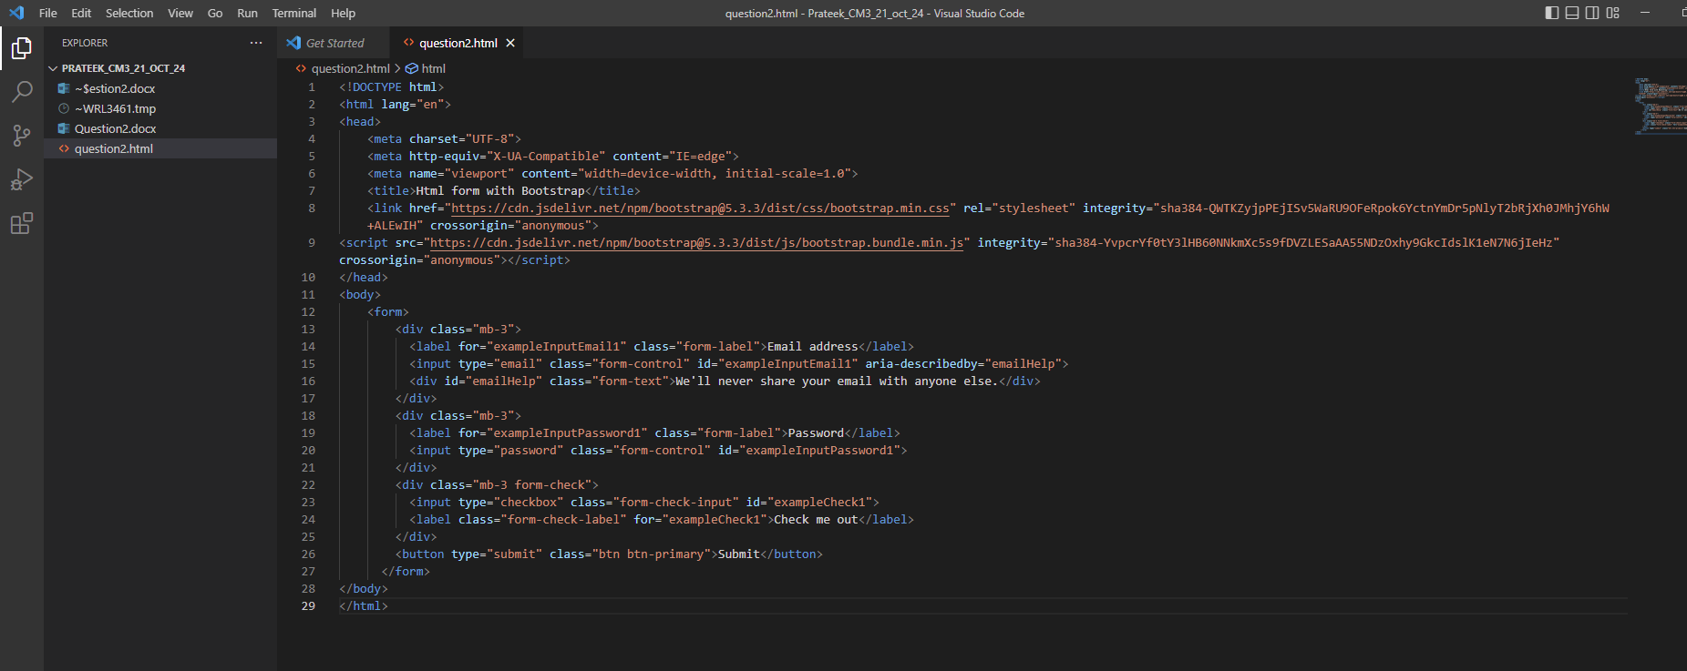

<!DOCTYPE html>

<html lang="en">

<head>

    <meta charset="UTF-8">

    <meta http-equiv="X-UA-Compatible" content="IE=edge">

    <meta name="viewport" content="width=device-width, initial-scale=1.0">

    <title>Html form with Bootstrap</title>

    <link href="https://cdn.jsdelivr.net/npm/bootstrap@5.3.3/dist/css/bootstrap.min.css" rel="stylesheet" integrity="sha384-QWTKZyjpPEjISv5WaRU9OFeRpok6YctnYmDr5pNlyT2bRjXh0JMhjY6hW+ALEwIH" crossorigin="anonymous">

<script src="https://cdn.jsdelivr.net/npm/bootstrap@5.3.3/dist/js/bootstrap.bundle.min.js" integrity="sha384-YvpcrYf0tY3lHB60NNkmXc5s9fDVZLESaAA55NDzOxhy9GkcIdslK1eN7N6jIeHz" crossorigin="anonymous"></script>

</head>

<body>

    <form>

        <div class="mb-3">

          <label for="exampleInputEmail1" class="form-label">Email address</label>

          <input type="email" class="form-control" id="exampleInputEmail1" aria-describedby="emailHelp">

          <div id="emailHelp" class="form-text">We'll never share your email with anyone else.</div>

        </div>

        <div class="mb-3">

          <label for="exampleInputPassword1" class="form-label">Password</label>

          <input type="password" class="form-control" id="exampleInputPassword1">

        </div>

        <div class="mb-3 form-check">

          <input type="checkbox" class="form-check-input" id="exampleCheck1">

          <label class="form-check-label" for="exampleCheck1">Check me out</label>

        </div>

        <button type="submit" class="btn btn-primary">Submit</button>

      </form>

</body>

</html>

It should look like this

**Step-7** Now customize the code according to the question as we need a username and a submit button and let’s customize it even more using bootstrap classes.

<!DOCTYPE html>

<html lang="en">

<head>

    <meta charset="UTF-8">

    <meta name="viewport" content="width=device-width, initial-scale=1.0">

    <title>Bootstrap Form Customization</title>

    <link href="https://cdn.jsdelivr.net/npm/bootstrap@5.3.3/dist/css/bootstrap.min.css" rel="stylesheet" integrity="sha384-QWTKZyjpPEjISv5WaRU9OFeRpok6YctnYmDr5pNlyT2bRjXh0JMhjY6hW+ALEwIH" crossorigin="anonymous">

</head>

<body>

    <div class="container my-5">

        <div class="row justify-content-center">

            <div class="col-md-6">

                <div class="card shadow-sm">

                    <div class="card-body p-4">

                        <h3 class="card-title text-center mb-4">Contact Us</h3>

                        <form>

                            <div class="mb-3">

                                <label for="exampleInputEmail1" class="form-label">Email address</label>

                                <input type="email" class="form-control" id="exampleInputEmail1" aria-describedby="emailHelp" placeholder="Enter your email">

                            </div>

                            <button type="submit" class="btn btn-primary w-100">Submit</button>

                        </form>

                    </div>

                </div>

            </div>

        </div>

    </div>

    <script src="https://cdn.jsdelivr.net/npm/bootstrap@5.3.3/dist/js/bootstrap.bundle.min.js" integrity="sha384-YvpcrYf0tY3lHB60NNkmXc5s9fDVZLESaAA55NDzOxhy9GkcIdslK1eN7N6jIeHz" crossorigin="anonymous"></script>

</body>

</html>

**Step-8** Now run the file in the browser and you will get the following output.

**Question 2: - Write a PHP script to insert a new record into a MYSQL table called products with fields name and price and display all the records from a product’s table where the price is Greater than 198.**

**Solution: -**

# Step 1: Set Up a Local Environment

1. Install XAMPP to set up a local server that supports PHP and MySQL.  
 - Download XAMPP from the official website: https://www.apachefriends.org/index.html  
 - Install and run Apache server and MySQL using XAMPP control panel.

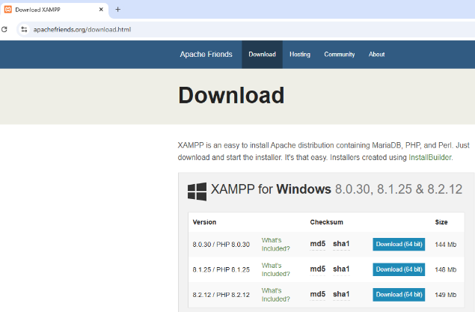

# Step 2: Create the Database and Table

1. Access phpMyAdmin via XAMPP control panel by clicking on the 'Admin' button next to MySQL than click on SQL and write following SQL queries.

2.create the database using

create database Company;

use company;

3. Create the 'products' table by running the following SQL command:

CREATE TABLE products (  
 id INT(6) UNSIGNED AUTO_INCREMENT PRIMARY KEY,  
 name VARCHAR(50) NOT NULL,  
 price DECIMAL(10, 2) NOT NULL  
 );

# Step 3: Write the PHP Script for Inserting Data and to display all the records from where the price is greater than 198.

<?php

$servername = "localhost";

$username = "root";

$password = "";

$dbname = "company";

// Create connection

$conn = new mysqli($servername, $username, $password, $dbname);

// Check connection

if ($conn->connect_error) {

    die("Connection failed: " . $conn->connect_error);

}

// Insert multiple records into the products table

$sql = "INSERT INTO products (name, price) VALUES

    ('ProductA', 150),

    ('ProductB', 250),

    ('ProductC', 300),

    ('ProductD', 100),

    ('ProductE', 500)";

if ($conn->query($sql) === TRUE) {

    echo "Records inserted successfully.<br>";

} else {

    echo "Error: " . $sql . "<br>" . $conn->error;

}

// Fetch records where price is greater than 198

$sql = "SELECT id, name, price FROM products WHERE price > 198";

$result = $conn->query($sql);

if ($result->num_rows > 0) {

    // Output data of each row

    while($row = $result->fetch_assoc()) {

        echo "ID: " . $row["id"]. " - Name: " . $row["name"]. " - Price: " . $row["price"]. "<br>";

    }

} else {

    echo "No records found";

}

$conn->close();

?>

# Step 4: Run the Script

1. Save the file as 'insert.php' and place it in the 'htdocs' folder of your XAMPP installation.  
    - The default path is usually C:\xampp\htdocs\ on Windows or /Applications/XAMPP/htdocs/ on macOS.  
   2. Start the Apache and MySQL servers from the XAMPP control panel.  
   3. Open your web browser and go to http://localhost/question2/insert.php to run the script.

# Step 5: Verify the Output

If the script runs correctly, the new product will be inserted and all products with a price greater than 198 will be displayed.

