**CORE MODULE 5**

**Business Data Analytics**

**PRACTICAL**

**Name : - Prateek Kumar**

**Registration No : - ADIT22AP00152**

**NSTI Name : - NSTI Noida**

**Course : - ADIT (IBM)**

**Date : - 23-10-2024**

**Module : - Core Module 5**

**Practical : - Business data analytics**

**Requirements/tools : -**

1. **Hardware: -** 
   * 1. **Working PC with Hard disk installed**
     2. **Internet connection**
2. **Software: -**
   * 1. **Browser for google collab**

**Question 1: - Write a NumPy program to generate a random number between 0 and 1.**

**Solution: -**

**STEP1:- Open google collab using google search than import the library (NumPy)**

**import numpy as np**

**STEP2: - Generate a random number using np.random.rand() it is a function from the NumPy library that generates random numbers.**

**random_number = np.random.rand()**

**STEP3: - Print the random number**

**print(random_number)**

**the complete code is**

**import numpy as np**

**random_number = np.random.rand()**

**print(random_number)**

**output**

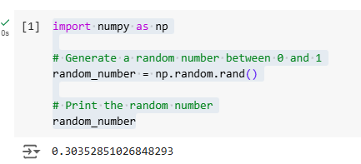

**Question 2: - Write a pandas program to create a dataframe from a dictionary and display it**

**Sample data: {‘X’:[78,85,96,80,86],’Y’:[84,94,89,83,86],** **'Z':[86,97,96,72,83]}**

**Solution: -**

**STEP1: - Open google collab using google search than import the library (pandas)**

**import pandas as pd**

**STEP2: - Create a variable named data and create a dictionary using our sample data.**

**data = {'X':[78,85,96,80,86], 'Y':[84,94,89,83,86], 'Z':[86,97,96,72,83]}**

**STEP3 :- create a dataframe named df using pandas dataframe to convert this dictionary in pandas data structure dataframe**

**df = pd.DataFrame(data)**

**STEP4: - Print the dataframe**

**Print(df)**

**the complete code is**

**import pandas as pd**

**data = {'X':[78,85,96,80,86], 'Y':[84,94,89,83,86], 'Z':[86,97,96,72,83]}**

**df = pd.DataFrame(data)**

**print(df)**

**output:-**

