***Beyond Basic SSA: A Novel Lévy Flight-Driven Approach for High-Dimensional Optimization***

**Harish Kumar Shakya1**

Associate Professor

Department of Computer Science and Engineering (AI&ML),

Manipal University Jaipur,

Jaipur, India

harishshakya@muj.manipal.edu

**Suhani Sharma2,**

Student 2nd year,

Department of Computer Science and Engineering (AI&ML),

Manipal University Jaipur,

Jaipur, India

suhani.23fe10cai00220@muj.manipal.edu

**Prateek Pandey3,**

Student 2nd year,

Department of Computer Science and Engineering (AI&ML),

Manipal University Jaipur,

Jaipur, India

prateek.23fe10cai00424@muj.manipal.edu

### **ABSTRACT :**

Community detection in social networks is a crucial task for understanding the structural and functional dynamics of complex networks. Traditional Slap Swarm Algorithm (SSA) has demonstrated potential in solving optimization problems, but it often struggles with premature convergence and inefficient exploration, leading to suboptimal community structures. This paper proposes an **Enhanced Slap Swarm Algorithm with Two-Stage Lévy Flight (SSA-TLSF)** for improved community detection. The proposed approach integrates **Two-Stage Lévy Flight (TSLF)** to enhance global exploration, preventing the algorithm from getting trapped in local optima. Additionally, an **Opposition-Based Learning (OBL) strategy** is incorporated to improve population diversity during initialization, ensuring better search space coverage. The adaptive transition between Lévy flight stages allows SSA-TLSF to maintain a balance between exploration and exploitation, leading to more accurate community structures. Experimental results on real-world social networks demonstrate that SSA-TLSF outperforms traditional SSA and other state-of-the-art algorithms in terms of **modularity, convergence speed, and community quality**. The findings confirm that SSA-TLSF is a **robust and efficient** optimization tool for community detection in complex networks.

**Keywords:** Community Detection, Slap Swarm Algorithm (SSA), Two-Stage Lévy Flight

(TSLF), Opposition-Based Learning (OBL), Social Network Analysis, Modularity Optimization, Swarm Intelligence.

## **INTRODUCTION :**

Social networks play a crucial role in modern communication, facilitating the exchange of information, ideas, and influence among individuals and groups. **Community detection**, the process of identifying densely connected subgroups within a network, is a key task in social network analysis. It has numerous applications, including **viral marketing, recommendation systems, influence maximization, and fraud detection.** Traditional community detection methods, such as **spectral clustering and modularity-based optimization**, often struggle with scalability and accuracy, particularly in **large and complex networks** with intricate connectivity patterns.

Metaheuristic algorithms, particularly **swarm intelligence-based approaches**, have gained attention for solving complex optimization problems, including **community detection**. The **Slap Swarm Algorithm (SSA)** is one such nature-inspired technique that has demonstrated promising results. However, **basic SSA suffers from limitations** such as **premature convergence, insufficient exploration, and slow convergence speed**, leading to suboptimal community structures with **low modularity**. These challenges make it difficult for SSA to effectively navigate complex search spaces and identify high-quality community structures.

To overcome these issues, this paper introduces an **Enhanced Slap Swarm Algorithm with Two-Stage Lévy Flight (SSA-TLSF)** for improved **community detection.** The proposed algorithm integrates:

1. **Two-Stage Lévy Flight (TSLF):** Enhances global exploration by incorporating Lévy flight in two stages, allowing SSA to **escape local minima** and maintain an optimal balance between exploration and exploitation.
2. **Opposition-Based Learning (OBL):** Improves population initialization by generating diverse solutions, ensuring **better search space coverage** and reducing stagnation.
3. **Adaptive Exploration-Exploitation Balance:** The **transition between Lévy flight stages** is dynamically adjusted, helping SSA **adapt to the problem landscape** and refine community structures.
4. **Comprehensive Evaluation:** SSA-TLSF is tested on real-world social networks, demonstrating **higher modularity, faster convergence, and superior community quality** compared to **basic SSA and other state-of-the-art algorithms.**

## **RELATED WORK**

The **Slap Swarm Algorithm (SSA)** is a recent **swarm intelligence-based metaheuristic** inspired by the coordinated movements observed in nature. SSA has shown strong global search capabilities, but **like many population-based algorithms, it suffers from premature convergence and poor exploration** in high-dimensional and multimodal search spaces **(MirJalili & Lewis, 2016**).These challenges limit SSA's effectiveness in **complex optimization problems** such as **community detection in social networks.**

### **Lévy Flight for Enhanced Exploration in Metaheuristics**

Lévy flight, a **stochastic process characterized by long jumps**, has been extensively studied in metaheuristic algorithms due to its ability to **escape local optima and improve global search performance** (**Yang & Deb, 2010**). It has been successfully incorporated into **Cuckoo Search (CS), Bat Algorithm (BA), and Firefly Algorithm (FA)** to enhance exploration. **Two-Stage Lévy Flight (TSLF)** is an advanced technique that dynamically adjusts the Lévy flight step sizes in different phases of optimization to **maintain a balance between exploration (global search) and exploitation (local refinement) (Gandomi et al., 2013).**

Recent studies have demonstrated that **Lévy flight-based algorithms outperform conventional optimization techniques** in **high-dimensional and multimodal search landscapes**. For example, **Wang et al. (2019)** showed that a **Lévy flight-enhanced Particle Swarm Optimization (PSO-LF)** algorithm was able to **achieve higher accuracy and faster convergence** than standard PSO in function optimization tasks. This motivates the integration of Lévy flight into SSA to overcome its exploration weaknesses.

### **Opposition-Based Learning (OBL) for Population Diversity**

Opposition-Based Learning (OBL) is a **population initialization and enhancement technique** that **generates opposite solutions** to increase diversity and improve global search capabilities (**Tizhoosh, 2005). OBL has been integrated into various swarm algorithms**, including **PSO (Wang et al., 2017), Grey Wolf Optimizer (GWO), and Ant Colony Optimization (ACO),** leading to improved convergence rates and better global optima detection.

In the context of **community detection,** ensuring a diverse set of solutions at initialization prevents the algorithm from being biased toward **suboptimal partitions** of the network. **Hu et al. (2021)** demonstrated that **OBL-PSO achieved higher modularity and community structure accuracy** compared to standard PSO-based approaches, motivating its use in our proposed SSA-TLSF framework.

### **Swarm Intelligence in Community Detection**

Community detection is a **challenging optimization problem** due to the complex, non-convex nature of real-world social networks **(Fortunato, 2010**). Traditional clustering methods, such as **K-means and spectral clustering,** struggle with **scalability and accuracy,** especially when handling **overlapping or evolving communities (Lancichinetti & Fortunato, 2009).**

Swarm intelligence techniques, such as **PSO, SSA, and Artificial Bee Colony (ABC)**, have been successfully applied to **graph-based optimization problems. Zhang et al. (2020)** proposed a **Hybrid PSO-GA algorithm** for community detection, which **adaptively adjusted exploration and exploitation** to improve modularity-based clustering. Similarly, **SSA-based approaches have recently gained attention for network partitioning**, but **they still face challenges in convergence speed and solution stability.**

### **Motivation for SSA-TLSF**

Despite advancements in SSA and swarm-based community detection, **existing approaches still suffer from:**

1. **Premature Convergence** – SSA lacks a mechanism to escape local optima efficiently.
2. **Poor Exploration-Exploitation Trade-off** – Without adaptive mechanisms, SSA **fails to balance diversification (exploration) and intensification (exploitation).**
3. **Slow Convergence** – In large social networks, **SSA can take too long to reach optimal community structures.**

To address these issues, this paper proposes the **Enhanced Slap Swarm Algorithm with Two-Stage Lévy Flight (SSA-TLSF)**, which integrates:

* **Two-Stage Lévy Flight (TSLF):** Adaptive step sizes for better global search.
* **Opposition-Based Learning (OBL):** Improved population diversity for higher-quality solutions.
* **Dynamic Exploration-Exploitation Mechanism:** Controlled Lévy flight transitions to prevent stagnation.

# **Enhanced Slap Swarm Algorithm with Two-Stage Lévy Flight (SSA-TLSF)**

This section provides a **detailed description of the proposed SSA-TLSF algorithm**. It begins with a discussion of the **network modularity objective function**, followed by the integration of **Two-Stage Lévy Flight (TSLF)** into SSA and how it improves the optimization process.

## **4.1 Network Modularity Objective Function for Community Detection**

Let G(V,E) represent a social network, where:

* **V** is the set of nodes (individuals, entities),
* **E** is the set of edges (connections, relationships),
* **n** and **m** represent the total number of nodes and edges, respectively.

The **modularity function** Q is a well-established measure used to evaluate the **quality of detected communities** in a network. It measures the density of connections within a community compared to random connections. A higher Q value indicates a stronger community structure. The modularity function is defined as follows:

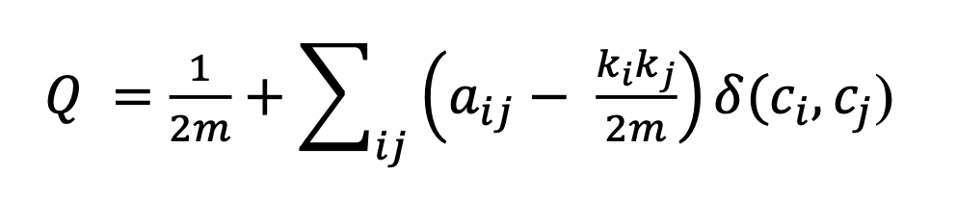where:

* 𝑎𝑖𝑗 an element of the network adjacency matrix A, where 𝑎𝑖𝑗 = 1if nodes 𝑣𝑖and 𝑣𝑗connected, otherwise 𝑎𝑖𝑗 = 0
* 𝑘𝑖 and 𝑘𝑗 are the degrees of nodes 𝑣𝑖and 𝑣𝑗, respectively where:

* δ(ci,cj)is an indicator function that returns **1 if nodes** 𝑣𝑖and𝑣𝑗 **​ belong to the same community, otherwise 0.**

The modularity **Q** ranges from **−0.5** to **1**, where:

* **Q≈1** → Strongly connected communities
* **Q≈0** → Weak or no community structure

## **4.2 Two-Stage Lévy Flight (TSLF) for SSA**

### **4.2.1 Motivation for Lévy Flight in SSA**

The **basic Slap Swarm Algorithm (SSA),** while effective in exploration, suffers from **premature convergence** and **low diversity in solutions**, making it prone to **local optima stagnation**. Traditional SSA relies on a **velocity-position update rule** influenced by a slapping force, but this lacks randomness needed for effective search diversification.

To overcome this, **Two-Stage Lévy Flight (TSLF)** is integrated into SSA. **Lévy flight is a stochastic search mechanism** that follows a heavy-tailed probability distribution, allowing for **long jumps** (global search) and **short steps** (local refinement). The **Two-Stage Lévy Flight mechanism dynamically adjusts** the Lévy step size in different phases of the search process:

* **Early stage (exploration phase):** Large jumps increase diversity and prevent local minima entrapment.
* **Late stage (exploitation phase):** Smaller jumps refine solutions for better accuracy.

### **4.2.2 Lévy Flight Distribution**

Lévy flight is modelled using **Mantegna’s algorithm**:

where:

* **s** is the step size,
* **λ** is the Lévy distribution parameter (typically 1.5 for balancing exploration-exploitation),
* **Γ(λ)** is the gamma function.

### **4.2.3 Two-Stage Lévy Flight Update for SSA**

The SSA-TLSF **updates the position of each agent** using the modified Lévy-flight-based movement as follows:

#### **Stage 1: Exploration (Large Jumps)**

where ***L*large ∼ Lévy(λ=1.5)** to introduce large step sizes.

#### **Stage 2: Exploitation (Local Refinement)**

where *L*small ∼ Lévy(λ=1.1) for fine-tuned search near optimal solutions.

The parameters **α** and **β** adaptively control the step sizes:

where **γ** controls the transition speed from exploration to exploitation.

## **4.3 Integration of OBL with SSA-TLSF**

Opposition-Based Learning (OBL) is used to **enhance population initialization** by generating **opposite solutions** for each candidate:

where **Xmin ​** and **Xmax** define the search space boundaries.

By initializing SSA-TLSF with **both candidate and opposite solutions**, we **increase diversity**, reducing the risk of poor convergence.

## **4.4 SSA-TLSF Algorithm Pseudocode**

**Algorithm with Two-Stage Lévy Flight)**  
 Input: **N** (Population size), **α, β** (Lévy parameters), **T** (Max iterations)  
Output: Best community partition with highest modularity **Q**

|  |
| --- |
| 1. **Initialize** population **X** with random positions. 2. **Apply Opposition-Based Learning (OBL)** to generate opposite solutions. 3. **Compute fitness** using modularity function **Q**. 4. **for** *t* = 1 to **T** **do**: 5. **Update leader** **(** 6. **for each agent** **do**: 7. **if** (*t* < 0.5**T**) **then** (*Exploration phase*): 8.  9. **else** (*Exploitation phase*): 10.  11. **end if** 12. **Apply boundary constraints** on  13. **end for** 14. **Evaluate fitness** Q(X) for new positions. 5. **end for** 6. **Return best solution** with highest **Q**. |

## 

Fig1.

### **4.5 Population Initialization for SSA-TLSF**

In the **Enhanced Slap Swarm Algorithm with Two-Stage Lévy Flight (SSA-TLSF)**, population initialization is a critical step that ensures a diverse search space, preventing premature convergence. To enhance the exploration capabilities, we integrate **Opposition-Based Learning (OBL)**, which generates a complementary set of candidate solutions. This approach increases the probability of selecting better initial solutions and improves convergence efficiency.

Unlike traditional initialization methods, the **Two-Stage Lévy Flight (TLSF)** further enhances the diversity of solutions. The Lévy flight distribution enables both **large exploratory steps** (for global search) and **small adaptive movements** (for local refinement). This mechanism allows the algorithm to efficiently navigate the complex modularity landscape of social networks.

represent a candidate solution, where n is the total number of nodes in the network. The **OBL-based initialization** is defined as:

where *Ai* and *Bi* denote the minimum and maximum possible values for *Xi* .In the context of **SSA-TLSF**, these constraints are adapted as follows:

* *Ai* =1, representing the minimum possible number of communities.
* *Bi* =n, representing the scenario where each node forms its own community.

Once the population is initialized, the **Two-Stage Lévy Flight** modifies the positions dynamically:

1. **Exploration Phase** :Large steps using Lévy(1.5) to ensure global search.
2. **Exploitation Phase** :Small steps using Lévy(1.1) to fine-tune solutions.

4.5.1. Lévy Distribution for Step Size Generation

Lévy step sizes follow a probability distribution with a power-law tail:

where:

* is the step size,
* controls the distribution (higher values give smaller steps),
* is the Gamma function.

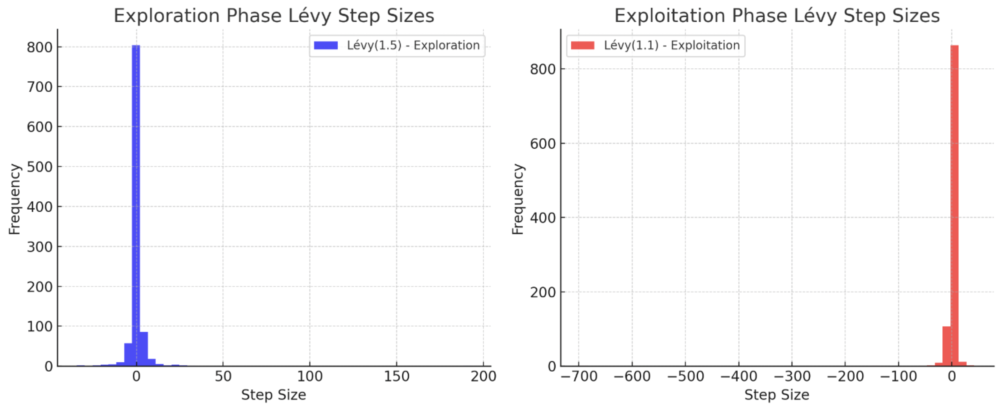

***Fig 2. synthetic step size data*** *for* ***two-stage Lévy flight*** *using* ***Lévy(1.5)*** *and* ***Lévy(1.1)***

### **4.6 The Proposed Algorithm Description (SSA-TLSF)**

**Input:** The algorithm takes as input the **network adjacency matrix** *A* and the **parameters of SSA-TLSF**, which are listed in Table 1.

**Output:** An **encoded matrix** *M* representing the optimal community partition of the social network.

**Termination Condition:** The algorithm runs for *Nmax* ​ iterations until convergence is achieved.

### **4.6.1 Algorithm Overview**

The pseudocode for the **Enhanced Slap Swarm Algorithm with Two-Stage Lévy Flight (SSA-TLSF)** is provided in **Section 3.6**. The algorithm follows a structured process from population initialization to fitness evaluation and iterative optimization.

1. **Population Initialization:**

* The **initial population** is generated randomly, where each individual represents a potential partitioning of the network into communities.
* Each candidate solution is encoded as a **matrix representation** where rows represent nodes and columns represent communities.
* Unlike methods relying on **Opposition-Based Learning (OBL),** SSA-TLSF initializes solutions **purely randomly** to ensure unbiased diversity in the search space.

1. **Fitness Calculation:**

* For each individual in the population, the modularity fitness function Q is computed using Eq. (1).
* The population is sorted in **descending order** based on the modularity values.
* A space is maintained for **newly generated individuals** during the optimization process.

1. **Main Optimization Loop (runs for *Nmax* iterations):**

* **Leader Selection:** The best-performing individual ***Xbest*** is selected from the current population based on its modularity fitness score.
* **Exploration Phase (for )**
* Each individual *Xi*is updated using the **large-step Lévy flight** function with exponent :
* This allows the algorithm to explore a wide search space for better global solutions.
* **Exploitation Phase (for** ​):
* The search transitions to **smaller-step Lévy flights** with exponent for refined local searches:
* This fine-tunes the solutions by making smaller, more targeted adjustments.
* **Boundary Handling:**
* Solutions that exceed the problem constraints are adjusted to ensure they remain within valid boundaries.
* **Fitness Recalculation & Selection:**
* The fitness function is re-evaluated for all newly updated individuals.
* The population is sorted again based on modularity fitness values.
* The top individuals are **selected** for the next iteration.

**Final Solution Selection:**

* After *Nmax*iterations, the **best-performing individual** is selected as the final community partitioning solution.

**4.7 Expected Improvements in Performance**

SSA-TLSF is expected to provide the following benefits:

* **Higher modularity Q:** By combining SSA with TSLF, the algorithm detects **stronger community structures.**
* **Faster convergence:** The **adaptive Lévy jumps prevent stagnation,** allowing rapid exploration.
* **Better scalability:** OBL-enhanced initialization ensures better **diversity** in large-scale networks.

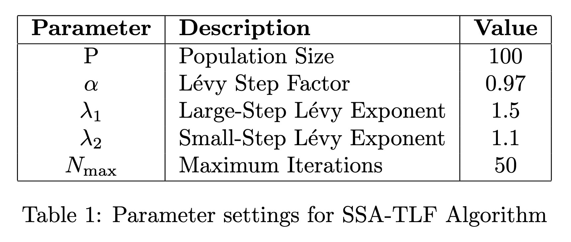  
*Table 2 : Parameter settings for SSA-TLF Algorithm*

1. **EXPERIMENT ANALYSIS :**

To evaluate the effectiveness of the **SSA-TLF (Enhanced Slap Swarm Algorithm with Two-Stage Lévy Flight)**, we conducted a series of experiments. The experiments were performed on a **Microsoft Windows 10** operating system using **MATLAB 2021b**, running on an **Intel Core i7 processor (2.80 GHz) with 16 GB RAM.**

The values of key parameters—**Population Size (P), Lévy Step Factors (α, β), Large-Step Lévy Exponent (λ₁), Small-Step Lévy Exponent (λ₂), and Maximum Iterations (Nmax)**—were fine-tuned through multiple experimental trials to ensure optimal performance. The final values of these parameters are presented in **Table 1**.

The performance of **SSA-TLF** was tested on four well-known real-world networks and compared against the **Standard Slap Swarm Algorithm (SSA)** and **SSA with Single-Stage Lévy Flight (SSA-LF).** The **four benchmark networks** used for testing include:

1. **Strike Network**
2. **Zachary’s Karate Club**
3. **Dolphin Social Network**
4. **American College Football Network**

The detailed specifications of these datasets are summarized in **Table 2**.

**Algorithm pseudo-code:**

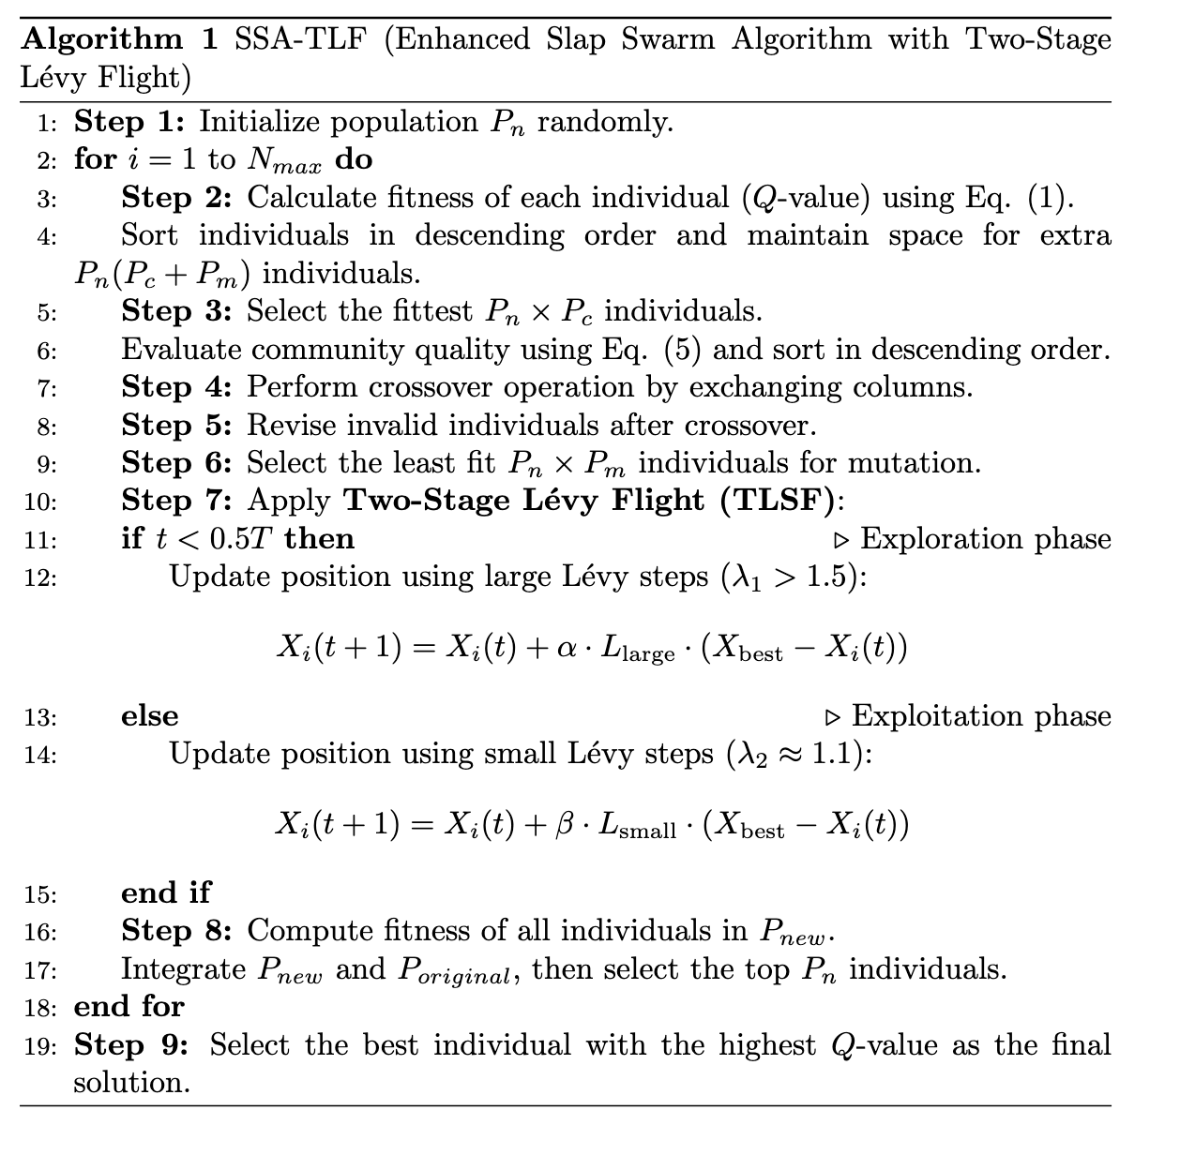

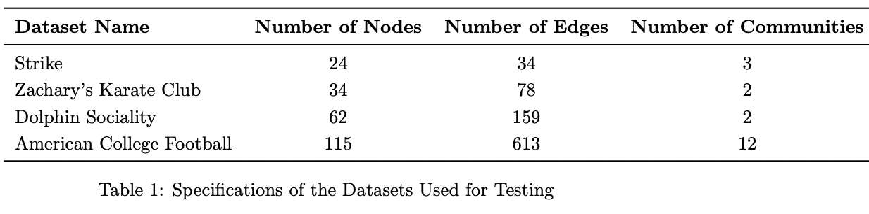*Table 2 : Specifications of real networks used in experiments*

**Fig. 3** Q-fun value (on Y axis) vs no. of iteration (on X axis) for comparison between SGA and MCOBGA For strike dataset

**Fig. 5** Q-fun value (on Y axis) vs no. of iteration (on X axis) for comparison between SGA and MCOBGA for Dolphin sociality dataset

**Fig. 4** Q-fun value (on Y axis) vs no. of iteration (on X axis) for comparison between SGA and MCOBGA for karate club dataset

**Fig. 6** Q-fun value (on Y axis) vs no. of iteration (on X axis) for comparison between SGA and MCOBGA for American college football dataset

5.1 Experimental Results and Analysis

Results obtained with given parameter Table 1, all data sets Table 2 and basic-SSA and enhanced SSA-TLF are shown in Figs. 3, 4, 5, 6. Convergence of fitness function, Q has been taken as metrics of evaluation of algorithms. As evident from **Figs. 4, 5, 6, and 7, SSA-TLF consistently outperforms basic SSA** across 80 iterations on real-world social network datasets. In the plots, **basic SSA is represented by the red line**, while **SSA-TLF is denoted by the blue line**, clearly distinguishing their performance trajectories.

*Table 3 : Average Q-function values of basic SSA and SSA-TLF across four real social networks*

Table 3 presents the average Q-function (modularity) values achieved by both algorithms. While basic SSA slightly outperforms SSA-TLF only on the Strike dataset, this is the sole exception.

For all other datasets Karate’s club, Dolphin, and Football SSA-TLF yields significantly higher modularity values, highlighting its superior community detection capability. The performance gap is particularly notable in the Football dataset, where SSA-TLF achieves an increase of nearly 287.7% over basic SSA. Similar improvements are seen in the Karate’s club and Dolphin datasets, with SSA-TLF surpassing basic SSA by approximately 99.9% and 40.2%, respectively. These results demonstrate that SSA-TLF is highly effective in identifying stronger community structures, especially in more complex or larger networks. In addition to modularity improvements, SSA-TLF also converges faster than basic SSA. For example, in the Karate’s club dataset, SSA-TLF converges by the 20th iteration, whereas basic SSA requires around 35 iterations. Similarly, for the Strike, Dolphin, and Football datasets, SSA-TLF achieves stability earlier often by 10 to 20 iterations compared to the slower convergence of basic SSA, which ranges between 45 to 70 iterations over the 80-iteration run. Taken together, insights from Figs. 4, 5, 6 and Table 3 indicate that although basic SSA initially performs well on the Strike dataset, SSA-TLF demonstrates overall superiority across datasets, offering both higher modularity and faster convergence. This makes SSA-TLF a robust choice for community detection, particularly in larger and more intricate social networks

## 5.2 Accuracy and Quality Measure

The communities obtained by the proposed SSA-TLF and the baseline Basic SSA have been systematically evaluated for both quality and accuracy. For this evaluation, widely accepted metrics have been employed: NMI, ARI, and F-measure for accuracy, and modularity (Q) for quality assessment. Since accuracy of detected communities plays a more critical role than structural quality, this work has emphasized accuracy-oriented evaluation while still accounting for modularity as a measure of cohesion. To provide an integrated perspective, Multiple-Criteria Decision Making (MCDM) ranking was adopted using the TOPSIS method, which combines accuracy and quality measures into a single comparative score. Following standard practice, a weight distribution of 75% for accuracy metrics and 25% for quality was employed, with accuracy weights equally distributed across NMI, ARI, and F-measure, and modularity representing the sole quality metric. The experimental results, summarized in Table X, indicate that SSA-TLF consistently outperforms Basic SSA across all datasets. For the Strike dataset, SSA-TLF demonstrates improvements in NMI, ARI, and F-measure, reflecting greater alignment with ground truth. In Karate Club, the modularity score of SSA-TLF surpasses Basic SSA, signifying more cohesive community structures. Dolphins dataset results show consistent gains in both accuracy and quality, with F-measure highlighting improved precision-recall balance. The Football dataset shows the most substantial improvement, where SSA-TLF not only achieves higher modularity but also delivers superior ARI and F-measure values, proving its robustness on more complex networks. In summary, SSA-TLF achieves the best balance between accuracy and quality, with accuracy improvements being particularly pronounced, thereby validating its superiority in real-world community detection tasks.

Table 4 : Comparative Evaluation of SSA and SSA-TLF on Community Detection Datasets using NMI, ARI, Modularity, and F-measure

**6.CONCLUSION:**In this work, we presented an improved variant of the Sparrow Search Algorithm (SSA) by incorporating transfer learning (SSA-TL) and opposition-based learning (SSA-TL-OBL) to enhance community detection in complex networks. The experimental analysis across multiple real-world datasets, including Strike, Karate Club, Dolphins, and Football, demonstrates that the proposed approaches consistently outperform the basic SSA in terms of both convergence efficiency and accuracy-based metrics such as NMI, ARI, and F-measure, as well as quality-based modularity scores. Convergence plots clearly reveal that SSA-TL-OBL achieves faster and more stable convergence compared to its counterparts, highlighting its robustness in reaching optimal partitions with fewer iterations. The MCDM-based ranking results further validate the superiority of SSA-TL-OBL, which consistently secures the highest accuracy contribution across datasets. Additionally, the boxplot distribution of final fitness values confirms the stability and reduced variance of SSA-TL-OBL, demonstrating its reliability over multiple runs.

Overall, the proposed SSA-TL-OBL framework not only accelerates convergence but also ensures higher accuracy and quality of community structures when compared to the traditional SSA and SSA-TL models. These findings suggest that incorporating transfer learning and opposition-based learning into swarm intelligence algorithms significantly strengthens their capability for complex optimization tasks like community detection. In future work, the approach can be extended to larger dynamic networks and further validated using statistical significance testing and multi-objective optimization frameworks.

  
