**Queue: This is similar to stack but in this unlike the stack which followed the system of last in first out LIFO the queue works on first in first out FIFO**

**Syntax: queue<data_type> variabel_name;**

**queue<data_type> variabel_name={elements}; not allowed like vec/list/deque.**

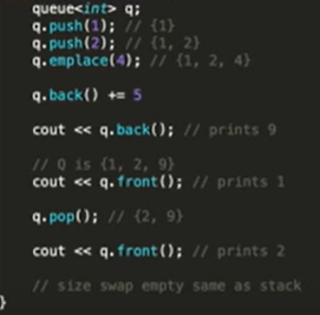

1. **INSERTING AN ELEMENT:**

In queue we can insert the elements using

**push()**

**emplace()**

**Note: However in the queue these functions act similar to push_back() unlike the stack where it acts like push_front(). Due to FIFO AND LIFO.**

1. **pop(): this removes the first element that was inserted in the queue.**
2. **front(): like in the stack how we say top() we say front() it gives the front element as we are using the queue.**
3. **back(): gives the last element in the queue**
4. **size(): gives the size of the queue.**

**Now how to print a queue**

**It is the same as how we did it for stack. We created a duplicate stack with the same value and used the top() with pop() which gave the stack in the LIFO order.**

**Same for the queue we use front() and pop() to print the elements in the queue.**

