PRACTICAL LAB 05
Abstract Classes, Inheritance and Run-Time Polymorphism

Student Name: Pratha Lalakia
Student ID: 25CS040
Practical Number: 05
Language / Environment: Java (JDK 17+)

Submission includes Part A practice programs and Part B MiniBank project,
source code, execution outputs, and post-lab analysis.

Part A — Practice Programs

Program 1: Shape Areas
Problem Statement: Create an abstract Shape class with area(). Implement Circle, Rectangle and Triangle. Store mixed shapes in a Shape array, print each area, compute the running total, and track the largest area in one polymorphic loop.

Source Code — ShapeArea.java
abstract class Shape {
abstract double area();
}

class Circle extends Shape {
double radius;

Circle(double radius) {
this.radius = radius;
}

double area() {
return Math.PI * radius * radius;
}
}

class Rectangle extends Shape {
double length, breadth;

Rectangle(double length, double breadth) {
this.length = length;
this.breadth = breadth;
}

double area() {
return length * breadth;
}
}

class Triangle extends Shape {
double base, height;

Triangle(double base, double height) {
this.base = base;
this.height = height;
}

double area() {
return 0.5 * base * height;
}
}

public class ShapeArea {
public static void main(String[] args) {
Shape[] shapes = {
new Circle(5),
new Rectangle(4, 6),
new Triangle(8, 5)
};

double total = 0;
double largest = 0;

for (Shape s : shapes) {
double a = s.area();
System.out.println("Area: " + a);
total += a;

if (a > largest) {
largest = a;
}
}

System.out.println("Total Area: " + total);
System.out.println("Largest Area: " + largest);
}
}
Execution Output:
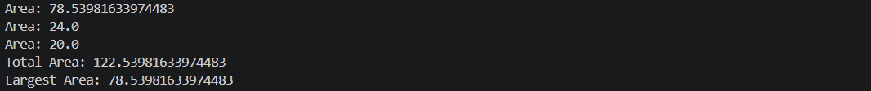

Program 2: Payroll
Problem Statement: Create an abstract Employee class with monthlySalary(). Implement FullTime, PartTime and Intern. Use super() for shared name and ID fields. Loop over a mixed Employee array to print salaries and their total, and use instanceof to print a note for interns.

Source Code — Payroll.java
abstract class Employee {
String name;
int id;

Employee(String name, int id) {
this.name = name;
this.id = id;
}

abstract double monthlySalary();
}

class FullTime extends Employee {
double salary;

FullTime(String name, int id, double salary) {
super(name, id);
this.salary = salary;
}

double monthlySalary() {
return salary;
}
}

class PartTime extends Employee {
double hours, rate;

PartTime(String name, int id, double hours, double rate) {
super(name, id);
this.hours = hours;
this.rate = rate;
}

double monthlySalary() {
return hours * rate;
}
}

class Intern extends Employee {
double stipend;

Intern(String name, int id, double stipend) {
super(name, id);
this.stipend = stipend;
}

double monthlySalary() {
return stipend;
}
}

public class Payroll {
public static void main(String[] args) {
Employee[] employees = {
new FullTime("Pratha", 101, 30000),
new PartTime("Rahul", 102, 80, 200),
new Intern("Priya", 103, 10000)
};

double total = 0;

for (Employee e : employees) {
double salary = e.monthlySalary();
System.out.println(e.name + " Salary: " + salary);

if (e instanceof Intern) {
System.out.println("Intern Employee");
}

total += salary;
}

System.out.println("Total Salary: " + total);
}
}
Execution Output:
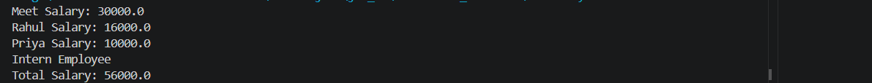

Program 3: Media Late Fees (Advanced)
Problem Statement: Design a media hierarchy in which Book, DVD and Magazine calculate late fees using different per-day rates. Process a mixed Media array and total the fees.

Source Code — MediaFee.java
abstract class Media {
String title;
int daysLate;

Media(String title, int daysLate) {
this.title = title;
this.daysLate = daysLate;
}

abstract double lateFee();
}

class Book extends Media {
Book(String title, int daysLate) {
super(title, daysLate);
}

double lateFee() {
return daysLate * 2;
}
}

class DVD extends Media {
DVD(String title, int daysLate) {
super(title, daysLate);
}

double lateFee() {
return daysLate * 5;
}
}

class Magazine extends Media {
Magazine(String title, int daysLate) {
super(title, daysLate);
}

double lateFee() {
return daysLate;
}
}

public class MediaFee {
public static void main(String[] args) {
Media[] items = {
new Book("Java Book", 3),
new DVD("Movie DVD", 4),
new Magazine("Tech Magazine", 2)
};

double total = 0;

for (Media m : items) {
double fee = m.lateFee();
System.out.println(m.title + " Late Fee: " + fee);
total += fee;
}

System.out.println("Total Late Fees: " + total);
}
}
Execution Output:
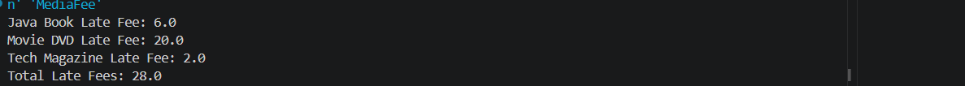

Part B — Project Work: MiniBank
Problem Statement: Make Account abstract with interestRate() and canWithdraw(). Implement SavingsAccount, CurrentAccount and FixedDepositAccount with their own interest and withdrawal rules. Use super() to initialise inherited fields, store all account types in an Account array, and demonstrate polymorphism and instanceof.

Source Code — MiniBank.java
abstract class Account {
String name;
int id;
long balance;

Account(String name, int id, long balance) {
this.name = name;
this.id = id;
this.balance = balance;
}

abstract double interestRate();

abstract boolean canWithdraw(long amount);

double monthlyInterest() {
return balance * interestRate() / 1200;
}
}

class SavingsAccount extends Account {
long minBalance;

SavingsAccount(String name, int id, long balance, long minBalance) {
super(name, id, balance);
this.minBalance = minBalance;
}

double interestRate() {
return 4.0;
}

boolean canWithdraw(long amount) {
return amount >= 0 && balance - amount >= minBalance;
}
}

class CurrentAccount extends Account {
long overdraftLimit;

CurrentAccount(String name, int id, long balance, long overdraftLimit) {
super(name, id, balance);
this.overdraftLimit = overdraftLimit;
}

double interestRate() {
return 0.0;
}

boolean canWithdraw(long amount) {
return amount >= 0 && balance - amount >= -overdraftLimit;
}
}

class FixedDepositAccount extends Account {
FixedDepositAccount(String name, int id, long balance) {
super(name, id, balance);
}

double interestRate() {
return 7.0;
}

boolean canWithdraw(long amount) {
return false;
}
}

public class MiniBank {
public static void main(String[] args) {
Account[] accounts = {
new SavingsAccount("Pratha", 101, 20000, 5000),
new CurrentAccount("Rahul", 102, 10000, 5000),
new FixedDepositAccount("Priya", 103, 50000)
};

for (Account a : accounts) {
System.out.println("Account Holder: " + a.name);
System.out.println("Account ID: " + a.id);
System.out.println("Interest Rate: " + a.interestRate() + "%");
System.out.println("Monthly Interest: " + a.monthlyInterest());

if (a instanceof SavingsAccount s) {
System.out.println("Minimum Balance: " + s.minBalance);
}

System.out.println("Can Withdraw 1000: " + a.canWithdraw(1000));
System.out.println();
}
}
}
Execution Output:
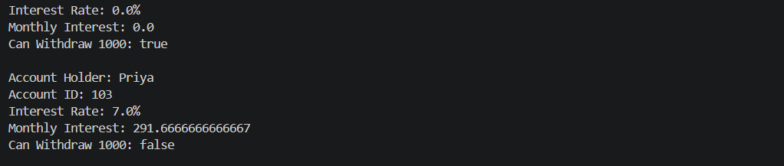

Key Questions / Analysis / Interpretation
1. What is the difference between an abstract class and a concrete class?
An abstract class cannot be instantiated directly. It can contain abstract methods that subclasses must implement, as well as fields and normal methods. A concrete class can be instantiated and provides implementations for all inherited abstract methods.
2. What is dynamic method dispatch (run-time polymorphism)?
Dynamic method dispatch is when Java selects an overridden method implementation at run time based on the actual object type, even when the object is referenced through a superclass variable. For example, a.interestRate() calls the correct method for each account object in the Account array.
3. What does the super keyword do in a subclass constructor?
super(...) calls the constructor of the parent class. It initialises inherited fields such as name, id and balance. It must be the first statement in the subclass constructor when used to call a parent constructor.

Supplementary Work
The Account class includes monthlyInterest(), which calculates monthly interest using the account balance and annual interest rate. The FixedDepositAccount currently blocks all withdrawals. The maturity-date extension can be added by storing a maturity date and allowing withdrawal only when the current date reaches or passes it.

Testing Summary
The programs were compiled and executed with Java. The MiniBank interest rates printed by the Account[] loop are 4.0% for SavingsAccount, 0.0% for CurrentAccount and 7.0% for FixedDepositAccount. The fixed deposit rejects the sample withdrawal because it is locked.

GitHub Repository
Push the source files to your lab repository and replace the repository placeholder in the footer with your official GitHub repository URL before submitting.
Program 1 — Shape Areas (VS Code execution output)
Program 2 — Payroll (VS Code execution output)
Program 3 — Media Late Fees (VS Code execution output)
Part B — MiniBank (VS Code execution output)

