JAVA PROGRAMMING

PRACTICAL SUBMISSION
PRACTICAL 10
Submitted By

Student Name | Pratha Lalakia
Student ID | 25CS040
Program | B.Tech – Computer Science and Engineering
University | CHARUSAT University of Science and Technology
Academic Year | 2026–2027
Department of Computer Science and Engineering

GitHub Repository: link

Practical 10

Program 1:

Problem Statement
Thread-pool runner: with a fixed pool of 3 (ExecutorService), submit about 10 Runnable tasks that print their id and sleep briefly; shut down and await completion, observing the few threads being reused.

Java Source Code
import java.util.concurrent.ExecutorService; import java.util.concurrent.Executors; import java.util.concurrent.TimeUnit;

public class ThreadPoolRunner
{

public static void main(String[] args) throws InterruptedException ExecutorService executor = Executors.newFixedThreadPool(3);
{

for (int i = 1; i <= 10; i++) { int taskId executor.submit(() ->
= i;
{
try
{
System.out.println("Task " + taskId + " is running on " + Thread.currentThread().getName());
Thread.sleep(200);
System.out.println("Task " + taskId + " completed by " + Thread.currentThread().getName());

catch (InterruptedException Thread.currentThread().interrupt();
}
}
e) {

});
}


executor.shutdown();
if (executor.awaitTermination(5, TimeUnit.SECONDS)) { System.out.println("All tasks completed.");
else
}
{
System.out.println("Some tasks did not finish.");
}
}

}

Execution Output
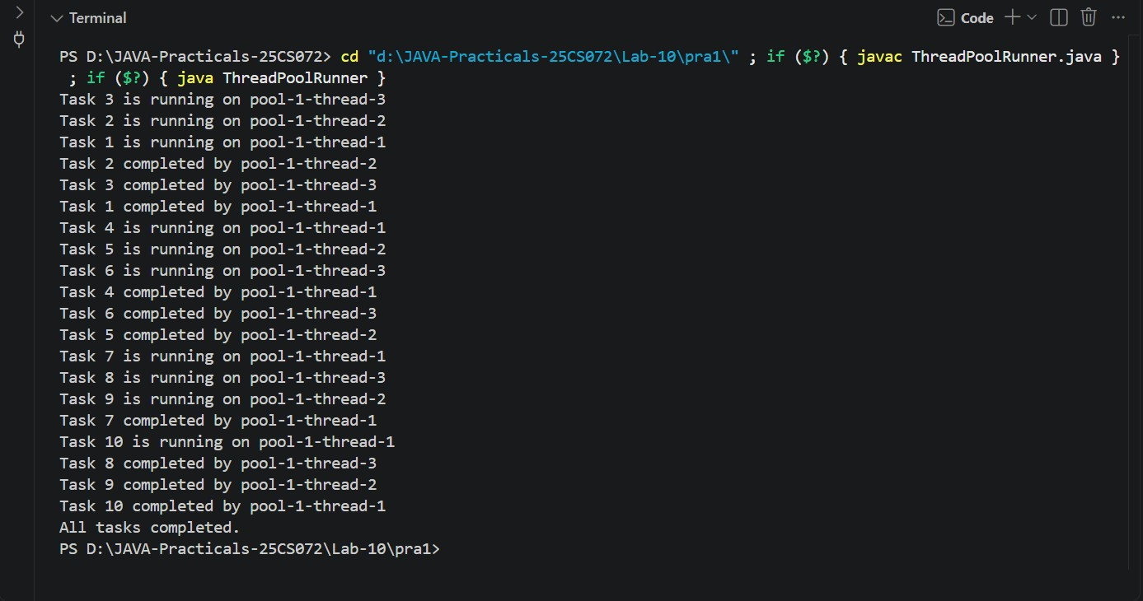

GitHub Repository:

JAVA PROGRAMMING PRACTICALS

Program 2:

Problem Statement
Producer–consumer: one thread adds numbers to a small shared buffer and another removes them, coordinated with wait()/notify(); produce and consume a fixed number of items in order with none lost.

Java Source Code
class SharedBuffer private int item;
{
private boolean available = false;

public synchronized void produce(int value) throws InterruptedException while (available) {
{

wait();
}

item = value; available = true;
System.out.println("Produced: " + value); notify();
}



public synchronized int consume() throws InterruptedException while (!available) {
{
wait();
}

int value = item; available = false;
System.out.println("Consumed: " + value);


return value;
}

}


public class ProducerConsumer public static void main(String[] args) {
{
SharedBuffer buffer = new SharedBuffer();

Thread producer = new Thread(() -> try
{
{
for (int i = 1; i <= 5; i++) {

buffer.produce(i);
}


catch (InterruptedException Thread.currentThread().interrupt();
}
});
}
e) {

Thread consumer = new Thread(() -> try
{
{

for (int i = 1; i <= 5; i++) { buffer.consume();
}

catch (InterruptedException Thread.currentThread().interrupt();
}
e) {
}

});

producer.start();



try
{

producer.join(); consumer.join();
}
e) {
catch (InterruptedException
Thread.currentThread().interrupt();
}

System.out.println("All items produced and consumed.");
}

}

Execution Output
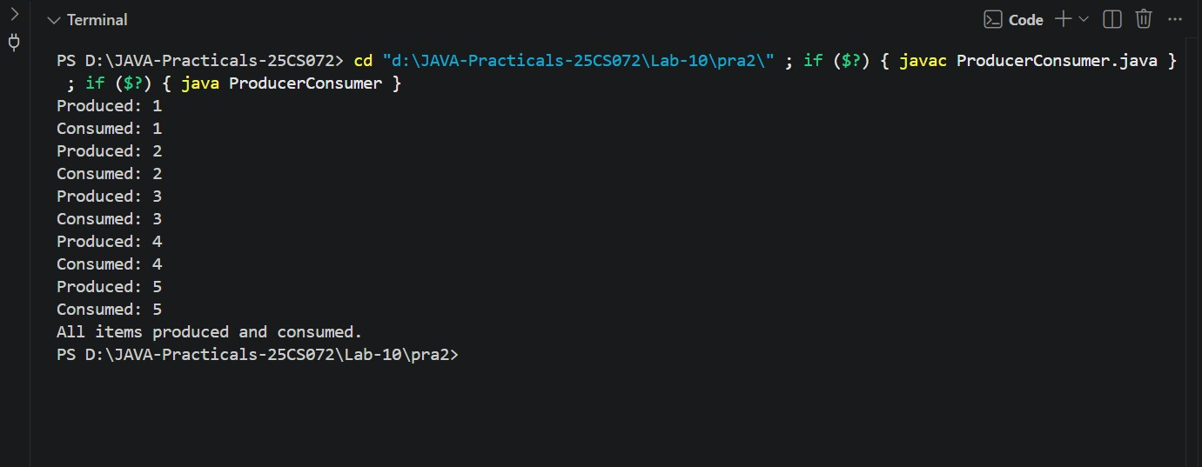

GitHub Repository:

