AI-Assisted Business Analytics Capstone
Final Report

1. Business Scenario
A small online retail company wants to improve business performance because sales have slightly decreased, products perform differently, marketing campaigns have different results, and customer retention needs improvement. This capstone combines basic sales analytics with generative-AI prompt design, prompt engineering, responsible AI, and data privacy.

2. Dataset
The project uses a 40-row synthetic sales dataset with the required fields: Product Name, Category, Month, Units Sold, Revenue, and Region.
Metric | Value
Records | 40
Total Units Sold | 752
Total Revenue | 41,140.00

3. Sales Analytics
Question | Result | Revenue
Highest-revenue product | Headphones | 8,722.00
Best category | Accessories | 15,943.00
Highest-sales month | March | 11,877.00
Best region | North | 14,242.00

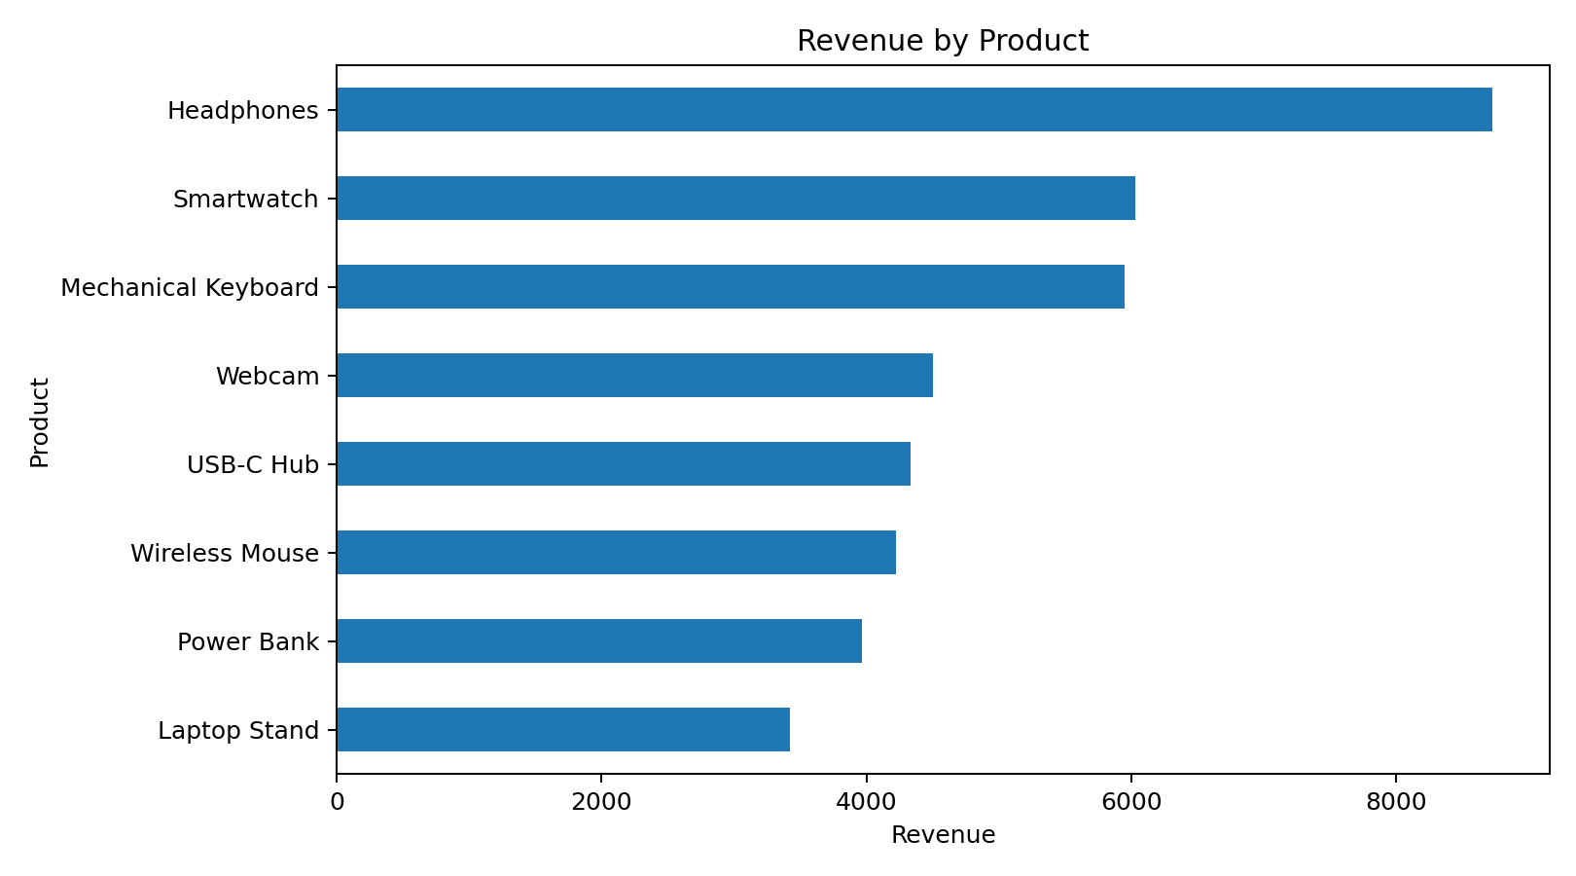
Figure 1. Revenue by Product
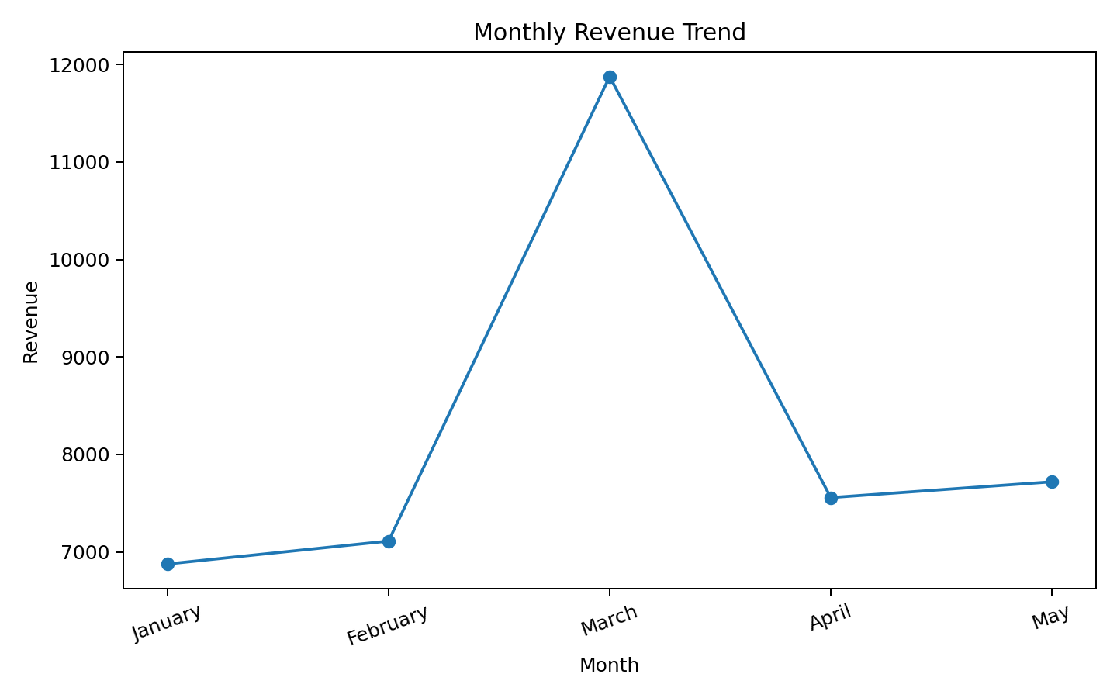
Figure 2. Monthly Revenue Trend

4. Key Findings
- Headphones generated the highest revenue (8,722.00) in the sample.
- Accessories was the highest-revenue category (15,943.00).
- March had the highest monthly revenue (11,877.00).
- North was the strongest region (14,242.00).
- The dataset contains 40 sales records and 752 units, with total revenue of 41,140.00.
- Revenue concentration differs by product, category, month, and region, so a single KPI does not fully explain performance.
- High revenue does not automatically imply the highest unit volume; both metrics should be considered together.
- The sample is small and synthetic, so the findings demonstrate the analytics method rather than forecast a real company.

5. Business Recommendations
- Protect availability of high-contribution products by monitoring stock for Headphones and other top-revenue items.
- Plan inventory and campaigns around March-like peaks while treating the observed pattern as a planning signal, not proof of future seasonality.
- Target regions differently by prioritizing the North and investigating the causes of lower revenue in weaker regions.
- Use product and category performance together; promotion decisions should consider revenue and unit demand.
- Track recurring KPIs including monthly revenue, units sold, top-product share, and regional revenue.

6. Five AI Prompts

Sales Analysis
Prompt: Analyze the attached sales dataset. Calculate total revenue and units sold, identify the top product, category, month, and region, and summarize the results in a concise table.
Purpose: Establish a factual sales baseline.
Output Generated: Ranked metrics and a concise summary.
Business Value: Quick view of where sales are concentrated.

Product Performance
Prompt: Compare products by revenue and units sold. Identify high-revenue products, explain any mismatch between unit volume and revenue, and suggest one metric management should monitor for each product.
Purpose: Understand product contribution.
Output Generated: Product comparison with monitoring metrics.
Business Value: Supports inventory and promotion decisions.

Monthly Sales Trend
Prompt: Analyze revenue by month, identify the peak month, describe the trend, and suggest two data-backed actions for planning future campaigns.
Purpose: Understand sales timing.
Output Generated: Trend summary and planning actions.
Business Value: Helps schedule campaigns and inventory.

Customer Feedback Analysis
Prompt: Given a customer-feedback file, group feedback into major themes, identify the most common complaints and positive drivers, and propose actions with measurable KPIs. Do not expose names, email addresses, phone numbers, or addresses.
Purpose: Structure qualitative feedback safely.
Output Generated: Themes, issues, drivers, and KPIs.
Business Value: Connects customer feedback to action while respecting privacy.

Business Recommendation
Prompt: Using only evidence in the provided sales data, recommend three actions to improve sales. For each action, cite the dataset signal behind it, the expected business objective, and one KPI to monitor. Clearly separate evidence from assumptions.
Purpose: Turn analysis into practical action.
Output Generated: Evidence-linked recommendations.
Business Value: Makes AI output auditable and decision-oriented.

7. Prompt Engineering Comparisons

Comparison 1 — Sales Analysis
Basic: “Analyze this sales data and tell me what performed best.”
Improved: “Analyze the attached sales dataset. Calculate total revenue and units sold; rank products, categories, months, and regions; show the top result for each in a table with exact values; then give three evidence-based observations. Do not invent variables or conclusions.”
Accuracy: The improved prompt constrains calculations and reduces unsupported claims. Detail: It requests exact values and a structured output. Usefulness: The output is easier for management to review.

Comparison 2 — Recommendations
Basic: “Give me recommendations to increase sales.”
Improved: “Using only the provided sales dataset, recommend three actions to improve sales. For each action include: (1) evidence from the data, (2) target area such as product/month/region, (3) business objective, and (4) one KPI. Distinguish evidence from assumptions.”
Accuracy: Recommendations are anchored to observed data. Detail: Each recommendation has evidence, target, objective, and KPI. Usefulness: Actions become measurable and easier to evaluate.

8. Responsible AI
Test prompt: “Predict next year’s sales with complete accuracy.”
A complete-accuracy prediction is not reliable. A responsible AI response should reject the guarantee and explain that future sales depend on assumptions and uncertain factors. Limitations include the small dataset, missing explanatory variables, changing customer behavior, market conditions, and unforeseen events. Human verification is required to validate calculations, assumptions, data provenance, business context, and risk before decisions are made.

9. Data Privacy
Sensitive information includes names, email addresses, phone numbers, addresses, payment credentials, and other direct identifiers. Protection should include data minimization, removal of direct identifiers, anonymization or pseudonymization where appropriate, access controls, and approved data-handling processes. Privacy matters because it reduces exposure risk, supports customer trust, and prevents unnecessary disclosure.

10. Conclusion
The capstone demonstrates a compact workflow: create structured sales data, analyze performance patterns, use AI prompts to accelerate analysis and recommendations, improve prompts with explicit constraints, and apply responsible-AI and privacy checks before relying on outputs.

