**NAME: Pratham Srivastava**

**Roll No: 2401330130192**

**Branch: IT**

**Section: C**

**Workshop Lab Number : D-203**

**Problem-1: SOURCE CODE**

1. **Main Class-**
2. import java.util.*;
3. class Employee {
4. private String name;
5. private *int* age;
6. private *double* salary;
7. public Employee(String *name*, *int* *age*, *double* *salary*) {
8. this.name = *name*;
9. this.age = *age*;
10. this.salary = *salary*;
11. }
12. public String getName() {
13. return name;
14. }
15. public *void* setName(String *name*) {
16. this.name = *name*;
17. }
18. public *int* getAge() {
19. return age;
20. }
21. public *void* setAge(*int* *age*) {
22. this.age = *age*;
23. }
24. public *double* getSalary() {
25. return salary;
26. }
27. public *void* setSalary(*double* *salary*) {
28. this.salary = *salary*;
29. }
30. }
31. public class Problem1 {
32. public static *void* main(String[] *args*) {
33. List<Employee> employees = new ArrayList<>();
34. employees.add(new Employee("Random1", 30, 15000));
35. employees.add(new Employee("Random2", 25, 20000));
36. employees.add(new Employee("Random3", 40, 8000));
37. employees.add(new Employee("Random4", 21, 45600));
38. System.out.println("Before sorting:");
39. for (Employee employee : employees) {
40. System.out.println(employee.getSalary());
41. }
42. Collections.sort(employees, (*e1*, *e2*) *->* Double.compare(*e2*.getSalary(), *e1*.getSalary()));
43. System.out.println("\nAfter sorting:");
44. for (Employee employee : employees) {
45. System.out.println(employee.getSalary());
46. }
47. }
48. }

**Problem-1: OUTPUT**

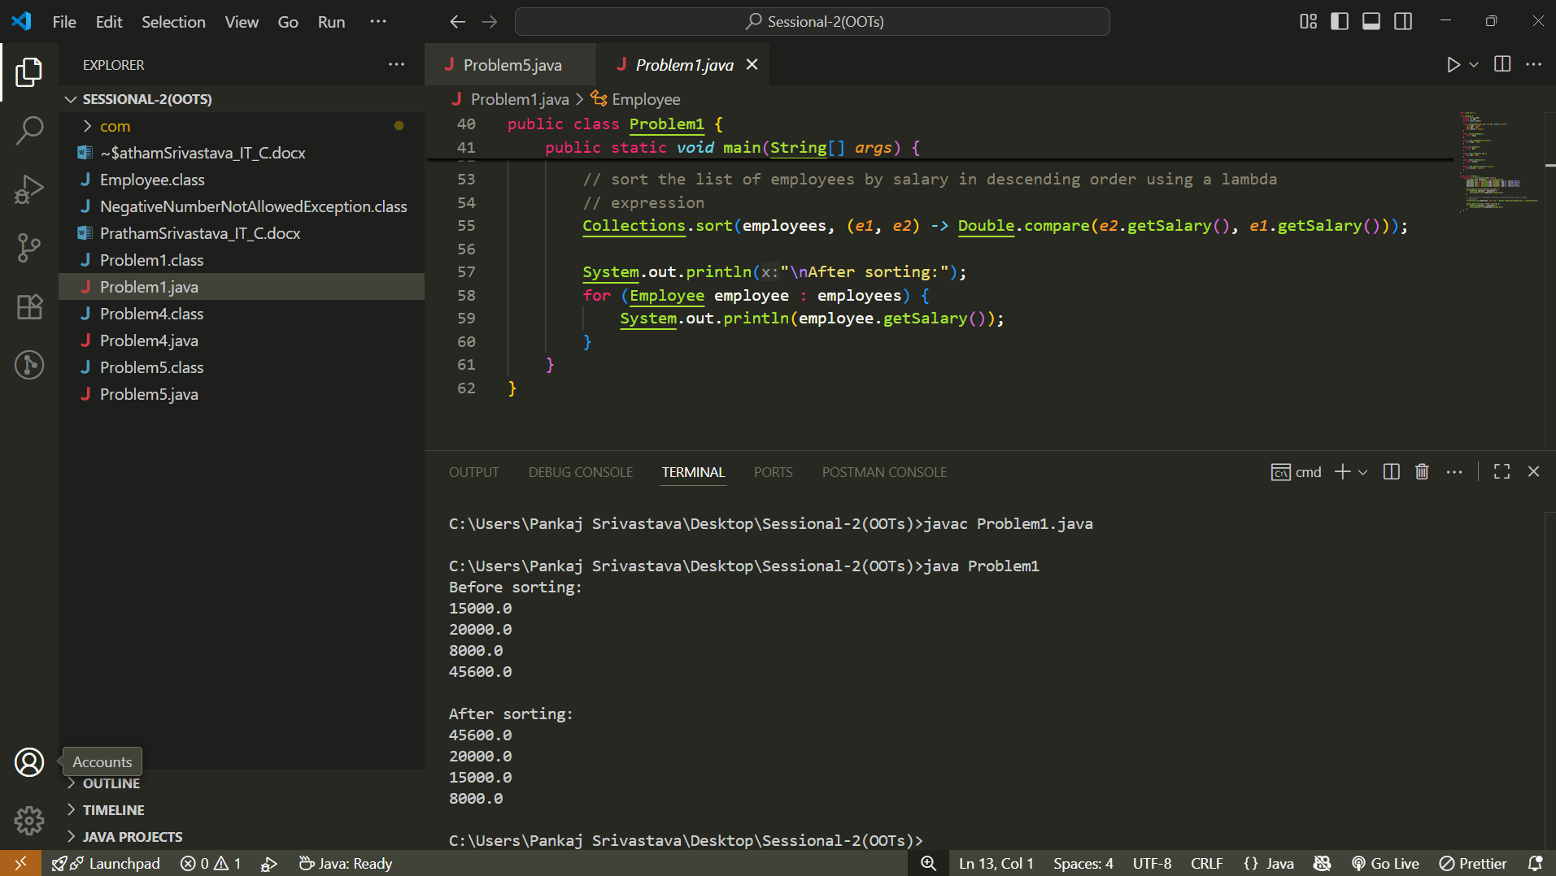

**Problem-2: SOURCE CODE**

**Main Class –**

package com.main;

import com.maths.*;

import com.maths.operations.Calculator;

public class Main {

    public static *void* main(String[] *args*) {

        Calculator calculator = new Calculator();

*int* result1 = calculator.add(5, 3);

        System.out.println("5 + 3 = " + result1);

*int* result2 = calculator.subtract(7, 4);

        System.out.println("7 - 4 = " + result2);

*int* result3 = calculator.multiply(8, 2);

        System.out.println("8 * 2 = " + result3);

*double* result4 = calculator.divide(16, 4);

        System.out.println("16 / 4 = " + result4);

    }

}

**MathOperations Class –**

package com.maths;

public class MathOperations {

    public static *int* add(*int* *x*, *int* *y*) {

        return *x* + *y*;

    }

    public static *int* subtract(*int* *x*, *int* *y*) {

        return *x* - *y*;

    }

    public static *int* multiply(*int* *x*, *int* *y*) {

        return *x* * *y*;

    }

    public static *int* divide(*int* *x*, *int* *y*) {

        return *x* / *y*;

    }

}

**Calculator Class –**

package com.maths.operations;

import com.maths.*;

public class Calculator {

    public *int* add(*int* *a*, *int* *b*) {

        return MathOperations.add(*a*, *b*);

    }

    public *int* subtract(*int* *a*, *int* *b*) {

        return MathOperations.subtract(*a*, *b*);

    }

    public *int* multiply(*int* *a*, *int* *b*) {

        return MathOperations.multiply(*a*, *b*);

    }

    public *double* divide(*int* *a*, *int* *b*) {

        return MathOperations.divide(*a*, *b*);

    }

}

**Problem-2: OUTPUT**

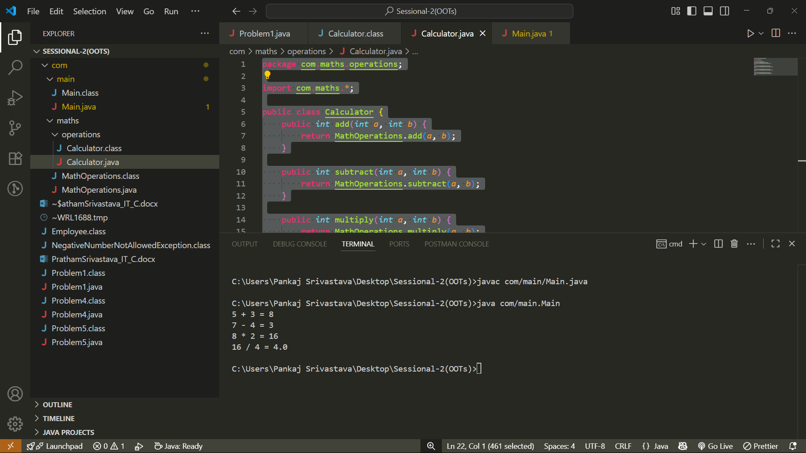

**Problem-4: SOURCE CODE**

public class Problem4 {

    public static *void* main(String[] *args*) {

        String test = "JavA ProgRaMMing";

        String forConcat = "Concatenated";

        String sub = test.substring(0, 7);

        String con = test.concat(forConcat);

*int* length = test.length();

        String forEquals = "Concatenated";

*boolean* checkEqual = forConcat.equals(forEquals);

*boolean* forContains = test.contains("P");

        System.out.println("This is the substring: " + sub);

        System.out.println("This is the concatenated string: " + con);

        System.out.println("The length of the string is: " + length);

        System.out.println();

        System.out.println("String 1: " + forConcat + " String 2: " + forEquals);

        if (checkEqual)

            System.out.println("Strings are equal.");

        else

            System.out.println("String are not equal.");

        System.out.println();

        System.out.println("String to check for (P): " + test);

        if (forContains)

            System.out.println("The string contains (P)");

        else

            System.out.println("The string does not contain (P)");

    }

}

**Problem-4: OUTPUT**

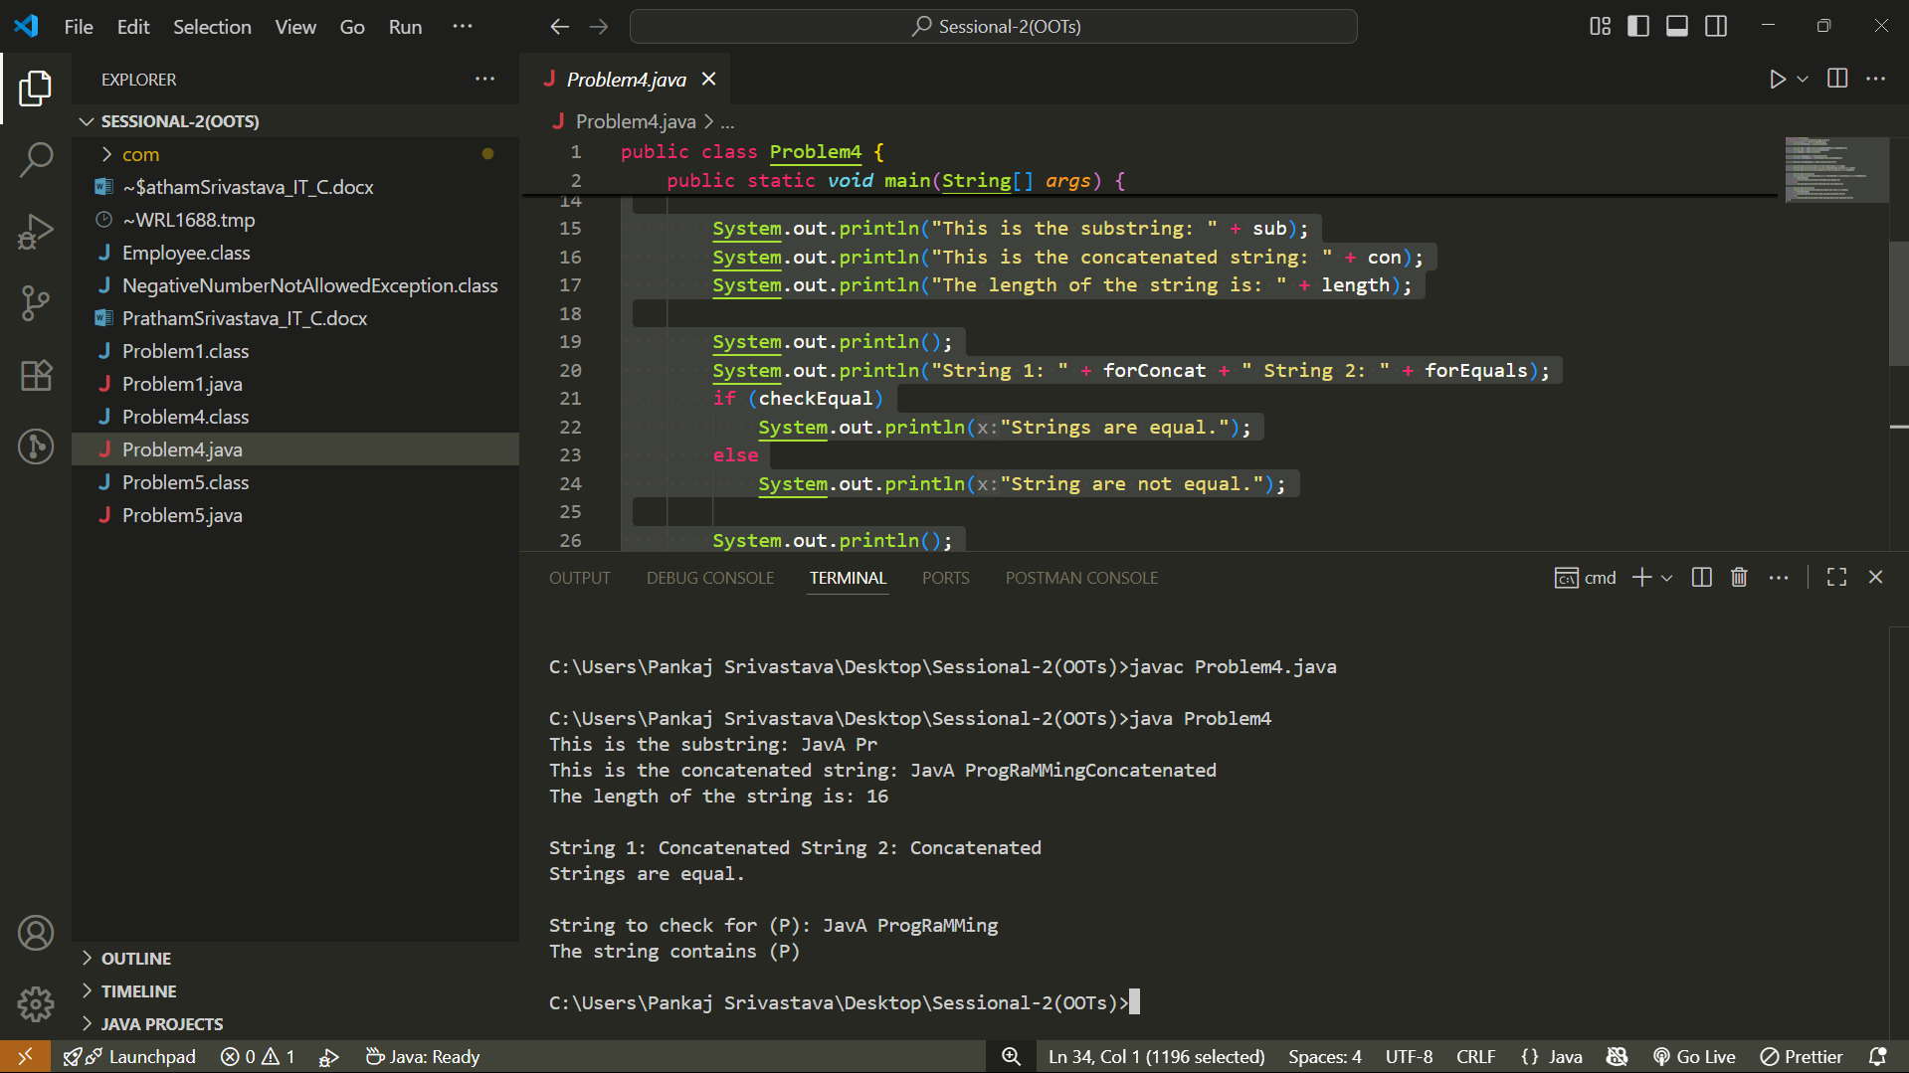

**Problem-5: SOURCE CODE**

import java.util.Scanner;

class NegativeNumberNotAllowedException extends Exception {

}

public class Problem5 {

    public static *void* main(String[] *args*) {

        Scanner scanner = new Scanner(System.in);

*int* n = 0;

        System.out.print("Enter the size of the array: ");

        n = scanner.nextInt();

*int*[] numbers = new *int*[n];

*int* index = 0;

        while (index < numbers.length) {

            System.out.print("Enter a number: ");

*int* input = scanner.nextInt();

            try {

*int* num = input;

                if (num < 0) {

                    throw new NegativeNumberNotAllowedException();

                }

                numbers[index] = num;

                index++;

            } catch (NumberFormatException e) {

                System.out.println("Invalid input, please enter a valid number.");

            } catch (NegativeNumberNotAllowedException e) {

                System.out.println("Negative numbers are not allowed.");

            }

        }

        scanner.close();

        for (*int* i = 0; i < index; i++) {

            System.out.print(numbers[i] + " ");

        }

    }

}

**PROBLEM-5: OUTPUT**

