Name: Pratham Srivastava

Roll No: 2401330130192

Branch: IT

Section: C

Workshop Lab Number: D-203

Q1.

class Car {

    String model;

*int* speed;

    public *void* display() {

        System.out.println("The mode of the car is: " + model + " with speed: " + speed);

    }

}

public class Question1 {

    public static *void* main(String[] *args*) {

        Car c1 = new Car();

        c1.model = "Honda";

        c1.speed = 45;

        Car c2 = new Car();

        c2.model = "Maruti";

        c2.speed = 55;

        c1.display();

        c2.display();

    }

}

OUTPUT FOR QUESTION-1

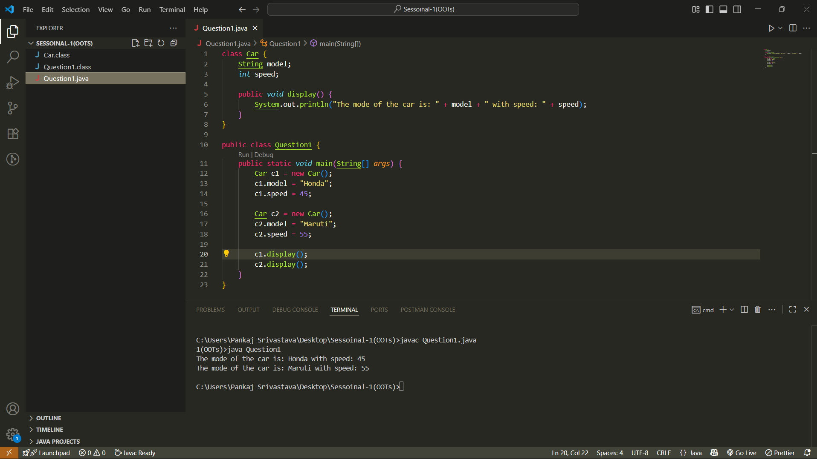

Q3.

abstract class Animal {

    abstract *void* sound();

}

class Cat extends Animal {

*void* sound() {

        System.out.println("Cat meows");

    }

}

public class Question3 {

    public static *void* main(String[] *args*) {

        Animal obj1 = new Cat();

        obj1.sound();

    }

}

OUTPUT FOR QUESTION-3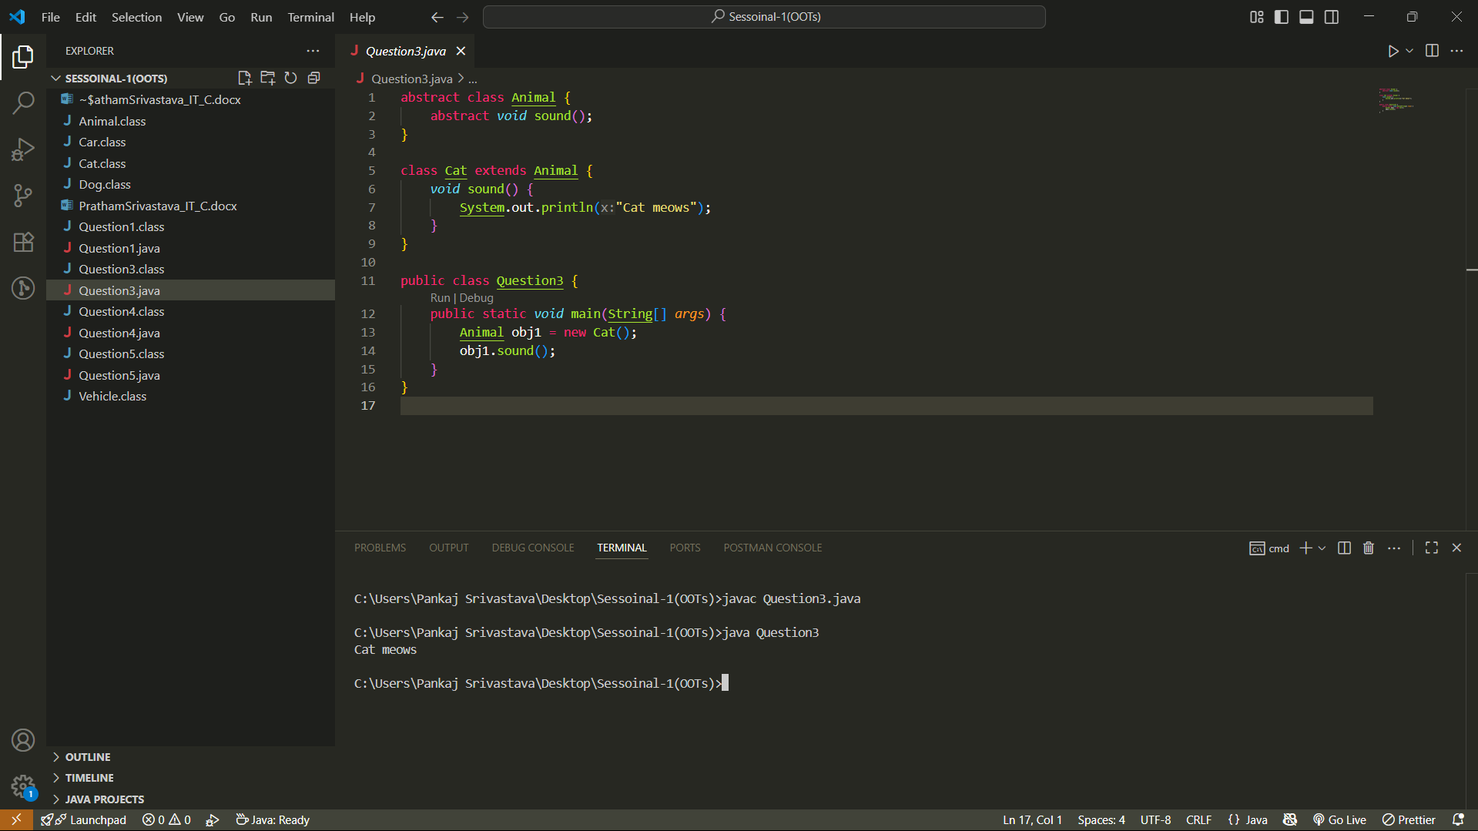

Q4.

class Vehicle {

    public *void* fuelType() {

        System.out.println("Vehicle uses fuel");

    }

}

class Car extends Vehicle {

    public *void* numberOfWheels() {

        System.out.println("Car has 4 wheels");

    }

}

public class Question4 {

    public static *void* main(String[] *args*) {

        Car v1 = new Car();

        v1.fuelType();

        v1.numberOfWheels();

    }

}

OUTPUT FOR QUESTION-4

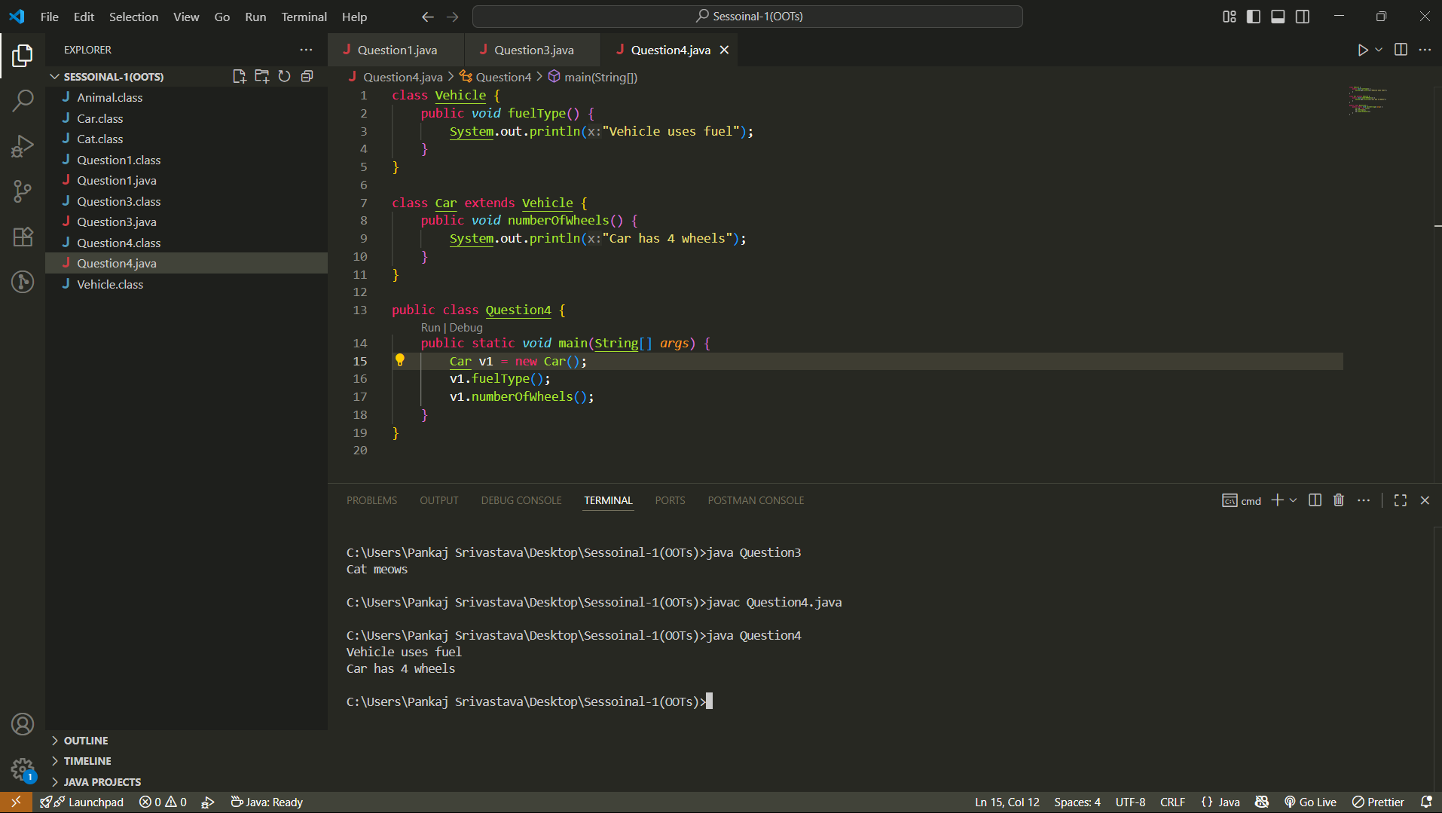

Q5.

class Animal {

    public *void* sound() {

        System.out.println("Animal makes a sound.");

    }

}

class Dog extends Animal {

    @*Override*

    public *void* sound() {

        System.out.println("Dog barks");

    }

}

public class Question5 {

    public static *void* main(String[] *args*) {

        Animal a1 = new Animal();

        Dog d1 = new Dog();

        a1.sound();

        d1.sound();

    }

}

OUTPUT FOR QUESTION-5

