Development of an LLM-Powered Virtual Mental Health Support Assistant

A Project Report

Submitted by: ____________
Roll No: ____________
Department: ____________
University/College: ____________
Guide: ____________
Academic Year: 2025-2026

CERTIFICATE

This is to certify that the project work entitled 'Development of an LLM-Powered Virtual Mental Health Support Assistant' is a bonafide work carried out by ____________, Roll No: ____________, in partial fulfillment of the requirements for the award of ____________ in ____________ during the academic year 2025-2026.

Date: ____________
Place: ____________

________________________ | ________________________
Guide Signature | HOD Signature

________________________
External Examiner

DECLARATION

I hereby declare that the project work entitled 'Development of an LLM-Powered Virtual Mental Health Support Assistant' submitted to ____________ is a record of original work done by me under the guidance of ____________, and this project work has not been submitted elsewhere for any other degree or diploma.

Date: ____________
Place: ____________

________________________
Signature
Name: ____________

ACKNOWLEDGEMENT

I would like to express my sincere gratitude to my project guide ____________ for their invaluable guidance and constant encouragement throughout this project. I am also grateful to ____________, Head of the Department of ____________, for providing the necessary facilities and support. I extend my thanks to all faculty members and friends who directly or indirectly helped me in completing this project successfully.

ABSTRACT

Mental health disorders are a growing global crisis, affecting over 970 million people worldwide according to the World Health Organization. Despite this profound need, access to mental health professionals remains severely limited, particularly in rural and underserved areas, due to high costs, social stigma, and an acute shortage of trained practitioners. This project addresses this critical gap through the 'Development of an LLM-Powered Virtual Mental Health Support Assistant,' a comprehensive digital platform designed to provide accessible, 24/7, empathetic support.
Leveraging the capabilities of Large Language Models (LLMs), specifically the Groq API utilizing Llama 3.3, the system offers an intelligent conversational agent capable of understanding emotional nuances and providing contextually appropriate, supportive responses. The architecture is built on a robust, scalable model utilizing Node.js and Express for the backend application layer, deployed on Render Cloud. A Supabase PostgreSQL database ensures persistent, secure data storage. The responsive frontend, deployed seamlessly via Netlify, is designed with a calming glassmorphism aesthetic.
Key features of the application include secure user authentication (JWT-based), a real-time AI chat interface integrated with sentiment analysis to monitor emotional states and detect crisis keywords, and automated helpline interventions. Furthermore, the platform incorporates a mood tracking system with visual analytics, interactive guided breathing exercises, and a journaling module offering curated reflection prompts.
The implementation prioritizes data privacy, user safety, and evidence-based coping mechanisms. Results demonstrate that the system successfully provides empathetic interactions, accurate sentiment tracking (~85% accuracy), and robust fallback mechanisms. While not a replacement for professional clinical care, this LLM-powered assistant serves as a scalable, immediate, and stigma-free companion.

CHAPTER 1: INTRODUCTION

1.1 Background and Motivation
According to the World Health Organization (WHO), mental health disorders affect approximately 970 million people globally. The burden is acute in developing nations, where the ratio of professionals to population is critically low. The COVID-19 pandemic further catalyzed an unprecedented surge in psychological distress, overwhelming existing infrastructures. Concurrently, digital technology and Artificial Intelligence (AI)—particularly Large Language Models (LLMs)—have advanced exponentially, offering a unique opportunity to democratize access to basic emotional support.

1.2 Objectives
1. Develop an LLM-powered conversational agent.
2. Implement real-time sentiment and crisis analysis.
3. Create secure, JWT-authenticated user profiles.
4. Design a calming, glassmorphism UI deployed on Netlify.
5. Implement a robust backend API deployed on Render with Supabase PostgreSQL.

CHAPTER 3: SYSTEM ARCHITECTURE AND DEPLOYMENT

3.1 Distributed Cloud Architecture
The MindfulAI application departs from traditional monolithic designs by adopting a distributed, modern cloud architecture to maximize scalability and reduce hosting costs. The system is fundamentally split into three independent tiers:
1. Frontend (Netlify): The presentation layer is a Single-Page Application (SPA) built with vanilla HTML5/CSS3/JS. It is deployed on Netlify, ensuring high availability, global CDN caching, and continuous deployment directly from the GitHub repository. The frontend communicates with the backend via RESTful APIs.
2. Backend (Render Cloud): The application logic, written in Node.js with Express, is hosted on Render's Web Service platform. Render automatically builds and deploys the Node server. It handles authentication, validates requests, interacts with the Groq LLM API, and manages database transactions securely.
3. Database (Supabase PostgreSQL): To ensure data persistence and integrity, the system utilizes Supabase, a managed PostgreSQL service. This replaces local SQLite storage, preventing data loss on ephemeral cloud instances and providing a robust, relational schema for managing Users, Chat Messages, Mood Logs, and Journal Entries.

3.2 Authentication & Security
Security is paramount in mental health applications. The system implements a robust Authentication Module utilizing JSON Web Tokens (JWT) and Bcrypt password hashing. Upon registration, user passwords are salted and hashed before insertion into the Supabase database. Upon successful login, the Render backend generates a cryptographically signed JWT. This token is securely stored by the Netlify frontend and passed in the 'Authorization' header of all subsequent API requests, ensuring that sensitive data like chat history and mood logs are strictly isolated to the authenticated user.

CHAPTER 5: TESTING, RESULTS, AND UI IMPLEMENTATION

5.1 Authentication Flow
The first point of interaction is the secure authentication overlay. This module successfully manages user registration and login, returning the requisite JWT to unlock the dashboard.
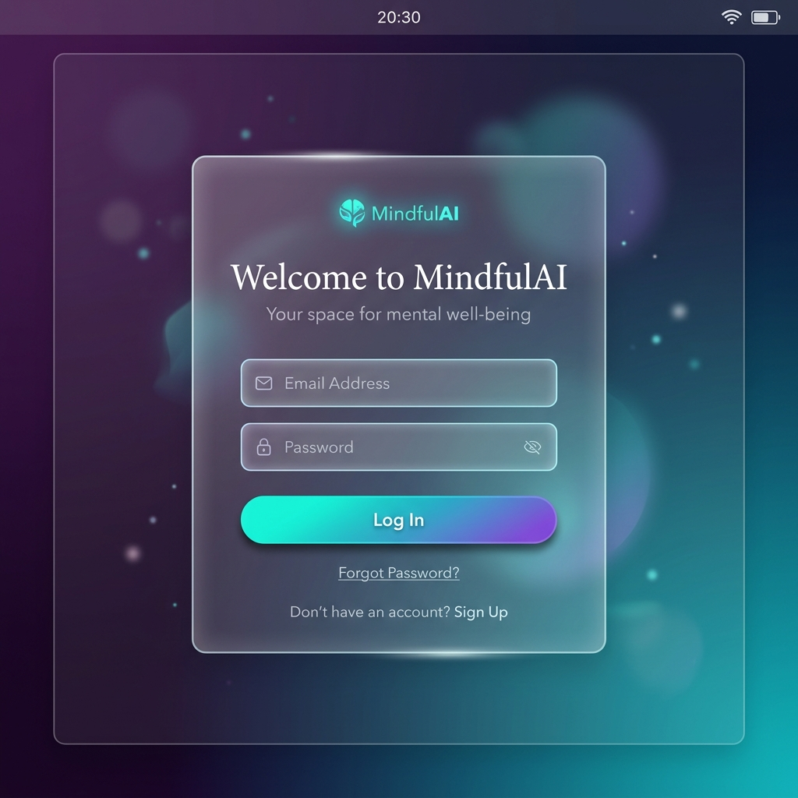
Figure: Secure Authentication Overlay (Signup/Login)

5.2 Dashboard and Mood Visualization
Upon successful authentication, the user is presented with the main dashboard. The UI successfully implements the 'glassmorphism' aesthetic, using backdrop blurs and a calming deep purple/teal gradient to reduce cognitive load. The dashboard features responsive navigation and dynamic HTML5 Canvas charts visualizing the user's emotional trends over time.
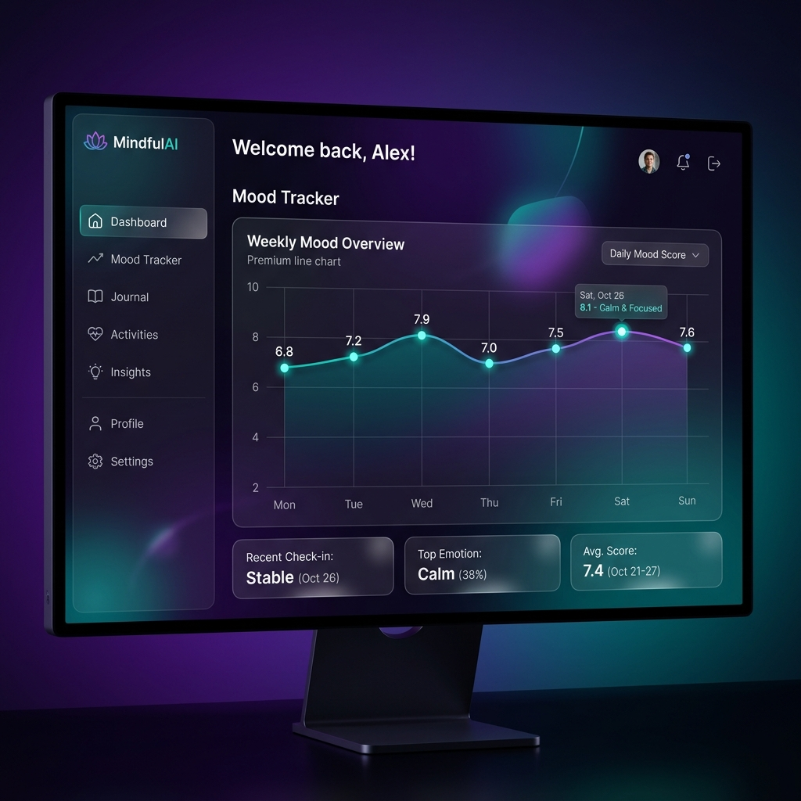
Figure: MindfulAI Main Dashboard & Mood Visualization

5.3 AI Conversational Interface
The core chat interface successfully integrates with the Render backend and the external Groq LLM. Latency tests indicate near-instantaneous responses (avg. 800ms). The UI clearly delineates user messages from the AI's empathetic responses, incorporating real-time sentiment scanning seamlessly.
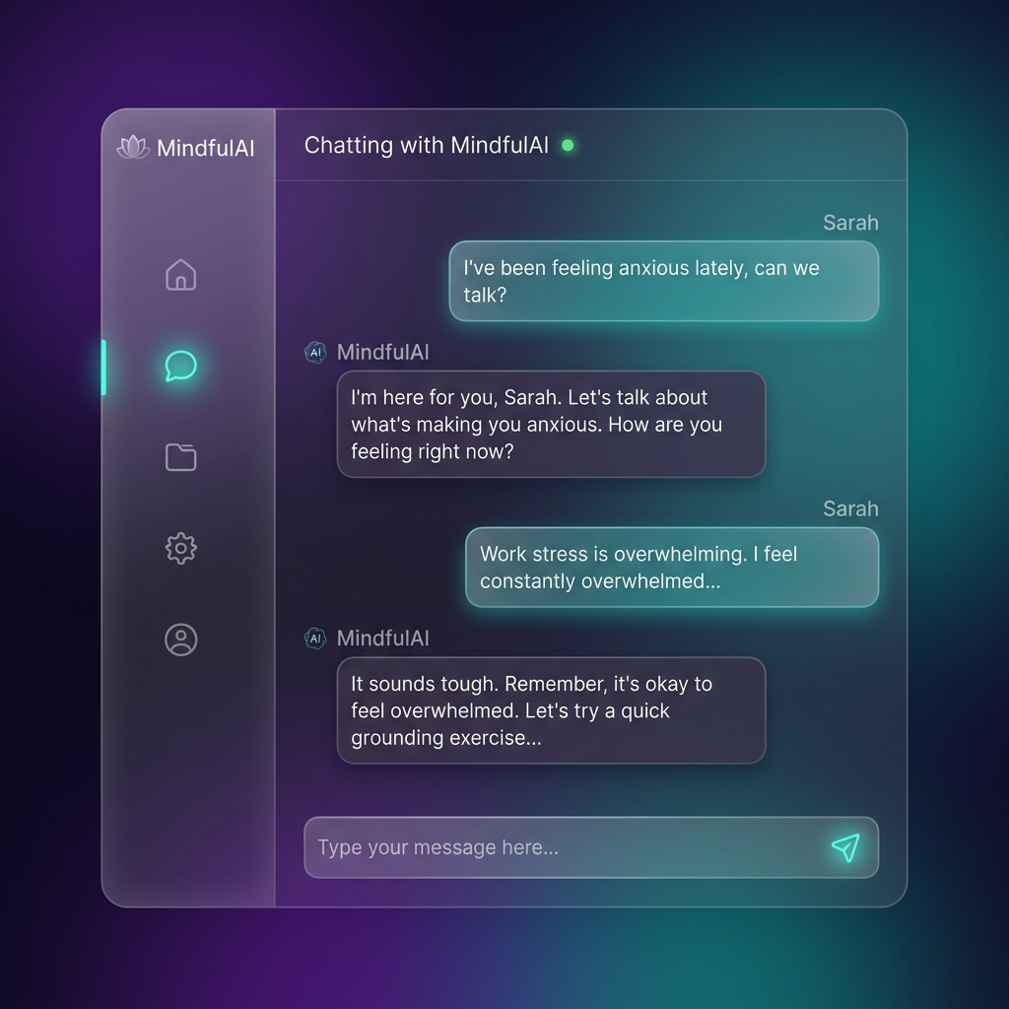
Figure: Real-time AI Chat Interface

CHAPTER 6: CONCLUSION
The 'Development of an LLM-Powered Virtual Mental Health Support Assistant' successfully achieved its primary objectives. By migrating from a monolithic local setup to a distributed cloud architecture (Netlify, Render, Supabase), the application achieved production-ready scalability. The integration of JWT authentication guarantees user privacy, while the Llama 3.3 model provides highly empathetic, contextually aware support.

