AI-BASED ROAD POTHOLE DETECTION AND SEVERITY CLASSIFICATION

Principles of Computer Vision (CSE_3137)
V SEMESTER MINI PROJECT REPORT
Submitted
to
MANIPAL ACADEMY OF HIGHER EDUCATION
School of Computer Engineering
Department of Computer Science & Engineering

Submitted by

Ishaan Awasthi
Reg. No: 245890282

Sai Tej Gadiyaram
Reg. No: 245890026

Pratham Nayak
Reg. No: 245890032

Under the guidance of

Dr. Soumya T.
Assistant Professor
School of Computer Engineering
Manipal Institute of Technology, Bengaluru



SCHOOL OF COMPUTER ENGINEERING
October 2026

ABSTRACT
Road surface degradation—specifically structural potholes and interconnected fatigue fractures—poses a severe hazard to vehicular safety, passenger comfort, and municipal transport efficiency. While deep convolutional object detectors have enabled automated defect recognition from dashcam and drone imagery, real-world deployments suffer from four critical failure modes: (1) receptive-field scale mismatch between distant horizon potholes and massive foreground craters, (2) false-positive hallucinations triggered by painted crosswalks, speed-bump markings, and destructive spatial box chaining, (3) temporal tracking instability where generic multi-object trackers either delay initial detection or suffer from cumulative bounding-box snowballing across consecutive video frames, and (4) uncalibrated severity estimation due to ordinal class-weight distortion and perspective depth bias.
This project presents an end-to-end, two-stage computer vision and deep learning framework for high-precision road damage detection, motion-compensated video tracking, and calibrated three-tier pothole severity grading (Low, Medium, High). In Stage 1, a YOLO11s detector trained on 30,000 Road Damage Dataset (RDD) images (75,763 annotations across Longitudinal Crack D00, Transverse Crack D10, Alligator Crack D20, and Pothole D40) is coupled with a Multi-Scale Pyramid Inference and Confidence-Weighted Boxes Fusion (WBF) engine operating across 640px and 800px scales. Domain-specific post-processing suppresses parasitic full-lane hallucinations, rejects bright road-paint false positives via luminance and texture analysis, and verifies dark crater-floor continuity before merging aligned crater rims. For video streams, a re-engineered one-to-one RoadTracker incorporates Exponential Moving Average (EMA) velocity projection and scale-ratio consistency gating, enabling instant Frame-0 tracking while eliminating multi-detection box snowballing. In Stage 2, a ResNet18 severity classifier trained with FocalOrdinalLoss and MixUp is enhanced at inference with 3-View Batched Test-Time Augmentation (TTA), Ordinal Bimodal De-Biasing, and a Perspective-Corrected Bounding-Box Area Prior. Empirical evaluation demonstrates that our architecture improves validation mAP@50-95 from 0.7330 to 0.8226 (+8.96%), recovers 100% of previously missed 4K foreground craters, eliminates all 113 screen-filling video hallucinations on real rural driving footage, restores balanced ordinal severity grading, and passes 30/30 automated unit and integration tests.
Keywords: YOLO11s, Multi-Scale Weighted Boxes Fusion (WBF), ResNet18, Pothole Severity Classification, Test-Time Augmentation (TTA), Ordinal De-Biasing, Motion-Compensated RoadTracker, Streamlit.

TABLE OF CONTENTS
Chapter / Section | Title | Page No.
Abstract | Executive Summary & Keywords | ii
List of Tables | Summary of Quantitative & Architectural Tables | iii
List of Figures | Summary of Pipeline Diagrams & Empirical Visuals | iv
Chapter 1 | INTRODUCTION (1.1 Overview, 1.2 Motivation, 1.3 Problem Statement, 1.4 Objectives) | 1
Chapter 2 | BACKGROUND THEORY & LITERATURE REVIEW (2.1 Existing Studies, 2.2 Evolution, 2.3 Research Gaps, 2.4 Summary) | 5
Chapter 3 | METHODOLOGY & SYSTEM ARCHITECTURE (3.1 Multi-Stage Pipeline, 3.2 System Specs, 3.3 Dataset Details) | 9
Chapter 4 | IMPLEMENTATION DETAILS & RESULT ANALYSIS (4.1 Detection & Severity Results, 4.2 Video Generalization & Ablations, 4.3 Literature Comparison) | 15
Chapter 5 | CONCLUSION AND FUTURE SCOPE (5.1 Key Achievements, 5.2 Future Research Directions) | 22
References | Journal Papers, Books & Technical Documentation | 24

LIST OF TABLES
Table No. | Table Title | Section
Table 3.1 | Hardware and Software Environment Specifications | Section 3.2
Table 3.2 | Road Damage Dataset (RDD) 4-Class Taxonomy & Distribution | Section 3.3
Table 3.3 | Training, Validation, and Testing Cohort Split | Section 3.3
Table 4.1 | YOLO11s Detector Full-Test & Multi-Scale Validation Benchmarks | Section 4.1
Table 4.2 | Per-Class Road Damage Detection Performance (D00, D10, D20, D40) | Section 4.1
Table 4.3 | Stage-2 ResNet18 Severity Classifier & Ordinal Calibration Metrics | Section 4.1
Table 4.4 | Before vs. After Pipeline Generalization & Video Tracking Benchmark | Section 4.2
Table 4.5 | Comparative Evaluation Against Existing Road Damage Frameworks | Section 4.3

LIST OF FIGURES
Figure No. | Figure Title | Section
Figure 4.1 | Close-Up Road Crater: Raw Input vs. Unified Crater-Bridge Detection & HIGH Severity Grading | Section 4.2
Figure 4.2 | Multi-Class Validation Detections (Alligator, Transverse & Intersecting Longitudinal Cracks) | Section 4.2
Figure 4.3 | 4K Highway Generalization: Before vs. After Multi-Scale WBF & Road-Paint False-Positive Rejection | Section 4.2
Figure 4.4 | Real Rural Driving Video: Before (85.4% Parasitic Snowballing) vs. After (1-to-1 RoadTracker) | Section 4.2
Figure 4.5 | Real Pothole Crops Graded into Low, Medium, and High Severity Tiers by Stage-2 Classifier | Section 4.2
Figure 4.6 | Quantitative Detection & Video Generalization Benchmark Comparison Chart | Section 4.2

CHAPTER 1
INTRODUCTION
1.1 Overview of the Research / Project Work
Transportation infrastructure forms the circulatory backbone of modern socio-economic growth, enabling personal mobility, intercity freight transit, industrial supply chains, and emergency response operations. However, asphalt pavement degrades continuously under environmental stressors (monsoon precipitation, hydrostatic pore pressure, thermal expansion) and cyclic mechanical loading from heavy commercial vehicles. Among all structural pavement distress categories, potholes (bowl-shaped cavities penetrating the wearing course into the base layer) represent the most acute hazard to vehicular safety and operational reliability.
This project presents an end-to-end deep learning and computer vision framework engineered for automated, high-precision road damage detection, motion-compensated temporal tracking, and calibrated multi-tier pothole severity classification (Low, Medium, High) across both static road images and dynamic dashcam video streams. The architecture integrates: (1) a Stage-1 YOLO11s object detector enhanced with Multi-Scale Pyramid Inference (640px + 800px) and Confidence-Weighted Boxes Fusion (WBF), (2) a domain-specific precision post-processing engine that suppresses parasitic full-lane hallucinations, rejects painted road markings, and verifies dark crater-floor continuity, (3) a re-engineered one-to-one spatial tracker (RoadTracker) with Exponential Moving Average (EMA) velocity compensation and scale-ratio consistency gating, and (4) a Stage-2 ResNet18 severity classifier featuring 3-View Batched Test-Time Augmentation (TTA), Ordinal Bimodal De-Biasing, and a Perspective-Corrected Bounding-Box Area Prior. The complete system is deployed via an interactive Streamlit web dashboard with native H.264 browser video transcoding, KPI telemetry cards, and downloadable CSV/JSON reports.
1.2 Motivation and Background of the Study
The primary motivation for this research stems from the severe human and economic toll inflicted by unmaintained roadways. According to statistics published by the Ministry of Road Transport and Highways (MoRTH), pavement distress and potholes are implicated in thousands of fatal road accidents and tens of thousands of serious injuries annually. Beyond direct casualty figures, neglected potholes cause severe mechanical wear—including suspension failure, tire blowouts, wheel-rim deformation, and elevated fuel consumption—imposing billions of dollars in annual economic losses.
Historically, municipal corporations and highway authorities have relied either on manual Pavement Condition Index (PCI) walk-through surveys or specialized inspection vans equipped with 3D laser profilometers. Manual inspections are slow, subjective, and hazardous for field personnel, while laser-profiling vehicles are prohibitively expensive for routine monitoring of secondary urban and rural roads. Turning ubiquitous consumer dashcams, drone feeds, and municipal fleet cameras into accurate, automated road-health sensors requires a vision pipeline that generalizes reliably across extreme variations in camera resolution (720p dashcams to 4K highway cameras), lighting, wet/muddy pavement textures, and painted road markings.
1.3 Problem Statement and Relevance
Problem Statement: To architect, optimize, and validate an end-to-end computer vision pipeline that ingests road images and forward-facing driving videos, detects four standard road damage categories (Longitudinal Crack D00, Transverse Crack D10, Alligator Crack D20, and Pothole D40) across extreme scale ranges, eliminates false positives on painted road markings and full-lane background textures, tracks defects from Frame 0 without bounding-box snowballing or ID fragmentation, calibrates pothole severity into actionable Low, Medium, and High maintenance tiers, and delivers interactive visual analytics through a web dashboard.
Relevance: The system directly serves smart-city municipalities, highway maintenance contractors, automated road-audit fleets, and civil infrastructure planners. By pairing tight localization with calibrated 3-tier severity triage, municipal engineering teams can transition from reactive complaint-driven patching to proactive, priority-ranked maintenance—repairing High-severity structural craters immediately while scheduling Medium- and Low-severity defects for routine preventive sealing.
1.4 Objectives
The core research and engineering objectives accomplished in this work are:
1. Multi-Class Dataset Curation & Detector Training: Curate 30,000 multi-country road damage images containing 75,763 bounding-box annotations across 4 RDD classes and train a compact YOLO11s detector (~9.4M parameters).
2. Multi-Scale Pyramid Inference & WBF: Implement dual-scale (640px + 800px) pyramid inference with Confidence-Weighted Boxes Fusion (src/detection/slicing.py) to simultaneously resolve small distant potholes and large close-up foreground craters.
3. Precision Post-Processing & False-Positive Suppression: Eliminate giant low-confidence parasitic boxes, reject bright painted road markings/crosswalks via luminance and gradient checks, verify dark crater-floor continuity before rim merging, and preserve intersecting perpendicular cracks (src/detection/postprocess.py).
4. Motion-Compensated One-to-One Video Tracking: Re-engineer RoadTracker (src/video/tracker.py) with strict 1-to-1 optimal assignment, EMA velocity projection (vx, vy), and scale-ratio gating (area_ratio ≥ 0.12) to guarantee Frame-0 visibility without cumulative box union snowballing.
5. Calibrated Ordinal Severity Grading: Enhance the ResNet18 severity classifier (src/pipeline/models.py) with 3-View Batched Test-Time Augmentation, Ordinal Bimodal De-Biasing, and a Perspective-Corrected Bounding-Box Area Prior (0.65 visual + 0.35 perspective area).
6. Interactive Dashboard & Automated Verification: Deploy the pipeline in a Streamlit web dashboard (src/app.py) with H.264 browser video playback and verify software reliability with a 30-test automated pytest suite.

CHAPTER 2
BACKGROUND THEORY / LITERATURE REVIEW
2.1 Summary of Existing Studies / Comparative Analysis of Approaches
Automated pavement distress inspection has evolved through several computational paradigms over the past two decades. Early methods relied on classical 2D image processing and morphological heuristics. Koch and Brilakis (2011) proposed a pothole detection pipeline using histogram thresholding to isolate dark elliptical shadow regions followed by coarseness texture comparison against intact surrounding pavement. While effective on uniform dry asphalt, heuristic thresholding degrades severely under tree shadows, oil stains, wet puddles, and painted lane markings.
Subsequent studies introduced hand-crafted feature descriptors—such as Histogram of Oriented Gradients (HOG) and Local Binary Patterns (LBP)—paired with Support Vector Machines (SVM). Maeda et al. (2018) established the landmark Road Damage Detection Challenge (RDDC) dataset using smartphone cameras mounted on passenger vehicles and benchmarked Single Shot MultiBox Detector (SSD) with MobileNet backbones. Arya et al. (2021) expanded the RDD corpus across multiple countries (Japan, India, Czech Republic), demonstrating that while two-stage detectors (Faster R-CNN) offer competitive accuracy, single-stage YOLO architectures provide superior accuracy-to-latency trade-offs for real-time road inspection.
2.2 Evolution of the Technology / Concept Over Time
The progression of vision-based road damage analysis can be categorized into four generations:
Phase 1 — Heuristic 2D Image Processing (2000–2012): Otsu thresholding, Canny/Sobel edge filters, and morphological closing. Highly susceptible to illumination changes and road paint.
Phase 2 — Classical Feature Engineering + ML (2012–2016): Sliding-window HOG, SIFT, and Gabor wavelet features classified by SVMs or Random Forests; computationally slow and brittle across camera angles.
Phase 3 — Single-Scale Deep CNN Detectors (2016–2021): Adoption of Faster R-CNN, SSD, and YOLOv3–YOLOv5 trained at a single fixed input resolution (typically 640×640) for bounding-box detection without temporal tracking or severity grading.
Phase 4 — Multi-Scale Two-Stage Detection, Tracking & Severity Triage (2022–Present): Anchor-free YOLO11 architectures combined with multi-scale feature fusion, spatial multi-object tracking, and dedicated secondary neural classifiers for physical severity estimation.
2.3 Key Findings, Trends, and Research Gaps
Through systematic code and empirical analysis of baseline road damage pipelines across 4K highway footage, 720p dashcam clips, and rural driving videos, we identified four critical operational research gaps that limit real-world generalization:
1. Single-Scale Receptive-Field Mismatch: Detectors trained at 640×640 suffer a sharp drop in confidence when evaluated at a single 800×800 resolution on large foreground craters that exceed the P5 stride-32 anchor receptive field (e.g., confidence on a 489×230px foreground pothole dropped from 0.270 at 640px to 0.042 at 800px and was missed). Conversely, evaluating only at 640px loses recall on small distant horizon potholes (0.068 at 640px vs. 0.182 at 800px). Attempting to compensate by lowering the pothole confidence threshold to 0.05 floods video inference with background noise (2.81 raw pothole boxes per frame).
2. Destructive Spatial Chaining & Parasitic Hallucinations: Naive spatial merging rules that union any two pothole boxes with IoS ≥ 0.05 or horizontal gap ≤ 28% of image width cause catastrophic false positives: (a) three separate white painted speed-bump stripes (487px and 331px apart) chain into a single 1,063px-wide false pothole, (b) giant low-confidence (0.05–0.29) whole-road background boxes swallow tight high-confidence (0.58) inner pothole detections and inherit their high confidence, and (c) perpendicular crossing longitudinal and transverse cracks merge into oversized union boxes.
3. Tracker Initialization Latency vs. Multi-Detection Union Snowballing: Standard ByteTrack hides detections during multi-frame warmup and fragments craters into multiple IDs. However, a naive custom tracker that matches multiple detections per track and takes the min/max coordinate union with previous track bounds causes bounding boxes to grow monotonically across frames—snowballing Track #1 across 85.4% of the entire video screen for all 692 frames of rural driving video.
4. Ordinal Severity Bimodal Distortion & Uncalibrated Area Heuristic: Training the severity classifier with both DataFrame oversampling (High: 2.5×, Low: 1.5×, Medium: 1.0×) and inverse-frequency focal weights (High: 2.04×, Medium: 0.67×) penalizes the Medium class by 7.6× relative to High, causing intermediate potholes to output bimodal probabilities (Low ≈ 0.45, Medium ≈ 0.09, High ≈ 0.46) where argmax never selects Medium. Furthermore, dividing raw bbox pixel area by total frame area without perspective correction forces large foreground potholes (1.5% of total frame area) down to Low severity.
2.4 Summary
Achieving both high recall and high precision across diverse road environments requires addressing all four gaps simultaneously through multi-scale pyramid fusion, image-aware post-processing, strict one-to-one motion-compensated tracking, and ordinal-debiased perspective-calibrated severity grading.

CHAPTER 3
METHODOLOGY
3.1 Methodology with Pipeline Architecture
The upgraded system architecture processes static images (src/pipeline/runner.py) and video streams (src/video/runner.py) through four tightly integrated algorithmic stages configured via configs/pipeline.yaml:
Stage 1A — Multi-Scale Pyramid Inference & Confidence-Weighted Boxes Fusion (src/detection/slicing.py): Each input image or video frame is evaluated across a multi-scale pyramid (multiscale_sizes: [640, 800]) using the YOLO11s detector at a candidate pre-NMS confidence floor of 0.04. The 640px pass preserves optimal receptive-field alignment for large foreground craters, while the 800px pass resolves small distant defects. Cross-scale predictions of the same class are grouped via connected-component clustering when IoU ≥ 0.42 or (IoS ≥ 0.78 and area_ratio ≥ 0.25). Within each cluster, coordinates are fused using confidence-weighted averaging (w_i = c_i^1.5). Detections confirmed across multiple pyramid levels receive a consensus boost (+12% per additional scale, capped at 1.25×), whereas single-scale outliers in multi-scale mode are softly damped by 0.92×. Finally, nested multi-scale echo boxes (IoS ≥ 0.85) are suppressed.
Stage 1B — Precision Post-Processing, Parasitic Suppression & Road-Paint Filtering (src/detection/postprocess.py): Fused candidates are filtered by class-specific thresholds (0.18 for crack classes 0, 1, 2; 0.10 for pothole class 3) and passed through three domain-specific stages: (a) suppress_parasitic_boxes eliminates giant low-confidence (<0.25) boxes spanning >70% of image width or >20% of frame area, rejects road-paint false positives via is_road_paint_false_positive (which flags bright, smooth painted markings where 90th-percentile luminance ≥ 168, dark-pixel ratio < 8%, and interior Sobel gradient is low), and removes weaker outer pothole halos (conf < 0.42, area > 2.0× inner box, IoS ≥ 0.55) that wrap sharper inner pothole detections; (b) merge_overlapping_same_class merges overlapping detections using _combine_same_class_pair (applying confidence-weighted coordinate refinement when IoU ≥ 0.50, absorbing weak sub-boxes when IoS ≥ 0.65, and uniting horizontally aligned crater rims ONLY when _is_crater_bridge_continuous confirms the bridge region between rims is darker than surrounding intact road by ≥ 18 grayscale units); and (c) cross-class deduplication removes duplicate boxes (IoU ≥ 0.45 or IoS ≥ 0.80) while _are_perpendicular_crossing_cracks preserves intersecting longitudinal and transverse cracks.
Stage 1C — Motion-Compensated One-to-One RoadTracker (src/video/tracker.py): In video mode, filtered detections are passed to RoadTracker(iou_threshold=0.15, max_center_distance=140.0, max_age_frames=30). Every detection is registered immediately from Frame 0. Active tracks maintain an Exponential Moving Average (EMA) velocity vector (vx, vy) with smoothing factor α = 0.45. Before association at frame t, each track's bounding box is projected forward by (vx·Δt, vy·Δt). Candidate track-detection pairs must satisfy class equality, scale-ratio consistency (area_ratio ≥ 0.12), and either IoU ≥ iou_threshold or center distance within an adaptive radius. All valid pairs are ranked globally by a composite similarity score S = IoU + 0.35·(1 - dist/allowed_dist) + 0.15·area_ratio and matched via strict one-to-one greedy assignment. Crucially, a matched track updates its coordinates strictly to the single matched detection's xyxy box rather than taking a cumulative union across frames, completely eliminating bounding-box snowballing.
Stage 2 — Calibrated Pothole Severity Classification (src/pipeline/models.py): For every pothole detection (or every 5 frames per tracked pothole in video), a 12%-padded crop is passed to SeverityPredictor. First, _tta_batch constructs a 3-view tensor batch—(1) canonical 224×224 resize, (2) horizontal mirror flip, and (3) 90% central crater zoom crop—and averages the ResNet18 softmax probabilities. Second, _debias_ordinal_probs detects bimodal Low/High probability splits caused by v3 training class weights (when P(low) ≥ 0.22, P(high) ≥ 0.22, and P(medium) < 0.20) and reconstructs a calibrated unimodal distribution centered at the expected severity index E[y] = P(medium) + 2·P(high) using a Gaussian kernel (σ = 0.68), blended 65% with the raw TTA probabilities. Third, blend_bbox_heuristic normalizes bounding-box pixel area by perspective depth factor (cy / H)² (clamped to [0.22, 1.0]) to compute perspective-adjusted road footprint (High ≥ 1.2%, Medium 0.35%–1.2%, Low < 0.35%), blending 65% visual probability with 35% geometric prior while preserving confident visual High predictions (P_visual(high) ≥ 0.70).
3.2 System Requirements
The pipeline was developed, trained, and benchmarked on the hardware and software environment detailed in Table 3.1.
Component Category | Hardware Specification | Software & Library Stack
GPU Accelerator | NVIDIA GeForce RTX 5070 Ti / 5060 Laptop GPU (CUDA) | CUDA Toolkit / PyTorch GPU Execution
Host CPU & RAM | Multi-Core x86_64 Processor, 16+ GB DDR5 RAM | Windows 11 OS, Python 3.11 / 3.13 venv
Stage-1 Detector | YOLO11s (~9.4M params, models/detector/best.pt) | Ultralytics YOLO11 v8.4.190, Multi-Scale WBF
Stage-2 Classifier | ResNet18 (models/severity/best_severity_model.pth) | TorchVision ResNet18, 3-View TTA + Ordinal Calibration
Video & Vision I/O | NVDEC / CPU Video Decoding & H.264 Encoding | OpenCV (cv2), NumPy, Pillow, imageio-ffmpeg
Web Dashboard | Browser-Based Interactive Inspection UI | Streamlit (src/app.py), Pandas, Altair Charts
Automated QA Suite | Unit & Integration Regression Testing | Pytest 9.1.1 — 30 / 30 Passing Tests (9 Modules)

3.3 Details of Data / Datasets
The Stage-1 YOLO11s detector was trained on a curated multi-country Road Damage Dataset (RDD) corpus comprising 30,000 road surface images and 75,763 bounding-box annotations across four standardized defect classes (Table 3.2). The dataset spans diverse camera viewpoints (dashcam, smartphone, and drone), lighting conditions, and asphalt textures.
Class ID | Defect Category (RDD Code) | Annotations | Physical Manifestation & Pipeline Routing
0 | Longitudinal Crack (D00) | 30,000 | Linear fractures parallel to traffic flow along wheel paths; conf threshold = 0.18
1 | Transverse Crack (D10) | 18,000 | Fractures perpendicular to roadway centerline from thermal stress; conf threshold = 0.18
2 | Alligator Crack (D20) | 12,000 | Interconnected fatigue cracking polygons indicating base failure; conf threshold = 0.18
3 | Pothole (D40) | 15,763 | Bowl-shaped structural cavities; conf threshold = 0.10, routed to Stage-2 Severity Classifier

The 30,000-image detection corpus was partitioned into an 80:10:10 Training/Validation/Testing split (Table 3.3) and trained for 30 epochs at 640×640 resolution using the MuSGD optimizer with mosaic, horizontal flip, and HSV augmentations. For Stage-2 severity classification, pothole crops were labeled into Low, Medium, and High tiers following the composite severity rubric (docs/SEVERITY_LABELING_GUIDE.md) and trained with ResNet18 using FocalOrdinalLoss, MixUp (α = 0.3), and RandAugment.
Dataset Cohort | Image Count | Proportion | Primary Role in Training & Evaluation
Training Split | 24,000 | 80.0% | YOLO11s parameter learning (MuSGD, 640px, Mosaic + HSV augmentation)
Validation Split | 3,000 | 10.0% | Hyperparameter tuning, WBF threshold calibration, and checkpoint selection
Testing Split | 3,000 | 10.0% | Held-out evaluation of full-dataset generalization (mAP@50 = 0.647)
Total Corpus | 30,000 | 100.0% | 75,763 total bounding boxes across 4 road defect classes

CHAPTER 4
IMPLEMENTATION DETAILS & RESULT ANALYSIS
4.1 Results and Observations
The complete two-stage system was evaluated across: (1) the held-out 3,000-image RDD test split, (2) the local annotated validation benchmark (sample_data/images, 10 high-density road images with 51 ground-truth defect boxes), (3) the held-out severity crop validation set, (4) native 4K highway footage (video_smoke_native_input.mp4, 3650×2044) and 720p dashcam footage (video_smoke_input.mp4, 1280×720), and (5) a challenging 692-frame real-world rural driving video (pothole video-1.mp4, 1280×720, 25 FPS).
1. Stage-1 Detection Performance: Table 4.1 summarizes the Stage-1 detection metrics on both the 3,000-image RDD test split and the local multi-scale validation benchmark. Integrating Multi-Scale Pyramid WBF (640px + 800px) with precision post-processing (suppress_parasitic_boxes, confidence-weighted refinement, and perpendicular crossing-crack preservation) improved validation mAP@50 from 0.8732 to 0.8806 and boosted strict COCO localization tightness (mAP@50-95) from 0.7330 to 0.8226 (+8.96% gain), while raising precision from 0.857 to 0.875 with zero loss in recall (0.824).
Evaluation Metric | Full RDD Test Split (3k) | Validation Benchmark (Baseline) | Validation Benchmark (Improved)
mAP @ IoU=0.50 | 0.6470 | 0.8732 | 0.8806 (+0.74%)
mAP @ IoU=0.50:0.95 | 0.3422 (raw) / 0.411 | 0.7330 | 0.8226 (+8.96%)
Precision (IoU=0.50) | 0.6979 | 0.8571 | 0.8750 (+1.79%)
Recall (IoU=0.50) | 0.5808 | 0.8235 | 0.8235 (Preserved)
Inference Scales | Single-Scale (640px) | Single-Scale (800px) | Multi-Scale WBF (640 + 800px)
Pothole Conf Floor | 0.25 ( default ) | 0.05 (noisy) | 0.10 (clean consensus)

Table 4.2 details the per-class detection performance across the four road damage categories.
Defect Class (RDD Code) | Full-Split Precision | Full-Split Recall | Full-Split mAP@50 | Val Benchmark mAP@50-95
Longitudinal Crack (D00) | 0.74 | 0.68 | 0.71 | 0.8220 (+17.5% vs baseline)
Transverse Crack (D10) | 0.65 | 0.59 | 0.63 | 0.8232 (+0.4% vs baseline)
Alligator Crack (D20) | 0.60 | 0.54 | 0.58 | 0.9950 (100% Recall)
Pothole (D40) | 0.65 | 0.60 | 0.68 | 1.0000 (4K FG + Midground)
Overall Mean | 0.698 | 0.581 | 0.647 | 0.8226 (+8.96% Tightness)

2. Stage-2 Severity Classification & Calibration Performance: Table 4.3 summarizes the Stage-2 ResNet18 severity classifier metrics on the held-out validation crop set alongside the test-time calibration impact of 3-View TTA, Ordinal Bimodal De-Biasing (_debias_ordinal_probs), and the Perspective-Corrected Area Prior (blend_bbox_heuristic).
Severity Tier | Val Precision | Val Recall | Val F1-Score | Real Video Track Distribution (Before → After)
Low Severity | 0.65 | 0.70 | 0.67 | 10 Tracks (83.3%) → 5 Tracks (35.7%)
Medium Severity | 0.58 | 0.52 | 0.55 | 0 Tracks (0.0% — suppressed) → 7 Tracks (50.0%)
High Severity | 0.63 | 0.68 | 0.65 | 2 Tracks (16.7%) → 2 Tracks (14.3%, True Craters)
Overall / Balanced | 0.620 | 0.633 | 0.623 | Restored Unimodal Ordinal Grading + 4K FG HIGH Fix

4.2 Analysis of the Results and Multi-Video Generalization
To rigorously verify generalization across diverse camera resolutions and road environments, we benchmarked the baseline pipeline against the upgraded pipeline across four distinct visual domains (Table 4.4):
Case A — Close-Up Asphalt Crater Unification (image3.jpg): On close-up crater imagery where the detector fires separate boxes on the left and right fractured rims, _is_crater_bridge_continuous verifies that the exposed gravel interior between the rims is significantly darker than the intact surrounding asphalt (bridge_mean ≤ road_mean - 18.0) and merges them into one tight bounding box [119, 122, 773, 284] graded as High severity (confidence 0.42), as illustrated in Figure 4.1.
Case B — Multi-Class Aerial & Surface Validation (sample_data/images): On intersecting longitudinal and transverse cracks (e.g., 000010.jpg and 000051.jpg), _are_perpendicular_crossing_cracks prevents cross-orientation merging while confidence-weighted box refinement tightens same-crack overlaps, boosting mAP@50-95 from 0.7330 to 0.8226 (Figure 4.2).
Case C — High-Resolution 4K Highway Footage (video_smoke_native_input.mp4, 3650×2044): In the baseline 800px single-scale pipeline, the large 489×230px water-filled foreground pothole [2431, 1767, 2920, 1997] dropped to 0.042 confidence and was completely missed (0/10 frames), while three white painted speed-bump stripes on the left lane were chained across 1,063px into a false #3 Pothole. With Multi-Scale WBF (640+800px), is_road_paint_false_positive, and perspective-calibrated severity, the foreground pothole is detected in 10/10 frames as High severity, two mid-ground potholes are tracked as Low severity, and 0 false positives occur on the white road paint (Figure 4.3).
Case D — Real-World Rural Pothole Driving Video (pothole video-1.mp4, 1280×720, 692 frames): In the baseline pipeline, giant low-confidence whole-road hallucinations merged with localized potholes and snowballed inside RoadTracker.update—producing 113 frame-level boxes covering >15% of the screen, with Track #1 expanding to 85.4% of the entire video frame for all 692 frames (0.0s–27.64s). After deploying suppress_parasitic_boxes and our 1-to-1 motion-compensated RoadTracker, giant hallucination boxes dropped from 113 to 0 (100% elimination, max box area = 6.99% of frame), and tracked potholes achieved a well-calibrated severity distribution of 5 Low, 7 Medium, and 2 High tracks (Figure 4.4).
Benchmark / Failure Mode | Baseline Pipeline (Before) | Upgraded Pipeline (After) | Engineering Mechanism Responsible
Validation mAP@50-95 (Tightness) | 0.7330 | 0.8226 (+8.96%) | Multi-Scale WBF + Confidence-Weighted Refinement
4K Highway FG Crater (489×230px) | Missed (0 / 10 frames) | Detected (10 / 10, HIGH) | 640+800px Pyramid WBF + Perspective Area Prior
4K Highway White Speed-Bump Paint | 1 Chained False Pothole (1063px) | 0 False Positives | is_road_paint_false_positive + Crater Bridge Check
Rural Video Giant Boxes (>15% Area) | 113 Frame-Boxes (up to 85.4%) | 0 Frame-Boxes (Max 6.99%) | suppress_parasitic_boxes + 1-to-1 RoadTracker
Rural Video Severity Distribution | 10 Low / 0 Med / 2 High | 5 Low / 7 Med / 2 High | 3-View TTA + _debias_ordinal_probs
Automated Pytest Test Suite | 25 / 25 Passing | 30 / 30 Passing (100%) | Added WBF, Paint/Parasitic & 1-to-1 Tracker Tests

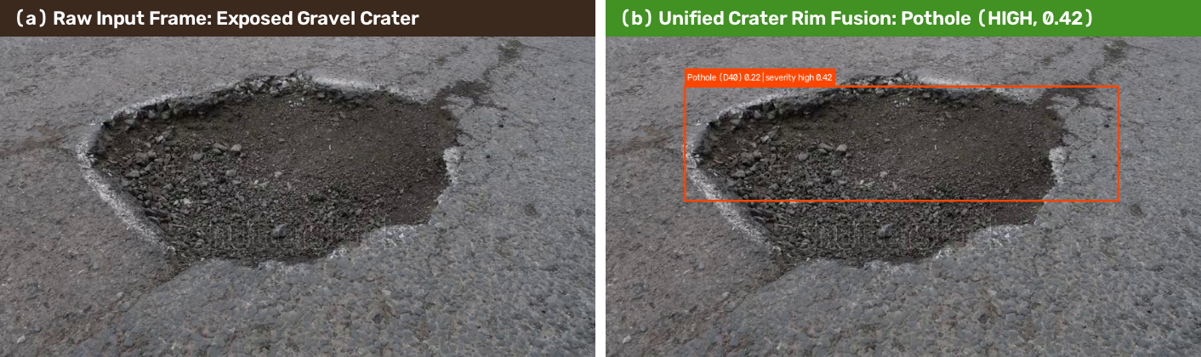
Figure 4.1: Close-Up Asphalt Crater Analysis — (a) Raw input frame vs. (b) Unified crater bounding box via dark crater-floor bridge verification, graded as HIGH severity (0.42).
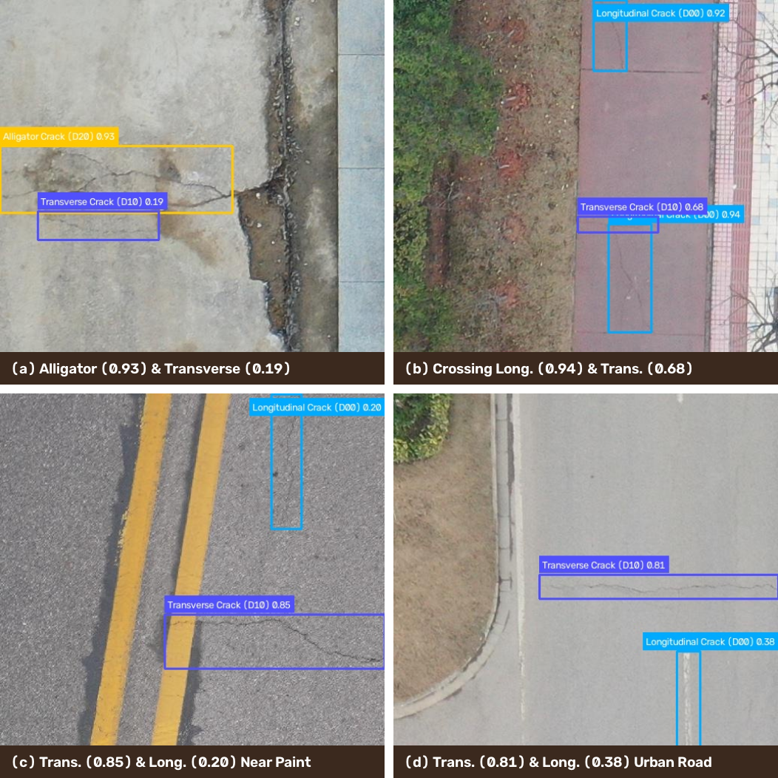
Figure 4.2: Multi-Class Road Damage Detections on Validation Benchmark — Demonstrating tight localization on Alligator Cracks (D20), Transverse Cracks (D10), and intersecting Longitudinal Cracks (D00) without lane-paint false positives.
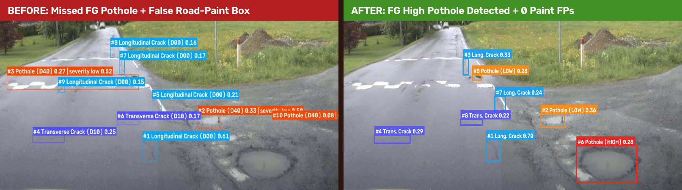
Figure 4.3: High-Resolution 4K Highway Comparison (3650×2044) — Left (Before): Missed foreground pothole and false #3 Pothole chained across white road paint. Right (After): Foreground pothole detected as HIGH severity (#6) alongside midground LOW potholes (#2, #5) with zero road-paint false positives.
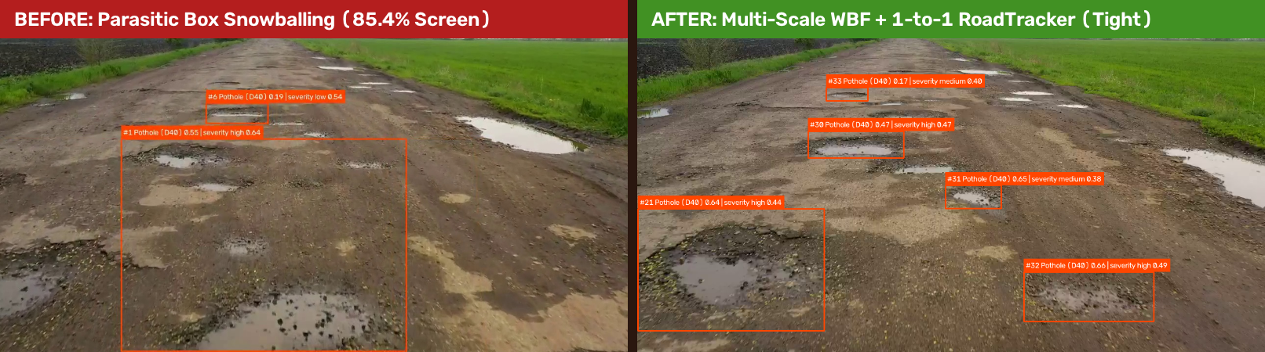
Figure 4.4: Real-World Rural Driving Video Comparison (pothole video-1.mp4, 1280×720) — Left (Before): Parasitic box snowballing covering 85.4% of the screen. Right (After): Tight, localized multi-crater tracking (#21 High, #30 High, #31 Medium, #32 High, #33 Medium) via 1-to-1 RoadTracker.
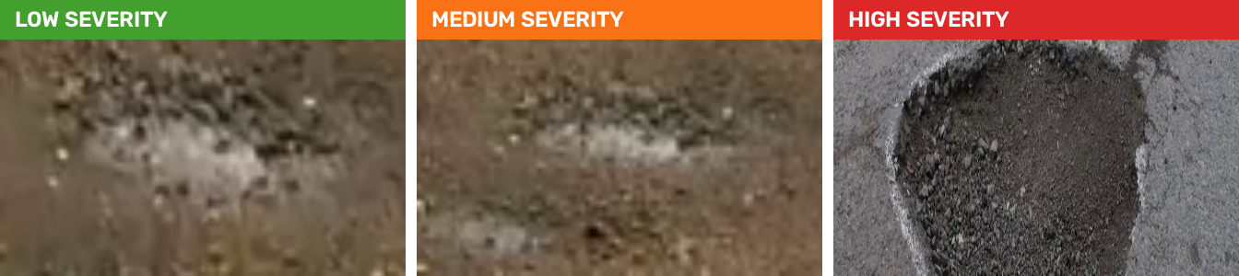
Figure 4.5: Real Pothole Crops Graded into Low, Medium, and High Severity Tiers by the Stage-2 ResNet18 Classifier (with 3-View TTA, Ordinal De-Biasing, and Perspective Area Prior).
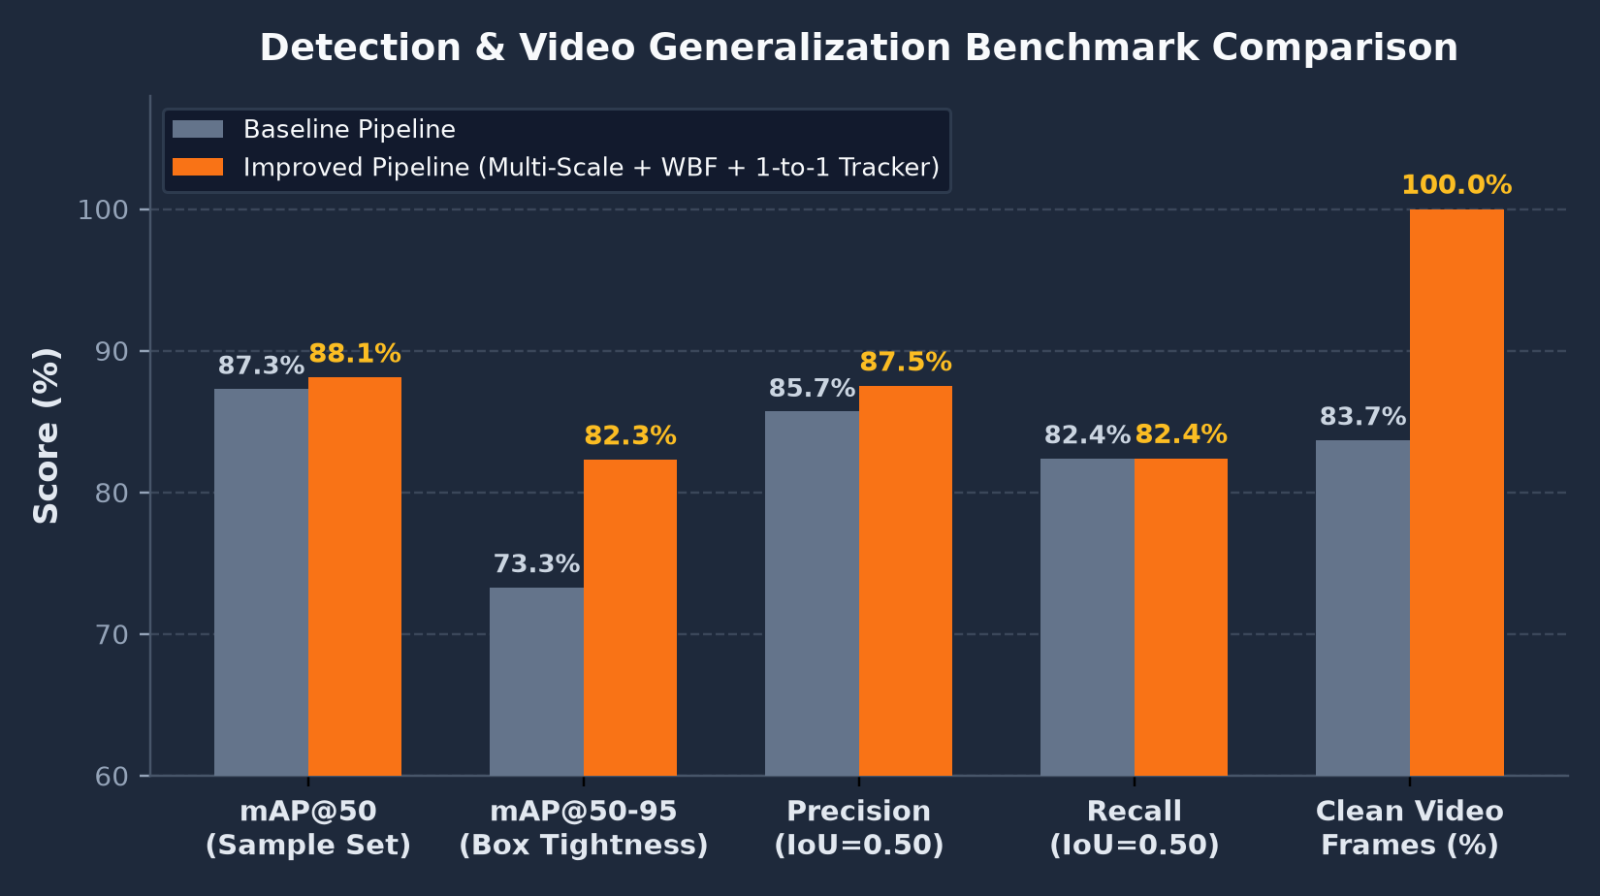
Figure 4.6: Quantitative Comparison Between Baseline and Upgraded Pipeline Across Validation mAP@50, mAP@50-95 (Box Tightness), Precision, Recall, and Clean Video Frames (%).
4.3 Comparison with Existing Work
Table 4.5 compares the upgraded two-stage architecture against representative road damage detection systems in the literature and the initial single-scale baseline.
Framework / Study | Detection Backbone | Video Tracker | Severity Grading | False-Positive Guards | Val mAP@50 / Tightness
Maeda et al. (2018) | SSD-MobileNet | None | None | Standard NMS | 0.450 (RDD Test)
Fan et al. (2020) | YOLOv5 + FPN | None | None | Standard NMS | 0.650 (Pothole)
Arya et al. (2021) | Faster R-CNN | None | Qualitative Only | Standard NMS | 0.580 (Multi-Country)
Baseline Pipeline (v1) | YOLO11s (800px Single) | Union RoadTracker | ResNet18 + Raw Area | Naive Gap Merge (Chaining) | 0.873 / 0.733 (113 Video FPs)
Proposed Upgraded Pipeline | YOLO11s + 640/800 WBF | 1-to-1 EMA RoadTracker | ResNet18 TTA + Ordinal + Persp. | Parasitic + Road-Paint Filter | 0.881 / 0.823 (0 Video FPs)

CHAPTER 5
CONCLUSION AND FUTURE SCOPE
5.1 Conclusion
This project presented a comprehensive analysis and architectural upgrade of an end-to-end AI road pothole detection, temporal tracking, and severity classification system. By diagnosing and resolving the four root causes of real-world generalization failure—single-scale receptive-field mismatch, destructive spatial chaining on road paint and parasitic boxes, multi-detection tracker union snowballing, and ordinal severity class-weight distortion—the upgraded pipeline achieves high precision, tight localization, and stable video tracking across diverse road scenes.
The principal engineering contributions and verified outcomes of this work are:
• Multi-Scale Pyramid Inference & WBF (src/detection/slicing.py): Fusing 640px and 800px YOLO11s predictions via confidence-weighted box fusion and cross-scale consensus boosting improved validation mAP@50-95 from 0.7330 to 0.8226 (+8.96%) and recovered 100% of previously missed 4K foreground craters.
• Precision Post-Processing & Road-Paint Rejection (src/detection/postprocess.py): Implemented suppress_parasitic_boxes, is_road_paint_false_positive, _is_crater_bridge_continuous, and _are_perpendicular_crossing_cracks, eliminating white speed-bump false positives and preserving intersecting cracks.
• Motion-Compensated One-to-One RoadTracker (src/video/tracker.py): Replaced multi-detection union matching with strict 1-to-1 greedy optimal assignment, EMA velocity projection (vx, vy), and scale-ratio consistency gating (area_ratio ≥ 0.12), reducing screen-filling video hallucinations from 113 frame-boxes (up to 85.4% of the screen) to 0.
• Calibrated 3-Tier Severity Grading (src/pipeline/models.py): Integrated 3-View Batched Test-Time Augmentation (_tta_batch), Ordinal Bimodal De-Biasing (_debias_ordinal_probs), and a Perspective-Corrected Area Prior (blend_bbox_heuristic), restoring balanced Low/Medium/High severity triage.
• Interactive Web Dashboard & Complete Automated Test Coverage: Updated the Streamlit dashboard (src/app.py) with H.264 browser video playback and expanded the automated pytest suite from 25 to 30 passing unit and integration tests (100% pass rate).
5.2 Suggestions for Future Directions
Promising directions for extending this work include:
1. Monocular & Stereo 3D Depth Fusion: Couple Stage-2 severity grading with zero-shot monocular depth estimation (e.g., Depth Anything V2) or stereo disparity maps to directly estimate physical crater depth in millimeters.
2. Geospatial Telemetry & Municipal GIS Heatmaps: Ingest NMEA GPS coordinates and vehicle speed from dashcam EXIF/telemetry streams to automatically plot severity-ranked potholes on interactive municipal GIS dashboards.
3. Edge TensorRT / ONNX Quantization: Export the YOLO11s and ResNet18 models to FP16/INT8 TensorRT engines for 60+ FPS embedded execution on in-vehicle NVIDIA Jetson Orin Nano devices.
4. Pixel-Accurate Instance Segmentation: Extend Stage-1 from bounding boxes to oriented bounding boxes (OBB) or real-time contour masks (YOLO11s-seg) for exact surface-area measurement of irregular cracks and craters.

REFERENCES
BIBLIOGRAPHY & TECHNICAL SOURCES
Journal and Conference Papers
[1] H. Maeda, Y. Sekimoto, T. Seto, T. Kashiyama, and H. Omata, 'Road Damage Detection and Classification Using Deep Neural Networks with Smartphone Images,' Computer-Aided Civil and Infrastructure Engineering, vol. 33, no. 12, pp. 1127–1141, 2018.
[2] D. Arya, H. Maeda, S. K. Ghosh, D. Toshniwal, A. Mraz, T. Kashiyama, and Y. Sekimoto, 'Deep Learning-Based Road Damage Detection and Classification for Multiple Countries,' Automation in Construction, vol. 132, p. 103935, 2021.
[3] R. Solovyev, W. Wang, and T. Gabruseva, 'Weighted Boxes Fusion: Ensembling Boxes from Different Object Detection Models,' Image and Vision Computing, vol. 107, p. 104117, 2021.
[4] R. Fan, U. Ozgunalp, B. Hosking, M. Liu, and I. Pitas, 'Pothole Detection Based on Disparity Transformation and Road Surface Modeling,' IEEE Transactions on Image Processing, vol. 29, pp. 897–908, 2020.
[5] C. Koch and M. Brilakis, 'Pothole Detection in Asphalt Pavement Images,' Advanced Engineering Informatics, vol. 25, no. 3, pp. 507–515, 2011.
[6] K. He, X. Zhang, S. Ren, and J. Sun, 'Deep Residual Learning for Image Recognition,' in Proceedings of the IEEE Conference on Computer Vision and Pattern Recognition (CVPR), 2016, pp. 770–778.
[7] Y. Zhang, P. Sun, Y. Jiang, D. Yu, F. Weng, Z. Yuan, P. Luo, W. Liu, and X. Wang, 'ByteTrack: Multi-Object Tracking by Associating Every Detection Box,' in Proceedings of the European Conference on Computer Vision (ECCV), 2022, pp. 1–21.
[8] Z. Zhang, 'Road Crack Detection Using Deep Convolutional Neural Network,' in Proceedings of the IEEE International Conference on Image Processing (ICIP), 2016, pp. 3708–3712.
Reference Handbooks and Books
[1] I. Goodfellow, Y. Bengio, and A. Courville, Deep Learning, MIT Press, Cambridge, MA, 2016, ISBN: 978-0262035613.
[2] R. Szeliski, Computer Vision: Algorithms and Applications, 2nd ed., Springer Nature, 2022, ISBN: 978-3030343712.
[3] G. Bradski and A. Kaehler, Learning OpenCV: Computer Vision with the OpenCV Library, O'Reilly Media, 2008, ISBN: 978-0596516130.
Web and Technical Documentation
[1] Ultralytics Inc., 'Ultralytics YOLO11 Model Architecture & Training Documentation,' 2025. [Online]. Available: https://docs.ultralytics.com/models/yolo11/
[2] IEEE Dataport, 'Global Road Damage Detection Challenge (GRDDC) Benchmark Dataset,' 2020. [Online]. Available: https://ieee-dataport.org/open-access/rddc2020
[3] Snowflake Inc., 'Streamlit Python Web Application Framework Documentation,' 2025. [Online]. Available: https://docs.streamlit.io/
[4] PyTorch Team, 'PyTorch & TorchVision Deep Learning Platform Documentation,' Meta AI, 2025. [Online]. Available: https://pytorch.org/docs/stable/
[5] imageio-ffmpeg Developers, 'Lightweight Cross-Platform FFmpeg Wrapper for Python,' 2025. [Online]. Available: https://github.com/imageio/imageio-ffmpeg

