**DOCUMENTATION (DB_Pr_07)**

***Devaansh Gupta (ID-..)***

***Pratham Oza (ID-2020A7PS1679P)***

**System requirement specification (SRS)**

***Functional Requirements:***

**1. The Laundromat has multiple services it offers, like, hand wash, machine wash, etc. on certain types of garments like shirts, pants, t-shirts, dress, etc.**

**2. The Laundromat should have a list of all its customers.**

**3. The Laundromat should have a life list of orders.**

**4. The Laundromat has stations for each service. It also has multiple stations with different capacities for each service.**

**5. Any user can at any point submit an order, check the status of their orders, and get an estimated time for their orders.**

**6. The store owner should be able to put clothes in stations and also remove them from there.**

**7. The store owner should at any point have access to their finances**

**8. Multiple users should be able to use the database at the same time**

***Data requirements:***

1. **Data Types; Int, Double, Varchar, Date.**
2. **All the primary keys and foreign keys are mentioned in the database design and ER Model below.**

**SCHEMA DESIGN:-**

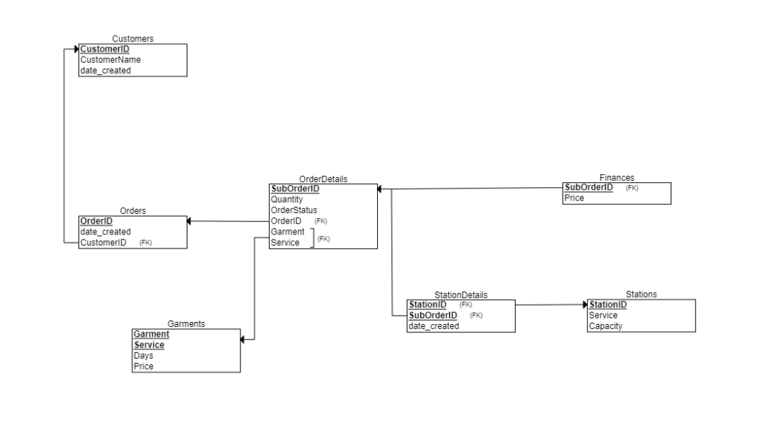

**ER MODEL:-**

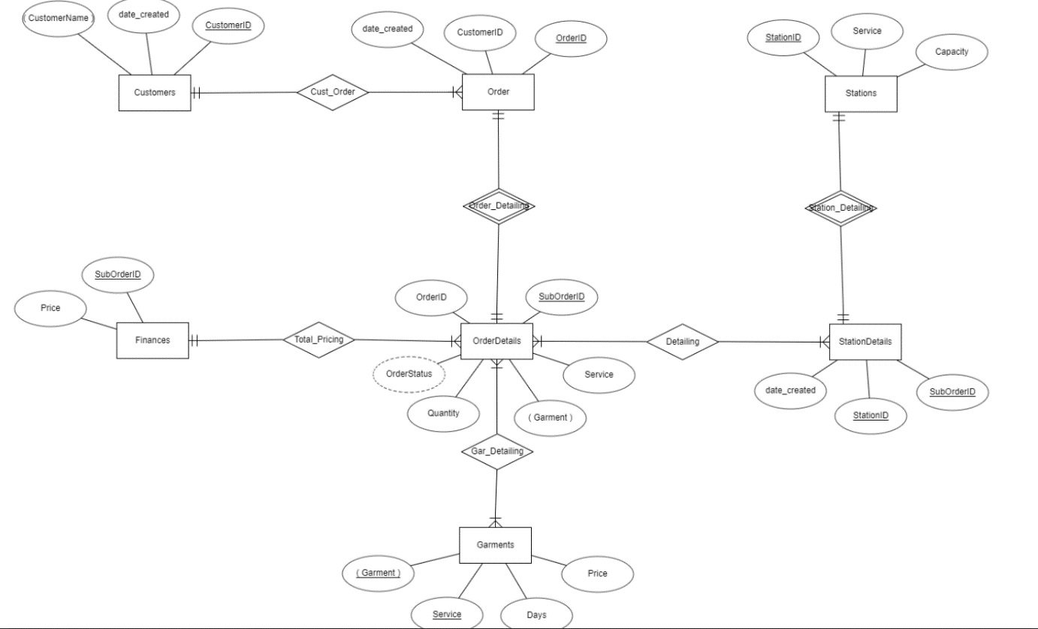

***Data normalization -* Have tried till 5nf. All tables are Normalized**

***List of tables required -***

**Customers ( CustomerID, CustomerName, date_created)**

**Orders ( OrderID, CustomerID, date_created)**

**OrderDetails ( SubOrderID, Quantity, OrderStatus, OrderID, Garment, Service)**

**Finances ( Price, SubOrderID)**

**Stations ( StationID, Service, Capacity)**

**StationDetails ( StationID, SubOrderID, date_created)**

**Garments ( Garment, Service, Days, Price)**

**Functions or procedures - list them down and write what they do(not how they do it, that’s unnecessary here). Also write its arguments.**