YuvaIntern
WEEK 2: DATA IDENTIFICATION, SOURCING STRATEGY AND INITIAL ANALYSIS PLANNING
Project Title: Exploratory Study of Beauty Product Characteristics and Customer Ratings
Domain: Data Science – Beauty and Wellness
Submitted By: Pratham Soni
Internship: Data Science with Python Analyst Internship
Submission Date: 25-10-26

1. Executive Summary
Data plays an important role in understanding product performance and consumer preferences in the beauty and personal care industry. Product attributes such as price, brand, ingredients, category, and customer ratings can provide useful information for evaluating how products are positioned in the market.
This report develops a data identification and sourcing strategy for studying beauty and cosmetic products. The primary objective is to identify suitable data sources, evaluate their quality, and establish a structured plan for collecting and analyzing relevant information.
The proposed study uses the Most Used Beauty and Cosmetic Products 2024 dataset as its initial data source. Additional data repositories will be investigated to identify alternative or supplementary datasets.
The report also defines important variables, data validation procedures, exploratory analysis methods, statistical techniques, and visualization approaches. The proposed workflow uses Python and its data analysis libraries to prepare a foundation for further investigation.
The expected outcome is a systematic plan that connects the selected data with the research objectives and supports evidence-based interpretation of beauty-product characteristics and ratings.
2. Introduction
The beauty and personal care sector includes a wide range of products, including skincare creams, cleansers, serums, makeup, haircare products, and other cosmetics. Customers may evaluate these products based on price, ingredients, brand reputation, product descriptions, and ratings.
Analyzing available product information can help identify differences between product groups and reveal patterns that deserve further investigation.
The purpose of this task is to establish a clear data collection strategy before proceeding with more detailed analysis. This includes identifying potential datasets, examining their suitability, documenting their limitations, and planning the analytical methods required to answer the research questions.
3. Problem Definition
Beauty businesses need useful information to understand the characteristics associated with product ratings. However, product attributes differ across categories and brands, making comparisons difficult without a structured analytical approach.
The study will investigate the following problem:
How can publicly available beauty-product data be analyzed to identify relationships between product characteristics, pricing, and customer ratings?
The investigation will focus on observed patterns in the available dataset. It will not assume that a particular characteristic directly causes a product to receive a higher rating.
4. Objectives of the Study
The main objectives are:
- Identify publicly accessible data sources relevant to beauty-product analysis.
- Determine which variables are necessary for the investigation.
- Evaluate the quality, accessibility, and relevance of potential datasets.
- Select an appropriate primary data source.
- Establish a reproducible method for obtaining and documenting the data.
- Examine the structure and completeness of the selected dataset.
- Plan suitable descriptive statistics and visualizations.
- Identify statistical techniques for investigating relationships between variables.
- Develop an initial data preprocessing strategy.
- Define the limitations that must be considered when interpreting the findings.
5. Research Questions
The following questions will guide the planned analysis:
- How do product ratings vary across different beauty-product categories?
- Are there differences in ratings among brands?
- What relationship, if any, exists between product price and rating?
- Do products with different review counts show different rating patterns?
- Do ratings vary across products intended for different skin types?
- Are rating distributions different across main-ingredient groups?
- Do cruelty-free and non-cruelty-free products show differences in price and ratings?
These questions will determine the required data fields and guide the selection of analytical techniques.
6. Identification of Data Requirements
The project requires structured data containing product descriptions and numerical measures.
The essential data fields include:
- Product name and brand
- Product category
- Product price
- Product rating
- Number of reviews
- Intended skin type
- Main ingredient
- Packaging type
- Cruelty-free status
- Country of origin
Numerical variables will support statistical calculations, while categorical variables will allow comparisons between product groups.
The selected dataset should contain enough relevant records for meaningful comparisons and should have clearly defined variables and accessible documentation.
7. Potential Data Sources
7.1 Kaggle
Website: https://www.kaggle.com/datasets
Kaggle is a public platform for discovering datasets across different subject areas. It will be used to locate beauty-product datasets containing product attributes, prices, ratings, and review counts.
The primary candidate is:
Most Used Beauty and Cosmetic Products 2024
Dataset link: https://www.kaggle.com/datasets/aashitanoah/most-used-beauty-and-cosmetic-products-2024
Advantages:
- Datasets may be downloaded in CSV format.
- Files can be processed using Python.
- Dataset descriptions may provide useful metadata.
- Alternative datasets can be considered.
Limitations:
- Documentation quality differs between datasets.
- Data collection methods may not always be clear.
- Licensing and representativeness require verification.
7.2 Hugging Face
Website: https://huggingface.co/datasets
Hugging Face provides datasets for data science and machine learning. It may contain suitable product-review or skincare datasets for supplementary investigation.
Advantages:
- Potential access to structured data and review text.
- Useful for future machine learning extensions.
- Supports discovery of datasets from different contributors.
Limitations:
- Some datasets may require additional preprocessing.
- Variable definitions may differ from those in the primary dataset.
- Each dataset's provenance and license must be examined.
7.3 Google Dataset Search
Website: https://datasetsearch.research.google.com/
This service can help identify datasets published across multiple repositories.
Search terms such as cosmetics ratings, skincare product reviews, and beauty product prices will be used to find relevant candidates.
Advantages:
- Provides access to a broad range of dataset listings.
- Helps identify additional data providers.
- Supports comparison of alternative resources.
Limitations:
- It does not itself guarantee the quality of the listed datasets.
- The original provider must be checked.
- Some results may not be directly suitable for the research.
7.4 Government Open Data Platform India
Website: https://www.data.gov.in/
This platform will be explored for potentially relevant industry or market-context information.
Government data may provide useful background information, but its suitability for direct product-rating analysis depends on the availability of appropriate variables.
The presence of a directly relevant dataset has not yet been confirmed.
7.5 Public Product-Review Data
Publicly available product-review datasets and documented APIs may provide additional information about ratings, reviews, and product characteristics.
Before using such a source, its access requirements, data definitions, collection methodology, license, and permitted uses will be examined.
An API will only be included in the final collection plan if a suitable provider and relevant endpoint can be verified.
8. Data Source Comparison
The candidate sources will be compared using a consistent evaluation framework.
Criterion | Purpose
Relevance | Determines whether the data supports the research questions.
Accessibility | Checks whether the resource can be obtained.
Completeness | Examines missing values in essential fields.
Reliability | Evaluates documentation and the credibility of the provider.
Timeliness | Records when the data was collected or updated, if known.
Volume | Checks whether enough observations are available.
Compatibility | Determines whether the data format and fields suit Python analysis.
Licensing | Establishes the conditions for use and redistribution.
The existing Kaggle dataset will be retained as the primary candidate because it contains the variables identified in the project requirements. Alternative sources will be selected only if they offer verified additional value.
The final source selection will be based on actual inspection rather than assumed quality.
9. Data Collection Procedure
The proposed collection workflow consists of the following stages.
Stage 1: Source Verification
Visit the original dataset page and review its description, documentation, license, and available files.
Stage 2: Data Acquisition
Download the relevant CSV file and save it in the project directory.
Stage 3: File Preservation
Keep an unchanged copy of the original dataset and perform analysis on a separate working copy.
Stage 4: Metadata Documentation
Record the dataset name, source link, access date, file format, number of records, number of columns, and available version information.
Stage 5: Initial Inspection
Use Pandas to examine column names, data types, missing values, duplicates, and numerical ranges.
Stage 6: Quality Evaluation
Determine whether the dataset is suitable for the research questions and identify limitations requiring further investigation.
Stage 7: Analysis Preparation
Prepare a documented mapping between research questions, relevant variables, statistical methods, and visualizations.
10. Initial Data Quality Assessment
The Week 1 project documentation reports that the selected dataset contains 15,000 records and 14 columns. These figures will be verified again during the current task.

The following checks will be conducted:
- Confirm the number of rows and columns. 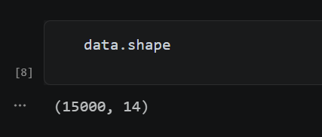
- Identify missing values.
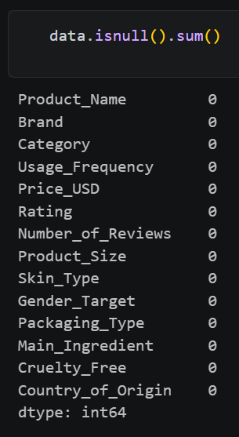

- Check exact duplicate records.
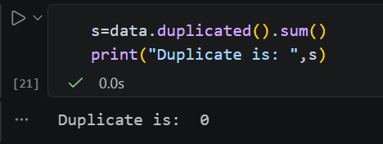
- Validate numerical data types.
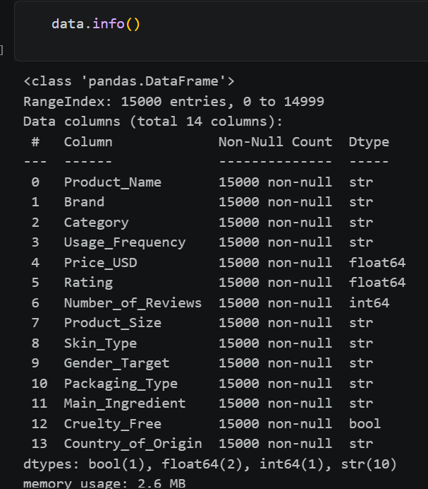
- Check whether prices are positive and ratings follow the expected scale.
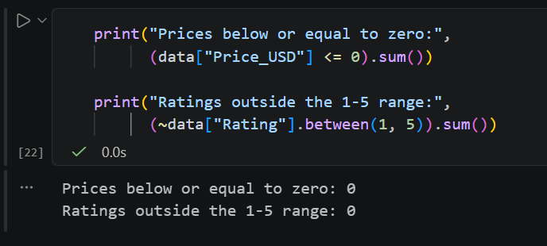

- Identify negative review counts.
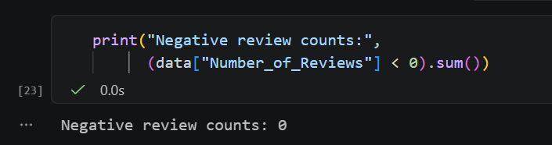
- Examine inconsistent category names. 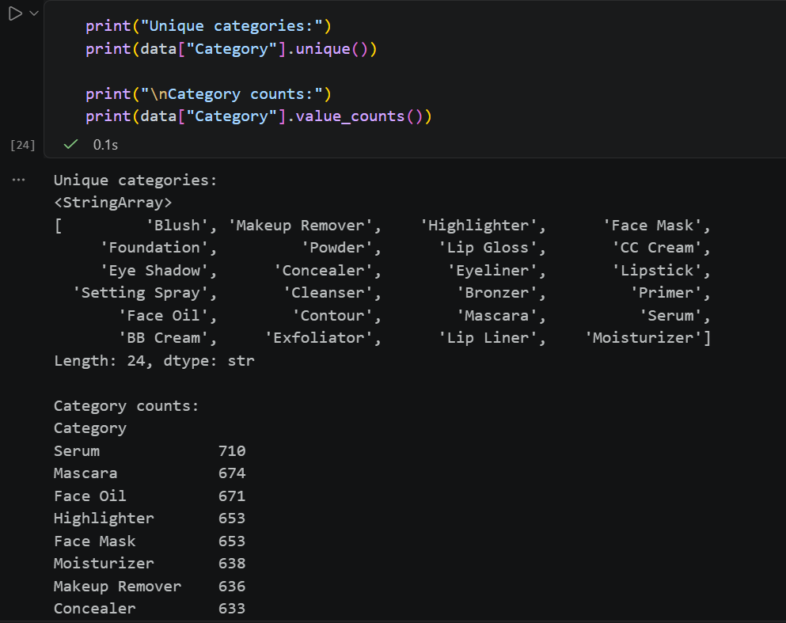
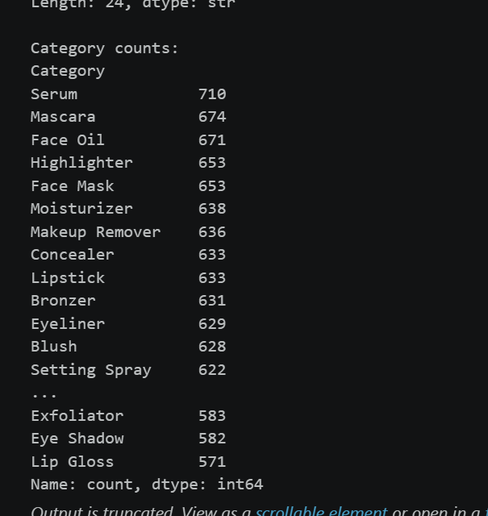

- Investigate unusual values and extreme observations.
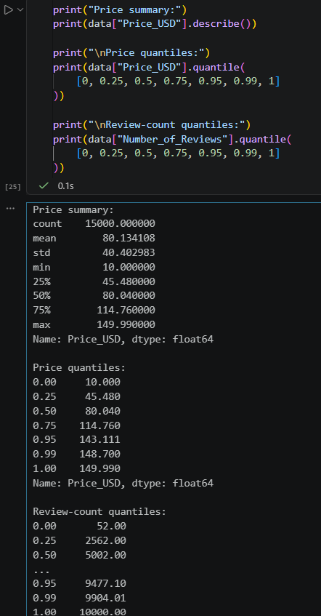
- Review the dataset's documentation and collection methodology.
The quality assessment will distinguish between structural completeness and overall reliability. A dataset may have no missing values but still have unclear provenance, biased sampling, or inaccurate observations.
11. Key Variables and Their Roles
Variable | Type | Analytical purpose
Product_Name | Text | Identifies products
Brand | Categorical | Supports brand comparisons
Category | Categorical | Supports category comparisons
Usage_Frequency | Categorical/text | Provides supplementary product information
Price_USD | Numerical | Supports pricing analysis
Rating | Numerical | Main outcome variable
Number_of_Reviews | Numerical | Measures available review-count activity
Product_Size | Categorical/text | Describes product size
Skin_Type | Categorical | Supports intended skin-type comparisons
Gender_Target | Categorical | Describes target audience
Packaging_Type | Categorical | Describes packaging characteristics
Main_Ingredient | Categorical | Supports ingredient-group analysis
Cruelty_Free | Boolean | Identifies recorded cruelty-free status
Country_of_Origin | Categorical | Supports geographic summaries
The actual definitions and data types will be verified against the dataset documentation and CSV file.
12. Initial Exploratory Analysis Plan
12.1 Descriptive Statistics
Mean, median, standard deviation, quartiles, minimum, maximum, and frequency distributions will be calculated where appropriate.
These measures will summarize the data and identify potential inconsistencies or unusual patterns.
12.2 Category-Level Comparison
Ratings will be summarized by product category.
Visualization: Bar chart of average ratings by category, with product counts.
This will help identify differences in the ratings represented in each category.
12.3 Brand-Level Comparison
Average and median ratings will be calculated for selected brands. Brands with insufficient observations will be treated cautiously.
Visualization: Ranked bar chart of selected brand-level averages.
12.4 Price and Rating Relationship
The association between product price and rating will be investigated using Pearson and Spearman correlation, where appropriate.
Visualization: Scatter plot of price against rating.
12.5 Review Count and Rating Relationship
The relationship between review counts and ratings will be investigated. A logarithmic scale may be considered if review counts are strongly skewed.
Visualization: Scatter plot of review count against rating.
12.6 Skin Type and Rating Comparison
Rating distributions will be compared across intended skin-type categories.
Visualization: Box plot.
ANOVA or Kruskal–Wallis testing may be considered after examining the data and relevant assumptions.
12.7 Ingredient and Rating Comparison
Ratings will be summarized across main-ingredient groups, taking the number of products in each group into account.
Visualization: Horizontal bar chart or box plot.
12.8 Cruelty-Free Status Comparison
Price and rating distributions will be compared between recorded cruelty-free groups.
Visualization: Separate box plots for price and rating.
Suitable statistical tests will be chosen after checking sample sizes and assumptions.
13. Data Cleaning and Preprocessing Plan
The following procedures will be applied when justified by the inspection results.
Missing values: Identify missing observations and select a suitable handling strategy based on the variable and extent of missingness.
Duplicates: Identify exact duplicate rows and investigate possible duplicate products before removing anything.
Data types: Confirm that numerical, categorical, and Boolean fields use appropriate types.
Range validation: Check the expected rating scale, positive prices, and non-negative review counts.
Categorical consistency: Standardize inconsistent labels, spelling, and whitespace where the intended meaning is clear.
Outlier investigation: Use descriptive statistics and visualizations to investigate unusual observations rather than automatically removing them.
Feature preparation: Encode categorical variables and prepare suitable features if predictive modeling is justified.
All transformations will be documented to make the analysis reproducible.
14. Tools and Technologies
The following tools will support the project:
- Python for programming and analysis.
- Pandas for data manipulation and summarization.
- NumPy for numerical operations.
- Matplotlib for plotting.
- Seaborn for statistical visualization.
- Jupyter Notebook for documenting analysis.
- VS Code for project development.
- Microsoft Word for the final report.
- GitHub for optional version control and project sharing.
15. Risks and Limitations
The proposed analysis has several limitations.
First, the reliability of the dataset depends on its original collection method and documentation. Second, product ratings may not be comparable across all categories or brands. Third, the number of reviews is not a direct measure of sales. Fourth, some groups may contain too few observations for meaningful comparisons.
Additional limitations may arise from inconsistent data definitions, unavailable supplementary sources, and differences between datasets.
The project will document these issues and avoid generalizing results beyond what the available evidence supports.
16. Expected Deliverables
The Week 2 task will produce:
- A list of potential data sources with links.
- A comparison of source accessibility, reliability, and relevance.
- A documented justification for the primary dataset.
- A data collection and metadata documentation plan.
- An initial data quality assessment.
- A mapping of research questions to variables.
- A planned set of descriptive statistics and visualizations.
- A statistical analysis and hypothesis-testing strategy.
- A data cleaning and preprocessing plan.
- A structured foundation for the next stage of the project.
17. Conclusion
This report establishes a systematic approach for identifying, evaluating, and preparing data for beauty-product performance analysis.
The selected Kaggle dataset offers a starting point for investigating relationships between product attributes, pricing, ratings, and review counts. Potential alternative sources have also been identified for further assessment.
The proposed workflow combines source evaluation, data-quality checks, descriptive statistics, visualization, and statistical analysis planning. These activities will support transparent and reproducible investigation in subsequent project stages.
The final findings will be interpreted carefully, with attention to dataset limitations and the distinction between association and causation.
References
- Kaggle. Most Used Beauty and Cosmetic Products 2024.
https://www.kaggle.com/datasets/aashitanoah/most-used-beauty-and-cosmetic-products-2024
- Hugging Face Datasets.
https://huggingface.co/datasets
- Google Dataset Search.
https://datasetsearch.research.google.com/
- Open Government Data Platform India.
https://www.data.gov.in/
- Pandas Documentation.
https://pandas.pydata.org/docs/
- NumPy Documentation.
https://numpy.org/doc/
- Matplotlib Documentation.
https://matplotlib.org/stable/
- Seaborn Documentation.
https://seaborn.pydata.org/

