GreenMind AI: A Multi-Metric Forecasting and Decision-Support Platform for Cloud GreenOps
Anonymous Submission Draft — Author affiliations to be inserted for camera-ready submission

Abstract
Modern cloud operations require optimizing resource utilization, cost, and environmental footprint simultaneously. GreenMind AI is an open-source decision-support prototype integrating five one-hour-ahead gradient-boosted forecasters, a five-domain multi-agent analysis engine (Cost, Performance, Sustainability, Security, Reliability), deterministic conflict arbitration, a non-destructive Digital Twin simulator, and an eight-tool explainable AI copilot. Evaluation on a deterministic 60-day synthetic dataset (5,756 records; strict 80/20 chronological split: N_train=4,604, N_test=1,152) shows MAE improvements of 25.4%–45.4% over a one-hour persistence baseline. Our audit reveals the stored rolling baseline reflects a 15-min prediction (not 1-hour); the true four-step rolling baseline yields higher error than persistence (CPU: 7.263% vs. 6.500%) due to diurnal phase shift. All evaluations derive from synthetic generator equations; live remediation is guarded by HTTP 501.
Index Terms: cloud computing; workload forecasting; gradient boosting; carbon-aware computing; multi-agent systems; digital twin; GreenOps.

I. Introduction
Cloud data centers consume a rising share of global electricity, driving GreenOps and FinOps disciplines [4, 6]. Proactive workload forecasting supports right-sizing, autoscaling, and carbon-aware scheduling, but high historical accuracy does not guarantee realized savings or SLO preservation [3, 8]. GreenMind AI addresses these challenges by unifying multi-metric gradient boosted forecasting, five-domain multi-agent orchestration, deterministic conflict resolution, Digital Twin simulation, and an eight-tool AI copilot.
Contributions:
- End-to-end architecture linking telemetry ingestion, multi-metric forecasting, multi-agent arbitration, Digital Twin simulation, and decision-support interfaces.
- Verified forecasting performance on five targets with a baseline alignment audit identifying a 15-min vs. 1-hour horizon discrepancy in the stored rolling baseline.
- Explicit empirical boundaries: synthetic data provenance, unverified live connectors, and the HTTP 501 live-remediation safety guard.

II. Related Work
Calheiros et al. [7] demonstrated ARIMA-based proactive scaling reducing QoS violations. Friedman's Gradient Boosting Machine [1] excels on structured tabular lag features. Rossi et al. [3] showed point forecasts miss operational uncertainty and accuracy degrades under cross-provider transfer. Bergmeir et al. [2] established chronological holdout as standard practice. Henderson et al. [4] and Lannelongue et al. [5] formalized ML carbon reporting. Radovanovic et al. [6] deployed carbon-aware scheduling at Google datacenters. Dodge et al. [8] measured carbon intensity across cloud instance types.

III. Platform Architecture and Implementation
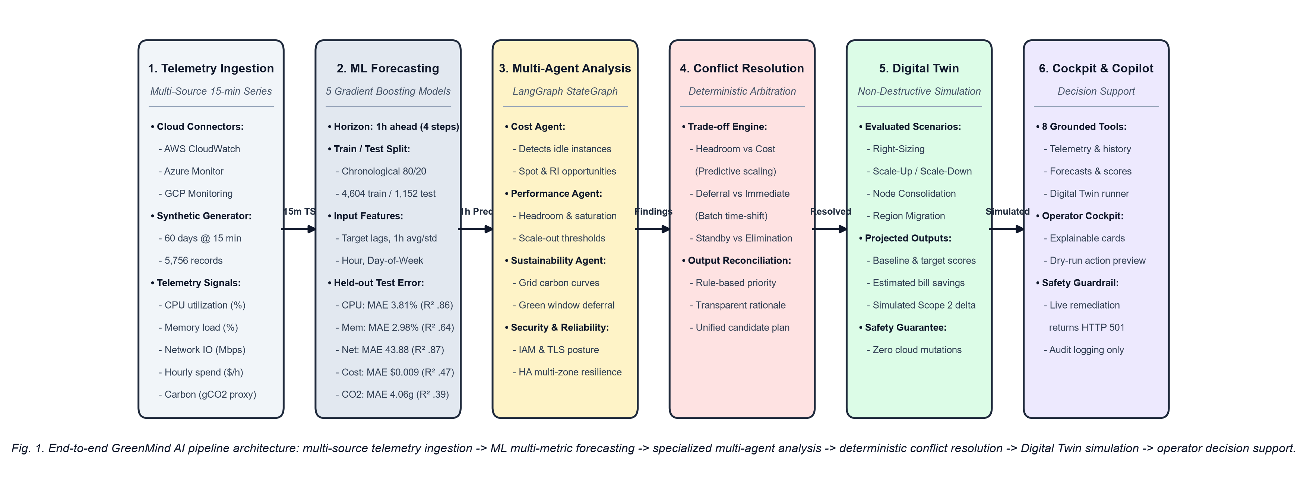
Figure 1. GreenMind AI pipeline: telemetry ingestion → ML forecasting → multi-agent analysis → conflict resolution → Digital Twin → decision support.

A. Telemetry Ingestion
FastAPI (Python 3.12; SQLite/PostgreSQL) ingests five 15-min signals: CPU (%), memory (%), network (Mbps), cost (USD/h), carbon proxy (gCO₂/15-min). AWS CloudWatch (boto3), Azure Monitor REST, GCP Cloud Monitoring v3 — each falls back to synthetic generator when credentials absent.

B. Multi-Metric ML Predictor
Five GradientBoostingRegressor models: 150 estimators, depth 3, lr=0.08, seed 42. Strictly backward-looking features: y_t, hour, day, rolling mean μ_{t,4}, rolling σ_{t,4}. Anomaly detection: z-score > 2.5.

C. Multi-Agent Engine
Five agents in a LangGraph StateGraph: CostAgent (right-sizing, Spot/RI), PerformanceAgent (saturation thresholds), SustainabilityAgent (green windows 01:00–06:00 UTC), SecurityAgent (IAM, TLS, ports), ReliabilityAgent (multi-AZ, backup RPO). Graceful sequential fallback.

D. Conflict Resolution
Three arbitration rules: Performance vs. Cost (right-size + autoscaling, 60-s buffer, conf. 0.88); Reliability vs. Cost (downsize + failover, conf. 0.92); Carbon deferral vs. Execution (green windows, conf. 0.87). Each emits a full audit record.

E. Digital Twin Simulator
Five non-destructive scenarios: Right-Size, Scale-Up/Down, Consolidate, Region Migration. Recomputes Optimization Score (0–100). All outputs: is_simulated=True, 'SIMULATED / ESTIMATED'.

F. AI Copilot
Eight grounded tools grounded in live application state. Non-dry-run and rollback calls return HTTP 501 Not Implemented.

IV. Experimental Methodology

A. Synthetic Dataset
generate_dataset.py: 5,760 observations at 15-min intervals, seed 42. CPU = clip(35 + 30·sin²((h−7)/24·2π)·W_t + τ_t + ε_t, 2, 98). Memory: [0,8]% drift. Network: 300+400·sin²(·) Mbps. Cost: $0.192·(1+cpu/100·0.5).

B. Carbon Target
us-east intensity I(h_t) in 320–470 gCO₂/kWh. C_t = clip(I(h_t)·0.35·0.25 + N(0,25), 0, 500) [gCO₂/15-min]. Excludes PUE, dynamic power states, Scope 3.

C. Split and Baselines
Targets shifted Δ=4 steps; 5,756 aligned records. Chronological 80/20: N_train=4,604, N_test=1,152. Persistence: ŷ_{t+4}=y_t. Stored Roll-4 evaluates ŷ_{t+1}=μ_{t,4} on unshifted data (N=1,148) — a 15-min prediction. True Roll-4 from origin yields higher error than persistence (CPU: 7.263% vs. 6.500%).

V. Experimental Results
Table I reports verified held-out metrics (train.py re-executed; seed 42; 6.4 s wall-clock). Gradient boosting outperforms persistence on all five targets. MAE gains: 25.4% (memory) to 45.4% (network). CPU/network: R²=0.855/0.871.
Table I. Verified Test-Set Metrics (N=1,152). Persistence: ŷ_{t+4}=y_t. Stored Roll-4: repository 1-step MA on unshifted data. True Roll-4: four-step rolling mean from origin t.
Target | MAE | RMSE | R² | Persistence MAE | Stored Roll-4 | True Roll-4 | Gain (%)
CPU Util. (%) | 3.809 | 4.811 | 0.855 | 6.500 | 4.622 | 7.263 | 41.4
Memory Util. (%) | 2.979 | 3.704 | 0.636 | 3.996 | 3.025 | 4.153 | 25.4
Net Traffic (Mbps) | 43.876 | 55.328 | 0.871 | 80.346 | 56.727 | 90.816 | 45.4
Hourly Cost ($/h) | 0.009 | 0.011 | 0.474 | 0.013 | 0.010 | N/A | 29.7
Carbon (gCO₂/15-min) | 4.061 | 5.087 | 0.391 | 5.846 | 4.571 | N/A | 30.5

VI. Discussion and Limitations
High R² reflects recovery of smooth sinusoidal generator formulas, not real-world generalization. Real cluster traces exhibit heavy-tailed distributions, preemptions, and non-stationary shifts [3]. Reported metrics establish synthetic benchmark performance only.

Documented Limitations
- Data provenance: single generator configuration (seed 42, 60-day, us-east).
- Recursive multi-step inconsistency: 5-min steps on 1-h models; carbon output (~30–40 gCO₂/15-min) fed as carbon_intensity (~350–450 gCO₂/kWh) — ~10× mismatch.
- Live connectors: fall back to synthetic data in test environments.
- HTTP 501: all cloud mutations blocked; Digital Twin savings are static projections.
- Carbon proxy: fixed 350 W server, excludes dynamic power states, PUE, Scope 3.

VII. Conclusion
GreenMind AI implements a complete prototype coupling five gradient boosted forecasters with five-domain multi-agent orchestration, deterministic conflict arbitration, Digital Twin simulation, and an eight-tool AI copilot. On a 60-day synthetic benchmark, MAE improves 25.4%–45.4% over persistence. Production validation requires open cluster traces, real-time grid feeds, recursive horizon refactoring, and canary cloud testing.

References
[1] J. H. Friedman, "Greedy function approximation: A gradient boosting machine," Ann. Statistics, vol. 29, no. 5, pp. 1189–1232, 2001. doi: 10.1214/aos/1013203451.
[2] C. Bergmeir, R. J. Hyndman, and B. Koo, "Cross-validation for autoregressive prediction," CSDA, vol. 120, pp. 70–83, 2018. doi: 10.1016/j.csda.2017.11.003.
[3] A. Rossi et al., "Forecasting workload in cloud computing," Cluster Comput., vol. 28, art. 258, 2025. doi: 10.1007/s10586-024-04933-2.
[4] P. Henderson et al., "Reporting energy/carbon footprints of ML," JMLR, vol. 21, no. 248, 2020.
[5] L. Lannelongue et al., "Green algorithms," Adv. Sci., vol. 8, art. 2100707, 2021. doi: 10.1002/advs.202100707.
[6] A. Radovanovic et al., "Carbon-aware computing for datacenters," IEEE Trans. Power Syst., vol. 38, no. 2, pp. 1270–1280, 2023. doi: 10.1109/TPWRS.2022.3173250.
[7] R. N. Calheiros et al., "Workload prediction using ARIMA," IEEE Trans. Cloud Comput., vol. 3, no. 4, pp. 449–458, 2015. doi: 10.1109/TCC.2014.2350475.
[8] J. Dodge et al., "Measuring carbon intensity of AI in cloud instances," in Proc. ACM FAccT 2022, pp. 1536–1546. doi: 10.1145/3531146.3533147.
[9] Pratham-stack-coder, "GreenMind-AI," GitHub, 2026. https://github.com/Pratham-stack-coder/GreenMind-AI.

