**Diwali_Fest** **Walkthrough**

**Hint:** Not every light you see burns outside — some shine within

1. You can see multiple image

1. Select **diwali4.jpeg** use steghide to find **secret.txt**

Password is nothing just enter

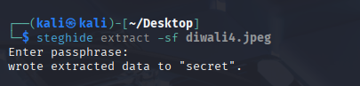

1. Open a secret.txt

1. Use this key with encrypted data

b89WHh1Q24s3uZNk45cFy5le0xc3CEKBzZe4ngI3opNmnBGKXSJXeA==

key: HappyDiwaLi

1. Des encryption see below

Refrence: <https://anycript.com/crypto/des>

FLAG: FORTIX{Happy_Diwali_SuccessFully}