**Lockbox – Walkthrough**

**Hint:** The final lock uses the community’s own handle as its grip.

**Another Hint📝:** in last step you need a key 🔑 to solve it.

**Step 1: decrypt the hex into text format**

**Step 2: decrypt text into rot 13**

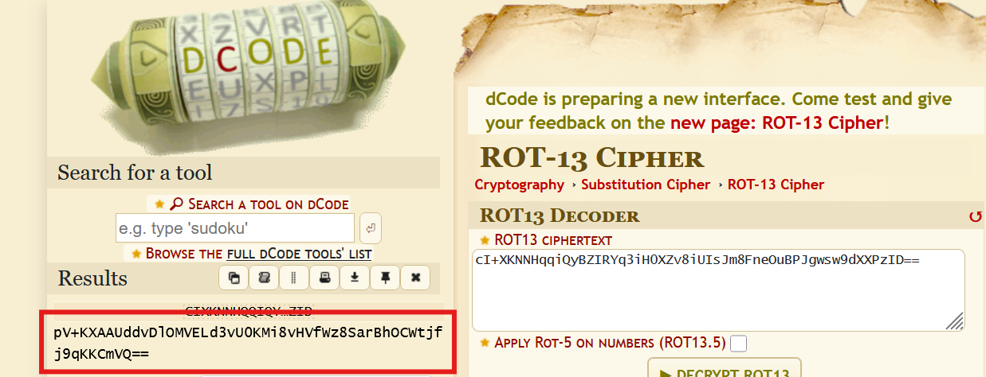

**Step 3: decrypt text into des encryption with key**

**Reference link:** <https://anycript.com/crypto/des> , <https://encode-decode.com/des-encrypt-online/>

Key is: fortixaisecurity

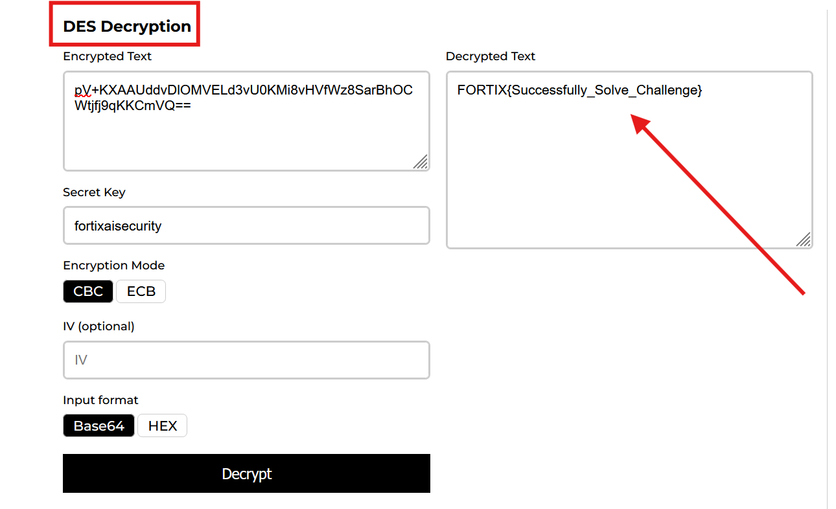

**Flag: FORTIX{Successfully_Solve_Challenge}**