**LAB5**

Q1. Write a Java program that reads a string from the user and uses StringTokenizer to split the string into individual words. Print each word on a new line.

Code-

package demo1;

import java.util.Scanner;

import java.util.StringTokenizer;

public class StringSplitter {

public static void main(String[] args) {

// Create a Scanner object to read input from the user

Scanner scanner = new Scanner(System.***in***);

// Prompt the user to enter a string

System.***out***.println("Enter a string:");

// Read the input string from the user

String inputString = scanner.nextLine();

// Create a StringTokenizer object to split the string into words

StringTokenizer tokenizer = new StringTokenizer(inputString);

// Print each word on a new line

while (tokenizer.hasMoreTokens()) {

String word = tokenizer.nextToken();

System.***out***.println(word);

}

// Close the scanner

scanner.close();

}

}

Output-

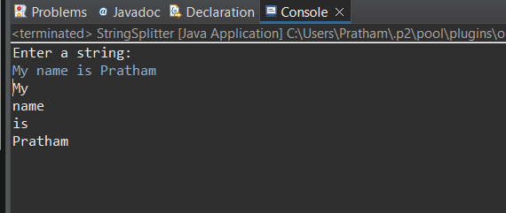

Q2.Write a Java program that reads a string from the user and uses StringTokenizer to count the number of words in the string.

Code-

package demo1;

import java.util.Scanner;

import java.util.StringTokenizer;

public class WordCounder {

public static void main(String[] args) {

// Create a Scanner object to read input from the user

Scanner scanner = new Scanner(System.***in***);

// Prompt the user to enter a string

System.***out***.println("Enter a string:");

// Read the input string from the user

String inputString = scanner.nextLine();

// Create a StringTokenizer object to split the string into words

StringTokenizer tokenizer = new StringTokenizer(inputString);

// Initialize a counter for the words

int wordCount = 0;

// Count the number of words

while (tokenizer.hasMoreTokens()) {

tokenizer.nextToken();

wordCount++;

}

// Print the number of words

System.***out***.println("Number of words: " + wordCount);

// Close the scanner

scanner.close();

}

}

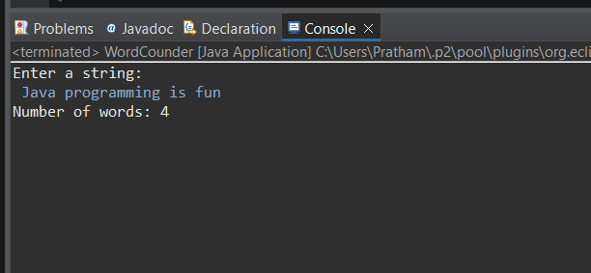Output

Q3. Write a Java program to create a LinkedList of strings, add elements at specific positions (beginning, middle, end), and print the list.

Code-

package demo1;

import java.util.LinkedList;

public class LinkedListdemo {

public static void main(String[] args) {

// Create a LinkedList of strings

LinkedList<String> list = new LinkedList<>();

list.add("End");// add to the end

list.addFirst("Beginning");// add to the beginning

// Add an element to the middle

// Assuming "middle" is index 1 for a 3-element list

list.add(1, "Middle");

// Print the LinkedList

System.***out***.println("LinkedList elements : ");

for (String element : list) {

System.***out***.println(element);

}

}

}

Output-

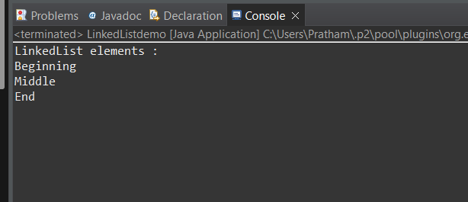

Q4. Write a Java program to sort a given array list.

Code-

package demo1;

import java.util.ArrayList;

import java.util.Collections;

public class SortArrayList {

public static void main(String[] args) {

ArrayList<String> list=new ArrayList<>();

// Add elements to the ArrayList

list.add("Banana");

list.add("Apple");

list.add("Mango");

list.add("Cherry");

list.add("Date");

// Print the ArrayList before sorting

System.***out***.println("ArrayList before Sorting : ");

for(String element :list )

{

System.***out***.println(element);

}

// Sort the ArrayList

Collections.*sort*(list);

// Print the ArrayList after sorting

System.***out***.println("\nArrayList after sorting:");

for (String element : list) {

System.***out***.println(element);

}

}

}

Output-

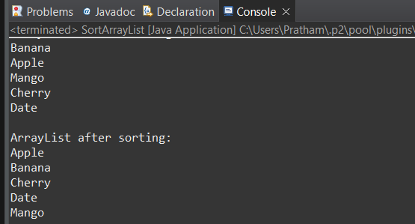

Q5. Write a Java program to replace the second element of an ArrayList with the specified element.

CODE-

package demo1;

import java.util.ArrayList;

public class ReplaceElement {

public static void main(String[] args) {

ArrayList<String> list = new ArrayList<>();

// Add elements to the ArrayList

list.add("PRATHAM");

list.add("ATHARVA");

list.add("ADITI");

list.add("PRACHIT");

list.add("MANGESH");

System.***out***.println("ArrayList before replacement : ");

for (String element : list) {

System.***out***.println(element);

}

// Replace the second element (index 1) with the specified element

String newElement = "AKASH";

list.set(1, newElement);

// Print the ArrayList after replacement

System.***out***.println("\nArrayList after replacement:");

for (String element : list) {

System.***out***.println(element);

}

}

}

Output-

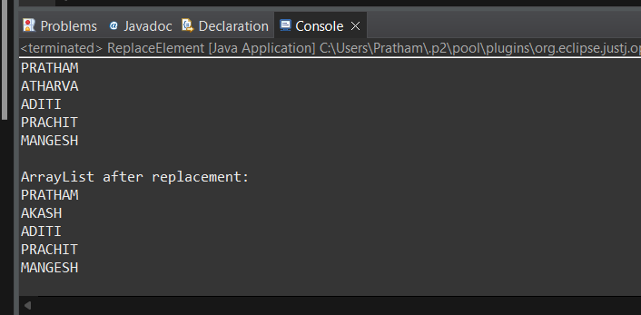

Q6. Write a Java program to iterate a linked list in reverse order.

Code-

package demo1;

import java.util.LinkedList;

import java.util.ListIterator;

public class ReverseLinkedList {

public static void main(String[] args) {

LinkedList<String> list = new LinkedList<>();

// Add elements to the LinkedList

list.add("PRATHAM");

list.add("ATHARVA");

list.add("ADITI");

list.add("PRACHIT");

list.add("MANGESH");

System.***out***.println("LinkedList element :");

for (String element : list) {

System.***out***.println(element);

}

// Iterate the LinkedList in reverse order

System.***out***.println("\nLinkedList elements in reverse order:");

ListIterator<String> iterator = list.listIterator(list.size());

while (iterator.hasPrevious()) {

System.***out***.println(iterator.previous());

}

}

}

OUTPUT—

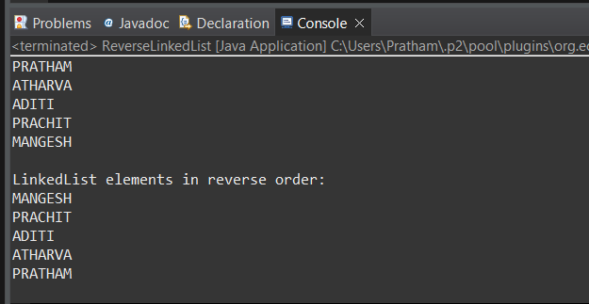

Q7. Write a Java program to retrieve, but not remove, the last element of a linked list.

CODE-

package demo1;

import java.util.LinkedList;

public class RetrieveLastElement {

public static void main(String[] args) {

// Create a LinkedList of strings

LinkedList<String> list = new LinkedList<>();

// Add elements to the LinkedList

list.add("Dog");

list.add("Rat");

list.add("Cat");

list.add("Bat");

// Retrieve, but do not remove, the last element

String lastElement = list.peekLast();

// Print the last element

System.***out***.println("The last element is: " + lastElement);

// Print the LinkedList to show it has not been modified

System.***out***.println("LinkedList elements:");

for (String element : list) {

System.***out***.println(element);

}

}

}

Output-

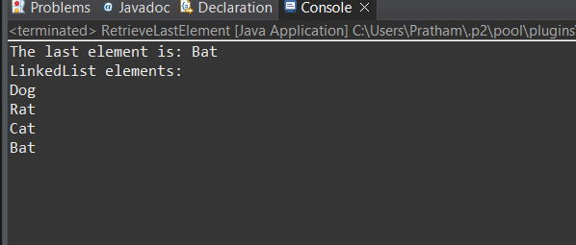

Q8. Write a Java program to create a LinkedList of integers and print all the elements.

Code-

package demo1;

import java.util.LinkedList;

public class LinkedListOfIntegers {

public static void main(String[] args) {

LinkedList<Integer> list = new LinkedList<>();

// Add elements to the LinkedList

list.add(10);

list.add(20);

list.add(30);

list.add(40);

list.add(50);

// Print the LinkedList elements

System.***out***.println("LinkedList elements : ");

for (Integer element : list) {

System.***out***.println(element);

}

}

}

Output-

