**Customer Relationship for Students**

**A PROJECT REPORT**

***Submitted by***

**Pratham Buddhadev – 92110133003**

***In partial fulfillment for IWT (01CT0408) Project***

**Sem – 4th**

**DEGREE ENGINEERING**

***in***

**Information and Communication Technology Engineering**



**Faculty of Technology**

**Marwadi University, Rajkot**

**Contents**

**Abstract II**

**List of Tables III**

**List of Figures IV**

1. **Introduction 2**
   1. Document purpose 2
   2. Product scope 2
   3. Intended audience and document overview 2
   4. Definitions and abbreviations 2
   5. Document conventions 2
   6. References and acknowledgments 3
2. **Overall description 4**
   1. Product perspective 4
   2. Product functionality 4
   3. Users and characteristics 4
   4. Operating environment 4
   5. Design and implementation constraints 5
   6. User documentation 5
   7. Assumptions and dependencies 5
3. **Specific requirements 6**
   1. External interface requirements 6
   2. Functional requirements 7
   3. Behavior requirements 7
4. **Other non-functional requirements 8**
   1. Performance requirements 8
   2. Safety and security requirements 8
   3. Software quality attributes 8
5. **Other requirements** **9**

**Appendix A – Data Dictionary 11**

**Appendix B – Plagiarism Report 12**

**Appendix C – User Manual**  **15**

**Abstract**

**Creative Project:** Customer Relationship Management

**Student:** Pratham Buddhadev

**Degree:** Information Communication and Technology

**College:** Marwadi University

**Date:** 02-04-2022

My project title is Customer Relationship Management (CRM) System. This project is how useful for college that I will try to describe. If any new student come to college for inquiry about admission to any professor that professor has store his/her data in CRM Web application. Professor can use that data from CRM web application at any place and time by using Internet.

There are two different kinds of login procedures: 1) The administrator user 2) Another person (Other login user) who has logged in.

The HOD of the ICT department is the admin user, while the other login users are our department's professors. HOD can read, store, and download data in excel sheets because he is the admin user. Professors in the department who are the other login users, on the other hand, can just save the data.

**List of Figure**

Figure 2.1 Use case...............................................................................................................................7

Figure 1 ER Diagram.............................................................................................................................V

Figure 2 Class diagram.........................................................................................................................VI

Figure 3 Activity Diagram...................................................................................................................VII

Figure 4 Sequence Diagram...............................................................................................................VIII

ER Diagram: -

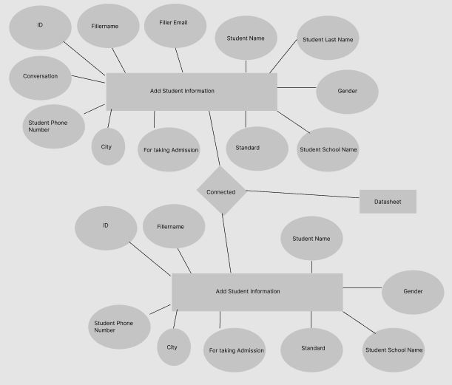

Class Diagram: -

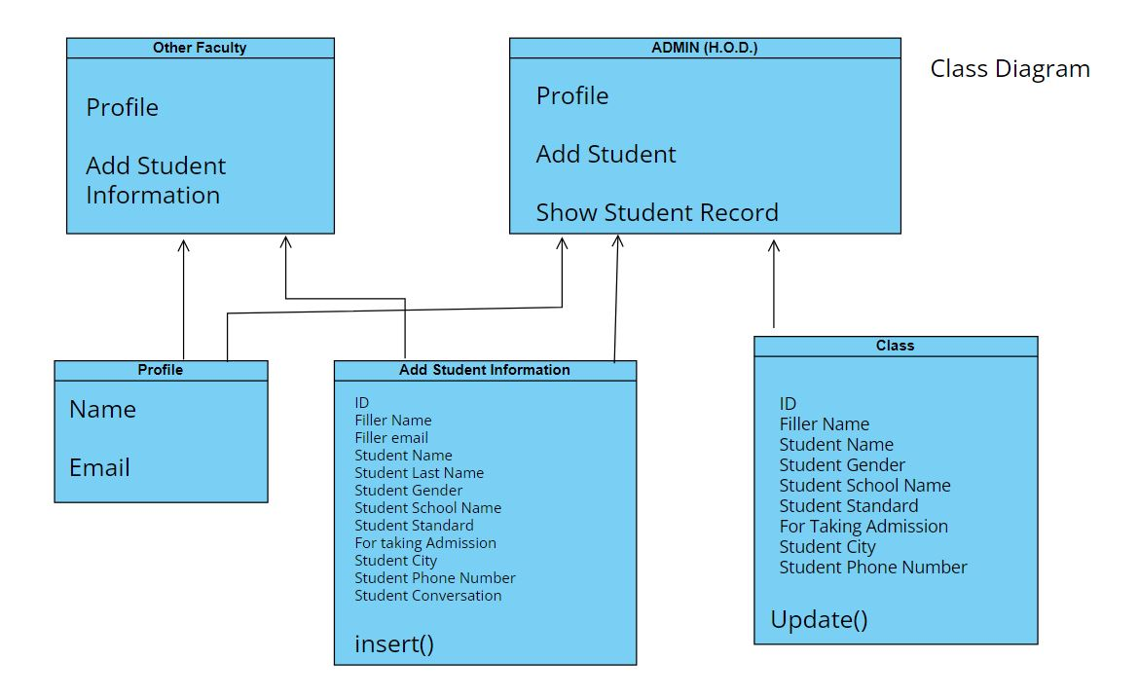

Activity Diagram: -

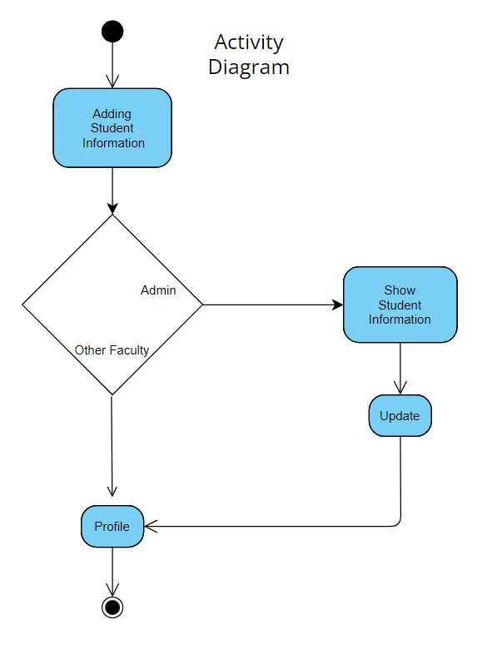

Sequence Diagram: -

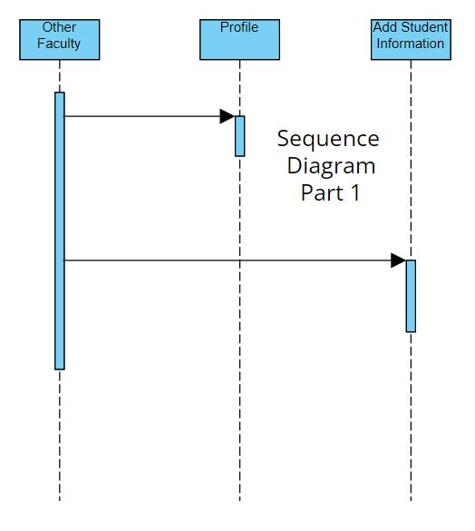

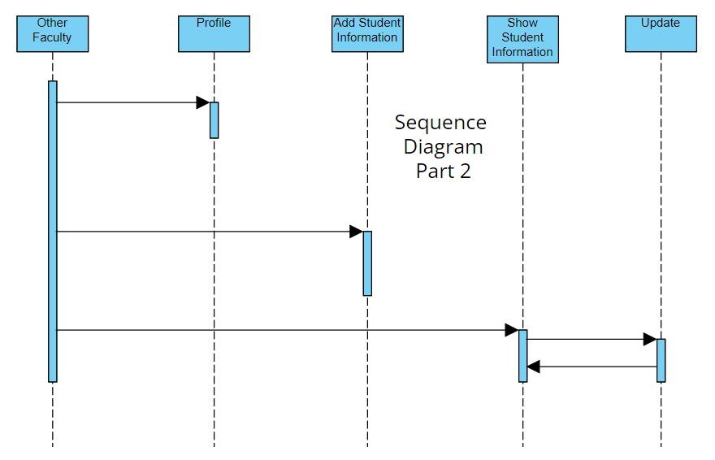

1. **Introduction**

## Document Purpose

Customer Relationship Management (CRM) for Students is the title of my project. In this project I attempt to describe the usefulness of the CRM for ICT department of Marwadi University. A higher education CRM is a software which is specifically tailored for the education industry to manage the whole process from inquiry to enrollment to alumni and beyond. For example, if a new students visit the college and enquires the professor about admission, the professor will store the student’s information in the CRM Web Application. H.O.D. can access, store or download data from CRM web apps from any location and at any time over the Internet. Although there are many micro processes handled by CRM, the most important ones are the applicant and inquiry management, student communication, analytics, and reporting.

## Product Scope

Majority of Higher learning institutions are adopting and implementing CRM software systems to help attract, retain and serve their clients (students) in the best way possible. With a CRM platform in place, it is quite easy to manage the complete student lifecycle all from a single platform. This will include the students’ academic documents, course & program they are admitted, full details of batch and roll number among other information necessary to facilitate the admission process. In this regard, a higher institution of learning is capable of identifying and recruiting the best candidates, engaging them and more importantly improving enrollment results for the institution.

## Intended Audience and Document Overview

With CRM for our department, it is easier to make follow up for all inquiries, keeping a proper record of the interactions with the students during counselling process, and maintaining an appropriate follow-up. The web application will also help to enhance communication between the department and the inquiring student.

## Document Conventions

Use Times New Roman font size 11 throughout the document for text. Document text should be single spaced and maintain the 1” margins found in this document. For Section and Subsection titles Use Times New Roman font size 14 and font are bold throughout the document for titles.

1. **Overall Description**

## Product Perspective

A CRM system allows only HOD of ICT department to access all student data rather quickly and seamlessly, including that of prospects, current students and alumni. This is a significant benefit brought along with the help of a CRM system so that all student records are readily available. This way, it is possible for the department to maintain better relationships with current and prospective students, as well as the graduates.

## Product Functionality

The major functions this product should perform are as follows:

* Allow other faculties and H.O.D. to add Students data.
* Allow H.O.D. to send mail to any student which is in record.
* Allow H.O.D. to send WhatsApp message to any student which is in record.
* Allow H.O.D. to send mail to anyone.
* Allow Other faculties and H.O.D. to see their own profile.
* Allow Other Faculties and H.O.D. to sign in with the Google Authentication.

## Users and Characteristics

The System is designed keeping two types of users: **1)** Admin (H.O.D.), **2)** Other Faculties

1. Admin (H.O.D.): Admin can sign in with the Google Authentication. Admin can insert the student data. Admin can view student list and his/her details. Admin can WhatsApp the students. Admin can mail the students.
2. Other Faculties: Other Faculties can sign in with the Google Authentication. Other Faculties can insert the student data.

## Operating Environment

Operating environment for the CRM for Students is as follows:

1. Operating System: Windows operating System that supports browsing
2. Database: MySQL, PhpMyAdmin
3. Front-end: HTML, CSS
4. Programming Language: PHP, JavaScript
5. Framework: Bootstrap

## Design and Implementation Constraints

The constraints while designing or implementing the system is as follows:

* Need internet connectivity for website to run fine.
* Admin and Other user can directly sign in with their email via Google Authentication.
* Information of Admin and Other user should be stored in database such that it can be accessible from anywhere when required.
* Software can only operate in English language so all users need to have that fundamental.
* Software can only run-in windows operating system.
* SQL commands for making things run, stored and processed in backend.
* Implementing database such that it is centralized database management system.
* Admin and Other user can store student data in database.
* Admin can only see the Student Information.
* Admin can WhatsApp the Student.
* Admin can Mail the Student.

## Assumptions and Dependencies

* Basic assumption made is that users can read and understand English.
* Users have smart devices (e.g.: Mobile, Laptop, etc.) those supports browsing and have internet connectivity.
* Users have basic knowledge of how do website drives through various modules and switch over them when required.
* External sources like MYSQL servers are there at admin side for storage.

1. **Specific Requirements**

## External Interface Requirements

### User Interfaces

**1)**

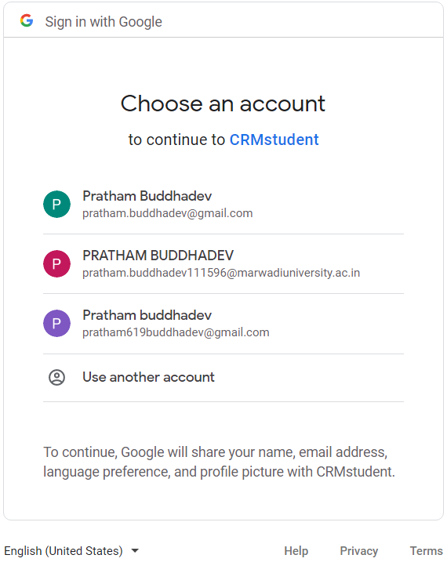

*There are two types of users Admin and Other user. Right now, Admin email id is* [*pratham.buddhadev111596@marwadiuniversity.ac.in*](mailto:pratham.buddhadev111596@marwadiuniversity.ac.in) *and Other user id is* [*pratham619buddhadev@gmail.com*](mailto:pratham619buddhadev@gmail.com) *. Both users can directly sign in via Google Authentication.*

**2)**

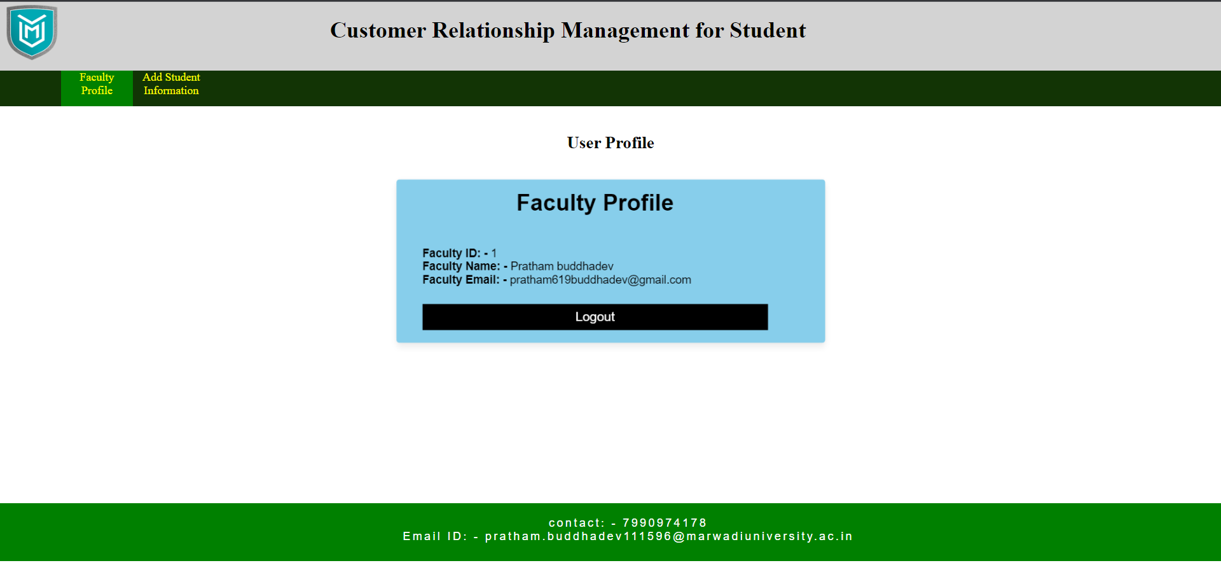This is an other user” Profile Page” where other user can see profile.

***3)***

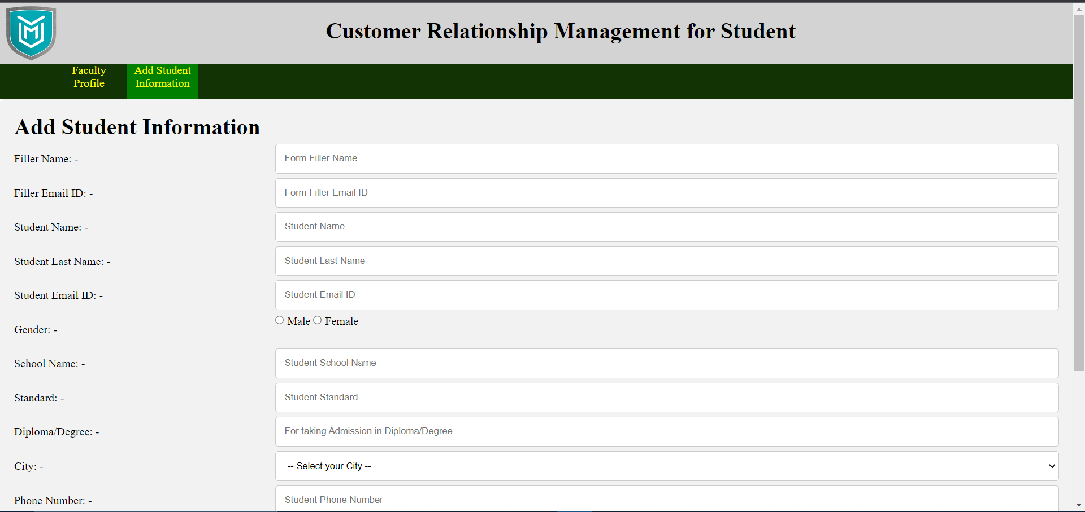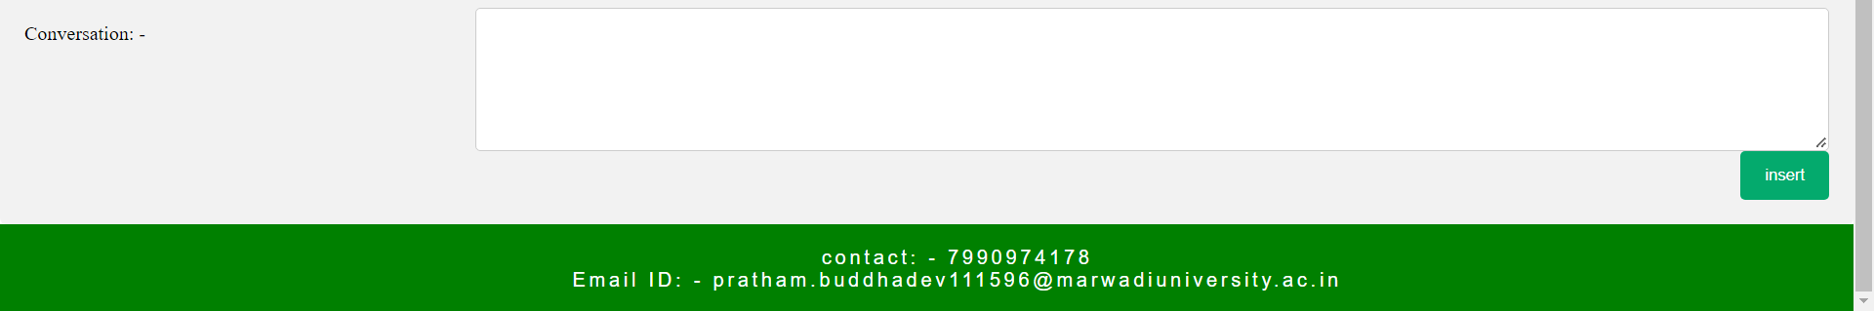*Above picture is a “Add Student Information” page where other user can insert student data in database.*

***4)***

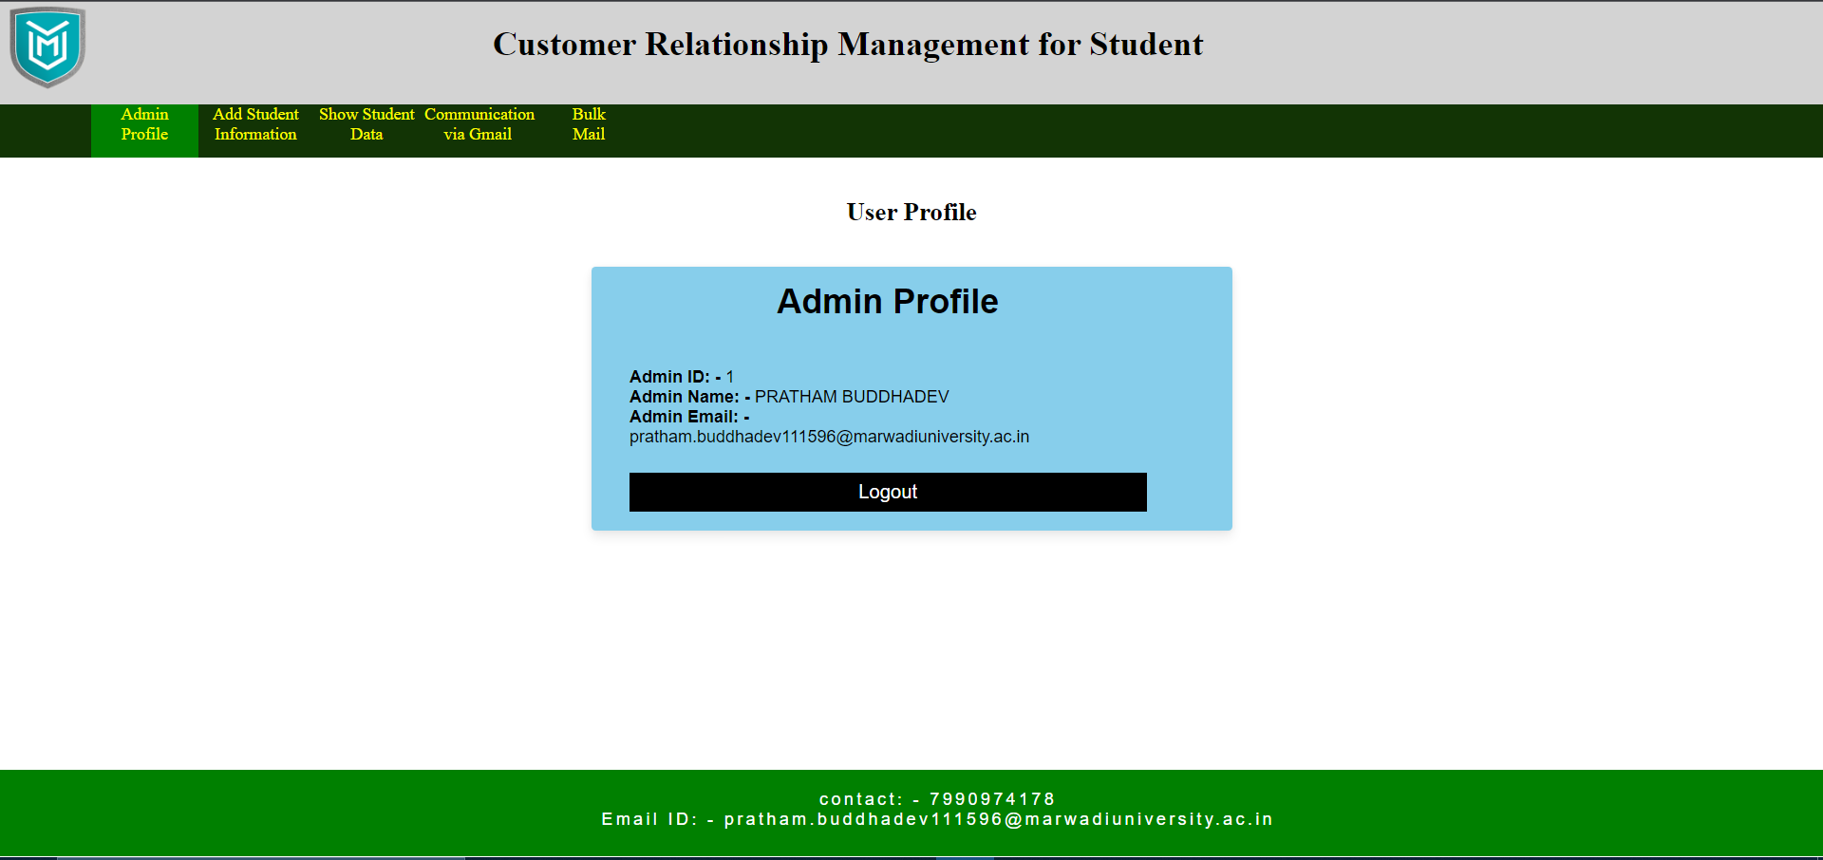*This is an Admin Profile where Admin can see profile.*

***5)***

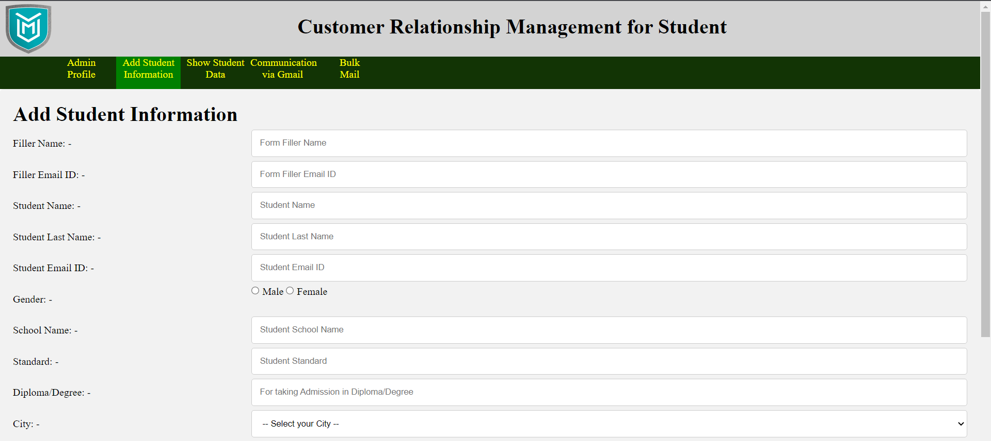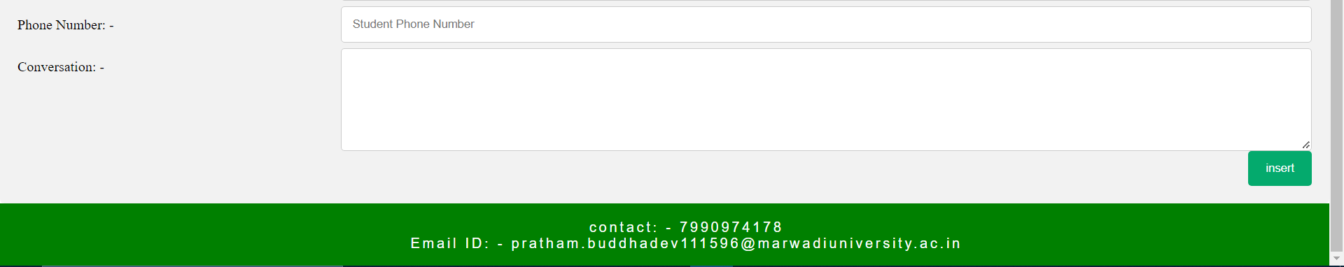*Above picture is a” Add Student Information” page where admin can insert student data.*

***6)***

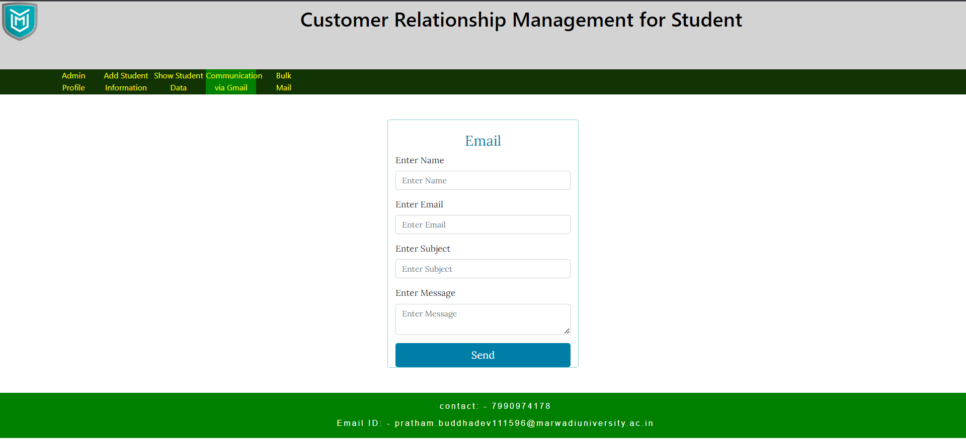

*Above picture is where admin can mail anyone.*

***7)***

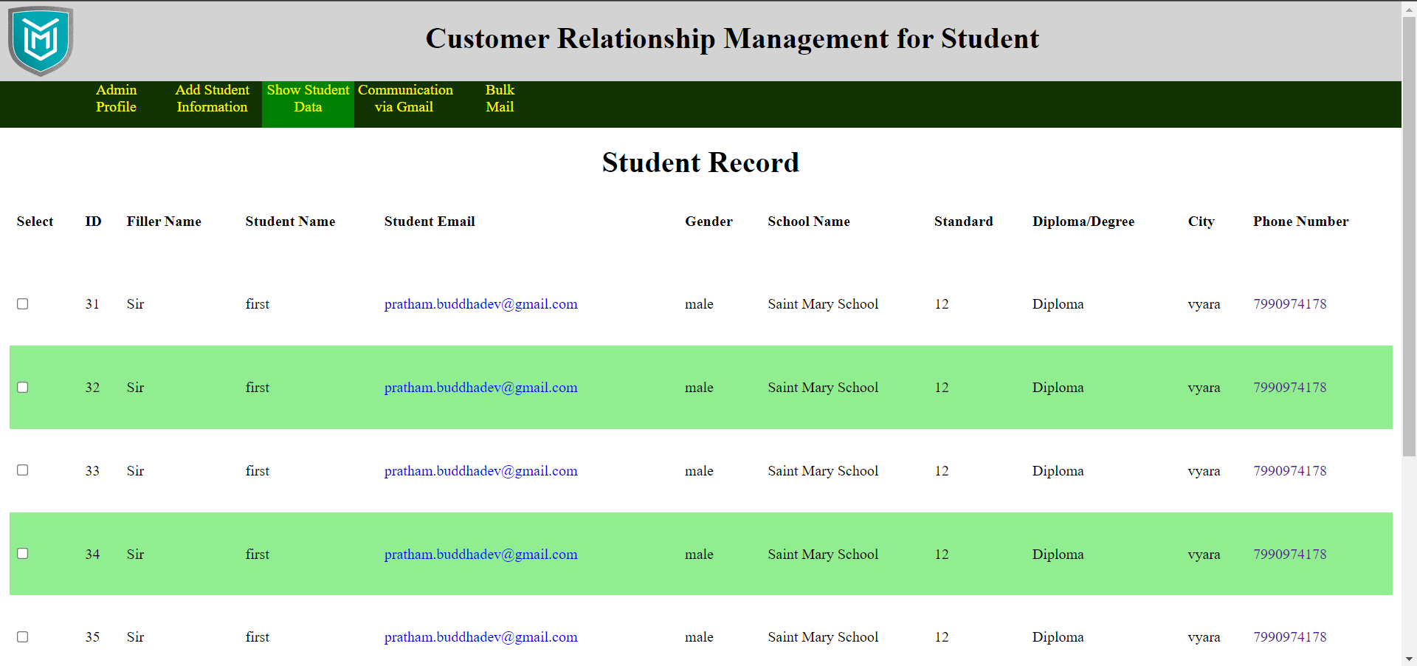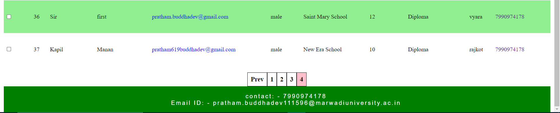*Above picture is an all-student data. Admin can only see this student data. From the student data there are two types of communications where Admin can communicate with the students. There are two types of communications are as follows:*

1. *Student Email*
2. *Phone Number*

*1) Student Email: - By click on any student email id Admin can mail to that particular student.*

*2) Phone Number: - By click on any student Phone Number Admin can WhatsApp to that particular student.*

***8)***

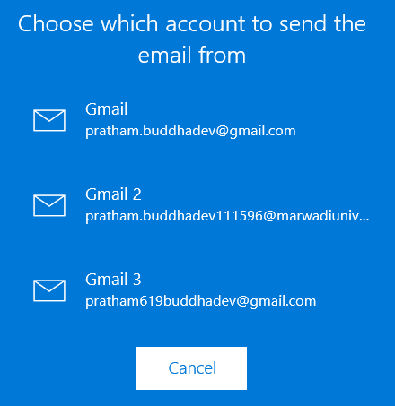

*Admin can choose from which email id he/she want to mail to student.*

***9)***

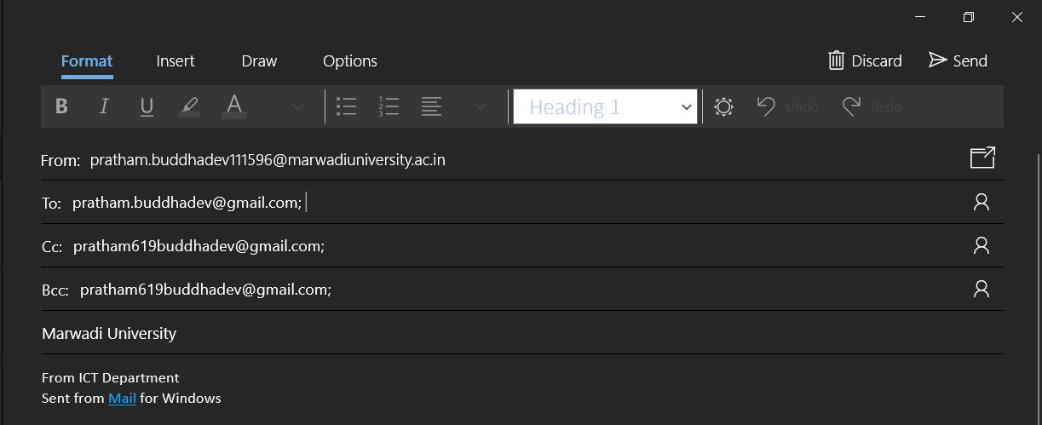*Automatically fill all components as per written code. Just Admin has to click on send button.*

***10)***

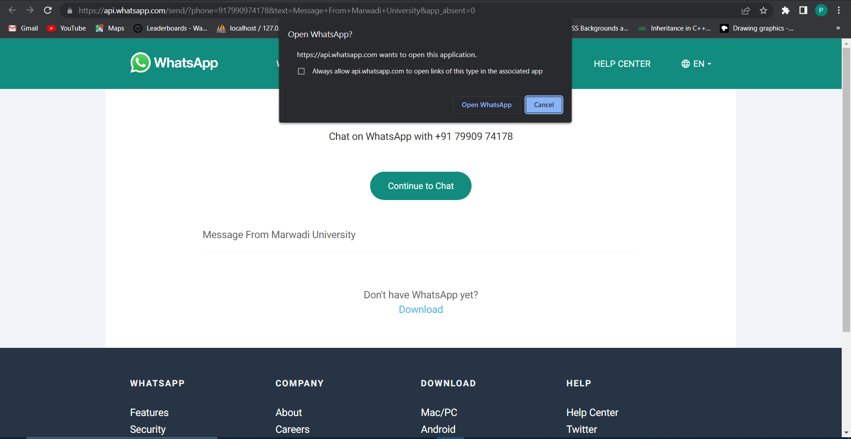*After clicking on student phone number admin come to this page where admin have an option to choose where admin want to use WhatsApp Web or WhatsApp Application.*

*Admin can use any from on that.*

***11)***

*After clicking on WhatsApp Application or WhatsApp Web message will print as per the written code and Admin can WhatsApp with that particular person.*

***12)***

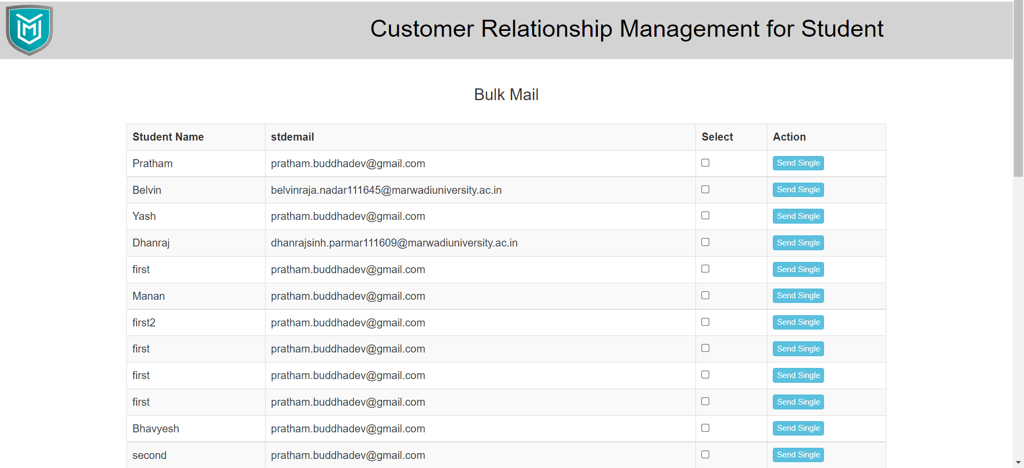 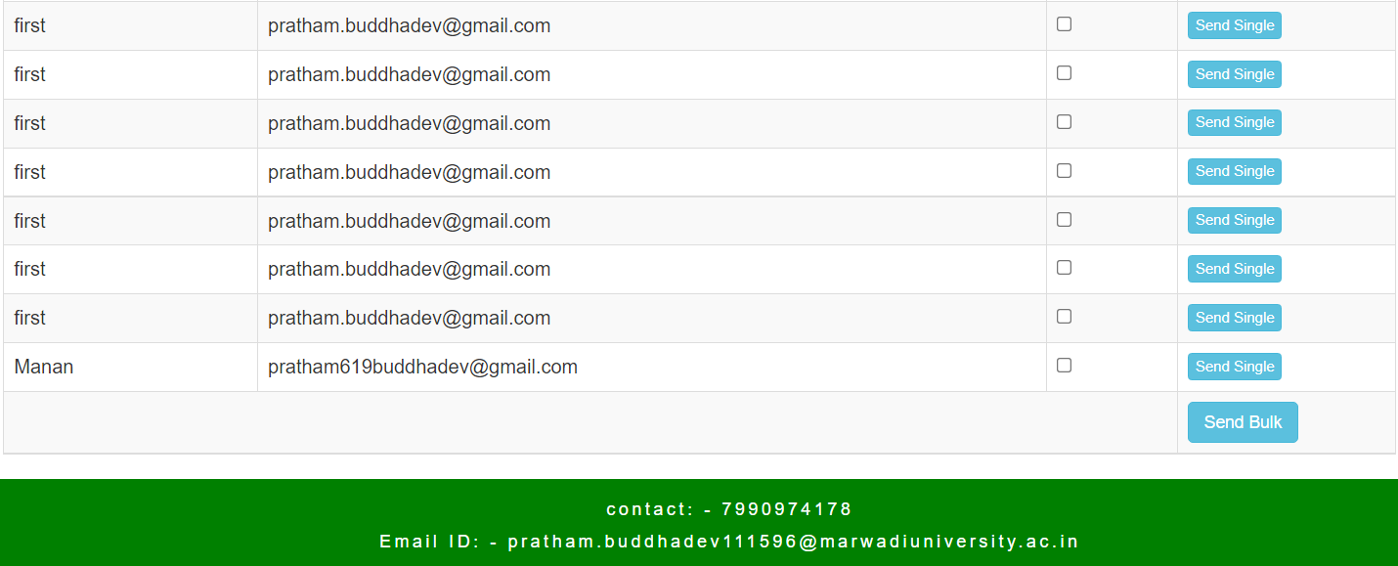

*From this Bulk mail page Admin can send mail all of them by clicking on all checkbox and send a bulk mail.*

### Hardware Interfaces

PC must have Windows Operating System. Should have browser with internet connectivity and can support HTML, JavaScript and CSS. Input devices like Keyboard and Mouse are needed if working with PC, can also work with tablet or smart phones.

### Software Interfaces

Scripting Language: HTML, CSS, Javascript

Front End: PHP

Back End: MySQL

Software: XAMPP V3.2.4

Server: Apache Server

Operating System: Windows

### Communications Interfaces

The Project supports all types of web browser (chrome or Mozilla Firefox or any other).

## Behaviour Requirements

### Use Case View

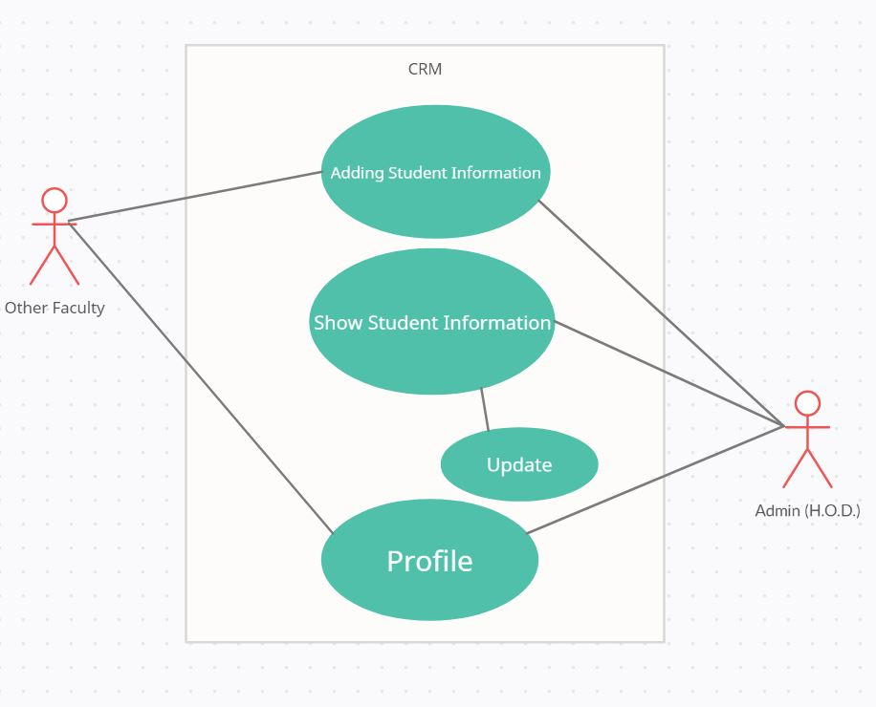

1. **Other Non-functional Requirements**

## Performance Requirements

The website should be functional for whole day (24 hours a day) so that user interaction can be done at any moment of time.

## Safety and Security Requirements

The database should be maintained by the admin so that no chaos results. There should be prevention from the fake ID cannot sign in via Google Authentication.

* Database should be kept secured.
* Admin and Other user data stored in database and no other one can see data.
* Other user email id and admin email id should be confidential and their corresponding details.

## Software Quality Attributes

The System should be reliable, should be scalable (means should support to store large number of students data), should be able to run in any of the supporting machine.

1. **Other Requirements**

# Appendix I: Glossary

SRS: It is for Software Requirements Specification.

HTML: Hyper-text Markup Language.

CSS: Cascading Style Sheets.

IEEE: Institute of Electrical and Electronics Engineers.

# Appendix II: Analysis Models

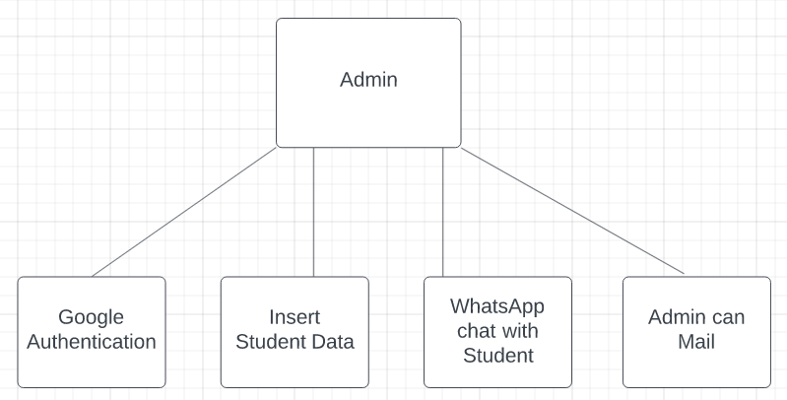

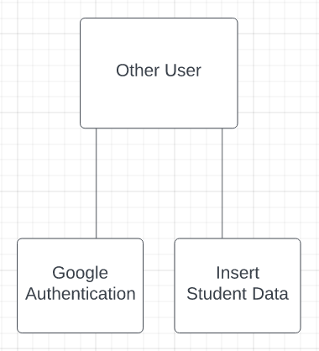

**Appendix A – Data Dictionary**

|  |  |  |
| --- | --- | --- |
| ***Key*** | ***Type*** | ***Constrain*** |
| *ID* | *INT* | *Not Null* |
| *Filler Name* | *String* | *Not Null* |
| *Filler Email ID* | *String* | *Not Null* |
| *Student Name* | *String* | *Not Null* |
| *Student Last Name* | *String* | *Not Null* |
| *Gender* | *String* | *Not Null* |
| *School Name* | *String* | *Not Null* |
| *Standard* | *String* | *Not Null* |
| *Degree/Diploma* | *String* | *Not Null* |
| *City* | *String* | *Not Null* |
| *Phone Number* | *String* | *Not Null* |
| *Conversation* | *String* | *Not Null* |

**Appendix B – Plagiarism Report**

