BRACT’s
Vishwakarma Institute of Technology, Pune
Practical Implementation Sheet
Department: CSE-AI Semester: 5 Academic Year: 2026-27
Division: E Batch: 3 Practical No: 7 g
Roll no:2 PRN No:12413751 Name of Student:Prathmesh Sandeep Horne
Subject Name : Deep Learning
BERT for Sentiment Analysis on IMDB Movie Reviews

Transfer Learning for Cats vs Dogs Image Classification

Problem Statement :
Implement transfer learning for Cats vs Dogs image classification using four pretrained CNN architectures: AlexNet, VGG16, ResNet50 and EfficientNetB0. Train and evaluate each model, then compare their accuracy, loss and training performance.

Algorithm :
- Install and import the required libraries (PyTorch, torchvision, Hugging Face datasets, pandas, matplotlib) and select the GPU if available.
- Load the Cats vs Dogs dataset from Hugging Face, take a random sample of 3,000 images and split it into 2,000 training and 1,000 validation images.
- Preprocess the images: resize to 224 × 224, apply random horizontal flip (training only), convert to tensors and normalize with ImageNet mean and standard deviation. Create DataLoaders with batch size 32.
- For each model (AlexNet, VGG16, ResNet50, EfficientNetB0): load ImageNet pretrained weights, freeze all convolutional layers and replace the final layer with a new 2-class (cat / dog) linear layer.
- Train only the new final layer using the Adam optimizer (learning rate 1e-3) and cross-entropy loss for 5 epochs, using mixed precision on the GPU.
- After every epoch, calculate training and validation loss and accuracy. Record the total training time of each model.
- Collect the results of all four models into a comparison table and plot accuracy and loss curves, training time and best validation accuracy.
- Compare the models and identify the best one based on accuracy, loss and training time.

Code :
# ---- Cell 1 ----
!pip install -q datasets
# ---- Cell 2 ----
import time
import torch, torch.nn as nn, torch.optim as optim
from torchvision import transforms, models
from torch.utils.data import DataLoader, Dataset
from datasets import load_dataset
import matplotlib.pyplot as plt
import pandas as pd

device = torch.device("cuda" if torch.cuda.is_available() else "cpu")
print("Using device:", device)

EPOCHS = 5 # increase for better accuracy
BATCH_SIZE = 32
LR = 1e-3
# ---- Cell 3 ----
# Load Cats vs Dogs from Hugging Face (3,000-image sample keeps training fast)
raw = load_dataset("microsoft/cats_vs_dogs", split="train").shuffle(seed=42).select(range(3000))
split = raw.train_test_split(test_size=1000, seed=42)

norm = transforms.Normalize([0.485, 0.456, 0.406], [0.229, 0.224, 0.225])
train_tf = transforms.Compose([
transforms.Resize((224, 224)),
transforms.RandomHorizontalFlip(),
transforms.ToTensor(), norm])
val_tf = transforms.Compose([
transforms.Resize((224, 224)),
transforms.ToTensor(), norm])

class HFImages(Dataset):
def __init__(self, ds, tf):
self.ds, self.tf = ds, tf
def __len__(self):
return len(self.ds)
def __getitem__(self, i):
row = self.ds[i]
return self.tf(row["image"].convert("RGB")), row["labels"]

train_ds = HFImages(split["train"], train_tf)
val_ds = HFImages(split["test"], val_tf)
train_dl = DataLoader(train_ds, BATCH_SIZE, shuffle=True, num_workers=2, pin_memory=True)
val_dl = DataLoader(val_ds, BATCH_SIZE, shuffle=False, num_workers=2, pin_memory=True)

print(len(train_ds), "train /", len(val_ds), "val images")
# ---- Cell 4 ----
def build_model(name):
if name == "AlexNet":
m = models.alexnet(weights=models.AlexNet_Weights.DEFAULT)
for p in m.parameters(): p.requires_grad = False
m.classifier[6] = nn.Linear(4096, 2)
elif name == "VGG16":
m = models.vgg16(weights=models.VGG16_Weights.DEFAULT)
for p in m.parameters(): p.requires_grad = False
m.classifier[6] = nn.Linear(4096, 2)
elif name == "ResNet50":
m = models.resnet50(weights=models.ResNet50_Weights.DEFAULT)
for p in m.parameters(): p.requires_grad = False
m.fc = nn.Linear(2048, 2)
elif name == "EfficientNetB0":
m = models.efficientnet_b0(weights=models.EfficientNet_B0_Weights.DEFAULT)
for p in m.parameters(): p.requires_grad = False
m.classifier[1] = nn.Linear(1280, 2)
return m.to(device) # new head is trainable by default
# ---- Cell 5 ----
def run_epoch(model, loader, criterion, optimizer=None):
train = optimizer is not None
model.train(train)
# keep frozen BatchNorm layers in eval mode for stable transfer learning
if train:
for mod in model.modules():
if isinstance(mod, nn.BatchNorm2d): mod.eval()
total_loss, correct, n = 0.0, 0, 0
with torch.set_grad_enabled(train):
for x, y in loader:
x, y = x.to(device, non_blocking=True), y.to(device, non_blocking=True)
with torch.autocast(device_type=device.type, enabled=device.type == "cuda"):
out = model(x)
loss = criterion(out, y)
if train:
optimizer.zero_grad()
loss.backward()
optimizer.step()
total_loss += loss.item() * x.size(0)
correct += (out.argmax(1) == y).sum().item()
n += x.size(0)
return total_loss / n, correct / n

def train_model(name):
model = build_model(name)
trainable = sum(p.numel() for p in model.parameters() if p.requires_grad)
criterion = nn.CrossEntropyLoss()
optimizer = optim.Adam(filter(lambda p: p.requires_grad, model.parameters()), lr=LR)
hist = {"train_loss": [], "val_loss": [], "train_acc": [], "val_acc": []}
best_acc, start = 0, time.time()
for ep in range(EPOCHS):
tl, ta = run_epoch(model, train_dl, criterion, optimizer)
vl, va = run_epoch(model, val_dl, criterion)
for k, v in zip(hist, [tl, vl, ta, va]): hist[k].append(v)
best_acc = max(best_acc, va)
print(f"{name} | epoch {ep+1}/{EPOCHS} | train loss {tl:.4f} acc {ta:.4f} | val loss {vl:.4f} acc {va:.4f}")
hist["time"] = time.time() - start
hist["trainable"] = trainable
hist["best_val_acc"] = best_acc
return hist
# ---- Cell 6 ----
results = {}
for name in ["AlexNet", "VGG16", "ResNet50", "EfficientNetB0"]:
print(f"\n===== {name} =====")
results[name] = train_model(name)
torch.cuda.empty_cache()
# ---- Cell 7 ----
summary = pd.DataFrame({
name: {
"Final Train Acc": h["train_acc"][-1],
"Final Val Acc": h["val_acc"][-1],
"Best Val Acc": h["best_val_acc"],
"Final Train Loss": h["train_loss"][-1],
"Final Val Loss": h["val_loss"][-1],
"Training Time (s)": h["time"],
"Trainable Params": h["trainable"],
} for name, h in results.items()
}).T.round(4)
summary
# ---- Cell 8 ----
fig, ax = plt.subplots(2, 2, figsize=(13, 9))
for name, h in results.items():
ep = range(1, EPOCHS + 1)
ax[0, 0].plot(ep, h["train_acc"], marker="o", label=name)
ax[0, 1].plot(ep, h["val_acc"], marker="o", label=name)
ax[1, 0].plot(ep, h["train_loss"], marker="o", label=name)
ax[1, 1].plot(ep, h["val_loss"], marker="o", label=name)
for a, t in zip(ax.flat, ["Train Accuracy", "Validation Accuracy", "Train Loss", "Validation Loss"]):
a.set_title(t); a.set_xlabel("Epoch"); a.grid(alpha=.3); a.legend()
plt.tight_layout(); plt.show()

fig, ax = plt.subplots(1, 2, figsize=(11, 4))
summary["Training Time (s)"].plot.bar(ax=ax[0], color="tab:orange", title="Training Time (s)")
summary["Best Val Acc"].plot.bar(ax=ax[1], color="tab:green", title="Best Validation Accuracy", ylim=(0.8, 1))
plt.tight_layout(); plt.show()

Output :
1. Dataset and device
Using device: cuda
2000 train / 1000 val images
2. Training log (5 epochs per model)
Model | Epoch | Train Loss | Train Acc | Val Loss | Val Acc
AlexNet | 1/5 | 0.1935 | 0.9210 | 0.1284 | 0.9450
AlexNet | 2/5 | 0.0924 | 0.9630 | 0.1271 | 0.9500
AlexNet | 3/5 | 0.0810 | 0.9705 | 0.1265 | 0.9500
AlexNet | 4/5 | 0.0565 | 0.9805 | 0.1371 | 0.9460
AlexNet | 5/5 | 0.0418 | 0.9845 | 0.1193 | 0.9560
VGG16 | 1/5 | 0.0791 | 0.9725 | 0.0330 | 0.9880
VGG16 | 2/5 | 0.0338 | 0.9875 | 0.0386 | 0.9870
VGG16 | 3/5 | 0.0272 | 0.9905 | 0.0357 | 0.9870
VGG16 | 4/5 | 0.0176 | 0.9920 | 0.0285 | 0.9870
VGG16 | 5/5 | 0.0171 | 0.9940 | 0.0308 | 0.9900
ResNet50 | 1/5 | 0.1841 | 0.9725 | 0.0653 | 0.9920
ResNet50 | 2/5 | 0.0442 | 0.9945 | 0.0416 | 0.9920
ResNet50 | 3/5 | 0.0278 | 0.9945 | 0.0315 | 0.9920
ResNet50 | 4/5 | 0.0194 | 0.9990 | 0.0252 | 0.9940
ResNet50 | 5/5 | 0.0144 | 0.9990 | 0.0221 | 0.9940
EfficientNetB0 | 1/5 | 0.1822 | 0.9480 | 0.0567 | 0.9930
EfficientNetB0 | 2/5 | 0.0518 | 0.9900 | 0.0361 | 0.9940
EfficientNetB0 | 3/5 | 0.0361 | 0.9925 | 0.0289 | 0.9950
EfficientNetB0 | 4/5 | 0.0278 | 0.9945 | 0.0250 | 0.9950
EfficientNetB0 | 5/5 | 0.0228 | 0.9950 | 0.0222 | 0.9940
3. Model comparison table
Model | Final Train Acc | Final Val Acc | Best Val Acc | Final Train Loss | Final Val Loss | Time (s) | Trainable Params
AlexNet | 0.9845 | 0.9560 | 0.9560 | 0.0418 | 0.1193 | 54.65 | 8,194
VGG16 | 0.9940 | 0.9900 | 0.9900 | 0.0171 | 0.0308 | 61.70 | 8,194
ResNet50 | 0.9990 | 0.9940 | 0.9940 | 0.0144 | 0.0221 | 57.16 | 4,098
EfficientNetB0 | 0.9950 | 0.9940 | 0.9950 | 0.0228 | 0.0222 | 57.11 | 2,562
4. Accuracy and loss curves
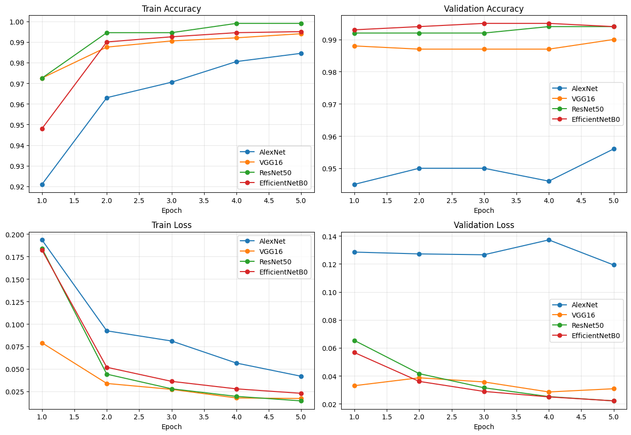
5. Training time and best validation accuracy
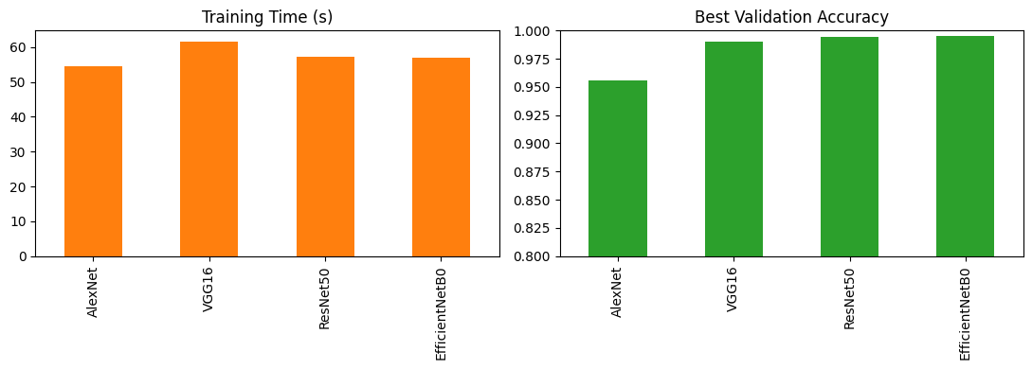
6. Result analysis
- EfficientNetB0 achieved the highest best validation accuracy (99.5%), closely followed by ResNet50 (99.4%) and VGG16 (99.0%).
- AlexNet performed lowest, with 95.6% validation accuracy and the highest validation loss (0.1193).
- ResNet50 and EfficientNetB0 had the lowest validation loss (about 0.022), showing the best generalization.
- Training times were similar (55–62 s) because only the final layer was trained. VGG16 was slightly slowest (61.7 s) and AlexNet slightly fastest (54.7 s).
- Conclusion: ResNet50 and EfficientNetB0 give the best balance of accuracy and loss for this task; EfficientNetB0 does so with the fewest trainable parameters.

