BRACT’s
Vishwakarma Institute of Technology, Pune
Practical Implementation Sheet
Department: CSE-AI Semester: 5 Academic Year: 2026-27
Division: E Batch: 3 Practical No: 9
Roll no:2 PRN No:12413751 Name of StudentPrathmesh Sandeep Horne
Subject Name : Deep Learning

Image Classification using a Pre-trained Vision Transformer (ViT) and Comparison with a CNN

Problem Statement :
Perform image classification using a pre-trained Vision Transformer (ViT) model and compare its performance with a CNN model.
Dataset used: CIFAR-10 (60,000 colour images of 32 × 32 pixels in 10 classes), loaded with torchvision. Models used: pre-trained ViT-B/16 and pre-trained ResNet50 (CNN), both trained on ImageNet.

Algorithm :
- Import the required libraries (PyTorch, torchvision, scikit-learn, pandas, matplotlib, seaborn) and select the GPU if available.
- Load the CIFAR-10 dataset with torchvision (downloaded automatically). Take a random subset of 5,000 training images and 2,000 test images to keep training fast.
- Preprocess the images: resize from 32 × 32 to 224 × 224 (the input size of the pre-trained models), apply a random horizontal flip (training only), convert to tensors and normalize with the ImageNet mean and standard deviation. Create DataLoaders with batch size 64.
- Visualize the data: class distribution of the training subset and sample images.
- Load the pre-trained ViT-B/16 (a Transformer that splits the image into 16 × 16 patches and processes them with self-attention) and the pre-trained ResNet50 (a convolutional network with residual connections), both with ImageNet weights.
- Freeze all pre-trained layers of both models and replace the final layer with a new 10-class linear layer (transfer learning).
- Train only the new final layer of each model with the Adam optimizer (learning rate 1e-3) and cross-entropy loss for 3 epochs, using mixed precision on the GPU.
- After every epoch, calculate the training and test loss and accuracy; record the total training time.
- Evaluate both models on the test set: accuracy, precision, recall, F1-score, classification report and confusion matrix.
- Measure the inference time per image of each model and count the total and trainable parameters.
- Compare ViT and CNN in a table and with plots (accuracy and loss curves, training time, inference time) and show sample predictions of both models.
- Conclude which model performs best and discuss the trade-offs.

Code :
# ---- Cell 1 ----
import time, random
import numpy as np
import pandas as pd
import matplotlib.pyplot as plt
import seaborn as sns
import torch, torch.nn as nn, torch.optim as optim
from torch.utils.data import DataLoader, Subset
from torchvision import datasets, transforms, models
from sklearn.metrics import accuracy_score, precision_recall_fscore_support, confusion_matrix, classification_report

SEED = 42
random.seed(SEED); np.random.seed(SEED); torch.manual_seed(SEED)

device = torch.device("cuda" if torch.cuda.is_available() else "cpu")
print("Using device:", device)

# ---- Settings (increase for higher accuracy) ----
TRAIN_SIZE = 5000 # images used for training (out of 50,000)
TEST_SIZE = 2000 # images used for testing (out of 10,000)
EPOCHS = 3
BATCH_SIZE = 64
LR = 1e-3
# ---- Cell 2 ----
# CIFAR-10 is downloaded automatically (about 170 MB) and images are resized to 224 x 224
norm = transforms.Normalize([0.485, 0.456, 0.406], [0.229, 0.224, 0.225])
train_tf = transforms.Compose([transforms.Resize(224), transforms.RandomHorizontalFlip(), transforms.ToTensor(), norm])
test_tf = transforms.Compose([transforms.Resize(224), transforms.ToTensor(), norm])

full_train = datasets.CIFAR10(root="./data", train=True, download=True, transform=train_tf)
full_test = datasets.CIFAR10(root="./data", train=False, download=True, transform=test_tf)

# Random subsets keep training fast
g = torch.Generator().manual_seed(SEED)
train_idx = torch.randperm(len(full_train), generator=g)[:TRAIN_SIZE].tolist()
test_idx = torch.randperm(len(full_test), generator=g)[:TEST_SIZE.].tolist()
train_ds, test_ds = Subset(full_train, train_idx), Subset(full_test, test_idx)

train_dl = DataLoader(train_ds, BATCH_SIZE, shuffle=True, num_workers=2, pin_memory=True)
test_dl = DataLoader(test_ds, BATCH_SIZE, shuffle=False, num_workers=2, pin_memory=True)

classes = full_train.classes
print("Classes:", classes)
print(f"Full dataset: {len(full_train)} train / {len(full_test)} test images (32 x 32 RGB)")
print(f"Used here : {len(train_ds)} train / {len(test_ds)} test images (resized to 224 x 224)")
# ---- Cell 3 ----
inv_mean = torch.tensor([0.485, 0.456, 0.406]).view(3, 1, 1)
inv_std = torch.tensor([0.229, 0.224, 0.225]).view(3, 1, 1)
def show_img(t):
return (t.cpu() * inv_std + inv_mean).clamp(0, 1).permute(1, 2, 0).numpy()

# class distribution of the training subset
labels = [full_train.targets[i] for i in train_idx]
counts = np.bincount(labels, minlength=10)
plt.figure(figsize=(8, 3.5))
plt.bar(classes, counts, color="tab:blue")
plt.title("Class distribution (training subset)")
plt.xticks(rotation=45); plt.ylabel("Images")
plt.tight_layout(); plt.show()

# sample images
x, y = next(iter(train_dl))
fig, axes = plt.subplots(2, 6, figsize=(12, 4.5))
for ax, img, lab in zip(axes.flat, x, y):
ax.imshow(show_img(img)); ax.set_title(classes[lab]); ax.axis("off")
plt.tight_layout(); plt.show()
# ---- Cell 4 ----
def build_model(name):
if name == "ViT-B/16":
m = models.vit_b_16(weights=models.ViT_B_16_Weights.IMAGENET1K_V1)
for p in m.parameters(): p.requires_grad = False
m.heads.head = nn.Linear(768, 10) # new classification head
elif name == "ResNet50 (CNN)":
m = models.resnet50(weights=models.ResNet50_Weights.IMAGENET1K_V2)
for p in m.parameters(): p.requires_grad = False
m.fc = nn.Linear(2048, 10) # new classification head
return m.to(device)

for n in ["ViT-B/16", "ResNet50 (CNN)"]:
m = build_model(n)
total = sum(p.numel() for p in m.parameters())
trainable = sum(p.numel() for p in m.parameters() if p.requires_grad)
print(f"{n:16s} total params: {total:,} | trainable params: {trainable:,}")
del m
# ---- Cell 5 ----
use_cuda = device.type == "cuda"

def run_epoch(model, loader, criterion, optimizer=None, scaler=None):
train = optimizer is not None
model.train(train)
if train: # keep frozen BatchNorm layers (ResNet) in eval mode
for mod in model.modules():
if isinstance(mod, nn.BatchNorm2d): mod.eval()
total_loss, correct, n = 0.0, 0, 0
with torch.set_grad_enabled(train):
for x, y in loader:
x, y = x.to(device, non_blocking=True), y.to(device, non_blocking=True)
with torch.autocast(device_type=device.type, enabled=use_cuda):
out = model(x)
loss = criterion(out, y)
if train:
optimizer.zero_grad()
scaler.scale(loss).backward()
scaler.step(optimizer)
scaler.update()
total_loss += loss.item() * x.size(0)
correct += (out.argmax(1) == y).sum().item()
n += x.size(0)
return total_loss / n, correct / n

def train_model(name):
model = build_model(name)
criterion = nn.CrossEntropyLoss()
optimizer = optim.Adam(filter(lambda p: p.requires_grad, model.parameters()), lr=LR)
scaler = torch.amp.GradScaler("cuda", enabled=use_cuda)
hist = {"train_loss": [], "train_acc": [], "test_loss": [], "test_acc": []}
start = time.time()
for ep in range(EPOCHS):
tl, ta = run_epoch(model, train_dl, criterion, optimizer, scaler)
vl, va = run_epoch(model, test_dl, criterion)
for k, v in zip(hist, [tl, ta, vl, va]): hist[k].append(v)
print(f"{name} | epoch {ep+1}/{EPOCHS} | train loss {tl:.4f} acc {ta:.4f} | test loss {vl:.4f} acc {va:.4f}")
hist["train_time"] = time.time() - start
return model, hist
# ---- Cell 6 ----
models_trained, history = {}, {}
for name in ["ViT-B/16", "ResNet50 (CNN)"]:
print(f"\n===== {name} =====")
models_trained[name], history[name] = train_model(name)
torch.cuda.empty_cache()
# ---- Cell 7 ----
@torch.no_grad()
def predict(model, loader):
model.eval()
ys, ps, elapsed = [], [], 0.0
for x, y in loader:
x = x.to(device, non_blocking=True)
if use_cuda: torch.cuda.synchronize()
start = time.time() # time only the model's forward pass
with torch.autocast(device_type=device.type, enabled=use_cuda):
out = model(x)
if use_cuda: torch.cuda.synchronize()
elapsed += time.time() - start
ps.append(out.argmax(1).cpu()); ys.append(y)
return torch.cat(ys).numpy(), torch.cat(ps).numpy(), elapsed

preds = {}
for name, model in models_trained.items():
y_true, y_pred, t = predict(model, test_dl)
preds[name] = (y_true, y_pred, t)
print(f"\n===== {name} =====")
print(f"Test accuracy: {accuracy_score(y_true, y_pred):.4f}")
print(classification_report(y_true, y_pred, target_names=classes, digits=3))
# ---- Cell 8 ----
fig, axes = plt.subplots(1, 2, figsize=(15, 6))
for ax, (name, (y_true, y_pred, _)) in zip(axes, preds.items()):
cm = confusion_matrix(y_true, y_pred)
sns.heatmap(cm, annot=True, fmt="d", cmap="Blues", xticklabels=classes, yticklabels=classes, ax=ax, cbar=False)
ax.set_title(f"Confusion Matrix: {name}")
ax.set_xlabel("Predicted"); ax.set_ylabel("Actual")
ax.tick_params(axis="x", rotation=45)
plt.tight_layout(); plt.show()
# ---- Cell 9 ----
rows = {}
for name in models_trained:
y_true, y_pred, t = preds[name]
p, r, f1, _ = precision_recall_fscore_support(y_true, y_pred, average="macro", zero_division=0)
m = models_trained[name]
rows[name] = {
"Test Accuracy": accuracy_score(y_true, y_pred),
"Test Loss": history[name]["test_loss"][-1],
"Precision (macro)": p, "Recall (macro)": r, "F1 (macro)": f1,
"Training Time (s)": history[name]["train_time"],
"Inference Time (ms/image)": 1000 * t / len(y_true),
"Total Params (M)": sum(q.numel() for q in m.parameters()) / 1e6,
"Trainable Params": sum(q.numel() for q in m.parameters() if q.requires_grad),
}
comparison = pd.DataFrame(rows).T
comparison.round(4)
# ---- Cell 10 ----
ep = range(1, EPOCHS + 1)
fig, ax = plt.subplots(2, 2, figsize=(12, 8))
for name, h in history.items():
ax[0, 0].plot(ep, h["train_acc"], marker="o", label=name)
ax[0, 1].plot(ep, h["test_acc"], marker="o", label=name)
ax[1, 0].plot(ep, h["train_loss"], marker="o", label=name)
ax[1, 1].plot(ep, h["test_loss"], marker="o", label=name)
for a, t in zip(ax.flat, ["Train Accuracy", "Test Accuracy", "Train Loss", "Test Loss"]):
a.set_title(t); a.set_xlabel("Epoch"); a.grid(alpha=.3); a.legend()
a.set_xticks(list(ep))
plt.tight_layout(); plt.show()

fig, ax = plt.subplots(1, 3, figsize=(14, 3.8))
comparison["Test Accuracy"].plot.bar(ax=ax[0], color=["tab:blue", "tab:orange"], title="Test Accuracy", rot=0)
comparison["Training Time (s)"].plot.bar(ax=ax[1], color=["tab:blue", "tab:orange"], title="Training Time (s)", rot=0)
comparison["Inference Time (ms/image)"].plot.bar(ax=ax[2], color=["tab:blue", "tab:orange"], title="Inference Time (ms/image)", rot=0)
plt.tight_layout(); plt.show()
# ---- Cell 11 ----
# Sample predictions of both models on the same test images
x, y = next(iter(test_dl))
x_gpu = x[:8].to(device)
out = {}
for name, model in models_trained.items():
model.eval()
with torch.no_grad(), torch.autocast(device_type=device.type, enabled=use_cuda):
out[name] = model(x_gpu).argmax(1).cpu()

fig, axes = plt.subplots(1, 8, figsize=(16, 3.2))
for i, ax in enumerate(axes):
ax.imshow(show_img(x[i])); ax.axis("off")
ax.set_title(f"True: {classes[y[i]]}\nViT: {classes[out['ViT-B/16'][i]]}\nCNN: {classes[out['ResNet50 (CNN)'][i]]}", fontsize=8)
plt.tight_layout(); plt.show()
# ---- Cell 12 ----
best = comparison["Test Accuracy"].idxmax()
print(f"Best model by test accuracy: {best} ({comparison.loc[best, 'Test Accuracy']:.4f})")
faster = comparison["Inference Time (ms/image)"].idxmin()
print(f"Fastest at inference: {faster} ({comparison.loc[faster, 'Inference Time (ms/image)']:.2f} ms/image)")

Output :
1. Device and dataset details
Using device: cuda
Classes: ['airplane', 'automobile', 'bird', 'cat', 'deer', 'dog', 'frog', 'horse', 'ship', 'truck']
Full dataset: 50000 train / 10000 test images (32 x 32 RGB)
Used here : 5000 train / 2000 test images (resized to 224 x 224)
2. Class distribution of the training subset
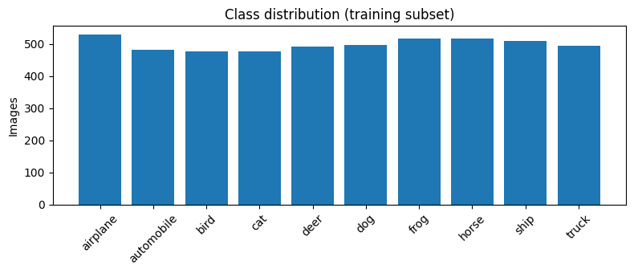
3. Sample training images
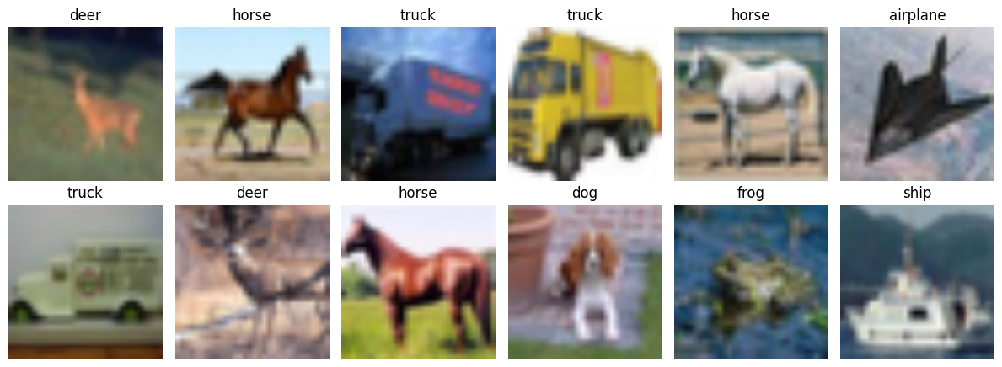
4. Total and trainable parameters
ViT-B/16 total params: 85,806,346 | trainable params: 7,690
ResNet50 (CNN) total params: 23,528,522 | trainable params: 20,490
5. Training log (3 epochs per model)
Model | Epoch | Train Loss | Train Acc | Test Loss | Test Acc
ViT-B/16 | 1/3 | 0.6475 | 0.8546 | 0.2628 | 0.9320
ViT-B/16 | 2/3 | 0.2125 | 0.9428 | 0.2121 | 0.9370
ViT-B/16 | 3/3 | 0.1673 | 0.9536 | 0.1922 | 0.9400
ResNet50 (CNN) | 1/3 | 1.1233 | 0.7472 | 0.6267 | 0.8490
ResNet50 (CNN) | 2/3 | 0.5050 | 0.8734 | 0.4533 | 0.8705
ResNet50 (CNN) | 3/3 | 0.3759 | 0.9020 | 0.3912 | 0.8860
6. Test accuracy and classification reports
ViT-B/16 Test accuracy: 0.9400
ResNet50 (CNN) Test accuracy: 0.8860
Class | ViT P | ViT R | ViT F1 | CNN P | CNN R | CNN F1 | Support
airplane | 0.951 | 0.964 | 0.957 | 0.897 | 0.910 | 0.903 | 221
automobile | 0.977 | 0.968 | 0.973 | 0.972 | 0.928 | 0.949 | 222
bird | 0.938 | 0.938 | 0.938 | 0.872 | 0.836 | 0.853 | 195
cat | 0.903 | 0.903 | 0.903 | 0.800 | 0.816 | 0.808 | 206
deer | 0.895 | 0.885 | 0.890 | 0.850 | 0.854 | 0.852 | 192
dog | 0.920 | 0.911 | 0.915 | 0.857 | 0.853 | 0.855 | 190
frog | 0.945 | 0.974 | 0.960 | 0.907 | 0.897 | 0.902 | 195
horse | 0.945 | 0.905 | 0.925 | 0.912 | 0.886 | 0.899 | 210
ship | 0.969 | 0.979 | 0.974 | 0.886 | 0.947 | 0.916 | 189
truck | 0.951 | 0.972 | 0.962 | 0.903 | 0.933 | 0.918 | 180
Accuracy |  |  | 0.940 |  |  | 0.886 | 2000
Macro avg | 0.939 | 0.940 | 0.940 | 0.886 | 0.886 | 0.885 | 2000
Weighted avg | 0.940 | 0.940 | 0.940 | 0.887 | 0.886 | 0.886 | 2000
P = precision, R = recall; ViT = ViT-B/16, CNN = ResNet50.
7. Confusion matrices
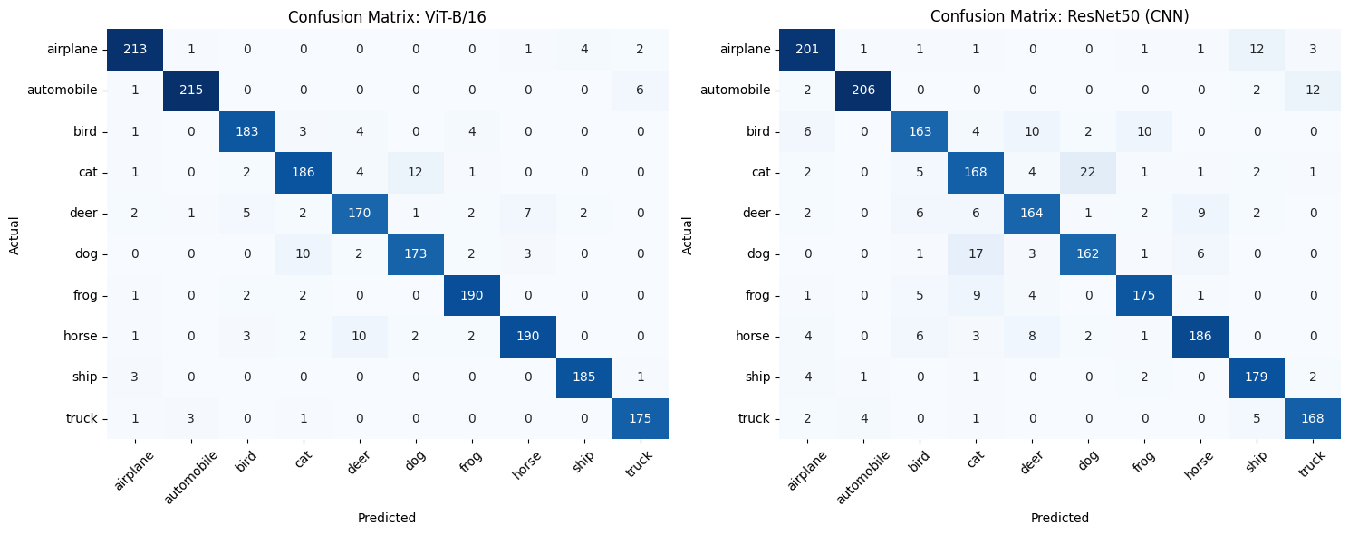
8. Comparison table
Metric | ViT-B/16 | ResNet50 (CNN)
Test accuracy | 0.9400 | 0.8860
Test loss | 0.1922 | 0.3912
Precision (macro) | 0.9395 | 0.8855
Recall (macro) | 0.9400 | 0.8859
F1-score (macro) | 0.9396 | 0.8855
Training time (s) | 65.26 | 39.24
Inference time (ms/image) | 3.03 | 1.19
Total parameters (M) | 85.81 | 23.53
Trainable parameters | 7,690 | 20,490
9. Accuracy and loss curves
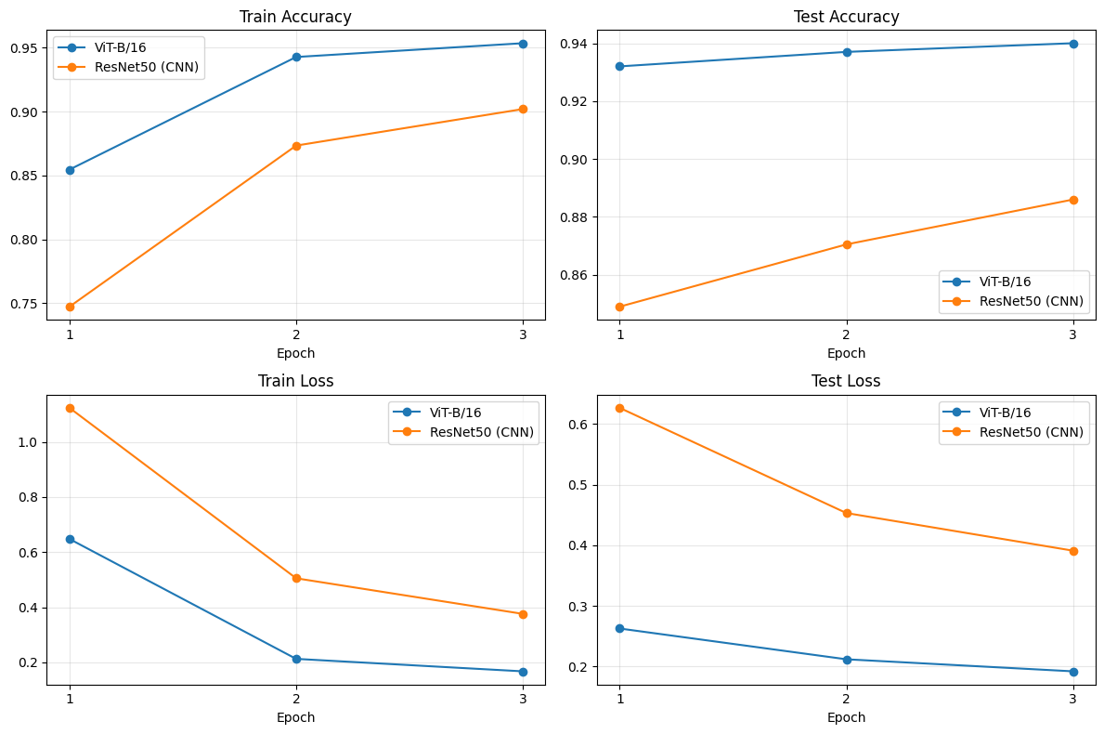
10. Test accuracy, training time and inference time
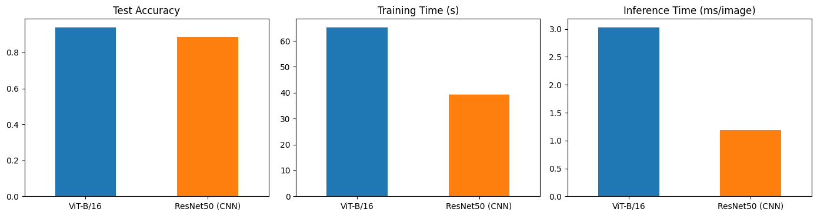
11. Sample predictions of ViT and CNN on the same test images
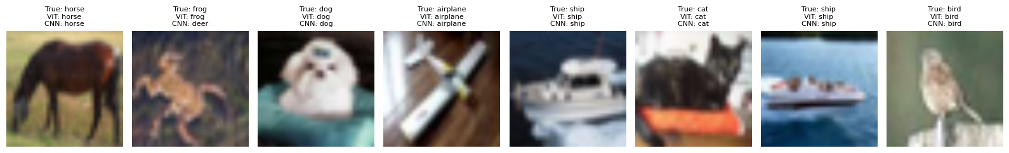
12. Best model
Best model by test accuracy: ViT-B/16 (0.9400)
Fastest at inference: ResNet50 (CNN) (1.19 ms/image)
13. Result analysis
- The pre-trained ViT-B/16 was clearly more accurate than the pre-trained ResNet50: 94.00% vs 88.60% test accuracy (5.4 points higher), with a lower test loss (0.192 vs 0.391) and a higher macro F1-score (0.940 vs 0.886).
- ViT had the higher F1-score on all ten classes. It also learned faster: after the first epoch its test accuracy was already 93.2%, while ResNet50 had 84.9%.
- ResNet50 was still improving at epoch 3 (84.9% → 87.1% → 88.6%), so the gap could become smaller with more epochs or with fine-tuning of the backbone.
- Both models found cat and dog the hardest classes. ViT confused cats and dogs 22 times in total (12 cats as dogs, 10 dogs as cats), ResNet50 39 times (22 and 17). ViT also confused horse with deer (10 horses predicted as deer), and ResNet50 mixed up airplane with ship (12), automobile with truck (12) and bird with deer or frog (10 each).
- The better accuracy has a cost: ViT took about 1.7 times longer to train (65.3 s vs 39.2 s), was about 2.6 times slower at inference (3.03 vs 1.19 ms per image) and has about 3.6 times more parameters (85.8 M vs 23.5 M).
- In the eight sample images ViT classified all correctly, while the CNN classified one incorrectly (a frog predicted as deer).
- Limitations: only the final layer was trained, on 5,000 images for 3 epochs and in a single run. The 32 × 32 images were enlarged to 224 × 224, which limits both models, and the ResNet50 weights used (ImageNet V2) are not identical in training recipe to the ViT weights (ImageNet V1), so the comparison is indicative rather than exact.

