BRACT’s
Vishwakarma Institute of Technology, Pune
Practical Implementation Sheet
Department: CSE-AI Semester: 5 Academic Year: 2026-27
Division: E Batch: 3 Practical No: 5
Roll no: 2 PRN No: 12413751 Name of Student: Prathmesh Sandeep Horne
Subject Name : Deep Learning
Comparison of RNN, LSTM and GRU for Sequence Classification

Problem Statement :
Implement and compare RNN, LSTM, and GRU models for sequence classification, and analyze their performance using appropriate evaluation metrics.
Dataset used: IMDB movie reviews (binary sentiment classification, positive / negative).

Algorithm :
- Import the required libraries (TensorFlow/Keras, NumPy, pandas, matplotlib, seaborn, scikit-learn).
- Load the IMDB dataset from Keras with a vocabulary of the 10,000 most frequent words (25,000 training and 25,000 test reviews).
- Analyze the review lengths (minimum 11, maximum 2,494, average 238.7 words) and check that the classes are balanced (12,500 negative and 12,500 positive).
- Pad or truncate every review to a fixed length of 200 words.
- Build three models with the same structure, differing only in the recurrent layer: Embedding(10000, 64) → SimpleRNN(64) / LSTM(64) / GRU(64) → Dense(1, sigmoid).
- Compile each model with the Adam optimizer and binary cross-entropy loss.
- Train each model for 3 epochs with batch size 64 and 20% of the training data used for validation.
- Evaluate all three models on the test set and compare accuracy and loss.
- Generate predictions and calculate precision, recall, F1-score, classification reports and confusion matrices for each model.
- Plot the comparison graphs and select the best-performing model.

Code :
# ---- Cell 1 ----
import numpy as np
import pandas as pd
import matplotlib.pyplot as plt
import tensorflow as tf
from tensorflow import keras
from tensorflow.keras import layers
from sklearn.metrics import accuracy_score, confusion_matrix, classification_report
import seaborn as sns
# ---- Cell 2 ----
vocab_size = 10000

max_length = 200

(X_train, y_train), (X_test, y_test) = keras.datasets.imdb.load_data(
num_words=vocab_size
)
# ---- Cell 3 ----
print("Training Samples:", len(X_train))
print("Testing Samples:", len(X_test))
print("First Review Sequence:", X_train[0])
print("First Label:", y_train[0])
# ---- Cell 4 ----
sequence_lengths = [len(sequence) for sequence in X_train]

print("Minimum Length:", min(sequence_lengths))
print("Maximum Length:", max(sequence_lengths))
print("Average Length:", np.mean(sequence_lengths))
# ---- Cell 5 ----
X_train = keras.utils.pad_sequences(
X_train,
maxlen=max_length,
padding="post",
truncating="post"
)

X_test = keras.utils.pad_sequences(
X_test,
maxlen=max_length,
padding="post",
truncating="post"
)

print("X_train Shape:", X_train.shape)
print("X_test Shape:", X_test.shape)
# ---- Cell 6 ----
print("Negative Reviews:", np.sum(y_train == 0))
print("Positive Reviews:", np.sum(y_train == 1))

plt.figure(figsize=(6, 4))

plt.bar(
["Negative", "Positive"],
[
np.sum(y_train == 0),
np.sum(y_train == 1)
]
)

plt.title("Sentiment Class Distribution")
plt.xlabel("Sentiment")
plt.ylabel("Number of Reviews")
plt.show()
# ---- Cell 7 ----
def create_rnn_model():
model = keras.Sequential([
layers.Embedding(vocab_size, 64, input_length=max_length),
layers.SimpleRNN(64),
layers.Dense(1, activation="sigmoid")
])

model.compile(
optimizer="adam",
loss="binary_crossentropy",
metrics=["accuracy"]
)

return model
# ---- Cell 8 ----
def create_lstm_model():
model = keras.Sequential([
layers.Embedding(vocab_size, 64, input_length=max_length),
layers.LSTM(64),
layers.Dense(1, activation="sigmoid")
])

model.compile(
optimizer="adam",
loss="binary_crossentropy",
metrics=["accuracy"]
)

return model
# ---- Cell 9 ----
def create_gru_model():
model = keras.Sequential([
layers.Embedding(vocab_size, 64, input_length=max_length),
layers.GRU(64),
layers.Dense(1, activation="sigmoid")
])

model.compile(
optimizer="adam",
loss="binary_crossentropy",
metrics=["accuracy"]
)

return model
# ---- Cell 10 ----
rnn_model = create_rnn_model()
rnn_model.summary()
# ---- Cell 11 ----
lstm_model = create_lstm_model()
lstm_model.summary()
# ---- Cell 12 ----
gru_model = create_gru_model()
gru_model.summary()
# ---- Cell 13 ----
rnn_history = rnn_model.fit(
X_train,
y_train,
validation_split=0.2,
epochs=3,
batch_size=64,
verbose=1
)
# ---- Cell 14 ----
lstm_history = lstm_model.fit(
X_train,
y_train,
validation_split=0.2,
epochs=3,
batch_size=64,
verbose=1
)
# ---- Cell 15 ----
gru_history = gru_model.fit(
X_train,
y_train,
validation_split=0.2,
epochs=3,
batch_size=64,
verbose=1
)
# ---- Cell 16 ----
rnn_loss, rnn_accuracy = rnn_model.evaluate(X_test, y_test)

lstm_loss, lstm_accuracy = lstm_model.evaluate(X_test, y_test)

gru_loss, gru_accuracy = gru_model.evaluate(X_test, y_test)

print("RNN Accuracy:", rnn_accuracy)
print("LSTM Accuracy:", lstm_accuracy)
print("GRU Accuracy:", gru_accuracy)
# ---- Cell 17 ----
comparison = pd.DataFrame({
"Model": ["RNN", "LSTM", "GRU"],
"Test Loss": [rnn_loss, lstm_loss, gru_loss],
"Test Accuracy": [
rnn_accuracy,
lstm_accuracy,
gru_accuracy
]
})

comparison
# ---- Cell 18 ----
plt.figure(figsize=(8, 5))

plt.bar(
comparison["Model"],
comparison["Test Accuracy"]
)

plt.xlabel("Model")
plt.ylabel("Test Accuracy")
plt.title("RNN vs LSTM vs GRU Accuracy")
plt.ylim(0, 1)
plt.show()
# ---- Cell 19 ----
plt.figure(figsize=(10, 6))

plt.plot(
rnn_history.history["accuracy"],
label="RNN Training Accuracy"
)

plt.plot(
lstm_history.history["accuracy"],
label="LSTM Training Accuracy"
)

plt.plot(
gru_history.history["accuracy"],
label="GRU Training Accuracy"
)

plt.xlabel("Epochs")
plt.ylabel("Accuracy")
plt.title("Training Accuracy Comparison")
plt.legend()
plt.grid(True)
plt.show()
# ---- Cell 20 ----
plt.figure(figsize=(10, 6))

plt.plot(
rnn_history.history["val_accuracy"],
label="RNN Validation Accuracy"
)

plt.plot(
lstm_history.history["val_accuracy"],
label="LSTM Validation Accuracy"
)

plt.plot(
gru_history.history["val_accuracy"],
label="GRU Validation Accuracy"
)

plt.xlabel("Epochs")
plt.ylabel("Validation Accuracy")
plt.title("Validation Accuracy Comparison")
plt.legend()
plt.grid(True)
plt.show()
# ---- Cell 21 ----
plt.figure(figsize=(10, 6))

plt.plot(
rnn_history.history["loss"],
label="RNN Loss"
)

plt.plot(
lstm_history.history["loss"],
label="LSTM Loss"
)

plt.plot(
gru_history.history["loss"],
label="GRU Loss"
)

plt.xlabel("Epochs")
plt.ylabel("Loss")
plt.title("Training Loss Comparison")
plt.legend()
plt.grid(True)
plt.show()
# ---- Cell 22 ----
rnn_predictions = (
rnn_model.predict(X_test) > 0.5
).astype("int32").flatten()

lstm_predictions = (
lstm_model.predict(X_test) > 0.5
).astype("int32").flatten()

gru_predictions = (
gru_model.predict(X_test) > 0.5
).astype("int32").flatten()
# ---- Cell 23 ----
print("RNN Classification Report")
print(
classification_report(
y_test,
rnn_predictions,
target_names=["Negative", "Positive"]
)
)

print("LSTM Classification Report")
print(
classification_report(
y_test,
lstm_predictions,
target_names=["Negative", "Positive"]
)
)

print("GRU Classification Report")
print(
classification_report(
y_test,
gru_predictions,
target_names=["Negative", "Positive"]
)
)
# ---- Cell 24 ----
cm_rnn = confusion_matrix(y_test, rnn_predictions)

plt.figure(figsize=(5, 4))

sns.heatmap(
cm_rnn,
annot=True,
fmt="d",
cmap="Blues",
xticklabels=["Negative", "Positive"],
yticklabels=["Negative", "Positive"]
)

plt.title("RNN Confusion Matrix")
plt.xlabel("Predicted")
plt.ylabel("Actual")
plt.show()
# ---- Cell 25 ----
cm_lstm = confusion_matrix(y_test, lstm_predictions)

plt.figure(figsize=(5, 4))

sns.heatmap(
cm_lstm,
annot=True,
fmt="d",
cmap="Blues",
xticklabels=["Negative", "Positive"],
yticklabels=["Negative", "Positive"]
)

plt.title("LSTM Confusion Matrix")
plt.xlabel("Predicted")
plt.ylabel("Actual")
plt.show()
# ---- Cell 26 ----
cm_gru = confusion_matrix(y_test, gru_predictions)

plt.figure(figsize=(5, 4))

sns.heatmap(
cm_gru,
annot=True,
fmt="d",
cmap="Blues",
xticklabels=["Negative", "Positive"],
yticklabels=["Negative", "Positive"]
)

plt.title("GRU Confusion Matrix")
plt.xlabel("Predicted")
plt.ylabel("Actual")
plt.show()
# ---- Cell 27 ----
from sklearn.metrics import precision_score, recall_score, f1_score

metrics_comparison = pd.DataFrame({
"Model": ["RNN", "LSTM", "GRU"],
"Accuracy": [
accuracy_score(y_test, rnn_predictions),
accuracy_score(y_test, lstm_predictions),
accuracy_score(y_test, gru_predictions)
],
"Precision": [
precision_score(y_test, rnn_predictions),
precision_score(y_test, lstm_predictions),
precision_score(y_test, gru_predictions)
],
"Recall": [
recall_score(y_test, rnn_predictions),
recall_score(y_test, lstm_predictions),
recall_score(y_test, gru_predictions)
],
"F1 Score": [
f1_score(y_test, rnn_predictions),
f1_score(y_test, lstm_predictions),
f1_score(y_test, gru_predictions)
]
})

metrics_comparison
# ---- Cell 28 ----
metrics_comparison.set_index("Model").plot(
kind="bar",
figsize=(10, 6)
)

plt.title("Performance Comparison of RNN, LSTM and GRU")
plt.ylabel("Score")
plt.ylim(0, 1)
plt.grid(axis="y")
plt.show()
# ---- Cell 29 ----
best_model = comparison.loc[
comparison["Test Accuracy"].idxmax(),
"Model"
]

print("The RNN, LSTM and GRU models were implemented for sentiment classification.")
print("All models were evaluated using accuracy, precision, recall and F1-score.")
print("The best-performing model was:", best_model)
print("LSTM and GRU generally handle long-term dependencies better than Simple RNN.")
print("GRU has fewer gates and parameters than LSTM, making it computationally efficient.")

Output :
1. Dataset details
Training Samples: 25000
Testing Samples: 25000
Minimum Length: 11
Maximum Length: 2494
Average Length: 238.71364
X_train Shape: (25000, 200)
X_test Shape: (25000, 200)
Negative Reviews: 12500
Positive Reviews: 12500
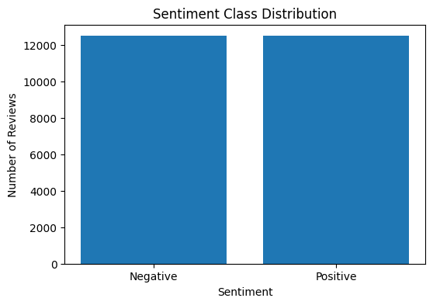
2. Training log (3 epochs per model)
Model | Epoch | Train Acc | Train Loss | Val Acc | Val Loss
RNN | 1/3 | 0.7394 | 0.3900 | 0.5018 | 0.9832
RNN | 2/3 | 0.7546 | 0.3643 | 0.5058 | 1.0771
RNN | 3/3 | 0.7659 | 0.3514 | 0.4992 | 1.1059
LSTM | 1/3 | 0.5200 | 0.6914 | 0.5332 | 0.6872
LSTM | 2/3 | 0.6029 | 0.6440 | 0.6082 | 0.6482
LSTM | 3/3 | 0.7010 | 0.5422 | 0.5480 | 0.6784
GRU | 1/3 | 0.5274 | 0.6901 | 0.5514 | 0.6774
GRU | 2/3 | 0.6186 | 0.6447 | 0.8034 | 0.5167
GRU | 3/3 | 0.8627 | 0.3392 | 0.8592 | 0.3383
3. Test accuracy and loss
RNN Accuracy: 0.4973599910736084
LSTM Accuracy: 0.5492799878120422
GRU Accuracy: 0.8571599721908569
Model | Test Loss | Test Accuracy
RNN | 1.0860 | 0.4974
LSTM | 0.6800 | 0.5493
GRU | 0.3391 | 0.8572
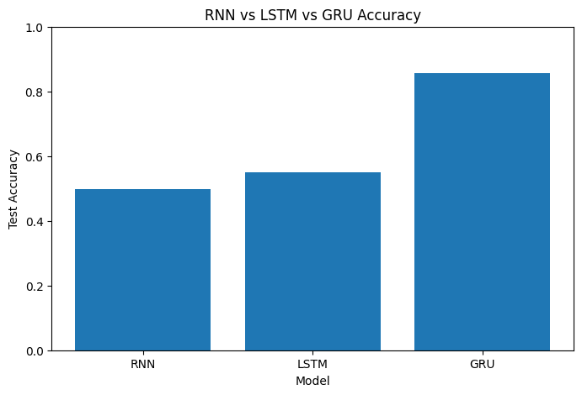
4. Training accuracy comparison
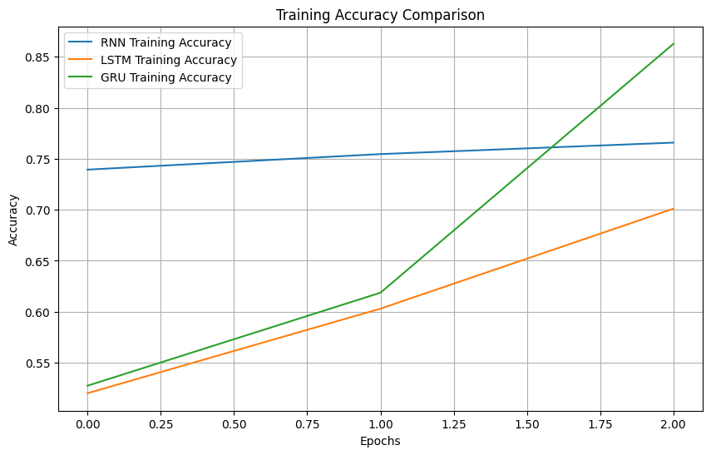
5. Validation accuracy comparison
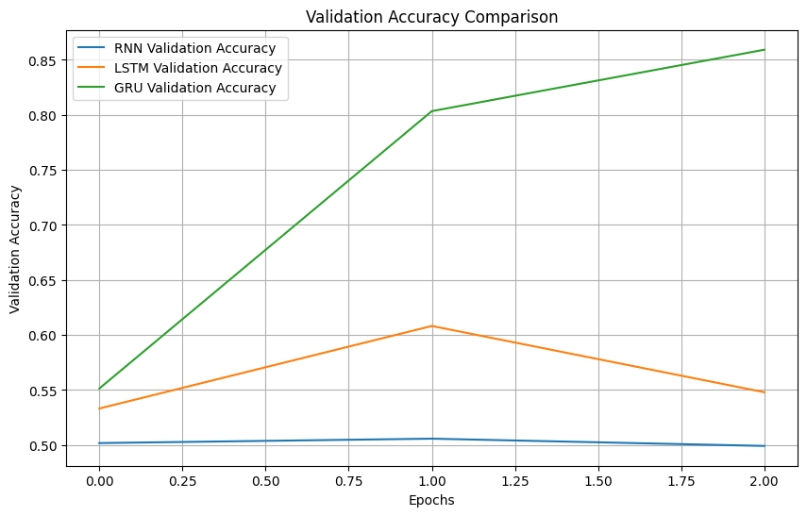
6. Training loss comparison
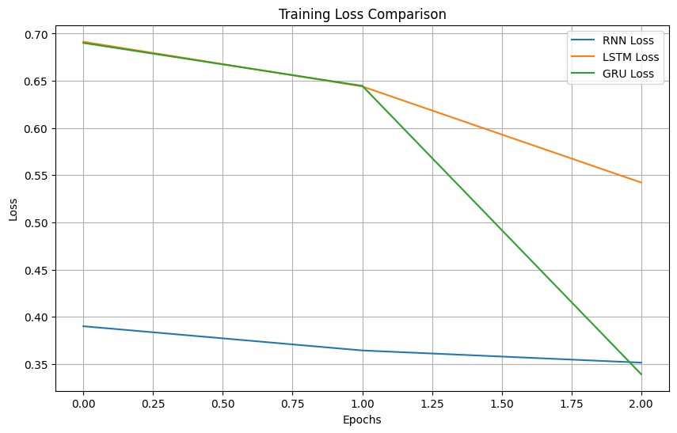
7. Classification reports
Model | Class | Precision | Recall | F1-score | Support
RNN | Negative | 0.50 | 0.72 | 0.59 | 12500
RNN | Positive | 0.50 | 0.27 | 0.35 | 12500
RNN | Accuracy |  |  | 0.50 | 25000
LSTM | Negative | 0.64 | 0.22 | 0.33 | 12500
LSTM | Positive | 0.53 | 0.88 | 0.66 | 12500
LSTM | Accuracy |  |  | 0.55 | 25000
GRU | Negative | 0.89 | 0.82 | 0.85 | 12500
GRU | Positive | 0.83 | 0.89 | 0.86 | 12500
GRU | Accuracy |  |  | 0.86 | 25000
8. Confusion matrices
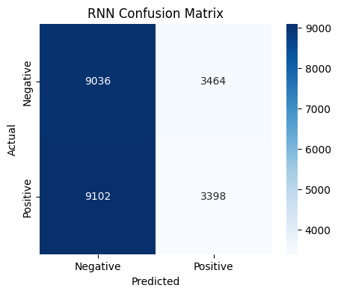
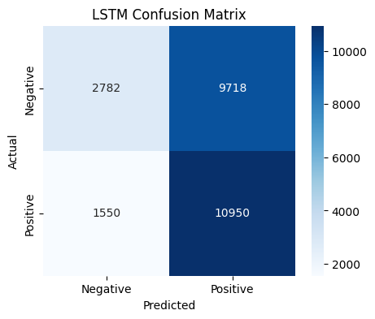
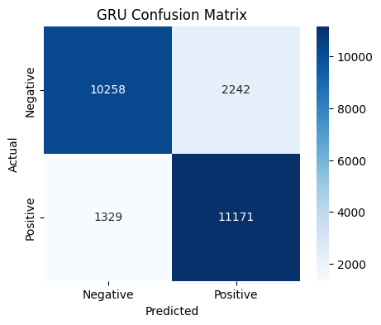
9. Performance comparison table
Model | Accuracy | Precision | Recall | F1 Score
RNN | 0.4974 | 0.4952 | 0.2718 | 0.3510
LSTM | 0.5493 | 0.5298 | 0.8760 | 0.6603
GRU | 0.8572 | 0.8328 | 0.8937 | 0.8622
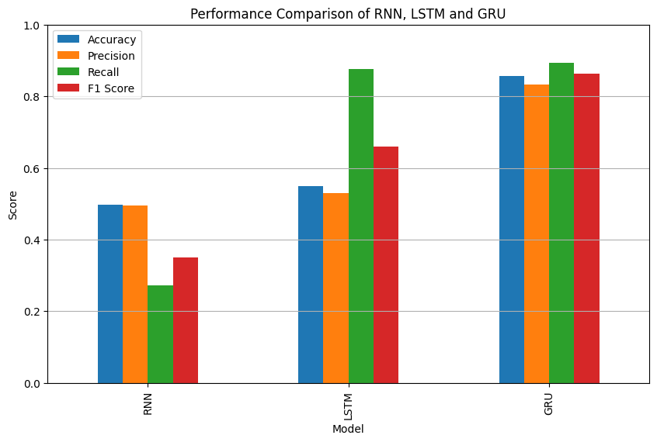
10. Conclusion printed by the notebook
The best-performing model was: GRU
11. Result analysis
- GRU was the best model: 85.7% test accuracy and an F1-score of 0.862, with balanced performance on both classes.
- RNN stayed at about 50% (chance level) on validation and test data, even though its training accuracy reached about 77%. It did not generalize, and its validation loss increased from 0.98 to 1.11.
- LSTM reached 54.9% accuracy and was biased toward the positive class (positive recall 0.88, negative recall only 0.22). Its validation accuracy fluctuated (53% → 61% → 55%), so it had not yet converged.
- GRU learned fastest: its validation accuracy jumped from 55% to 80% to 86% over the three epochs.
- These results come from this setup only (3 epochs, padding added at the end of each review, 200-word limit). LSTM usually performs similarly to GRU when trained for more epochs, so the low LSTM score should not be read as LSTM being generally worse.
- GRU has fewer gates and parameters than LSTM, which makes it faster and easier to train on a small number of epochs.

