Design and implement a Multilayer Perceptron (MLP) for classification of the Iris or Wine
dataset, and evaluate its performance using accuracy and a confusion matrix.

Problem Statement :
Design and implement a Multilayer Perceptron (MLP) for classification of the Iris or Wine dataset, and evaluate its performance using accuracy and a confusion matrix.
Dataset used: Wine recognition dataset (178 samples, 13 chemical features, 3 wine classes), loaded from scikit-learn.

Algorithm :
- Import the required libraries: NumPy, pandas, matplotlib, seaborn and scikit-learn (MLPClassifier, StandardScaler, train_test_split and the evaluation metrics).
- Load the Wine dataset and separate the features (13 chemical measurements) from the target labels (3 classes).
- Explore the data: shape, feature names, data types, summary statistics, missing values, duplicate rows and class distribution.
- Visualize the data using histograms, a box plot, a pair plot, a correlation heatmap and a scatter plot.
- Split the data into 80% training (142 samples) and 20% testing (36 samples) using train_test_split with stratify = y, so each class keeps the same proportion in both sets (random_state = 42).
- Standardize the features with StandardScaler: fit the scaler on the training data only, then apply it to both the training and test data.
- Design the MLP: 13 input neurons → hidden layer of 10 neurons (ReLU) → hidden layer of 10 neurons (ReLU) → 3 output neurons (one per class). Use the Adam optimizer with a maximum of 1,000 iterations.
- Train the MLP on the training data. During training, forward propagation calculates the predictions and the loss, and backpropagation updates the weights.
- Plot the training loss curve to check that training converged.
- Predict the classes of the test data and calculate the accuracy.
- Evaluate the model with the confusion matrix and the classification report (precision, recall, F1-score).
- Compare the actual and predicted labels and write the conclusion.

Code :
# ---- Cell 1 ----

import numpy as np

import pandas as pd

import matplotlib.pyplot as plt
import seaborn as sns

from sklearn.datasets import load_wine

from sklearn.model_selection import train_test_split

from sklearn.preprocessing import StandardScaler

from sklearn.neural_network import MLPClassifier

from sklearn.metrics import (
accuracy_score,
confusion_matrix,
classification_report
)
# ---- Cell 2 ----
# Load the Wine dataset
wine = load_wine()

# Features (independent variables)
X = wine.data

# Target labels (dependent variable)
y = wine.target
# ---- Cell 3 ----
print("Dataset Description:\n")
print(wine.DESCR)

print("\nShape of Dataset:", X.shape)
print("Number of Samples:", X.shape[0])
print("Number of Features:", X.shape[1])

print("\nFeature Names:")
print(wine.feature_names)

print("\nTarget Classes:")
print(wine.target_names)
# ---- Cell 4 ----
df = pd.DataFrame(X, columns=wine.feature_names)
df["Class"] = y

df.head()
# ---- Cell 5 ----
df.info()
# ---- Cell 6 ----
df.describe()
# ---- Cell 7 ----
df.isnull().sum()
# ---- Cell 8 ----
print("Duplicate Rows:", df.duplicated().sum())
# ---- Cell 9 ----
print(df["Class"].value_counts())

plt.figure(figsize=(6,4))
sns.countplot(x="Class", data=df)
plt.title("Class Distribution")
plt.show()
# ---- Cell 10 ----
df.hist(figsize=(15,12))
plt.tight_layout()
plt.show()
# ---- Cell 11 ----
plt.figure(figsize=(15,8))
sns.boxplot(data=df.iloc[:,:13])
plt.xticks(rotation=90)
plt.title("Box Plot of Features")
plt.show()
# ---- Cell 12 ----
sns.pairplot(df, hue="Class", diag_kind="hist")
plt.show()
# ---- Cell 13 ----
plt.figure(figsize=(12,10))

sns.heatmap(
df.corr(),
annot=True,
cmap="coolwarm",
fmt=".2f"
)

plt.title("Correlation Heatmap")
plt.show()
# ---- Cell 14 ----
plt.figure(figsize=(8,6))

sns.scatterplot(
data=df,
x="alcohol",
y="color_intensity",
hue="Class",
palette="Set1"
)

plt.title("Alcohol vs Color Intensity")
plt.show()
# ---- Cell 15 ----
X_train, X_test, y_train, y_test = train_test_split(
X,
y,
test_size=0.2,
random_state=42,
stratify=y
)
# ---- Cell 16 ----
scaler = StandardScaler()

X_train = scaler.fit_transform(X_train)

X_test = scaler.transform(X_test)
# ---- Cell 17 ----
mlp = MLPClassifier(
hidden_layer_sizes=(10,10),
activation="relu",
solver="adam",
max_iter=1000,
random_state=42
)
# ---- Cell 18 ----
mlp.fit(X_train, y_train)
# ---- Cell 19 ----
plt.figure(figsize=(8,5))

plt.plot(mlp.loss_curve_, linewidth=2)

plt.title("Training Loss Curve")
plt.xlabel("Iterations")
plt.ylabel("Loss")
plt.grid(True)

plt.show()
# ---- Cell 20 ----
y_pred = mlp.predict(X_test)
# ---- Cell 21 ----
accuracy = accuracy_score(y_test, y_pred)

print("Accuracy:", round(accuracy*100,2),"%")
# ---- Cell 22 ----
cm = confusion_matrix(y_test, y_pred)

plt.figure(figsize=(6,5))

sns.heatmap(
cm,
annot=True,
fmt="d",
cmap="Blues",
xticklabels=wine.target_names,
yticklabels=wine.target_names
)

plt.xlabel("Predicted")
plt.ylabel("Actual")
plt.title("Confusion Matrix")

plt.show()
# ---- Cell 23 ----
print(classification_report(
y_test,
y_pred,
target_names=wine.target_names
))
# ---- Cell 24 ----
results = pd.DataFrame({
"Actual": y_test,
"Predicted": y_pred
})

results.head(15)
# ---- Cell 25 ----
print("""
Conclusion:
The Wine dataset was successfully classified using a Multilayer Perceptron (MLP).
The dataset contains 178 samples, 13 features, and 3 target classes.
Exploratory Data Analysis (EDA) was performed using histograms, box plots,
pair plots, scatter plots, and a correlation heatmap. After preprocessing
and feature scaling, the MLP model was trained and evaluated. The model
achieved high accuracy, and the confusion matrix and classification report
showed that it classified the wine samples effectively.
""")

Output :
1. Dataset information
Shape of Dataset: (178, 13)
Number of Samples: 178
Number of Features: 13
Feature Names: alcohol, malic_acid, ash, alcalinity_of_ash, magnesium, total_phenols, flavanoids,
nonflavanoid_phenols, proanthocyanins, color_intensity, hue, od280/od315_of_diluted_wines, proline
Target Classes: class_0, class_1, class_2
Missing values: 0 in every column
Duplicate Rows: 0
2. First five rows (selected columns)
alcohol | malic acid | ash | alcalinity of ash | magnesium | total phenols | flavanoids | proline | Class
14.23 | 1.71 | 2.43 | 15.6 | 127.0 | 2.80 | 3.06 | 1065.0 | 0
13.20 | 1.78 | 2.14 | 11.2 | 100.0 | 2.65 | 2.76 | 1050.0 | 0
13.16 | 2.36 | 2.67 | 18.6 | 101.0 | 2.80 | 3.24 | 1185.0 | 0
14.37 | 1.95 | 2.50 | 16.8 | 113.0 | 3.85 | 3.49 | 1480.0 | 0
13.24 | 2.59 | 2.87 | 21.0 | 118.0 | 2.80 | 2.69 | 735.0 | 0
3. Summary statistics of the features
Feature | Mean | Std | Min | Max
alcohol | 13.0006 | 0.8118 | 11.03 | 14.83
malic_acid | 2.3363 | 1.1171 | 0.74 | 5.80
ash | 2.3665 | 0.2743 | 1.36 | 3.23
alcalinity_of_ash | 19.4949 | 3.3396 | 10.60 | 30.00
magnesium | 99.7416 | 14.2825 | 70.00 | 162.00
total_phenols | 2.2951 | 0.6259 | 0.98 | 3.88
flavanoids | 2.0293 | 0.9989 | 0.34 | 5.08
nonflavanoid_phenols | 0.3619 | 0.1245 | 0.13 | 0.66
proanthocyanins | 1.5909 | 0.5724 | 0.41 | 3.58
color_intensity | 5.0581 | 2.3183 | 1.28 | 13.00
hue | 0.9574 | 0.2286 | 0.48 | 1.71
od280/od315_of_diluted_wines | 2.6117 | 0.7100 | 1.27 | 4.00
proline | 746.8933 | 314.9075 | 278.00 | 1680.00
4. Class distribution
Class
1 71
0 59
2 48
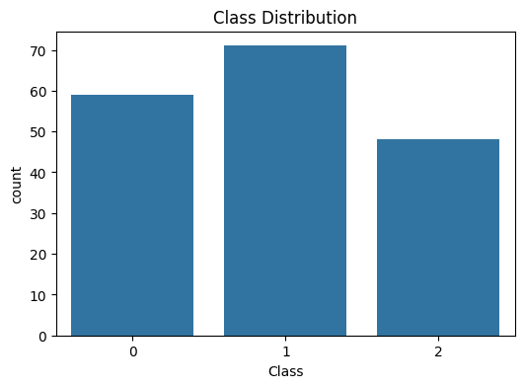
5. Histograms of the features
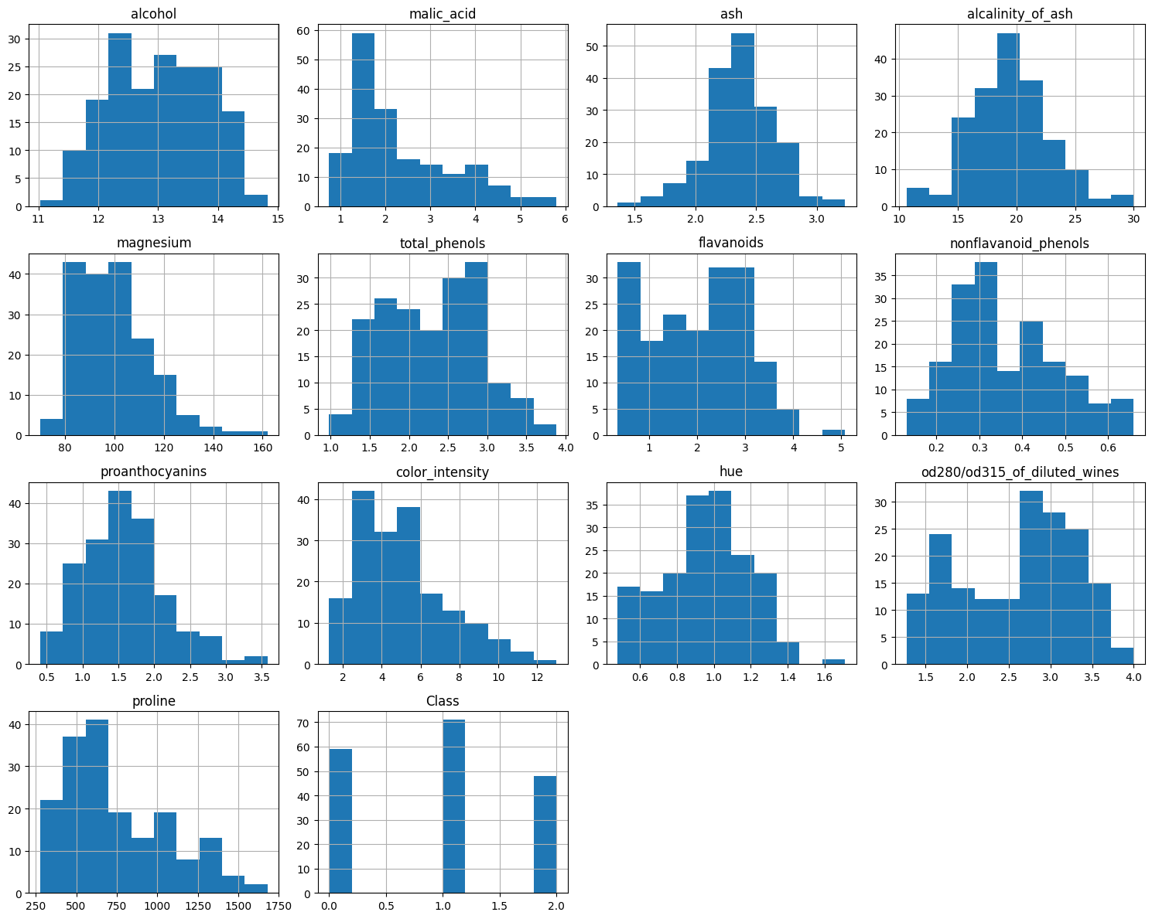
6. Box plot of the features
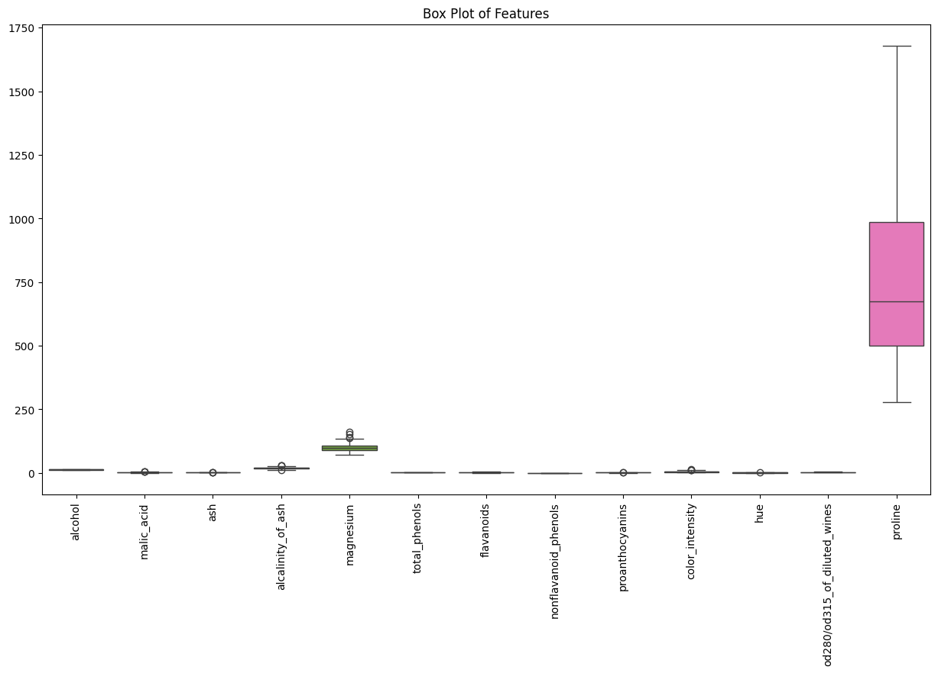
7. Pair plot
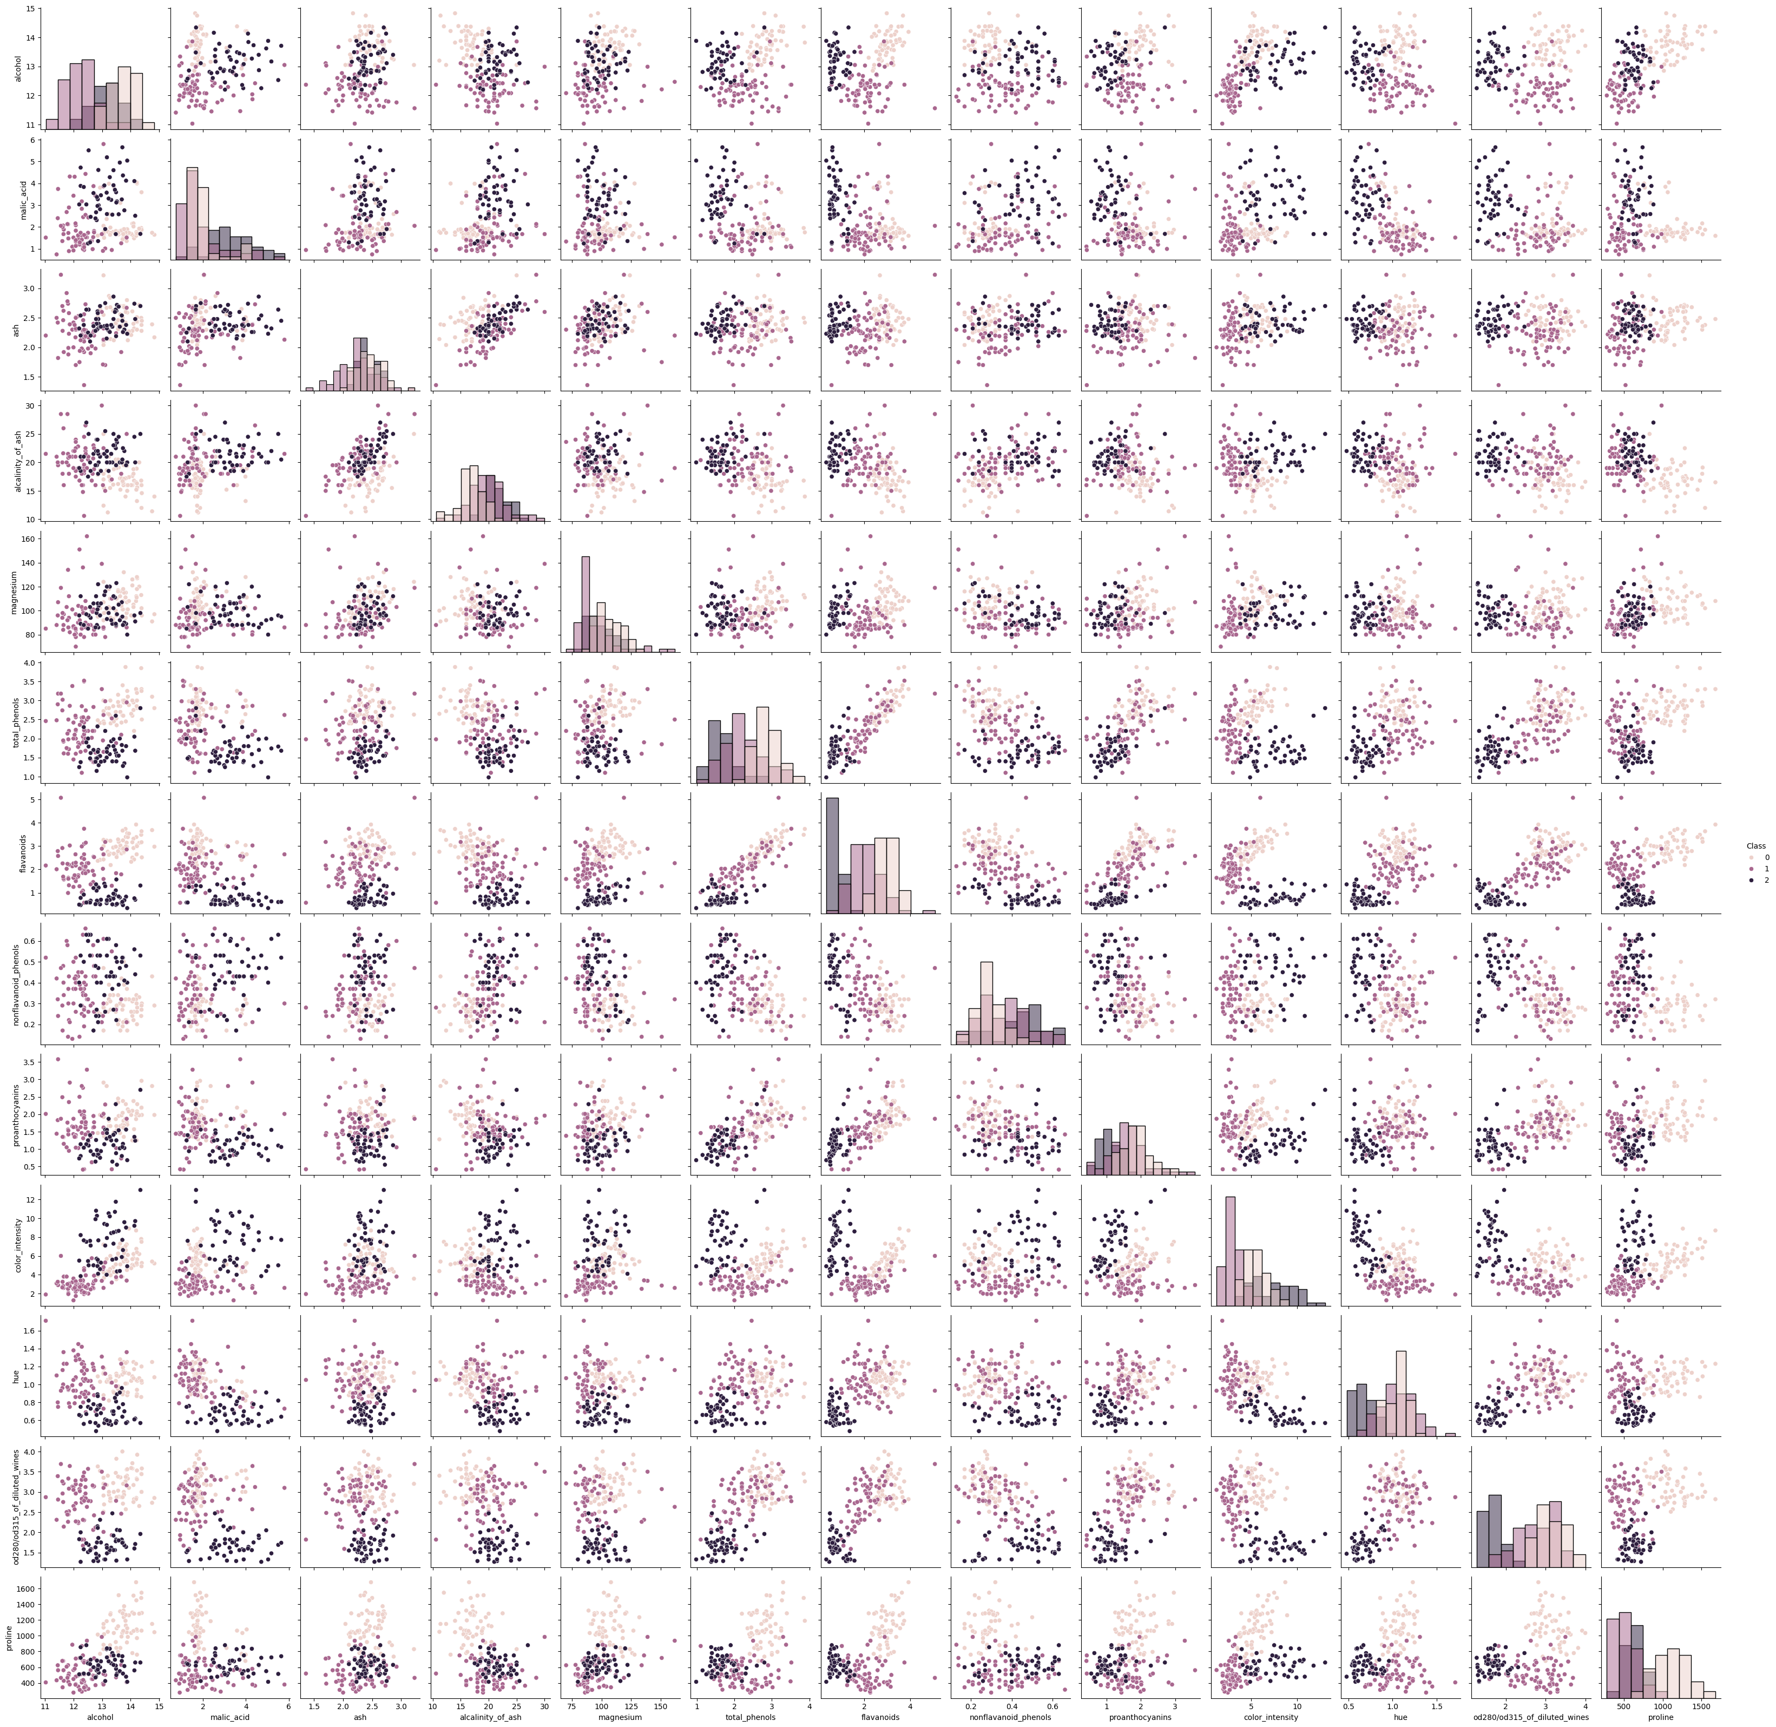
8. Correlation heatmap
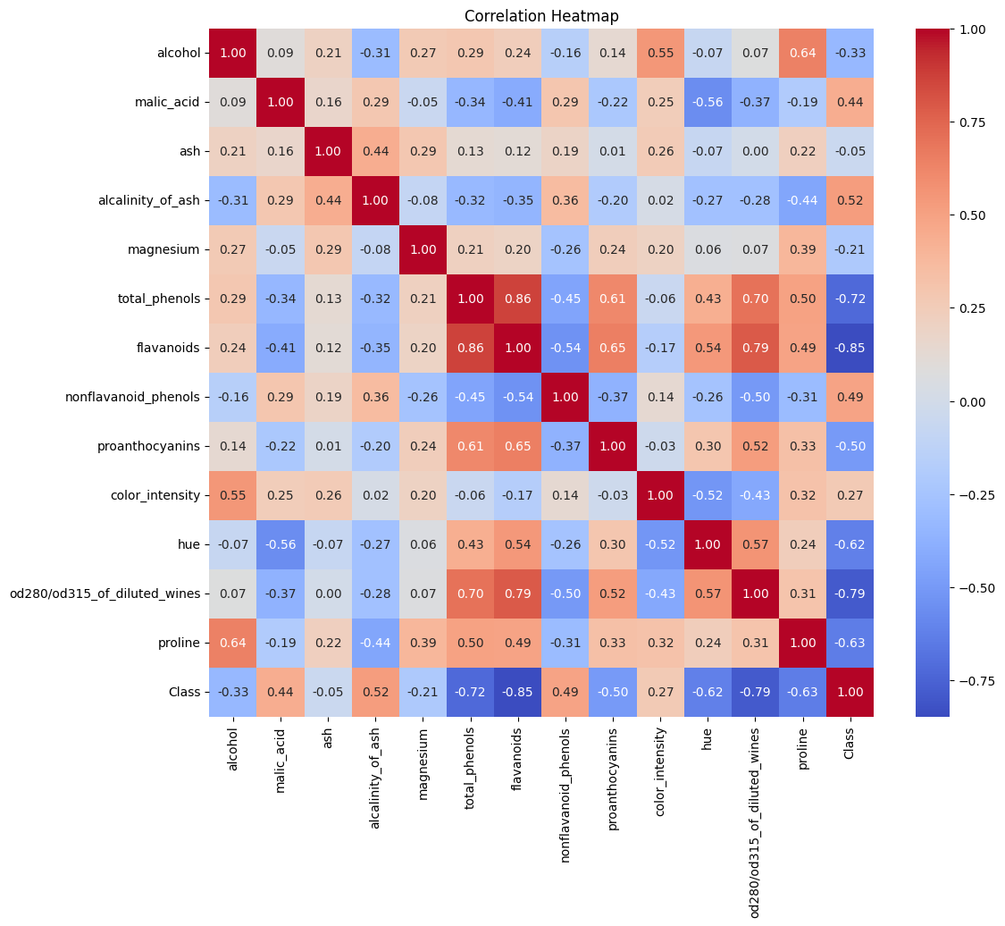
9. Alcohol vs color intensity
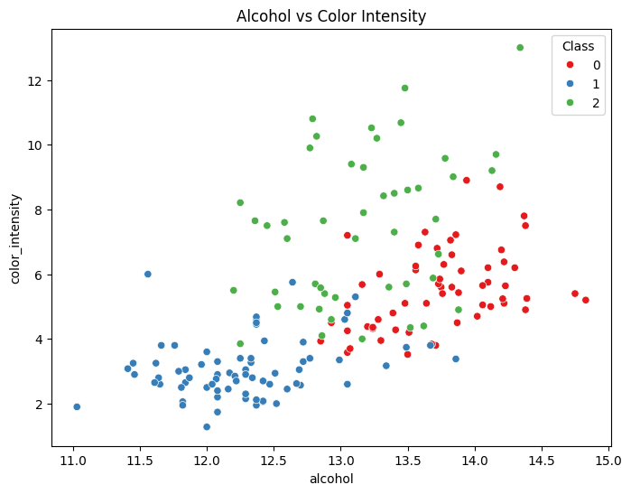
10. MLP configuration
MLPClassifier(hidden_layer_sizes=(10, 10), activation='relu', solver='adam', max_iter=1000, random_state=42)
11. Training loss curve
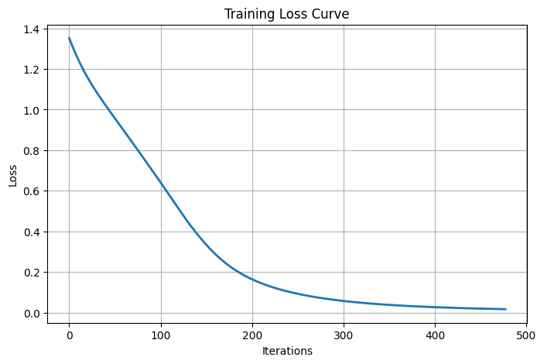
12. Accuracy
Accuracy: 97.22 %
13. Confusion matrix
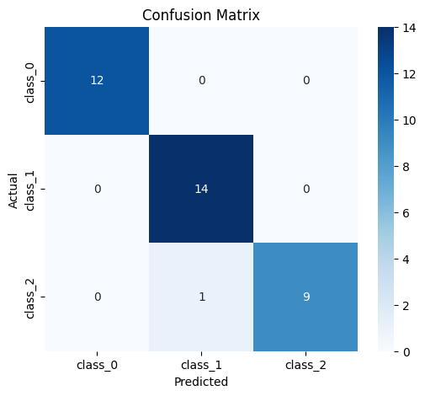
Actual \ Predicted | class_0 | class_1 | class_2
class_0 | 12 | 0 | 0
class_1 | 0 | 14 | 0
class_2 | 0 | 1 | 9
14. Classification report
Class | Precision | Recall | F1-score | Support
class_0 | 1.00 | 1.00 | 1.00 | 12
class_1 | 0.93 | 1.00 | 0.97 | 14
class_2 | 1.00 | 0.90 | 0.95 | 10
Accuracy |  |  | 0.97 | 36
Macro avg | 0.98 | 0.97 | 0.97 | 36
Weighted avg | 0.97 | 0.97 | 0.97 | 36
15. Actual vs predicted labels (first 15 test samples)
Index | Actual | Predicted | Index | Actual | Predicted
0 | 0 | 0 | 8 | 1 | 1
1 | 2 | 1 | 9 | 2 | 2
2 | 0 | 0 | 10 | 1 | 1
3 | 1 | 1 | 11 | 2 | 2
4 | 1 | 1 | 12 | 0 | 0
5 | 0 | 0 | 13 | 2 | 2
6 | 0 | 0 | 14 | 0 | 0
7 | 1 | 1
16. Conclusion printed by the notebook
The Wine dataset was successfully classified using a Multilayer Perceptron (MLP).
The model achieved high accuracy, and the confusion matrix and classification
report showed that it classified the wine samples effectively.
17. Result analysis
- The MLP reached 97.22% accuracy on the test set: 35 of the 36 wines were classified correctly.
- The confusion matrix shows only one error: a class_2 wine was predicted as class_1 (test sample 1 in the table above). class_0 was classified perfectly (precision and recall 1.00).
- class_1 had recall 1.00 and precision 0.93; class_2 had precision 1.00 and recall 0.90. Macro-average F1-score was 0.97.
- The training loss decreased smoothly from about 1.35 to close to 0 and levelled off after roughly 475 iterations, well before the limit of 1,000, so training converged without problems.
- The features have very different scales (for example proline up to 1,680 and hue up to 1.71), so standardization was needed. The scaler was fitted on the training data only, so no information from the test set was used.
- The heatmap shows that flavanoids (-0.85), OD280/OD315 (-0.79) and total phenols (-0.72) are the features most strongly related to the wine class. These three features are also strongly correlated with each other (0.70–0.86).
- In the alcohol vs color intensity plot, class 1 is clearly separated (low color intensity), while classes 0 and 2 overlap, so all 13 features are needed for good classification.
- The test set has only 36 samples, so a single mistake changes the accuracy by about 2.8 percentage points. A stratified split was used so each class is represented in the same proportion as in the full dataset.

