BRACT’s
Vishwakarma Institute of Technology, Pune
Practical Implementation Sheet
Department: CSE-AI Semester: 5 Academic Year: 2026-27
Division: E Batch: 3 Practical No: 6
Roll no: 21 PRN No: 12413751 Name of Student: Prathmesh Sandeep Horne
Subject Name : Deep Learning
CNN for Tomato Leaf Disease Classification

Problem Statement :
Design and implement a Convolutional Neural Network (CNN) for image classification using the Tomato or Soybean disease dataset.
Dataset used: Tomato leaf images (10 classes) from the PlantVillage dataset.

Algorithm :
- Import the required libraries (TensorFlow/Keras, NumPy, pandas, matplotlib, seaborn, scikit-learn).
- Download the PlantVillage dataset from GitHub and copy the 10 Tomato disease classes into a separate folder (18,160 images in total).
- Count the images in each class and plot the class distribution.
- Load the images with image_dataset_from_directory: resize to 128 × 128, batch size 32, 80% training (14,528 images) and 20% validation (3,632 images).
- Normalize the pixel values to the range 0–1 using a Rescaling layer; apply cache, shuffle and prefetch to speed up training.
- Build the CNN: three Conv2D layers (32, 64, 128 filters, 3 × 3, ReLU), each followed by 2 × 2 MaxPooling, then Flatten, Dense(128, ReLU), Dropout(0.5) and a Dense(10, softmax) output layer.
- Compile the model with the Adam optimizer and sparse categorical cross-entropy loss, and train it for 3 epochs.
- Plot the training and validation accuracy and loss curves.
- Evaluate the model on the validation set using the confusion matrix, classification report (precision, recall, F1-score) and accuracy.
- Display sample predictions (actual vs predicted label) for validation images.

Code :
# ---- Cell 1 ----
import os
import shutil
import tensorflow as tf
import numpy as np
import pandas as pd
import matplotlib.pyplot as plt
import seaborn as sns
from tensorflow import keras
from tensorflow.keras import layers
from sklearn.metrics import confusion_matrix, classification_report
# ---- Cell 2 ----
!git clone https://github.com/spMohanty/PlantVillage-Dataset.git
# ---- Cell 3 ----
dataset_path = "/content/PlantVillage-Dataset/raw/color"
print(os.listdir(dataset_path)[:20])
# ---- Cell 4 ----
tomato_classes = [
folder for folder in os.listdir(dataset_path)
if folder.startswith("Tomato")
]

print("Number of Tomato Classes:", len(tomato_classes))
print(tomato_classes)
# ---- Cell 5 ----
tomato_path = "/content/tomato_dataset"

os.makedirs(tomato_path, exist_ok=True)

for class_name in tomato_classes:
os.makedirs(os.path.join(tomato_path, class_name), exist_ok=True)
# ---- Cell 6 ----
for class_name in tomato_classes:
source_folder = os.path.join(dataset_path, class_name)
destination_folder = os.path.join(tomato_path, class_name)

files = os.listdir(source_folder)

for file in files:
source_file = os.path.join(source_folder, file)
destination_file = os.path.join(destination_folder, file)
shutil.copy(source_file, destination_file)

print("Tomato images copied successfully")
# ---- Cell 7 ----
class_counts = {}

for class_name in tomato_classes:
folder_path = os.path.join(tomato_path, class_name)
class_counts[class_name] = len(os.listdir(folder_path))

print(class_counts)
# ---- Cell 8 ----
plt.figure(figsize=(12, 6))
plt.bar(class_counts.keys(), class_counts.values())
plt.xticks(rotation=45, ha="right")
plt.xlabel("Tomato Disease Classes")
plt.ylabel("Number of Images")
plt.title("Class Distribution")
plt.tight_layout()
plt.show()
# ---- Cell 9 ----
img_size = (128, 128)
batch_size = 32

train_ds = tf.keras.utils.image_dataset_from_directory(
tomato_path,
validation_split=0.2,
subset="training",
seed=42,
image_size=img_size,
batch_size=batch_size
)

val_ds = tf.keras.utils.image_dataset_from_directory(
tomato_path,
validation_split=0.2,
subset="validation",
seed=42,
image_size=img_size,
batch_size=batch_size
)
# ---- Cell 10 ----
class_names = train_ds.class_names

print("Class Names:")
print(class_names)
print("Number of Classes:", len(class_names))
# ---- Cell 11 ----
plt.figure(figsize=(10, 10))

for images, labels in train_ds.take(1):
for i in range(9):
ax = plt.subplot(3, 3, i + 1)
plt.imshow(images[i].numpy().astype("uint8"))
plt.title(class_names[labels[i]])
plt.axis("off")

plt.tight_layout()
plt.show()
# ---- Cell 12 ----
normalization_layer = layers.Rescaling(1./255)

train_ds = train_ds.map(
lambda x, y: (normalization_layer(x), y)
)

val_ds = val_ds.map(
lambda x, y: (normalization_layer(x), y)
)
# ---- Cell 13 ----
AUTOTUNE = tf.data.AUTOTUNE

train_ds = train_ds.shuffle(1000).prefetch(
buffer_size=AUTOTUNE
)

val_ds = val_ds.prefetch(
buffer_size=AUTOTUNE
)
# ---- Cell 14 ----
train_ds = train_ds.cache().shuffle(1000).prefetch(
buffer_size=AUTOTUNE
)

val_ds = val_ds.cache().prefetch(
buffer_size=AUTOTUNE
)
# ---- Cell 15 ----
model = keras.Sequential([
layers.Conv2D(
32,
(3, 3),
activation="relu",
input_shape=(128, 128, 3)
),
layers.MaxPooling2D((2, 2)),

layers.Conv2D(
64,
(3, 3),
activation="relu"
),
layers.MaxPooling2D((2, 2)),

layers.Conv2D(
128,
(3, 3),
activation="relu"
),
layers.MaxPooling2D((2, 2)),

layers.Flatten(),

layers.Dense(
128,
activation="relu"
),

layers.Dropout(0.5),

layers.Dense(
len(class_names),
activation="softmax"
)
])
# ---- Cell 16 ----
model.summary()
# ---- Cell 17 ----
model.compile(
optimizer="adam",
loss="sparse_categorical_crossentropy",
metrics=["accuracy"]
)
# ---- Cell 18 ----
history = model.fit(
train_ds,
validation_data=val_ds,
epochs=3
)
# ---- Cell 19 ----
plt.figure(figsize=(8, 5))

plt.plot(
history.history["accuracy"],
label="Training Accuracy"
)

plt.plot(
history.history["val_accuracy"],
label="Validation Accuracy"
)

plt.xlabel("Epochs")
plt.ylabel("Accuracy")
plt.title("Training and Validation Accuracy")
plt.legend()
plt.grid(True)
plt.show()
# ---- Cell 20 ----
plt.figure(figsize=(8, 5))

plt.plot(
history.history["loss"],
label="Training Loss"
)

plt.plot(
history.history["val_loss"],
label="Validation Loss"
)

plt.xlabel("Epochs")
plt.ylabel("Loss")
plt.title("Training and Validation Loss")
plt.legend()
plt.grid(True)
plt.show()
# ---- Cell 21 ----
y_true = []
y_pred = []

for images, labels in val_ds:
predictions = model.predict(images, verbose=0)

y_true.extend(labels.numpy())
y_pred.extend(np.argmax(predictions, axis=1))
# ---- Cell 22 ----
cm = confusion_matrix(y_true, y_pred)

plt.figure(figsize=(10, 8))

sns.heatmap(
cm,
annot=True,
fmt="d",
cmap="Blues",
xticklabels=class_names,
yticklabels=class_names
)

plt.xlabel("Predicted Label")
plt.ylabel("Actual Label")
plt.title("Confusion Matrix")
plt.xticks(rotation=45, ha="right")
plt.yticks(rotation=0)
plt.tight_layout()
plt.show()
# ---- Cell 23 ----
print(
classification_report(
y_true,
y_pred,
target_names=class_names
)
)
# ---- Cell 24 ----
plt.figure(figsize=(12, 12))

for images, labels in val_ds.take(1):
predictions = model.predict(images, verbose=0)
predicted_labels = np.argmax(predictions, axis=1)

for i in range(9):
ax = plt.subplot(3, 3, i + 1)

plt.imshow(images[i].numpy())

actual = class_names[labels[i]]
predicted = class_names[predicted_labels[i]]

plt.title(
"Actual: " + actual +
"\nPredicted: " + predicted
)

plt.axis("off")

plt.tight_layout()
plt.show()
# ---- Cell 25 ----
correct_predictions = np.sum(
np.array(y_true) == np.array(y_pred)
)

total_predictions = len(y_true)

manual_accuracy = correct_predictions / total_predictions

print("Correct Predictions:", correct_predictions)
print("Total Predictions:", total_predictions)
print("Manual Accuracy:", manual_accuracy)
# ---- Cell 26 ----
print("A Convolutional Neural Network was implemented for tomato disease classification.")
print("The CNN used convolution, pooling, flattening, dense and dropout layers.")
print("The model was trained for 3 epochs due to computational constraints.")
print("Model performance was evaluated using accuracy, loss curves, confusion matrix and classification report.")

Output :
1. Tomato classes and number of images per class
Number of Tomato Classes: 10
Class | Images
Tomato___Yellow_Leaf_Curl_Virus | 5,357
Tomato___Bacterial_spot | 2,127
Tomato___Late_blight | 1,909
Tomato___Septoria_leaf_spot | 1,771
Tomato___Spider_mites Two-spotted_spider_mite | 1,676
Tomato___healthy | 1,591
Tomato___Target_Spot | 1,404
Tomato___Early_blight | 1,000
Tomato___Leaf_Mold | 952
Tomato___Tomato_mosaic_virus | 373
Total | 18,160
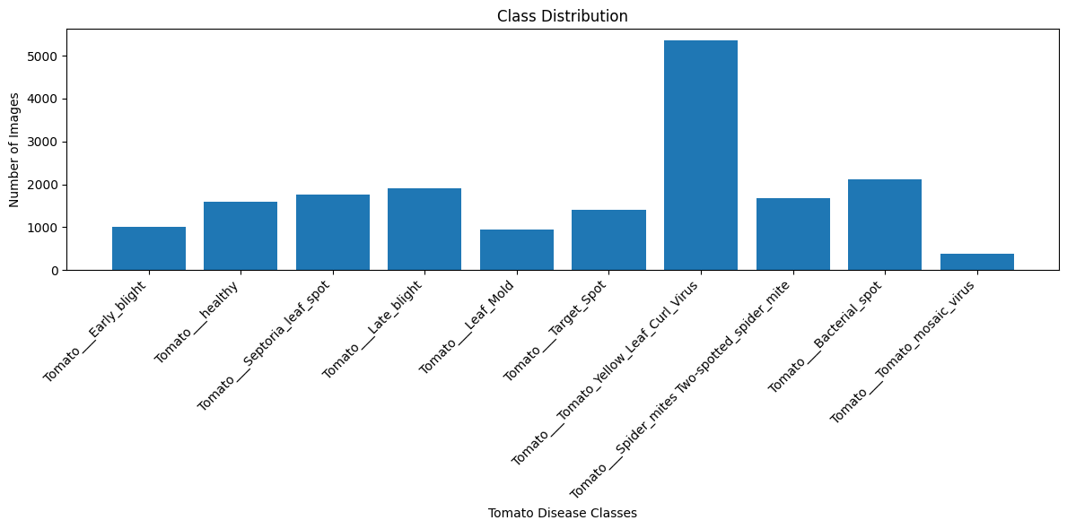
2. Dataset split
Found 18160 files belonging to 10 classes.
Using 14528 files for training.
Found 18160 files belonging to 10 classes.
Using 3632 files for validation.
3. Sample training images
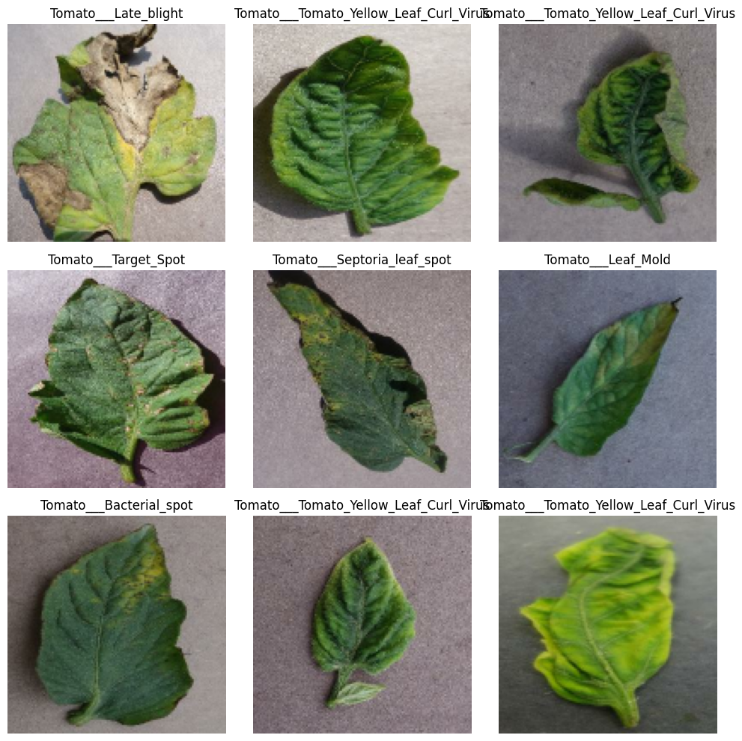
4. Model summary
Model: "sequential"

┏━━━━━━━━━━━━━━━━━━━━━━━━━━━━━━━━━┳━━━━━━━━━━━━━━━━━━━━━━━━┳━━━━━━━━━━━━━━━┓
┃ Layer (type) ┃ Output Shape ┃ Param # ┃
┡━━━━━━━━━━━━━━━━━━━━━━━━━━━━━━━━━╇━━━━━━━━━━━━━━━━━━━━━━━━╇━━━━━━━━━━━━━━━┩
│ conv2d (Conv2D) │ (None, 126, 126, 32) │ 896 │
├─────────────────────────────────┼────────────────────────┼───────────────┤
│ max_pooling2d (MaxPooling2D) │ (None, 63, 63, 32) │ 0 │
├─────────────────────────────────┼────────────────────────┼───────────────┤
│ conv2d_1 (Conv2D) │ (None, 61, 61, 64) │ 18,496 │
├─────────────────────────────────┼────────────────────────┼───────────────┤
│ max_pooling2d_1 (MaxPooling2D) │ (None, 30, 30, 64) │ 0 │
├─────────────────────────────────┼────────────────────────┼───────────────┤
│ conv2d_2 (Conv2D) │ (None, 28, 28, 128) │ 73,856 │
├─────────────────────────────────┼────────────────────────┼───────────────┤
│ max_pooling2d_2 (MaxPooling2D) │ (None, 14, 14, 128) │ 0 │
├─────────────────────────────────┼────────────────────────┼───────────────┤
│ flatten (Flatten) │ (None, 25088) │ 0 │
├─────────────────────────────────┼────────────────────────┼───────────────┤
│ dense (Dense) │ (None, 128) │ 3,211,392 │
├─────────────────────────────────┼────────────────────────┼───────────────┤
│ dropout (Dropout) │ (None, 128) │ 0 │
├─────────────────────────────────┼────────────────────────┼───────────────┤
│ dense_1 (Dense) │ (None, 10) │ 1,290 │
└─────────────────────────────────┴────────────────────────┴───────────────┘

Total params: 3,305,930 (12.61 MB)

Trainable params: 3,305,930 (12.61 MB)

Non-trainable params: 0 (0.00 B)

5. Training log (3 epochs)
Epoch | Train Accuracy | Train Loss | Val Accuracy | Val Loss | Time / epoch
1/3 | 0.5891 | 1.2160 | 0.7971 | 0.6363 | 526 s
2/3 | 0.7761 | 0.6564 | 0.8544 | 0.4156 | 526 s
3/3 | 0.8287 | 0.5032 | 0.8824 | 0.3364 | 519 s
6. Training and validation accuracy
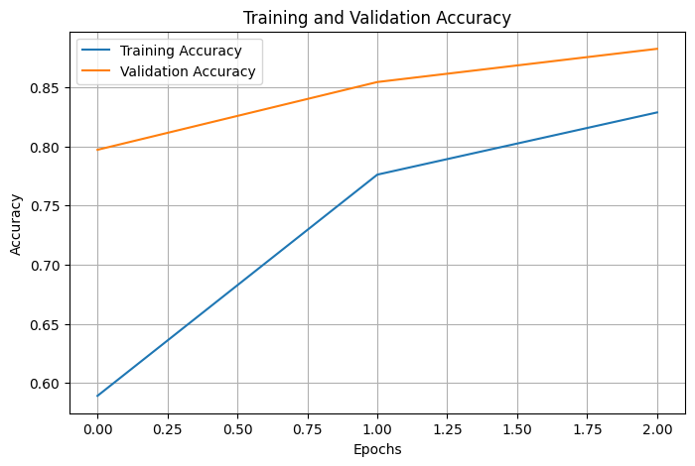
7. Training and validation loss
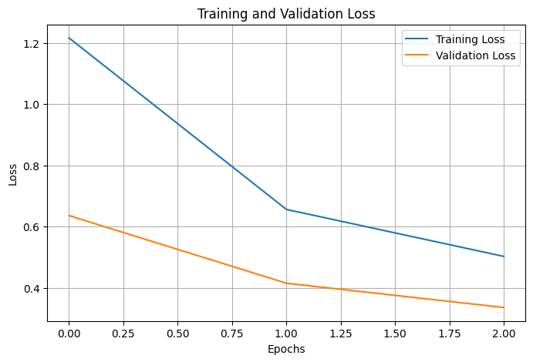
8. Confusion matrix
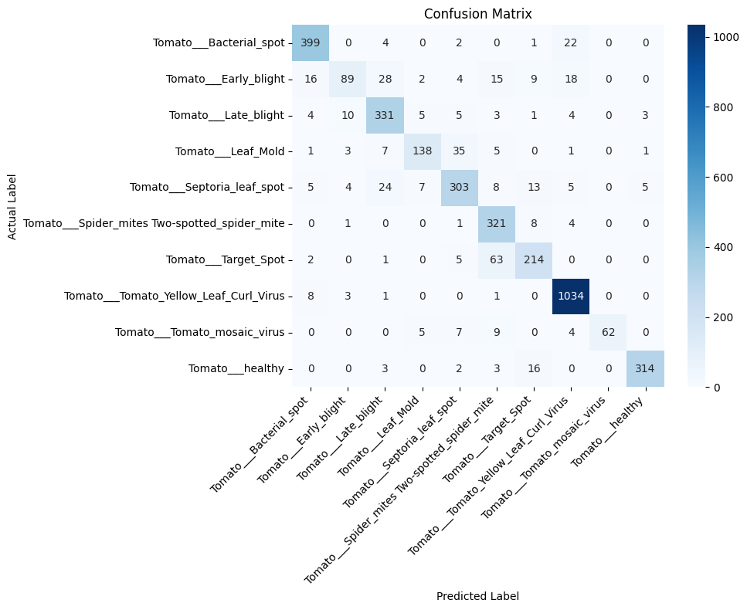
9. Classification report
Class | Precision | Recall | F1-score | Support
Bacterial_spot | 0.92 | 0.93 | 0.92 | 428
Early_blight | 0.81 | 0.49 | 0.61 | 181
Late_blight | 0.83 | 0.90 | 0.87 | 366
Leaf_Mold | 0.88 | 0.72 | 0.79 | 191
Septoria_leaf_spot | 0.83 | 0.81 | 0.82 | 374
Spider_mites | 0.75 | 0.96 | 0.84 | 335
Target_Spot | 0.82 | 0.75 | 0.78 | 285
Yellow_Leaf_Curl_Virus | 0.95 | 0.99 | 0.97 | 1047
Tomato_mosaic_virus | 1.00 | 0.71 | 0.83 | 87
healthy | 0.97 | 0.93 | 0.95 | 338
Accuracy |  |  | 0.88 | 3632
Macro avg | 0.88 | 0.82 | 0.84 | 3632
Weighted avg | 0.88 | 0.88 | 0.88 | 3632
10. Sample predictions (actual vs predicted)
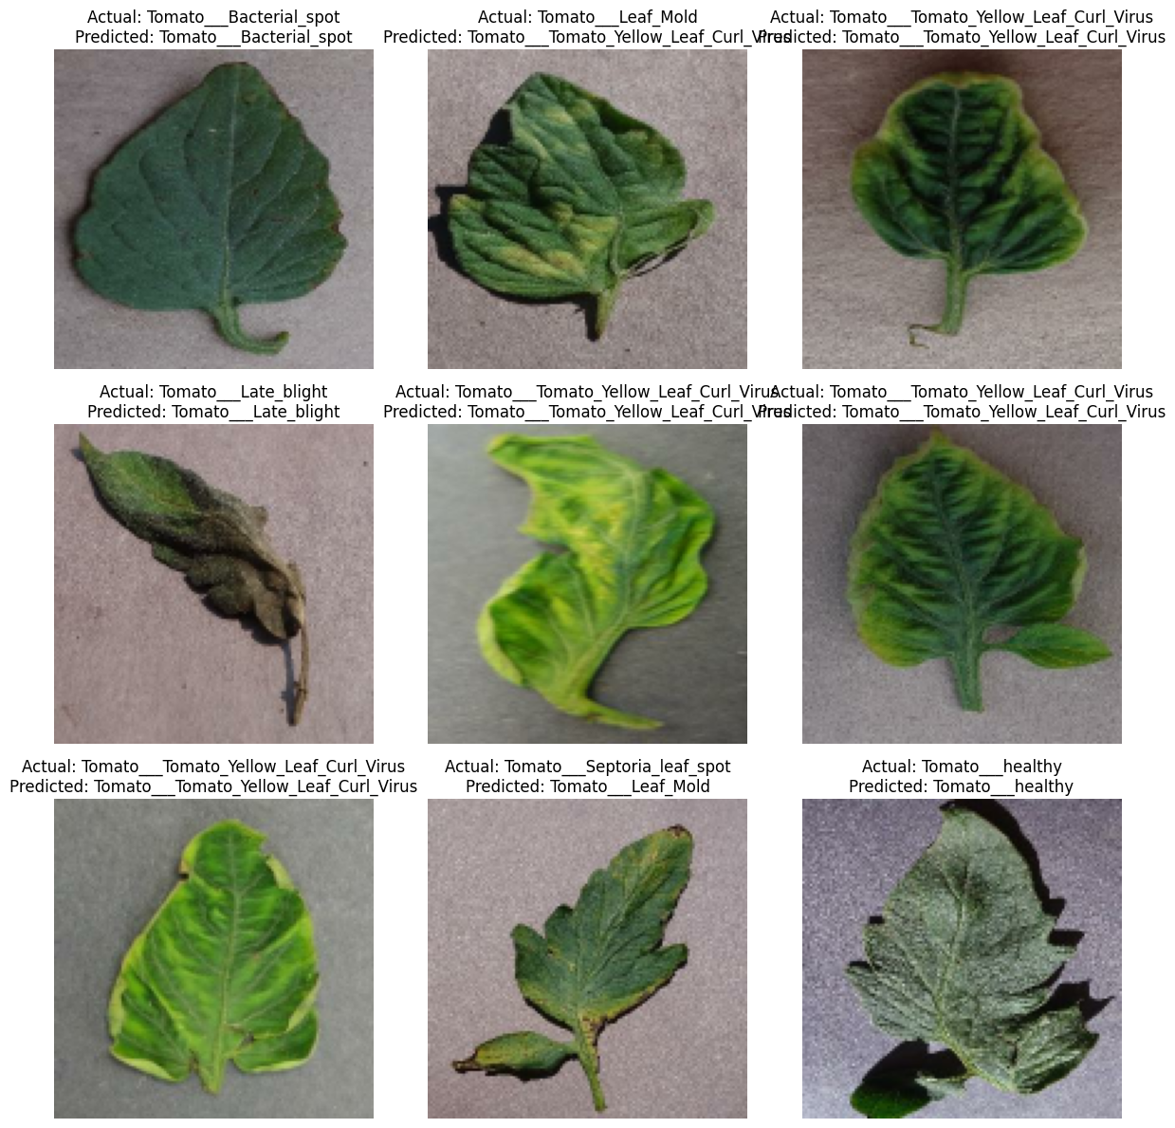
11. Final accuracy
Correct Predictions: 3205
Total Predictions: 3632
Manual Accuracy: 0.8824339207048458
12. Result analysis
- The CNN reached 88.24% validation accuracy (3,205 of 3,632 images correct) after only 3 epochs. Validation accuracy rose from 79.7% to 88.2% and validation loss fell from 0.636 to 0.336.
- Validation accuracy is slightly above training accuracy, which is normal here because dropout is active during training and the training figures are averaged over the epoch.
- Best classes: Yellow Leaf Curl Virus (F1 0.97), healthy leaves (0.95) and Bacterial spot (0.92). Yellow Leaf Curl Virus is also the largest class (5,357 images).
- Weakest classes: Early blight (recall 0.49, F1 0.61), Target Spot (F1 0.78) and Leaf Mold (F1 0.79). Tomato mosaic virus had perfect precision but only 0.71 recall and is the smallest class (373 images).
- Both curves were still improving at epoch 3, so training for more epochs (each epoch took about 9 minutes here) should raise the accuracy further.

