BRACT’s
Vishwakarma Institute of Technology, Pune
Practical Implementation Sheet
Department: CSE-AI Semester: 5 Academic Year: 2026-27
Division: E Batch: 3 Practical No: 4
Roll no: 21 PRN No: 12413751 Name of Student: Prathmesh Sandeep Horne
Subject Name : Deep Learning
LSTM-Based Time-Series Forecasting of Stock Prices

Problem Statement :
Develop an LSTM-based model for time-series forecasting using stock price, weather, or sales datasets.
Dataset used: Apple (AAPL) daily stock prices, February 2015 to February 2017 (506 trading days); the closing price is forecast.

Algorithm :
- Import the required libraries (TensorFlow/Keras, NumPy, pandas, matplotlib, scikit-learn).
- Load the Apple stock dataset from a CSV file and inspect its shape, columns, data types, summary statistics and missing values (none found).
- Convert the Date column to datetime, sort the data by date, and plot the closing price over time.
- Select the closing price (AAPL.Close) and scale it to the range 0–1 using MinMaxScaler.
- Split the data into 80% training (404 days) and 20% testing (102 days) in time order, without shuffling.
- Create sequences using a sliding window: the previous 60 days are the input and the next day's closing price is the target. Reshape the input to (samples, 60, 1).
- Build the model: LSTM(50, return sequences) → Dropout(0.2) → LSTM(50) → Dropout(0.2) → Dense(25, ReLU) → Dense(1).
- Compile with the Adam optimizer and mean squared error loss; train for 5 epochs with batch size 32 and 10% of the training data for validation.
- Plot the training and validation loss.
- Predict on the test sequences and convert the predictions back to the original price scale with inverse_transform.
- Evaluate the forecast using MSE, RMSE and MAE, and plot actual vs predicted prices.
- Use the last 60 days of data to forecast the next closing price.

Code :
# ---- Cell 1 ----
import numpy as np
import pandas as pd
import matplotlib.pyplot as plt
import tensorflow as tf
from tensorflow import keras
from tensorflow.keras import layers
from sklearn.preprocessing import MinMaxScaler
from sklearn.metrics import mean_squared_error, mean_absolute_error
# ---- Cell 2 ----
url = "https://raw.githubusercontent.com/plotly/datasets/master/finance-charts-apple.csv"

df = pd.read_csv(url)

df.head()
# ---- Cell 3 ----
print(df.shape)
print(df.columns)
print(df.info())
# ---- Cell 4 ----
df.describe()
# ---- Cell 5 ----
print(df.isnull().sum())
# ---- Cell 6 ----
df["Date"] = pd.to_datetime(df["Date"])
df = df.sort_values("Date")
# ---- Cell 7 ----
plt.figure(figsize=(14, 6))

plt.plot(
df["Date"],
df["AAPL.Close"]
)

plt.xlabel("Date")
plt.ylabel("Closing Price")
plt.title("Apple Stock Closing Price")
plt.grid(True)
plt.show()
# ---- Cell 8 ----
data = df[["AAPL.Close"]].values
# ---- Cell 9 ----
scaler = MinMaxScaler(feature_range=(0, 1))

scaled_data = scaler.fit_transform(data)

print(scaled_data[:5])
# ---- Cell 10 ----
train_size = int(len(scaled_data) * 0.8)

train_data = scaled_data[:train_size]
test_data = scaled_data[train_size:]

print("Training Samples:", len(train_data))
print("Testing Samples:", len(test_data))
# ---- Cell 11 ----
def create_sequences(dataset, time_step=60):
X = []
y = []

for i in range(time_step, len(dataset)):
X.append(dataset[i-time_step:i, 0])
y.append(dataset[i, 0])

return np.array(X), np.array(y)
# ---- Cell 12 ----
X_train, y_train = create_sequences(train_data, 60)

combined_data = np.concatenate(
(train_data[-60:], test_data),
axis=0
)

X_test, y_test = create_sequences(combined_data, 60)

print("X_train Shape:", X_train.shape)
print("y_train Shape:", y_train.shape)
print("X_test Shape:", X_test.shape)
print("y_test Shape:", y_test.shape)
# ---- Cell 13 ----
X_train = X_train.reshape(
X_train.shape[0],
X_train.shape[1],
1
)

X_test = X_test.reshape(
X_test.shape[0],
X_test.shape[1],
1
)

print(X_train.shape)
print(X_test.shape)
# ---- Cell 14 ----
model = keras.Sequential([
layers.LSTM(
50,
return_sequences=True,
input_shape=(X_train.shape[1], 1)
),

layers.Dropout(0.2),

layers.LSTM(
50,
return_sequences=False
),

layers.Dropout(0.2),

layers.Dense(25, activation="relu"),

layers.Dense(1)
])
# ---- Cell 15 ----
model.summary()
# ---- Cell 16 ----
model.compile(
optimizer="adam",
loss="mean_squared_error"
)
# ---- Cell 17 ----
history = model.fit(
X_train,
y_train,
epochs=5,
batch_size=32,
validation_split=0.1,
verbose=1
)
# ---- Cell 18 ----
plt.figure(figsize=(8, 5))

plt.plot(
history.history["loss"],
label="Training Loss"
)

plt.plot(
history.history["val_loss"],
label="Validation Loss"
)

plt.xlabel("Epochs")
plt.ylabel("Loss")
plt.title("LSTM Training and Validation Loss")
plt.legend()
plt.grid(True)
plt.show()
# ---- Cell 19 ----
predictions = model.predict(X_test)
# ---- Cell 20 ----
predictions = scaler.inverse_transform(predictions)

actual_prices = scaler.inverse_transform(
y_test.reshape(-1, 1)
)
# ---- Cell 21 ----
mse = mean_squared_error(actual_prices, predictions)
rmse = np.sqrt(mse)
mae = mean_absolute_error(actual_prices, predictions)

print("Mean Squared Error:", mse)
print("Root Mean Squared Error:", rmse)
print("Mean Absolute Error:", mae)
# ---- Cell 22 ----
plt.figure(figsize=(14, 6))

plt.plot(
actual_prices,
label="Actual Prices"
)

plt.plot(
predictions,
label="Predicted Prices"
)

plt.xlabel("Time")
plt.ylabel("Stock Price")
plt.title("Actual vs Predicted Stock Prices")
plt.legend()
plt.grid(True)
plt.show()
# ---- Cell 23 ----
results = pd.DataFrame({
"Actual Price": actual_prices.flatten(),
"Predicted Price": predictions.flatten()
})

results.head(20)
# ---- Cell 24 ----
last_60_days = scaled_data[-60:]

last_60_days = last_60_days.reshape(
1,
60,
1
)

next_prediction = model.predict(last_60_days)

next_prediction = scaler.inverse_transform(
next_prediction
)

print("Predicted Next Closing Price:", next_prediction[0][0])
# ---- Cell 25 ----
print("An LSTM-based time-series forecasting model was developed.")
print("The model used the previous 60 stock prices to predict the next closing price.")
print("The data was normalized using MinMaxScaler.")
print("The model performance was evaluated using MSE, RMSE and MAE.")
print("Actual and predicted stock prices were visualized using a comparison graph.")

Output :
1. Dataset overview
Shape: (506, 11)
Columns: Date, AAPL.Open, AAPL.High, AAPL.Low, AAPL.Close, AAPL.Volume, AAPL.Adjusted, dn, mavg, up, direction
Missing values: 0 in every column
Date | AAPL.Open | AAPL.High | AAPL.Low | AAPL.Close | AAPL.Volume
2015-02-17 | 127.49 | 128.88 | 126.92 | 127.83 | 63,152,400
2015-02-18 | 127.63 | 128.78 | 127.45 | 128.72 | 44,891,700
2015-02-19 | 128.48 | 129.03 | 128.33 | 128.45 | 37,362,400
2015-02-20 | 128.62 | 129.50 | 128.05 | 129.50 | 48,948,400
2015-02-23 | 130.02 | 133.00 | 129.66 | 133.00 | 70,974,100
2. Apple stock closing price
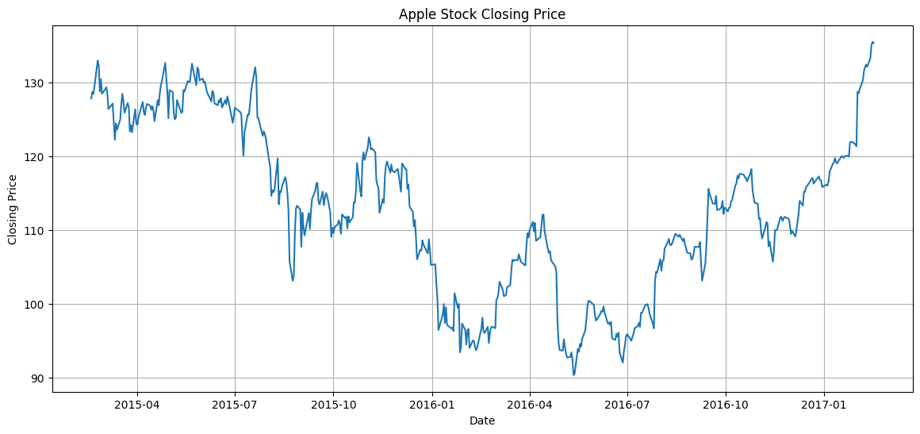
3. Data split and sequences
Training Samples: 404
Testing Samples: 102
X_train Shape: (344, 60)
y_train Shape: (344,)
X_test Shape: (102, 60)
y_test Shape: (102,)
Reshaped: (344, 60, 1) and (102, 60, 1)
4. Model summary
Model: "sequential"

┏━━━━━━━━━━━━━━━━━━━━━━━━━━━━━━━━━┳━━━━━━━━━━━━━━━━━━━━━━━━┳━━━━━━━━━━━━━━━┓
┃ Layer (type) ┃ Output Shape ┃ Param # ┃
┡━━━━━━━━━━━━━━━━━━━━━━━━━━━━━━━━━╇━━━━━━━━━━━━━━━━━━━━━━━━╇━━━━━━━━━━━━━━━┩
│ lstm (LSTM) │ (None, 60, 50) │ 10,400 │
├─────────────────────────────────┼────────────────────────┼───────────────┤
│ dropout (Dropout) │ (None, 60, 50) │ 0 │
├─────────────────────────────────┼────────────────────────┼───────────────┤
│ lstm_1 (LSTM) │ (None, 50) │ 20,200 │
├─────────────────────────────────┼────────────────────────┼───────────────┤
│ dropout_1 (Dropout) │ (None, 50) │ 0 │
├─────────────────────────────────┼────────────────────────┼───────────────┤
│ dense (Dense) │ (None, 25) │ 1,275 │
├─────────────────────────────────┼────────────────────────┼───────────────┤
│ dense_1 (Dense) │ (None, 1) │ 26 │
└─────────────────────────────────┴────────────────────────┴───────────────┘

Total params: 31,901 (124.61 KB)

Trainable params: 31,901 (124.61 KB)

Non-trainable params: 0 (0.00 B)

5. Training log (5 epochs)
Epoch | Training Loss | Validation Loss
1/5 | 0.1199 | 0.0106
2/5 | 0.0301 | 0.0183
3/5 | 0.0233 | 0.0055
4/5 | 0.0157 | 0.0064
5/5 | 0.0142 | 0.0090
6. Training and validation loss
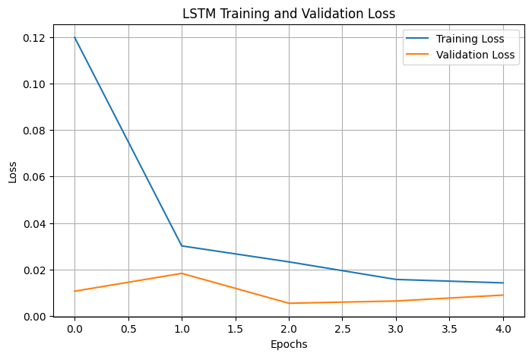
7. Evaluation metrics
Mean Squared Error: 27.350611801584026
Root Mean Squared Error: 5.22978123840606
Mean Absolute Error: 4.308923983345781
Metric | Value
MSE | 27.3506
RMSE | 5.2298
MAE | 4.3089
8. Actual vs predicted stock prices
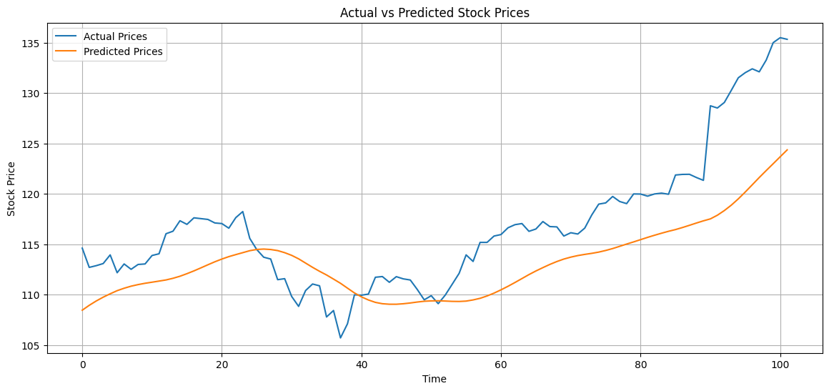
9. Sample of actual and predicted prices (first 10 test days)
Day | Actual Price | Predicted Price
0 | 114.62 | 108.46
1 | 112.71 | 108.94
2 | 112.88 | 109.37
3 | 113.09 | 109.75
4 | 113.95 | 110.09
5 | 112.18 | 110.40
6 | 113.05 | 110.64
7 | 112.52 | 110.85
8 | 113.00 | 111.00
9 | 113.05 | 111.13
10. Next-day forecast
Predicted Next Closing Price: 125.01934
11. Result analysis
- The LSTM forecast follows the overall trend of the stock. On the test period the RMSE is about $5.23 and the MAE about $4.31, roughly 3.8% of the average closing price (about $113).
- The predicted curve is smoother than the actual one and lags behind it. It underestimates the sharp rise at the end of the test period (actual price near 135, prediction near 124), because the test prices are higher than most prices seen during training.
- Training loss fell from 0.120 to 0.014. Validation loss was lowest at epoch 3 (0.0055) and then varied slightly; the validation set is small (35 sequences), so these changes are noisy.
- The next-day forecast of 125.02 is lower than the most recent prices (about 135), which is consistent with the model's tendency to underestimate sharp rises.
- Accuracy could be improved by training for more epochs, using a larger dataset, and adding more input features such as volume or moving averages.

