BRACT’s
Vishwakarma Institute of Technology, Pune
Practical Implementation Sheet
Department: CSE-AI Semester: 5 Academic Year: 2026-27
Division: E Batch: 3 Practical No:1
Roll no: 21 PRN No: 12413751 Name of Student: Prathmesh Sandeep Horne
Subject Name : Deep Learning
Installing and Configuring TensorFlow/Keras in Google Colab: Data Preprocessing and Visualization

Problem Statement :
Install and configure TensorFlow/Keras in Google Colab. Perform data preprocessing, normalization, train-test splitting, and data visualization on a sample dataset.
Dataset used: Iris flower dataset (150 samples, 4 features, 3 classes), loaded from scikit-learn.

Algorithm :
- Open Google Colab and create a new notebook. TensorFlow and Keras come pre-installed in Colab (if a different version is needed, install it with pip install tensorflow).
- Import TensorFlow and Keras and print the TensorFlow version to confirm that the installation and configuration are working.
- Import the data-handling and visualization libraries: pandas, NumPy, scikit-learn, matplotlib and seaborn.
- Load the Iris dataset from scikit-learn into a pandas DataFrame and display the first rows.
- Explore the data: check the shape, data types, summary statistics (describe) and missing values.
- Normalize the features with StandardScaler so each feature has mean 0 and standard deviation 1.
- Split the scaled data into 80% training and 20% testing sets using train_test_split (random_state = 42).
- Visualize the data using a pair plot, a correlation heatmap, histograms and a box plot.
- Build a small Keras Sequential model (Dense(8, ReLU) → Dense(3, softmax)) and print its summary to confirm that Keras works.

Code :
# ---- Cell 1 ----
import tensorflow as tf
from tensorflow import keras

print("TensorFlow Version:", tf.__version__)
# ---- Cell 2 ----
import pandas as pd
import numpy as np

from sklearn.datasets import load_iris
from sklearn.model_selection import train_test_split
from sklearn.preprocessing import StandardScaler

import matplotlib.pyplot as plt
import seaborn as sns
# ---- Cell 3 ----
iris = load_iris()

X = pd.DataFrame(iris.data, columns=iris.feature_names)
y = iris.target

print(X.head())
# ---- Cell 4 ----
print(X.shape)

print(X.info())

print(X.describe())

print(X.isnull().sum())
# ---- Cell 5 ----
X = iris.data
y = iris.target
# ---- Cell 6 ----
scaler = StandardScaler()

X_scaled = scaler.fit_transform(X)

print(X_scaled[:5])
# ---- Cell 7 ----
X_train, X_test, y_train, y_test = train_test_split(
X_scaled,
y,
test_size=0.2,
random_state=42
)

print("Training Data:", X_train.shape)
print("Testing Data:", X_test.shape)
# ---- Cell 8 ----
df = pd.DataFrame(iris.data, columns=iris.feature_names)
df['Species'] = iris.target

sns.pairplot(df, hue="Species")
plt.show()
# ---- Cell 9 ----
plt.figure(figsize=(8,6))
sns.heatmap(df.corr(), annot=True, cmap="coolwarm")
plt.show()
# ---- Cell 10 ----
df.hist(figsize=(10,8))
plt.show()
# ---- Cell 11 ----
plt.figure(figsize=(10,6))
sns.boxplot(data=df.iloc[:,:4])
plt.show()
# ---- Cell 12 ----
model = keras.Sequential([
keras.layers.Dense(8, activation='relu', input_shape=(4,)),
keras.layers.Dense(3, activation='softmax')
])

model.summary()

Output :
1. TensorFlow installation check
TensorFlow Version: 2.20.0
2. First five rows of the dataset
Index | Sepal length (cm) | Sepal width (cm) | Petal length (cm) | Petal width (cm)
0 | 5.1 | 3.5 | 1.4 | 0.2
1 | 4.9 | 3.0 | 1.4 | 0.2
2 | 4.7 | 3.2 | 1.3 | 0.2
3 | 4.6 | 3.1 | 1.5 | 0.2
4 | 5.0 | 3.6 | 1.4 | 0.2
3. Dataset information
Shape: (150, 4)
Columns: 4 (all float64), 150 non-null entries each
Missing values: 0 in every column
Statistic | Sepal length | Sepal width | Petal length | Petal width
count | 150 | 150 | 150 | 150
mean | 5.843 | 3.057 | 3.758 | 1.199
std | 0.828 | 0.436 | 1.765 | 0.762
min | 4.3 | 2.0 | 1.0 | 0.1
25% | 5.1 | 2.8 | 1.6 | 0.3
50% | 5.8 | 3.0 | 4.35 | 1.3
75% | 6.4 | 3.3 | 5.1 | 1.8
max | 7.9 | 4.4 | 6.9 | 2.5
4. After normalization (first five rows, StandardScaler)
Sepal length | Sepal width | Petal length | Petal width
-0.9007 | 1.0190 | -1.3402 | -1.3154
-1.1430 | -0.1320 | -1.3402 | -1.3154
-1.3854 | 0.3284 | -1.3971 | -1.3154
-1.5065 | 0.0982 | -1.2834 | -1.3154
-1.0218 | 1.2492 | -1.3402 | -1.3154
5. Train-test split
Training Data: (120, 4)
Testing Data: (30, 4)
6. Pair plot (species 0, 1, 2)
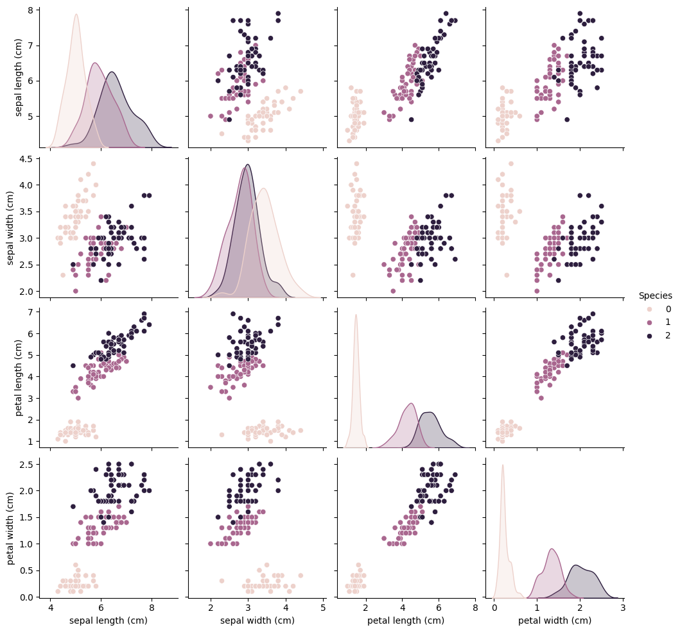
7. Correlation heatmap
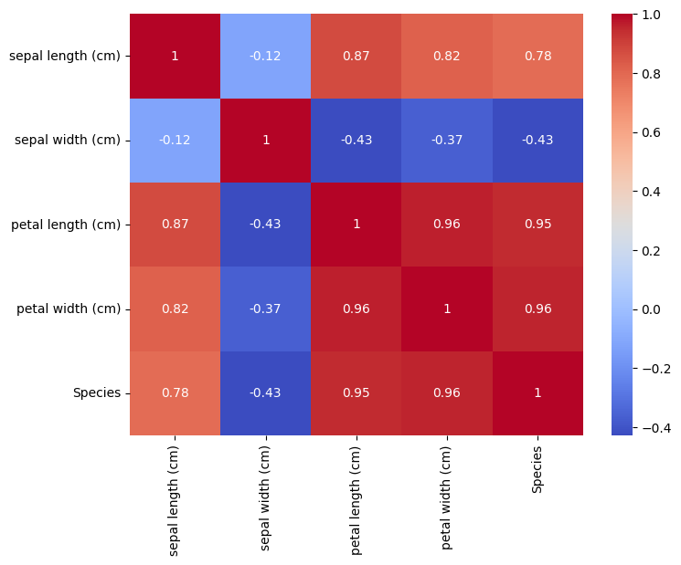
8. Histograms of the features
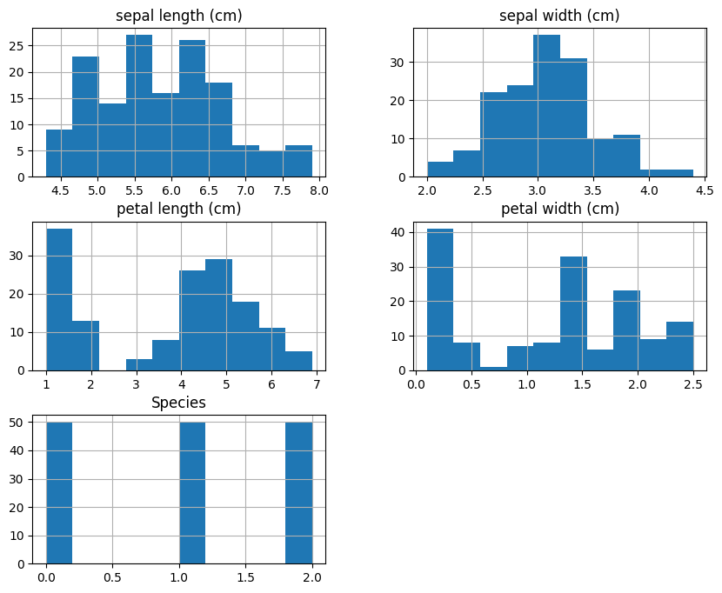
9. Box plot of the features
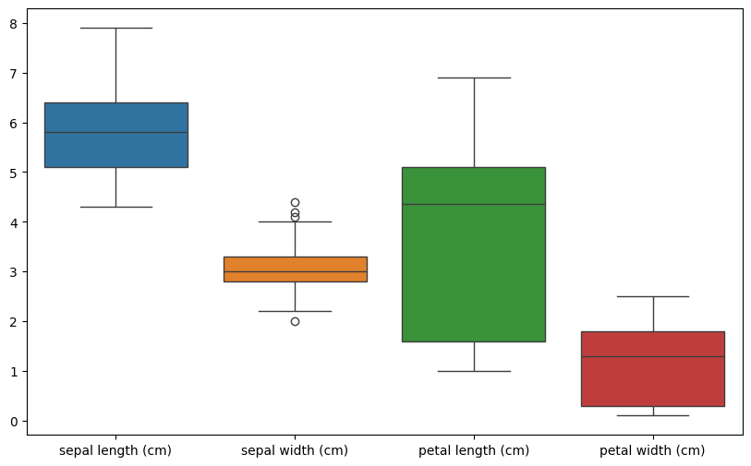
10. Keras model summary
Model: "sequential"
┏━━━━━━━━━━━━━━━━━━━━━━━━━━━━━━━━━┳━━━━━━━━━━━━━━━━━━━━━━━━┳━━━━━━━━━━━━━━━┓
┃ Layer (type) ┃ Output Shape ┃ Param # ┃
┡━━━━━━━━━━━━━━━━━━━━━━━━━━━━━━━━━╇━━━━━━━━━━━━━━━━━━━━━━━━╇━━━━━━━━━━━━━━━┩
│ dense (Dense) │ (None, 8) │ 40 │
├─────────────────────────────────┼────────────────────────┼───────────────┤
│ dense_1 (Dense) │ (None, 3) │ 27 │
└─────────────────────────────────┴────────────────────────┴───────────────┘
Total params: 67 (268.00 B)
Trainable params: 67 (268.00 B)
Non-trainable params: 0 (0.00 B)
11. Result analysis
- TensorFlow 2.20.0 was available in Colab and the Keras model was built successfully, so the environment is configured correctly.
- The Iris dataset has 150 samples, 4 numeric features and no missing values, so no cleaning was needed.
- The features have different ranges (for example petal length 1.0–6.9 and petal width 0.1–2.5). StandardScaler brought them to mean 0 and standard deviation 1, which helps neural networks train.
- The data was split into 120 training and 30 testing samples (80% / 20%).
- The pair plot shows that species 0 (setosa) is clearly separated from the other two, while species 1 and 2 overlap slightly.
- The heatmap shows a very strong correlation between petal length and petal width (0.96), and both are strongly correlated with the species (0.95 and 0.96). Sepal width is negatively correlated with the other features.

