BRACT’s
Vishwakarma Institute of Technology, Pune
Practical Implementation Sheet
Department: CSE-AI Semester: 5 Academic Year: 2026-27
Division: E Batch: 3 Practical No: 3
Roll no: 21 PRN No: 12413751 Name of Student: Prathmesh Sandeep Horne
Subject Name : Deep Learning
Forward Propagation and Backpropagation using TensorFlow/Keras: Effect of Learning Rate and Epochs

Problem Statement :
Implement forward propagation and backpropagation using TensorFlow/Keras. Analyze the effect of different learning rates and the number of epochs on model performance.
Dataset used: Fashion-MNIST (70,000 grayscale images of 28 × 28 pixels, 10 clothing classes).

Algorithm :
- Import TensorFlow/Keras, NumPy, pandas, matplotlib, seaborn and scikit-learn.
- Load the Fashion-MNIST dataset (60,000 training and 10,000 test images) and display sample images with their class names.
- Normalize the pixel values from 0–255 to the range 0–1 by dividing by 255.
- Build the neural network: Flatten (784 inputs) → Dense(128, ReLU) → Dense(64, ReLU) → Dense(10, softmax).
- Forward propagation: the input image is passed through each layer, where the output is activation(weights × input + bias). The softmax layer gives the probability of each of the 10 classes, and the loss is calculated with sparse categorical cross-entropy.
- Backpropagation: the gradient of the loss with respect to every weight and bias is calculated layer by layer from the output back to the input (chain rule). The Adam optimizer then updates the weights using these gradients and the learning rate. Keras performs both steps automatically in every batch of model.fit().
- Train the model for 10 epochs with a learning rate of 0.001 and 20% of the training data for validation; plot the accuracy and loss curves.
- Evaluate the model on the test set and generate the confusion matrix and classification report.
- Learning-rate analysis: train the same architecture with learning rates 0.1, 0.01 and 0.001 for 10 epochs and compare the validation accuracy.
- Epoch analysis: train the same architecture for 5, 10 and 20 epochs and compare the validation accuracy.
- Compare the results and conclude which learning rate and number of epochs perform best.

Code :
# ---- Cell 1 ----
import tensorflow as tf
from tensorflow import keras
from tensorflow.keras import layers
import pandas as pd

import numpy as np

import matplotlib.pyplot as plt
import seaborn as sns

from sklearn.metrics import confusion_matrix, classification_report
# ---- Cell 2 ----
(X_train, y_train), (X_test, y_test) = keras.datasets.fashion_mnist.load_data()
# ---- Cell 3 ----
print("Training Data Shape:", X_train.shape)
print("Testing Data Shape:", X_test.shape)

print("Number of Training Images:", X_train.shape[0])
print("Number of Testing Images:", X_test.shape[0])

print("Image Size:", X_train.shape[1], "x", X_train.shape[2])
# ---- Cell 4 ----
class_names = [
"T-shirt",
"Trouser",
"Pullover",
"Dress",
"Coat",
"Sandal",
"Shirt",
"Sneaker",
"Bag",
"Ankle Boot"
]

print(class_names)
# ---- Cell 5 ----
plt.figure(figsize=(10,8))

for i in range(9):
plt.subplot(3,3,i+1)
plt.imshow(X_train[i], cmap="gray")
plt.title(class_names[y_train[i]])
plt.axis("off")

plt.tight_layout()
plt.show()
# ---- Cell 6 ----
X_train = X_train / 255.0
X_test = X_test / 255.0
# ---- Cell 7 ----
model = keras.Sequential([
layers.Flatten(input_shape=(28,28)),
layers.Dense(128, activation="relu"),
layers.Dense(64, activation="relu"),
layers.Dense(10, activation="softmax")
])
# ---- Cell 8 ----
model.summary()
# ---- Cell 9 ----
model.compile(
optimizer=keras.optimizers.Adam(learning_rate=0.001),
loss="sparse_categorical_crossentropy",
metrics=["accuracy"]
)
# ---- Cell 10 ----
history = model.fit(
X_train,
y_train,
epochs=10,
validation_split=0.2
)
# ---- Cell 11 ----
test_loss, test_accuracy = model.evaluate(X_test, y_test)

print("Test Loss:", test_loss)
print("Test Accuracy:", test_accuracy)
# ---- Cell 12 ----
plt.figure(figsize=(8,5))

plt.plot(history.history["accuracy"], label="Training Accuracy")
plt.plot(history.history["val_accuracy"], label="Validation Accuracy")

plt.xlabel("Epochs")
plt.ylabel("Accuracy")
plt.title("Training and Validation Accuracy")
plt.legend()

plt.show()
# ---- Cell 13 ----
plt.figure(figsize=(8,5))

plt.plot(history.history["loss"], label="Training Loss")
plt.plot(history.history["val_loss"], label="Validation Loss")

plt.xlabel("Epochs")
plt.ylabel("Loss")
plt.title("Training and Validation Loss")
plt.legend()

plt.show()
# ---- Cell 14 ----
y_pred = model.predict(X_test)

y_pred_classes = np.argmax(y_pred, axis=1)
# ---- Cell 15 ----
cm = confusion_matrix(y_test, y_pred_classes)

plt.figure(figsize=(8,6))

sns.heatmap(
cm,
annot=True,
fmt="d",
cmap="Blues",
xticklabels=class_names,
yticklabels=class_names
)

plt.xlabel("Predicted")
plt.ylabel("Actual")
plt.title("Confusion Matrix")

plt.show()
# ---- Cell 16 ----
print(classification_report(
y_test,
y_pred_classes,
target_names=class_names
))
# ---- Cell 17 ----
results = pd.DataFrame({
"Actual": y_test,
"Predicted": y_pred_classes
})

results.head(20)
# ---- Cell 18 ----
model_lr1 = keras.Sequential([
layers.Flatten(input_shape=(28,28)),
layers.Dense(128, activation="relu"),
layers.Dense(64, activation="relu"),
layers.Dense(10, activation="softmax")
])

model_lr1.compile(
optimizer=keras.optimizers.Adam(learning_rate=0.1),
loss="sparse_categorical_crossentropy",
metrics=["accuracy"]
)

history_lr1 = model_lr1.fit(
X_train,
y_train,
epochs=10,
validation_split=0.2,
verbose=0
)

print("Accuracy (LR=0.1):", history_lr1.history["val_accuracy"][-1])
# ---- Cell 19 ----
model_lr2 = keras.Sequential([
layers.Flatten(input_shape=(28,28)),
layers.Dense(128, activation="relu"),
layers.Dense(64, activation="relu"),
layers.Dense(10, activation="softmax")
])

model_lr2.compile(
optimizer=keras.optimizers.Adam(learning_rate=0.01),
loss="sparse_categorical_crossentropy",
metrics=["accuracy"]
)

history_lr2 = model_lr2.fit(
X_train,
y_train,
epochs=10,
validation_split=0.2,
verbose=0
)

print("Accuracy (LR=0.01):", history_lr2.history["val_accuracy"][-1])
# ---- Cell 20 ----
model_lr3 = keras.Sequential([
layers.Flatten(input_shape=(28,28)),
layers.Dense(128, activation="relu"),
layers.Dense(64, activation="relu"),
layers.Dense(10, activation="softmax")
])

model_lr3.compile(
optimizer=keras.optimizers.Adam(learning_rate=0.001),
loss="sparse_categorical_crossentropy",
metrics=["accuracy"]
)

history_lr3 = model_lr3.fit(
X_train,
y_train,
epochs=10,
validation_split=0.2,
verbose=0
)

print("Accuracy (LR=0.001):", history_lr3.history["val_accuracy"][-1])
# ---- Cell 21 ----
learning_rates = ["0.1", "0.01", "0.001"]

accuracies = [
history_lr1.history["val_accuracy"][-1],
history_lr2.history["val_accuracy"][-1],
history_lr3.history["val_accuracy"][-1]
]

plt.figure(figsize=(6,4))

plt.bar(learning_rates, accuracies)

plt.xlabel("Learning Rate")
plt.ylabel("Validation Accuracy")
plt.title("Learning Rate Comparison")

plt.show()
# ---- Cell 22 ----
model5 = keras.models.clone_model(model)
model5.compile(
optimizer="adam",
loss="sparse_categorical_crossentropy",
metrics=["accuracy"]
)

history5 = model5.fit(
X_train,
y_train,
epochs=5,
validation_split=0.2,
verbose=0
)

print("Validation Accuracy (5 Epochs):", history5.history["val_accuracy"][-1])
# ---- Cell 23 ----
model10 = keras.models.clone_model(model)
model10.compile(
optimizer="adam",
loss="sparse_categorical_crossentropy",
metrics=["accuracy"]
)

history10 = model10.fit(
X_train,
y_train,
epochs=10,
validation_split=0.2,
verbose=0
)

print("Validation Accuracy (10 Epochs):", history10.history["val_accuracy"][-1])
# ---- Cell 24 ----
model20 = keras.models.clone_model(model)
model20.compile(
optimizer="adam",
loss="sparse_categorical_crossentropy",
metrics=["accuracy"]
)

history20 = model20.fit(
X_train,
y_train,
epochs=20,
validation_split=0.2,
verbose=0
)

print("Validation Accuracy (20 Epochs):", history20.history["val_accuracy"][-1])
# ---- Cell 25 ----
epochs = ["5", "10", "20"]

accuracy = [
history5.history["val_accuracy"][-1],
history10.history["val_accuracy"][-1],
history20.history["val_accuracy"][-1]
]

plt.figure(figsize=(6,4))

plt.bar(epochs, accuracy)

plt.xlabel("Epochs")
plt.ylabel("Validation Accuracy")
plt.title("Epoch Comparison")

plt.show()

Output :
1. Dataset details
Training Data Shape: (60000, 28, 28)
Testing Data Shape: (10000, 28, 28)
Number of Training Images: 60000
Number of Testing Images: 10000
Image Size: 28 x 28
Classes: ['T-shirt', 'Trouser', 'Pullover', 'Dress', 'Coat', 'Sandal', 'Shirt', 'Sneaker', 'Bag', 'Ankle Boot']
2. Sample training images
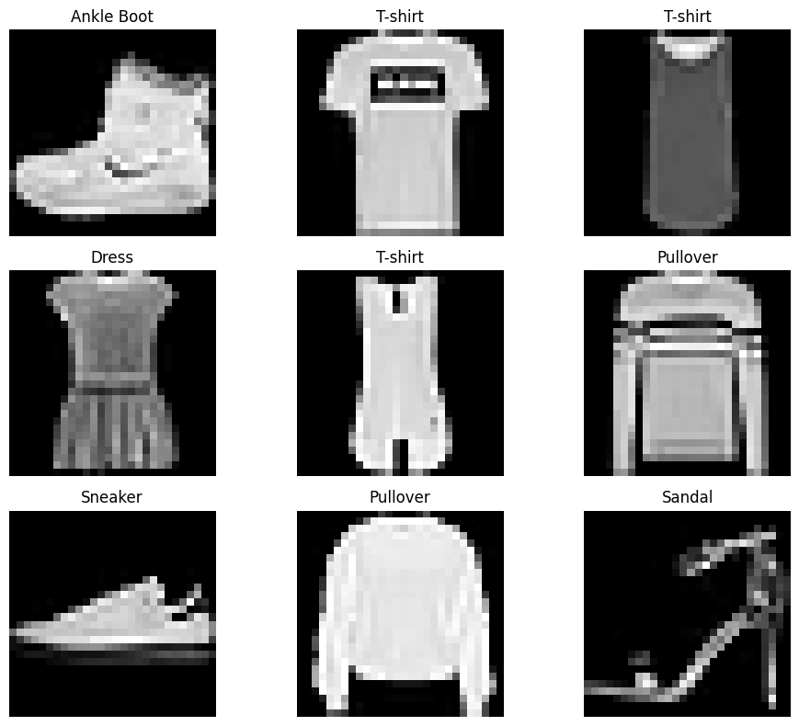
3. Model summary
Model: "sequential"
┏━━━━━━━━━━━━━━━━━━━━━━━━━━━━━━━━━┳━━━━━━━━━━━━━━━━━━━━━━━━┳━━━━━━━━━━━━━━━┓
┃ Layer (type) ┃ Output Shape ┃ Param # ┃
┡━━━━━━━━━━━━━━━━━━━━━━━━━━━━━━━━━╇━━━━━━━━━━━━━━━━━━━━━━━━╇━━━━━━━━━━━━━━━┩
│ flatten (Flatten) │ (None, 784) │ 0 │
├─────────────────────────────────┼────────────────────────┼───────────────┤
│ dense (Dense) │ (None, 128) │ 100,480 │
├─────────────────────────────────┼────────────────────────┼───────────────┤
│ dense_1 (Dense) │ (None, 64) │ 8,256 │
├─────────────────────────────────┼────────────────────────┼───────────────┤
│ dense_2 (Dense) │ (None, 10) │ 650 │
└─────────────────────────────────┴────────────────────────┴───────────────┘
Total params: 109,386 (427.29 KB)
Trainable params: 109,386 (427.29 KB)
Non-trainable params: 0 (0.00 B)
4. Training log (10 epochs, learning rate 0.001)
Epoch | Train Accuracy | Train Loss | Val Accuracy | Val Loss
1/10 | 0.8175 | 0.5181 | 0.8571 | 0.3926
2/10 | 0.8627 | 0.3789 | 0.8657 | 0.3629
3/10 | 0.8742 | 0.3400 | 0.8733 | 0.3486
4/10 | 0.8823 | 0.3159 | 0.8764 | 0.3407
5/10 | 0.8887 | 0.2969 | 0.8798 | 0.3339
6/10 | 0.8954 | 0.2809 | 0.8761 | 0.3442
7/10 | 0.9003 | 0.2659 | 0.8842 | 0.3233
8/10 | 0.9041 | 0.2567 | 0.8867 | 0.3239
9/10 | 0.9066 | 0.2473 | 0.8906 | 0.3154
10/10 | 0.9105 | 0.2399 | 0.8899 | 0.3176
5. Test evaluation
Test Loss: 0.3496529757976532
Test Accuracy: 0.883400022983551
6. Training and validation accuracy
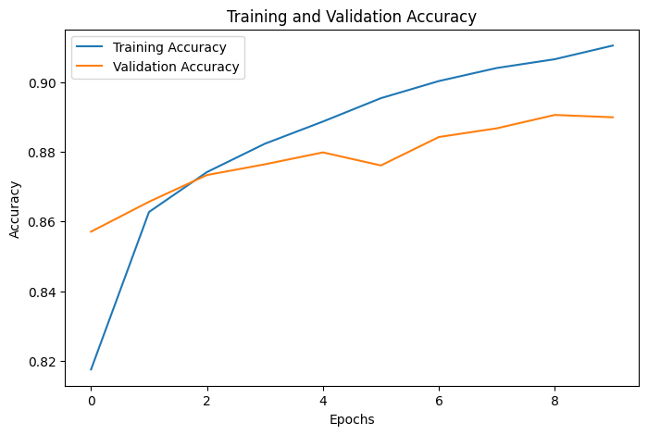
7. Training and validation loss
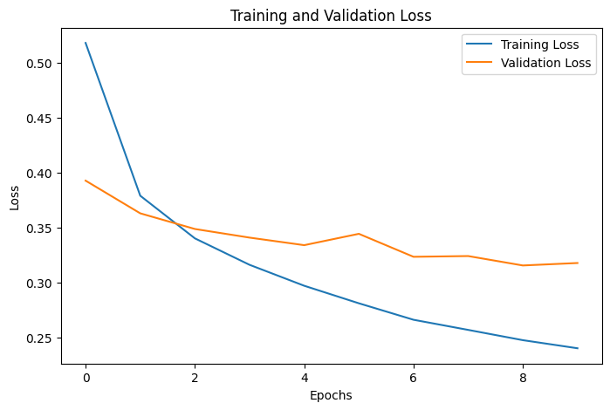
8. Confusion matrix
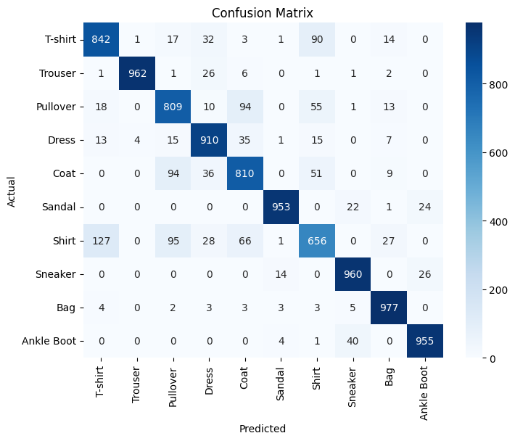
9. Classification report
Class | Precision | Recall | F1-score | Support
T-shirt | 0.84 | 0.84 | 0.84 | 1000
Trouser | 0.99 | 0.96 | 0.98 | 1000
Pullover | 0.78 | 0.81 | 0.80 | 1000
Dress | 0.87 | 0.91 | 0.89 | 1000
Coat | 0.80 | 0.81 | 0.80 | 1000
Sandal | 0.98 | 0.95 | 0.96 | 1000
Shirt | 0.75 | 0.66 | 0.70 | 1000
Sneaker | 0.93 | 0.96 | 0.95 | 1000
Bag | 0.93 | 0.98 | 0.95 | 1000
Ankle Boot | 0.95 | 0.95 | 0.95 | 1000
Accuracy |  |  | 0.88 | 10000
Macro avg | 0.88 | 0.88 | 0.88 | 10000
Weighted avg | 0.88 | 0.88 | 0.88 | 10000
10. Actual vs predicted labels (first 20 test images)
Index | Actual | Predicted | Index | Actual | Predicted
0 | 9 | 9 | 10 | 4 | 4
1 | 2 | 2 | 11 | 5 | 5
2 | 1 | 1 | 12 | 7 | 7
3 | 1 | 1 | 13 | 3 | 3
4 | 6 | 6 | 14 | 4 | 4
5 | 1 | 1 | 15 | 1 | 1
6 | 4 | 4 | 16 | 2 | 2
7 | 6 | 6 | 17 | 4 | 2
8 | 5 | 5 | 18 | 8 | 8
9 | 7 | 7 | 19 | 0 | 0
11. Effect of the learning rate (10 epochs, Adam)
Accuracy (LR=0.1): 0.09833333641290665
Accuracy (LR=0.01): 0.8534166812896729
Accuracy (LR=0.001): 0.8787500262260437
Learning rate | Validation accuracy
0.1 | 0.0983 (9.83%)
0.01 | 0.8534 (85.34%)
0.001 | 0.8788 (87.88%)
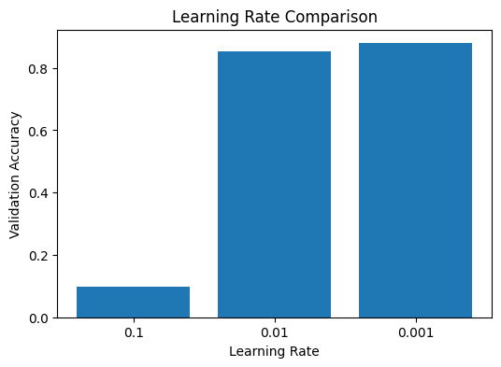
12. Effect of the number of epochs (learning rate 0.001, Adam)
Validation Accuracy (5 Epochs): 0.8738333582878113
Validation Accuracy (10 Epochs): 0.8869166374206543
Validation Accuracy (20 Epochs): 0.8911666870117188
Epochs | Validation accuracy
5 | 0.8738 (87.38%)
10 | 0.8869 (88.69%)
20 | 0.8912 (89.12%)
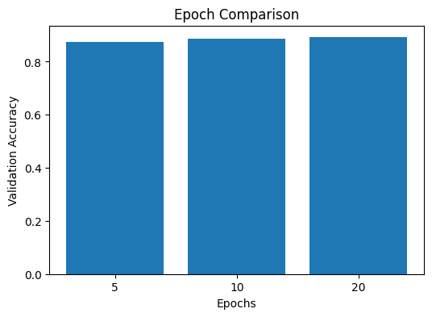
13. Result analysis
- The network reached 88.34% test accuracy (test loss 0.350) after 10 epochs with a learning rate of 0.001. Training accuracy rose from 81.8% to 91.1% and validation accuracy from 85.7% to 89.0%.
- From about epoch 9 the validation loss stopped improving (0.3154 → 0.3176) while the training loss kept falling, which is an early sign of overfitting.
- Best classes: Trouser (F1 0.98), Sandal (0.96), Sneaker, Bag and Ankle Boot (0.95). Weakest class: Shirt (F1 0.70, recall 0.66), followed by Pullover and Coat (0.80), which look similar to each other.
- Learning rate: 0.1 was too large; the weights were updated by steps that were too big, the model could not learn, and accuracy stayed at about 9.8%, which is chance level for 10 classes. 0.01 gave 85.34% and 0.001 gave the best result, 87.88%. A smaller learning rate gave more stable training here.
- Epochs: validation accuracy increased from 87.38% (5 epochs) to 88.69% (10) and 89.12% (20). The gain shrinks from +1.31 points to +0.43 points, so more epochs give diminishing returns while taking longer and increasing the risk of overfitting.
- Because each model starts from different random weights, results can vary slightly between runs (for example, the 10-epoch runs gave 88.99% and 88.69%).

