BRACT’s
Vishwakarma Institute of Technology, Pune
Practical Implementation Sheet
Department: CSE-AI Semester: 5 Academic Year: 2026-27
Division: E Batch: 3 Practical No: 10
Roll no:2 PRN No:12413751 Name of Student:Prathmesh Sandeep Horne
Subject Name : Deep Learning

Deep Learning Application for Audio Classification with Speech-to-Text (STT) and Text-to-Speech (TTS)

Problem Statement :
Design and implement a deep learning application for audio classification that incorporates Speech-to-Text (STT) and Text-to-Speech (TTS) using an appropriate deep learning architecture, and evaluate its performance using suitable metrics.
Dataset used: Free Spoken Digit Dataset (3,000 recordings of the digits 0–9 spoken by 6 speakers, 8 kHz). Models used: a CNN on log-mel spectrograms for audio classification (trained from scratch), pre-trained Whisper (openai/whisper-tiny.en) for STT and pre-trained MMS-TTS (facebook/mms-tts-eng, VITS) for TTS.

Algorithm :
- Install and import the required libraries (PyTorch, librosa, Hugging Face transformers, jiwer, scikit-learn, matplotlib, seaborn) and select the GPU if available.
- Clone the Free Spoken Digit Dataset from GitHub, read the recordings with librosa at 8 kHz and take the digit (0–9) from each file name as the class label.
- Visualize the data: number of recordings per digit, waveforms and mel spectrograms, and play sample audio.
- Feature extraction: convert each waveform into a log-mel spectrogram (64 mel bands, fixed length of 80 frames) and scale it to about the range −1 to 1, so that the audio can be treated as an image.
- Split the data with stratification into 70% training (2,099), 15% validation (451) and 15% test (450) sets.
- Build the CNN: four blocks of Conv2D (3 × 3) → BatchNorm → ReLU → MaxPooling with 16, 32, 64 and 128 filters, followed by global average pooling, Dropout (0.3) and a Dense layer with 10 outputs.
- Train the CNN with the Adam optimizer (learning rate 1e-3) and cross-entropy loss for 20 epochs, and keep the weights with the best validation accuracy.
- Evaluate the CNN on the test set with accuracy, precision, recall, F1-score, the classification report and the confusion matrix.
- Speech-to-Text: load the pre-trained Whisper model, resample the recordings to 16 kHz, transcribe 200 test recordings and normalize the text (lower case, no punctuation, digits written as words). Calculate the Word Error Rate (WER), the Character Error Rate (CER) and the digit recognition accuracy, and compare with the CNN.
- Text-to-Speech: load the pre-trained MMS-TTS model and synthesize the ten digit words and the ten sentences “the predicted digit is …”. Evaluate by transcribing the generated speech again with Whisper (round trip) and calculating the WER; measure the real-time factor.
- Combine everything into one application: for an input recording the CNN predicts the digit, Whisper transcribes the speech, TTS speaks the predicted digit and Whisper checks the spoken answer.
- Summarize the performance of the three components in one table and conclude.

Code :
# ---- Cell 1 ----
!pip install -q jiwer
# ---- Cell 2 ----
import os, re, glob, time, copy, random
import numpy as np
import pandas as pd
import matplotlib.pyplot as plt
import seaborn as sns
import librosa
import jiwer
import torch, torch.nn as nn, torch.optim as optim
from torch.utils.data import TensorDataset, DataLoader
from sklearn.model_selection import train_test_split
from sklearn.metrics import accuracy_score, precision_recall_fscore_support, confusion_matrix, classification_report
from IPython.display import Audio, display

SEED = 42
random.seed(SEED); np.random.seed(SEED); torch.manual_seed(SEED)
device = torch.device("cuda" if torch.cuda.is_available() else "cpu")
print("Using device:", device)

# ---- Settings ----
EPOCHS = 20
BATCH_SIZE = 64
LR = 1e-3
STT_SAMPLES = 200 # number of test recordings used to evaluate Speech-to-Text
SR = 8000 # sampling rate of the dataset (8 kHz)
N_MELS, MAX_FRAMES = 64, 80
WORDS = ["zero", "one", "two", "three", "four", "five", "six", "seven", "eight", "nine"]
# ---- Cell 3 ----
# Free Spoken Digit Dataset: recordings of spoken digits 0-9 (files named digit_speaker_index.wav)
if not os.path.exists("free-spoken-digit-dataset"):
!git clone -q --depth 1 https://github.com/Jakobovski/free-spoken-digit-dataset.git

files = sorted(glob.glob("free-spoken-digit-dataset/recordings/*.wav"))
labels = np.array([int(os.path.basename(f).split("_")[0]) for f in files])
speakers = sorted(set(os.path.basename(f).split("_")[1] for f in files))

waves = [librosa.load(f, sr=SR)[0] for f in files] # raw waveforms (8 kHz)
durations = np.array([len(w) / SR for w in waves])

print("Recordings:", len(files))
print("Speakers :", speakers)
print("Classes :", WORDS)
print("Recordings per digit:", np.bincount(labels))
print(f"Duration : min {durations.min():.2f}s | mean {durations.mean():.2f}s | max {durations.max():.2f}s")
# ---- Cell 4 ----
def to_mel(y):
"""Waveform -> log-mel spectrogram of fixed size (N_MELS x MAX_FRAMES), scaled to about [-1, 1]."""
m = librosa.feature.melspectrogram(y=y, sr=SR, n_fft=512, hop_length=128, n_mels=N_MELS, fmax=SR // 2)
m = librosa.power_to_db(m, ref=np.max) # range [-80, 0] dB
if m.shape[1] < MAX_FRAMES:
m = np.pad(m, ((0, 0), (0, MAX_FRAMES - m.shape[1])), constant_values=-80.0)
return ((m[:, :MAX_FRAMES] + 40.0) / 40.0).astype(np.float32)

plt.figure(figsize=(8, 3.5))
plt.bar(WORDS, np.bincount(labels), color="tab:blue")
plt.title("Number of recordings per digit"); plt.ylabel("Recordings"); plt.tight_layout(); plt.show()

fig, axes = plt.subplots(2, 4, figsize=(15, 6))
for j, d in enumerate([0, 3, 5, 8]):
i = int(np.where(labels == d)[0][0])
t = np.arange(len(waves[i])) / SR
axes[0, j].plot(t, waves[i], lw=0.7); axes[0, j].set_title(f'Waveform: "{WORDS[d]}"'); axes[0, j].set_xlabel("Time (s)")
axes[1, j].imshow(to_mel(waves[i]), origin="lower", aspect="auto", cmap="magma")
axes[1, j].set_title(f'Mel spectrogram: "{WORDS[d]}"'); axes[1, j].set_xlabel("Frames"); axes[1, j].set_ylabel("Mel bands")
plt.tight_layout(); plt.show()

print("Listen to a sample:")
display(Audio(waves[0], rate=SR))
# ---- Cell 5 ----
# Features and stratified split: 70% train / 15% validation / 15% test
X = torch.tensor(np.stack([to_mel(w) for w in waves])).unsqueeze(1) # (N, 1, 64, 80)
y = torch.tensor(labels)
idx = np.arange(len(labels))
tr_val_idx, test_idx = train_test_split(idx, test_size=0.15, stratify=labels, random_state=SEED)
train_idx, val_idx = train_test_split(tr_val_idx, test_size=0.1765, stratify=labels[tr_val_idx], random_state=SEED)

def loader(ix, shuffle):
return DataLoader(TensorDataset(X[ix], y[ix]), BATCH_SIZE, shuffle=shuffle)
train_dl, val_dl, test_dl = loader(train_idx, True), loader(val_idx, False), loader(test_idx, False)
print("Input shape:", tuple(X.shape[1:]))
print(f"Train: {len(train_idx)} | Validation: {len(val_idx)} | Test: {len(test_idx)}")
# ---- Cell 6 ----
class AudioCNN(nn.Module):
def __init__(self, n_classes=10):
super().__init__()
def block(i, o):
return nn.Sequential(nn.Conv2d(i, o, 3, padding=1), nn.BatchNorm2d(o), nn.ReLU(), nn.MaxPool2d(2))
self.features = nn.Sequential(block(1, 16), block(16, 32), block(32, 64), block(64, 128))
self.pool = nn.AdaptiveAvgPool2d(1)
self.classifier = nn.Sequential(nn.Flatten(), nn.Dropout(0.3), nn.Linear(128, n_classes))
def forward(self, x):
return self.classifier(self.pool(self.features(x)))

cnn = AudioCNN().to(device)
print(cnn)
print("Trainable parameters:", f"{sum(p.numel() for p in cnn.parameters() if p.requires_grad):,}")
# ---- Cell 7 ----
def run_epoch(model, dl, criterion, optimizer=None):
train = optimizer is not None
model.train(train)
total, correct, n = 0.0, 0, 0
with torch.set_grad_enabled(train):
for xb, yb in dl:
xb, yb = xb.to(device), yb.to(device)
out = model(xb)
loss = criterion(out, yb)
if train:
optimizer.zero_grad(); loss.backward(); optimizer.step()
total += loss.item() * xb.size(0)
correct += (out.argmax(1) == yb).sum().item()
n += xb.size(0)
return total / n, correct / n

criterion = nn.CrossEntropyLoss()
optimizer = optim.Adam(cnn.parameters(), lr=LR)
hist = {"train_loss": [], "train_acc": [], "val_loss": [], "val_acc": []}
best_acc, best_state, start = 0.0, None, time.time()
for ep in range(EPOCHS):
tl, ta = run_epoch(cnn, train_dl, criterion, optimizer)
vl, va = run_epoch(cnn, val_dl, criterion)
for k, v in zip(hist, [tl, ta, vl, va]): hist[k].append(v)
if va > best_acc:
best_acc, best_state = va, copy.deepcopy(cnn.state_dict())
print(f"Epoch {ep+1:2d}/{EPOCHS} | train loss {tl:.4f} acc {ta:.4f} | val loss {vl:.4f} acc {va:.4f}")
cnn.load_state_dict(best_state) # keep the best model (highest validation accuracy)
print(f"\nTraining time: {time.time() - start:.1f} s | best validation accuracy: {best_acc:.4f}")
# ---- Cell 8 ----
ep = range(1, EPOCHS + 1)
fig, ax = plt.subplots(1, 2, figsize=(12, 4))
ax[0].plot(ep, hist["train_acc"], label="Train"); ax[0].plot(ep, hist["val_acc"], label="Validation"); ax[0].set_title("Accuracy")
ax[1].plot(ep, hist["train_loss"], label="Train"); ax[1].plot(ep, hist["val_loss"], label="Validation"); ax[1].set_title("Loss")
for a in ax: a.set_xlabel("Epoch"); a.grid(alpha=.3); a.legend()
plt.tight_layout(); plt.show()
# ---- Cell 9 ----
@torch.no_grad()
def predict(model, dl):
model.eval()
ps = []
for xb, _ in dl:
ps.append(model(xb.to(device)).argmax(1).cpu())
return torch.cat(ps).numpy()

y_test = labels[test_idx]
t0 = time.time()
y_pred = predict(cnn, test_dl)
cnn_ms = 1000 * (time.time() - t0) / len(y_test)

cnn_acc = accuracy_score(y_test, y_pred)
p, r, f1, _ = precision_recall_fscore_support(y_test, y_pred, average="macro", zero_division=0)
print(f"Test accuracy : {cnn_acc:.4f}")
print(f"Precision (macro): {p:.4f} | Recall (macro): {r:.4f} | F1 (macro): {f1:.4f}\n")
print(classification_report(y_test, y_pred, target_names=WORDS, digits=3))

cm = confusion_matrix(y_test, y_pred)
plt.figure(figsize=(7, 6))
sns.heatmap(cm, annot=True, fmt="d", cmap="Blues", xticklabels=WORDS, yticklabels=WORDS)
plt.title("Confusion Matrix: CNN audio classifier"); plt.xlabel("Predicted"); plt.ylabel("Actual")
plt.tight_layout(); plt.show()
# ---- Cell 10 ----
from transformers import pipeline

stt = pipeline("automatic-speech-recognition", model="openai/whisper-tiny.en", device=0 if device.type == "cuda" else -1)

NUM2WORD = {str(i): w for i, w in enumerate(WORDS)}
HOMOPHONES = {"oh": "zero", "won": "one", "to": "two", "too": "two", "for": "four", "fore": "four", "ate": "eight"}

def normalize(text):
"""Lower-case, remove punctuation, write digits as words (7 -> seven) and map common homophones."""
text = re.sub(r"[^a-z0-9 ]", "", text.lower().replace("-", " "))
return " ".join(NUM2WORD.get(w, HOMOPHONES.get(w, w)) for w in text.split())

def to_16k(w):
return librosa.resample(w, orig_sr=SR, target_sr=16000).astype(np.float32) # Whisper needs 16 kHz

def transcribe(wave_list, batch_size=16):
outs = stt([{"raw": to_16k(w), "sampling_rate": 16000} for w in wave_list], batch_size=batch_size)
return [o["text"] for o in outs]
# ---- Cell 11 ----
stt_idx = test_idx[:STT_SAMPLES]
t0 = time.time()
raw_text = transcribe([waves[i] for i in stt_idx])
stt_ms = 1000 * (time.time() - t0) / len(stt_idx)

refs = [WORDS[labels[i]] for i in stt_idx]
hyps = [normalize(t) for t in raw_text]

wer = jiwer.wer(refs, hyps)
cer = jiwer.cer(refs, hyps)
stt_digits = np.array([next((WORDS.index(w) for w in h.split() if w in WORDS), -1) for h in hyps])
stt_acc = accuracy_score(labels[stt_idx], stt_digits)
cnn_acc_subset = accuracy_score(labels[stt_idx], predict(cnn, loader(stt_idx, False)))

print(f"Whisper on {len(stt_idx)} test recordings")
print(f"Word Error Rate (WER) : {wer:.4f}")
print(f"Character Error Rate (CER): {cer:.4f}")
print(f"Digit recognition accuracy: {stt_acc:.4f} (CNN on the same recordings: {cnn_acc_subset:.4f})")
print(f"Speed: {stt_ms:.1f} ms per recording\n")

print(pd.DataFrame({"Reference": refs[:12], "Whisper output": [t.strip() for t in raw_text[:12]], "Normalized": hyps[:12]}).to_string(index=False))
# ---- Cell 12 ----
# Per-digit accuracy: CNN vs Whisper on the same recordings
cnn_pred_subset = predict(cnn, loader(stt_idx, False))
true_sub = labels[stt_idx]
per_digit = pd.DataFrame({
"CNN": [np.mean(cnn_pred_subset[true_sub == d] == d) for d in range(10)],
"Whisper STT": [np.mean(stt_digits[true_sub == d] == d) for d in range(10)]}, index=WORDS)
per_digit.plot.bar(figsize=(10, 4), rot=0, ylim=(0, 1.05), title="Per-digit accuracy on the same test recordings")
plt.ylabel("Accuracy"); plt.grid(axis="y", alpha=.3); plt.tight_layout(); plt.show()
per_digit.round(3)
# ---- Cell 13 ----
from transformers import VitsModel, AutoTokenizer

tts_tok = AutoTokenizer.from_pretrained("facebook/mms-tts-eng")
tts_model = VitsModel.from_pretrained("facebook/mms-tts-eng").to(device).eval()
TTS_SR = tts_model.config.sampling_rate

def synthesize(text):
inputs = tts_tok(text, return_tensors="pt").to(device)
with torch.no_grad():
wav = tts_model(**inputs).waveform
return wav.squeeze().cpu().numpy().astype(np.float32)

print("TTS sampling rate:", TTS_SR, "Hz")
display(Audio(synthesize("the predicted digit is seven"), rate=TTS_SR))
# ---- Cell 14 ----
# TTS evaluation: synthesize text, transcribe it again with Whisper (round trip) and compute WER
texts = WORDS + [f"the predicted digit is {w}" for w in WORDS]
torch.manual_seed(SEED)
synth, audio_sec, t0 = [], 0.0, time.time()
for t in texts:
a = synthesize(t)
synth.append(a); audio_sec += len(a) / TTS_SR
rtf = (time.time() - t0) / audio_sec # real-time factor (< 1 means faster than real time)

round_trip = [t["text"] for t in stt([{"raw": a, "sampling_rate": TTS_SR} for a in synth], batch_size=8)]
rt_norm = [normalize(t) for t in round_trip]
ref_norm = [normalize(t) for t in texts]

tts_wer_words = jiwer.wer(ref_norm[:10], rt_norm[:10])
tts_wer_sent = jiwer.wer(ref_norm[10:], rt_norm[10:])
tts_wer_all = jiwer.wer(ref_norm, rt_norm)

print(f"Round-trip WER (single words) : {tts_wer_words:.4f}")
print(f"Round-trip WER (sentences) : {tts_wer_sent:.4f}")
print(f"Round-trip WER (all) : {tts_wer_all:.4f}")
print(f"Real-time factor : {rtf:.3f} (synthesis time / audio duration)\n")
print(pd.DataFrame({"Input text": texts, "Whisper heard": [t.strip() for t in round_trip]}).to_string(index=False))
# ---- Cell 15 ----
def run_pipeline(index):
"""Takes one recording and (1) classifies it with the CNN, (2) transcribes it with Whisper,
(3) speaks the result with TTS and (4) checks the spoken answer by transcribing it again."""
w = waves[index]
pred = int(predict(cnn, loader(np.array([index]), False))[0])
heard = transcribe([w])[0].strip()
reply = f"the predicted digit is {WORDS[pred]}"
speech = synthesize(reply)
check = stt({"raw": speech, "sampling_rate": TTS_SR})["text"].strip()
print(f"Actual digit : {WORDS[labels[index]]}")
print(f"CNN prediction : {WORDS[pred]}")
print(f"Whisper transcript: {heard}")
print(f"TTS reply text : {reply}")
print(f"Whisper check of TTS audio: {check}")
print("Input audio:"); display(Audio(w, rate=SR))
print("TTS reply:"); display(Audio(speech, rate=TTS_SR))

for i in test_idx[:3]:
print("-" * 60)
run_pipeline(int(i))
# ---- Cell 16 ----
summary = pd.DataFrame([
["Audio classification (CNN)", "Test accuracy", f"{cnn_acc:.4f}"],
["Audio classification (CNN)", "Macro F1-score", f"{f1:.4f}"],
["Audio classification (CNN)", "Inference time (ms/recording)", f"{cnn_ms:.2f}"],
["Speech-to-Text (Whisper)", "Word Error Rate (WER)", f"{wer:.4f}"],
["Speech-to-Text (Whisper)", "Character Error Rate (CER)", f"{cer:.4f}"],
["Speech-to-Text (Whisper)", "Digit recognition accuracy", f"{stt_acc:.4f}"],
["Speech-to-Text (Whisper)", "Time (ms/recording)", f"{stt_ms:.1f}"],
["Text-to-Speech (MMS-TTS)", "Round-trip WER (all texts)", f"{tts_wer_all:.4f}"],
["Text-to-Speech (MMS-TTS)", "Real-time factor", f"{rtf:.3f}"],
], columns=["Component", "Metric", "Value"])
summary

Output :
1. Dataset details
Recordings: 3000
Speakers : ['george', 'jackson', 'lucas', 'nicolas', 'theo', 'yweweler']
Classes : ['zero', 'one', 'two', 'three', 'four', 'five', 'six', 'seven', 'eight', 'nine']
Recordings per digit: [300 300 300 300 300 300 300 300 300 300]
Duration : min 0.14s | mean 0.44s | max 2.28s
Using device: cuda
2. Recordings per digit
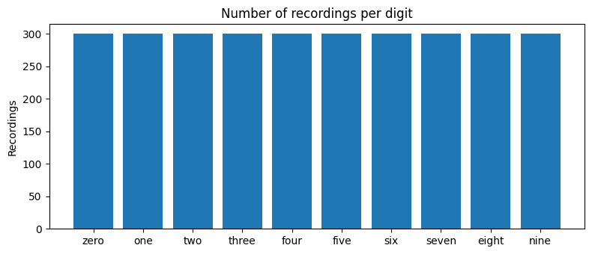
3. Waveforms and mel spectrograms (audio playback is available in the notebook)
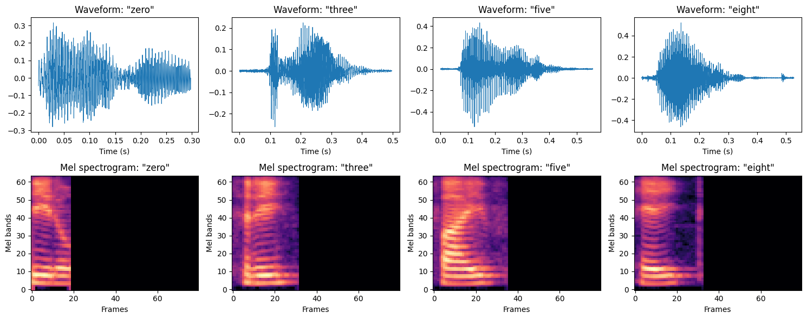
4. Data split and CNN architecture
Input shape: (1, 64, 80)
Train: 2099 | Validation: 451 | Test: 450
Layer | Details
Block 1 | Conv2D(1 → 16, 3 × 3) → BatchNorm → ReLU → MaxPool(2)
Block 2 | Conv2D(16 → 32, 3 × 3) → BatchNorm → ReLU → MaxPool(2)
Block 3 | Conv2D(32 → 64, 3 × 3) → BatchNorm → ReLU → MaxPool(2)
Block 4 | Conv2D(64 → 128, 3 × 3) → BatchNorm → ReLU → MaxPool(2)
Pooling | AdaptiveAvgPool2D(1)
Classifier | Flatten → Dropout(0.3) → Linear(128 → 10)
Trainable parameters: 98,922
5. Training log (20 epochs)
Epoch | Train Loss | Train Acc | Val Loss | Val Acc
1 | 2.0370 | 0.2878 | 2.0258 | 0.3126
2 | 1.5376 | 0.5479 | 1.3993 | 0.6297
3 | 1.1420 | 0.7213 | 1.1193 | 0.6785
4 | 0.8076 | 0.8347 | 0.7580 | 0.8559
5 | 0.5873 | 0.8919 | 0.5885 | 0.8603
6 | 0.4503 | 0.9223 | 0.5065 | 0.9002
7 | 0.3547 | 0.9409 | 0.3626 | 0.9401
8 | 0.2752 | 0.9595 | 0.3345 | 0.9113
9 | 0.2260 | 0.9676 | 0.2770 | 0.9335
10 | 0.1859 | 0.9743 | 0.2043 | 0.9623
11 | 0.1651 | 0.9747 | 0.2762 | 0.9379
12 | 0.1357 | 0.9819 | 0.1758 | 0.9667
13 | 0.1203 | 0.9833 | 0.1605 | 0.9667
14 | 0.0985 | 0.9876 | 0.1994 | 0.9645
15 | 0.0994 | 0.9857 | 0.1454 | 0.9690
16 | 0.0774 | 0.9914 | 0.1189 | 0.9778
17 | 0.0626 | 0.9938 | 0.1119 | 0.9690
18 | 0.0648 | 0.9924 | 0.1364 | 0.9734
19 | 0.0708 | 0.9914 | 0.2163 | 0.9424
20 | 0.0598 | 0.9929 | 0.2242 | 0.9268
Training time: 10.1 s | best validation accuracy: 0.9778
6. Training and validation accuracy and loss curves
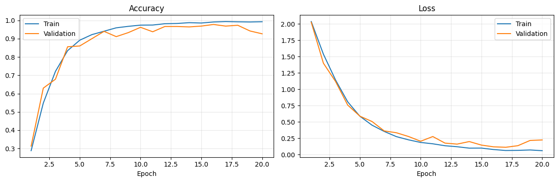
7. CNN test results
Test accuracy : 0.9756
Precision (macro): 0.9772 | Recall (macro): 0.9756 | F1 (macro): 0.9752
Class | Precision | Recall | F1-score | Support
zero | 0.978 | 1.000 | 0.989 | 45
one | 1.000 | 0.844 | 0.916 | 45
two | 1.000 | 1.000 | 1.000 | 45
three | 0.938 | 1.000 | 0.968 | 45
four | 1.000 | 1.000 | 1.000 | 45
five | 0.918 | 1.000 | 0.957 | 45
six | 1.000 | 0.956 | 0.977 | 45
seven | 1.000 | 0.978 | 0.989 | 45
eight | 1.000 | 0.978 | 0.989 | 45
nine | 0.938 | 1.000 | 0.968 | 45
Accuracy |  |  | 0.976 | 450
Macro avg | 0.977 | 0.976 | 0.975 | 450
Weighted avg | 0.977 | 0.976 | 0.975 | 450
8. Confusion matrix of the CNN
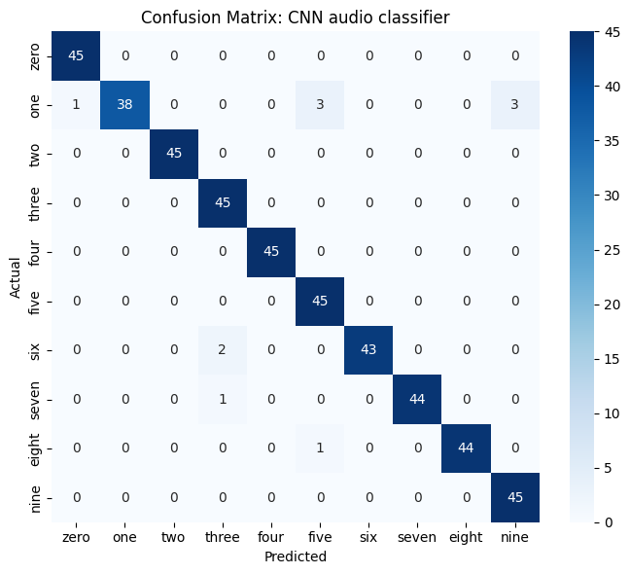
9. Speech-to-Text results (Whisper, 200 test recordings)
Word Error Rate (WER) : 0.6250
Character Error Rate (CER): 0.5934
Digit recognition accuracy: 0.5800 (CNN on the same recordings: 0.9800)
Speed: 64.3 ms per recording
Reference | Whisper output | Normalized
nine | 9. | nine
three | Three. | three
one | one. | one
one | one. | one
zero | Zero. | zero
five | Bye. | bye
seven | Thank you very much. | thank you very much
seven | 7. | seven
five | five. | five
five | Bye. | bye
two | Thank you. | thank you
eight | Hey. | hey
10. Per-digit accuracy: CNN vs Whisper (same 200 recordings)
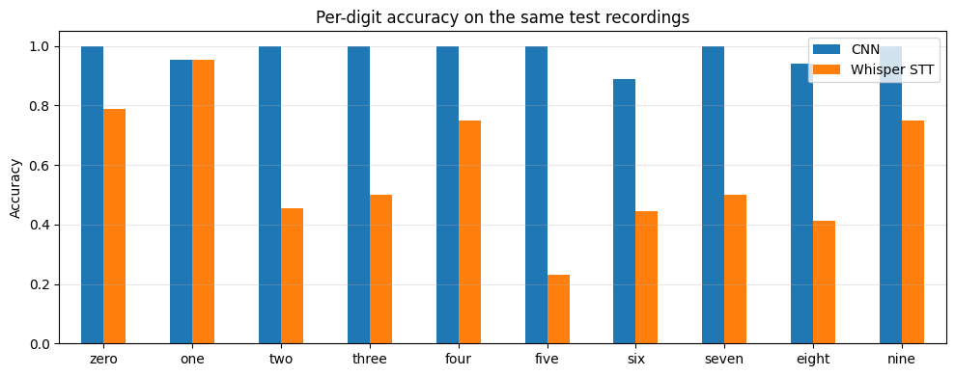
Digit | CNN | Whisper STT
zero | 1.000 | 0.789
one | 0.955 | 0.955
two | 1.000 | 0.455
three | 1.000 | 0.500
four | 1.000 | 0.750
five | 1.000 | 0.231
six | 0.889 | 0.444
seven | 1.000 | 0.500
eight | 0.941 | 0.412
nine | 1.000 | 0.750
11. Text-to-Speech results (MMS-TTS, 16 kHz)
Round-trip WER (single words) : 1.0000
Round-trip WER (sentences) : 0.1800
Round-trip WER (all) : 0.3167
Real-time factor : 0.098 (synthesis time / audio duration)
Input text | Whisper heard
zero | Firo.
one | the
two | Yep.
three | Three.
four | Howard.
five | Thiof.
six | Here.
seven | HEN!
eight | Eight.
nine | Thanks for watching!
the predicted digit is zero | The predicted dignity is zero.
the predicted digit is one | The predicted digit is 1.
the predicted digit is two | The predicted digit is 2.
the predicted digit is three | The predicted digginess tree.
the predicted digit is four | The predicted digit is 4.
the predicted digit is five | The Predicted Digit is 5.
the predicted digit is six | The predicted digit is seats.
the predicted digit is seven | The Predicate Digit is 7.
the predicted digit is eight | The predicted Digit is eight.
the predicted digit is nine | The predicted did it as nine.
12. End-to-end application demo (3 test recordings; audio playback is available in the notebook)
Actual | CNN prediction | Whisper transcript | TTS reply text | Whisper check of TTS audio
nine | nine | 9. | the predicted digit is nine | The predicate did it is nine.
three | three | Three. | the predicted digit is three | The predicted date is 3.
one | one | one. | the predicted digit is one | The predicted dig it is one.
13. Performance summary
Component | Metric | Value
Audio classification (CNN) | Test accuracy | 0.9756
Audio classification (CNN) | Macro F1-score | 0.9752
Audio classification (CNN) | Inference time (ms/recording) | 0.08
Speech-to-Text (Whisper) | Word Error Rate (WER) | 0.6250
Speech-to-Text (Whisper) | Character Error Rate (CER) | 0.5934
Speech-to-Text (Whisper) | Digit recognition accuracy | 0.5800
Speech-to-Text (Whisper) | Time (ms/recording) | 64.3
Text-to-Speech (MMS-TTS) | Round-trip WER (all texts) | 0.3167
Text-to-Speech (MMS-TTS) | Real-time factor | 0.098
14. Result analysis
- Audio classification: the CNN reached 97.56% test accuracy (439 of 450 recordings) and a macro F1-score of 0.975. Training the 98,922-parameter model for 20 epochs took only 10.1 seconds.
- The CNN made 11 errors. Most were the digit “one” (recall 0.844): 7 of the 45 “one” recordings were wrongly predicted (3 as five, 3 as nine and 1 as zero). The other errors were six predicted as three (2), seven as three (1) and eight as five (1).
- The validation loss started to rise in the last epochs (0.112 at epoch 17 to 0.224 at epoch 20) while the training loss kept falling, a sign of mild overfitting. This was handled by keeping the weights with the best validation accuracy (epoch 16, 97.78%).
- Speech-to-Text: Whisper reached only 58% digit accuracy (WER 0.625, CER 0.593) on the same 200 recordings where the CNN reached 98%. For many recordings Whisper returned unrelated phrases such as “Bye.”, “Hey.” or “Thank you very much.”. This is probably because the recordings are extremely short (0.44 s on average, 8 kHz) and Whisper is built for longer natural speech, and it tends to produce such phrases for very short clips.
- Whisper was best on “one” (95.5%, same as the CNN) and “zero” (78.9%) and worst on “five” (23.1%), “eight” (41.2%) and “six” (44.4%).
- This comparison favours the CNN: it was trained on this dataset for a fixed vocabulary of 10 digits (and the same 6 speakers appear in its training and test sets), whereas Whisper is a general model that can transcribe any speech but was not trained on this data.
- Text-to-Speech: spoken sentences were understood well (round-trip WER 0.18) and the digit was recognized in all three demo replies. Isolated words were not: only “three” and “eight” were recognized correctly (WER 1.00). Because the round trip also depends on Whisper, which is weak on very short clips, these errors cannot be assigned to the TTS model alone.
- TTS speed: the real-time factor of 0.098 means the speech was generated about 10 times faster than real time on the GPU.
- End-to-end application: for all three demo recordings the CNN predicted the right digit and Whisper transcribed the input correctly (“9.”, “Three.”, “one.”). Whisper’s check of the spoken replies was imperfect (for example “The predicate did it is nine.”) but contained the correct digit each time.
- Limitations: the system recognizes only 10 spoken digits, the dataset is small with only 6 speakers, and the train/test split is random across speakers, so performance on new speakers may be lower. A larger Whisper model, fine-tuning Whisper, or a speaker-independent split would improve and test the system further.

