USER GUIDE MANNUAL

* **After running a System, You will enter a Login page. You have to enter a user name and password and press ligin button to enter inside the system.**

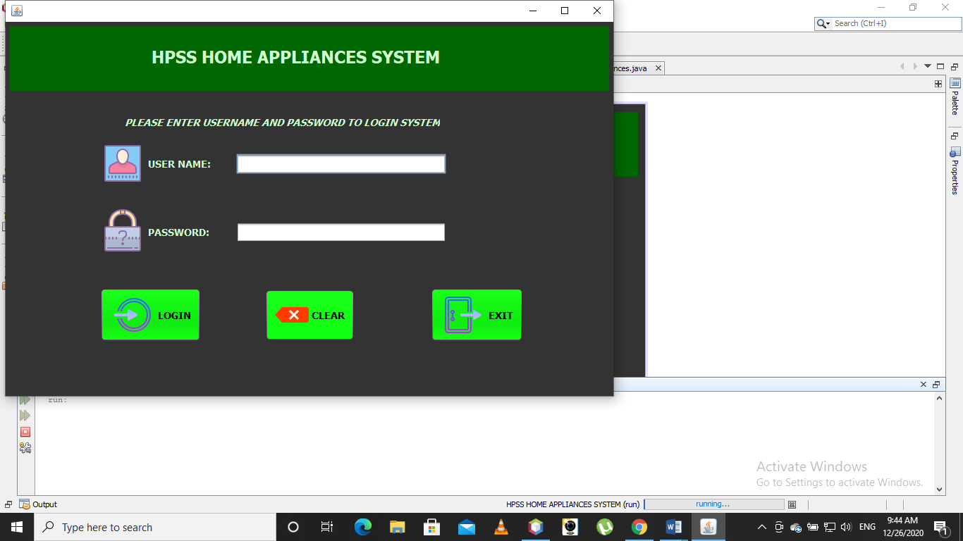

* **After log in you see this type of page which is a main page of system.**

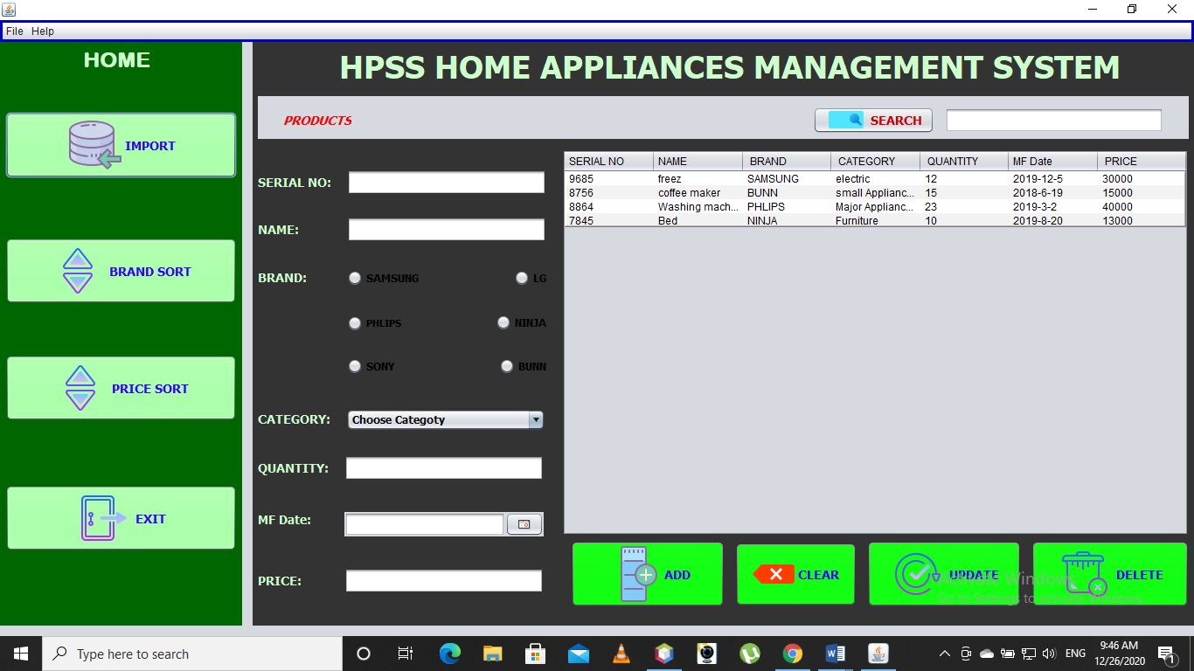

* **We have different function in this system.**
* **First we can import excel data from excel file in the system.**
* **We can sort the product according to brand and also sort product according to price.**
* **For adding the product we just have to fill the products serial no , name, brand, category, quantity, quality, mf date, and price and click the add button.**
* **We can click clear button to erase the data from text field. We can also update the data. By clicking in update button.**
* **We can also delete the product by selecting by product by mouse click the the table data and press delete button.**
* **To exit the system we just have to press exit.**

**.........................................................THE END………………………………………………………………..**