Customer Transaction Analysis Report

1. Dataset Overview
Total rows: 500
Columns: customer_id, age, income, purchase_amount, product_category, satisfaction_score, churned

2. Descriptive Statistics
Metric | customer_id | age | income | purchase_amount | satisfaction_score | churned
count | 500.0 | 500.0 | 500.0 | 500.0 | 500.0 | 500.0
mean | 250.5 | 39.68 | 25233.24 | 2498.41 | 1.52 | 0.97
std | 144.48 | 11.43 | 13107.81 | 1533.71 | 0.67 | 0.18
min | 1.0 | 18.0 | 5719.04 | 454.4 | 1.0 | 0.0
25% | 125.75 | 31.0 | 16356.12 | 1455.5 | 1.0 | 1.0
50% | 250.5 | 40.0 | 22342.94 | 2137.17 | 1.0 | 1.0
75% | 375.25 | 47.0 | 30504.26 | 3240.14 | 2.0 | 1.0
max | 500.0 | 75.0 | 82140.87 | 10924.09 | 5.0 | 1.0

3. Pearson Correlation Matrix
Correlation coefficients between numeric variables:
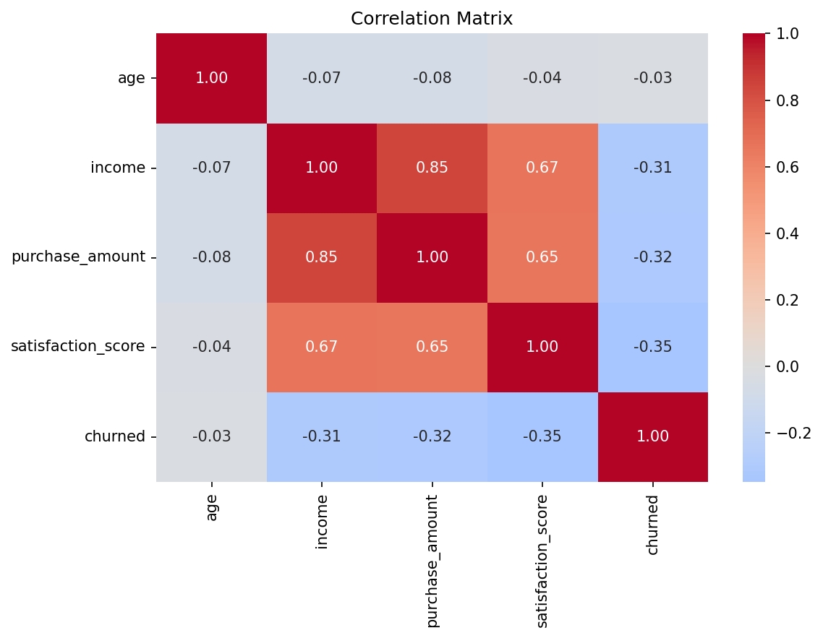

4. Chi-Square Test of Independence (Product Category vs Churn)
Chi-square statistic: 2.4740
p-value: 6.4930e-01
Degrees of freedom: 4
Conclusion: No statistically significant association between product category and churn (p ≥ 0.05).

5. Logistic Regression for Churn Prediction
Model coefficients and odds ratios:
Note: Odds ratio > 1 indicates increased churn likelihood; < 1 indicates decreased churn likelihood.
Feature | Coefficient | Odds Ratio | 95% CI Lower | 95% CI Upper
age | -0.2256 | 0.7980 | 0.7861 | 0.8101
income | -0.2036 | 0.8158 | 0.7922 | 0.8400
purchase_amount | -0.1951 | 0.8227 | 0.7993 | 0.8469
satisfaction_score | -0.9728 | 0.3780 | 0.3703 | 0.3859
product_category | 0.4061 | 1.5009 | 1.4784 | 1.5237

6. K-Means Clustering (k=3)
Silhouette Score: 0.2554
Clusters are formed based on age, income, purchase amount, and satisfaction score.
Cluster distribution:
Cluster 0: 203 customers (40.6%)
Cluster 1: 103 customers (20.6%)
Cluster 2: 194 customers (38.8%)

