RPA Requirement Document for

(Travel Request Bot)

Submitted to

**Automation Edge**

Prepared By

Gaurav Bagal

Prathamesh Shimpi

Gaurav Bagal

AutomationEdge Professional Services



Table of Contents

1. Document Control 3

Document History 3

2. Document Purpose 5

Purpose 5

Intended Audience 5

3. Automationedge Requirement Gathering Guidelines 6

Pre-requisites 6

Requirement Gathering & Process Walkthrough Procedure 6

4. Process Summary 7

5. Details of Applications involved in the Business Process 9

6. Automation Feasibility Observations 10

Automation Feasibility Observations 10

Technical Feasibility Observation 10

RPA Benefits 10

7. Process Details: Existing Process Flow Diagram 11

8. Business Process User Profiles 11

9. Business Process Detailed Description 12

10. Process Details: Screen Response Details 13

11. Process Details: Input, Output Formats and Details 14

Validations 14

Exceptions 14

Rules 14

12. Process Validations, Exceptions and Rules 15

Functional Requirements 15

Non Functional Requirements 15

13. Additional Requirements from Customer for Automation 16

14. Process Re-engineering Recommendations 17

15. Proposed Automation Process Flow Diagram…………………………………………………………………………....19

16. Signoff 20

# Document Control

## Document History

|  |  |  |  |
| --- | --- | --- | --- |
| Version | Contributor | Date | Description of Change |
| 1.0 | Gaurav Bagal | 18/09/2025 | First Draft |
| 2. 0 | Prathamesh Shimpi | 20/09/2025 | Second Draft |
| 3.0 | Prathamesh Shimpi | 23 /09/2025 | Final Draft |
|  |  |  |  |
|  |  |  |  |
|  |  |  |  |
|  |  |  |  |
|  |  |  |  |

## Related Documentation

|  |  |  |  |
| --- | --- | --- | --- |
| Document Name | Author | Version | Date |
| Domestic Traveller | Na | NA |  |
| International Traveller | NA | NA |  |
|  |  |  |  |
|  |  |  |  |
|  |  |  |  |
|  |  |  |  |
|  |  |  |  |
|  |  |  |  |

# Document Purpose

## Purpose

This document captures the AutomationEdge requirements for **AutomationEdge**. It includes the details of current procedure and process followed during manual execution of process referred by name **Travel Request Bot** . It also includes details of business logic, validations and rules used during execution of the process for generation of various expected outputs, results and outcomes. It will cover details of applications used during execution of this process and related inputs and intermediate results.

Following details are covered in detail as applicable.

* Business Process Purpose
* Business Process Description
* Details of Applications involved in the Business Process
* Business Process Use Case Scenarios
* Business Process Flow/ Click Stream details
* Business Process Logic Flowchart
* Business Process Data Flow Diagrams
* Business Process Input, output details at various steps/stages of process execution
* User Profiles
* Process data load and execution time
* Validations, Exceptions & Rules
* Other details as applicable for given process
* Expected Process Flow post Automation
* Non Functional Requirements (TAT, SLA, Scalability, Report)

## Intended Audience

This document is intended for anyone interested in the automation of this process using AutomationEdge. The roles of such interested people might include but not be limited to Process Owner, Process User, System Engineers, System Architects, Systems Administrators, Network Administrators, Security Administrators, Storage Administrators, Managers, and Other Stakeholders.

# Automationedge Requirement Gathering Guidelines

## Pre-requisites

* Process Owner/ SME to share process Concept Note along with Standard Operating Procedure & other details.
* Process Owner/ SME to collect Input, Output & Intermediate Data & Documents for discussion and understanding.
* Process Owner/ SME to share list of Applications & their functional roles, Integration between the applications (Fill the Excel Sheet Provided).
* AutomationEdge to identify & allocate BA for requirement gathering.

## Requirement Gathering & Process Walkthrough Procedure

* Process Owner/SME to explain concepts, standard operating procedure and broad overview on objective of process
* Process Owner/SME to demonstrate steps performed on Applications involved in process
* Process Owner/SME to explain Input, Output & Intermediary data & documents format required.
* Process Owner/SME to explain the UI, Screens and Behavior/ Functionality on the screen for each Application involved in the process.
* Process Owner/SME to explain Rules, Validations & Exceptions for each screen/Application involved in the process.
* Process Owner/SME to share stepwise screen shots for documentation.
* Process Owner/SME to explain Current Pain Areas.
* Process Owner/SME to explain non-functional requirements.
* Process Owner/SME to explain on To Be process expectation.
* Process Owner/SME to discuss re-engineering aspects.
* Business Analyst to understand and make note of all the inputs provided by Process Owner/SME
* Process Owner to validate process understanding by Business Analyst.
* Business Analyst to highlight on Technical Feasibility & Challenges.
* Business Analyst to highlight Business Benefit & ROI aspects.
* Business Analyst to capture & prepare Business Requirement Document (BRD).
* Business Analyst to submit BRD for Review & Inputs.
* Business Analyst to jointly review the feedback and update the BRD.
* Business Analyst to submit the updated BRD for Sign Off.

# Process Summary

|  |  |
| --- | --- |
| Process Name & Identification Code | * Travel Request BOT |
| Process Purpose and Brief Description | * Automate handling of domestic & international travel requests via email |
| SME/Process Owner(Name , Email, Phone No) | * AutomationEdge Training, * aetrainings@automationedge.com |
| No. of Applications involved in this Process(Please provide Names) | * Email , Excel, postgresSQL |
| Nature Of Processing (UI reading & Writing. Data Massaging, API Interface, DB Access) | * Email Reading & Writing, Data Massaging |
| User Profile  No of roles(Maker/Checker/ Approver) | * Maker : Employee/User who raises the travel request * Checker : Travel Desk (verifies ticketing, cancellations, etc.) * Approver : Group Head (approves or rejects the request) |
| No.of Users(In each User Profile)  No. of Maker/Checker | * Maker: N number of Traveller * Checker: Group Heads(Managers) |
| Frequency of Execution(Continuous, Daily, Weekly, Monthly) & Location of Processing | * 9.30 AM to 6.30 PM (Mon–Fri) |
| End to end process completion time & Step wise time taken(List the major step details and time taken) | * Read travel request mail : 1 min * Forward to Group Head with CC :5min * Read approval/rejection mail : 5 min * If approved : Create ticket in 5 min * Update records in files : 5 min   Total : 15–20 mins per case |
| TAT/SLA requirement(Time) | * 15 mins per case |
| User working Hours for the Process(Continuous & Daily processes start & End time)  For other Processes (Weekly, Monthly. Daily) Start & End Time | * 9.30 AM to 6.30 PM (Mon–Fri) * But travel desk ticketing/checking → usually 09:00 AM – 06:00 PM (Mon–Fri) |
| Process Trigger point/How Input is received/How activity is starting?  Email/Queue in Application/DB Record/SFTP/Folder | * Trigger: Email received in travel request mailbox |
| Volume(Daily/Weekly/Monthly/Quarterly/Yearly) No of Records/Cases/Files processed | * Daily: 20–30 requests * Weekly: 100–150 requests * Monthly: 400–500 requests * Yearly: 5000+ requests |
| No.of Input Files involved per case | * Usually 1 File per case |
| Type of Input File(Txt/xls/xlsx/PDF/Tiff/JPEG/PNG) | * xlsx |
| Provide Description of Data in input file  For Excel - No of rows/column  For PDF - Describe content in the document | * Excel Type: * No Of Rows :21 * No Of Columns:2 |
| No of Output files to be generated per case | * Usually 1 file per case |
| Type of Output File(Txt/xls/xlsx/PDF) | * Xlsx |
| Provide Description of Data in Output file  For Excel - No of rows/column  For PDF - Describe content in the document | * For Excel: * Column : 6 * Rows : As per number of requests |
| OCR/NLP /Machine Learning Requirement  Provide Details | * Not required for this use case (data is structured in email subject/body) |
| Pain Areas(Scaling Up/Volume Variation/TAT Reduction/Manual Error/Too many rules & exception Handling/Validations & Calculations/Customer Experience) | * Approvals may get delayed if Group Head misses mail * Scaling issue if travel requests increase suddenly * Need automation to ensure timely ticket creation + monthly reporting without errors |

# Details of Applications involved in the Business Process

Please fill details in the embedded excel sheet for all the Application involved in the business process.



# Automation Feasibility Observations

## Automation Feasibility Observations

(Yes/No/Validate)

Yes

## Technical Feasibility Observation

(Citrix/Captcha/Silverlite/Applet/Desktop Application)

No

## RPA Benefits

|  |  |  |
| --- | --- | --- |
| Benefit Name | Current State | Future State (%) |
| FTE saving | 2 | Will be discussed during solution designing |
| TAT improvement | 4 days | Will be discussed during solution designing |
| Error and Calculation reduction | NA | Will be discussed during solution designing |
|  |  |  |

# Process Details: Existing Process Flow Diagram

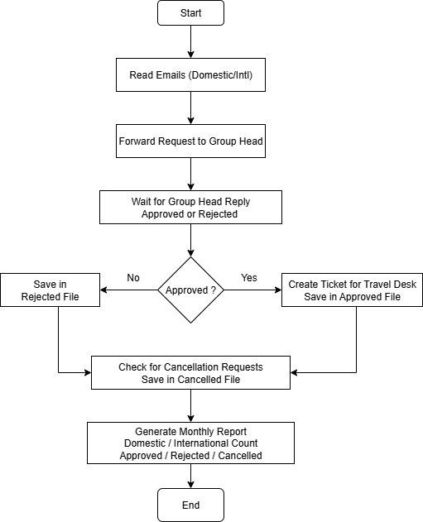

# Business Process Detailed Description, Screen Sequence and Click Stream Sequence and Business Logics (As Is)

This section contains current Process Detailed Description with detailed screenshots with user actions on each screen during manual process execution. It covers sequences of all use cases and conditions to be implemented. It covers all applications involved in process. This is used for UI automation hence accuracy is very important.

Each Screen captures following details:

1. Screen Name
2. Screen ID
3. Screen Function/Description
4. Screen Image with marking and comments (User Actions, popup, data extract, data input, Validation rules, File Upload, File download, click required.)

* 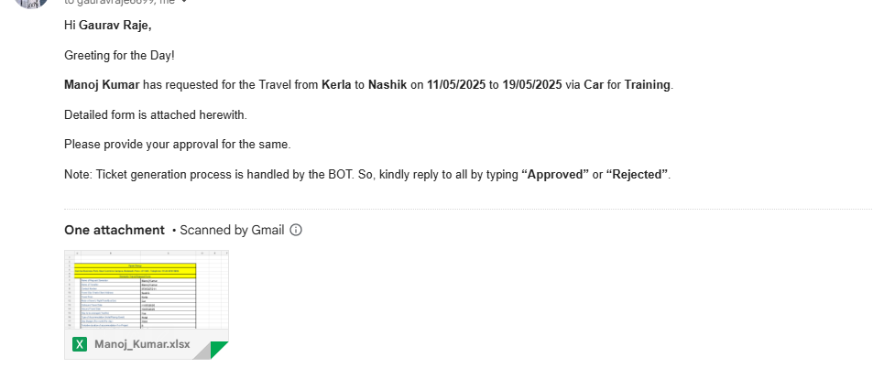Approved Request to respective Group Head.



* 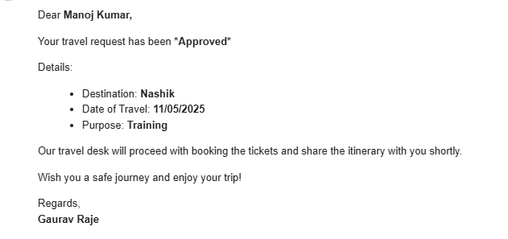Ticket Generated

# Process Details: Screen Response Details

This section captures in table loading and response time for each screen shown during process walkthrough

|  |  |  |  |
| --- | --- | --- | --- |
| **Screen No.** | **Screen Name** | **Screen Description** | **Screen Loading/ Response Time for activities performed in Seconds** |
| 1 | NA | NA | NA |

# Process Details: Input, Output Formats and Details

This section captures following details for all inputs, outputs and intermediate data/results used at various stages in process execution.

1. Data Formats and Details for each inputs/outputs/Intermediate IO points
2. Description
3. Data Source
4. Format/Fields/Columns and Their Meaning/Purpose/Data Validation Rules
5. Size/Data Type for each field
6. No of record in input (Min/Typical/Average/Max)

**Note: It is not possible to capture all details in this document. Please refer to excel sheet mentioned in reference for more details for each file.**

|  |  |  |  |
| --- | --- | --- | --- |
| Input or File Name | Description and Purpose and reference file | Data Source | Data Size/batch size  Min/Avg/Max |
| Domestic_Traveller | Input File | Email | 756 KB |
| International_Traveller | Input File | Email | 1.5 MB |
| Report | Output File | Excel | 2.5 MB |
| Cancel Request | Output File | Excel | 2.5 MB |
|  |  |  |  |
|  |  |  |  |
|  |  |  |  |
|  |  |  |  |

# Process Validations, Exceptions and Rules

This section captures exceptions at process level, application and implementation level.

## Validations

(Process related validations carried by User)

|  |  |  |  |  |
| --- | --- | --- | --- | --- |
| Field Name | Field Type(Mandatory/Non Mandatory) | Data Type(Text/Numeric/Alphanumeric) | Screen Reference No. | Validation Steps |
| Inbound Travel Date | Mandatory | Date |  | Not Null |
| Traveller Name | Mandatory | Date |  | Not Null |
| Outbound Travel Date | Mandatory | Date |  | Must be > Todays Date |
| GroupHeadName | Mandatory | String |  | Not Null |
| Mode of travel | Mandatory | String |  | Not Null |
| Stay Budget | Mandatory | Number |  | Not Null |

## Exceptions

(Process related exceptions faced by User in day to day processing)

**1. Email Exceptions:** Travel request email not received in the mailbox.

2. **Data Extraction Exceptions:** Missing mandatory fields.

3**. Approval Exceptions:** Approval mail not received or delayed.

4. **Output Exceptions:** Ticket not generated after successful booking.

## Rules

(Process related rules applied by User)

#### **1. Request Submission Rules**

* The employee must submit the travel request at least **7–10 days before** the planned travel date.
* All mandatory fields must be filled (e.g., name, employee ID, destination, dates, purpose).
* Travel must be for **official/project-related** purposes only.

#### **2. Approval Rules**

* Requests are first verified by the **employee’s reporting manager**.
* After manager approval, the **HR or Admin team** reviews the travel budget and policy compliance.
* Requests exceeding the approved budget or involving international destinations require **senior management approval**.

#### **3 Cancellation & Modification Rules**

* Cancellations must be communicated at least **48 hours before** the travel date.
* If the ticket is already booked, cancellation charges (if any) are borne as per company policy.
* Modification requests (change of date or destination) require **re-approval**.

# Additional Requirements from Customer for Automation

This section will capture additional client requirements which add value to the existing process.

## Functional Requirements

Additional Functional Requirement related to the process (Masters to be used, Macro to be used or created)

No Functional Requirment

## Non Functional Requirements

Additional Non Functional Requirement related to the process (EOD Reports, Additional Reports, and Dashboard)

No Non Functional Requirment

# Process Re-engineering Recommendations

This section captures recommendations to/ from client in terms of process re-engineering. These process changes are required to optimize implementation during automated process design.

# Proposed Automation Process Flow Diagram (To Be)



# Annexure 1

## Email Template

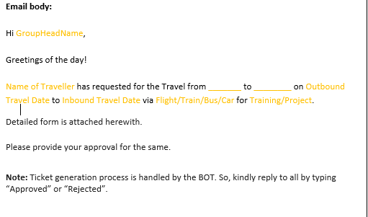

## Input file format: Ticketing tool input format

|  |  |  |
| --- | --- | --- |
| **Vyom Group** | | |
| **Sunrise Business Park, Near Cummins Campus, Balewadi, Pune -411 045 , Telephone: 91-20-6725 5000.** | | |
|
| **Domestic Travel Request Form** | | |
|  | Name of Request Generator |  |
|  | Name of Traveller |  |
|  | Contact Number |  |
|  | Travel City/ Onsite Client Address |  |
|  | Mode of travel ( Flight/Train/Bus/Car) |  |
|  | Outbound Travel Date |  |
|  | Inbound Travel Date |  |
|  | Stay to be arranged (Yes/No) |  |
|  | Type of Accommodation (Hotel/Paying Guest) |  |
|  | Stay Budget (Per month/Per day) |  |
|  | Tentative duration of accommodation if on Project |  |
|  | Expense borne by (Our Company/Client) |  |
|  | Purpose of Travel (Training/Project) |  |
|  | Approval to be taken from (Name of the GH) |  |

## Input file format: Attached Input file format

|  |  |  |
| --- | --- | --- |
| **Vyom Group** | | |
| **Sunrise Business Park, Near Cummins Campus, Balewadi, Pune -411 045 , Telephone: 91-20-6725 5000.** | | |
|
| **Domestic Travel Request Form** | | |
|  | Name of Request Generator |  |
|  | Name of Traveller |  |
|  | Contact Number |  |
|  | Travel City/ Onsite Client Address |  |
|  | Mode of travel ( Flight/Train/Bus/Car) |  |
|  | Outbound Travel Date |  |
|  | Inbound Travel Date |  |
|  | Stay to be arranged (Yes/No) |  |
|  | Type of Accommodation (Hotel/Paying Guest) |  |
|  | Stay Budget (Per month/Per day) |  |
|  | Tentative duration of accommodation if on Project |  |
|  | Expense borne by (Our Company/Client) |  |
|  | Purpose of Travel (Training/Project) |  |
|  | Approval to be taken from (Name of the GH) |  |

## Output file format: Attached Output file format

**Output file format: Attached Report file format**

|  |  |  |  |  |  |
| --- | --- | --- | --- | --- | --- |
| **No. of Domestic Travel Requests** | **No. of International Travel Requests** | **Status (Approved/Rejected)** | **No. of Cancelled Requests** | **Location-wise summary** | **Traveler-wise summary** |
|  |  |  |  |  |  |

# Signoff

Requirements captured in this document are correct and define the scope for solution design, development and implementation of this process through AutomationEdge. Any changes outside this scope will be considered as change requests and will be addressed through change management process.

**Agreed and Signed By**

|  |  |  |  |
| --- | --- | --- | --- |
| **Client Project Manager:** |  | | |
| **Signature:** |  | | |
| **Title:** |  | **Date:** |  |
|  | | | |
| **VyomLabs Project Manager:** |  | | |
| **Signature:** |  | | |
| **Title:** |  | **Date:** |  |