Solution Design Document for

Travel Request BOT

Submitted to

**Automation Edge**



Prepared By

Gaurav Bagal

Prathamesh Shimpi

AutomationEdge Professional Services

Table of Contents

1 Document Control 3

1.1 Document History 3

1.2Related Documentation 3

1.3 Approvals 3

2 Introduction 4

2.1 Purpose 4

2.2 Scope 4

3 Solution Design 4

4 Assumptions 7

5 Dependencies and Constraints - 7

5.1Exceptions 7

5.2Risks 7

5.3Business Rules 7

6 Solution Deployment 8

6.1AutomationEdge Specifications 8

# Document Control

## Document History

|  |  |  |  |
| --- | --- | --- | --- |
| Version | Contributor | Date | Description of Change |
| 1.0 | Gaurav Bagal | 28/09/2025 | First Draft |
| 2. 0 | Prathamesh Shimpi | 1/10/2025 | Final |
| 3. 0 | Gaurav Bagal | 6/10/2025 | Draft |
|  |  |  |  |
|  |  |  |  |
|  |  |  |  |
|  |  |  |  |

## 

## Related Documentation

|  |  |  |  |
| --- | --- | --- | --- |
| Document Name | Author | Version | Date |
| Domestic Traveller Data | NA | NA |  |
| International Traveller Data | NA | NA |  |
|  |  |  |  |

## 

## Approvals

|  |  |  |  |
| --- | --- | --- | --- |
| Name | Title, Department | Remarks | Date |
| Mayuri Hirgude | **Trainer** |  |  |
|  |  |  |  |
|  |  |  |  |
|  |  |  |  |
|  |  |  |  |
|  |  |  |  |
|  |  |  |  |

# Introduction

# Purpose

This document describes design and specifications for **Travel Request Use case** using AutomationEdge. It covers various components identified for implementation of end-to-end Automation of **Travel Request** IT process. It also identifies process-reengineering requirement with respect to current manual process from end user, System users, IT Systems, participating Applications point of view for successful implementation of RPA. All other process specific technical ­­­­details are captured.

Following details are covered in detail as applicable.

* Functional flow Design Diagram and Description
* Design and Implementation Details for Each Robot
* Design and Implementation Details for other components
* Process Reengineering Requirements
* Deployment Details
* Other process specific details.

# Intended Audience

This document is intended for anyone interested in the automation of this process using AutomationEdge. The roles of such interested people might include but not be limited to Process Owner, Process User, System Engineers, System Architects, Systems Administrators, Network Administrators, Security Administrators, Storage Administrators, Managers, and Other Stakeholders

# Scope

The Travel Request Bot is designed to automate and streamline the process of managing employee travel requests within an organization. The bot will act as a digital assistant to reduce manual intervention, minimize errors, and ensure faster processing of travel-related activities.

Process Flow for App Monitoring:

* Reading and monitoring emails for travel request submissions with predefined subject lines.
* Extracting relevant details (e.g., employee name, destination, travel dates, purpose) from requests.
* Validating requests against organizational policies and approval workflows.
* Forwarding travel requests to the concerned authority for approval.
* Generating tickets for approved travel requests through integration with travel portals or internal systems.
* Sending automated notifications and updates (e.g., confirmation, rejection, ticket details) to employees.
* Maintaining a log/report of all processed requests for auditing and tracking purposes.

# Out of Scope

* Handling ad-hoc travel bookings made outside the organization’s standard process.
* Processing incomplete or invalid travel request formats.
* Providing financial reimbursements or expense settlement functionalities.
* Integration with third-party HR/ERP systems beyond travel approval workflows (unless specified later).

# Solution Design

The Travel Request Bot is designed to automate the end-to-end handling of employee travel requests, ensuring efficiency, accuracy, and compliance with organizational policies. The solution integrates email monitoring, data extraction, approval workflow, and ticket generation into a streamlined automated process.

**3.1 High-Level Workflow**

1. **Email Monitoring** – The bot continuously monitors a dedicated mailbox for travel request emails with predefined subject lines (e.g., *TravelRequest_Domestic*, *TravelRequest_International*).
2. **Data Extraction** – Extracts required details such as employee name, employee ID, travel type, origin, destination, dates, and purpose of travel.
3. **Validation** – Validates the request format, checks completeness of details, and ensures alignment with organizational travel policies.
4. **Approval Process** – Routes the request to the designated manager/authority for approval or rejection.
5. **Ticket Generation** – For approved requests, the bot integrates with the travel booking system or internal portal to generate tickets.
6. **Notification** – Sends automated email notifications to employees regarding approval, rejection, or ticket details.
7. **Logging & Reporting** – Maintains a centralized log of all requests for tracking, compliance, and reporting purposes.

**3.2 System Components**

* **Input Channel**: Corporate email inbox for receiving requests.
* **Processing Engine**: Travel Request Bot (automation logic, data validation, approval workflow).
* **Integration Layer**: APIs or connectors for travel booking systems and organizational approval workflows.
* **Output Channel**: Email notifications and reporting dashboards.

**3.3 Key Features**

* Automated request handling with minimal human intervention.
* Configurable rules for approval workflows.
* Secure handling of employee and travel data.
* Audit trail and logs for compliance.

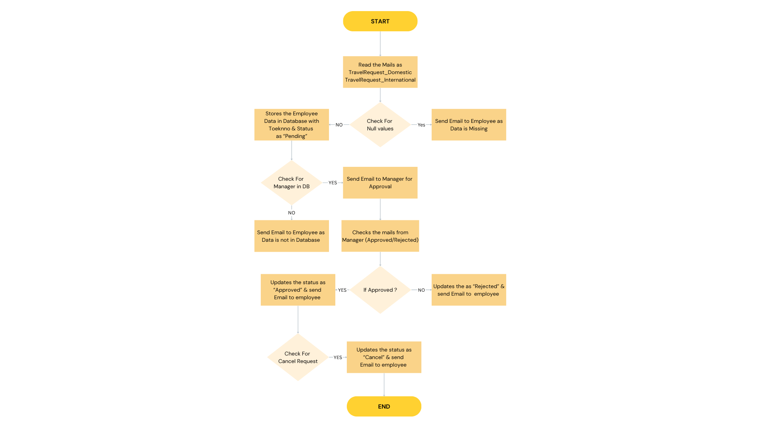

|  |  |  |  |  |  |  |  |  |  |
| --- | --- | --- | --- | --- | --- | --- | --- | --- | --- |
| ApplicationName | ApplicationCategory | URL | URLFieldXpath | LoginPageXpath | UsernameXpath | PasswordXpath | LoginButtonXpath | LoginVerificationXpath | PICTeamEmailID |

# Master Workflow Travel Bot –

1. The main workflow serves as the central controller for processing all travel requests.
2. It evaluates incoming requests and determines the type of travel (Domestic or International).
3. Based on the request type, the main workflow triggers the respective child workflow:

* International Travel Request Workflow – Handles rules, validations, and processes specific to international travel.
* Domestic Travel Request Workflow – Handles rules, validations, and processes specific to domestic travel.

# Approval Checker Workflow

* In the **Ticket Generation Workflow,** the approval status is first checked from the approver.
* If **Approved**, the bot generates the ticket and stores the booking details in the output file.
* If **Rejected**, the bot records the request in the rejected file for tracking.
* Notifications are sent to the employee and stakeholders with the final status.

# Booking Cancellation Workflow

* The **Booking Cancellation Workflow** reads the **cancellation request** received from the traveler.
* It verifies the booking details and proceeds to **cancel the ticket** in the system.
* The canceled request details are then **stored in the** cancel.xlsx **file** for record-keeping and reporting.
* An **email notification** is sent to the traveler and stakeholders confirming the cancellation status.

# Report Generation Workflow

* The Report Generation Workflow creates a monthly travel summary report from processed requests.
* It includes:

No. of Domestic Travel Requests

No. of International Travel Requests

Status (Approved/Rejected)

No. of Cancelled Requests

Location-wise summary

Traveler-wise summary

* The report is saved in the designated folder and emailed to stakeholders automatically for review and analysis.

# Output excel file –

# Send Mail To the Group head

Construct mail body as given below.

Hi **GroupHeadName**,

Greetings of the day!

**Name of Traveller** has requested for the Travel from _______ to _______ on **Outbound Travel Date** to **Inbound Travel Date** via **Flight/Train/Bus/Car** for **Training/Project**.

Detailed form is attached herewith.

Please provide your approval for the same.

**Note:** Ticket generation process is handled by the BOT. So, kindly reply to all by typing “Approved” or “Rejected”.

In CC field put email ID of Managers team (Configuration parameter - Email CC Address).

* Request generator’s email ID – xyz@gmail.com
* Traveller’s email ID - abc@gmail.com

# 

# Assumptions

* Employees will submit travel requests only through the **designated email ID** with the correct subject line (TravelRequest_Domestic/ TravelRequest_International).
* All travel request emails will contain **complete details** or a valid attachment in the defined format.
* The **credential pool** and mailbox access will be properly configured before bot execution.
* Approvers (Group Heads) will **respond within the defined time frame** for approval decisions.
* The **travel booking system/portal** will be available and accessible during ticket generation.
* Stakeholder email IDs will be **preconfigured** in the workflow for notifications.
* Network connectivity and system resources will remain stable during bot execution.

# Dependencies and Constraints -

Below are some constraints to be consider-

# Exceptions

|  |  |  |  |  |
| --- | --- | --- | --- | --- |
| **Sr. No** | **Scenario** | **Success status** | **Message in AE Request Tab** | **Action** |
| 1 | On successful execution | TRUE | Execution Succesful | 1. Request will be Completed in AE. 2. Mail will be sent to respective Traveller with status file. |
| 2 | If the **travel request email** is missing mandatory details | TRUE | Field is missing in Attachment | The bot logs the request as **complete** and notifies the employee. |
| 3 | If the **attached file** is corrupted, unreadable, or in the wrong format | TRUE | Field is missing in Attachment | The bot logs the request as **complete** and notifies the employee. |
| 4 | If traveller data is not present in database | TRUE | Employee data not present in Database | The bot logs the request as **complete** and notifies the employee. |
| 5 | If Duplicate file occurs | TRUE | Execution Successful | The bot logs the request as **complete** and send mail to Manager. |
| 6 | No mail received from employees | TRUE | No Records found for Domestic\International | The bot logs the request as **complete** |
| 7 | If employees manager is not found in Database | TRUE | Manager record is not found in Database | The bot logs the request as **complete. And send mail to** employee. |
| 8 | If employee cancel the request before approved | TRUE | Succesfully cancelled the request | The bot updates the status in Database and send mail to employee |
| 9 |  |  |  |  |

# Risks

* Incomplete or Incorrect Requests: Employees may submit travel requests without mandatory details, leading to delays.
* Approval Delays: Approvers may not respond within the defined time, causing pending requests.
* System Downtime: Email server downtime could disrupt the workflow.
* Integration Failures: Issues in connecting with external travel portals or approval systems may halt ticket generation.
* Notification Failures: Stakeholders may miss updates if email delivery fails or distribution lists are outdated.
* Unexpected Exceptions: Unhandled errors could stop the workflow and require manual intervention.

# Stake holders/Business Owner

* Mention Cliet Names (SMEs – Major stakeholders) and Emails

# Solution Deployment

* 1. **Architecture Overview**

# Mention AE Architecture Diagram

AE Agent Server

AE Application Server

**Email/Outlook**

**SMTP Server**

**Database**

* 1. **AutomationEdge Components**
* Component - AutomationEdge Server

|  |  |  |  |
| --- | --- | --- | --- |
| **Service** | **Location** | **Description** | **Platform** |
| AutomationEdge App Server | https://t3.automationedge.com | AutomationEdge Automation Platform | Google chrome |

* Component - AutomationEdge Agent

|  |  |  |  |
| --- | --- | --- | --- |
| **Service** | **Location** | **Description** | **Platform** |
| AutomationEdge Agent | On-premises | AutomationEdge Agent communicates with Target Applications to perform actions. | Windows i5 |

* Component – Target Applications

|  |  |  |  |
| --- | --- | --- | --- |
| **Service** | **Location** | **Description** | **Platform** |
| Email Message | Google Mail / Outlook | Email Messgae | Google Mail / Outlook |
| Database | On-premises | Store and update the Data of the Traveller | postgresSQL |
| Excel | Microsoft excel | To generate a Report | Excel |

* 1. **AutomationEdge Workflow Configurations**

|  |  |
| --- | --- |
| Workflow Schedule | Workflow Run Daily after office hours  Frequency: Daily / Weekly / Monthly  Days: Mon/Tue/..  Time: 09:30 AM to 06:30 PM  Repeat: After every 1 hour |
| Configurable Parameters (Design time) | 1. Email Subject 2. SMTP Credentials |
| Configurable Parameters (Run time) | 1. Email Subject 2. SMTP Credentials |