FINAL EXAM REVIEW: ANSWER KEY

- Recall the psa dataset that we used in lab 4. I built a logistic regression model for predicting capsule=1 that included psa, age, and gleason in the model (model 1). Part of the resulting SAS output follows:

Model 1:
Model Fit Statistics
Intercept
Intercept and
Criterion Only Covariates

AIC 514.289 411.208
SC 518.229 426.969
-2 Log L 512.289 403.208

Analysis of Maximum Likelihood Estimates
Parameter DF Estimate Error Chi-Square Pr > ChiSq

Intercept 1 -6.3896 1.4976 18.2045 <.0001
psa 1 0.0266 0.00894 8.8442 0.0029
age 1 -0.0208 0.0188 1.2351 0.2664
gleason 1 1.0790 0.1611 44.8373 <.0001

a. Write the resulting logistic regression equation for model 1 below:

Predicted logit (capsule) = -6.3896 + 0.0266 (psa) - 0.0208 (age) +1.0790 (gleason)

b. What is the predicted probability of having capsule=1 for a 69-year old man with a psa level of 10 mg/ml and a gleason score of 5, according to model 1?

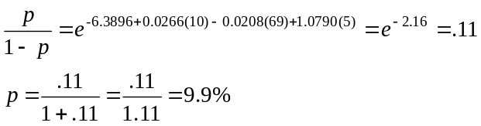

c. What does the intercept from the model tell you?
Model 1: The log odds of capsule=1 for a man aged 0, with 0 psa and 0 gleason.

d. Calculate the odds ratio and 95% confidence interval for psa from model 1. Interpret.
Exp(0.0266)= 1.027
Exp(0.0266+1.96*0.00894)= 1.045
Exp(0.0266-1.96*0.00894)= 1.009

e. What would be different about the output if this was a conditional logistic regression? An ordinal logistic regression?
Conditional = no intercept
Ordinal = 2 or more intercepts

2. The following results are from a prospective study that considered predictors of mammography use in women. The investigators used logistic regression to analyze their data.

Table 3 Results of a logistic regression predicting annual mammography use
Variable name | Parameter estimate (std error) | Significance value
Family history-associated risk group | .14 (.09) | not sig.
Age | -.04 (.02) | <0.05
Worry | -.04 (.01) | <0.05
Worryx family history-associated risk group | -.05 (.02) | <0.05

- What is the odds ratio for getting a mammogram for every 10-year increase in age?

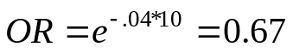

- What is(are) the odds ratio(s) for every 1-unit increase in worry?

Among women with no family history of breast cancer, the odds ratio for a 1-unit increase in worry is:

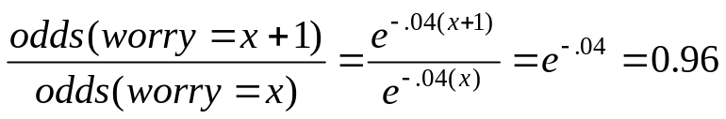

Among women with a family history of breast cancer, the odds ratio for worry a 1-unit increase in worry is:

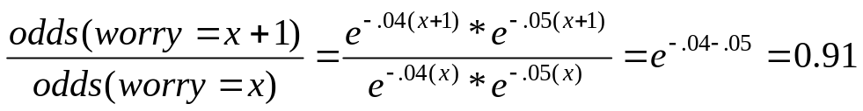

- What is(are) the odds ratio(s) for having a positive family history?

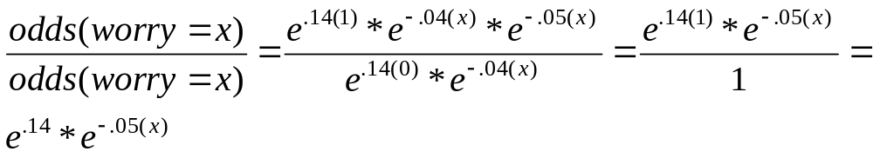

- What do these results mean?

3. The following table came from a study on predictors of breastfeeding. The authors used ordinal logistic regression, where the outcome variable was coded 2=exclusive breastfeeding; 1=partial breastfeeding, and 0=no breastfeeding. Questions are based on the “breastfeeding at 3 months after delivery” column.

Table 3. Ordinal Logistic Regression Analysis of Factors Associated with Breastfeeding
Variable | Breastfeeding Initiation during Hospital Stay (n =2,064) OR (95% CI) | Breastfeeding at 1 mo after Delivery (n =1,336)* OR (95% CI) | Breastfeeding at 3 mo after Delivery (n =1,453)†OR (95% CI)
Age (yr)
< 20 | 0.49 (0.26–0.90) | 0.28 (0.10–0.66) | 0.28 (0.11–0.74)
20–24 | 0.67 (0.48–0.94) | 0.73 (0.48–1.12) | 0.96 (0.63–1.47)
25–29 | 0.80 (0.59–1.07) | 1.05 (0.73–1.50) | 0.94 (0.65–1.35)
30–34 | 0.87 (0.64–1.18) | 0.98 (0.68–1.41) | 1.31 (0.90–1.90)
Education
Junior high school or lower | 0.35 (0.25–0.49) | 1.00 (0.64–1.57) | 0.94 (0.63–1.42)
Senior high school or vocational school | 0.43 (0.35–0.53) | 0.74 (0.58–0.95) | 0.76 (0.59–0.97)
Work status
Full time | 1.23 (1.03–1.48) | 0.58 (0.46–0.72) | 0.38 (0.30–0.48)
Part time | 1.00 (0.73–1.37) | 1.12 (0.74–1.69) | 1.03 (0.71–1.50)
Father's support for breastfeeding | 1.02 (1.01–1.03) | 1.03 (1.02–1.04) | 1.01 (0.995–1.02)
Method of delivery
Cesarean | 1.19 (0.995–1.43) | 0.69 (0.55–0.86) | 0.70 (0.56–0.88)
Assisted vaginal | 0.88 (0.68–1.15) | 0.75 (0.53–1.06) | 0.67 (0.48–0.93)
Initiation of breastfeeding within 30 min of delivery | NA | 1.47 (1.13–1.90) | 1.57 (1.21–2.05)
The dependent variable was coded as exclusive breastfeeding (2), partial breastfeeding (1), and no breastfeeding (0). The reference group comprised mothers aged 35 years or more, who had an educational level of university or higher, who did not work, who had unassisted vaginal delivery, who did not initiate breastfeeding within 30 min of delivery, and who initiated breastfeeding during hospital stay.
* Among mothers who initiated breastfeeding during hospital stay ; †among mothers who breastfed at 1 mo after delivery.
NA = not applicable.

- What factors predicted a significantly higher level of breastfeeding at 3 months post-delivery?
Age>=35 vs. Age<20. University educated vs. senior high school or vocational school. Stay at home moms vs. full time. Vaginal vs. other modes of delivery. And initiating breastfeeding within 30 min delivery vs. not.

- Among all the predictor variables shown in the table above, how many categorical predictors are there? Binary? Ordinal? Continuous?
Cat: age, education, work status, method of delivery. Binary: intitation of BF within 30 min delivery; ordinal: none; cont: father’s support for breastfeeding.

- Among women who did not initiate breastfeeding within 30 minutes of delivery, 15% were still breastfeeding exclusively at 3 months and 30% were breastfeeding at all (partial or exclusive). The authors ran an ordinal logistic regression model with only “initiation of breastfeeding within 30 minutes of delivery” as the predictor and 3-month breastfeeding status as their outcome. The resulting unadjusted OR for “initiation of breastfeeding within 30 minutes of delivery” is 1.50. Write out the fitted logistic regression model/s.
Intercepts:
Logit (15%) = -1.7
Logit (30%) = -.85

Beta:
Ln(1.5) = 0.4

4. The following data arose from a case-control study of coronary heart disease (CHD). Patients aged 30-79 at presentation with suspected acute myocardial infarction (heart attack) were eligible if they had a sibling of the same sex and similar age (within 5 years) who reported no history of coronary heart disease—these siblings became the control group for the study.

The following data describe the baseline characteristics of the cases and controls. Using these data and an appropriate statistical test, fill in the p-value for smokers below.

Characteristic | Cases (n=510) | Controls (n=510) | p-value | Odds Ratio
No (%) of current smokers | 220 (43) | 139 (27) |  | 2.0
No (%) with treated diabetes | 30 (6) | 22 (4) |  | 1.5
No (%) with treated hypertension | 155 (30) | 115 (23) |  | 3.0
No (%) ended education <16 years | 385 (75) | 392 (77) |  | 0.5
No (%) with household income <$50,000/year | 115 (25) | 98 (21) |  | 1.2

This is paired data; and you DO have enough information (using a bit of algebra) to reconstruct the paired 2x2 table.
For example, you’re given the following information for smoking:
Case | Matched-control
 | Smoker | Non-smoker
Smoker | a | b | 220
Non-smoker | c | d
 | 139 |  | 510
Thus, you have 3 equations and 3 unknowns, from which you can solve for b and c: 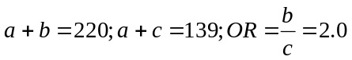
Case | Matched-control
 | Smoker | Non-smoker
Smoker | 58 | 162 | 220
Non-smoker | 81 | 209 | 290
 | 139 | 371 | 510

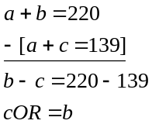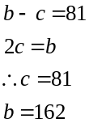
(general solution: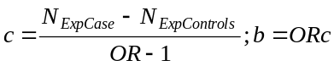)
Once you have solved for a and b, then use McNemar’s Test to get a p-value:
