**Autumn 2015**

**CHN-201 Heat Transfer Lab**

List of Experiments

|  |  |
| --- | --- |
| **Sr. no.** | **Title of the experiment** |
|
| 1. | Shell and tube heat exchanger |
| 2. | Parallel and counter flow heat exchanger |
| 3. | Finned tube heat exchanger |
| 4. | Heat transfer in natural convection |
| 5. | Drop–wise and Film–wise condensation |
| 6. | Open pan evaporator |
| 7. | Single Effect Evaporator |

Instructions

* *Students should discuss the experimental setup in their reports along with a manual drawing.*
* *Students must show a sample calculation for one data set (different for each team member) and draw graphs manually on graph sheet. Calculations for other data sets may be performed in a software (e.g. Excel) but must be discussed in the report.*
* *Students should write the observations in the provided data sheets and get it signed by the TA at the end of the experiment.*
* *Students should collect the index sheet on the first day of the laboratory and bring a folder containing the filled index sheet with list of all experiments on the second day. The dates of experiment and report submission will be filled by the TA, who will also put the corrected reports in the folders.*
* *Students should bring a stapled report in A4 sheet (with the original observation data sheet) of the experiment performed in the last turn, when the lab begins.*
* *There will be a penalty for late submissions (50% of marks of the experiment) and students coming late would not be permitted.*

Evaluation (20 marks, 20% weightage)

* Report: 12 marks (Students will be continuously and individually graded based on their contribution in performing experiments and the quality of report)
* Oral quiz: 8 marks (Students will be for viva individually or in teams on any date of the experiment)

**Experiment number: 1**

**Experiment title: Shell and Tube Heat Exchanger**

1. **Aim:**
2. To determine the rate of heat transfer, log mean temperature difference (LMTD) and overall heat transfer coefficient in the shell and tube heat exchanger.
3. Compute the inside and outside film heat transfer coefficients.
4. **Theory and Experimental Setup:**

The heat exchanger is a device used to transfer heat from one fluid to another, which is at different temperatures. It is used in almost all chemical process industries. There are various types of heat exchangers used in the process industry, such as shell–and–tube, parallel tube with co–flow and counter–flow configurations, finned tube, plate and frame, helical and spiral heat exchangers etc. Shell and tube heat exchanger consists of a tube bundle, which is inserted in a shell. It is used when required heat transfer area is more than 10-20 m2. One fluid flows in the tube and another in shell. Here the flow pattern may be either parallel flow pattern or as counter flow pattern, but the current apparatus has counter flow pattern.

Temperatures are measured with the help of thermocouples. Readings are recorded when steady state is reached. The shell is provided with adequate insulation to check heat loss. The present experimental setup for shell and tube heat exchanger experiment consists of the following components:

1. Main frame
2. Shell and tube heat exchanger
3. Temperature indicators and sensors
4. Hot water generator
5. Rotameters for hot and cold water flow rate measurements.

Hot fluid is hot water, which is heated with the help of heater fitted in the tank and circulated with the help of magnetic drive pump. Cold water flows in the inner tube and hot water flows in the shell. Different valves are provided in the system to regulate the flow rate of liquid. Water tank is fitted with heater and digital temperature controller. Temperatures and flow rates were measured at inlets and outlets for both tube and shell sides of the heat exchangers. The schematic diagram of the apparatus is shown in Figure. 1.

1. **Specifications:**

Outer diameter of tube, : 0.016 m

Inner diameter of tube , : 0.013 m

Number of tubes, : 24 (12 + 12)

Length of tube, : 0.5 m

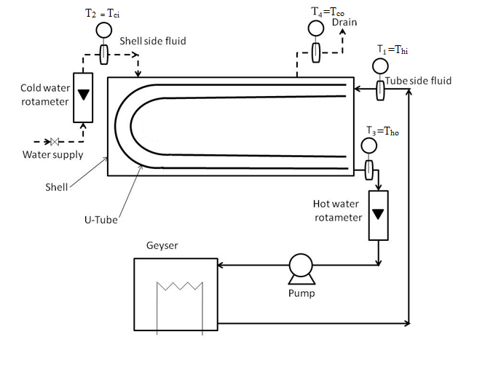

**Figure 1:** Schematic diagram for shell and tube heat exchanger.

1. **Experimental procedure**
2. Fill water bath ¾ with clean water and switch ON pump to circulate water. Once water flow is continuous, switch ON the heaters.
3. Adjust the required temperature of hot water using Digital Temperature Controller (DTC) (i.e., around 55 0C to 60 0C) in the water bath and maintain the hot water temperature at a constant value throughout the experiment, either at 55 0C or 60 0C.
4. Once the temperature of the hot water has reached the required value, start the flow of water through both hot and cold water side and maintain the constant flow rate of hot water in the shell side and cold water flow rate may vary.
5. Once the flow gets stabilized in both hot and cold side record the temperature and flow rate readings.
6. Change the flow rates of cold water, wait for steady state, and note down another set of readings. In this way, take 6-7 readings at different flow rates of cold water, while keeping the hot water flow rate constant.
7. Now, change the temperature or flow rate of hot water and repeat steps iii-iv.
8. **Observations& calculations:**

**5.1 Observation Table:**

|  |  |  |  |  |  |  |
| --- | --- | --- | --- | --- | --- | --- |
| **Sr.**  **No.** | **Hot water side** | | | **Cold water side** | | |
| **Flow rate (Fh), LPH** | **Inlet temperature (Thi),** | **Outlet temperature (Tho),** | **Flow rate (Fc), LPH** | **Inlet temperature (Tci),** | **Outlet temperature (Tco),** |
| **1.** |  |  |  |  |  |  |
| **2.** |  |  |  |  |  |  |
| **3.** |  |  |  |  |  |  |
| **4.** |  |  |  |  |  |  |
| **5.** |  |  |  |  |  |  |
| **6.** |  |  |  |  |  |  |
| **7.** |  |  |  |  |  |  |

**5.2 Properties:**

Estimate the properties of water for both hot side and cold side (*Reference: Perry’s Handbook of Chemical Engineering*) at average temperature as follows:

Specific heat of cold water, *cpc = _________________* J/kg.K

Specific heat of hot water, *cph = _________________* J/kg.K

Density of cold water, *ρc* *= _________________* kg/m3

Density of hot water, *ρh* *= _________________* kg/m3

1. **Calculations:**

Perform calculations for all sets of readings in the report. Show detailed calculations of one set of readings. All the students in the group will show detailed calculations of different sets of readings in the report. Following procedure should be followed for calculations.

1. Velocity of cold water (m/s):
2. Mass flow rate of hot water (mh) (kg/s):
3. Heat transferred from hot water (Qh) (W):
4. Mass flow rate of cold water (mc) (kg/s):
5. Heat transferred to cold water (Qc) (W)
6. Heat loss from the exchanger W = _______________ W
7. Efficiency of the heat exchanger = = _______________
8. Logarithmic mean temperature difference (Tm), in C

∆T1 = Thi – Tci = ________________ oC

∆T2 = Tho – Tco = ________________ oC

As it is a U–tube heat exchanger, multiply the LMTD with the correction factor (FT) to get the modified LMTD (Figure 2).

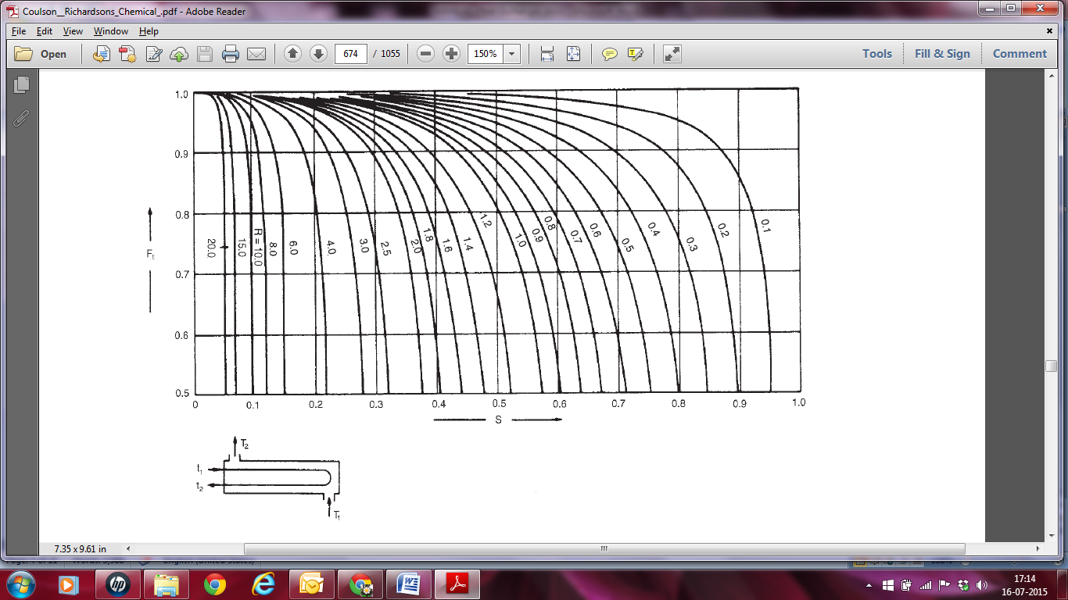

**Figure 2:** LMTD correction factor: one shell pass and two tube passes (Reference: Coulson and Richardson’s Chemical Engineering, Volume 6, page number – 657, Figure 12.19)

1. Outer surface area for the inner tube:

Ao= NπDoL = __________________ m2

1. Overall heat transfer coefficient (U), W/m2
2. Use Seider-Tate equation to compute the inside film heat transfer coefficient by assuming viscosity correction factor as unity.

where (*jh.Re*) is obtained from Figure 3, where is the Reynolds number and .

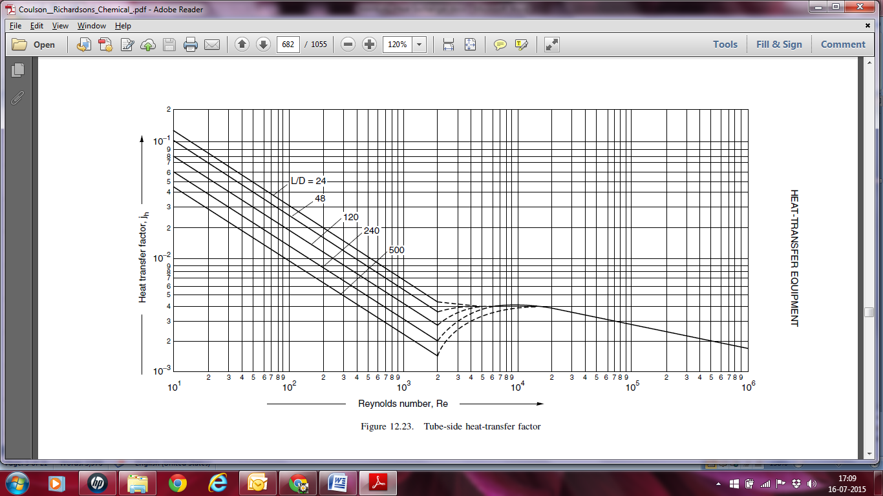

Figure 3: Heat transfer factor for flow inside tubes (Reference: Coulson and Richardson’s Chemical Engineering, Volume 6, page number – 665, Figure 12.23)

1. Compute the outside film heat transfer coefficient using the relation
2. Repeat steps i-xii for all set of readings
3. **Results & Discussions:**
4. Make a plot of and against and provide a physical interpretation of the results obtained.
5. Explain the possible reasons of heat loss or low efficiency of the heat exchanger.
6. **Precautions:**
7. Do not put on heater unless water flow is continuous.
8. Once the flow is fixed, do not change it until you note down the readings for that flow.
9. Thermocouple should be kept in pockets.
10. Once the experiment is completed, drain out the water from both the tubes.
11. **References:**
12. Coulson, J.M., Richardson, J.F., "Coulson & Richardson's Chemical Engineering” Volume 6, 6th ed., Asian Books ltd., ND, 1996, Page 655–668.
13. Holman, J.P., “Heat transfer”, 9th Edition, McGraw Hill, NY, 2008, Page 525-526, 528-531.
14. Kern, D. Q., “Process Heat Transfer” 8th ed.,McGraw Hill,1997,Page No:127-172.
15. Perry’s Chemical Engineers’ Handbook, 7th ed.,1997,Page 11-33 -11-45

**Experiment number: 2**

**Experiment title: Double Pipe Heat exchanger with Parallel/Counter Flow Configuration**

1. **Aim:**
2. To calculate rate of heat transfer, log mean temperature difference (LMTD) and overall heat transfer coefficient for parallel and counter flow heat exchangers.
3. To compare the performance of parallel and counter flow heat exchanger using effectiveness–NTU method.
4. Compute the individual film coefficients.
5. **Theory:**

Heat exchanger is a device used to transfer heat from one fluid to another fluid which are at different temperatures. It is used in almost all industries. Simplest example of heat exchanger is the double pipe heat exchanger. Double pipe heat exchanger consists of two cocentric pipes in pipes, in which one fluid flows through the inner pipe and the other fluid flows through the annulus. Heat transfer takes place across the wall of inner tube. The experiment is conducted by keeping the flow rates same (approximately) while running the apparatus as parallel flow (when fluid moves in the same direction) or as counter flow (when fluids move in opposite directions). Temperatures are measured with the help of thermocouples. Readings are recorded when steady state is reached. The outer tube is provided with adequate insulation to check heat loss. The present experimental setup for parallel/counter flow heat exchanger consist of following components:

* 1. Main Frame
  2. Heat exchanger
  3. Temperature Indicator
  4. Hot water generator
  5. Rotameter for hot and cold water flow rate measurement.
  6. Temperature Sensors

Hot fluid is hot water which is heated with the help of heater fitted in the tank and circulated with the help of pump. Cold water flows in the annular tube. Different valves are provided in the apparatus to regulate the flow rate of liquid and make the system to run in parallel− or counter− flow mode. The schematic diagram of the double pipe heat exchanger experiment is given in Figure 1 below:

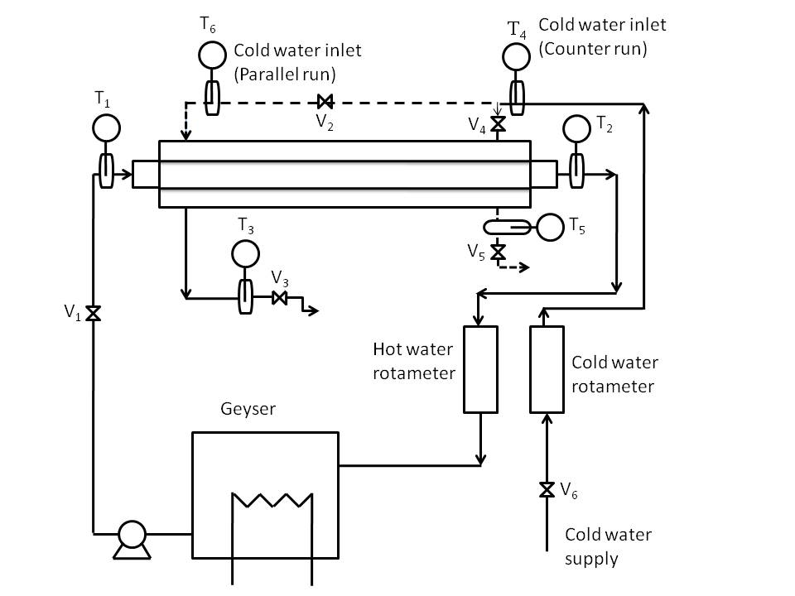

**Figure 1:** Schematic diagram for double pipe counter and parallel flow heat exchangers.

1. **Specifications:**

Inner tube material : Copper

Inner diameter of inner tube, : 9.5 mm

Outer diameter of inner tube, : 12.7 mm

Outer tube material : G.I. (GALVANIZED IRON)

Inner diameter of outer tube, : 28 mm

Outer diameter of outer tube, : 34 mm

Length of tube : 1.6m

Heater power : 3 kW

Thermostat : 1 (range 100-1000 C)

MCB : 16 Amp Heater, 6 Amp for Pump

Type of Pump : magnetic drive pump, power ¼ HP

1. **Experimental procedure**
2. Fill water bath ¾ with clean water and switch ON pump to circulate water. Once water flow is continuous, switch ON the heaters.
3. Adjust the required temperature of hot water using Digital Temperature Controller (DTC) (i.e., around 55 0C to 60 0C) in the water bath and maintain the hot water temperature at a constant value throughout the experiment, either at 55 0C or 60 0C.
4. For parallel flow, the flow of hot and cold water should be on the same end of the heat exchanger and for counter flow, the flow of hot and cold water should be from the opposite ends. Make this arrangement as per the instructions below:
5. **For Parallel Flow:**
6. Open the valves V1, V2, V5 and V6 and close the valves V4 and V3.
   1. Once the temperature of the hot water has reached the required value, start the flow of water through both hot and cold water side and maintain the constant flow rate of hot water in the annulus and cold water flow rate in the inside pipe may vary.
   2. Wait for the temperature to stabilize on the indicator.
   3. Record the flow rate of hot and cold water from the rotameter attached to the instrument.
   4. As the temperature gets steady, record the temperature for different four channels, i.e. T1, T2, T6 and T5 using switch on the panel.
   5. Take 6-7 readings for different cold water flow rates at constant hot water flow rare in the annulus.
7. **For Counter-current flow:**
8. Open the valves V1, V4, V3, and V6 and close the valves V5 and V2.
9. Once the temperature of the hot water has reached the required value, start the flow of water through both hot and cold water side and maintain the constant flow rate of hot water in the annulus and cold water flow rate in the inside pipe may vary.
10. Wait for the temperature to stabilize on the indicator.
11. Record the flow rate of hot and cold water from the otameter attached to the instrument
12. As the temperature gets steady, record the temperature for different four channels, i.e. T1, T2, T3 and T4 using switch on the panel.
13. Take 6-7 readings for different cold water flow rates at constant hot water flow rare in the annulus.
14. **Observations& calculations:**

**5.1 Observation Tables:**

*5.1.1 Parallel flow:*

|  |  |  |  |  |  |  |
| --- | --- | --- | --- | --- | --- | --- |
| **Sr.**  **No.** | **Hot water side** | | | **Cold water side** | | |
| **Flow rate (Fh), LPH** | **Inlet temp. (Thi or T1),** | **Outlet temp. (Tho or T2),** | **Flow rate (Fc), LPH** | **Inlet temp. (Tci or T6),** | **Outlet temp. (Tco or T5),** |
| **1.** |  |  |  |  |  |  |
| **2.** |  |  |  |  |  |  |
| **3.** |  |  |  |  |  |  |
| **4.** |  |  |  |  |  |  |
| **5.** |  |  |  |  |  |  |
| **6.** |  |  |  |  |  |  |

*5.1.2 Counter flow:*

|  |  |  |  |  |  |  |
| --- | --- | --- | --- | --- | --- | --- |
| **Sr.**  **No.** | **Hot water side** | | | **Cold water side** | | |
| **Flow rate (Fh), LPH** | **Inlet temperature (Thi or T1),** | **Outlet temperature (Tho or T2),** | **Flow rate (Fc), LPH** | **Inlet temperature (Tci or T4),** | **Outlet temperature (Tco or T3),** |
| **1.** |  |  |  |  |  |  |
| **2.** |  |  |  |  |  |  |
| **3.** |  |  |  |  |  |  |
| **4.** |  |  |  |  |  |  |
| **5.** |  |  |  |  |  |  |
| **6.** |  |  |  |  |  |  |

**5.2 Properties:**

Estimate the properties of water for both hot side and cold side, from the data book, at average temperature as follows:

|  |  |  |
| --- | --- | --- |
| **Property** | **Parallel flow** | **Counter flow** |
| Specific heat of cold water, *cpc,* kJ/kg.K |  |  |
| Specific heat of hot water, *cph,* kJ/kg.K |  |  |
| Density of cold water, *ρc*, kg/m3 |  |  |
| Density of hot water, *ρh*, kg/m3 |  |  |

**5.3 Calculations for parallel/counter flow:**

1. Velocity of cold water, in m/s

1. Velocity of hot water in the annulus, in m/s

1. Mass flow rate of hot water (mh), in kg/s
2. Heat transferred from hot water (Qh), in W
3. Mass flow rate of cold water (mc), in kg/s
4. Heat transferred to cold water (Qc), in W
5. Heat loss from the exchanger W
6. Efficiency of the heat exchanger =
7. Logarithmic mean temperature difference (Tm), in C

For parallel flow,

∆T1 = Thi – Tci = ________________ oC

∆T2 = Tho – Tco = ________________ oC

For counter flow,

∆T1 = Thi – Tco = ________________ oC

∆T2 = Tho – Tci = ________________ oC

1. Outer surface area for the inner tube:

Ao= πdoL = __________________ m2

1. Overall heat transfer coefficient (U), W/m2
2. Use Seider-Tate equation to compute the inside and outside film heat transfer coefficientand by assuming viscosity correction factor as unity.

where for inside film coefficient and for outside film coefficient. Here, is the hydraulic radius defined as

(*jH/Re*) is obtained from Figure 2, where is the Reynolds number and .



**Figure 2:** Heat transfer factor for flow inside tubes (Reference: Coulson and Richardson’s Chemical Engineering, Volume 6, page number – 665, Figure 12.23)

Heat transfer coefficient (h) for tube side can also be estimated using the correlation proposed by Eagle and Ferguson (1930):

1. Compute the theoretical value of overall heat transfer coefficient by neglecting wall resistance.
2. Capacity ratio, C
3. Effectiveness of heat exchanger, ε

When,

When,

1. Number of transfer unit for inner surface, NTU
2. Repeat steps i-xvi for all set of readings
3. **Results & Discussions:**
4. Make a plot of against of inside fluid for both parallel and counter flow arrangement and give a physical interpretation of obtained results.
5. Report and discuss the findings for ε and NTU values obtained in the present experiment.
6. **Precautions:**
7. Do not put on heater unless water flow is continuous.
8. Once the flow is fixed, do not change it until note down the readings for that flow.
9. Thermocouple should be kept in pockets.
10. Once the experiment is completed drain out the water from in both the tubes.
11. **References:**
12. Coulson, J.M., Richardson, J.F., "Coulson & Richardson's Chemical Engineering” Volume 6, 6th ed., Asian Books ltd., ND, 1996, Page 655–668.
13. Holman, J.P., “Heat transfer”, 9th Edition, McGraw Hill, NY, 2008, Page 525-526, 528-531.
14. Kern, D. Q., “Process Heat Transfer” ” 8th ed., McGraw Hill,1997, Page 102-126.
15. Perry’s Chemical Engineers’ Handbook, 7th ed., 1997, Page 11-46 -11-47.

**Experiment number: 3**

**Experiment title: Finned Tube Heat Exchanger**

* 1. **Aim:**
  2. to calculate rate of heat transfer, LMTD (Log Mean Temperature Difference) and overall heat transfer coefficient for parallel/counter flow type of heat exchanger, and
  3. to obtain the effectiveness of the given heat exchanger.
  4. **Theory:**

Extended surfaces of fins are used to increase the heat transfer rate from a surface to a fluid wherever it is not possible to increase the value of the surface heat transfer coefficient or the temperature difference between the surface and the fluid. The fins are attached to the primary heat transfer surface to increase the heat transfer coefficient for low thermal conductivity fluids. The temperature difference with surrounding fluid will steadily diminish as one moves out along the fin. Some of the applications of the fins are: circumferential fins around the cylinder of a motor cycle engine, fins attached to condenser tubes of a refrigerator, etc. The finned tube heat exchangers, depending on fins, are categorized as follows:

* + 1. An individually ﬁnned tube exchanger or simply a ﬁnned tube exchanger, having normal ﬁns on individual tubes;
    2. a tube-ﬁn exchanger having ﬂat (continuous) ﬁns; the ﬁns can be plain, wavy,or interrupted, and the array of tubes can have tubes of circular, oval, rectangular, or other shapes; and

1. longitudinal ﬁns on individual tubes (a) continuous plain; (b) cut and twisted; (c) perforated; (d) internal and external longitudinal ﬁns.

The finned parallel/counter-flow heat exchanger consists of following components:

1. Main frame
2. Tube attached with circumferential fins
3. Temperature sensors and indicators
4. Hot water generator (geyser)
5. Flow rate sensors and indicators

Hot fluid is hot water, which is heated with the help of heater fitted in the tank and circulated with the help of a pump. Cold fluid is air and pumped in the inner tube with the help of a blower. Different valves are provided in the system to regulate the flow rate of liquid and make the system to run in parallel mode or counter-flow mode.

* 1. **Experimental setup schematic and description:**

The apparatus consists of a tube in tube type concentric tube heat exchanger. The hot fluid is hot water which is obtained from geyser fitted in the tank. It flow through the inner tube while cold fluid is air flowing through annulus. The hot water flows in one direction while direction of air can be reversed with the help of valves to run the apparatus in parallel flow mode or counter-flow mode. Air is passed using blower which passes through orifice meter attached with manometer. Manometric fluid is water.

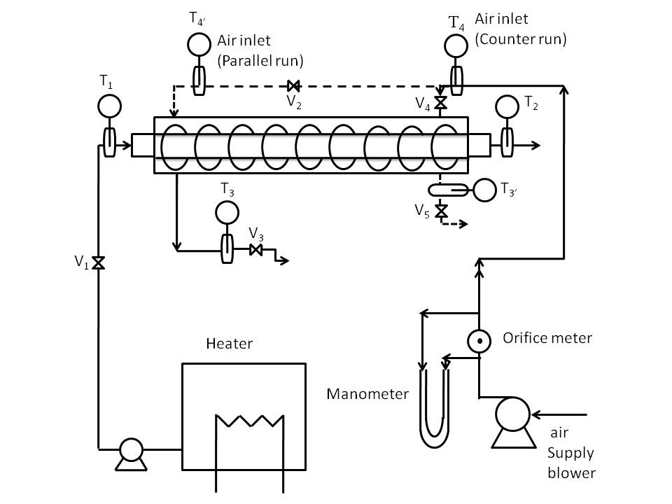

**Figure 1** Schematic diagram for finned tube heat exchangers.

* 1. **Specifications:**

Inner tube material : Copper

Outer diameter : 15 mm

Inner diameter : 19 mm

Outer tube material : G.I. (GALVANIZED IRON)

Inner diameter : 65.3 mm

No. of longitudinal fins : 41

Length of tube : 1000 mm

Heater : 3 kW (3 nos.)

Digital Temp. Indicator : 0–300 0C

Orifice diameter : 0.025 m

Area of the orifice (A = : 4.9 x 10-4 m2

Diameter of fin : 50 mm

Width of fin : 2 mm

* 1. **Experimental procedure**

1. Start the flow of water, by adjusting the valve.
2. Switch on the heaters (geysers).
3. Run the unit either in parallel flow or counter flow arrangement.
4. For parallel flow, the flow of hot and cold water should be from the same end and for counter flow the flow of hot and cold water should be from opposite end. Make this arrangement as per requirement.
5. The description for parallel and counter flow arrangement, as per the Figure 1, is as follows:
   * + 1. **For Parallel Flow:**
6. Open the valves V1, V2, V3 and V4 and close the valve V5.
7. Wait for the temperature to stabilize on the indicator.
8. As the temperatures become steady, note down the air and water flow rates.
9. Record the temperature for the four channels, i.e. T1, T2, T3 and T4, using switch on the panel.
   * + 1. **For Counter-current flow:**
10. Open the valves V1, V2 and V5 and close the valves V3 and V4.
11. Wait for the temperature to stabilize on the indicator.
12. As the temperatures become steady, note down the air and water flow rates.
13. Record the temperature for the four channels, i.e. T1, T2, T4 and T3, using switch on the panel.
14. Switch on the blower to have air flow in the annulus section.
15. Adjust the air flow rate with the help of gate valve and manometer.
16. Leave the system for 15 minutes to get stabilized.
17. Once the temperature of the hot water gets stabilized, note down the temperatures and flow rates.
18. Record the readings by varying flow rates for both hot and cold sides.
    1. **Observations & calculations:**

**6.1 Observation Table:**

|  |  |  |  |  |  |  |  |
| --- | --- | --- | --- | --- | --- | --- | --- |
| Sr.  no. | Flow configuration | Hot water | | | Air | | |
| Inlet temperature | Outlet temperature | Flow rate, (lph) | Inlet temperature | Outlet temperature | Flow rate (kg/h) |
| 1. | Parallel Flow |  |  |  |  |  |  |
| 2. | Counter Flow |  |  |  |  |  |  |
| 3. | Parallel Flow |  |  |  |  |  |  |
| 4. | Counter Flow |  |  |  |  |  |  |

**6.2 Calculations:**

1. Air flow rate (Qa)

where

Cd is the discharge coefficient of orifice (0.64),

g is the gravitational acceleration (9.81 m/s2), and

H is the air head over the orifice and is estimated using the following equation:

where h is the manometer difference, andρa is the density of air at STP (kg/m3) and estimated using the following equation

where M is the molecular weight of air, P is the pressure (Pa) and Ta is the air temperature at the inlet (ᵒC)

1. Mass flow rate of air (ma), kg/hr
2. Heat transfer rate from the hot water (qh), (assume cph = 1.0 kcal/kg.0C)
3. Heat transfer rate to the air (qa), (assume cpa = 0.24 kcal/kg.0C)
4. Average heat transfer rate (q), in kcal/hr
5. Logarithmic mean temperature difference (Tm), in K
6. Inner and outer surface area for the inner tube:

Ai= πdiL = __________________ m2

Ao= πdoL + area of fins = __________________ m2

1. Inner overall heat transfer coefficient (Ui), W/m2
2. Outside heat transfer coefficient (Uo), W/m2
3. Capacity ratio, C
4. Effectiveness of heat exchanger, ε

When,

When,

1. Predict the overall heat transfer coefficient value using the forced convection heat transfer correlations for flow through tube and annulus, i.e.

where ri is di /2, ro is do/2, k is the thermal conductivity of tube material (330 W/m.0C), and hi is the inner heat transfer coefficient, and it estimated as

The equivalent properties have to be calculated at an average temperature:

ho is the annulus side heat transfer coefficient, and it estimated as

The characteristic length in Nu and Re is (Di – do), which is the equivqlent diameter for flow through annulus.The equivalent properties have to be calculated at average temperature:

* 1. **Results & Discussions:**

1. The overall heat transfer coefficients, effectiveness and number of transfer units in finned tube heat exchanger for both parallel and counter flow configurations are as follows:

|  |  |  |  |  |  |
| --- | --- | --- | --- | --- | --- |
| Flow configuration | *Ui* | *Uo* | ε | *NTUi* | *NTUo* |
| Parallel flow |  |  |  |  |  |
| Counter flow |  |  |  |  |  |

1. Compare the values of ε, Uo, Ui for both cases and discuss its physical significance.
   1. **Nomenclature:**

Ai Area of inner tube, m2

Ao Area of outer surface of inner tubeand the fins, m2

Cd Coefficient of discharge= 0.64

di Inner diameter of inner tube , m

do Outer diameter of inner tube, m

Di Inner diameter of outer tube, m

g Acceleration due to gravity.

H Air head over the orifice.

qh Heat transfer rate from hot water,

qa Heat transfer rate from air,

q Average heat transfer rate, kcal/hr

ΔTm Logarithmic mean temperature difference, K

Uo Overall heat transfer coefficient based on outer area including fins, kcal/m2.s.0C

Ui Overall heat transfer coefficient based on inner area, kcal/m2.s.0C

C Capacity ratio

Cmin Minimum heat capacity

Cmax Maximum heat capacity

ε Effectiveness of heat exchanger

A Area of orifice, m2

* 1. **Precautions:**

1. Never run the apparatus if power supply is less than 180V and above 230V.
2. Never switch ON mains supply before ensuring that all the ON/OFF switches given on the panel are at OFF position.
3. Do not put on heater unless water flow is continuous.
4. Equipment should be earthed properly.
5. Once the experiment is complete, drain out the water from both the tubes.
   1. **References:**
6. Coulson, J.M., Richardson, J.F., "Coulson & Richardson's Chemical Engineering” Volume 6, 6th ed., Asian Books ltd., ND, 1996, Page 655–668.
7. McCabe, Smith ,J.C., Hariott, P., “Unit Operations of Chemical Engineering”, Seventh Edition. McGraw Hill, NY, 2005, Page 327-329,331-333.
8. Cengel Yunus A," Heat and Mass Transfer" 2nd Edition, Mc Graw Hill, Chapter 13, Page 667–705.

**Experiment number: 4**

**Experiment title: Heat Transfer in Natural Convection**

* 1. **Aim:**

1. to study the heat transfer phenomena in natural convection, and
2. to determine heat transfer coefficientfor vertical cylinder in natural convection.
   1. **Theory:**

Convectionis the mechanism of heat transfer through a fluid in the presence of bulk fluid motion. Convection is classified as natural(or free) and forcedconvection*,* depending on how the fluid motion is initiated. In forced convection, the fluid is forced to flow over a surface or in a pipe by external means such as a pump or a fan. In natural convection, fluid motion is caused by natural means such as the buoyancy effect, which manifests itself as the rise of warmer fluid and the fall of the cooler fluid. Convection is also classified as externaland internal*,* depending on whether the fluid is forced to flow over a surface or in a channel.

The natural convection phenomenon is due to the temperature difference between surface and the fluid by natural means, i.e without any external agency. The setup is designed and fabricated to study the natural convection phenomenon from a vertical cylinder in terms of average heat transfer coefficient. The heat transfer coefficient is given by:

where h is the heat transfer coefficient, A is the surface area for heat transfer, *Qa* is the heat rate, and *Ts* and *Ta* are the temperature of surface and air, respectively.

* 1. **Experimental setup schematic and description:**

The apparatus consists of a brass tube fitted in rectangular duct in a vertical fashion. The duct is open from the top and the bottom and forms an enclosure and serves the purpose of undisturbed surrounding. One side of it is made of glass/acrylic for visualization. A heating element is kept in vertical tube, which heats the tube surface. The heat is lost from the tube surface to the surrounding air by natural convection. Digital temperature indicator measure the temperature at different points with the help of seven temperature sensors. The heat input to the heater is measured by Digital Ammeter and Digital Voltmeter and can be varied by dimmerstat.

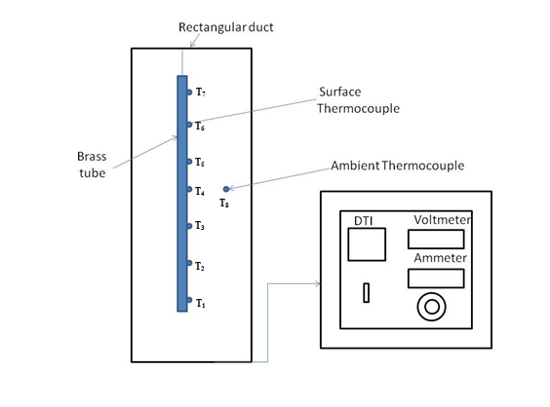

**Figure 1** Schematic diagram for natural convection experimental setup.

* 1. **Experimental procedure**

1. First clean the apparatus and make it free from dust.
2. Ensure that all ON/OFF Switch given in the panel are inthe OFF position.
3. Ensure that variac Knob position is at zero position given on the panel.
4. Switch on the panel to the heater with the help of ON/OFF switch given on the panel.
5. Fix the power input to the heater with the help of variac, Voltmeter and Ammeter provided.
6. After 30 minutes record the temperature of the test section at various points in each 5 minutes interval.
7. If temperature readings are same for three times assume that steady state is achieved.
8. Record the final temperature.
   1. **Observations& calculations:**

**Data:**

d = 0.038 m

L = 0.5 m

**Observation table:**

|  |  |  |  |  |  |  |  |  |  |  |
| --- | --- | --- | --- | --- | --- | --- | --- | --- | --- | --- |
| Sr.No. | V  volt | I  amp | T1 | T2 | T3 | T4 | T5 | T6 | T7 | T8 |
| 1. |  |  |  |  |  |  |  |  |  |  |
| 2. |  |  |  |  |  |  |  |  |  |  |

**Calculations:**

1. Amount of heat transfer (Q), in W

Q = V*I = ________________ W

1. Heat transfer area of cylindrical column (A), in m2

A =*πdL*= _______________m2

1. Average temperature of the cylindrical column

where Ta = T8

* 1. **Results and discussions:**

The heat transfer coefficient for a vertical tube losing heat by natural convection is ___________ W/m2.oC

* 1. **Nomenclature:**

A Heat transfer area of cylindrical column (A), in m2

d Diameter of cylinder, m

h Heat transfer coefficient,

L Length of cylinder, m

Q Amount of heat transfer, W

I Ampere reading, amp

V Voltmeter reading, volts

Ts Average surface temperature,

Ta Temperature of air,

T1 to T7 Surface temperature of test section at different points, .

* 1. **Precautions:**

1. Never run the apparatus if the power supply is less than 180 volts and above than 230 volts.
2. Never switch ON main power supply before ensuring that all the ON/OFF switches given in the panel are inthe OFF position.
3. Operate selector switch of temperature indicator gently.
4. Always keep the apparatus free from dust.
5. Do not flockthe passage of air on top.
   1. **References:**
6. Holman, J.P., “Heat transfer”, 9th Edition, McGraw Hill, NY, 2008
7. McCabe, Smith ,J.C., Hariott, P., “Unit Operations of Chemical Engineering”, Seventh Edition. McGraw Hill, NY, 2005, Page 459-464

**Experiment number: 5**

**Experiment title: Dropwise and Filmwise Condensation**

* 1. **Aim:**

1. to have a visual observation of filmwise and dropwise condensation, and
2. to determine overall heat transfer coefficients in both filmwise and dropwise condensation both experimentally as well as theoretically.
3. **Theory:**

In all process, the steam must condense as it transfers heat to a cooling medium, e.g. cold water in condenser of a generating station, hot water in a heating calorimeter etc. during condensation very high heat fluxes are possible and provided the heat can quickly be transferred from the condensing surface to cooling medium, heat exchangers using steam can be compact and effective.

Steam condenses on surface by two types: 'filmwise' and 'dropwise'. For the same temperature difference between steam and surface dropwise condensation is more effective than filmwise condensation.

1. Filmwise condensation:

Most materials are wettable and as condensation occurs a film condensate spreads over the surface. The thickness of film depends upon a number of factors like rate of condensation, the viscosity of condensate and whether surface is horizontal or vertical. Fresh vapor condenses on outside of film and heat is transferred by conduction through the film to the metal surface beneath. As the film thickness increases, it flows downwards and dips from lowest point, leaving the film intact. The film of liquid is a barrier to the transfer of heat and its resistance accounts for most of the difference between the effectiveness of filmwise and dropwise condensation.

1. Dropwise condensation:

By specialy treating the condenser surface, the contact angle can be changed and surface become non- wettable. As steam condenses, a large number of beads cover the surface. As condensation proceeds the beads become larger, coalesces and strikes downward over the surface. The moving beads gather all static beads along with it in its downwardspath in its trail. The bare surface offers very little resistance to the transfer of heat and very high heat fluxes are possible. Unfortunately, due to the nature of material used in the construction of condenses, filmwise condensation is normal.

1. **Experimental setup schematic and description:**

The apparatus consists of a vertical frame. Condensation tubes are fitted inside compact glass cylinder. The steam is provided in the cylinder from a steam generator. Two valves are fitted to control flow rate of water in individual tubes. Digital temperature indicators are used to monitor the temperatures at different locations in the experimental setup. A Digital Temperature Controller is provided for controlling temperature of steam. Pressure gauge is used to observe steam pressure and a rotameter is used to measure the cold water flow rate. Water Level Indicator(not shown) is provided to safeguard the heater. Condensate is measured using a measuring cylinder after the completion of the experiment.

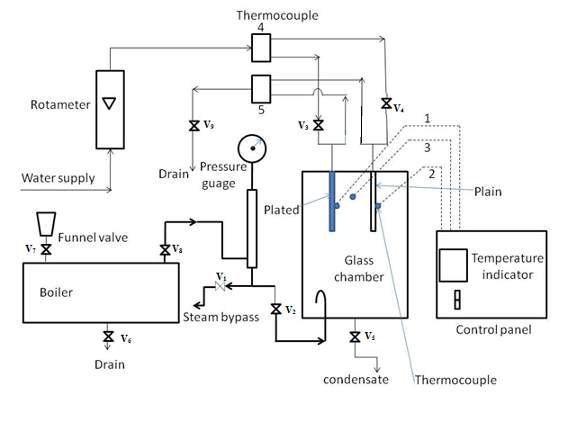

**Figure 1** Schematic diagram for filmwise and dropwise condensation experimental setup.

1. **Experimental procedure**
2. Ensure that ON/OFF switches given on the panel are at OFF positions.
3. Close all drain valves.
4. Open the funnel valve and air vent valve provided at the top of the steam generator.
5. Fill water in the steam generator up to ¾th of its capacity by observing the level of water in level indicator.
6. Switch ON the main supply.
7. Set the required steam temperature with the help of DTC, above 100.
8. Switch ON the heater and wait until the steam temperature reaches to the required value.
9. Ensure that wet steam vent valve(V1)and gate valve(V2)provided at the front are closed.
10. Allow steam to pass through the pipe and slowly open wet steam vent valve(V1)to release wet steam from the pipe.
11. Close the vent valve(V1).
12. Connect cooling water supply.
13. Open the valve (V3) or (V4) to allow cooling water to flow through the desired condenser (Ensure that during experiment, water is flowing only through the condenser under test and the second valve is closed).
14. Set the flow rate of cooling water by Rotameter.
15. Open the gate valve(V2) to allow steam to enter in the test section and start the stop watch to measure mass of steam condensed.
16. Observe the steam that gets condensed on the tubes, and falls down in the glass cylinder (Depending upon the type of condenser under test i.e. Dropwise or Filmwise condensation).
17. After reaching the steady state, record the temperature, flow rate of cooling water and steam pressure.
18. Stop the steam supply to the column with the help of gate valve(V2) and stop the stop watch and open the drain valve(V5) of the glass chamber to measure the condensate in a particular time.
19. **Observations& calculations:**

**Data:**

Do = 0.019 m

Di = 0.016 m

L = 0.175 m

**Fluid Properties:** From physical property data at experimental condition from literature.

k (at 40) = 0.628 W/m.

(at 100) = 0.6775 W/m.

**Observation table:**

|  |  |  |  |  |  |  |  |  |
| --- | --- | --- | --- | --- | --- | --- | --- | --- |
| Sr.  No. | Fw, lph | V, ml | Time,  T(s) | T1 | T2 | T3 | T4 | T5 |
|  |  |  |  |  |  |  |  |  |
|  |  |  |  |  |  |  |  |  |

**Calculations:**

1. Density of steam at T,P noted ____________________________
2. Steam mass flow rate (Ms), in
3. Mass flow rate of water (Mw), in kg/s
4. Heat loss from steam (Qs), in W
5. Heat transferred to cold water (Qw), in W
6. Average heat transfer (Q), in W
7. Inside heat transfer coefficient (hi), W/m2
8. Outside heat transfer coefficient (ho), W/m2
9. Logarithmic mean temperature difference (Tm), in K

∆T1= T3 – T1 For Plated condenser

∆T1 = T3 – T2  For Plain condenser

∆T2= T4 – T5 (Water outlet – Water inlet)

1. Experimental overall heat transfer coefficient (Uex),in W/m2
2. Calculation of Theoretical overall heat transfer coefficient (Uth), in W/m2
3. **Results & Discussions:**

The overall heat transfer coefficients from both experimental and theoretical calculations for filmwise and dropwise condensation processes is as follows:

|  |  |  |
| --- | --- | --- |
| **Condensation process** | **Experimental overall heat transfer coefficient (Uex)** | **Theoretical overall heat transfer coefficient (Uth)** |
| Filmwise condensation |  |  |
| Dropwise condensation |  |  |

1. **Nomenclature:**

Ai Inside heat transfer area, m2

Ao Outside het transfer area, m2

Di Inner diameter of plated and plain cylinder, m

Do Outside diameter of plated and plain cylinder, m

Fw Flow rate of cooling water, LPH

hi Inside heat transfer coefficient, W/m2

ho Outside heat transfer coefficient, W/m2

Ms Rate of steam condensation, kg/s

Cold Water Flow rate, kg/s

Nusselt number

Pr Prandtl number

Q Average heat transfer, W

Qs Heat losses from steam, W

Qw Heat taken by water, W

Reynolds number

Temperature of steam, ᵒC

Temperature of condenser wall, ᵒC

Surface Temperature of Plated Condenser, ᵒC

Surface Temperature of Plain Condenser, ᵒC

Temperature of steam in column, ᵒC

Water inlet Temperature, ᵒC

Water outlet Temperature, ᵒC

Δ Log mean temp difference, ᵒC

t Time taken to collect V ml of condensed steam, in s

Uex Experimental overall heat transfer coefficient,

Uth Theoretical overall heat transfer coefficient, W

V Volume of condensed steam collected in measuring cylinder, in ml

Specific heat of water, kJ/kg K

L Length of condenser, m

Density of water, kg/

ν Kinematic Viscosity,

k Thermal conductivity, W/m ᵒC

λ Latent heat of steam, J/kg

1. **Precautions:**
   1. Never run the apparatus if power supply is less than 180 volts and above 230 volts.
   2. Never switch ON mains power supply before ensuring that all the ON/OFF switches given on the panel are at OFF position.
   3. Operator should switch OFF the temperature indicator gently.
   4. Always keep the apparatus free from dust.
2. **References:**
3. Coulson, J.M., Richardson, J.F., "Coulson & Richardson's Chemical Engineering Volume 2", 5th ed., Asian Books ltd., ND, 1996, Page 623-624.
4. Jutz-Scharkus, "Westarmann Tables", 3"1 ed., New Age International Publishers., ND, 2008, Page 32.
5. Arora, D., “A Course in Heat & Mass Transfer”, 6thed., Dhanpat Rai & CO.(P) LTD.,NY,2003, page A.6.

**Experiment number: 6**

**Experiment title: Open Pan Evaporator**

* 1. **Aim:**

To determine the overall heat transfer coefficient, capacity, steam consumption, and economy of an open pan evaporator.

* 1. **Theory:**

Evaporation is a process of concentrating the solution of a non-volatile solute and volatile solvent (water). The concentrated solution is produced by the removal of required amount of volatile solvent. The heat is supplied to the solution to increase the temperature of the solution to its boiling point and to evaporate the solvent from the solution. The heat transfer coefficient of an open pan evaporator reduces due to the deposition of solids from the evaporating solution into the evaporator heat transfer surface, which gives rise to an additional heat transfer resistance. Also, the heat transfer area may reduce with time with a decrease in the liquid level, resulting in an additional decrease in the heat transfer coefficient.

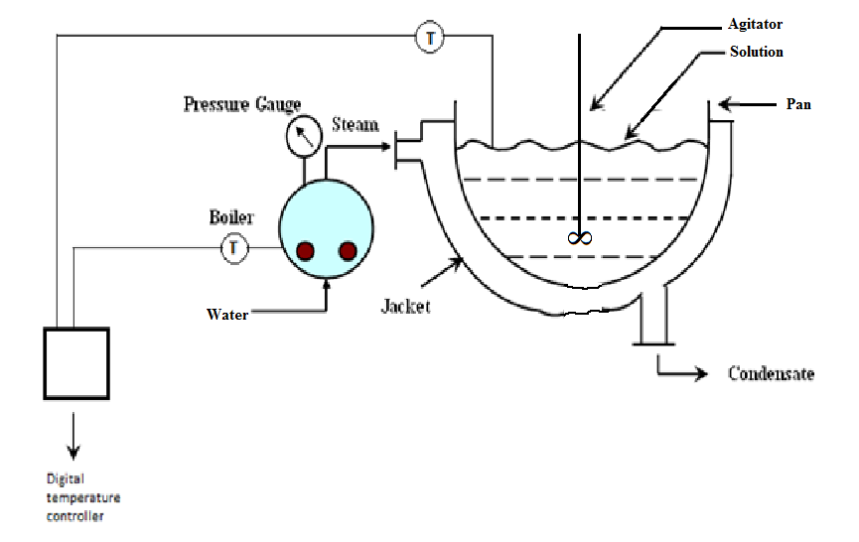

Figure 1 Schematic diagram for open pan evaporator experimental setup.

* 1. **Experimental procedure**

1. Prepare 10 wt. % solution of sodium carbonate and fill evaporator up to hemispherical level.
2. Record the level of solution.
3. Fill the steam generator about 3/4th of its capacity with water and set the temperature of steam with the help of a digital temperature controller.
4. Open the valve of steam when the set temperature of steam is achieved.
5. Record the temperature of solution.
6. When this temperature becomes almost constant, note the height of solution with the help of scale and start the stop watch.
7. Record the height of solution at different instants of time, e.g., every three minutes for around ~90 min.
   1. **Observations:**

Radius of sphere, R = 0.145 m

Solution temperature, =

Entering steam temperature, =

Amount of condensate collected,

|  |  |  |
| --- | --- | --- |
| S. No. | Time, θ | Solution level () |
|  |  |  |
|  |  |  |
|  |  |  |
|  |  |  |
|  |  |  |

* 1. **Calculations:**

a) Show that the volume of liquid at a time is given by

where is the height of solution at time

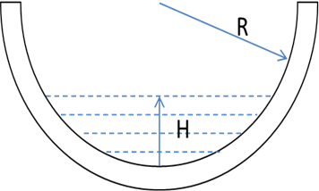

Also, show that the heat transfer area can be approximated by

b) Find the total amount of water evaporated after time using the formula

Here, ρ is the density of water (at the solution temperature found from literature)

c) Assuming the density of the solution ρ is nearly constant and the solute is not vaporized, estimate the final weight % of solute by the solute material balance,

Solute Material Balance: , where and are weight fraction of solute in the initial and final solution, respectively, and is the final solution volume.

Can you suggest how to proceed if we also want to account for the density change with time?

d) Find the total heat transfer after time using

where λ is the latent heat of vaporization (at the boiling point of water). We assume that the sensible heat for heating the solution to the boiling point is negligible.

How can we account for the sensible heat in this equation?

e) Find the heat transfer coefficient at time , , using the equation

where is the heat transfer rate at time evaluated from the slope of vs. curve, and

f) Find the capacity of the evaporator as the kgs of water evaporated per hour, steam consumption as the kgs of steam fed per hour, economy as the number of kgs of water vapor vaporized per kg of steam fed to the unit.

* 1. **Results and Discussions**:

Overall heat transfer coefficient, U =.............................

Capacity =..................................

Steam consumption=………….

Economy=.................................

Plot vs and explain your results.

Suggest methods to improve the economy of the evaporator.

If you have performed the single effect evaporator experiment, explain the similarities and differences between the two evaporators.

* 1. **Precautions:**
  2. Never run the apparatus if power supply is less than 180 volts and above 230 volts.
  3. Never switch ON mains power supply before ensuring that all the ON/OFF switches given on the panel are at OFF position.
  4. Operator switch OFF temperature indicator gently.
  5. Always keep the apparatus free from dust.
  6. **References:**

1. Coulson, J.M., Richardson, J.F., "Coulson & Richardson's Chemical Engineering Volume 2", 5th ed., Asian Books ltd., ND, 1996, Page 623-624.
2. Jutz-Scharkus, "Westarmann Tables", 3"1 ed., New Age International Publishers., ND, 2008, Page 32.
3. Arora, D., “A Course in Heat & Mass Transfer”, ed., Dhanpat Rai & CO.(P) LTD.,NY,2003, page A.6.
4. Geankoplis, Christie. Transport processes and separation process principles (includes unit operations). Prentice Hall Press, 2003.

**Experiment number: 7**

**Single Effect Evaporator**

1. **Aim**: To perform the material and energy balance and determine the capacity, steam consumption, and economy of a single effect evaporator.

1. **Theory:** Evaporation is a process of concentrating the solution of a non-volatile solute and volatile solvent (water). The concentrated solution is produced by the removal of required amount of volatile solvent. The heat is supplied to the solution to increase the temperature of the solution to its boiling point and to evaporate the solvent from the solution.



Figure 1: Schematic of the experimental setup

1. **Description of the experimental setup**

The set up consists of stainless steel tubes surrounded by a stainless steel jacket fitted with accumulator. Dilute solution is fed to tubes. Steam from steam generator is supplied to shell to concentrate the dilute feed solution to a desired level. The jacket is fitted with steam trap and the condensate is collected at the end of trap. The vapors of volatile solvent are condensed in a shell and tube type condenser and the balance non-volatile solute collected in the accumulator is recycled through the evaporator.

1. **Experimental procedure:**

Starting procedure:

1. Tabulate refractive index (RI) versus weight % for sodium carbonate and water solution at room temperature by performing experiments of different weight % of solutions (at least five different solutions, 5 wt/ %, 10 wt/ %, 20 wt. %, 30 wt. %, 40 wt. %)
2. Prepare 5% solution of sodium carbonate in water.
3. Close all the valves.
4. Fill cooling water tank with water.
5. Open funnel valve and air vent valve to steam generator and fill it 3/4th with water.
6. Close both the valves.
7. Ensure that switches given on the panel are at OFF position.
8. Connect electric supply to the set up.
9. Set the desired steam temperature (110 oC to 120 oC) by operating the increment or decrement and set button of DTC.
10. Switch ON the heater and wait till desired temperature achieves.
11. Open the funnel valve and vent valve of feed tank, fill the solution in feed tank and close both the valve after it.
12. Connect compressed air supply to the set up and adjust the pressure of the feed tank in the range 0.5 to 1 kg/cm2 by pressure regulator and pressure gauge.
13. Open feed supply valve and allow feed to enter in the evaporator by control valve and Rotameter.
14. Open steam valve supply.
15. Open vent valve before steam trap to release air and then close the valve.
16. Stop feed supply valve through Rotameter after maintaining a level of solution in front glass of evaporator.
17. Open recirculation valve and wait till observing rise in temperature of vapor.
18. Switch ON the pump and set the flow rate of cooling water by Rotameter.
19. Partially open the product outlet valve and start collecting the product in tank.
20. Open feed supply from Rotameter and adjust the flow rate of feed so that the level of solution in the side glass remains constant.
21. Record the flow rate of steam condensed by measuring cylinder and stop watch.
22. Record the evaporated vapor condensation rate by measuring cylinder and stop watch.
23. Record the temperature and flow rate of product
24. Measure the density of the product using density bottle
25. Measure the refractive index of the product

Closing procedure:

1. When experiment is over switch OFF heaters.
2. Partially open vent valve of steam generator to release pressure.
3. Switch OFF the pump.
4. Switch OFF Power Supply to Panel.
5. Stop compressed air supply to the set up and release air pressure by the regulator.
6. Drain feed tank by the drain valve provided.
7. Drain the evaporator liquid by the product outlet valve.
8. Drain the condenser by the drain valve provided.
9. Drain water from steam generator.
10. **Observations:**

Calibration

|  |  |
| --- | --- |
| Weight % of sodium carbonate | RI |
|  |  |
|  |  |

Evaporator

Density of product,

RI of product =

T1  = Steam inlet temperature =

T2 = Temperature of condensed steam =

T3 = Temperature of feed at inlet =

T4 = Temperature of vapor inlet to condenser =

T5 = Cold water Inlet temperature =

T6 = Cold water Outlet temperature =

Vs  = Volume of steam condensate collected in time ts = …. for ts =

Vp  = Volume of product collected in time tp= …. for tp =

Vv = Volume of condensate collected from condenser in time tv=.. for tv=..

Ff = Flow rate of feed=

Fc = Flow rate of cold water =

1. **Calculations:**
2. Mp = Weight of Vp volume of product =

Plot the calibration curve (RI versus weight %). Compute the weight % of solute in the product from the calibration curve, corresponding to the RI of product.

1. Show that the following overall material balance and solute material balance is satisfied.

Feed(Wf, Xf)

Feed(WP, XP)

Vapor WV

Overall Material Balance:

Rate of mass in= Rate of mass out

Where, is mass flow rate of feed, is mass flow rate of product, and is rate of condensation of vapor from condenser. Mass flow rates can be determined by multiplying the volumetric flow rates (volume/time) with appropriate density.

Solute Balance:

Here, and are the weight fraction of solute in the feed and product, respectively.

1. Neglecting heat losses to the surroundings and negligible heat of dilution, the steady state heat balance around the evaporator can be written as

where, is rate of steam condensation (mass flow rate of the condensed steam)

is latent heat of steam at experimental conditions (find from steam tables in literature)

is enthalpy of feed per unit mass

is enthalpy of product per unit mass

is enthalpy of water vapor evaporated per unit mass

Above enthalpies per unit mass can be calculated using the equation, , where is the appropriate specific heat (found from steam table), is the stream temperature and is a reference temperature (e.g., at the boiling point of water).

Show that this energy balance is satisfied.

1. Find the following for the evaporator.

Capacity: kg of water evaporated per hour.

Steam consumptions: kgs of steam fed per hour.

Economy: kg of water evaporated per kg of steam used.

1. **Discussion**
2. Suggest methods to improve the economy of the evaporator.
3. If you have performed the open pan evaporator experiment, discuss the similarities and differences between the two experiments.
4. **Precautions:**
5. Never run apparatus if power supply is less than 180 volts and above 230 volts.
6. Never switch ON mains power supply before ensuring that all the ON/OFF switches given on the panel are at OFF position.
7. Operator selector switch OFF temperature indicator gently.
8. Always keep the apparatus free from dust.
9. **References**:

McCabe W.L., Smith J.C., Harrirott P., "Unit Operations of Chemical Engineering", 7th ed. McGraw Hill, NY 2005. page 487-488, 500-502

Arora.Domkundwar, "A Course in Heat and Mass Transfer", 6th ed., Dhanpat Rai & CO.(P)LTD., NY, 2003, Page A.6, A.9

Geankoplis C.J."Transport Processes and Separation Process Principles", 4th ed., PHI Learning Private LTD., NY 2008, page 534-541

Rajput R.K., "Thermal Engineering", 6th ed., Laxmi publications (P) LTD, 2006, page 1653-1663