

INT213 (PYTHON PROGRAMMING) – PROJECT
on
YOUTUBE VIDEO DOWNLOADER

Submitted By:
NAME:
PRATHAM TABISH ABHISHEK
REGISTRATION NUMBER:
11905015 11904995 11905011
ROLL NUMBER:
15 21 14
Submitted to:
Mr. SAGAR PANDE
School of Computer Science & Engineering
Lovely Professional University, Phagwara, Punjab
(November, 2020)

ACKNOWLEDGEMENT

We have completed our project on the topic Youtube Video Downloader. We have taken efforts in this project.
In completion of the project, we have to take help through some online platforms , YouTube,
and guidance of each other. As the completion of this project gave us much pleasure, we
would like to show our gratitude to Mr. Sagar Pande for giving us such a wonderful task.
We would like to show our gratitude to our friends and family members who directly or indirectly helped and guided us in this project.

TABLE OF CONTENT

- Introduction
- Technology learnt
- Implementation
- Code
- Result
- How it will help us in future
- References /Bibliography

INTRODUCTION

YouTube is very popular video sharing website. Downloading a video from YouTube is a tough job.

Downloading the Downloader and get the video using that or go to any other website which fetches the video and saves on your computer. Using Python, this task is very easy. Few lines of code will download the video from YouTube for you. For this, there a python library named as ‘pytube’. pytube is a lightweight, dependency-free Python library which is used for downloading videos from the web.
pytube is not the native library. You need to install it before using it. Installation is easy when you have pip. In the Terminal or Command Prompt, type the following command to install pytube.

Technology Learnt
Pytube Module:
pytube
pytube is a lightweight, Pythonic, dependency-free, library (and command-line utility) for downloading YouTube Videos.
Features
- Support for Both Progressive & DASH Streams
- Easily Register on_download_progress & on_download_complete callbacks
- Command-line Interfaced Included
- Caption Track Support
- Outputs Caption Tracks to .srt format (SubRip Subtitle)
- Ability to Capture Thumbnail URL.
- Extensively Documented Source Code
- No Third-Party Dependencies
.
tkinter

The tkinter package (“Tk interface”) is the standard Python interface to the Tk GUI toolkit. Both Tk and tkinter are available on most Unix platforms, as well as on Windows systems. (Tk itself is not part of Python; it is maintained at ActiveState.)

Pillow

Python Imaging Library (expansion of PIL) is the de facto image processing package for Python language. It incorporates lightweight image processing tools that aids in editing, creating and saving images. Support for Python Imaging Library got discontinued in 2011, but a project named pillow forked the original PIL project and added Python3.x support to it. Pillow was announced as a replacement for PIL for future usage. Pillow supports a large number of image file formats including BMP, PNG, JPEG, and TIFF. The library encourages adding support for newer formats in the library by creating new file decoders.
Pyinstaller
We create lots of Python programs per day and want to share it with the world. It is not that you share that Python program with everyone and they will run this script in some IDLE shell. But you want everyone to run your Python script without the installation of Python. So for this work, you can convert the .py file to .exe file. In this article, you will learn how you can convert .py file to .exe file. Follow the below steps for the same.
Speed test
While troubleshooting with Internet speed. We need to first check internet bandwidth speed. So, pyspeedtest module test network bandwidth using Speedtest.net servers. So, before starting we need to install pyspeedtest into your system. Run these code to your command line
pip install speedtest
Approach:
- Import pyspeedtest
- Create object for SpeedTest()
- Check ping with ping()
- Check Download speed with download()
- Check Upload speed with upload()

IMPLEMENTATION

Interface:
Libraries used:
- pytube
- pygame
- tkinter
- speedtest
- pyinstaller
- pillow

■ First, we create the base of our game structure which is the window.
Here, we have taken the geometric height and width as 500x740
.
■ Then the window loop is created which holds the game window
unless and until exit or cross is not pressed. The value is stated true in the
loop.
■ Then the photos are imported which enables us to see the logo, icon or
. We use pilow. PIL function for this.
■ For music pygame is used .
■ For internet speed netspeed is used.
■ Web browser module is used to directly redirected to youtube
■ pyinstaller is used to making python file to.exe
■ pytube is used to download video form youtube

CODE

from pytube import YouTube
from tkinter.filedialog import *
from tkinter.messagebox import *
from tkinter import *
from speedtest import Speedtest
from threading import *
from PIL import Image,ImageTk
import webbrowser
import pygame
from pygame import mixer
pygame.mixer.init()
pygame.init()
def music_start():
pygame.mixer.music.load("./res/s.mp3")
pygame.mixer.music.play(-1)
music_start()
font = ('verdana', 20)
file_size = 0
# oncomplete callback function
def completeDownload(stream=None, file_path=None):
print("download completed")
showinfo("Message", "File has been downloaded...")
downloadBtn['text'] = "Download Video"
downloadBtn['state'] = "active"
urlField.delete(0, END)
# onprogress callbackfunction
def progressDownload(stream=None, chunk=None, bytes_remaining=None):
percent = (100 * ((file_size - bytes_remaining) / file_size))
downloadBtn['text'] = "{:00.0f}% downloaded ".format(percent)
# download function
def startDownload(url):
global file_size
path_to_save = askdirectory()
if path_to_save is None:
return
try:
yt = YouTube(url)
st = yt.streams.first()
yt.register_on_complete_callback(completeDownload)
yt.register_on_progress_callback(progressDownload)
file_size = st.filesize
st.download(output_path=path_to_save)
except Exception as e:
print(e)
print("something went wrong")
def btnClicked():
try:
downloadBtn['text'] = "Please wait..."
downloadBtn['state'] = 'disabled'
url = urlField.get()
if url == '':
return
print(url)
thread = Thread(target=startDownload, args=(url,))
thread.start()
except Exception as e:
print(e)
# gui coding
root = Tk()
root.title("My Youtube downloader")
root.iconbitmap("./res/op.ico")
root.geometry("500x740")
root.resizable(0,0)
# main icon section
head=Label(root,text="MPA VIDEO DOWNLOADER",font=("arial",25,"bold"),fg="white",bg="black",borderwidth=10,relief="raised",padx=40)
head.pack()
root.configure(background="black")
last=Label(root,text="© This App Is Made By Tabish,Pratham,Abhishek",bg="black",fg="white",font=("arial",16,"bold"))
last.pack(side='bottom',pady=5)
file = Image.open("./res/download.png")
file=ImageTk.PhotoImage(file)
headingIcon = Label(root, image=file)
headingIcon.pack(side=TOP, pady=8)
# making url field
urlField = Entry(root, font=font, justify=CENTER)
urlField.pack(side=TOP, fill=X, padx=10,pady=10)
urlField.focus()
# download btn
downloadBtn = Button(root, text="Download Video", font=font,bd=10, relief='ridge', command=btnClicked)
downloadBtn.pack(side=TOP, pady=20)
l=Label(root,text="CLICK BELOW YT BUTTON WILL BE REDIRECTED TO YOUTUBE",font=("arial",12,"italic"),fg="white",bg="black")
l.pack()
def utube():
webbrowser.open("www.youtube.com")
my=Image.open("./res/tr.png")
my=ImageTk.PhotoImage(my)
google=Button(root,image=my,command=utube,bd=5)
google.pack(pady=10)
def update_text():
speed_test = Speedtest()
download = speed_test.download()
upload = speed_test.upload()
download_speed = round(download / (10**6), 2)
upload_speed = round(upload / (10**6), 2)
down_label.config(text= "Download Speed - " + str(download_speed) + "Mbps")
up_label.config(text= "Upload Speed - " + str(upload_speed) + "Mbps")
button = Button(root,text="CHECK YOUR NET SPEED",font=("arial",10,"bold"), width=30, command=update_text)
button.pack(side='bottom',pady=1)
down_label = Label(root, text="")
down_label.pack()
up_label = Label(root, text="")
up_label.pack()
root.mainloop()

RESULT:
Application Main Window

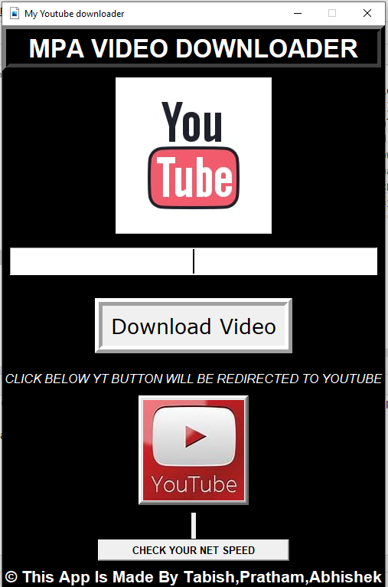

WHILE DOWNLOADING

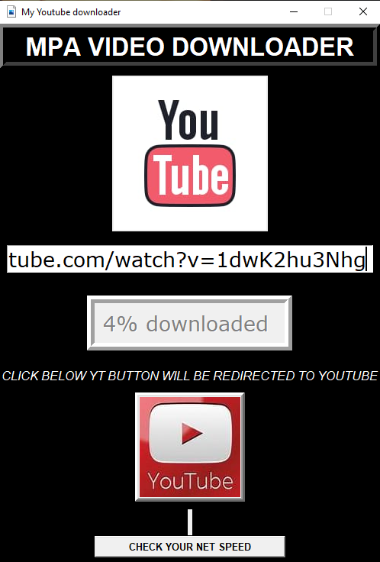
Downloading Complete

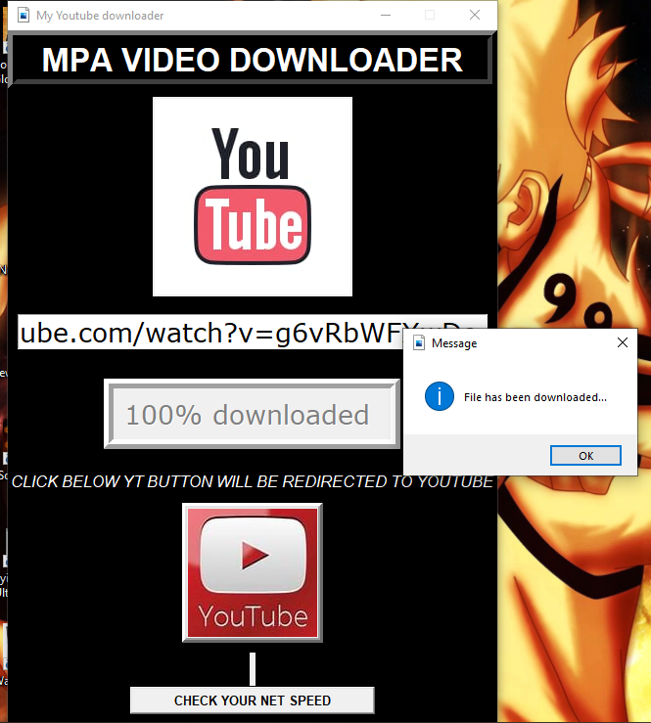

NET SPEED CHECKER

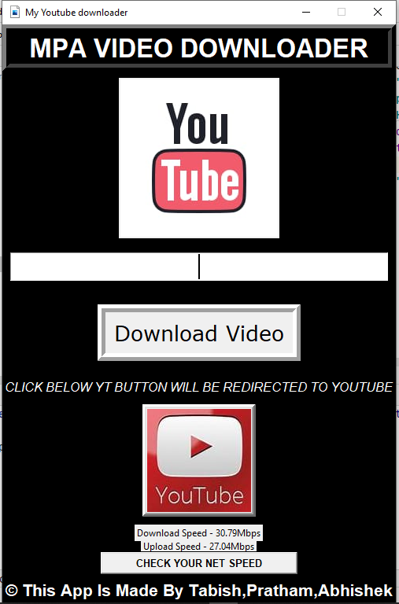

HOW IT WILL HELP US IN FUTURE

Python is a general purpose programming language. Hence, we can use the programming language for developing both desktop and web applications. Also, we can use Python for developing complex scientific and numeric applications. Python is designed with features to facilitate data analysis and visualization.
Game programming is very rewarding nowadays and it can also be used in advertising and as a teaching tool too. Game development includes mathematics, logic, physics, AI, and much more and it can be amazingly fun. In python, game programming is done in pygame and it is one of the best modules for doing so.
Most of the other programming languages have supports issues. Also, some of them lack in the documentation which makes it difficult for a programmer to build his project.
Python doesn’t have these issues. It has been around for a long time, so there are plenty of documentation, tutorials, guides and much more to help a programmer.
Career opportunities associated with python:
With many different programming languages available, Python has tremendously outraced the other languages. Career opportunities associated with Python have also grown significantly as its popularity has increased by 40%.
Many IT businesses are looking for more candidates with experience and skills in Python programming languages. This has illustrated the better career scope for the Python programmers in the near future.

REFERENCES

- https://pypi.org/project/speedtest-cli/
- https://python-pytube.readthedocs.io/en/latest/
- https://www.geeksforgeeks.org/introduction-to-pygame/
- https://www.geeksforgeeks.org/convert-python-script-to-exe-file/
- https://www.geeksforgeeks.org/python-gui-tkinter/

