School of Computer Engineering
Manipal Institute of Technology
Manipal India

Mini Project Report
An Automated Vision-Based System for Industrial Defect Detection and Localization
Team member | Roll number | Registration number
Devansh Prejit | 41 | 240962500
Pratham Hemrajani | 40 | 240962496
Agastya Choudhary | 42 | 240962502
AIML A
Faculty guide: Dr. Ashalatha Nayak
Academic year: 2026-27
Submission date: 08-10-2026
An Automated Vision-Based System for Industrial Defect Detection and Localization

Devansh Prejit  AIML A  School of Computer Engineering  Manipal Institute of Technology  Manipal India  devansh.mitmpl2024@learner.manipal.edu | Pratham Hemrajani  AIML A  School of Computer Engineering  Manipal Institute of Technology  Manipal India  pratham3.mitmpl2024@learner.manipal.edu | Agastya Choudhary  AIML A  School of Computer Engineering  Manipal Institute of Technology  Manipal India  Agastya1.mitmpl2024@learner.manipal.edu

Abstract - Industrial visual inspection requires systems that can recognize familiar surface defects and identify unexpected deviations when defective training examples are scarce. This project develops a multi-paradigm inspection framework combining handcrafted texture and edge descriptors with a Random Forest classifier, transfer learning with EfficientNet-B0, and a planned PatchCore anomaly detector trained on defect-free images. Gradient-based activation maps support visual interpretation, while an interactive dashboard presents predictions and inspection records. Preliminary experiments on six steel surface defect categories use 1,440 training images and 360 evaluation images. The saved Random Forest outputs report 93.33 percent classification accuracy, and the convolutional classifier confusion matrix contains 359 correct predictions, corresponding to 99.72 percent accuracy. The latter is a development result because the same evaluation split was used for checkpoint selection. The proposed anomaly detection and localization study will use the MVTec Anomaly Detection dataset with separate image-level and pixel-level evaluation. Final anomaly scores, localization measurements, independent test performance, and inference timings remain to be established. The framework provides a structured basis for comparing inspection approaches while distinguishing defect-category recognition from validated product acceptance.

Index Terms - Automated visual inspection, computer vision, defect localization, industrial defect detection, visual anomaly detection

Introduction
Surface flaws can affect the appearance and usability of manufactured products. Inspection therefore needs to identify defects consistently, locate suspicious regions, and record decisions for review. Manual inspection depends on operator attention and working conditions; automated inspection offers a repeatable image-based procedure, but its reliability depends on representative data and an appropriate evaluation protocol. Reviews describe approaches ranging from engineered descriptors to learned representations and anomaly detection [1], [2].
The learning problem is complicated by rare defects, changing illumination, surface texture variation, and small irregular flaws. A classifier trained on known defect categories may assign an unfamiliar image to an existing class even when that class is inappropriate. Steel inspection also requires attention to imaging hardware and variations within each defect category [3]. Broader metal-surface inspection studies identify acquisition conditions and feature selection as central design concerns [4].
This project investigates three complementary approaches: a classical baseline, a supervised convolutional classifier, and normal-only anomaly detection. It combines quantitative evaluation with visual explanations and a dashboard. The NEU steel experiments establish preliminary defect-category classification results. MVTec AD is the intended benchmark for genuine defect-free versus defective inspection and pixel-level localization. These tasks are evaluated separately because success on a defect-only classification dataset cannot establish a reliable product acceptance decision.

Literature Survey

I. Classical descriptors and learned representations
Deep networks learn successive visual representations instead of relying exclusively on manually designed descriptors [5]. However, classical features remain useful as a transparent, inexpensive comparison. Haralick texture measures summarize gray-level spatial relationships [6], Canny identifies intensity boundaries [7], and Otsu provides an intensity-based thresholding criterion [8]. The project uses texture statistics and edges for its baseline; threshold-based segmentation is an optional preprocessing comparison rather than an assumed defect detector. Random Forests aggregate randomized decision trees and provide a practical classifier for such descriptors [9].

II. Supervision and annotation requirements
Tabernik et al. connect surface anomaly detection to segmentation and investigate learning with a limited number of defective examples [10]. Bozic et al. study mixed supervision, combining image-level and more detailed annotations [11]. These studies show why classification labels and localization masks should be treated as different resources. The project can train supervised models only on explicitly identified labeled data. The official MVTec normal-only training partition must not be described as a supervised defect-classification training set.

III. Anomaly detection and localization
Bergmann et al. provide an industrial benchmark with normal training images and pixel-level anomaly annotations for evaluation [12]. Pang et al. organize deep anomaly detection methods around their assumptions and learning objectives [13]. Tang et al. use pretrained features with a skip autoencoder, providing a reconstruction-based alternative to memory-based detection [14]. The proposed PatchCore branch compares local embeddings against a representative memory of normal appearances. It is selected as a normal-only route; this report does not claim that its MVTec performance has already been measured.

IV. Robustness and data augmentation
Zhang et al. investigate steel inspection with domain adaptation, illustrating the problem of transferring models between visual conditions [15]. Buslaev et al. provide a flexible augmentation framework [16], while Shorten and Khoshgoftaar review augmentation choices and their role in limited-data learning [17]. For this project, transformations must preserve defect identity and image-mask alignment. Excessive distortion or noise can remove a subtle flaw or generate an unrealistic one, so each augmentation requires inspection and ablation rather than automatic acceptance.

V. Explainability and deployment efficiency
The journal treatment of Grad-CAM describes gradient-based visual explanations for convolutional networks [18]. Such explanations indicate influential image regions; they are not automatically pixel-accurate defect masks. Liu et al. examine real-time inspection methods and the trade-off between accuracy and computation [19]. Cumbajin et al. organize convolutional surface inspection research by surface characteristics [20]. Together, these works motivate separate reporting of classification, localization, runtime, and surface-specific failures. Song and Yan offer a noise-robust steel recognition method associated with the NEU benchmark used for the preliminary experiments [21].

VI. Research gaps and project response
The project addresses four practical gaps: limited defective examples, unseen defect appearance, small irregular regions, and deployment constraints. The supervised branch addresses known-category recognition; the normal-only branch addresses deviations without requiring every defect type in training. Grad-CAM and anomaly maps provide complementary visual outputs. Category-wise results, threshold analysis, and runtime measurements are needed to establish the conditions under which each branch is useful. A combined dashboard is a means of inspection and review, not evidence of industrial readiness.

Objectives
- Develop a reproducible image pipeline with noise reduction, contrast enhancement, region-of-interest handling, and training-only augmentation. Record the settings actually used and assess their effect on subtle defects.
- Build a Random Forest baseline from Canny edge statistics, intensity histograms, and gray-level co-occurrence descriptors; compare it with an EfficientNet-B0 transfer-learning classifier using a common supervised evaluation split.
- Implement and evaluate PatchCore using genuinely defect-free MVTec training images. Measure image-level anomaly ranking and pixel-level localization independently of supervised classification.
- Use Grad-CAM for visual explanation and inspect both correct and incorrect predictions. Quantify localization only where appropriate ground-truth masks and evaluation procedures exist.
- Evaluate accuracy, precision, recall, F1-score, receiver operating characteristic area, memory consumption, and latency. The synopsis recall target of at least 95 percent is a target to assess, not an assumed result.
- Provide single-image and batch inspection through Streamlit, with confidence displays, an explicit uncertainty state, and persistent inspection records. Validate PASS decisions using a model trained to recognize genuinely normal products.

Data Source

I. MVTec anomaly detection benchmark
MVTec AD contains 5,354 images across 15 object and texture categories and supports image-level anomaly detection and pixel-level evaluation [12]. The training images are defect-free; evaluation includes both normal and anomalous examples. The project will retain the official training and test separation for its normal-only study. Product categories are distinct from defect subtypes, and a category-specific normal model is the initial evaluation design.
Data provider: MVTec Software GmbH. Dataset access: www.mvtec.com/company/research/datasets/mvtec-ad. Any held-out calibration data must be identified without moving official test images into model fitting.

II. NEU preliminary classification data
The NEU surface defect database provides six steel defect categories [21]: crazing, inclusion, patches, pitted surface, rolled-in scale, and scratches. The present saved exploratory summary records 1,440 training images, 240 per class, with image shape 200 by 200 by 3 after loading. The classification report and matrices contain 360 evaluation images, 60 per class. Thus, the observed experiment uses an 80/20 division of 1,800 examples.
NEU is used here to recognize defect types. Its six classes do not provide a defect-free acceptance class. It cannot establish the false rejection rate on good products or the missed-defect rate for a binary inspection system. The MVTec study supplies the separate normal-versus-anomalous evaluation needed by the synopsis.

III. Data integrity and annotation handling
A manifest should record image identifier, source category, split, defect subtype, mask path, and any group identifier available. Check image readability, exact duplicates, near duplicates, and inconsistent labels before fitting. Fit learned preprocessing only on training data. Apply stochastic transformations only to training images, and apply geometric transformations identically to images and masks. Test data must remain fixed after the protocol is selected. The saved exploratory outputs confirm a balanced training split of 1,440 images, with 240 images in each of the six classes, and an evaluation split of 360 images, with 60 images per class. Loaded images have dimensions of 200 × 200 pixels.

Methodology

I. Inspection workflow
The intended workflow is image acquisition or upload, input validation, branch-specific preprocessing, feature extraction, prediction, explanation or anomaly-map generation, and inspection logging. The supervised and anomaly branches remain separate models. Their outputs should be combined only after a decision policy has been calibrated on suitable data. The anomaly branch decides whether an image deviates from normal appearance; the classifier supplies a known defect category where applicable.

II. Preprocessing and augmentation
The synopsis proposes noise reduction, Contrast Limited Adaptive Histogram Equalization (CLAHE), dynamic region-of-interest extraction, and augmentation. A region-of-interest stage should remove irrelevant background only when it preserves all inspection areas. Optional filtering must retain fine scratches and cracks. Preserve original dimensions and any crop coordinates so an output heatmap can be mapped back to the source image. No separate denoising filter or region-of-interest crop was used in the completed NEU experiments. The classical baseline resizes images to 200 × 200 pixels using OpenCV’s default linear interpolation and applies CLAHE with a clip limit of 4.0 and an 8 × 8 tile grid. The CNN converts images to three-channel grayscale, resizes them to 224 × 224 pixels using bilinear interpolation, and applies ImageNet normalization. No formal preprocessing ablation study was performed.

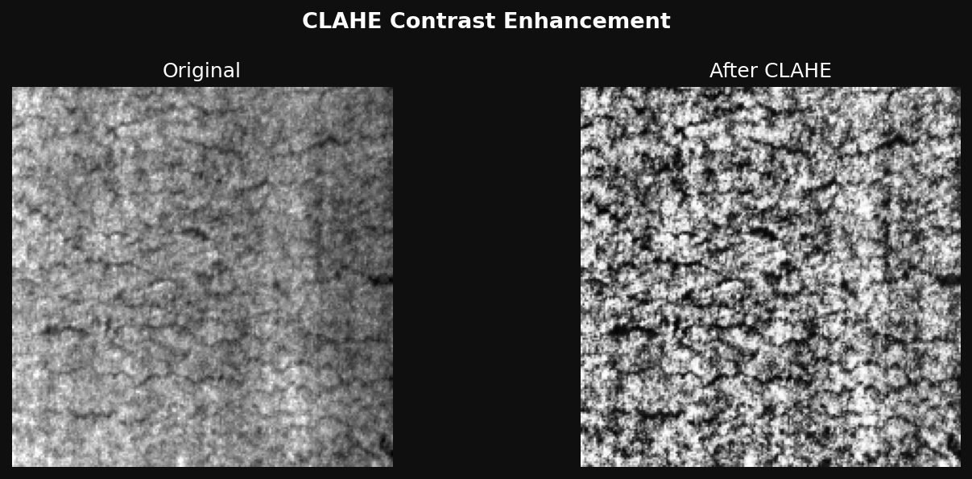

For the completed NEU baseline, images are resized to 200 by 200 pixels and enhanced with CLAHE using clip limit 4.0 and an 8 by 8 tile grid. The CNN uses grayscale replicated across three channels, a 224 by 224 resize, and pretrained-model normalization. Its training transforms include horizontal and vertical flips, rotations up to 15 degrees, brightness and contrast jitter of 0.3, and random erasing probability 0.2. CLAHE is not applied in the current CNN transform. Elastic distortion, Gaussian noise, and Albumentations are synopsis proposals requiring confirmation before being reported as implemented [16], [17].

III. Classical computer vision baseline
The baseline calculates edge density, pixel standard deviation, four texture descriptors, and a normalized 32-bin intensity histogram. This yields 38 features for a readable image. Canny thresholds are 50 and 150. Texture analysis quantizes grayscale to 64 levels and uses distances of 1 and 3 pixels at angles 0, 45, 90, and 135 degrees. Contrast, homogeneity, energy, and correlation are averaged over these configurations [6], [7]. Standard scaling is fitted on the training features and applied to the evaluation features.
The Random Forest uses 200 trees, unrestricted maximum depth, a minimum leaf size of 2, and random seed 42 [9]. Its class prediction is the ensemble output. Feature importance can summarize which descriptors contribute to the fitted model but does not prove causal defect localization. Invalid images should be rejected explicitly; the present feature function returns a 37-element zero vector for unreadable files, inconsistent with the normal 38-feature output. This path needs correction before further experiments.

IV. Supervised deep classification
EfficientNet-B0 is initialized with pretrained image representations, and its head is replaced by dropout of 0.3 and a six-output linear classifier. The current script unfreezes feature blocks 7 and 8 and the classification head. Training uses AdamW, learning rate 0.0001, weight decay 0.0001, batch size 16, and 30 epochs. Cross-entropy includes label smoothing of 0.1; gradient norm is clipped at 1.0. Cosine annealing lowers the learning rate toward 0.000001.
For final benchmarking, reserve a validation subset from training data, select checkpoints only on validation performance, and evaluate the selected model once on an untouched test set. The existing CNN script instead evaluates data/test every epoch and uses its accuracy for checkpoint selection. Its reported 99.72 percent is therefore development performance on a reused evaluation split, not an independent estimate. A supervised MVTec extension would need an explicitly labeled training subset with defect examples; it must be reported as a separate protocol from normal-only anomaly detection.

V. PatchCore normal-only anomaly detection
The proposed anomaly detector extracts pretrained local features from defect-free images, aligns features from selected layers, and forms a memory bank of normal patch embeddings. A coreset retains representative embeddings to control storage and search cost. At inference, local distance to the normal memory yields an anomaly score map. Category-specific calibration then converts an image score and a pixel map into inspection outputs. The current demonstration script specifies a pretrained Wide ResNet-50-2 backbone, features from layer2 and layer3, an input resolution of 224 × 224 pixels, nine nearest neighbors, and min-max score normalization.
For query embedding q and memory M, the basic patch score is s(q) = min over m in M of ||q - m||2. A simple image summary is the maximum patch score, while the final implementation must document any neighbor reweighting or aggregation. The spatial map is resized to the original image coordinates and any smoothing is recorded. Thresholds are selected on an identified calibration set and fixed before final testing. Selecting thresholds on test labels would invalidate an independent test estimate.
The current anomaly script uses an NEU inclusion class as its nominal normal class and treats other defects as anomalies. This is a class-discrimination demonstration, not training on defect-free products. The same script also constructs a score distribution from random samples. Such a distribution must not be used as empirical PatchCore evidence. MVTec normal-only fitting, saved image scores, and actual localization maps are required to complete this objective.

VI. Explainability and evaluation
Grad-CAM combines feature activations using weights derived from the gradient of a selected class score [18]. Generate maps for both correct and incorrect cases, state whether the explained class is predicted or ground truth, and compare attention with the visible flaw. An activation map can highlight relevant texture without accurately outlining every defect pixel. It should be described as qualitative explanation unless a reproducible mask comparison has been performed.
For classification, report accuracy, per-class precision, recall, F1-score, support, and a confusion matrix. With TP, FP, and FN defined for one class, precision = TP/(TP + FP), recall = TP/(TP + FN), and F1 = 2PR/(P + R). Macro averages give equal weight to each class. For MVTec, report image AUROC separately from pixel AUROC and mask overlap at a fixed threshold. Include category-wise values and aggregation rules. Measure runtime after warm-up on a stated device, distinguishing model inference from preprocessing, explanation generation, and dashboard overhead [19].

Implementation Details

I. Software components and configuration
The workspace contains Python scripts for exploratory analysis, feature-based classification, CNN training, and anomaly detection, plus a prediction module, dataset splitting utility, and Streamlit dashboard. The intended stack includes OpenCV, scikit-image, scikit-learn, PyTorch, torchvision, an anomaly-detection library, and a Grad-CAM implementation. The archived environment is Windows-based and records Python 3.13.1. Available package metadata includes PyTorch 2.14.1+cpu, OpenCV 5.0.0.93, scikit-learn 1.9.1, scikit-image 0.26.0, Matplotlib 3.11.2, Seaborn 0.13.2, Streamlit 1.65.0, Albumentations 2.0.8, Anomalib 2.7.0, grad-cam 1.5.7, pandas 3.0.6, and Pillow 12.3.0. The archived PyTorch build is CPU-only.
The baseline saves its classifier, scaler, and class order together. The CNN saves a weight checkpoint and reconstructs the same six-class architecture for inference. Store preprocessing settings and label order alongside each model to prevent discrepancies between training and upload prediction. Reproducibility requires fixed split manifests and seeds, plus a record of deterministic backend settings when relevant. A seed alone does not demonstrate identical results on every device.

II. Dashboard and decision policy
The dashboard code supports image inspection, class confidence displays, batch summaries, and downloadable records. The prediction module applies a confidence threshold of 0.70, producing FAIL above the threshold and UNCERTAIN otherwise. Because all six CNN classes represent defects, this module cannot produce a validated PASS prediction. The synopsis PASS/FAIL objective therefore remains dependent on a calibrated normal-versus-anomalous model. Softmax confidence is a score among the known classes; it is not automatically the probability that a product is defective.
The final interface should display the input image, selected model version, verdict, class or anomaly score, explanation, and processing time. Persist timestamp, image identifier, model identifier, score, threshold, verdict, and operator review status to an audit file. The current code should be checked for persistence across application restarts; a downloadable session table does not by itself establish persistent logging. 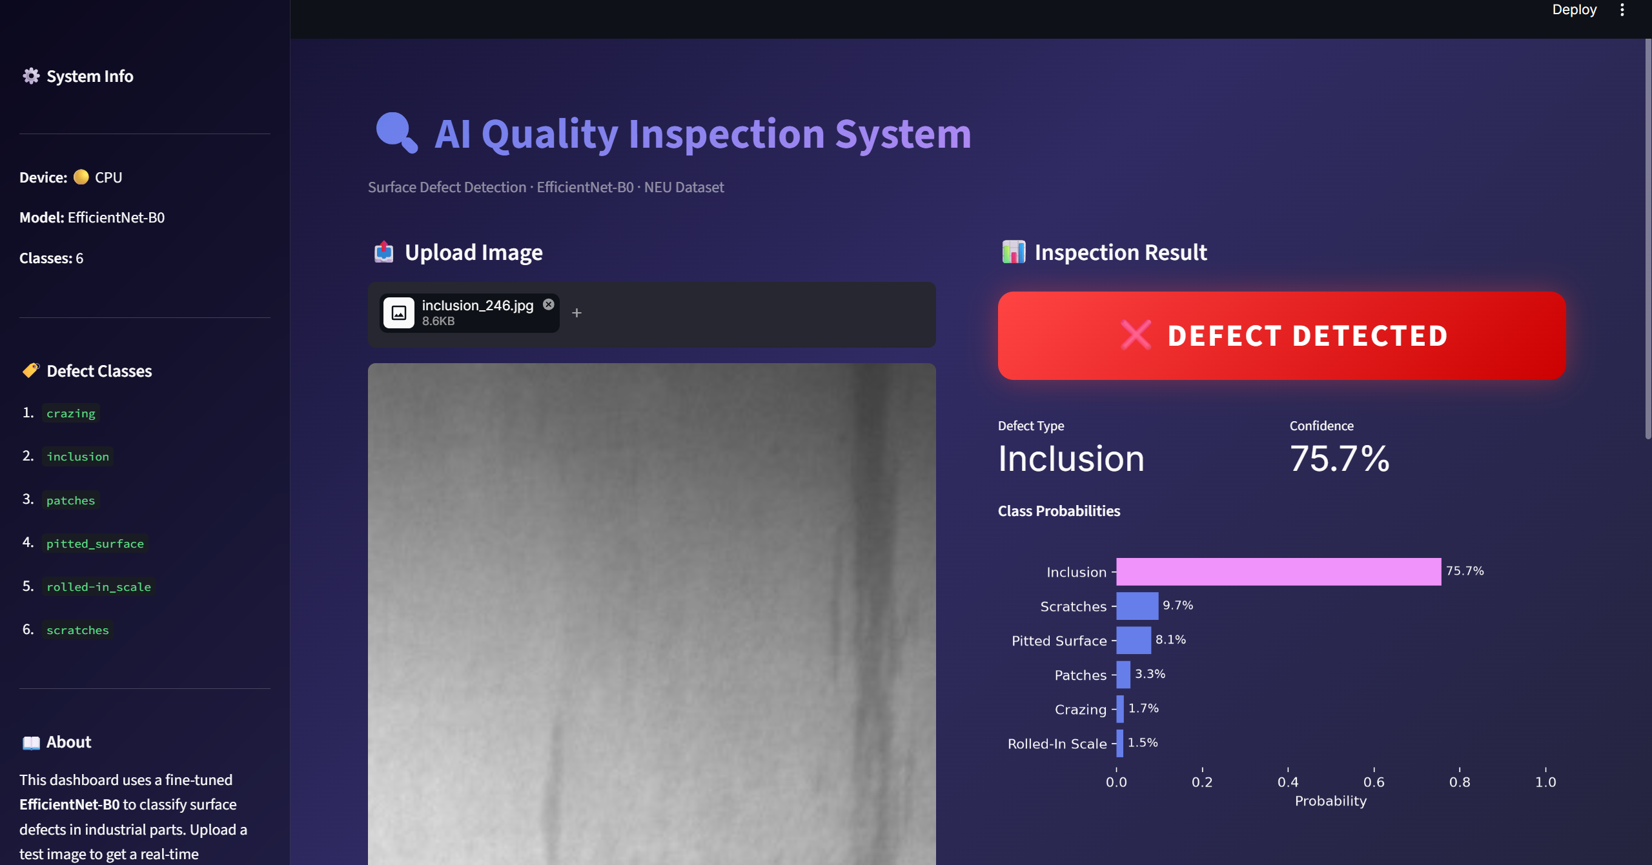


III. Verification and completion criteria
Verify single-image versus batch consistency, readable and unreadable inputs, expected image channels, checkpoint loading, and class-order alignment. For the anomaly route, verify that only normal training images enter the memory bank, no test annotations determine fitting or thresholds, and output maps retain image alignment. Compare saved predictions with metric calculations. Grad-CAM outputs and MVTec artifacts are not present among the current saved results and require experiment evidence.

Results and Discussion

I. Preliminary NEU results
Table 1 summarizes the saved NEU confusion matrices. Each matrix contains 360 evaluation images, with 60 examples per class. Values below are calculated from those matrix counts. They describe this experiment and should not be compared directly with MVTec anomaly scores. The CNN checkpoint-selection limitation described above applies to every CNN value in the table.
Table 1. Preliminary NEU classification metrics
Metric | Random Forest | CNN
Correct / total | 336 / 360 | 359 / 360
Accuracy | 93.33% | 99.72%
Macro precision | 93.59% | 99.73%
Macro recall | 93.33% | 99.72%
Macro F1 | 93.26% | 99.72%
The baseline misclassifies 24 images. Its largest confusion is inclusion predicted as pitted surface, accounting for 13 cases. Six pitted-surface images are predicted as scratches. Inclusion recall is 47/60, or 78.33 percent, and pitted-surface recall is 51/60, or 85.00 percent. This pattern suggests that the current descriptor set has difficulty separating certain irregular or fine-texture defects. It does not identify a single cause; representative failures and feature distributions should be examined before changing the model.
Figures 1 and 2 reproduce the saved confusion matrices. The CNN has one off-diagonal case: an inclusion image predicted as scratches. This gives inclusion recall of 98.33 percent and scratches precision of 60/61, or 98.36 percent. The CNN exceeds the baseline accuracy by 6.39 percentage points on the reused evaluation split. This supports further investigation of learned representations, but the comparison must be repeated with validation-based selection and an untouched test set before claiming a generalization advantage.
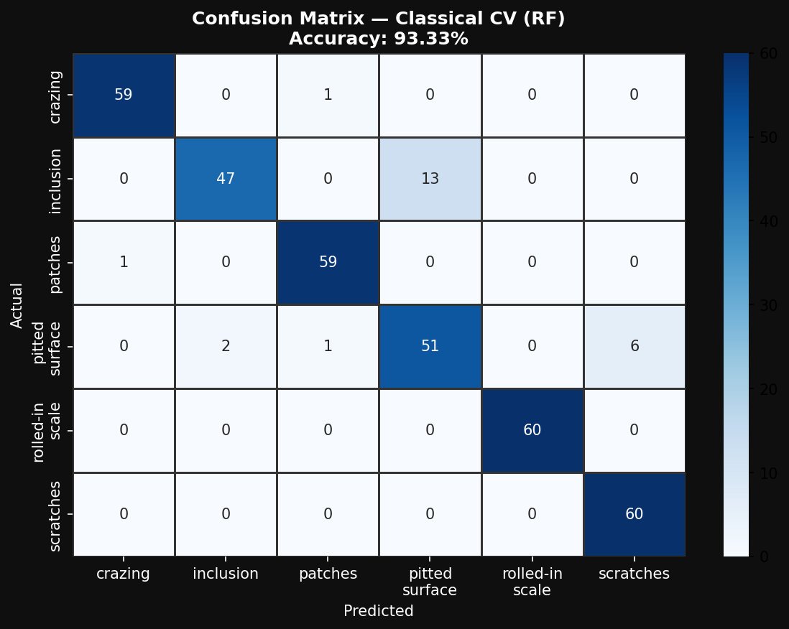
Figure 1. Random Forest confusion matrix. Rows are true classes and columns are predictions. Source: saved project output results/confusion_matrix_cv.png.
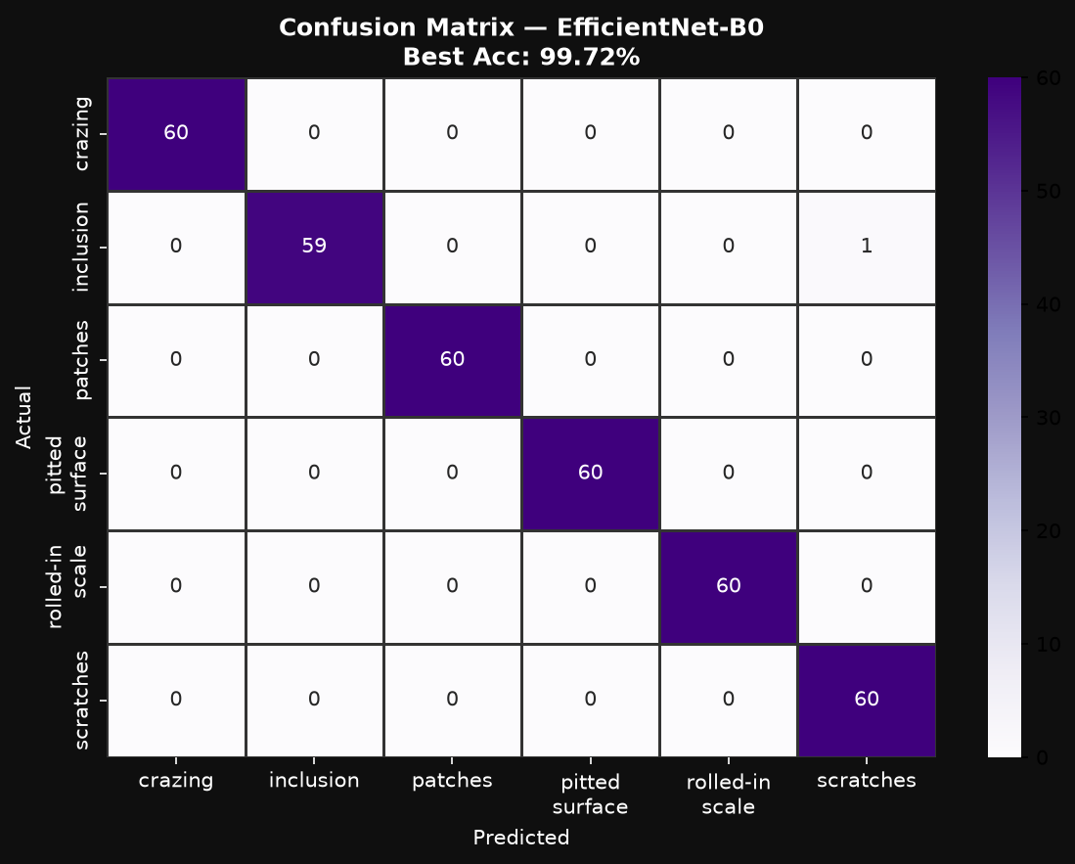
Figure 2. EfficientNet-B0 confusion matrix. The best checkpoint was selected using this evaluation split. Source: saved project output results/confusion_matrix_cnn.png.

II. Training behavior and interpretation
The saved 30-epoch training figure shows a steep early loss decrease followed by a flatter trajectory. Its evaluation accuracy remains high with small fluctuations. Figures 3 and 4 reproduce its two panels. Because the plotted evaluation set is used repeatedly for model selection, the curve cannot replace an independent generalization test. The training loss also includes label smoothing, so a nonzero plateau is not directly inconsistent with high classification accuracy.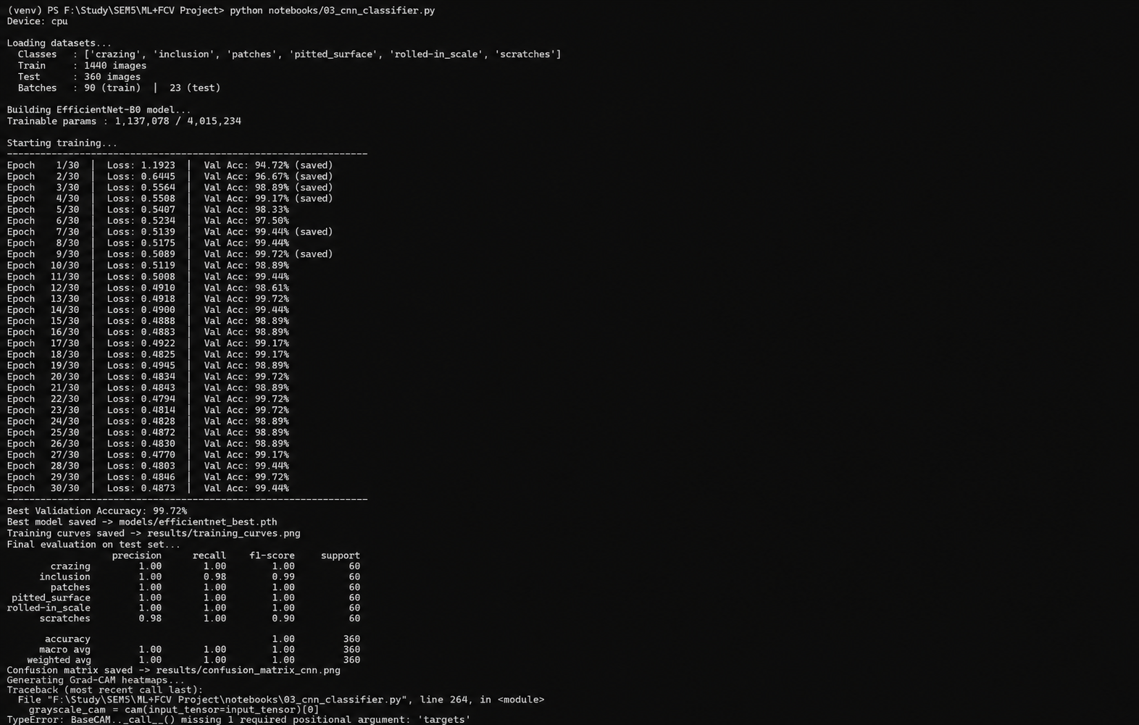

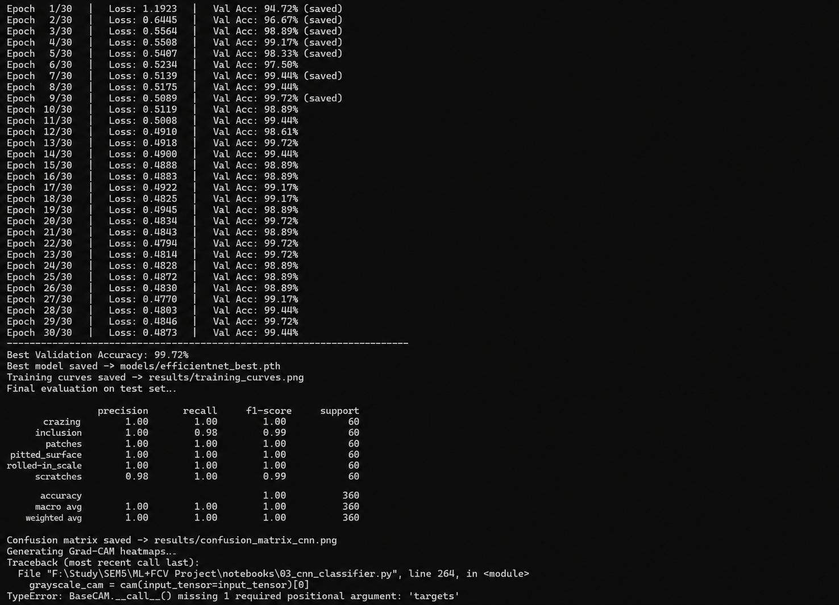
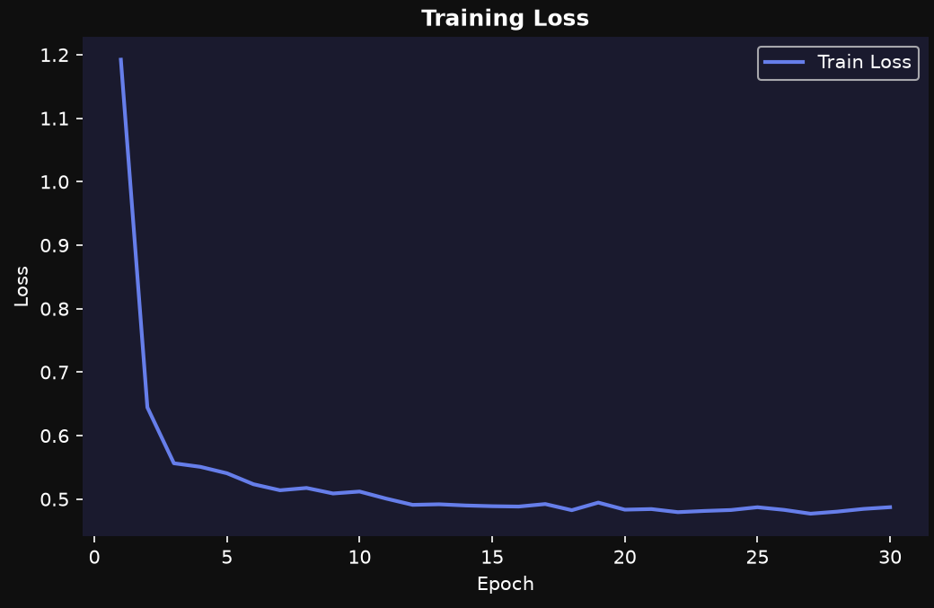
Figure 3. CNN training Log and Log loss over 30 epochs. Panel reproduced from the saved project output results/training_curves.png.
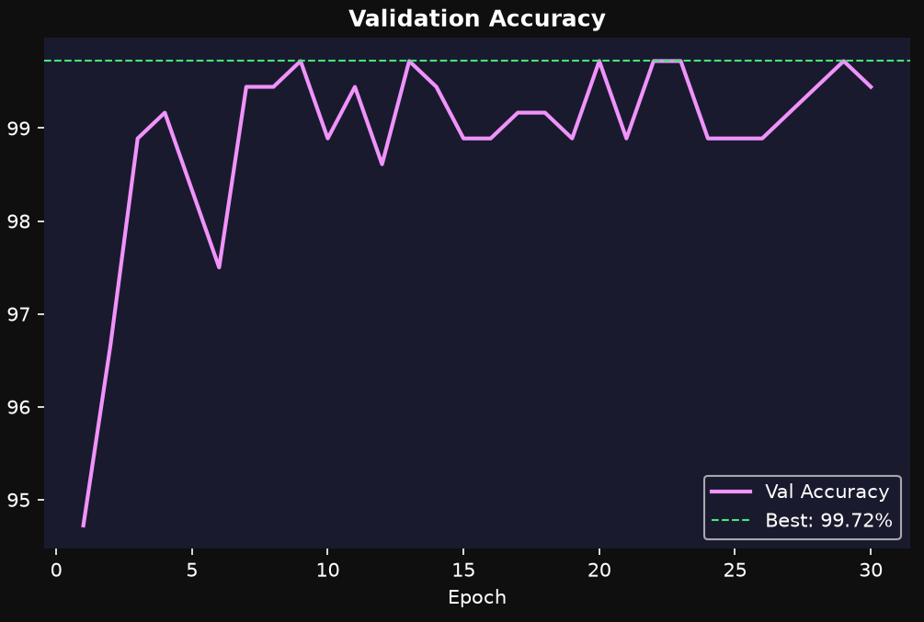
Figure 4. CNN development accuracy. The plot calls this validation accuracy, but the code uses data/test for checkpoint selection. Panel reproduced from results/training_curves.png.
The 95 percent recall objective must be interpreted carefully. The NEU baseline does not reach 95 percent macro recall, whereas the CNN development matrix does. However, these are recalls for assigning defect categories among already defective images. They do not measure the recall of a detector separating defective from normal products. Neither matrix establishes the synopsis binary defect-recall objective under industrial inspection conditions.

III. MVTec evaluation results to complete
Table 2 reserves the measurements required for the normal-only study. Include one row per selected product category, identify the anomaly-map threshold, and retain both successful and failed examples. Do not fill these entries with expected accuracy ranges, generated score distributions, or values from external publications.
Table 2. MVTec evaluation measurements
Measurement | Result
Categories and test counts | Ongoing
Image AUROC | Ongoing
Pixel AUROC | Ongoing
Recall and false positive rate | Ongoing
Mask IoU or Dice | Ongoing
Inference time and memory | Ongoing

IV. Limitations and validity
The preliminary evidence is limited to one balanced NEU split and saved outputs. The underlying images and full run logs need to be retained to reproduce the experiment. CNN checkpoint selection reuses its evaluation split; normal-image acceptance has not been established; and quantitative localization, calibrated uncertainty, latency, and external-domain robustness remain unmeasured. The synthetic anomaly-score demonstration is excluded from results. These limitations define the remaining experiments rather than invalidating the useful preliminary classifier comparison.
Further analysis should test sensitivity to lighting changes, contrast enhancement, small defect size, and reduced labeled training data. Compare preprocessing variants using an identical split and repeat selected experiments across seeds. For class imbalance, include per-class recall and precision-recall analysis. For deployment, report the proportion routed to operator review and the false acceptance rate at the chosen threshold. No preprocessing ablation or repeated-seed experiment was completed. In the Random Forest matrix, the largest error group consists of 13 inclusion images classified as pitted surface, followed by six pitted-surface images classified as scratches. The CNN matrix contains one inclusion image classified as scratches. The corresponding source images and filenames were not retained as an error-analysis set, so representative error-case figures should only be added after predictions are rerun and saved.

Conclusion and Future Scope
The project combines classical texture and edge features, supervised transfer learning, and a planned normal-only anomaly detector within an explainable inspection workflow. The preliminary NEU baseline records 93.33 percent classification accuracy. The saved EfficientNet-B0 development matrix records 99.72 percent, with one category error, but checkpoint selection on the same evaluation split prevents treating this as an independent test result. These experiments demonstrate known defect-category recognition and establish a starting point for the broader synopsis objectives.
Completion requires genuine MVTec normal-only experiments, independent evaluation of classification where applicable, measured pixel localization, and a validated product acceptance policy. The completed evidence supports six-class recognition of known NEU surface defects: the Random Forest achieves 93.33% accuracy, while the EfficientNet-B0 checkpoint records 99.72% development accuracy on the reused evaluation split. These results do not establish normal-versus-defective product acceptance or pixel-level defect localization. Consequently, the overall system remains a prototype until MVTec normal-only experiments, threshold calibration, localization measurements, and independent testing are completed. Grad-CAM explanations should remain distinct from segmentation claims, and performance should be reported with its dataset, split, and threshold context.
Future work includes category-specific calibration, robust handling of uncertain and unfamiliar inputs, multi-scale processing for small flaws, broader testing across lighting and material changes, and memory-efficient anomaly search. An edge-device version could be investigated after measuring a desktop baseline. Camera acquisition and production-line integration would require validation on representative site images, timing under realistic throughput, and monitoring for drift. Persistent logging and reviewed error cases would support updates as new defect appearances are encountered.

References

[1] Y. Chen et al., "Surface defect detection methods for industrial products: A review," Applied Sciences, vol. 11, no. 16, Art. no. 7657, 2021, doi: 10.3390/app11167657.

[2] J. Diers and C. Pigorsch, "A survey of methods for automated quality control based on images," International Journal of Computer Vision, vol. 131, pp. 2553-2581, 2023, doi: 10.1007/s11263-023-01822-w.

[3] X. Wen et al., "Steel surface defect recognition: A survey," Coatings, vol. 13, no. 1, Art. no. 17, 2023, doi: 10.3390/coatings13010017.

[4] X. Fang et al., "Research progress of automated visual surface defect detection for industrial metal planar materials," Sensors, vol. 20, no. 18, Art. no. 5136, 2020, doi: 10.3390/s20185136.

[5] Y. LeCun et al., "Deep learning," Nature, vol. 521, pp. 436-444, 2015, doi: 10.1038/nature14539.

[6] R. M. Haralick et al., "Textural features for image classification," IEEE Transactions on Systems, Man, and Cybernetics, vol. SMC-3, no. 6, pp. 610-621, 1973, doi: 10.1109/TSMC.1973.4309314.

[7] J. Canny, "A computational approach to edge detection," IEEE Transactions on Pattern Analysis and Machine Intelligence, vol. PAMI-8, no. 6, pp. 679-698, 1986, doi: 10.1109/TPAMI.1986.4767851.

[8] N. Otsu, "A threshold selection method from gray-level histograms," IEEE Transactions on Systems, Man, and Cybernetics, vol. 9, no. 1, pp. 62-66, 1979, doi: 10.1109/TSMC.1979.4310076.

[9] L. Breiman, "Random forests," Machine Learning, vol. 45, pp. 5-32, 2001, doi: 10.1023/A:1010933404324.

[10] D. Tabernik et al., "Segmentation-based deep-learning approach for surface-defect detection," Journal of Intelligent Manufacturing, vol. 31, pp. 759-776, 2020, doi: 10.1007/s10845-019-01476-x.

[11] J. Bozic et al., "Mixed supervision for surface-defect detection: From weakly to fully supervised learning," Computers in Industry, vol. 129, Art. no. 103459, 2021, doi: 10.1016/j.compind.2021.103459.

[12] P. Bergmann et al., "The MVTec anomaly detection dataset: A comprehensive real-world dataset for unsupervised anomaly detection," International Journal of Computer Vision, vol. 129, pp. 1038-1059, 2021, doi: 10.1007/s11263-020-01400-4.

[13] G. Pang et al., "Deep learning for anomaly detection: A review," ACM Computing Surveys, vol. 54, no. 2, Art. no. 38, pp. 1-38, 2021, doi: 10.1145/3439950.

[14] T.-W. Tang et al., "Industrial anomaly detection with skip autoencoder and deep feature extractor," Sensors, vol. 22, no. 23, Art. no. 9327, 2022, doi: 10.3390/s22239327.

[15] S. Zhang et al., "Visual inspection of steel surface defects based on domain adaptation and adaptive convolutional neural network," Mechanical Systems and Signal Processing, vol. 153, Art. no. 107541, 2021, doi: 10.1016/j.ymssp.2020.107541.

[16] A. Buslaev et al., "Albumentations: Fast and flexible image augmentations," Information, vol. 11, no. 2, Art. no. 125, 2020, doi: 10.3390/info11020125.

[17] C. Shorten and T. M. Khoshgoftaar, "A survey on image data augmentation for deep learning," Journal of Big Data, vol. 6, Art. no. 60, 2019, doi: 10.1186/s40537-019-0197-0.

[18] R. R. Selvaraju et al., "Grad-CAM: Visual explanations from deep networks via gradient-based localization," International Journal of Computer Vision, vol. 128, pp. 336-359, 2020, doi: 10.1007/s11263-019-01228-7.

[19] Y. Liu et al., "A survey of real-time surface defect inspection methods based on deep learning," Artificial Intelligence Review, vol. 56, pp. 12131-12170, 2023, doi: 10.1007/s10462-023-10475-7.

[20] E. Cumbajin et al., "A systematic review on deep learning with CNNs applied to surface defect detection," Journal of Imaging, vol. 9, no. 10, Art. no. 193, 2023, doi: 10.3390/jimaging9100193.

[21] K. Song and Y. Yan, "A noise robust method based on completed local binary patterns for hot-rolled steel strip surface defects," Applied Surface Science, vol. 285, pp. 858-864, 2013, doi: 10.1016/j.apsusc.2013.09.002.

