DATA SCIENCE INTERNSHIP PROJECT REPORT
Flight Fare Intelligence
What drives domestic flight fares in India, a model that predicts them, and a deployed dashboard
445,366  flights analysed | 9 | 42  airlines | routes | R² 0.953  on held-out flights | 4 tabs  dashboard + predictor
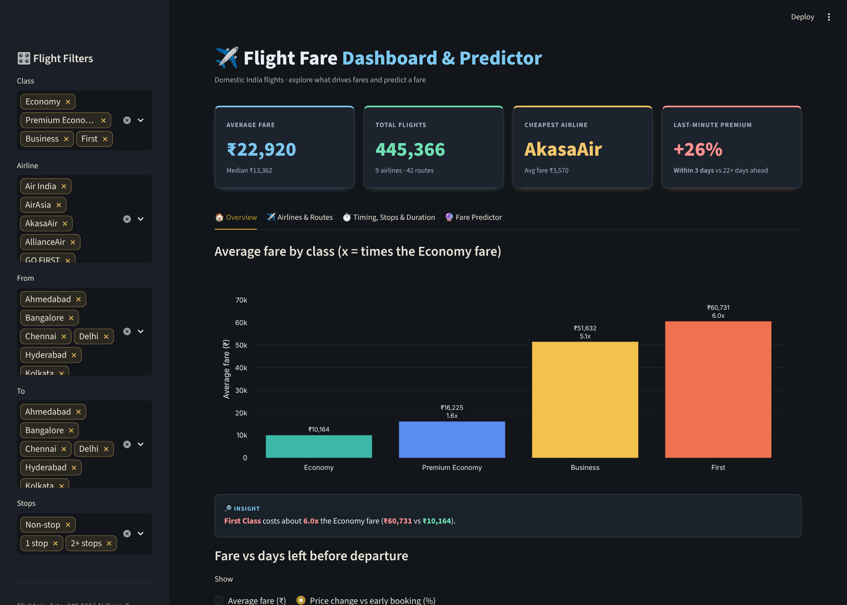
The deployed Flight Fare Dashboard & Predictor
Author | Pratham Rangoonwala
Internship at | Naviotech Solution Pvt. Ltd.
Submitted to | Naviotech Solution Pvt. Ltd.
Date | October 2026
Live app | https://flight-fare-intelligence.streamlit.app/
Code | https://github.com/Pratham719/flight-fare-intelligence

Abstract
Domestic airfares in India vary widely, and travellers have little way to tell whether a fare is high or low for a given trip. This project analyses 445,366 flight fares across seven cities, nine airlines and 42 routes to find out what drives price, and builds a Hist Gradient Boosting model that predicts the fare of a trip (R² 0.953 and a mean absolute error of ₹2,386 on 89,074 held-out flights).
Class is the strongest driver, followed by flight duration, route and airline. Late booking carries a clear premium: Economy flights leaving within three days cost 49% more than flights leaving 22 or more days ahead. The findings and the model are delivered as a deployed Streamlit dashboard with five filters, KPIs and insight boxes that recalculate with every filter, 14 interactive charts, data-driven booking tips and a fare predictor that responds instantly to every input.
All prices were collected on a single day, so predictions are estimates of what a flight sells for in that snapshot, not live booking prices.
Keywords: airfare prediction, India, gradient boosting, Streamlit, interactive dashboard

1. Executive summary
This project analyses 445,366 domestic flight fares across seven Indian cities, builds a model that predicts the fare of a trip, and ships both as an interactive Streamlit dashboard. The questions were simple: what makes a fare high or low, how reliably can it be predicted, and how can a traveller use that.
Key results
- Class sets the baseline. Average fares are ₹10,164 in Economy, 1.6x that in Premium Economy, 5.1x in Business and 6.0x in First (only 144 flights).
- Late booking is expensive. Economy flights leaving within 3 days cost 49% more than flights leaving 22 or more days ahead (₹13,461 vs ₹9,054). Premium Economy is +89% and Business +22%.
- Airline matters. In Economy, Vistara (₹12,082) and Air India (₹11,276) average 38 to 47% more than Indigo (₹8,199); AkasaAir is cheapest at ₹3,570.
- Prediction is reliable on average. The tuned HistGradientBoosting model reaches R² 0.953 and a mean absolute error of ₹2,386 on 89,074 held-out flights; the median error is 7.4% and 64% of predictions fall within 11% of the actual fare.
- Class dominates the model. Shuffling Class raises error by ₹14,722, five times more than the next feature (flight duration).
- The dashboard makes this usable. KPIs and insight boxes recalculate with every filter, 14 interactive charts and a fare predictor respond instantly, and booking tips are generated from the data (section 6.5).
Read with care: every price in the data was collected on a single day. The fare vs days-left patterns are real within that snapshot, but the model produces estimates, not live booking prices.

2. Objective and scope
The project has three goals:
- Explain which factors (class, airline, route, stops, timing, booking window) move fares, and by how much.
- Build and honestly evaluate a model that predicts the fare of a specific trip.
- Deliver the findings as a public dashboard with filters, data-driven booking tips and a fare predictor.
Out of scope: forecasting future prices, real-time booking, and any factor absent from the data such as holidays, fuel prices or seat availability.

3. Data and preparation

3.1 Dataset
The file Cleaned_dataset.csv holds domestic India flight fares for seven cities: Ahmedabad, Bangalore, Chennai, Delhi, Hyderabad, Kolkata and Mumbai. After cleaning it contains 445,366 flights from 9 airlines on 42 routes, departing between 16 January and 6 March 2023, with 1 to 50 days left before departure.
Column | Role | Description
Airline | Feature | Carrier operating the flight (9 airlines)
Class | Feature | Economy, Premium Economy, Business or First
Source, Destination | Features | Origin and destination city; Route = Source → Destination is derived for the dashboard
Departure, Arrival | Features | Time slot: Before 6 AM, 6 AM to 12 PM, 12 PM to 6 PM, After 6 PM
Journey_day | Feature | Day of week of the flight
Stops | Feature | Converted from Total_stops to 0, 1 or 2+
Duration_in_hours | Feature | Total flight duration in hours
Days_left | Feature | Days between the price snapshot and departure
Fare | Target | Ticket price in Indian rupees (₹)

Coverage | Flights | Average fare
Economy | 248,323 | ₹10,164
Premium Economy | 70,364 | ₹16,225
Business | 126,535 | ₹51,632
First | 144 | ₹60,731
All classes | 445,366 | ₹22,920 (median ₹13,362)
Table 1. Class mix. The average is pulled up by Business and First; the median is the better single number for a typical fare.

3.2 Cleaning
- Strip leading and trailing spaces from text columns and convert Fare, Duration_in_hours and Days_left to numbers.
- Drop rows with missing values and exact duplicates: 6,722 of 452,088 rows (1.5%). In the notebook this happens before the train/test split, so identical rows cannot sit in both sets and inflate the score.
- Drop Date_of_journey and Flight_code, which are not used.
- Convert Total_stops to Stops (0, 1, 2+) and add the Route column.

3.3 Important limitation
All prices were collected on one day. Days_left therefore moves together with the calendar date of departure, and the data cannot show how one specific flight's price changes over time. Findings about booking windows describe the cross-section of flights on that day.

4. What drives fares
Unless stated otherwise, comparisons below use Economy only, so that cheap and expensive cabins are not mixed.

4.1 Class
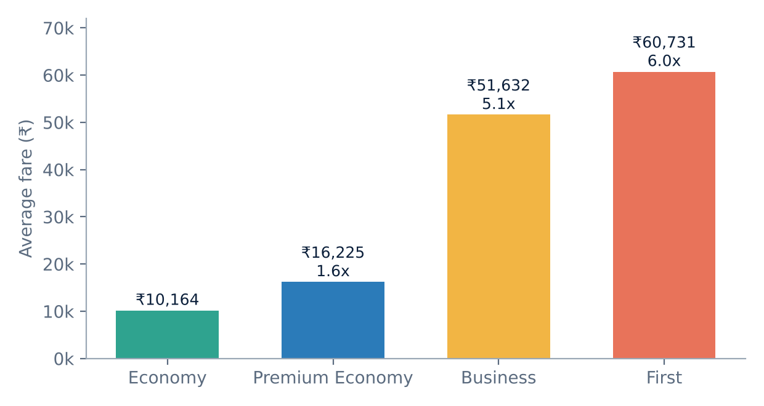
Figure 1. Average fare by class, with the multiple of the Economy fare. First has only 144 flights, all on Air India.

4.2 Booking window
Fares rise as departure approaches, gradually from about three weeks out and most steeply in the final week. Comparing flights leaving within 3 days with flights leaving 22 or more days ahead:
Class | ≤ 3 days left | ≥ 22 days left | Premium
Economy | ₹13,461 | ₹9,054 | +49%
Premium Economy | ₹25,707 | ₹13,614 | +89%
Business | ₹60,060 | ₹49,398 | +22%
First | ₹61,390 | ₹61,870 | -1% (144 flights)
Table 2. Last-minute premium by class (average fares).
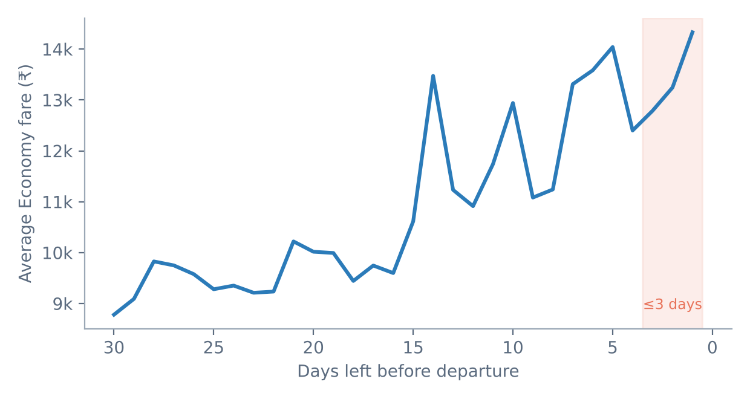
Figure 2. Average Economy fare by days left before departure. The shaded band marks the last three days.

4.3 Airlines and routes
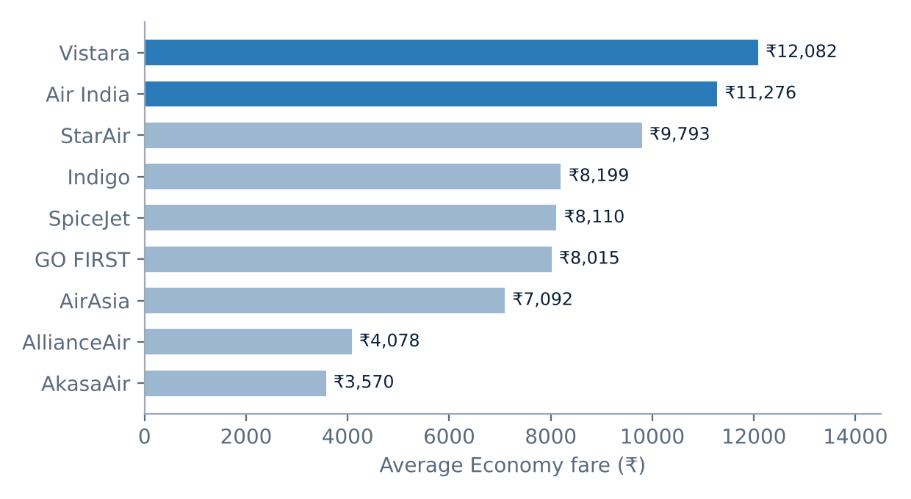
Figure 3. Average Economy fare by airline. StarAir has only 62 Economy flights and AllianceAir 393, so treat their averages as indicative.
- Full-service carriers (Vistara, Air India) are clearly dearer than low-cost carriers (Indigo, AirAsia, GO FIRST, SpiceJet, AkasaAir).
- Fare predictability differs: the middle 50% of AllianceAir fares spans 31% of its median, SpiceJet 42%, Air India 43%, Indigo 57%, AkasaAir 68%.
- Only Air India and Vistara sell Business, and only Air India sells First. Airline averages across all classes therefore overstate their cost: the all-class gap between Vistara (₹27,438) and AkasaAir (₹3,570) is 669%, which is mostly class mix.
- Costliest Economy routes (30+ flights): Ahmedabad → Kolkata ₹13,338, Ahmedabad → Mumbai ₹13,057, Kolkata → Mumbai ₹12,814. Cheapest: Chennai → Bangalore ₹7,211, Delhi → Bangalore ₹8,549, Bangalore → Delhi ₹8,664.
- Busiest routes: Bangalore → Delhi (10,526 Economy flights), Delhi → Bangalore (10,407) and Delhi → Mumbai (10,276). By origin, Kolkata (₹12,161) and Ahmedabad (₹11,447) are the dearest places to depart from.

4.4 Stops and duration
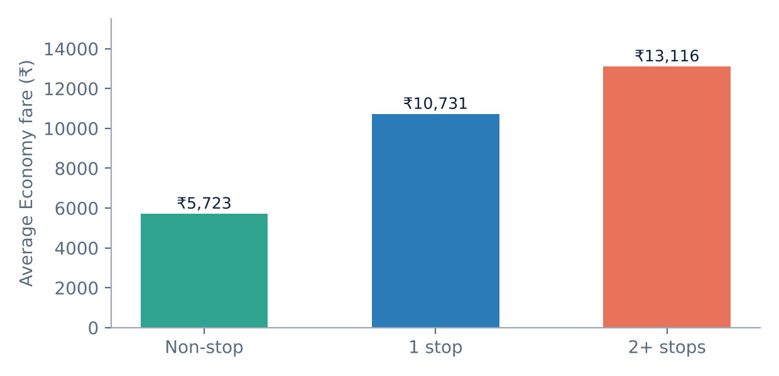
Figure 4. Average Economy fare by number of stops.
Non-stop flights are only 11.6% of all flights (1 stop 82.3%, 2+ stops 6.1%). In Economy, one-stop flights cost 88% more than non-stop (₹10,731 vs ₹5,723) and take about 12.0 hours instead of 2.1. This is a descriptive gap, not a claim that adding a stop raises the price: the non-stop and connecting flights differ in airline, route and class mix. Across Economy, the correlation between duration and fare is 0.33, a moderate link.

4.5 Timing
- Departure slot (Economy): before 6 AM is cheapest (₹9,004), 6 AM to 12 PM is dearest (₹10,696), a gap of 19%. 12 PM to 6 PM averages ₹10,153 and after 6 PM ₹9,693.
- Arrival slot (Economy): before 6 AM ₹8,706, 6 AM to 12 PM ₹9,464, 12 PM to 6 PM ₹10,343, after 6 PM ₹10,779.
- Day of week (Economy): Tuesday is cheapest (₹9,824) and Sunday dearest (₹10,640), only 8% apart. Because all prices were collected on one day, this also mixes in the days-left effect.

5. Predictive model

5.1 Set-up
The target is Fare. The features are seven categorical columns (Airline, Class, Source, Destination, Departure, Arrival, Journey_day) and three numeric ones (Stops, Duration_in_hours, Days_left). Data were split 80/20, stratified by Class because First has so few rows: 356,292 training and 89,074 test flights, random seed 42. Linear models use one-hot encoding with scaling; tree models use ordinal codes; gradient boosting uses its native categorical support. Fares are right-skewed, so the models learn log(1 + fare) and predictions are converted back to rupees. All metrics below are computed on the rupee scale.

5.2 Model comparison
Model | MAE (₹) | RMSE (₹) | Median AE (₹) | MAPE (%) | R²
Tuned Hist Gradient Boosting | 2,385.7 | 4,402.3 | 1,069.0 | 10.8 | 0.9531
Random Forest | 2,356.7 | 4,621.1 | 873.0 | 10.8 | 0.9483
Decision Tree | 2,586.9 | 5,079.5 | 965.8 | 12.3 | 0.9375
Hist Gradient Boosting (default) | 3,120.1 | 5,434.5 | 1,576.6 | 14.7 | 0.9285
Linear Regression | 4,710.8 | 7,543.8 | 2,589.9 | 23.7 | 0.8622
Ridge | 4,710.8 | 7,543.8 | 2,589.3 | 23.7 | 0.8622
Mean baseline | 16,724.2 | 20,323.4 | 14,223.9 | 127.3 | 0.0000
Table 3. Test-set results for all models.
Tree-based models beat linear regression by a wide margin, so fares depend on interactions between class, airline, route and duration that a linear model cannot capture. Random Forest has a slightly lower MAE (about 1%), but the tuned gradient-boosting model has the best R² and RMSE, trains roughly three times faster (about 15 s vs 41 s) and saves to a 5.8 MB file, which suits deployment.

5.3 Tuning
Hyper-parameters were tuned with a 3-fold randomized search on a 100,000-row sample of the training set only; the test set was never touched. The best cross-validated MAE was ₹2,762. The chosen settings were min_samples_leaf 20, max_leaf_nodes 127, max_iter 300, learning_rate 0.2 and l2_regularization 0.1. The final model was then refitted on the full training data and saved as flight_fare_model.joblib with scikit-learn 1.8.0.

5.4 Final performance
Metric (89,074 test flights) | Value
R² | 0.953
Mean absolute error (MAE) | ₹2,385.7
Root mean squared error (RMSE) | ₹4,402.3
Mean absolute percentage error (MAPE) | 10.8%
Median absolute percentage error | 7.4%
Weighted absolute percentage error (WAPE) | 10.4%

Prediction within… | Flights | Share of test set
5% of actual | 33,192 | 37.3%
10% of actual | 53,862 | 60.5%
11% of actual | 56,974 | 64.0%
15% of actual | 66,813 | 75.0%
20% of actual | 74,956 | 84.2%
Table 4. Final metrics and tolerance bands.

5.5 Error analysis
Class | Test flights | MAE (₹) | Mean % error
Economy | 49,665 | 1,213 | 11.6%
Premium Economy | 14,073 | 1,951 | 11.0%
Business | 25,307 | 4,927 | 9.2%
First | 29 | 3,692 | 5.0% (tiny sample)
Table 5. Test error by class.
Rupee error is larger on expensive cabins but the percentage error is similar (9 to 12%) for the three main classes. In Economy, the highest percentage errors among the large carriers are GO FIRST (14.4%) and Indigo (14.2%). The worst individual misses are cheap fares predicted far too high: the largest is a ₹3,439 fare predicted at ₹17,503, about five times the actual.
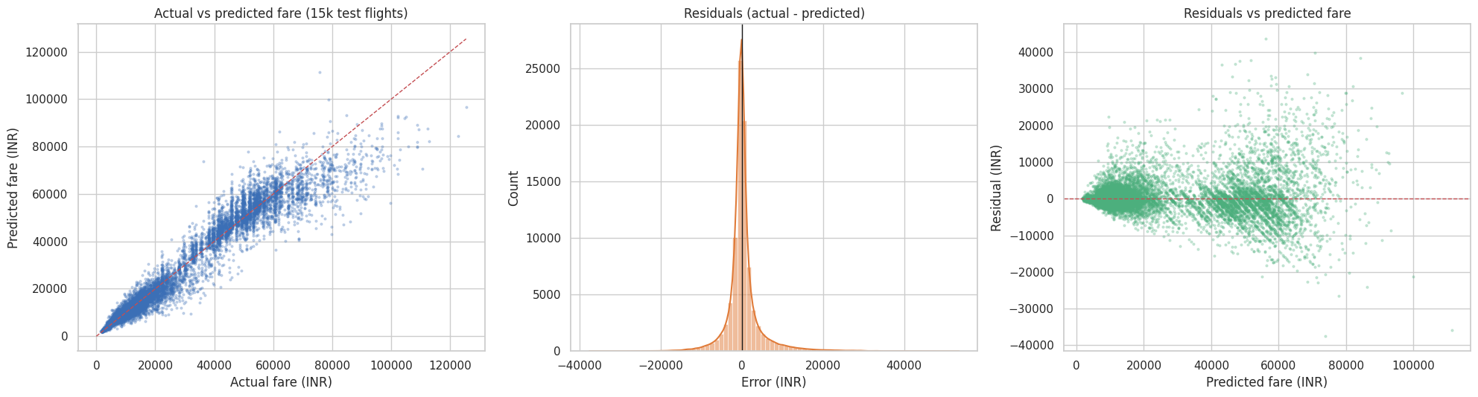
Figure 5. Actual vs predicted fare, residual distribution and residuals vs prediction (from the notebook).

5.6 Feature importance
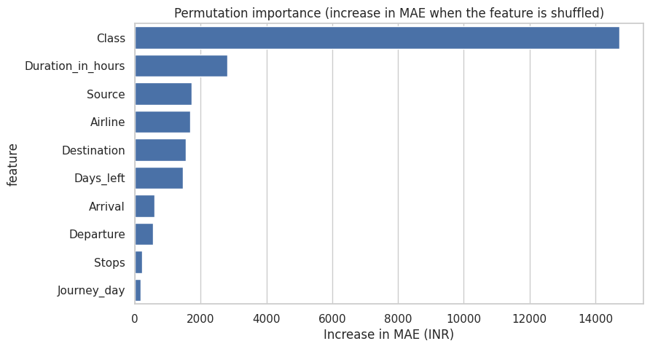
Figure 6. Permutation importance: increase in MAE (₹) when a feature is shuffled, on 20,000 test flights.
- Class (₹14,722) dominates, about five times the next feature.
- Duration (₹2,815) is second. Source (₹1,719) and Destination (₹1,555) together make the route a major driver, close behind duration and ahead of Airline (₹1,671 on its own).
- Days left (₹1,459) matters about as much as airline.
- Departure slot, arrival slot, stops and weekday are each under ₹600. Stops adds little once duration is known, because connecting flights are the long flights.

5.7 How to read the predictions
- The model learned from one day's prices, so it estimates what a flight with these attributes sells for in that snapshot, not what it will cost on a future date.
- A random split was used. Because similar flights appear across dates, the test score may overstate accuracy on genuinely unseen future flights.
- The predicted-fare-vs-days-left curve in the dashboard is jagged rather than smooth because days left is entangled with calendar date in the training data.
- If the saved model fails to load, the app trains a fallback model of the same type on a 200,000-row sample, so its accuracy can differ slightly. The sidebar always shows which model is in use.

6. The dashboard

6.1 Overview
The app is built with Streamlit and Plotly, uses a dark theme and adapts to tablet and phone widths. A sidebar offers five filters (Class, Airline, From, To, Stops). Above the tabs, a row of hero KPIs shows the average fare, total flights, cheapest airline and the last-minute premium for the current selection. Four tabs follow, containing 12 analysis charts and 2 predictor charts, one chart per row; radio buttons appear only where charts share axes.

6.2 Tab by tab
Overview. Average fare by class (as a multiple of Economy), fare vs days left (switch between average fare and % change vs early booking), and the fare distribution (histogram or box plot by class).
Figure 7. Overview tab with hero KPIs.
Airlines & Routes. Four KPI cards (costliest airline, airline price gap, costliest and cheapest route) and five charts: average fare by airline, fare spread by airline, route heatmap, top 10 routes (costliest, cheapest or busiest) and class mix by airline.
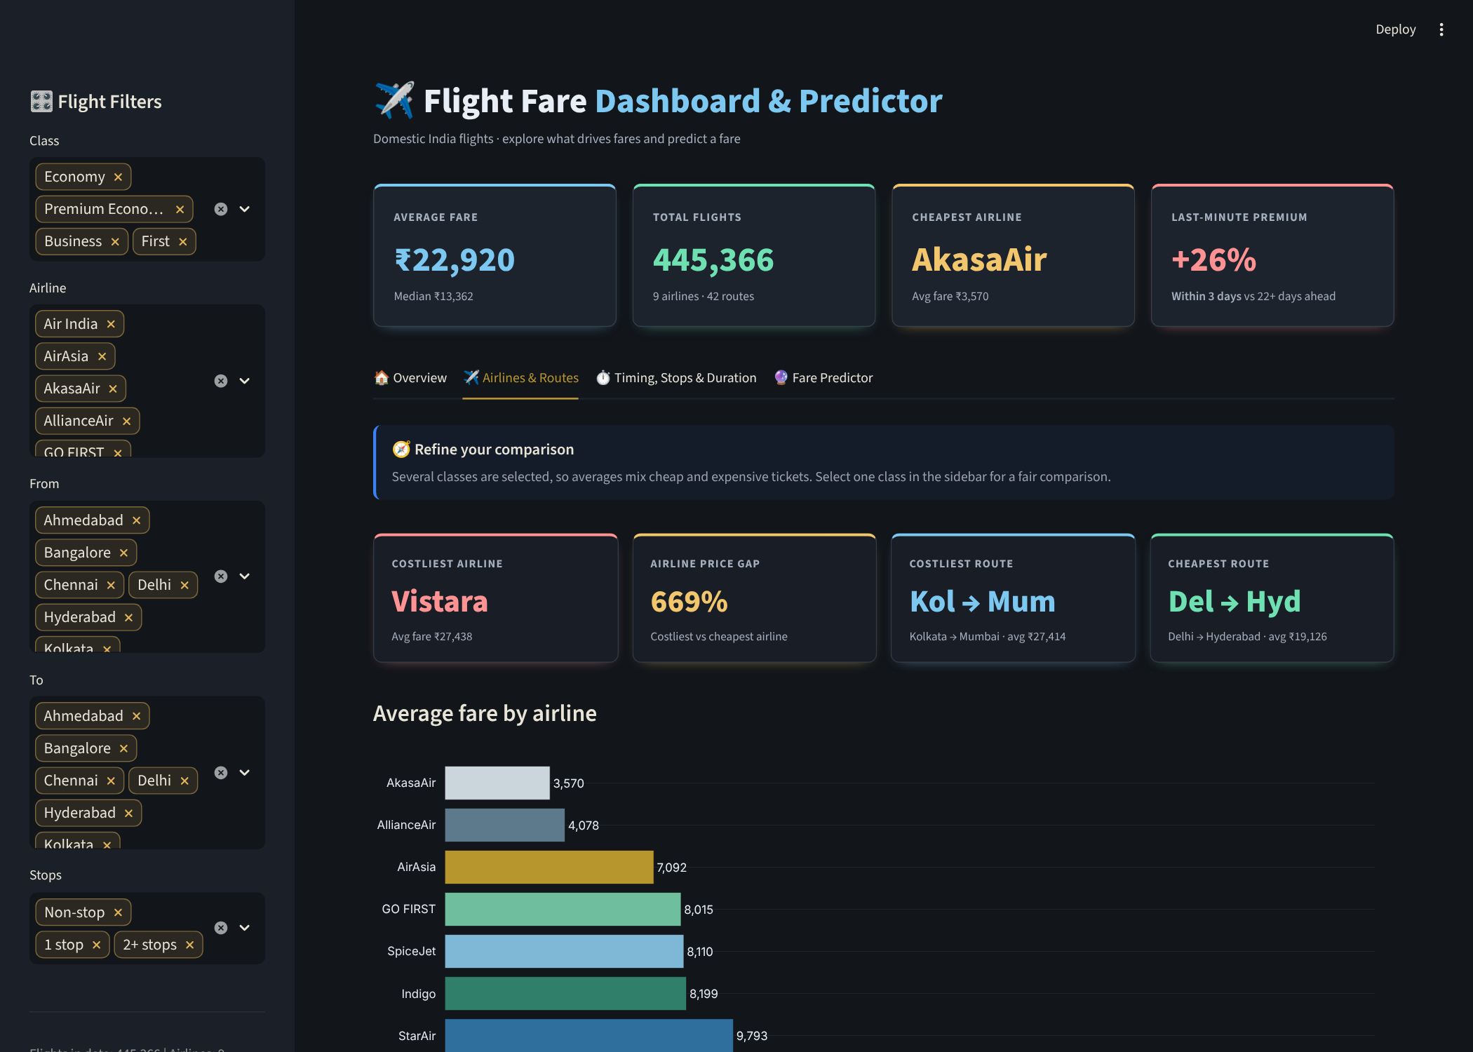
Figure 8. Airlines & Routes tab. With all classes selected, a “Refine your comparison” note explains why airline averages mix cheap and expensive tickets.
Timing, Stops & Duration. Four KPI cards (non-stop share, average duration, connecting-flight premium, cheapest departure slot) and four charts: fare by departure or arrival time, by day of week, by number of stops, and duration vs fare.
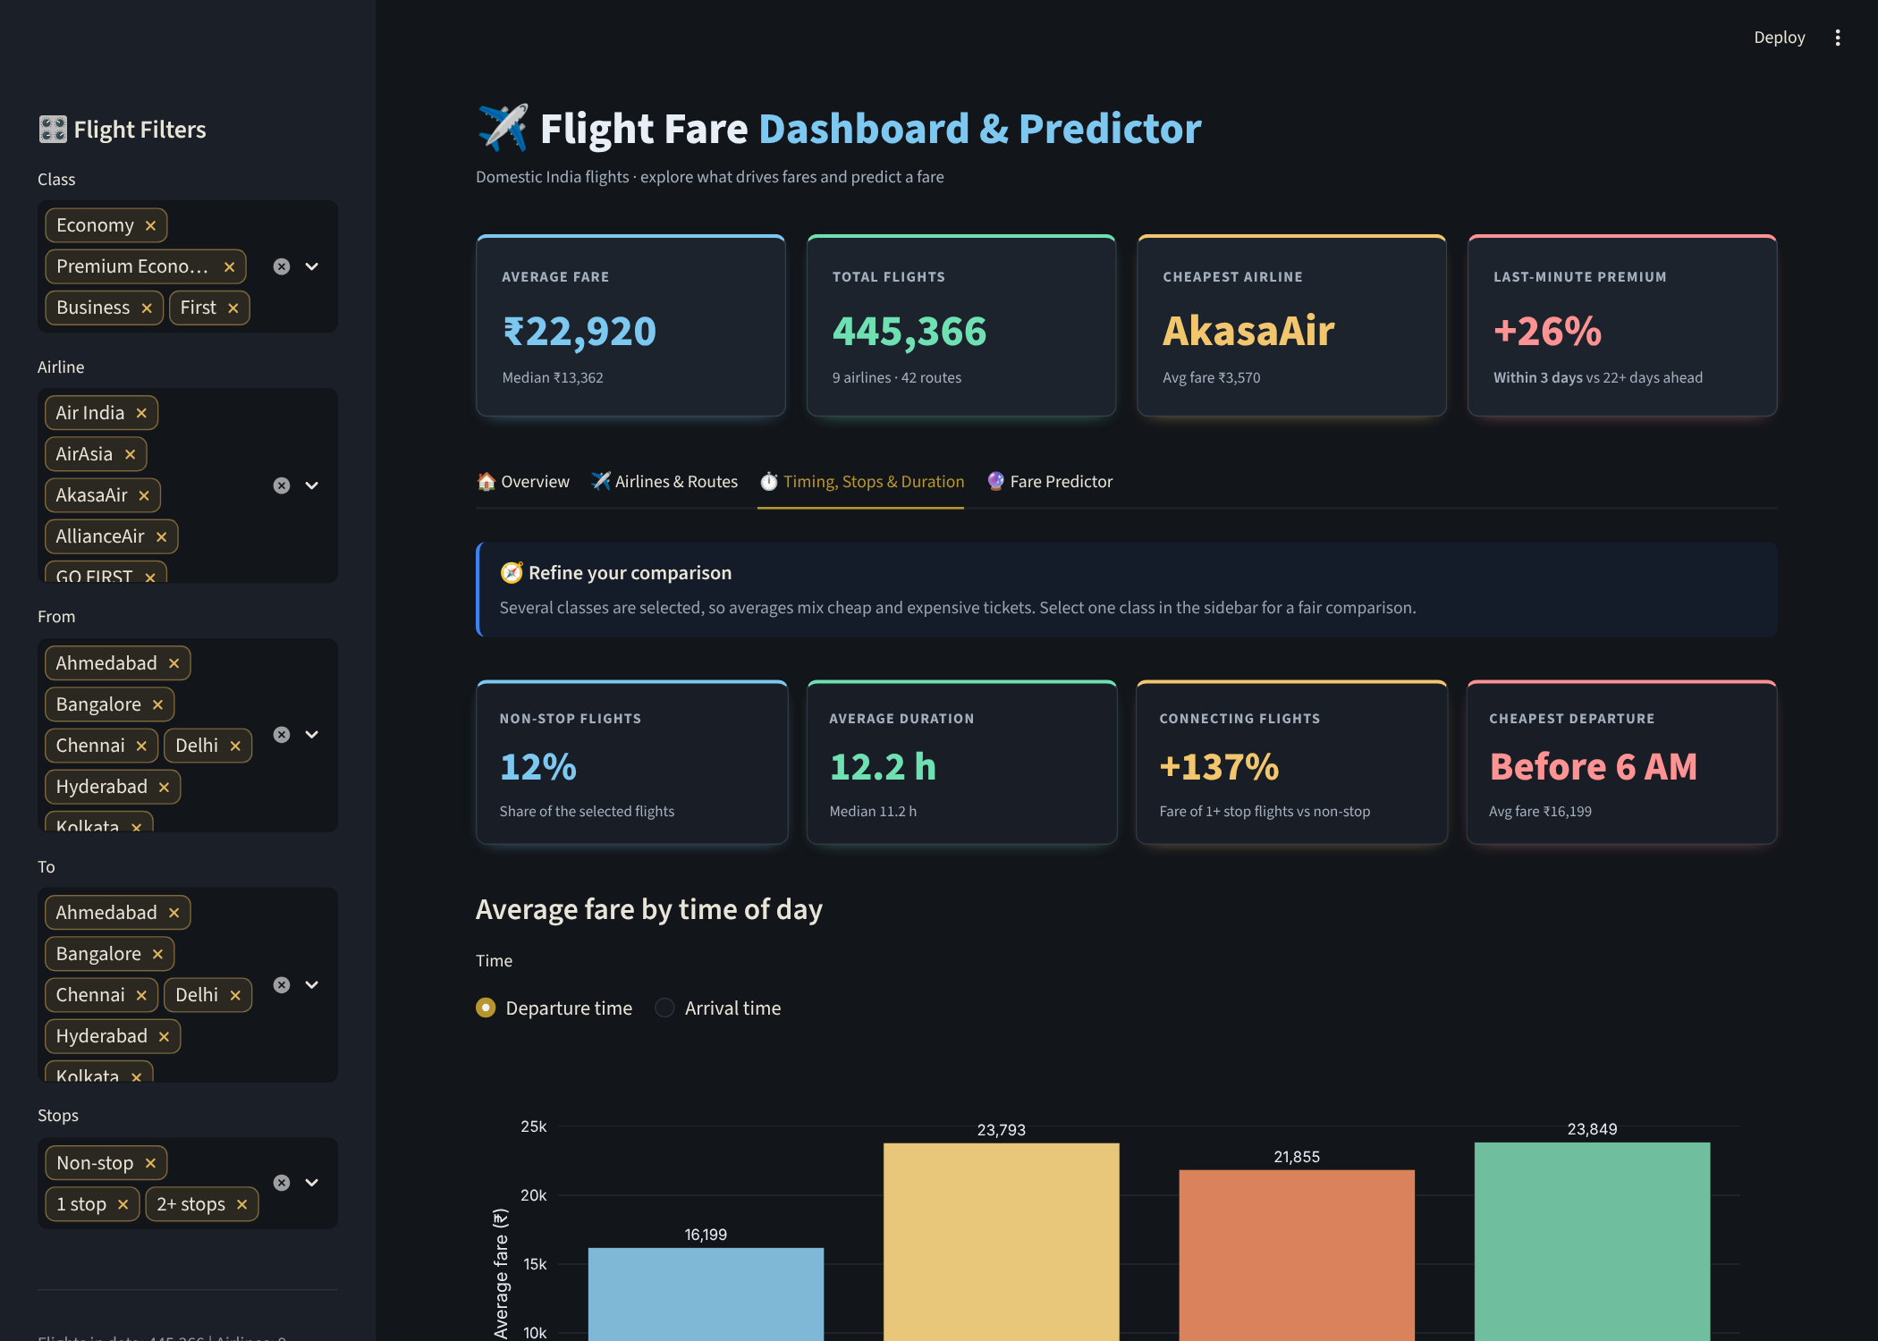
Figure 9. Timing, Stops & Duration tab.
Fare Predictor. Inputs for class, route, airline, stops, days left, departure and arrival time, day and duration. It returns the predicted fare, the route median, the typical range (middle 50% of fares) and the difference from the median, plus a predicted fare vs days-left curve and the same trip on every airline selling that class.
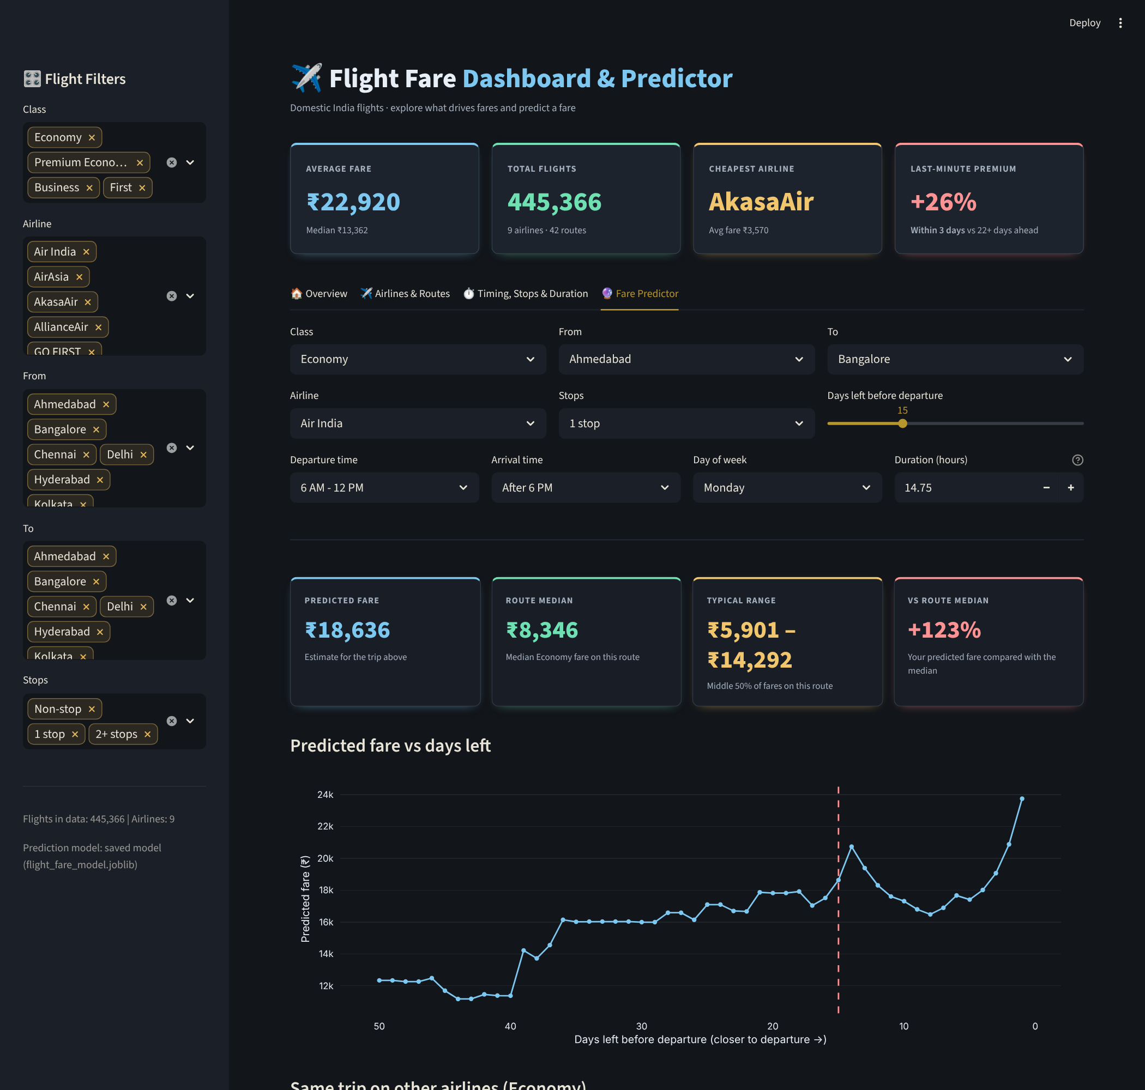
Figure 10. Fare Predictor tab (Economy, Ahmedabad → Bangalore, Air India, 1 stop, 15 days left).

6.3 Filters in action
Changing a sidebar filter recalculates the KPIs and the insight text. Selecting Economy only moves the average fare from ₹22,920 to ₹10,164, flights from 445,366 to 248,323 and the last-minute premium from +26% to +49%.
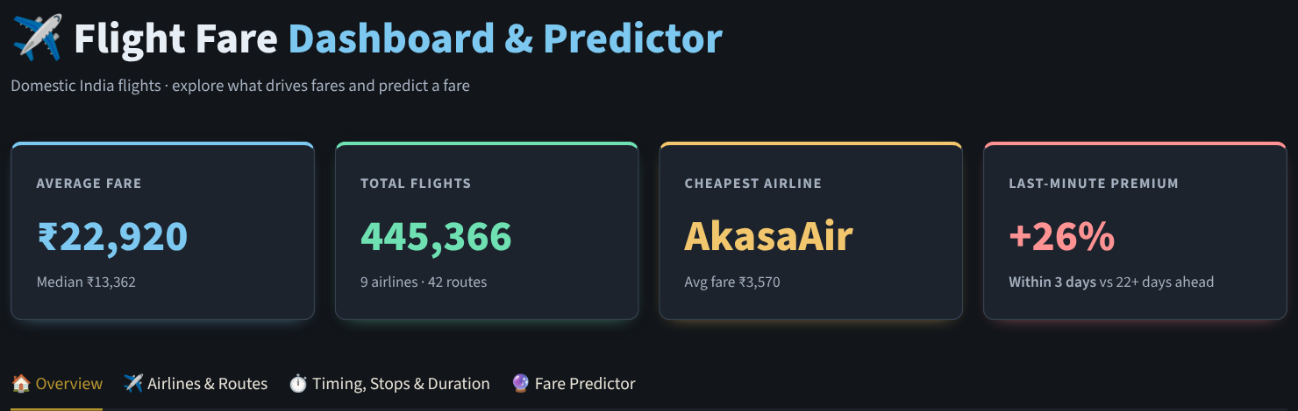
Figure 11a. All classes selected.
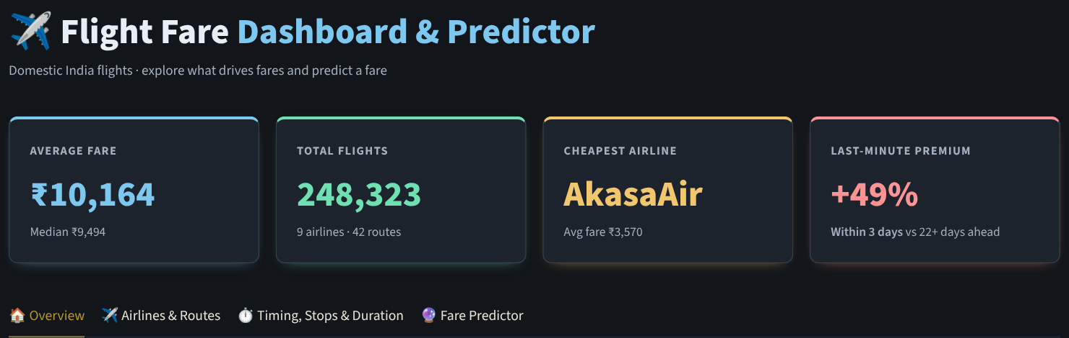
Figure 11b. Class filter set to Economy only.

6.4 What is dynamic and what is not
Component | Follows sidebar filters? | Behaviour
Hero KPIs and tab KPI cards | Yes | Recalculated from the filtered data on every change. The last-minute premium compares fares within 3 days to fares 22 or more days ahead.
Charts | Yes | All charts use the filtered data, except Class mix by airline, which deliberately ignores the Class filter.
Insight boxes (🔎) | Yes | Numbers and names are generated from the filtered data. A few explanatory phrases are fixed text, and the model-accuracy note on the predictor tab is static.
Smart Booking Tips | No | Generated automatically from the full dataset (airline names, routes and percentages come from the data, nothing is hardcoded) and intentionally independent of the sidebar. Up to four cards on Overview, Airlines and Timing. On Airlines and Timing they change with a class selector, Economy by default.
Fare Predictor | Own inputs | Every output updates instantly on any input change. Duration auto-fills with the typical value for the chosen airline, class, route and stops.
Warnings | Automatic | “Refine your comparison” appears on Airlines and Timing when several classes are selected; a low-confidence note appears when the chosen airline, class, route and stops combination is not in the data; a warning appears if the filters leave no flights.
Table 6. Dashboard behaviour.

6.5 Key advantages
The dashboard is designed so that a traveller or analyst gets an answer without writing a query or reading raw tables. Its main advantages are:
Feature | What it does | Benefit
Dynamic KPIs | Hero KPIs (average fare, total flights, cheapest airline, last-minute premium) and the tab KPI cards recalculate from the sidebar filters. | A headline answer for any segment, such as Economy on one route, in one click.
Dynamic insight boxes (🔎) | Under each chart, a short sentence is generated from the filtered data, with changing numbers, airline names and class names. | The takeaway is stated in plain words, so charts do not need to be decoded.
Interactive charts | 14 Plotly charts with hover details and toggles: average vs % change, histogram vs box plot, costliest / cheapest / busiest routes, departure vs arrival time. | Explore the same data from several angles without leaving the page.
Five sidebar filters | Class, Airline, From, To and Stops apply to every tab at once. | One consistent view across all charts and KPIs.
Smart Booking Tips | Up to four tips per tab, written automatically from the full dataset with a class selector on the Airlines and Timing tabs. Nothing is hardcoded. | Actionable advice that stays correct if the data is refreshed.
Fare Predictor | Updates instantly on any input, auto-fills duration, shows the route median and typical range, a fare vs days-left curve and the same trip on every airline. | Checks whether a fare is high or low and which airline is cheapest for the same trip.
Smart warnings | Notes appear automatically when several classes are mixed, when a combination is not in the data, or when filters return no flights. | Prevents misleading comparisons and over-trusting weak estimates.
Mobile-friendly design | Dark theme, responsive KPI and tip grids, short city codes on charts and legends that wrap on small screens. | Readable on a phone as well as a laptop.
Fast on 450k rows | Cached data and model, pre-binned histogram, sampled box and scatter plots, and per-tab fragments. | Interactions stay quick on the free hosting tier.
Transparent | The sidebar shows which model is serving, and the predictor states that prices are one-day estimates. | Users can see what they are relying on.
Table 7. Key dashboard advantages.

7. Engineering challenges and solutions
Problem | Cause | Solution
Memory | 450k rows copied on every click ran the app out of memory. | One cached copy of the data and model (st.cache_resource); filtered frames keep only the 12 columns needed; the histogram is pre-binned so the browser receives 50 rows; box and scatter plots use samples (up to 10,000 points); each tab is a Streamlit fragment.
Model loading | The saved model failed with a scikit-learn version mismatch (_RemainderColsList error). | Re-saved the model in Colab with the same version as the app (1.8.0).
Deployment | On Streamlit Cloud, a second error appeared: No module named '_loss'. | Pinned exact package versions in requirements.txt.
Debug visibility | Hard to tell which model was serving after a silent failure. | The sidebar shows whether the saved or the fallback model is in use; the fallback is a matching HistGradientBoosting pipeline trained automatically.
Repo hygiene | Unused .pkl model files cluttered the repository. | Removed them; only the joblib model remains.

8. Deployment and reproducibility
The app is deployed on Streamlit Cloud from GitHub at https://flight-fare-intelligence.streamlit.app/ (code at https://github.com/Pratham719/flight-fare-intelligence). The repository contains app.py, Cleaned_dataset.csv, the notebook flight_fare_prediction.ipynb, the model in model/flight_fare_model.joblib, a .streamlit/config.toml theme file, requirements.txt, a README and a licence.
Package | Version
joblib | 1.5.3
numpy | 2.4.1
pandas | 2.3.3
plotly | 6.7.0
scikit-learn | 1.8.0
scipy | 1.17.1
streamlit | 1.55.0
Table 8. Pinned requirements.
To run locally: install the requirements with pip, then run streamlit run app.py from the repository folder. To rebuild the model, run flight_fare_prediction.ipynb top to bottom in Google Colab with scikit-learn 1.8.0 and re-save flight_fare_model.joblib.

9. Limitations
- All prices come from a single day, so the data cannot separate days-left from calendar date, and the model cannot learn how prices move over time.
- Departures span only about seven weeks and exclude major festivals and holiday periods.
- First class has 144 flights, all on Air India; its results are not reliable.
- A random train/test split was used, so reported accuracy may be optimistic for unseen future flights.
- Some airlines have very few Economy flights (StarAir 62, AllianceAir 393), so their statistics are indicative only.

10. Conclusions and next steps
Fares in this dataset are driven first by class, then by flight duration, route and airline, with booking window a close next. Late booking carries a clear premium in Economy and Premium Economy, while timing slots and weekday matter far less. A tuned gradient-boosting model predicts fares with R² 0.953 and a typical error of about 7%, and the dashboard turns these findings into something a traveller can filter, compare and act on, with live KPIs, insight boxes, booking tips and warnings that keep the comparison fair.
Next steps
- Collect fares on many different days so the model can learn real price movement over time.
- Add public holidays, fuel prices and seat availability.
- Use quantile regression to return a fare range instead of a single price.
- Validate with a time-based split and compare XGBoost and LightGBM.

