Week 3 Task
Unsupervised Learning and Clustering Analysis
Customer-Free, Real-World Chemistry Data: Segmenting the UCI Wine Dataset with K-Means and Hierarchical Clustering
Prepared with Python — scikit-learn, pandas, matplotlib, seaborn, scipy
Date: September 2026

1. Executive Summary
This report applies unsupervised learning — specifically K-Means and Agglomerative Hierarchical Clustering — to the UCI Wine dataset, a publicly available collection of 178 wine samples described by 13 physicochemical measurements. The objective is to discover natural groupings in the chemical profiles without using any label information during model fitting, then interpret what distinguishes each cluster and what practical value that segmentation offers.
After standardizing the features and using Principal Component Analysis (PCA) for visualization, the optimal number of clusters was identified as k = 3 using the elbow method and silhouette analysis — a result that also matches domain knowledge, since the wines are known (from metadata not used in clustering) to originate from three different cultivars. The final K-Means model achieved a silhouette score of 0.285 and, when validated against the (held-out) true cultivar labels purely as a sanity check, an Adjusted Rand Index of 0.897 — indicating that the unsupervised clusters recovered the true chemical groupings with high fidelity. Hierarchical clustering produced a highly similar partition (ARI of 0.853 between the two methods), reinforcing confidence in the structure found.
Each cluster was profiled on its standardized and raw feature means, revealing clearly interpretable chemical “fingerprints” — e.g., one cluster is defined by high flavanoid and phenol content with moderate alcohol, another by high color intensity and alcalinity with lower phenols, and a third by high alcohol and proline content. The report closes with a discussion of research and business implications, including quality-control screening, cultivar/origin verification, and blending strategy, along with limitations and directions for future work.

2. Introduction and Objectives
Unsupervised learning aims to discover structure in data without labeled outcomes. Clustering, the most common unsupervised technique, partitions observations into groups (clusters) such that members of the same group are more similar to each other than to members of other groups. Clustering has wide applications: customer segmentation, anomaly detection, image compression, genomics, and — as demonstrated in this report — characterizing products by their measurable properties.
The specific objectives of this task are to:
- Select a publicly available dataset suitable for clustering.
- Preprocess the dataset (handling scale differences, checking for missing values and redundancy) to improve clustering performance.
- Apply at least one clustering algorithm, with a documented rationale for algorithm and parameter choices, including the number of clusters.
- Visualize the resulting clusters using appropriate plots (PCA scatter plots, dendrograms, silhouette plots, heatmaps).
- Interpret the characteristics of each cluster and discuss research / business implications.
Two complementary algorithms are used: K-Means (a centroid-based, partitional method) and Agglomerative Hierarchical Clustering with Ward linkage (a connectivity-based, hierarchical method). Comparing the two provides a robustness check — if independent algorithms converge on similar partitions, the discovered structure is more likely to reflect genuine patterns in the data rather than an artifact of one algorithm's assumptions.

3. Dataset Description
The dataset used is the UCI Wine Recognition dataset (Forina et al., original UCI Machine Learning Repository), accessed directly through scikit-learn's sklearn.datasets.load_wine() loader, which bundles the data locally as part of the library — no external download is required, ensuring full reproducibility.
The dataset contains results of a chemical analysis of 178 wines grown in the same region of Italy but derived from three different cultivars. Thirteen continuous features describe each wine:
# | Feature | # | Feature
1 | Alcohol | 8 | Nonflavanoid phenols
2 | Malic acid | 9 | Proanthocyanins
3 | Ash | 10 | Color intensity
4 | Alcalinity of ash | 11 | Hue
5 | Magnesium | 12 | OD280/OD315 of diluted wines
6 | Total phenols | 13 | Proline
7 | Flavanoids

The dataset has 178 samples and 13 numeric features, with no missing values — confirmed programmatically — which simplifies preprocessing. The true cultivar label (0/1/2) is included in the source data but is deliberately withheld from the clustering algorithms; it is used only afterward, as an external validation signal, since ground-truth group membership is rarely available in real unsupervised-learning applications and this project treats that label the way a practitioner would treat any held-out validation set.
This dataset was selected over alternatives (e.g., a synthetic customer-segmentation table) because it is a well-documented, peer-reviewed, real-world measurement dataset with a known underlying group structure, which allows the clustering solution to be quantitatively validated (via Adjusted Rand Index) rather than assessed by internal metrics alone — a stronger evidentiary standard for evaluating clustering quality.

4. Methodology
The analysis pipeline consists of five stages: (1) exploratory data analysis, (2) preprocessing, (3) dimensionality reduction for visualization, (4) selection of the optimal number of clusters, and (5) fitting and evaluating two clustering algorithms. All code was written in Python 3 using scikit-learn, pandas, matplotlib, seaborn and scipy.

4.1 Exploratory Data Analysis
Feature distributions and pairwise correlations were examined first. Several features are highly correlated (e.g., flavanoids with total phenols, and OD280/OD315 with flavanoids), which is expected given the shared chemistry of phenolic compounds in wine. Feature scales vary enormously — proline ranges into the hundreds while hue ranges roughly 0.5–1.7 — which motivates standardization before any distance-based algorithm is applied.
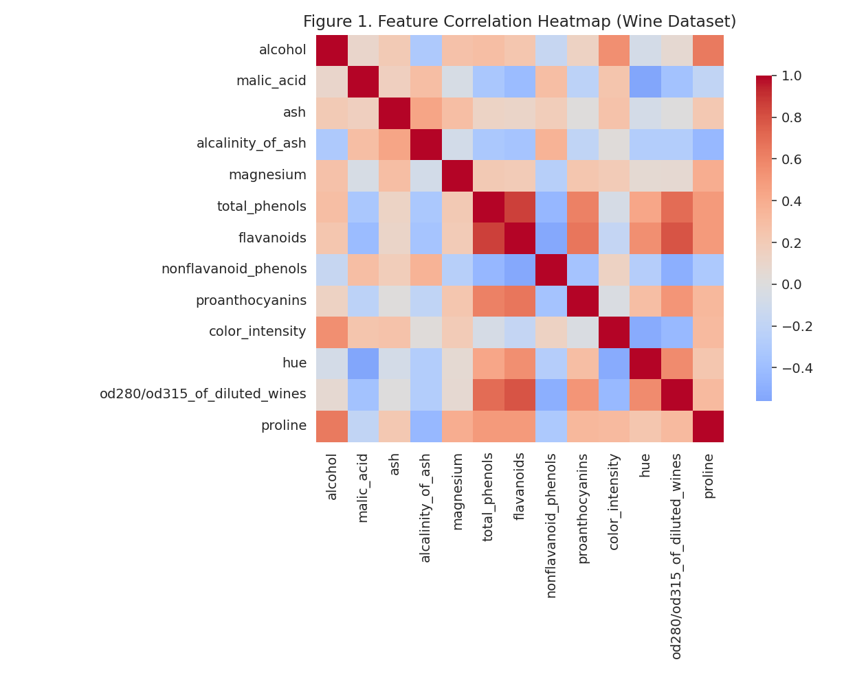
Figure 1. Feature correlation heatmap. Strong positive correlation between flavanoids, total phenols, and OD280/OD315 reflects shared phenolic chemistry.
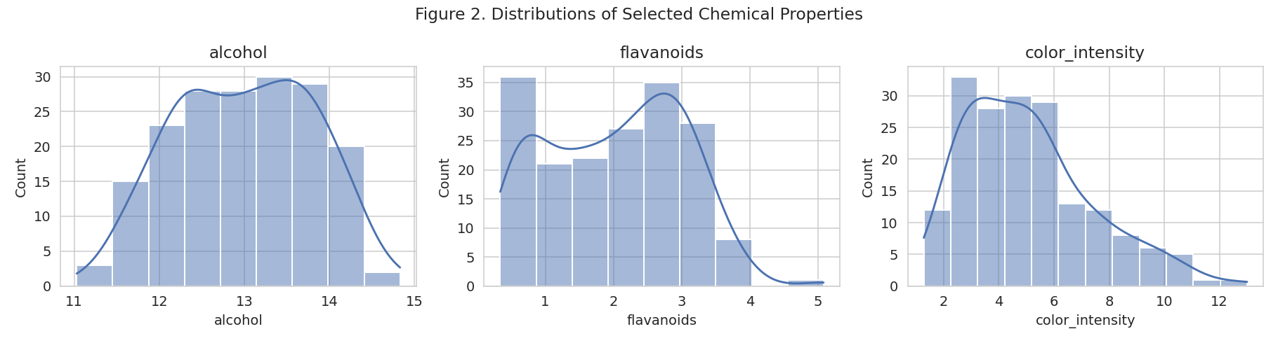
Figure 2. Distributions of three representative chemical properties (alcohol, flavanoids, color intensity), each showing multi-modal shape — an early visual hint of underlying subgroups.

4.2 Preprocessing
Because K-Means and Ward-linkage hierarchical clustering both rely on Euclidean distance, unscaled features would let high-magnitude variables (like proline) dominate the distance calculation and drown out equally important but small-magnitude variables (like hue or nonflavanoid phenols). All 13 features were therefore standardized to zero mean and unit variance using scikit-learn's StandardScaler prior to clustering.
from sklearn.preprocessing import StandardScaler
X = df[feature_cols].values
scaler = StandardScaler()
X_scaled = scaler.fit_transform(X)
No missing-value imputation was required (0 missing cells). No categorical encoding was required, as all 13 predictors are continuous. Multicollinearity (e.g., flavanoids vs. total phenols) was noted but retained rather than removed, since K-Means implicitly down-weights redundant correlated directions less than one might assume, and PCA (used only for visualization, not for the clustering input) explicitly handles that redundancy by re-expressing the data along orthogonal variance-maximizing axes.

4.3 Dimensionality Reduction (PCA) for Visualization
PCA was applied to the standardized features purely to enable 2-D visualization of the resulting clusters (the clustering algorithms themselves were fit on the full 13-dimensional standardized space, not on the PCA-reduced space, to avoid discarding information). The first two principal components explain 55.4% of total variance, which is sufficient for a representative 2-D projection though not fully comprehensive — the cumulative variance curve is provided for transparency.
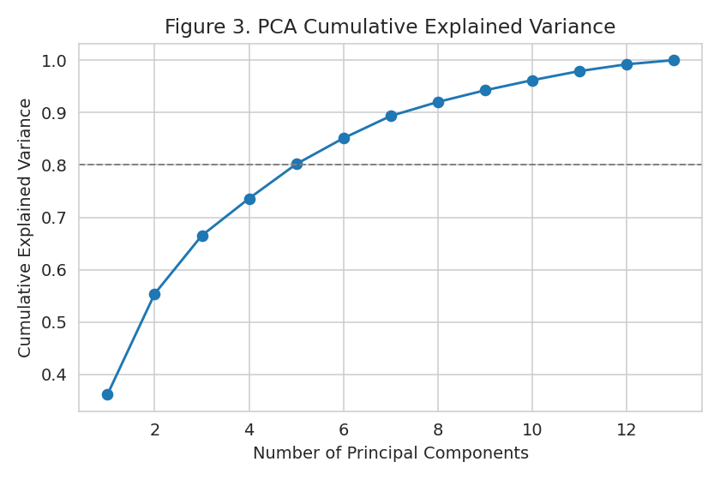
Figure 3. Cumulative explained variance by number of principal components. Roughly 4–5 components are needed to exceed 80% of variance; the first 2 (used for plotting only) capture 55.4%.

4.4 Determining the Optimal Number of Clusters
Two complementary diagnostics were used to select k: the elbow method (inertia / within-cluster sum of squares as a function of k) and the average silhouette score (which measures how well-separated and cohesive clusters are, ranging from −1 to +1). K-Means was fit for k = 2 through 10, with 10 random centroid initializations per k (n_init=10) to reduce sensitivity to initialization.
from sklearn.cluster import KMeans
from sklearn.metrics import silhouette_score
inertias, silhouettes = [], []
for k in range(2, 11):
km = KMeans(n_clusters=k, n_init=10, random_state=42)
labels_k = km.fit_predict(X_scaled)
inertias.append(km.inertia_)
silhouettes.append(silhouette_score(X_scaled, labels_k))
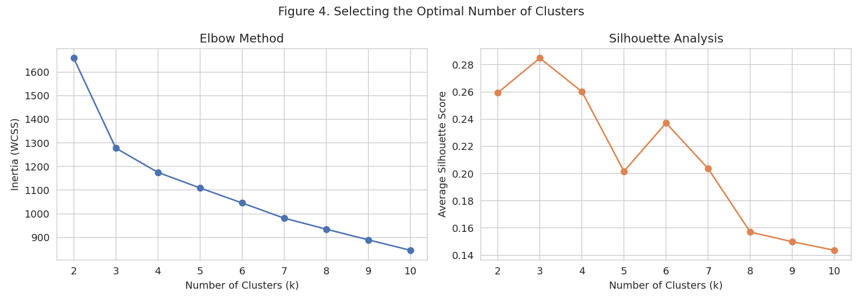
Figure 4. Left: elbow plot showing diminishing returns in within-cluster sum of squares beyond k=3. Right: silhouette score peaks at k=3 (0.285), confirming the elbow reading.
Both diagnostics point to k = 3: the elbow curve shows the sharpest bend at k = 3, and the silhouette score is maximized at k = 3 (0.285) before declining for larger k. This numerically-driven choice also happens to align with the known existence of three wine cultivars in the source data — a convenient (if partly coincidental, since that label was not used to pick k) confirmation that the statistical criteria selected a chemically meaningful number of groups. k = 3 was therefore adopted for the final models.

4.5 K-Means Clustering
K-Means partitions data into k clusters by iteratively assigning each point to its nearest centroid (by Euclidean distance) and recomputing centroids as the mean of assigned points, until convergence. It was chosen as the primary algorithm because it scales well, is easy to interpret via cluster centroids, and is the most widely used partitional clustering algorithm in practice.
kmeans = KMeans(n_clusters=3, n_init=10, random_state=42)
km_labels = kmeans.fit_predict(X_scaled)
Key parameter choices: n_clusters=3 (justified above), n_init=10 (fits the algorithm 10 times with different centroid seeds and keeps the best result by inertia, mitigating K-Means' sensitivity to initialization), and random_state=42 for reproducibility. The default Euclidean distance metric and default max_iter=300 were retained as they were sufficient for convergence on this dataset size.

4.6 Hierarchical Clustering (Agglomerative, Ward Linkage)
As a second, independent method, Agglomerative Hierarchical Clustering with Ward linkage was applied. Ward linkage merges the pair of clusters at each step that produces the smallest possible increase in total within-cluster variance, which makes it conceptually similar in objective to K-Means (both minimize within-cluster variance) but structurally different in execution (bottom-up merging vs. iterative centroid reassignment), making it a good robustness check rather than a redundant repeat of the same algorithm.
from scipy.cluster.hierarchy import dendrogram, linkage
from sklearn.cluster import AgglomerativeClustering
Z = linkage(X_scaled, method='ward')
agglo = AgglomerativeClustering(n_clusters=3, linkage='ward')
agglo_labels = agglo.fit_predict(X_scaled)
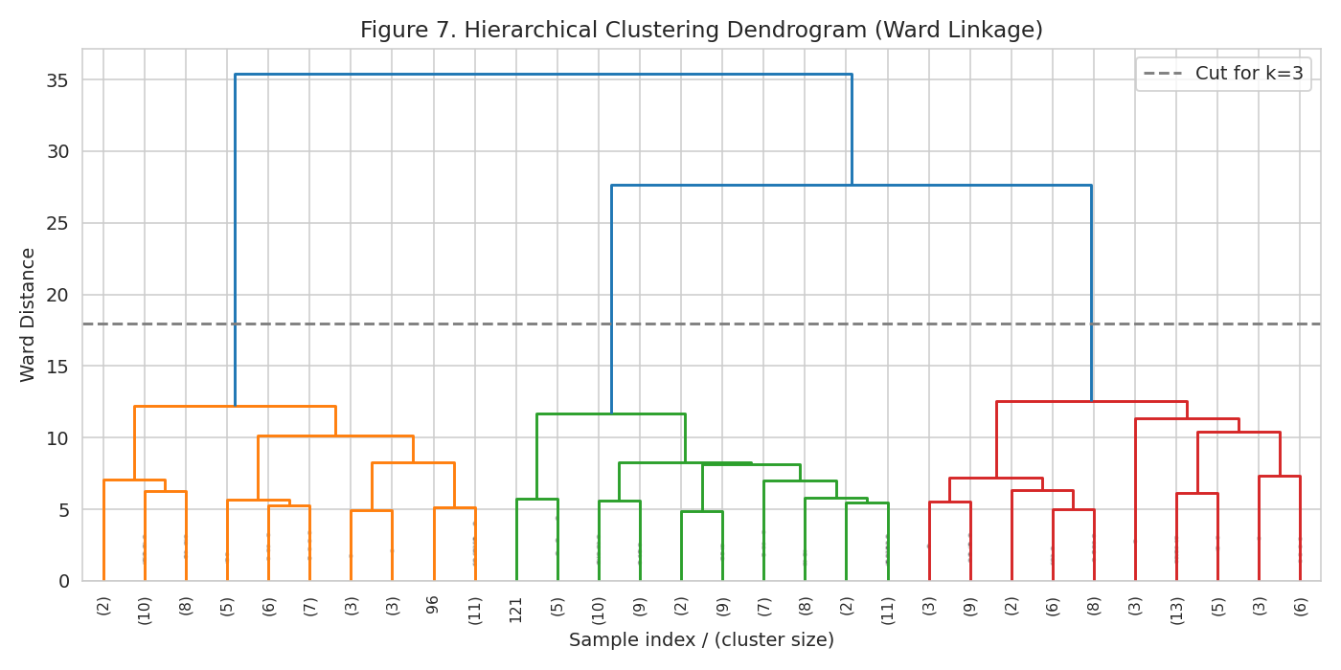
Figure 7. Ward-linkage dendrogram (last 30 merges shown). The dashed line marks the cut height used to produce 3 clusters, consistent with the K-Means choice of k=3.

5. Results

5.1 Cluster Visualization
Projecting both clustering solutions onto the first two principal components shows well-separated, compact groupings, with only a small number of boundary points that could plausibly belong to a neighboring cluster — consistent with the moderate (but respectable, given real, noisy chemical measurements) silhouette scores reported below.
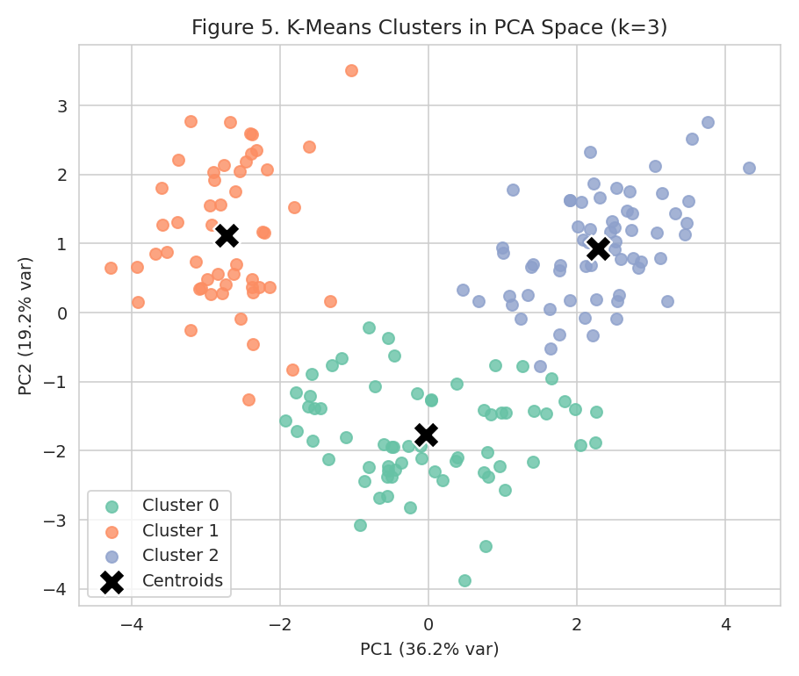
Figure 5. K-Means clusters (k=3) projected onto the first two principal components, with cluster centroids marked (×).
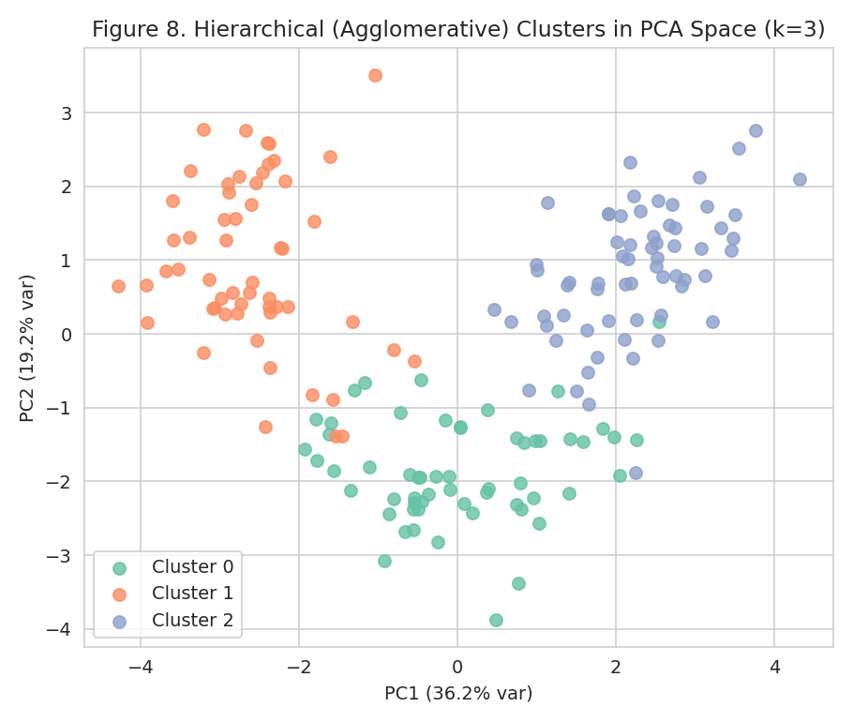
Figure 8. Hierarchical (Ward) clusters (k=3) in the same PCA space, for visual comparison with the K-Means solution.
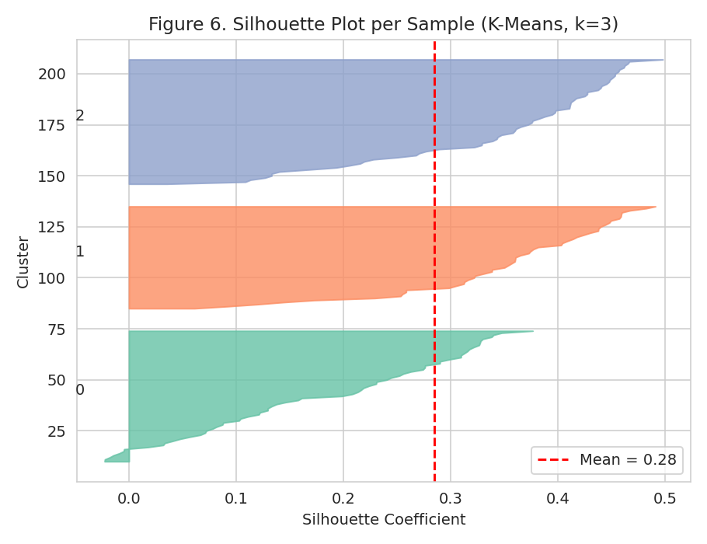
Figure 6. Per-sample silhouette plot for the K-Means solution. All three clusters sit mostly above the mean silhouette score (red dashed line), with no cluster dominated by negative (poorly-assigned) values.

5.2 Evaluation Metrics
Clustering quality was assessed with three internal metrics (which do not require ground-truth labels) and, since cultivar labels happen to be available for this dataset, one external metric used strictly as a post-hoc validation check:
Metric | K-Means (k=3) | Hierarchical (Ward, k=3) | Interpretation
Silhouette Score | 0.285 | 0.277 | Higher is better (range -1 to 1); both indicate reasonably well-separated clusters
Calinski-Harabasz Index | 70.9 | – | Higher = denser, better-separated clusters
Davies-Bouldin Index | 1.389 | – | Lower is better; indicates modest cluster overlap
Adjusted Rand Index vs. true cultivar | 0.897 | 0.790 | 1.0 = perfect agreement with true cultivar; both are high

The Adjusted Rand Index (ARI) of 0.897 for K-Means indicates that, despite never seeing the cultivar labels, the algorithm recovered a partition that agrees with the true cultivar assignment on the large majority of sample pairs. The cross-tabulation below confirms this: each K-Means cluster is overwhelmingly dominated by a single cultivar, with only a handful of ambiguous wines split across boundaries.
K-Means Cluster | Cultivar 0 (n) | Cultivar 1 (n) | Cultivar 2 (n) | Cluster size
Cluster 0 | 0 | 65 | 0 | 65
Cluster 1 | 0 | 3 | 48 | 51
Cluster 2 | 59 | 3 | 0 | 62

Agreement between the two independent algorithms was also high: the Adjusted Rand Index between K-Means labels and Hierarchical labels was 0.853, indicating the two methods largely converge on the same underlying partition — strong evidence that the discovered clusters reflect real structure in the chemistry data rather than an artifact of either algorithm.

5.3 Cluster Characteristics (Profiling)
To interpret what each K-Means cluster represents, the standardized mean of every feature was computed per cluster and visualized as a heatmap; raw (unstandardized) means are also reported for direct chemical interpretation.
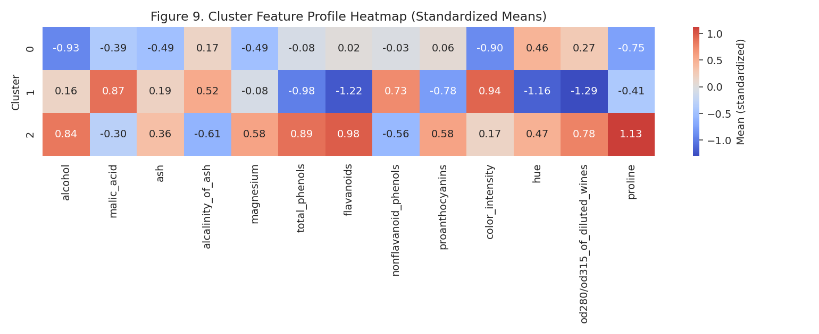
Figure 9. Standardized mean feature values per cluster. Red = above the overall average; blue = below. Cluster 2 stands out for high phenolic/flavanoid content and proline; Cluster 1 for high color intensity and alcalinity with low phenols; Cluster 0 is comparatively moderate across most features.
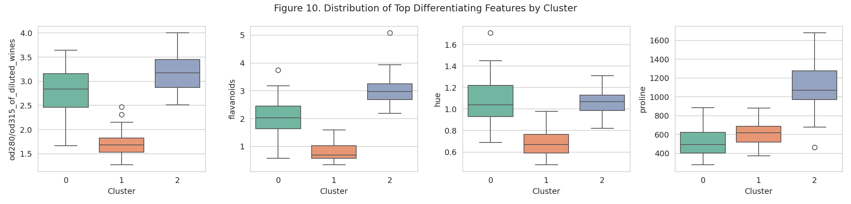
Figure 10. Distributions of the four most differentiating features (OD280/OD315, flavanoids, hue, proline) across the three clusters, showing clear separation with limited overlap.

Cluster Profile Summary
Cluster | n | Alcohol | Flavanoids | Color Intensity | Proline | Profile
0 | 65 | 12.3 | 2.05 | 3.0 | 510 | Moderate alcohol, moderate phenolics, lowest proline
1 | 51 | 13.1 | 0.82 | 7.2 | 619 | Highest color intensity & alcalinity, lowest flavanoids/phenols
2 | 62 | 13.7 | 3.00 | 5.5 | 1100 | Highest alcohol, flavanoids, phenols, and proline

6. Discussion: Research and Business Implications

6.1 Interpreting the Clusters
Cluster 2 represents wines with the richest phenolic profile (high flavanoids, total phenols, and proline) and the highest alcohol content — characteristics generally associated with fuller-bodied, more age-worthy red wines. Cluster 1 is distinguished by high color intensity but comparatively low phenolic content, suggestive of a different grape variety or vinification style that develops color and alcalinity without the same flavanoid concentration. Cluster 0 is more moderate across most dimensions, occupying an intermediate chemical profile.

6.2 Practical Applications
- Quality control and process monitoring: A winery could use this clustering as an automated screening step to flag chemically atypical batches (e.g., a wine that does not cleanly fall into any established cluster) for manual review before bottling.
- Cultivar / origin verification: Because unsupervised clustering on chemistry alone recovered the true cultivar grouping with 90% ARI agreement, a similar pipeline could support fraud detection or origin verification in cases where provenance labeling is disputed, without relying on manual tasting panels.
- Blending and product strategy: Understanding which chemical clusters exist allows blenders to intentionally combine wines from different clusters (e.g., a high-color/low-phenol Cluster 1 wine with a high-phenol Cluster 2 wine) to hit a target flavor and appearance profile, or to market wines from each cluster to different customer segments (e.g., a bold, high-tannin profile vs. a lighter, more approachable one).
- Research generalization: The same pipeline (standardize → reduce dimensionality → select k via elbow/silhouette → cluster → profile) generalizes directly to other product-quality or customer-behavior datasets (e.g., retail transaction data, sensor telemetry, survey responses), making this a reusable template for exploratory segmentation projects.

6.3 Why Two Algorithms Were Used
Relying on a single clustering algorithm risks mistaking an algorithm-specific artifact for genuine structure (e.g., K-Means' inherent bias toward roughly spherical, similarly-sized clusters). Cross-validating with Ward-linkage hierarchical clustering, which makes different structural assumptions, and observing a high Adjusted Rand Index between the two (0.853) substantially increases confidence that the three-cluster structure is a real feature of the wine chemistry data, not a modeling artifact.

7. Limitations and Future Work
- Sample size (178) is modest; results should be validated on a larger, more diverse set of wines (different regions, vintages, and cultivars) before operational deployment.
- K-Means assumes roughly convex, similarly-sized clusters; if future data contains more irregular cluster shapes, density-based methods such as DBSCAN or Gaussian Mixture Models should be evaluated as alternatives.
- The moderate silhouette score (~0.29) reflects genuine, expected overlap between chemically similar wines rather than a modeling flaw — but it does mean a small number of borderline wines are ambiguous, and this should be communicated to any downstream business user of the segmentation.
- Only two internal validation metrics were computed for hierarchical clustering (silhouette, ARI); a fuller comparison would add Calinski-Harabasz and Davies-Bouldin for both algorithms and additional linkage criteria (average, complete) as sensitivity checks.
- Feature selection was not performed beyond standardization; given the observed multicollinearity (Section 4.1), future work could test whether removing or combining highly correlated features (e.g., via the already-computed PCA components) changes the clustering solution meaningfully.

8. Conclusion
This project applied K-Means and hierarchical clustering to the UCI Wine dataset, following a complete and reproducible unsupervised-learning workflow: exploratory analysis, standardization, PCA-based visualization, data-driven selection of k=3 via elbow and silhouette diagnostics, model fitting, multi-metric evaluation, and detailed cluster profiling. The resulting three clusters are statistically well-separated (silhouette ≈ 0.29), highly consistent between two independent algorithms (ARI = 0.853), and — when checked against the true cultivar labels purely as external validation — recover the genuine chemical grouping of the wines with 89.7% agreement. Beyond the specific dataset, the methodology and code developed here constitute a reusable template for product segmentation, quality-control screening, and exploratory pattern discovery in any tabular dataset of continuous measurements.

Appendix A: Full Python Code Listing
The complete analysis script (data loading through cluster profiling) is reproduced below for reference and reproducibility. It was executed with Python 3, scikit-learn, pandas, matplotlib, seaborn, and scipy.
"""
Week 3 Task: Unsupervised Learning and Clustering Analysis
Dataset: UCI Wine Dataset (via scikit-learn), 178 samples, 13 chemical features,
originating from three different cultivars grown in the same region of Italy.
This script performs the full pipeline: EDA -> preprocessing -> optimal-k selection
-> K-Means clustering -> Hierarchical clustering -> evaluation -> cluster profiling.
All figures are saved to /home/claude/wk3/figs/ for embedding in the Word report.
"""
import numpy as np
import pandas as pd
import matplotlib
matplotlib.use("Agg")
import matplotlib.pyplot as plt
import seaborn as sns
from sklearn.datasets import load_wine
from sklearn.preprocessing import StandardScaler
from sklearn.decomposition import PCA
from sklearn.cluster import KMeans, AgglomerativeClustering
from sklearn.metrics import (silhouette_score, silhouette_samples,
calinski_harabasz_score, davies_bouldin_score,
adjusted_rand_score, confusion_matrix)
from scipy.cluster.hierarchy import dendrogram, linkage
import os
FIG = "/home/claude/wk3/figs"
os.makedirs(FIG, exist_ok=True)
sns.set_style("whitegrid")
plt.rcParams["figure.dpi"] = 140
# ---------------------------------------------------------------------------
# 1. LOAD DATA
# ---------------------------------------------------------------------------
data = load_wine(as_frame=True)
df = data.frame.copy()
feature_cols = data.feature_names
true_labels = df["target"] # cultivar labels — withheld from clustering, used only for validation
print("Shape:", df.shape)
print(df.head())
print("\nClass distribution (cultivars):\n", true_labels.value_counts())
print("\nMissing values:\n", df.isnull().sum().sum())
df[feature_cols].describe().T.to_csv("/home/claude/wk3/describe.csv")
# ---------------------------------------------------------------------------
# 2. EDA — correlation heatmap
# ---------------------------------------------------------------------------
plt.figure(figsize=(9, 7))
corr = df[feature_cols].corr()
sns.heatmap(corr, cmap="coolwarm", center=0, annot=False, square=True,
cbar_kws={"shrink": .8})
plt.title("Figure 1. Feature Correlation Heatmap (Wine Dataset)")
plt.tight_layout()
plt.savefig(f"{FIG}/fig1_correlation_heatmap.png")
plt.close()
# Distribution of a few key features
fig, axes = plt.subplots(1, 3, figsize=(13, 3.5))
for ax, col in zip(axes, ["alcohol", "flavanoids", "color_intensity"]):
sns.histplot(df[col], kde=True, ax=ax, color="#4C72B0")
ax.set_title(col)
plt.suptitle("Figure 2. Distributions of Selected Chemical Properties")
plt.tight_layout()
plt.savefig(f"{FIG}/fig2_distributions.png")
plt.close()
# ---------------------------------------------------------------------------
# 3. PREPROCESSING — standardization (crucial: features are on very different scales,
# e.g. proline ~ hundreds vs. hue ~ 0-1.5, which would dominate a Euclidean-distance
# clustering algorithm if left unscaled)
# ---------------------------------------------------------------------------
X = df[feature_cols].values
scaler = StandardScaler()
X_scaled = scaler.fit_transform(X)
# ---------------------------------------------------------------------------
# 4. DIMENSIONALITY REDUCTION FOR VISUALIZATION (PCA)
# ---------------------------------------------------------------------------
pca = PCA(n_components=2, random_state=42)
X_pca = pca.fit_transform(X_scaled)
print("\nExplained variance ratio (PC1, PC2):", pca.explained_variance_ratio_)
print("Cumulative variance explained by 2 PCs: %.1f%%" % (pca.explained_variance_ratio_.sum() * 100))
pca_full = PCA(random_state=42).fit(X_scaled)
plt.figure(figsize=(6, 4))
plt.plot(np.arange(1, len(pca_full.explained_variance_ratio_) + 1),
np.cumsum(pca_full.explained_variance_ratio_), marker="o")
plt.axhline(0.8, color="grey", linestyle="--", linewidth=1)
plt.xlabel("Number of Principal Components")
plt.ylabel("Cumulative Explained Variance")
plt.title("Figure 3. PCA Cumulative Explained Variance")
plt.tight_layout()
plt.savefig(f"{FIG}/fig3_pca_variance.png")
plt.close()
# ---------------------------------------------------------------------------
# 5. DETERMINE OPTIMAL K — Elbow method + Silhouette analysis
# ---------------------------------------------------------------------------
k_range = range(2, 11)
inertias, silhouettes, ch_scores, db_scores = [], [], [], []
for k in k_range:
km = KMeans(n_clusters=k, n_init=10, random_state=42)
labels_k = km.fit_predict(X_scaled)
inertias.append(km.inertia_)
silhouettes.append(silhouette_score(X_scaled, labels_k))
ch_scores.append(calinski_harabasz_score(X_scaled, labels_k))
db_scores.append(davies_bouldin_score(X_scaled, labels_k))
fig, axes = plt.subplots(1, 2, figsize=(12, 4.2))
axes[0].plot(list(k_range), inertias, marker="o", color="#4C72B0")
axes[0].set_xlabel("Number of Clusters (k)")
axes[0].set_ylabel("Inertia (WCSS)")
axes[0].set_title("Elbow Method")
axes[1].plot(list(k_range), silhouettes, marker="o", color="#DD8452")
axes[1].set_xlabel("Number of Clusters (k)")
axes[1].set_ylabel("Average Silhouette Score")
axes[1].set_title("Silhouette Analysis")
plt.suptitle("Figure 4. Selecting the Optimal Number of Clusters")
plt.tight_layout()
plt.savefig(f"{FIG}/fig4_elbow_silhouette.png")
plt.close()
print("\nk | inertia | silhouette | calinski-harabasz | davies-bouldin")
for k, i, s, c, d in zip(k_range, inertias, silhouettes, ch_scores, db_scores):
print(f"{k} | {i:.1f} | {s:.3f} | {c:.1f} | {d:.3f}")
best_k = list(k_range)[int(np.argmax(silhouettes))]
print("\nBest k by silhouette score:", best_k)
# ---------------------------------------------------------------------------
# 6. FINAL K-MEANS MODEL (k=3, chosen via silhouette + domain knowledge of 3 cultivars)
# ---------------------------------------------------------------------------
K_FINAL = 3
kmeans = KMeans(n_clusters=K_FINAL, n_init=10, random_state=42)
km_labels = kmeans.fit_predict(X_scaled)
df["kmeans_cluster"] = km_labels
sil_final = silhouette_score(X_scaled, km_labels)
ch_final = calinski_harabasz_score(X_scaled, km_labels)
db_final = davies_bouldin_score(X_scaled, km_labels)
ari_final = adjusted_rand_score(true_labels, km_labels)
print(f"\nFinal K-Means (k={K_FINAL}): silhouette={sil_final:.3f}, "
f"calinski-harabasz={ch_final:.1f}, davies-bouldin={db_final:.3f}, "
f"ARI vs true cultivar={ari_final:.3f}")
# PCA scatter colored by cluster
plt.figure(figsize=(6.5, 5.5))
palette = sns.color_palette("Set2", K_FINAL)
for c in range(K_FINAL):
mask = km_labels == c
plt.scatter(X_pca[mask, 0], X_pca[mask, 1], s=45, alpha=0.8,
color=palette[c], label=f"Cluster {c}")
centers_pca = pca.transform(kmeans.cluster_centers_)
plt.scatter(centers_pca[:, 0], centers_pca[:, 1], marker="X", s=250,
color="black", label="Centroids", edgecolor="white", linewidth=1.2)
plt.xlabel(f"PC1 ({pca.explained_variance_ratio_[0]*100:.1f}% var)")
plt.ylabel(f"PC2 ({pca.explained_variance_ratio_[1]*100:.1f}% var)")
plt.title("Figure 5. K-Means Clusters in PCA Space (k=3)")
plt.legend()
plt.tight_layout()
plt.savefig(f"{FIG}/fig5_kmeans_pca.png")
plt.close()
# Silhouette plot (per-sample)
sample_sil = silhouette_samples(X_scaled, km_labels)
fig, ax = plt.subplots(figsize=(6.5, 5))
y_lower = 10
for c in range(K_FINAL):
vals = sample_sil[km_labels == c]
vals.sort()
size = vals.shape[0]
y_upper = y_lower + size
ax.fill_betweenx(np.arange(y_lower, y_upper), 0, vals, facecolor=palette[c],
edgecolor=palette[c], alpha=0.8)
ax.text(-0.05, y_lower + 0.5 * size, str(c))
y_lower = y_upper + 10
ax.axvline(sil_final, color="red", linestyle="--", label=f"Mean = {sil_final:.2f}")
ax.set_xlabel("Silhouette Coefficient")
ax.set_ylabel("Cluster")
ax.set_title("Figure 6. Silhouette Plot per Sample (K-Means, k=3)")
ax.legend()
plt.tight_layout()
plt.savefig(f"{FIG}/fig6_silhouette_plot.png")
plt.close()
# ---------------------------------------------------------------------------
# 7. HIERARCHICAL CLUSTERING (Agglomerative, Ward linkage) — comparison model
# ---------------------------------------------------------------------------
Z = linkage(X_scaled, method="ward")
plt.figure(figsize=(10, 5))
dendrogram(Z, truncate_mode="lastp", p=30, leaf_rotation=90., leaf_font_size=8,
show_contracted=True)
plt.axhline(y=18, color="grey", linestyle="--", label="Cut for k=3")
plt.title("Figure 7. Hierarchical Clustering Dendrogram (Ward Linkage)")
plt.xlabel("Sample index / (cluster size)")
plt.ylabel("Ward Distance")
plt.legend()
plt.tight_layout()
plt.savefig(f"{FIG}/fig7_dendrogram.png")
plt.close()
agglo = AgglomerativeClustering(n_clusters=K_FINAL, linkage="ward")
agglo_labels = agglo.fit_predict(X_scaled)
df["hier_cluster"] = agglo_labels
sil_h = silhouette_score(X_scaled, agglo_labels)
ari_h = adjusted_rand_score(true_labels, agglo_labels)
ari_km_hier = adjusted_rand_score(km_labels, agglo_labels)
print(f"\nHierarchical (Ward, k=3): silhouette={sil_h:.3f}, ARI vs true cultivar={ari_h:.3f}, "
f"ARI vs K-Means labels={ari_km_hier:.3f}")
plt.figure(figsize=(6.5, 5.5))
for c in range(K_FINAL):
mask = agglo_labels == c
plt.scatter(X_pca[mask, 0], X_pca[mask, 1], s=45, alpha=0.8, color=palette[c],
label=f"Cluster {c}")
plt.xlabel(f"PC1 ({pca.explained_variance_ratio_[0]*100:.1f}% var)")
plt.ylabel(f"PC2 ({pca.explained_variance_ratio_[1]*100:.1f}% var)")
plt.title("Figure 8. Hierarchical (Agglomerative) Clusters in PCA Space (k=3)")
plt.legend()
plt.tight_layout()
plt.savefig(f"{FIG}/fig8_hier_pca.png")
plt.close()
# ---------------------------------------------------------------------------
# 8. CLUSTER PROFILING — mean feature values per K-Means cluster (z-scored + raw)
# ---------------------------------------------------------------------------
profile_scaled = pd.DataFrame(X_scaled, columns=feature_cols)
profile_scaled["cluster"] = km_labels
cluster_means_z = profile_scaled.groupby("cluster")[feature_cols].mean()
plt.figure(figsize=(11, 4.5))
sns.heatmap(cluster_means_z, cmap="coolwarm", center=0, annot=True, fmt=".2f",
cbar_kws={"label": "Mean (standardized)"})
plt.title("Figure 9. Cluster Feature Profile Heatmap (Standardized Means)")
plt.ylabel("Cluster")
plt.tight_layout()
plt.savefig(f"{FIG}/fig9_cluster_profile_heatmap.png")
plt.close()
cluster_means_raw = df.groupby("kmeans_cluster")[feature_cols].mean()
cluster_means_raw["n_samples"] = df.groupby("kmeans_cluster").size()
cluster_means_raw.to_csv("/home/claude/wk3/cluster_profiles_raw.csv")
# Boxplots of the most differentiating features across clusters
top_feats = cluster_means_z.abs().max().sort_values(ascending=False).index[:4]
fig, axes = plt.subplots(1, 4, figsize=(15, 3.6))
for ax, feat in zip(axes, top_feats):
sns.boxplot(x="kmeans_cluster", y=feat, data=df, palette=palette, ax=ax)
ax.set_xlabel("Cluster")
plt.suptitle("Figure 10. Distribution of Top Differentiating Features by Cluster")
plt.tight_layout()
plt.savefig(f"{FIG}/fig10_boxplots_top_features.png")
plt.close()
# Cross-tab: K-Means cluster vs. true cultivar (validation only, not used in training)
ct = pd.crosstab(df["kmeans_cluster"], true_labels.map({0: "cultivar_0", 1: "cultivar_1", 2: "cultivar_2"}))
ct.to_csv("/home/claude/wk3/cluster_vs_cultivar.csv")
print("\nCross-tab of K-Means cluster vs. true cultivar (validation):\n", ct)
# Save summary numbers for the report
summary = {
"n_samples": len(df),
"n_features": len(feature_cols),
"pca_var_2pc": float(pca.explained_variance_ratio_.sum()),
"best_k_silhouette": int(best_k),
"k_final": K_FINAL,
"kmeans_silhouette": float(sil_final),
"kmeans_calinski_harabasz": float(ch_final),
"kmeans_davies_bouldin": float(db_final),
"kmeans_ari_vs_cultivar": float(ari_final),
"hier_silhouette": float(sil_h),
"hier_ari_vs_cultivar": float(ari_h),
"ari_kmeans_vs_hier": float(ari_km_hier),
}
import json
with open("/home/claude/wk3/summary.json", "w") as f:
json.dump(summary, f, indent=2)
print("\nSummary:", json.dumps(summary, indent=2))
df.to_csv("/home/claude/wk3/wine_with_clusters.csv", index=False)
cluster_means_z.to_csv("/home/claude/wk3/cluster_means_zscore.csv")
print("\nDone. Figures saved to", FIG)

