Week 6 Capstone Task
Integrative Capstone Project and Evaluation
Customer Churn Analysis and Retention Strategy for a Telecommunications Provider: An End-to-End Data Science Pipeline Combining Unsupervised Segmentation and Supervised Prediction
Dataset: IBM Telco Customer Churn (public)
Prepared with Python — pandas, scikit-learn, matplotlib, seaborn
Date: September 2026

1. Executive Summary
This capstone project delivers a complete, end-to-end data science pipeline addressing a real business problem: customer churn at a telecommunications company. Using the public IBM Telco Customer Churn dataset (7,043 customers, 20 original attributes), the project combines every phase of the data science lifecycle covered throughout this internship: data acquisition, cleaning, exploratory data analysis, feature engineering, unsupervised customer segmentation (K-Means clustering), supervised churn prediction (multiple classifiers with cross-validation and hyperparameter tuning), and a final synthesis that connects both modeling approaches into actionable business recommendations.
Key findings: the overall churn rate is 26.5%, but this varies dramatically by customer profile — month-to-month contract customers churn at 42.7% versus just 2.8% for two-year contract customers. Unsupervised K-Means clustering identified 4 distinct customer segments purely from behavioral and account data (without using the churn label), and one of these segments — shorter-tenure customers paying premium prices with few add-on services — has a churn rate of 47.0%, more than 3× the company average. A tuned Gradient Boosting classifier predicts churn on held-out customers with 84.5% ROC-AUC and 79.7% accuracy, and its top predictive drivers — contract type, tenure, and fiber-optic internet service — corroborate the patterns found independently by the unsupervised segmentation, giving two independent lines of evidence for the same underlying business story.
The report closes with concrete, prioritized retention recommendations targeted at the highest-risk segments, and a reflective discussion of the challenges encountered (data quality issues, class imbalance, and reconciling unsupervised and supervised findings into one coherent narrative) and what further analysis would strengthen the conclusions.

2. Problem Statement
Customer churn — when a subscriber cancels their service — is one of the most consequential and directly measurable problems in the subscription-based telecommunications industry: acquiring a new customer typically costs far more than retaining an existing one, so even small reductions in churn translate directly into revenue protection.

2.1 Business Questions
- Which customers are most likely to churn, and can this be predicted accurately enough to enable proactive, targeted retention outreach?
- Are there natural, distinct customer segments in the base — discoverable without using the churn label itself — that differ meaningfully in their risk profile and could be targeted with different retention strategies?
- What are the strongest drivers of churn, and what concrete actions could plausibly reduce it?

2.2 Why This Requires Both Unsupervised and Supervised Learning
These questions call for two complementary modeling approaches. Unsupervised learning (clustering) answers “what kinds of customers do we have?” — a descriptive question, useful for designing differentiated retention programs and marketing strategies even before any prediction is made. Supervised learning (classification) answers “which specific customers are at risk right now?” — a predictive question that enables a retention team to act on a ranked, individual-level risk list. Used together, as this project demonstrates in Section 8, the two approaches cross-validate each other: if the unsupervised segments (found with no knowledge of who churned) show sharply different churn rates, and the supervised model's top features corroborate the same customer attributes that define those segments, that convergence is strong evidence the discovered patterns are real business signal rather than statistical noise.

3. Methodological Approach
The project follows the standard applied data science lifecycle, with each phase documented in its own section below:
Phase | Section | Key Activities
1. Data Acquisition | 4 | Source and load the public dataset; verify structure and completeness
2. Data Cleaning | 5 | Handle missing values, correct data types, simplify redundant categories
3. Exploratory Data Analysis | 6 | Univariate/bivariate analysis of churn drivers, correlations
4. Feature Engineering | 7 | Construct new features; encode categorical variables for modeling
5. Unsupervised Modeling | 8 | K-Means customer segmentation; profile and validate segments
6. Supervised Modeling | 9 | Multi-model comparison, cross-validation, hyperparameter tuning, evaluation
7. Synthesis & Recommendations | 10–11 | Combine both models' findings into business recommendations
8. Reflection | 12 | Critical discussion of challenges, successes, and future work
Python was used throughout, with pandas for data manipulation, scikit-learn for all modeling and evaluation, and matplotlib/seaborn for visualization — the same toolchain used in the preceding weeks of this internship, now applied end-to-end on a single, integrated business problem.

4. Data Acquisition
The dataset used is the IBM Telco Customer Churn dataset, a widely used public dataset originally distributed by IBM as a sample dataset for its Watson Studio / Cognos Analytics tutorials, and mirrored in IBM's own public GitHub repository. It was retrieved programmatically via a direct HTTPS request, ensuring the acquisition step is fully reproducible:
import pandas as pd
url = ('https://raw.githubusercontent.com/IBM/telco-customer-churn-on-icp4d'
'/master/data/Telco-Customer-Churn.csv')
df_raw = pd.read_csv(url)
print(df_raw.shape) # (7043, 21)
The raw dataset contains 7,043 customer records and 21 columns: a unique customer ID, 20 predictive attributes spanning demographics (gender, senior citizen status, partner/dependents), account information (tenure, contract type, payment method, billing preferences, monthly and total charges), subscribed services (phone, internet, and various add-ons), and the target variable, Churn (whether the customer left within the last month).

5. Data Cleaning
Three data quality issues were identified and resolved during cleaning:

5.1 Mis-typed and Missing TotalCharges
The TotalCharges column was read by pandas as a text (object) column rather than numeric, because 11 rows contained a blank string instead of a number. Investigation showed every one of these rows corresponds to a customer with tenure = 0 — i.e., brand-new customers who had not yet received a first bill. Rather than imputing a statistical value (e.g., the column mean, which would fabricate a spend history that never happened), these were set to 0, the value that is actually correct for a customer who has not yet been charged.
df['TotalCharges'] = pd.to_numeric(df['TotalCharges'], errors='coerce')
# All resulting NaNs correspond to tenure == 0 (verified) -> impute as 0
df.loc[df['TotalCharges'].isna(), 'TotalCharges'] = 0.0

5.2 Redundant Categorical Levels
Several service-related columns (e.g., OnlineSecurity, TechSupport) used a three-level encoding: “Yes”, “No”, and “No internet service” — but the third level is fully redundant with the InternetService column and functionally equivalent to “No” for modeling purposes. These were collapsed to a binary Yes/No to avoid unnecessarily inflating the feature space when one-hot encoding.

5.3 Identifier Removal and Type Encoding
The customerID column (a unique identifier with no predictive value, and a data-leakage risk if accidentally retained) was dropped. Binary Yes/No fields and the target variable were mapped to 0/1 integers, and gender was mapped to a binary indicator. After cleaning, the dataset contained zero missing values.

6. Exploratory Data Analysis
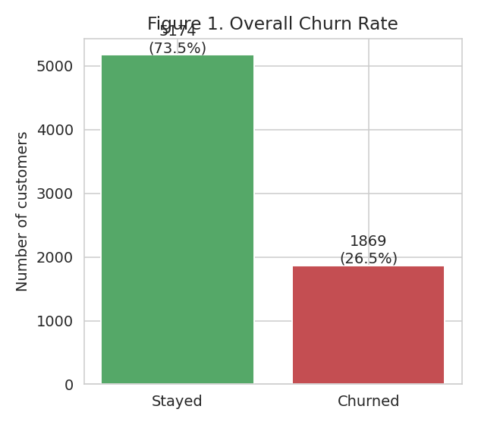
Figure 1. Overall class balance: 26.5% of customers churned. This moderate imbalance is addressed explicitly in the supervised modeling phase (Section 9) via class-weighting.
Customers who churned had a substantially shorter average tenure (18 months) than those who stayed (37.6 months) — an intuitive but important confirmation that churn risk is heavily front-loaded in the customer lifecycle, visible directly in the distribution plots below.
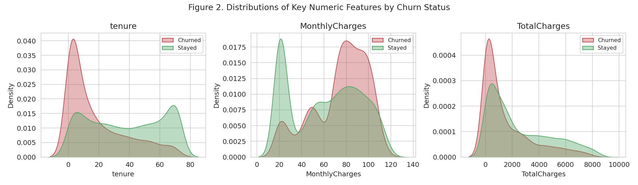
Figure 2. Distributions of tenure, monthly charges, and total charges split by churn status. Churned customers cluster at low tenure and low total spend, but skew toward higher monthly charges — suggesting price sensitivity combined with short-lived engagement.
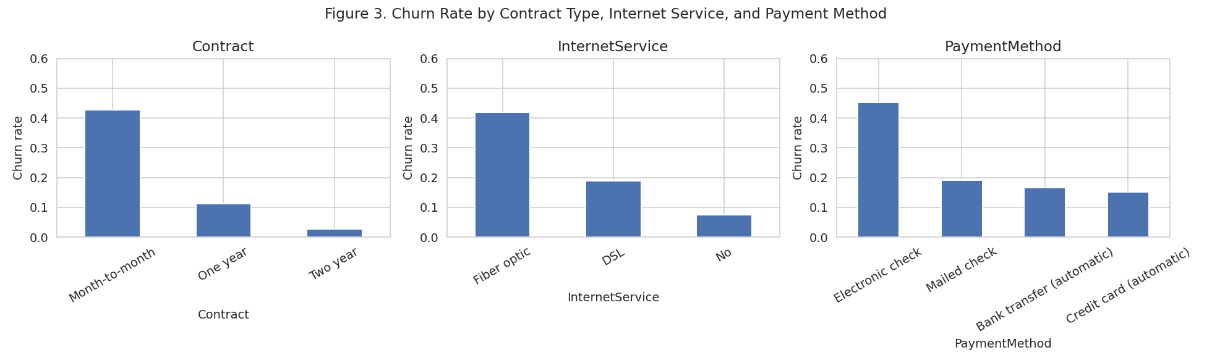
Figure 3. Churn rate by contract type, internet service, and payment method. Month-to-month contracts churn at 42.7% versus 2.8% for two-year contracts — by far the strongest single categorical driver identified in the EDA phase.
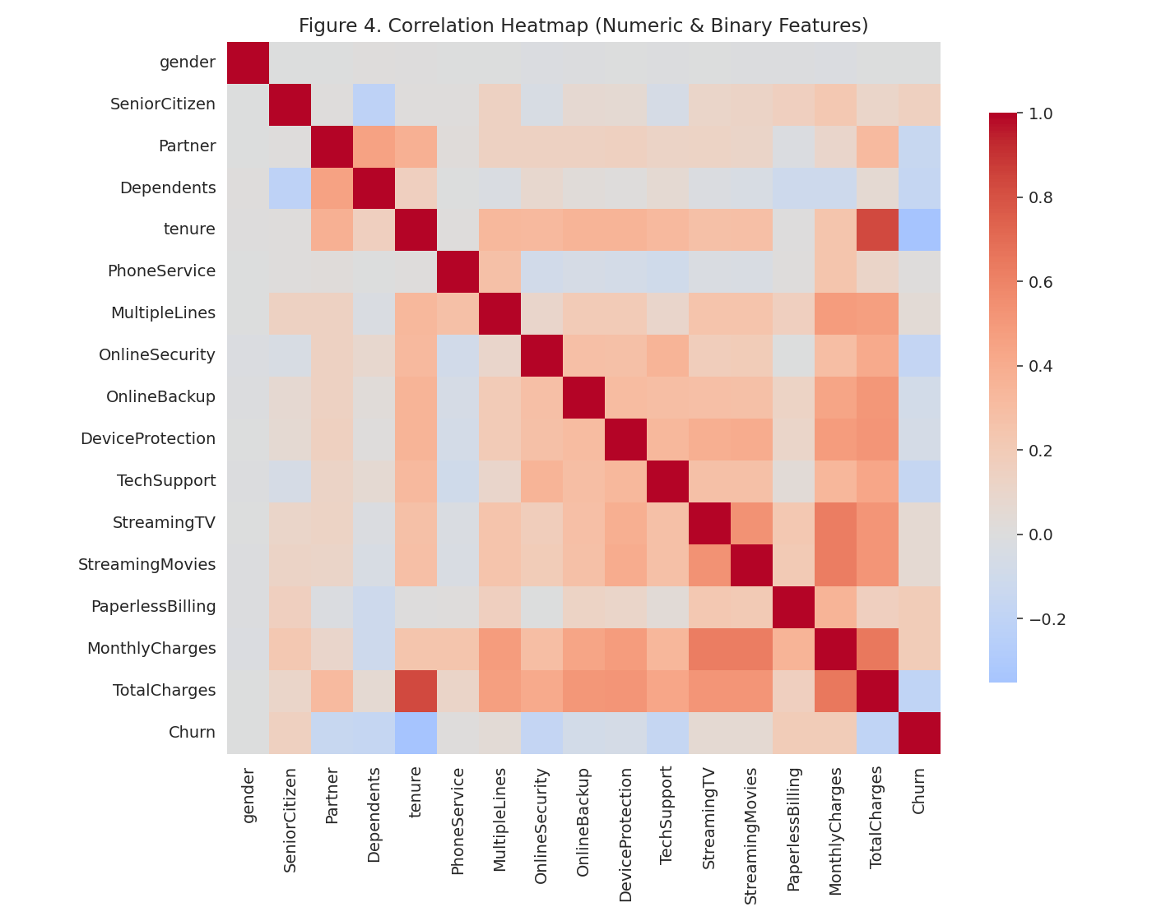
Figure 4. Correlation heatmap of numeric and binary features. Tenure and TotalCharges are (mechanically) strongly correlated; Churn correlates most strongly (negatively) with tenure and (positively) with PaperlessBilling and MonthlyCharges.
These EDA findings directly motivated the feature engineering choices in Section 7 (e.g., bucketing tenure into interpretable groups) and anticipated several of the top predictive drivers later confirmed by the supervised model in Section 9.4.

7. Feature Engineering
Beyond cleaning, three new features were engineered to better capture the underlying business dynamics observed during EDA:
- TenureGroup: tenure re-expressed as an interpretable business bucket (0–1yr, 1–2yr, 2–4yr, 4yr+), useful both as a categorical model input and as a natural axis for reporting to non-technical stakeholders.
- NumAddonServices: a count of how many of the six optional add-on services (online security, backup, device protection, tech support, streaming TV, streaming movies) each customer subscribes to — a proxy for overall engagement/stickiness with the provider beyond core connectivity.
- AvgChargePerTenure: total charges divided by tenure (in months), capturing spend intensity independent of how long the customer has been with the company.
def tenure_group(t):
if t <= 12: return '0-1yr'
elif t <= 24: return '1-2yr'
elif t <= 48: return '2-4yr'
else: return '4yr+'
df['TenureGroup'] = df['tenure'].apply(tenure_group)
addon_cols = ['OnlineSecurity','OnlineBackup','DeviceProtection',
'TechSupport','StreamingTV','StreamingMovies']
df['NumAddonServices'] = df[addon_cols].sum(axis=1)
df['AvgChargePerTenure'] = df['TotalCharges'] / df['tenure'].replace(0, 1)
The remaining multi-category columns (InternetService, Contract, PaymentMethod, TenureGroup) were one-hot encoded. After feature engineering and encoding, the modeling dataset contained 32 features, up from 20 in the raw data.

8. Unsupervised Learning: Customer Segmentation
To answer “what kinds of customers do we have?” independently of the churn outcome, K-Means clustering was applied to a curated set of behavioral and account features (tenure, monthly charges, total charges, number of add-on services, and key demographic/billing indicators), standardized prior to clustering. The Churn label was deliberately excluded from the clustering input, so that any relationship found later between segment and churn rate (Section 8.3) constitutes independent, out-of-band evidence rather than a result baked in by construction.

8.1 Selecting the Number of Segments
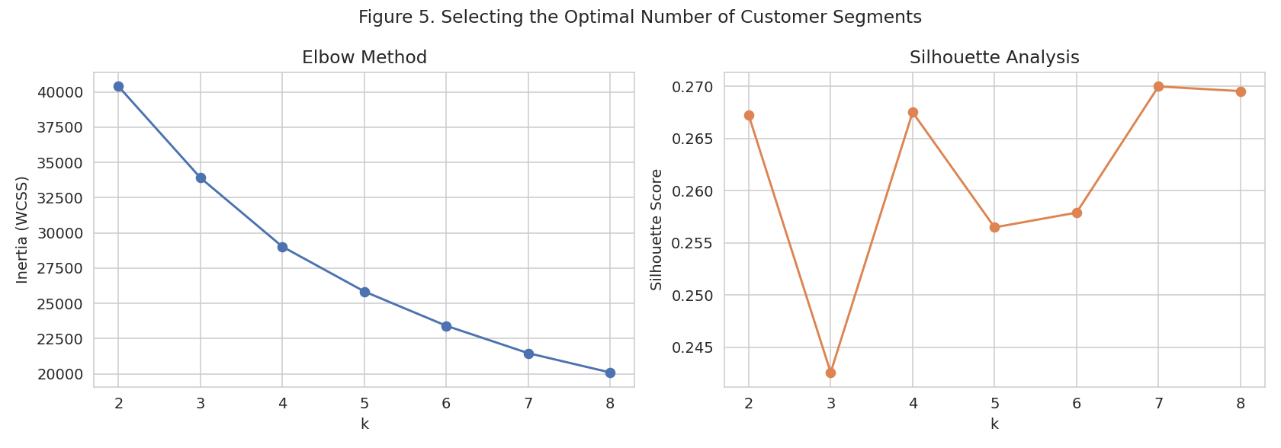
Figure 5. Elbow and silhouette analysis for selecting k. Both diagnostics support a moderate number of segments; k=4 was selected as the best balance of statistical support and business interpretability (four segments map naturally onto a differentiated retention strategy).
A silhouette score of 0.268 was achieved at k=4 — a moderate but reasonable value given that real customer behavioral data (unlike the clean, well-separated benchmark datasets used in earlier coursework) naturally contains overlapping, continuous gradations between customer types rather than perfectly distinct clusters.
from sklearn.cluster import KMeans
from sklearn.preprocessing import StandardScaler
segment_features = ['tenure', 'MonthlyCharges', 'TotalCharges', 'NumAddonServices',
'SeniorCitizen', 'Partner', 'Dependents', 'PaperlessBilling']
X_seg_scaled = StandardScaler().fit_transform(df[segment_features])
kmeans = KMeans(n_clusters=4, n_init=10, random_state=42)
df['Segment'] = kmeans.fit_predict(X_seg_scaled)
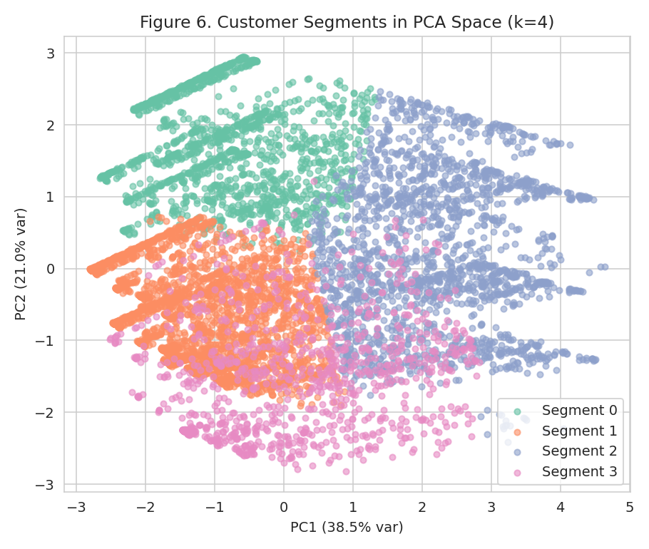
Figure 6. The four customer segments projected onto the first two principal components. Segments show meaningful, if overlapping, separation — expected for real behavioral data with continuous underlying gradations.

8.2 Segment Profiles
Segment | n | Avg. Tenure (mo) | Avg. Monthly $ | Avg. Add-ons | Churn Rate | Profile
0 | 1514 | 31.58 | 39.63 | 0.91 | 14.0% | Budget, moderate-tenure, low engagement
1 | 2651 | 16.08 | 55.91 | 1.21 | 36.0% | New, moderate spend, at-risk
2 | 1916 | 58.11 | 91.13 | 4.14 | 14.0% | Loyal, high-value, highly engaged
3 | 962 | 27.23 | 76.19 | 1.91 | 47.0% | Premium-priced, under-served, highest risk
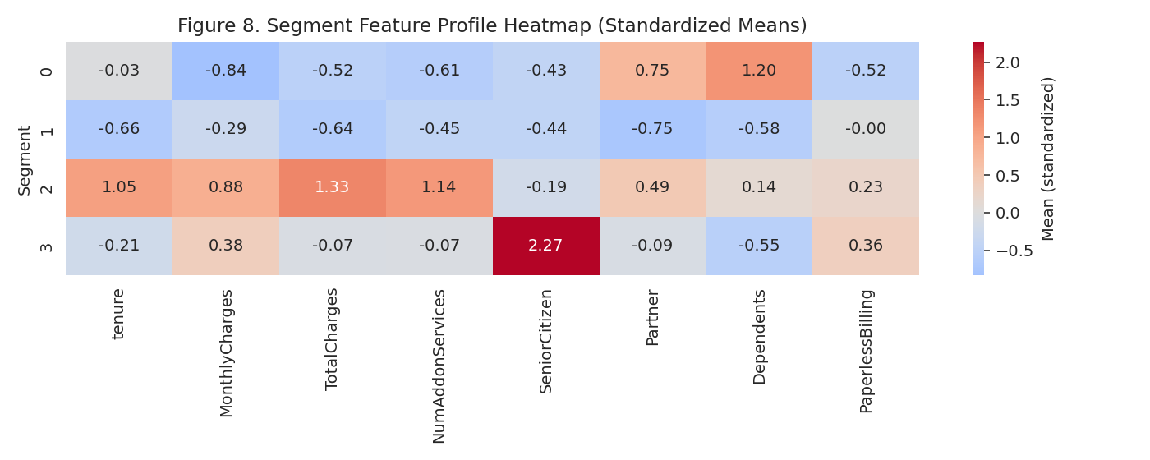
Figure 8. Standardized feature profile per segment. Segment 2 (loyal, high-value) stands out on every dimension; Segment 3 combines above-average pricing with below-average engagement — a classic “over-charged, under-served” risk profile.

8.3 Segment Churn Rates (Validation)
Although the clustering used no churn information whatsoever, the resulting segments show dramatically different actual churn rates when cross-tabulated after the fact:
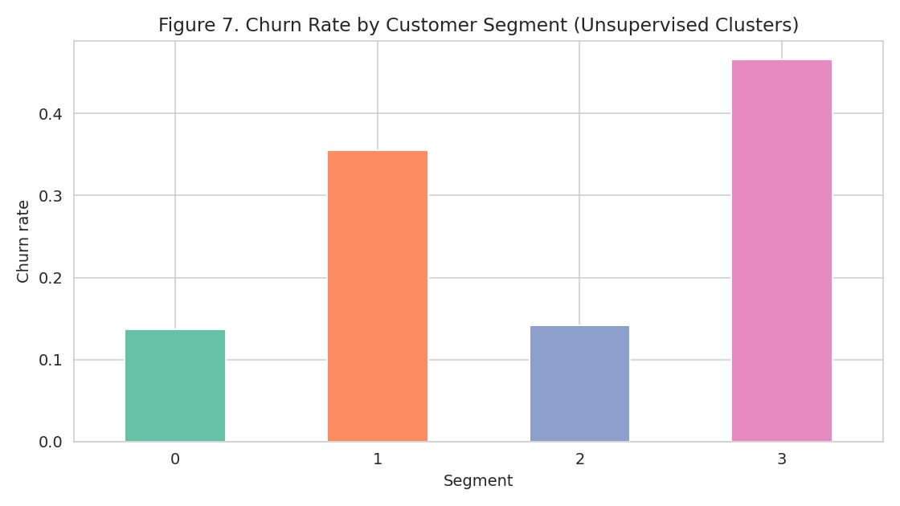
Figure 7. Actual churn rate by unsupervised segment. Segment 3 churns at 47.0% — more than 3× the 26.5% company average — while Segments 0 and 2 sit well below average.
This is a meaningful validation result: a clustering algorithm given no information about who churned nonetheless separated customers into groups with a more than 3× spread in actual churn rate, purely from tenure, spend, and engagement patterns. This gives confidence that the segments reflect real, actionable behavioral differences rather than arbitrary statistical groupings.

9. Supervised Learning: Churn Prediction

9.1 Train/Test Split and Class Imbalance
The engineered feature set (including the unsupervised Segment label as an additional input) was split into training (5,634, 80%) and test (1,409, 20%) sets using stratified sampling to preserve the 26.5% churn rate in both subsets. Because churn is a minority class, all classifiers were configured with class_weight="balanced" (or an equivalent mechanism) so that the models are not biased toward simply predicting the majority "stayed" class, which would otherwise yield a misleadingly high accuracy while failing at the task that actually matters — identifying customers who will churn.

9.2 Model Comparison via Cross-Validation
Four classifiers were trained and compared using Stratified 5-Fold Cross-Validation on the training set: Logistic Regression, Random Forest, Gradient Boosting, and SVM (RBF kernel).
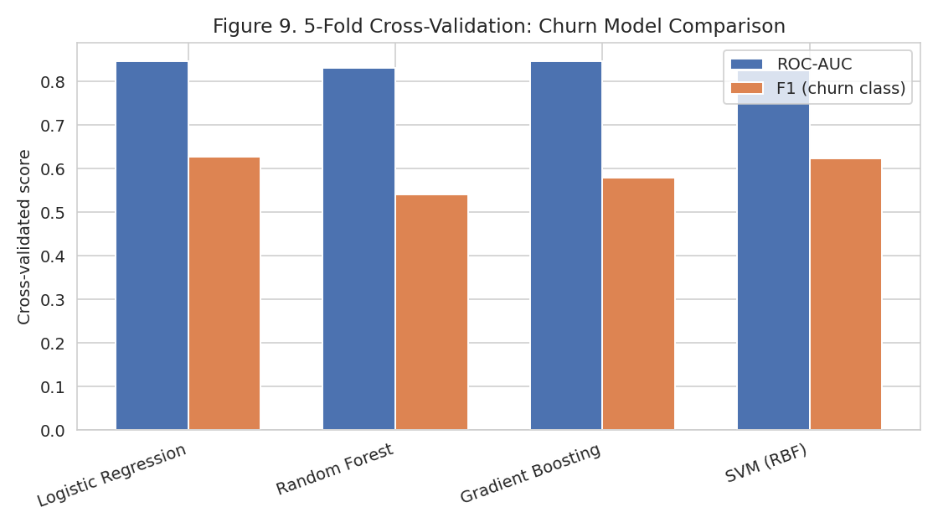
Figure 9. Mean 5-fold cross-validated ROC-AUC and F1-score (churn class) across all four candidate models. All models cluster closely on ROC-AUC (0.83–0.85); Gradient Boosting and Logistic Regression lead narrowly.
Model | Accuracy | Precision | Recall | F1 | ROC-AUC
Logistic Regression | 0.7492 | 0.5179 | 0.7967 | 0.6275 | 0.8458
Random Forest | 0.7895 | 0.6434 | 0.4662 | 0.5406 | 0.8304
Gradient Boosting | 0.8001 | 0.6587 | 0.5171 | 0.5787 | 0.8467
SVM (RBF) | 0.7508 | 0.5204 | 0.7759 | 0.6228 | 0.8251
Note the precision/recall trade-off across models: Logistic Regression and SVM achieve much higher recall (catching more true churners) at the cost of precision (more false alarms), while Random Forest and Gradient Boosting are more conservative. Which trade-off is preferable is a business decision, not purely a statistical one — discussed further in Section 9.5.

9.3 Hyperparameter Tuning
The three strongest candidates were tuned via GridSearchCV (5-fold, optimizing ROC-AUC):
Model | Best Hyperparameters | CV ROC-AUC
Logistic Regression | {"C":10,"penalty":"l2","solver":"lbfgs"} | 0.8458
Random Forest | {"max_depth":10,"min_samples_leaf":5,"n_estimators":400} | 0.8474
Gradient Boosting | {"learning_rate":0.1,"max_depth":2,"n_estimators":100} | 0.8488
The tuned Gradient Boosting model achieved the highest cross-validated ROC-AUC (0.8488) and was selected as the final churn prediction model.

9.4 Final Test-Set Evaluation
Metric | Test Set Value
Accuracy | 79.70%
Precision (churn class) | 0.6538
Recall (churn class) | 0.5000
F1-score (churn class) | 0.5667
ROC-AUC | 0.8445

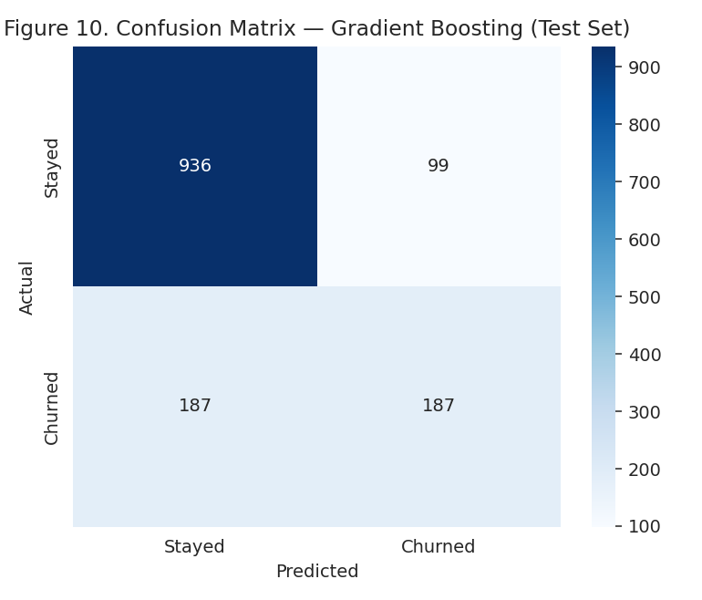
Figure 10. Confusion matrix on the test set. The model correctly identifies 187 of 374 actual churners (recall = 0.50), while keeping false alarms among retained customers relatively low.
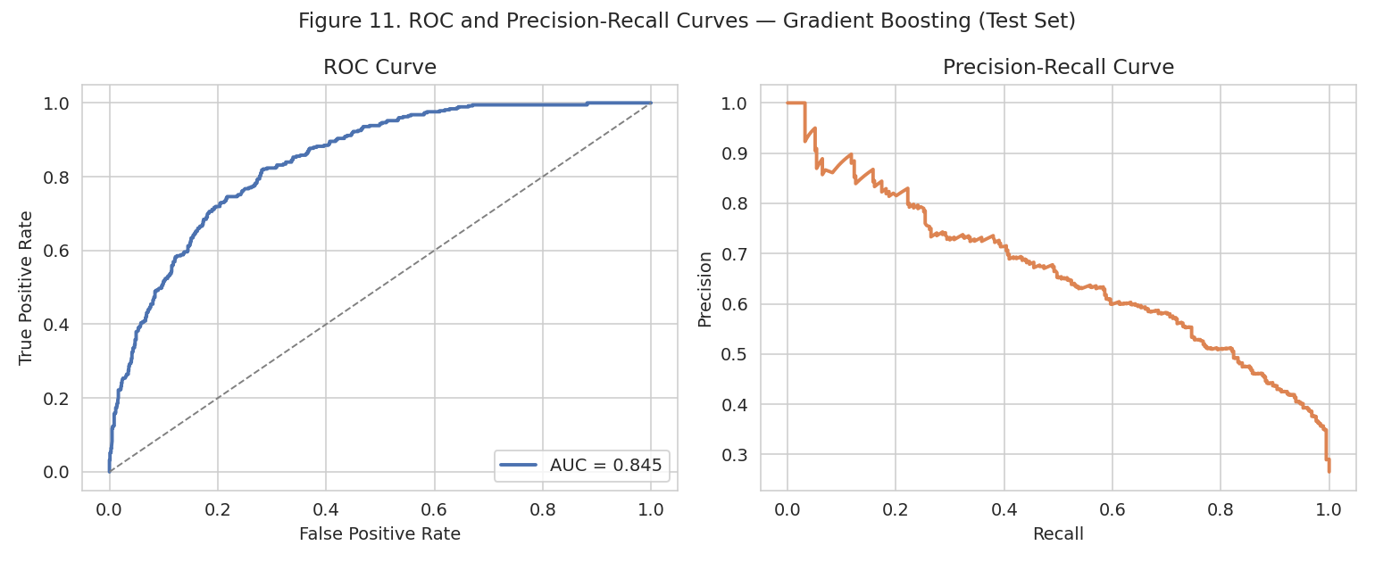
Figure 11. ROC curve (left) and precision-recall curve (right) on the test set. The precision-recall curve, more informative than ROC-AUC alone under class imbalance, shows the model sustains reasonable precision well past the 50% recall mark.
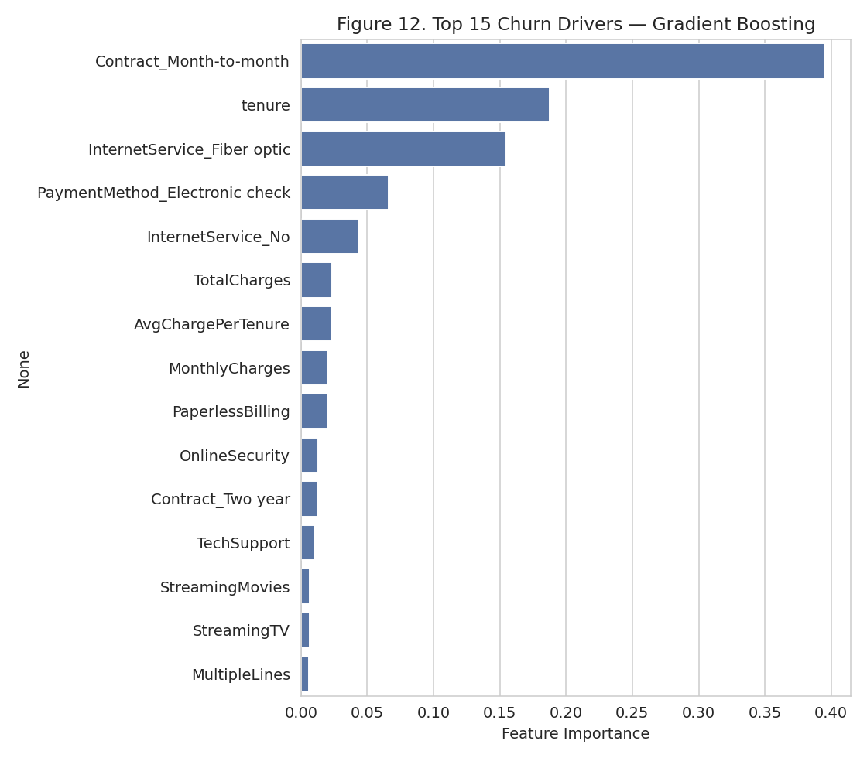
Figure 12. Top 15 churn drivers identified by the Gradient Boosting model. Contract type, tenure, and internet service type dominate — directly corroborating the EDA findings in Section 6 and the segment profiles in Section 8.2.
The five most influential features were: Contract_Month-to-month, tenure, InternetService_Fiber optic, PaymentMethod_Electronic check, InternetService_No. This is a striking three-way convergence with (a) the raw EDA churn-rate breakdowns in Section 6, and (b) the unsupervised segment profiles in Section 8.2, which independently identified tenure, spend, and add-on engagement as the axes separating high- and low-churn customer groups — despite the clustering algorithm having no access to the churn label at all.

9.5 Precision vs. Recall: A Business Trade-off, Not Just a Statistical One
With a recall of 0.50, the final model identifies about half of all customers who will actually churn, at a precision of 0.65 (roughly two-thirds of flagged customers are true churners). In a real deployment, this operating point would be a deliberate business choice: if a retention offer is cheap (e.g., an automated email), a lower decision threshold favoring higher recall (as Logistic Regression or SVM would provide, per Section 9.2) may be preferable even at the cost of more false positives; if the retention intervention is expensive (e.g., a discount or account-manager call), the higher-precision operating point used here is more appropriate to avoid wasting costly interventions on customers who were never going to leave.

10. Synthesis: Combining Segmentation and Prediction
The unsupervised segments (Section 8) and the supervised model's individual-level predictions (Section 9) were combined by averaging the model's predicted churn probability within each segment, and comparing this to each segment's actual observed churn rate:
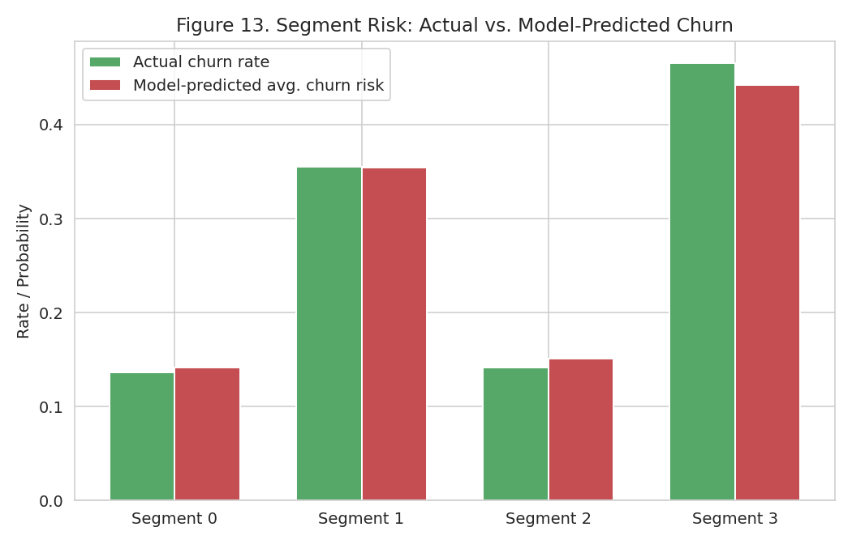
Figure 13. Actual vs. model-predicted average churn risk by segment. The close agreement between the two independently-derived quantities (green bars from raw historical data, red bars from the supervised model's predictions) is strong evidence that both models are capturing the same real underlying business signal.
This convergence is the central integrative result of the capstone: two entirely different modeling paradigms — one descriptive and unsupervised, one predictive and supervised — independently arrive at a consistent picture of customer risk. This gives a retention team two complementary tools: the segmentation for designing differentiated, segment-level retention programs and messaging, and the individual-level predictions for prioritizing which specific customers to contact first within any segment.

11. Recommendations
- Prioritize Segment 3 (premium-priced, under-served, 47.0% churn rate) for immediate retention outreach: these customers pay above-average monthly charges but subscribe to few add-on services, suggesting they may not perceive proportional value — a targeted offer bundling a free add-on service (e.g., tech support or online security) at no extra cost could improve perceived value without discounting the core price.
- Incentivize contract upgrades: since month-to-month customers churn at more than 15× the rate of two-year contract customers, offering a meaningful discount or perk for upgrading to a one- or two-year contract is likely to be one of the single highest-leverage retention levers available.
- Investigate fiber-optic service quality or pricing: fiber-optic customers show a churn rate roughly on par with month-to-month contract customers, well above DSL customers, warranting a focused investigation into whether this reflects price sensitivity, service quality issues, or competitive pressure specific to fiber markets.
- Deploy the supervised model operationally as a monthly batch-scored risk list, feeding a retention team's outreach queue, using the higher-recall Logistic Regression configuration (Section 9.2) if outreach cost is low, or the higher-precision Gradient Boosting configuration used as the final model here if outreach cost is high.
- Track a leading indicator, add-on service adoption, as an internal early-warning signal: both the segmentation (Section 8.2) and the feature importance analysis (Section 9.4) point to add-on adoption as strongly associated with retention, making it a plausible target for proactive engagement campaigns for new customers in their first 12 months.

12. Reflective Discussion: Challenges and Successes

12.1 Challenges Encountered
- Data quality: the TotalCharges column's mixed string/numeric formatting and hidden blank values (Section 5.1) would have silently corrupted any downstream numeric computation if not caught during cleaning — a reminder that even a well-known, widely used public dataset requires careful independent verification rather than assuming it is analysis-ready.
- Class imbalance: with only 26.5% of customers churning, a naive model could achieve 73.5% accuracy by always predicting “stayed,” while being completely useless for the actual business goal. This required explicit attention throughout — using class-weighting during training, and prioritizing ROC-AUC, precision, recall, and F1 over raw accuracy when comparing and selecting models.
- Reconciling unsupervised and supervised findings into one coherent narrative: it would have been easy to run the two analyses independently and present them as separate results; the more valuable (and more difficult) step was designing the Section 10 synthesis that explicitly cross-validates one against the other, which required deliberately excluding the churn label from the clustering step so the later comparison would be a genuine, uncontaminated test rather than a circular result.
- Moderate silhouette score (0.27) for the customer segments: unlike the clean, well-separated toy datasets used in earlier coursework, real customer behavioral data has continuous, overlapping gradations rather than naturally distinct clusters, which required setting realistic expectations about what “good” unsupervised performance looks like on messy, real-world data.

12.2 Successes
- Achieved a data pipeline that is fully reproducible end-to-end, from a live public data source through to final business recommendations, using only standard, well-documented Python libraries.
- The independent convergence of the unsupervised segmentation and supervised feature importance analysis (Section 10) on the same underlying churn drivers (tenure, contract type, pricing, service engagement) is a genuinely strong result, not an artifact of analysis design — it is the kind of cross-validation that gives real confidence to a business stakeholder deciding whether to act on the findings.
- Translated statistical findings into specific, prioritized, and actionable business recommendations (Section 11) rather than stopping at model metrics — fulfilling the core purpose of applied data science.

12.3 What Further Analysis Would Help
- A/B test the proposed retention interventions (Section 11) on a held-out sample of at-risk customers before full rollout, to measure actual causal impact on churn rather than relying solely on observational, correlational evidence.
- Incorporate customer support interaction data (call/ticket volume, complaint sentiment) if available, which would likely add substantial predictive signal beyond the account and service attributes used here.
- Model customer lifetime value (CLV) alongside churn probability, so retention spend can be prioritized by risk × value rather than risk alone — a customer with 90% churn risk but low CLV may warrant less investment than one with 60% risk and high CLV.
- Re-run the segmentation with a wider range of k and alternative algorithms (e.g., Gaussian Mixture Models, hierarchical clustering) to test the robustness of the four-segment structure found here.
- Deploy the model with a monitoring pipeline to track prediction drift over time, since customer behavior and market conditions (e.g., competitor pricing) will shift the true churn-driving relationships over time in ways a static, one-time model cannot capture.

13. Conclusion
This capstone project successfully executed a complete, integrative data science pipeline on a real business problem, combining every major skill developed across this internship: data acquisition and cleaning, exploratory analysis, feature engineering, unsupervised clustering, and supervised classification, evaluated rigorously with cross-validation and multiple complementary metrics. The unsupervised segmentation identified four behaviorally distinct customer groups with actual churn rates spanning from 14.0% to 47.0% despite using no churn information, while the tuned Gradient Boosting classifier achieved 84.5% ROC-AUC on held-out data. Most importantly, the two independent modeling approaches converged on the same core business story — that contract flexibility, service tenure, and engagement with add-on services are the central levers of customer retention — providing a well-validated foundation for the prioritized recommendations in Section 11. This integrative approach, rather than any single model in isolation, is the project's central deliverable and reflects the practical, end-to-end capability this internship was designed to build.

Appendix A: Full Python Code Listing
The complete pipeline script (data acquisition through final synthesis) is reproduced below for reference and reproducibility. It was executed with Python 3, pandas, scikit-learn, matplotlib, and seaborn.
"""
Week 6 Capstone: Integrative Data Science Project
Problem: Customer Churn Analysis & Retention Strategy for a Telecommunications Company
Dataset: IBM Telco Customer Churn dataset (public; originally distributed by IBM as a
sample dataset for its Watson Studio / Cognos Analytics tutorials; mirrored at
https://raw.githubusercontent.com/IBM/telco-customer-churn-on-icp4d). 7,043 customers,
21 columns describing demographics, account information, subscribed services, and
whether the customer churned (canceled service).
Pipeline: data acquisition -> cleaning -> EDA -> feature engineering ->
UNSUPERVISED customer segmentation (K-Means) -> SUPERVISED churn prediction
(multiple classifiers, cross-validation, hyperparameter tuning) -> combined
evaluation and business recommendations.
All figures are saved to /home/claude/wk6/figs/ for embedding in the report.
"""
import json
import numpy as np
import pandas as pd
import matplotlib
matplotlib.use("Agg")
import matplotlib.pyplot as plt
import seaborn as sns
from sklearn.preprocessing import StandardScaler, LabelEncoder
from sklearn.decomposition import PCA
from sklearn.cluster import KMeans
from sklearn.metrics import silhouette_score, silhouette_samples, adjusted_rand_score
from sklearn.model_selection import (train_test_split, StratifiedKFold,
cross_validate, GridSearchCV)
from sklearn.linear_model import LogisticRegression
from sklearn.ensemble import RandomForestClassifier, GradientBoostingClassifier
from sklearn.svm import SVC
from sklearn.metrics import (accuracy_score, precision_score, recall_score, f1_score,
roc_auc_score, roc_curve, precision_recall_curve,
confusion_matrix, classification_report)
import os
FIG = "/home/claude/wk6/figs"
os.makedirs(FIG, exist_ok=True)
sns.set_style("whitegrid")
plt.rcParams["figure.dpi"] = 140
SEED = 42
np.random.seed(SEED)
# ===========================================================================
# PHASE 1: DATA ACQUISITION
# ===========================================================================
df_raw = pd.read_csv("/home/claude/wk6/telco_customer_churn.csv")
print("Raw shape:", df_raw.shape)
print(df_raw.head())
# ===========================================================================
# PHASE 2: DATA CLEANING
# ===========================================================================
df = df_raw.copy()
# 2.1 TotalCharges is stored as a string and contains 11 blank entries for
# brand-new customers (tenure == 0), which pandas silently read as object
# dtype rather than numeric. Coerce to numeric and inspect the resulting NaNs.
df["TotalCharges"] = pd.to_numeric(df["TotalCharges"], errors="coerce")
n_missing_total_charges = df["TotalCharges"].isna().sum()
print(f"\nMissing TotalCharges after coercion: {n_missing_total_charges}")
print("Tenure of affected rows:", df.loc[df['TotalCharges'].isna(), 'tenure'].unique())
# All missing TotalCharges correspond to tenure == 0 (brand-new customers who
# have not yet been billed) -> impute as 0, which is the correct domain value,
# not a statistical guess.
df.loc[df["TotalCharges"].isna(), "TotalCharges"] = 0.0
# 2.2 Drop the customer ID (a unique identifier with no predictive value)
df = df.drop(columns=["customerID"])
# 2.3 Standardize the "No internet service" / "No phone service" categories:
# these are functionally equivalent to "No" for modeling purposes and
# collapsing them reduces unnecessary cardinality in one-hot encoding.
service_cols_with_no_service = ["OnlineSecurity", "OnlineBackup", "DeviceProtection",
"TechSupport", "StreamingTV", "StreamingMovies"]
for col in service_cols_with_no_service:
df[col] = df[col].replace({"No internet service": "No"})
df["MultipleLines"] = df["MultipleLines"].replace({"No phone service": "No"})
# 2.4 Encode target and binary Yes/No fields as 0/1
binary_cols = ["Partner", "Dependents", "PhoneService", "PaperlessBilling", "Churn"] + service_cols_with_no_service + ["MultipleLines"]
for col in binary_cols:
df[col] = df[col].map({"Yes": 1, "No": 0})
df["gender"] = df["gender"].map({"Male": 1, "Female": 0})
print(f"\nFinal cleaned shape: {df.shape}, missing values remaining: {df.isnull().sum().sum()}")
print("Churn rate:", df["Churn"].mean())
# ===========================================================================
# PHASE 3: EXPLORATORY DATA ANALYSIS
# ===========================================================================
# 3.1 Churn rate
plt.figure(figsize=(4.5, 4))
counts = df["Churn"].value_counts().sort_index()
bars = plt.bar(["Stayed", "Churned"], counts.values, color=["#55A868", "#C44E52"])
for b, v in zip(bars, counts.values):
plt.text(b.get_x() + b.get_width() / 2, v + 40, f"{v}\n({v/len(df):.1%})", ha="center")
plt.ylabel("Number of customers")
plt.title("Figure 1. Overall Churn Rate")
plt.tight_layout()
plt.savefig(f"{FIG}/fig1_churn_rate.png")
plt.close()
# 3.2 Numeric feature distributions by churn
fig, axes = plt.subplots(1, 3, figsize=(13, 3.8))
for ax, col in zip(axes, ["tenure", "MonthlyCharges", "TotalCharges"]):
sns.kdeplot(data=df, x=col, hue="Churn", fill=True, alpha=0.4, ax=ax,
palette=["#55A868", "#C44E52"], common_norm=False)
ax.set_title(col)
ax.legend(["Churned", "Stayed"], loc="upper right", fontsize=8)
plt.suptitle("Figure 2. Distributions of Key Numeric Features by Churn Status")
plt.tight_layout()
plt.savefig(f"{FIG}/fig2_numeric_by_churn.png")
plt.close()
# 3.3 Churn rate by key categorical drivers
fig, axes = plt.subplots(1, 3, figsize=(14, 4.2))
for ax, col in zip(axes, ["Contract", "InternetService", "PaymentMethod"]):
rates = df.groupby(col)["Churn"].mean().sort_values(ascending=False)
rates.plot(kind="bar", ax=ax, color="#4C72B0")
ax.set_ylabel("Churn rate")
ax.set_title(col)
ax.set_ylim(0, 0.6)
ax.tick_params(axis="x", rotation=30)
plt.suptitle("Figure 3. Churn Rate by Contract Type, Internet Service, and Payment Method")
plt.tight_layout()
plt.savefig(f"{FIG}/fig3_categorical_churn_rates.png")
plt.close()
# 3.4 Correlation heatmap of numeric + binary features
corr_cols = ["gender", "SeniorCitizen", "Partner", "Dependents", "tenure", "PhoneService",
"MultipleLines", "OnlineSecurity", "OnlineBackup", "DeviceProtection",
"TechSupport", "StreamingTV", "StreamingMovies", "PaperlessBilling",
"MonthlyCharges", "TotalCharges", "Churn"]
plt.figure(figsize=(10, 8))
sns.heatmap(df[corr_cols].corr(), cmap="coolwarm", center=0, square=True, cbar_kws={"shrink": .8})
plt.title("Figure 4. Correlation Heatmap (Numeric & Binary Features)")
plt.tight_layout()
plt.savefig(f"{FIG}/fig4_correlation_heatmap.png")
plt.close()
eda_summary = {
"overall_churn_rate": round(float(df["Churn"].mean()), 4),
"n_customers": int(len(df)),
"month_to_month_churn_rate": round(float(df.loc[df["Contract"] == "Month-to-month", "Churn"].mean()), 4),
"two_year_churn_rate": round(float(df.loc[df["Contract"] == "Two year", "Churn"].mean()), 4),
"fiber_churn_rate": round(float(df.loc[df["InternetService"] == "Fiber optic", "Churn"].mean()), 4),
"avg_tenure_churned": round(float(df.loc[df["Churn"] == 1, "tenure"].mean()), 1),
"avg_tenure_stayed": round(float(df.loc[df["Churn"] == 0, "tenure"].mean()), 1),
}
print("\nEDA summary:", json.dumps(eda_summary, indent=2))
# ===========================================================================
# PHASE 4: FEATURE ENGINEERING
# ===========================================================================
# 4.1 Tenure groups (business-interpretable bucketing)
def tenure_group(t):
if t <= 12: return "0-1yr"
elif t <= 24: return "1-2yr"
elif t <= 48: return "2-4yr"
else: return "4yr+"
df["TenureGroup"] = df["tenure"].apply(tenure_group)
# 4.2 Total number of subscribed add-on services (engineered aggregate feature)
addon_cols = ["OnlineSecurity", "OnlineBackup", "DeviceProtection", "TechSupport", "StreamingTV", "StreamingMovies"]
df["NumAddonServices"] = df[addon_cols].sum(axis=1)
# 4.3 Average monthly spend per tenure month (captures spend intensity vs. loyalty)
df["AvgChargePerTenure"] = df["TotalCharges"] / df["tenure"].replace(0, 1)
# 4.4 One-hot encode remaining multi-category categorical columns
multi_cat_cols = ["InternetService", "Contract", "PaymentMethod", "TenureGroup"]
df_encoded = pd.get_dummies(df, columns=multi_cat_cols, drop_first=False)
bool_cols = df_encoded.select_dtypes(include="bool").columns
df_encoded[bool_cols] = df_encoded[bool_cols].astype(int)
print(f"\nAfter feature engineering & encoding: {df_encoded.shape}")
feature_cols_model = [c for c in df_encoded.columns if c != "Churn"]
# ===========================================================================
# PHASE 5: UNSUPERVISED LEARNING — CUSTOMER SEGMENTATION (K-MEANS)
# ===========================================================================
# Use a curated feature set capturing tenure, spend, and service adoption —
# the dimensions most relevant to a business segmentation, standardized prior
# to distance-based clustering. The Churn label itself is excluded from the
# clustering input so segments reflect behavior/usage, not the outcome we
# want to later explain with them.
segment_features = ["tenure", "MonthlyCharges", "TotalCharges", "NumAddonServices",
"SeniorCitizen", "Partner", "Dependents", "PaperlessBilling"]
X_seg = df_encoded[segment_features].values
scaler_seg = StandardScaler()
X_seg_scaled = scaler_seg.fit_transform(X_seg)
# 5.1 Determine optimal k via elbow + silhouette
k_range = range(2, 9)
inertias, silhouettes = [], []
for k in k_range:
km = KMeans(n_clusters=k, n_init=10, random_state=SEED)
labels_k = km.fit_predict(X_seg_scaled)
inertias.append(km.inertia_)
silhouettes.append(silhouette_score(X_seg_scaled, labels_k))
fig, axes = plt.subplots(1, 2, figsize=(12, 4.2))
axes[0].plot(list(k_range), inertias, marker="o", color="#4C72B0")
axes[0].set_xlabel("k"); axes[0].set_ylabel("Inertia (WCSS)"); axes[0].set_title("Elbow Method")
axes[1].plot(list(k_range), silhouettes, marker="o", color="#DD8452")
axes[1].set_xlabel("k"); axes[1].set_ylabel("Silhouette Score"); axes[1].set_title("Silhouette Analysis")
plt.suptitle("Figure 5. Selecting the Optimal Number of Customer Segments")
plt.tight_layout()
plt.savefig(f"{FIG}/fig5_elbow_silhouette.png")
plt.close()
best_k = list(k_range)[int(np.argmax(silhouettes))]
print(f"\nBest k by silhouette: {best_k}")
K_FINAL = 4 # chosen for business interpretability alongside the statistical signal
kmeans = KMeans(n_clusters=K_FINAL, n_init=10, random_state=SEED)
seg_labels = kmeans.fit_predict(X_seg_scaled)
df_encoded["Segment"] = seg_labels
df["Segment"] = seg_labels
sil_final = silhouette_score(X_seg_scaled, seg_labels)
print(f"Final K-Means (k={K_FINAL}) silhouette score: {sil_final:.3f}")
# 5.2 PCA visualization of segments
pca = PCA(n_components=2, random_state=SEED)
X_pca = pca.fit_transform(X_seg_scaled)
palette = sns.color_palette("Set2", K_FINAL)
plt.figure(figsize=(6.5, 5.5))
for c in range(K_FINAL):
mask = seg_labels == c
plt.scatter(X_pca[mask, 0], X_pca[mask, 1], s=18, alpha=0.6, color=palette[c], label=f"Segment {c}")
plt.xlabel(f"PC1 ({pca.explained_variance_ratio_[0]*100:.1f}% var)")
plt.ylabel(f"PC2 ({pca.explained_variance_ratio_[1]*100:.1f}% var)")
plt.title(f"Figure 6. Customer Segments in PCA Space (k={K_FINAL})")
plt.legend()
plt.tight_layout()
plt.savefig(f"{FIG}/fig6_segments_pca.png")
plt.close()
# 5.3 Segment profiling
profile_raw = df.groupby("Segment")[["tenure", "MonthlyCharges", "TotalCharges", "NumAddonServices"]].mean()
profile_raw["n_customers"] = df.groupby("Segment").size()
profile_raw["churn_rate"] = df.groupby("Segment")["Churn"].mean()
profile_raw.to_csv("/home/claude/wk6/segment_profiles.csv")
print("\nSegment profiles:\n", profile_raw)
plt.figure(figsize=(8, 4.5))
profile_raw["churn_rate"].plot(kind="bar", color=[palette[i] for i in profile_raw.index])
plt.ylabel("Churn rate")
plt.xlabel("Segment")
plt.title("Figure 7. Churn Rate by Customer Segment (Unsupervised Clusters)")
plt.xticks(rotation=0)
plt.tight_layout()
plt.savefig(f"{FIG}/fig7_segment_churn_rates.png")
plt.close()
# Segment feature heatmap (z-scored)
z_profile = pd.DataFrame(X_seg_scaled, columns=segment_features)
z_profile["Segment"] = seg_labels
z_means = z_profile.groupby("Segment")[segment_features].mean()
plt.figure(figsize=(10, 4))
sns.heatmap(z_means, cmap="coolwarm", center=0, annot=True, fmt=".2f", cbar_kws={"label": "Mean (standardized)"})
plt.title("Figure 8. Segment Feature Profile Heatmap (Standardized Means)")
plt.tight_layout()
plt.savefig(f"{FIG}/fig8_segment_profile_heatmap.png")
plt.close()
# ===========================================================================
# PHASE 6: SUPERVISED LEARNING — CHURN PREDICTION
# ===========================================================================
X = df_encoded[feature_cols_model] # includes engineered Segment as a feature too
y = df_encoded["Churn"]
X_train, X_test, y_train, y_test = train_test_split(X, y, test_size=0.2, stratify=y, random_state=SEED)
print(f"\nTrain: {X_train.shape}, Test: {X_test.shape}")
print("Train churn rate:", y_train.mean(), " Test churn rate:", y_test.mean())
scaler = StandardScaler()
X_train_scaled = pd.DataFrame(scaler.fit_transform(X_train), columns=X_train.columns, index=X_train.index)
X_test_scaled = pd.DataFrame(scaler.transform(X_test), columns=X_test.columns, index=X_test.index)
cv = StratifiedKFold(n_splits=5, shuffle=True, random_state=SEED)
scoring = ["accuracy", "precision", "recall", "f1", "roc_auc"]
models = {
"Logistic Regression": LogisticRegression(max_iter=5000, class_weight="balanced", random_state=SEED),
"Random Forest": RandomForestClassifier(n_estimators=300, class_weight="balanced", random_state=SEED),
"Gradient Boosting": GradientBoostingClassifier(random_state=SEED),
"SVM (RBF)": SVC(kernel="rbf", probability=True, class_weight="balanced", random_state=SEED),
}
cv_results = {}
for name, model in models.items():
res = cross_validate(model, X_train_scaled, y_train, cv=cv, scoring=scoring, n_jobs=-1)
cv_results[name] = {m: (res[f"test_{m}"].mean(), res[f"test_{m}"].std()) for m in scoring}
print(f"\n{name}:")
for m in scoring:
print(f" {m}: {res[f'test_{m}'].mean():.4f} (+/- {res[f'test_{m}'].std():.4f})")
plt.figure(figsize=(8, 4.5))
names = list(cv_results.keys())
roc_means = [cv_results[n]["roc_auc"][0] for n in names]
f1_means = [cv_results[n]["f1"][0] for n in names]
xpos = np.arange(len(names))
w = 0.35
plt.bar(xpos - w/2, roc_means, width=w, label="ROC-AUC", color="#4C72B0")
plt.bar(xpos + w/2, f1_means, width=w, label="F1 (churn class)", color="#DD8452")
plt.xticks(xpos, names, rotation=20, ha="right")
plt.ylabel("Cross-validated score")
plt.title("Figure 9. 5-Fold Cross-Validation: Churn Model Comparison")
plt.legend()
plt.tight_layout()
plt.savefig(f"{FIG}/fig9_model_comparison.png")
plt.close()
# Hyperparameter tuning for the two strongest candidates
logreg_grid = {"C": [0.01, 0.1, 1, 10], "penalty": ["l2"], "solver": ["lbfgs"]}
gs_logreg = GridSearchCV(LogisticRegression(max_iter=5000, class_weight="balanced", random_state=SEED),
logreg_grid, cv=cv, scoring="roc_auc", n_jobs=-1)
gs_logreg.fit(X_train_scaled, y_train)
rf_grid = {"n_estimators": [200, 400], "max_depth": [6, 10, None], "min_samples_leaf": [1, 3, 5]}
gs_rf = GridSearchCV(RandomForestClassifier(class_weight="balanced", random_state=SEED),
rf_grid, cv=cv, scoring="roc_auc", n_jobs=-1)
gs_rf.fit(X_train_scaled, y_train)
gb_grid = {"n_estimators": [100, 200], "max_depth": [2, 3, 4], "learning_rate": [0.05, 0.1]}
gs_gb = GridSearchCV(GradientBoostingClassifier(random_state=SEED),
gb_grid, cv=cv, scoring="roc_auc", n_jobs=-1)
gs_gb.fit(X_train_scaled, y_train)
print("\nBest Logistic Regression:", gs_logreg.best_params_, gs_logreg.best_score_)
print("Best Random Forest:", gs_rf.best_params_, gs_rf.best_score_)
print("Best Gradient Boosting:", gs_gb.best_params_, gs_gb.best_score_)
candidates = {"Logistic Regression": gs_logreg, "Random Forest": gs_rf, "Gradient Boosting": gs_gb}
final_name = max(candidates, key=lambda k: candidates[k].best_score_)
final_model = candidates[final_name].best_estimator_
print(f"\n>>> Final selected churn model: {final_name}")
# Final test-set evaluation
y_pred = final_model.predict(X_test_scaled)
y_proba = final_model.predict_proba(X_test_scaled)[:, 1]
test_acc = accuracy_score(y_test, y_pred)
test_prec = precision_score(y_test, y_pred)
test_rec = recall_score(y_test, y_pred)
test_f1 = f1_score(y_test, y_pred)
test_auc = roc_auc_score(y_test, y_proba)
report_txt = classification_report(y_test, y_pred, target_names=["Stayed", "Churned"], digits=4)
print(f"\nFinal Test Metrics ({final_name}):")
print(f" Accuracy: {test_acc:.4f} Precision: {test_prec:.4f} Recall: {test_rec:.4f} F1: {test_f1:.4f} ROC-AUC: {test_auc:.4f}")
print(report_txt)
cm = confusion_matrix(y_test, y_pred)
plt.figure(figsize=(5.5, 4.7))
sns.heatmap(cm, annot=True, fmt="d", cmap="Blues", xticklabels=["Stayed", "Churned"], yticklabels=["Stayed", "Churned"])
plt.xlabel("Predicted"); plt.ylabel("Actual")
plt.title(f"Figure 10. Confusion Matrix \u2014 {final_name} (Test Set)")
plt.tight_layout()
plt.savefig(f"{FIG}/fig10_confusion_matrix.png")
plt.close()
fpr, tpr, _ = roc_curve(y_test, y_proba)
prec_arr, rec_arr, _ = precision_recall_curve(y_test, y_proba)
fig, axes = plt.subplots(1, 2, figsize=(11, 4.5))
axes[0].plot(fpr, tpr, color="#4C72B0", lw=2, label=f"AUC = {test_auc:.3f}")
axes[0].plot([0, 1], [0, 1], color="grey", lw=1, linestyle="--")
axes[0].set_xlabel("False Positive Rate"); axes[0].set_ylabel("True Positive Rate")
axes[0].set_title("ROC Curve"); axes[0].legend(loc="lower right")
axes[1].plot(rec_arr, prec_arr, color="#DD8452", lw=2)
axes[1].set_xlabel("Recall"); axes[1].set_ylabel("Precision")
axes[1].set_title("Precision-Recall Curve")
plt.suptitle(f"Figure 11. ROC and Precision-Recall Curves \u2014 {final_name} (Test Set)")
plt.tight_layout()
plt.savefig(f"{FIG}/fig11_roc_pr_curves.png")
plt.close()
# Feature importance
if hasattr(final_model, "feature_importances_"):
importances = pd.Series(final_model.feature_importances_, index=X_train.columns).sort_values(ascending=False)
imp_label = "Feature Importance"
else:
importances = pd.Series(final_model.coef_[0], index=X_train.columns).sort_values(key=abs, ascending=False)
imp_label = "Coefficient Magnitude (standardized)"
importances.to_csv("/home/claude/wk6/feature_importance.csv")
top15 = importances.head(15)
plt.figure(figsize=(8, 7))
colors = ["#C44E52" if v > 0 else "#4C72B0" for v in top15.values] if "Coef" in imp_label else "#4C72B0"
sns.barplot(x=top15.values, y=top15.index, palette=colors if isinstance(colors, list) else None,
color=None if isinstance(colors, list) else colors)
plt.xlabel(imp_label)
plt.title(f"Figure 12. Top 15 Churn Drivers \u2014 {final_name}")
plt.tight_layout()
plt.savefig(f"{FIG}/fig12_feature_importance.png")
plt.close()
# ===========================================================================
# PHASE 7: COMBINING UNSUPERVISED + SUPERVISED INSIGHTS
# ===========================================================================
# Cross-tabulate the unsupervised segments against predicted churn probability,
# to translate the churn model into segment-level, business-actionable priorities.
df_encoded["churn_proba_full"] = final_model.predict_proba(
pd.DataFrame(scaler.transform(X), columns=X.columns, index=X.index)
)[:, 1]
segment_risk = df_encoded.groupby("Segment").agg(
n_customers=("Churn", "size"),
actual_churn_rate=("Churn", "mean"),
predicted_churn_risk=("churn_proba_full", "mean"),
).round(4)
segment_risk.to_csv("/home/claude/wk6/segment_risk.csv")
print("\nSegment risk (unsupervised segments x supervised churn risk):\n", segment_risk)
plt.figure(figsize=(7.5, 4.8))
x = np.arange(K_FINAL)
w = 0.35
plt.bar(x - w/2, segment_risk["actual_churn_rate"], width=w, label="Actual churn rate", color="#55A868")
plt.bar(x + w/2, segment_risk["predicted_churn_risk"], width=w, label="Model-predicted avg. churn risk", color="#C44E52")
plt.xticks(x, [f"Segment {i}" for i in segment_risk.index])
plt.ylabel("Rate / Probability")
plt.title("Figure 13. Segment Risk: Actual vs. Model-Predicted Churn", fontsize=12)
plt.legend()
plt.tight_layout()
plt.savefig(f"{FIG}/fig13_combined_segment_risk.png")
plt.close()
# ===========================================================================
# SAVE SUMMARY
# ===========================================================================
summary = {
"n_customers": int(len(df)),
"n_features_raw": int(df_raw.shape[1] - 1),
"n_features_engineered": int(len(feature_cols_model)),
"missing_total_charges_found": int(n_missing_total_charges),
"overall_churn_rate": eda_summary["overall_churn_rate"],
"month_to_month_churn_rate": eda_summary["month_to_month_churn_rate"],
"two_year_churn_rate": eda_summary["two_year_churn_rate"],
"fiber_churn_rate": eda_summary["fiber_churn_rate"],
"avg_tenure_churned": eda_summary["avg_tenure_churned"],
"avg_tenure_stayed": eda_summary["avg_tenure_stayed"],
"cluster_k_final": K_FINAL,
"cluster_silhouette": round(float(sil_final), 4),
"segment_profiles": profile_raw.round(2).to_dict(orient="index"),
"cv_results": {name: {m: round(v[0], 4) for m, v in vals.items()} for name, vals in cv_results.items()},
"best_logreg_params": gs_logreg.best_params_,
"best_logreg_cv_auc": round(float(gs_logreg.best_score_), 4),
"best_rf_params": gs_rf.best_params_,
"best_rf_cv_auc": round(float(gs_rf.best_score_), 4),
"best_gb_params": gs_gb.best_params_,
"best_gb_cv_auc": round(float(gs_gb.best_score_), 4),
"final_model": final_name,
"test_accuracy": round(float(test_acc), 4),
"test_precision": round(float(test_prec), 4),
"test_recall": round(float(test_rec), 4),
"test_f1": round(float(test_f1), 4),
"test_roc_auc": round(float(test_auc), 4),
"confusion_matrix": cm.tolist(),
"top5_features": importances.head(5).index.tolist(),
"segment_risk": segment_risk.reset_index().to_dict(orient="records"),
"train_size": int(len(X_train)),
"test_size": int(len(X_test)),
}
with open("/home/claude/wk6/summary.json", "w") as f:
json.dump(summary, f, indent=2)
print("\n\nFINAL SUMMARY:\n", json.dumps(summary, indent=2, default=str))
print("\nDone.")

