Partical No:-1
1)WAP in c++ to create a class called as student data member are rollno,name&fees of the student write apporiate get()&put()function to scan and display the student data
Program:-
#include <iostream>
using namespace std;

class Student {
private:
int rollno;
string name;
float fees;

public:
void get() {
cout << "Enter Roll Number: ";
cin >> rollno;

cin.ignore();
cout << "Enter Name: ";
getline(cin, name);

cout << "Enter Fees: ";
cin >> fees;
}
void put() {
cout << "\n--- Student Details ---\n";
cout << "Roll Number : " << rollno << endl;
cout << "Name : " << name << endl;
cout << "Fees : " << fees << endl;
}
};

int main() {
Student s;
s.get();
s.put();
return 0;
}
Output:

Program No:-2
2)WAP in C++ to create a class called as employee. Data members are eid, sal& name of the employee. Scan the data for 10 such employees & display the same by using array of objects
Program:-
#include <iostream>
using namespace std;

class Employee {
private:
int eid;
float sal;
string name;

public:
void input() {
cout << "Enter Employee ID: ";
cin >> eid;
cout << "Enter Employee Name: ";
cin >> name;
cout << "Enter Salary: ";
cin >> sal;
cout << endl;
}
void display() {
cout << "Employee ID: " << eid << endl;
cout << "Name: " << name << endl;
cout << "Salary: " << sal << endl;
cout << "------------------------" << endl;
}
};

int main() {
Employee emp[10];

cout << "Enter details for 10 employees:\n\n";
for (int i = 0; i < 10; i++) {
cout << "Employee " << i + 1 << endl;
emp[i].input();
}

cout << "\nDisplaying Employee Details:\n\n";
for (int i = 0; i < 10; i++) {
cout << "Employee " << i + 1 << " Details:\n";
emp[i].display();
}
return 0;
}
Output:-

Program No:-3
3)WAP in c++ to create a class called as book data member are name of the book &price write default ,parameterized&copy constructor to initialize &display book object values
Program:-
#include <iostream>
#include <string>
using namespace std;
class Book {
string name;
float price;

public:
Book() {
name = "Unknown";
price = 0.0;
}
Book(string n, float p) {
name = n;
price = p;
}
Book(const Book &b) {
name = b.name;
price = b.price;
}
void display() {
cout << "Book Name: " << name << endl;
cout << "Price: " << price << endl;
}
};
int main() {
Book b1;
Book b2("C++ Basics", 250.50);
Book b3(b2);

cout << "Default Constructor Object:\n";
b1.display();

cout << "\nParameterized Constructor Object:\n";
b2.display();

cout << "\nCopy Constructor Object:\n";
b3.display();

return 0;
}

Output: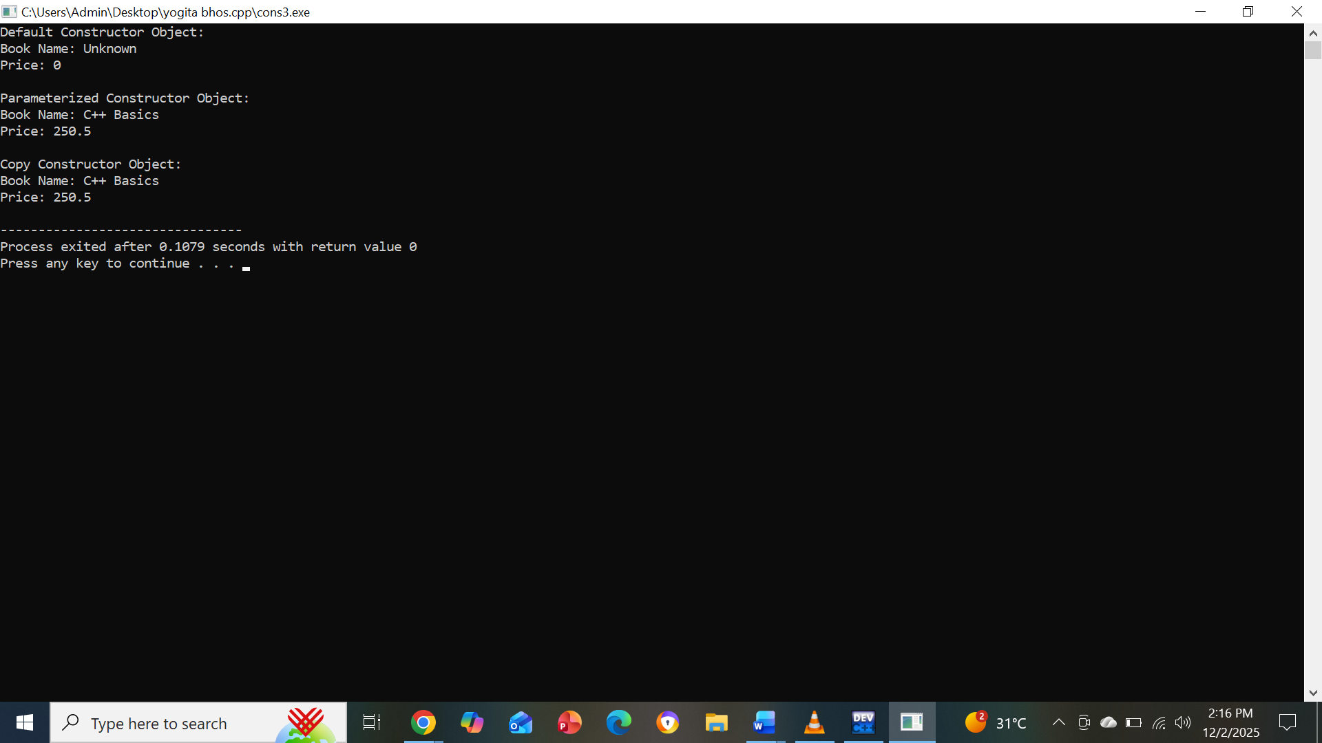

Program No:-4
WAP in c++ to create a class called as distance member are ft&in assgin appropriate values to object D1&D2 and add their values by overloading binary'+'operator to store the result inD3
Program:-
#include <iostream>
using namespace std;

class Distance {
int ft, in;

public:
Distance(int f = 0, int i = 0) {
ft = f;
in = i;
}
Distance operator + (Distance d) {
Distance temp;
temp.ft = ft + d.ft;
temp.in = in + d.in;

if (temp.in >= 12) {
temp.ft += temp.in / 12;
temp.in = temp.in % 12;
}
return temp;
}
void display() {
cout << ft << " ft " << in << " in" << endl;
}
};

int main() {
Distance D1(5, 8);
Distance D2(3, 10);

Distance D3 = D1 + D2;

cout << "D1 = "; D1.display();
cout << "D2 = "; D2.display();
cout << "D3 = "; D3.display();

return 0;
}

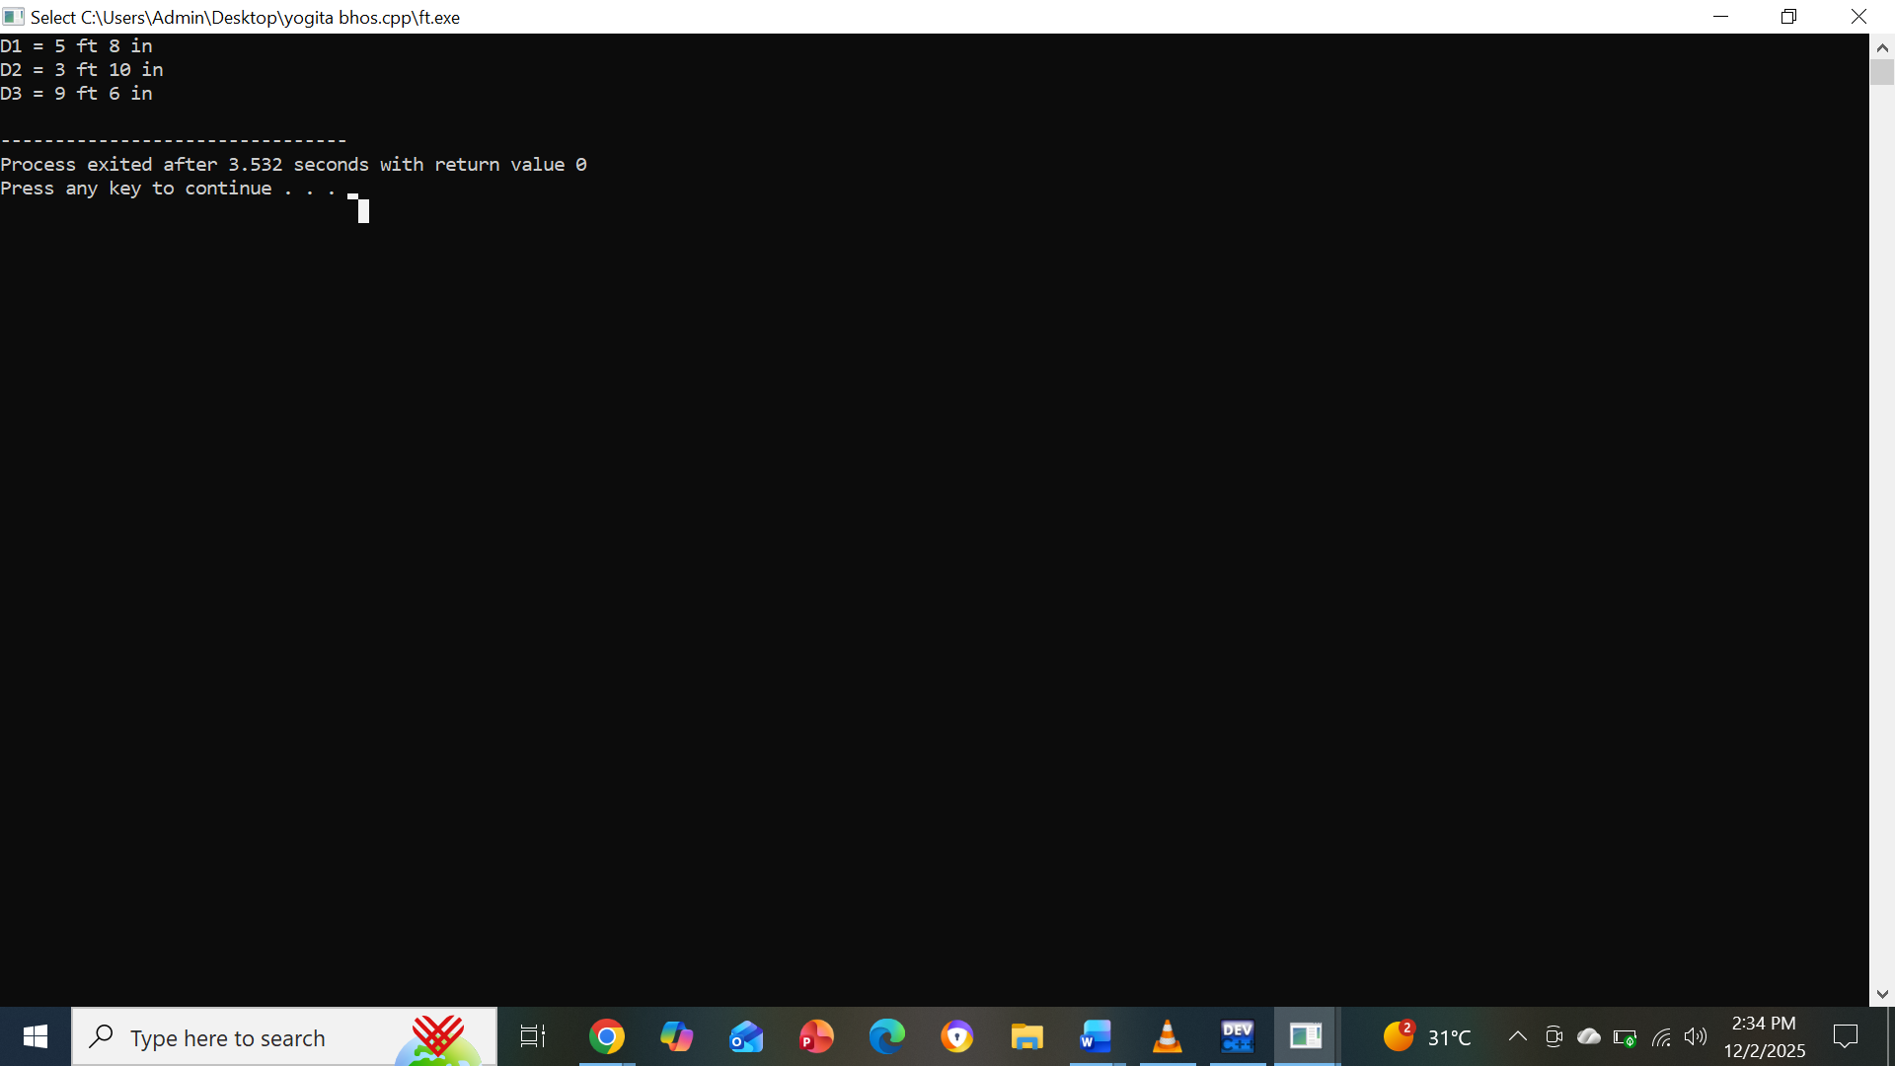

Partical No:-5
5)WAP in C to create a class called as student, having member as roll_no& name of the student. Create another class Exam having members as markl & mark2. Finally create a class called result which is derived from student & Exam. Write a show function in it to show student info & percentage of marks scored using Multiple Inheritance.
#include <iostream>
using namespace std;

class Student {
protected:
int roll_no;
string name;

public:
void getStudentData() {
cout << "Enter Roll Number: ";
cin >> roll_no;
cout << "Enter Name: ";
cin >> name;
}
};
class Exam {
protected:
float mark1, mark2;

public:
void getExamData() {
cout << "Enter Mark 1: ";
cin >> mark1;
cout << "Enter Mark 2: ";
cin >> mark2;
}
};
class Result : public Student, public Exam {
public:
void show() {
float percentage = (mark1 + mark2) / 2;

cout << "\n---- Student Result ----\n";
cout << "Roll Number : " << roll_no << endl;
cout << "Name : " << name << endl;
cout << "Mark 1 : " << mark1 << endl;
cout << "Mark 2 : " << mark2 << endl;
cout << "Percentage : " << percentage << "%" << endl;
}
};

int main() {
Result r;

r.getStudentData();
r.getExamData();
r.show();

return 0;
}
output:-
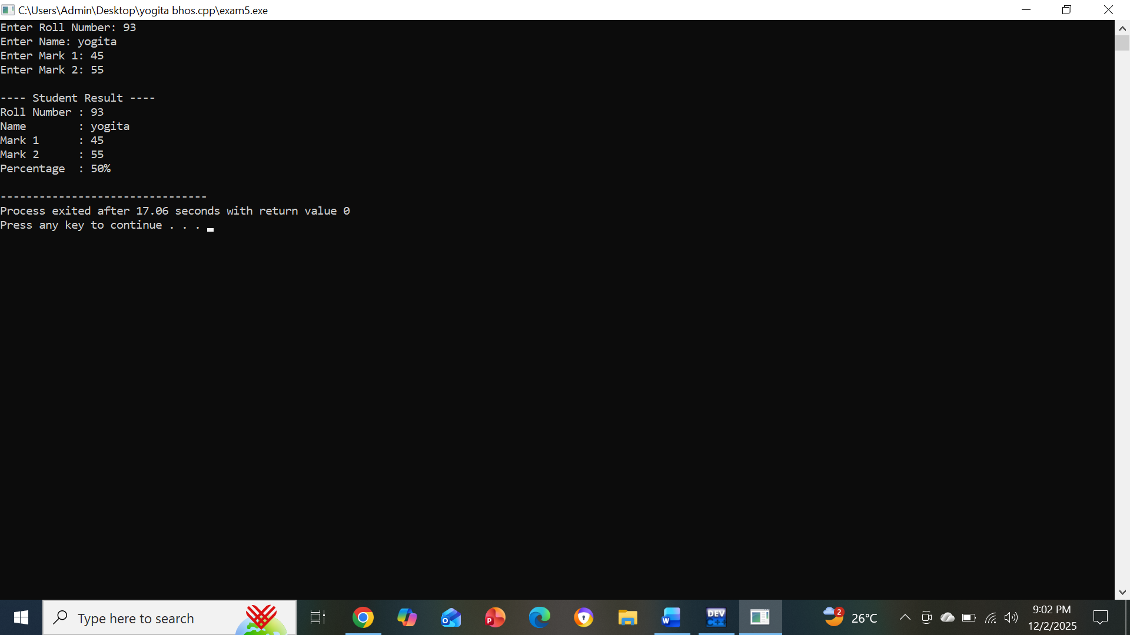

Partical N0:-6
6)WAP in c++ to demonstrate Derived class constructor
#include <iostream>
using namespace std;

class Base {
public:
Base() {
cout << "Base class constructor called." << endl;
}
};
class Derived : public Base {
public:
Derived() {
cout << "Derived class constructor called." << endl;
}
};

int main() {
Derived obj;
return 0;
}

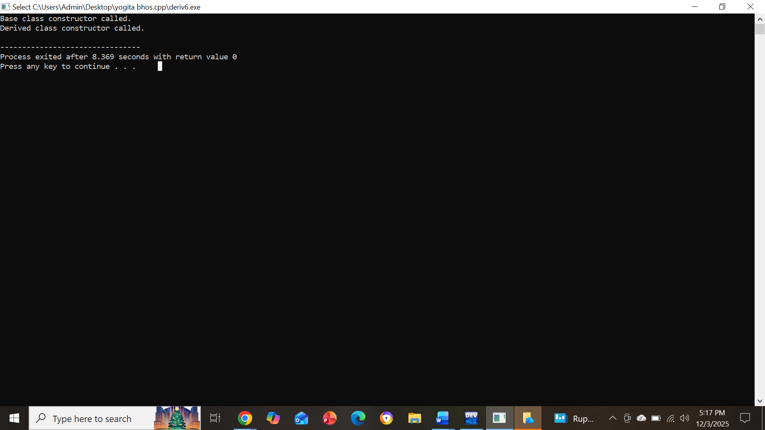

Partical N0:-7
7)WAP in c++ to implement friend function acting as bridge between the two classes
#include <iostream>
using namespace std;

class ClassB;

class ClassA {
private:
int numA;

public:
ClassA(int x) : numA(x) {}

friend void bridgeFunction(ClassA, ClassB);
};

class ClassB {
private:
int numB;

public:
ClassB(int y) : numB(y) {}

friend void bridgeFunction(ClassA, ClassB);
};

void bridgeFunction(ClassA objA, ClassB objB) {
cout << "Accessing private data of ClassA: " << objA.numA << endl;
cout << "Accessing private data of ClassB: " << objB.numB << endl;

cout << "Sum of both values = " << objA.numA + objB.numB << endl;
}

int main() {
ClassA a(10);
ClassB b(20);

bridgeFunction(a, b);

return 0;
}

Output:-
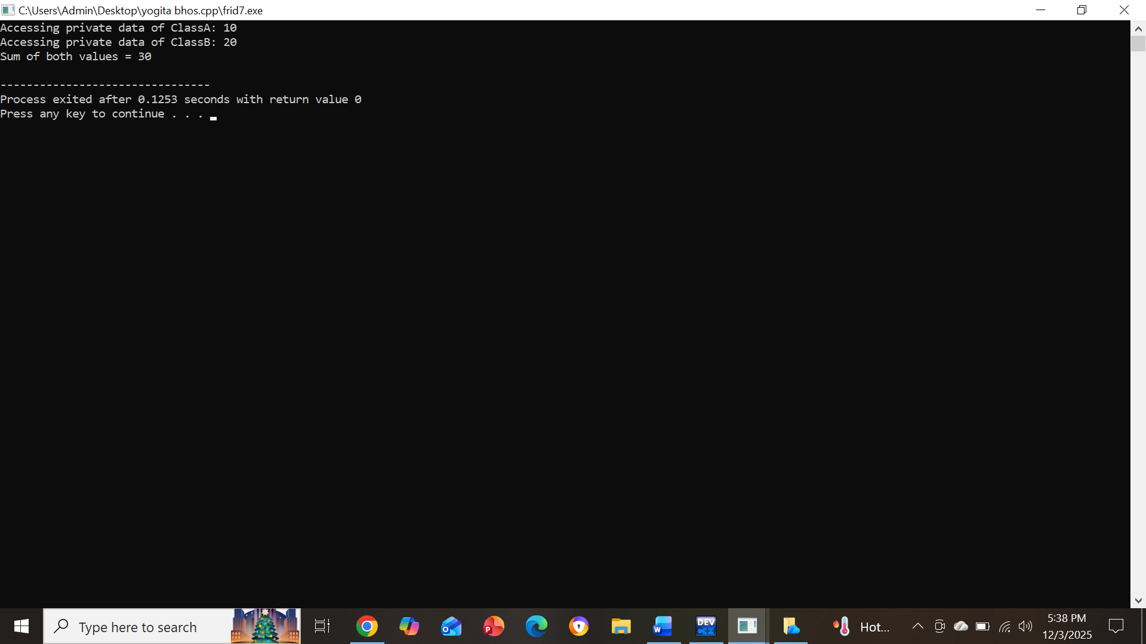

Partical No:-8
8)WAP in c++ implement virtual function for function overriding
#include <iostream>
using namespace std;

class Base {
public:
virtual void show() {
cout << "Base class show()" << endl;
}
};

class Derived : public Base {
public:
void show() override {
cout << "Derived class show()" << endl;
}
};

int main() {
Base *ptr;
Derived obj;

ptr = &obj;
ptr->show();

return 0;
}

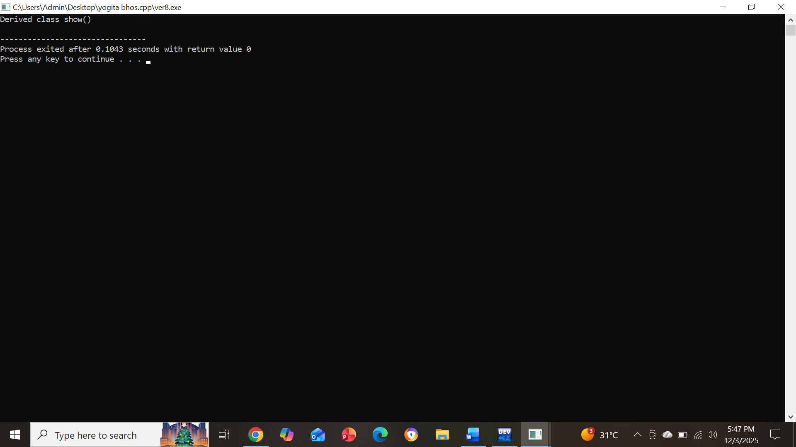

Partical N0:-9
9)WAP in c++ to overload virtual (>>)&extraction(<<)operators for objects
#include <iostream>
using namespace std;

class Student {
private:
string name;
int age;

public:
friend istream& operator>>(istream &in, Student &s);
friend ostream& operator<<(ostream &out, const Student &s);
};
istream& operator>>(istream &in, Student &s) {
cout << "Enter name: ";
in >> s.name;
cout << "Enter age: ";
in >> s.age;
return in;
}
ostream& operator<<(ostream &out, const Student &s) {
out << "Name: " << s.name << "\nAge: " << s.age;
return out;
}

int main() {
Student s;
cin >> s;
cout << "\nStudent Details:\n";
cout << s << endl;

return 0;
}

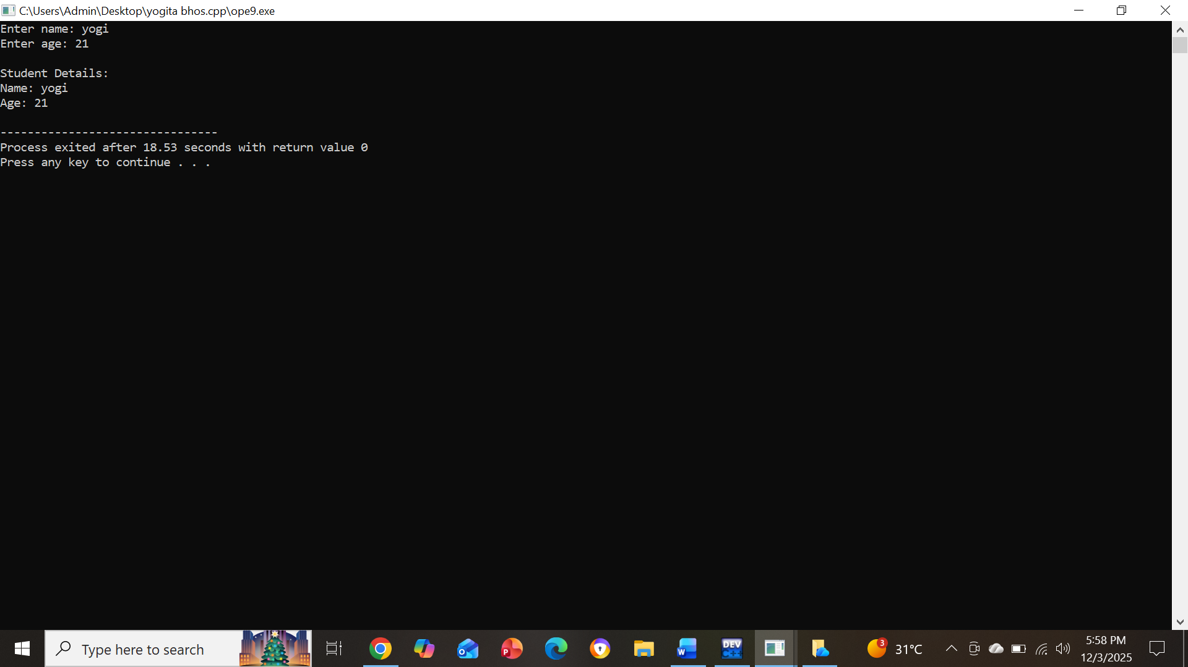

Partical N0:-10
10)WAP to implement function Template
#include <iostream>
using namespace std;

template <class T>
T add(T a, T b) {
return a + b;
}

int main() {
cout << "Integer addition: " << add(10, 20) << endl;
cout << "Float addition: " << add(10.5f, 20.3f) << endl;
cout << "Double addition: " << add(5.55, 4.45) << endl;

return 0;
}

