**Project Report**

**Student Name:** Pratham Bansal **UID:**  23MCI10131

**Branch:**  MCA(AI/ML) **Section/Group:**  23MAM-1(B)

**Semester:**  3 **Date of Performance:** 01/09/2024

**Subject Name:**  Data Analytics **Subject Code:**  23CAH-725

**1. OBJECTIVE:** A Superstore wants to create an annual sales report for 2022. So that, owner can understand their customers and grow more sales in 2023.

**2. Dataset:** Superstore Data Analysis.xlsx (Source = GitHub)

**Columns:**

1. Index **11.** Size
2. Order ID **12.** Qty
3. Cust ID **13.** Currency
4. Gender **14.** Amount
5. Age **15.** ship-city
6. Date **16.** ship-state
7. Status **17.** ship-postal-code
8. Channel **18.** ship-country
9. SKU **19.** B2B
10. Category
11. **Sample Questions:**

* Which month got the highest sales and orders?
* Who purchased more – men or women in 2022?
* What were different order status in 2022?
* List top 7 states contributing to sales.
* Relation between age and gender based on number of sales
* Which channel is contributing to sales maximum
* Highest selling category?,etc.

1. **Steps Followed:**
2. **Data Cleaning**: Select the dataset using Ctrl+A and then format it as a Table using Ctrl+T. After that use filter button for each column and :-

* Look for Null values
* Look for Duplicates
* Structured Errors(Here, Replaced M and W to Men and Women respectively

using Find and Replace(Ctrl+F).

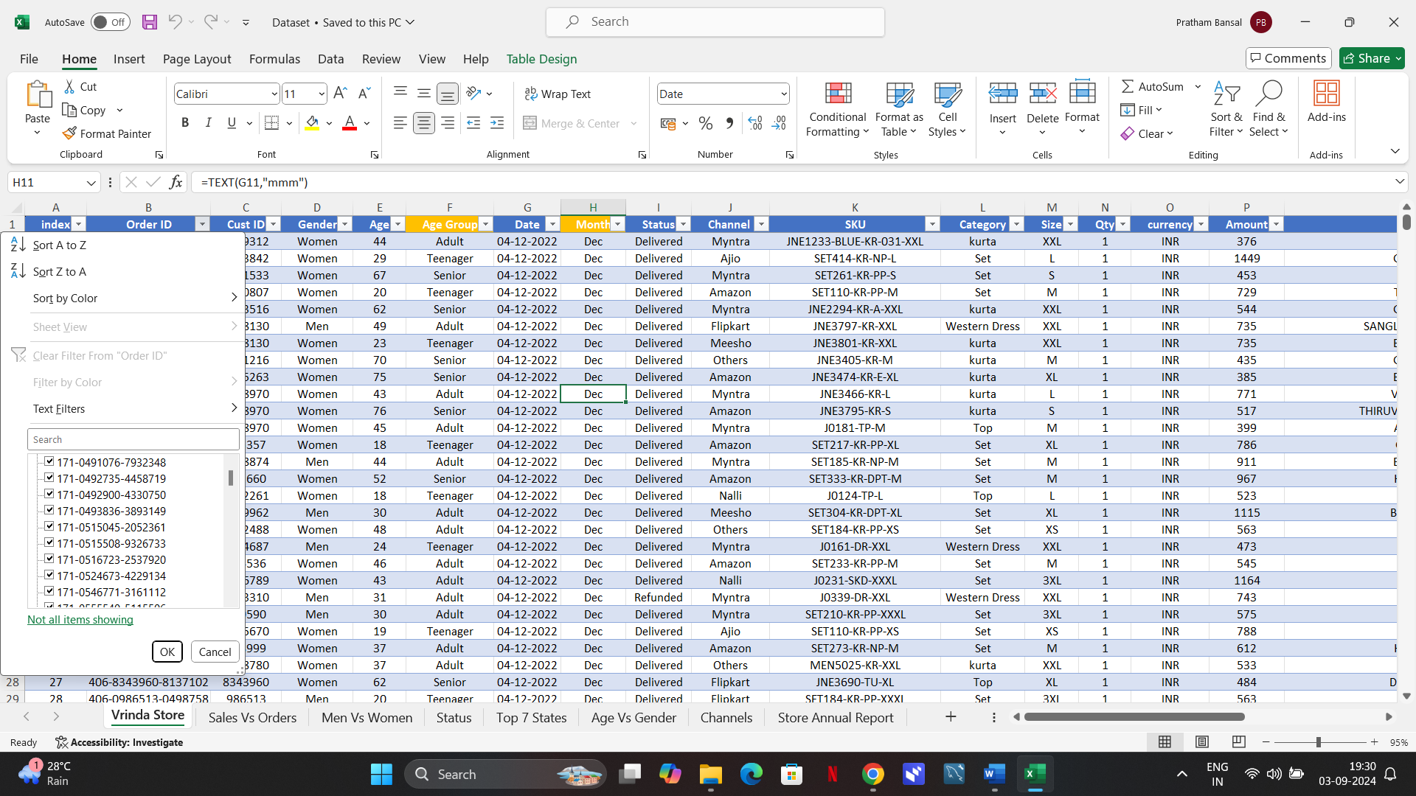

1. **Data Processing:** Utilize Built-in functions to extract meaningful data from the dataset.

Here, we performed two tasks:

1. Age Group from Age Column:

Formula used : =IF(E2>=50,"Senior",IF(E2>=30,"Adult","Teenager"))

1. Month from Date Column:

Formula used : =TEXT(G2,"mmm")

1. **Data Analysis:** Go to Insert Tab and insert Pivot for the following:
2. Pivot Table1: Month Vs Sales and Orders

Pivot Chart : Clustered Column – Line on Secondary Axis

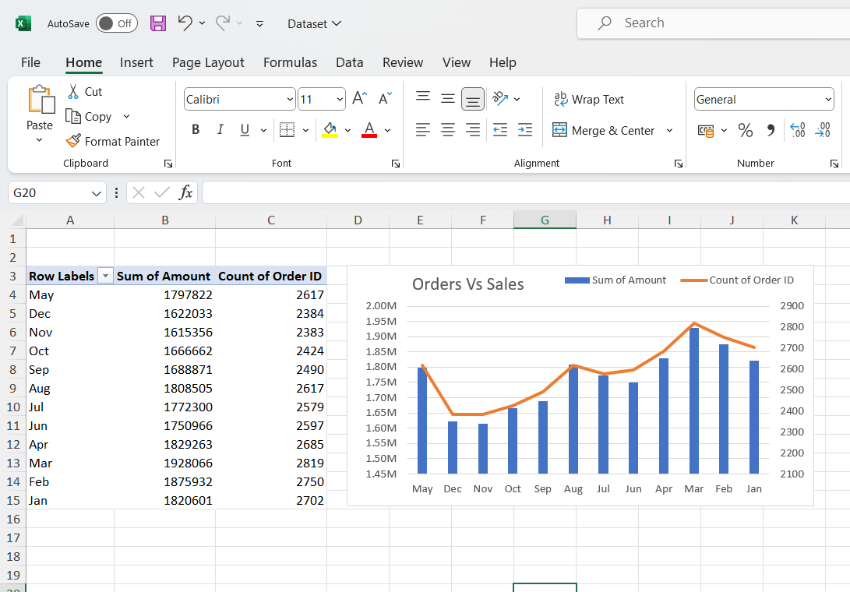

1. Pivot Table2: Gender Vs Amount

Pivot Chart: 3–D Pie

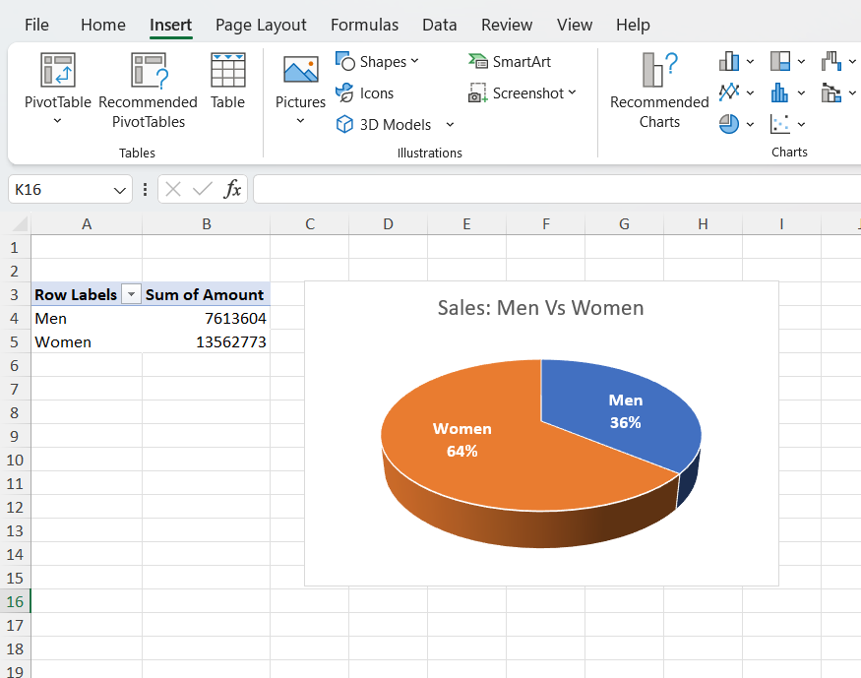

1. Pivot Table3: Status Vs Order ID

Pivot Chart: Pie

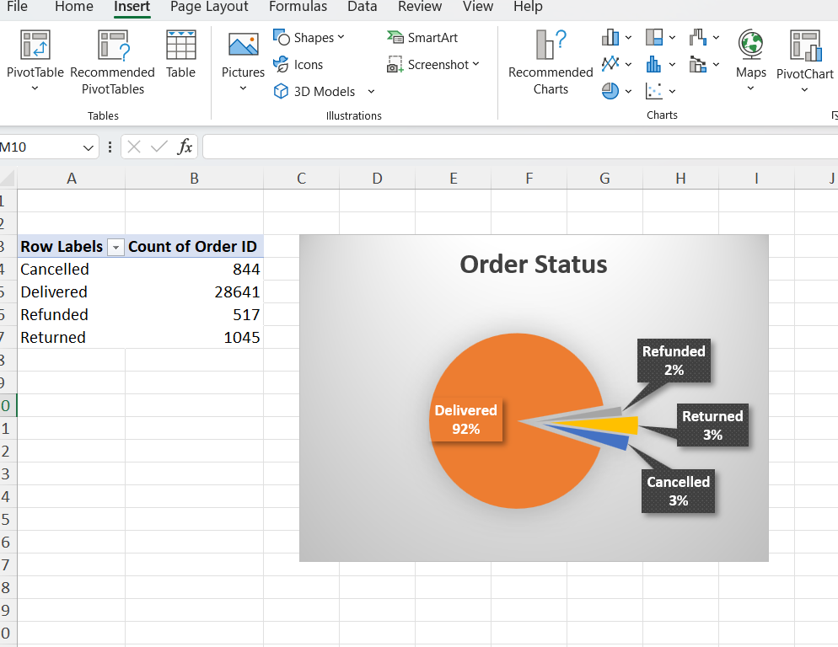

1. Pivot Table4: States Vs Amount

Pivot Chart: Clustered Bar

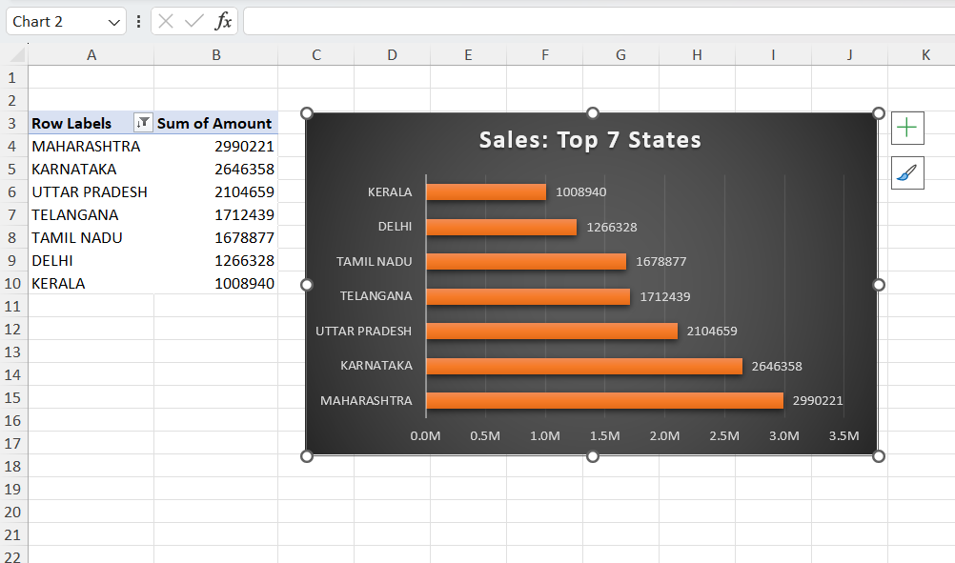

1. Pivot Table5: Age Vs Gender and Order ID

Pivot Chart: Clustered Column

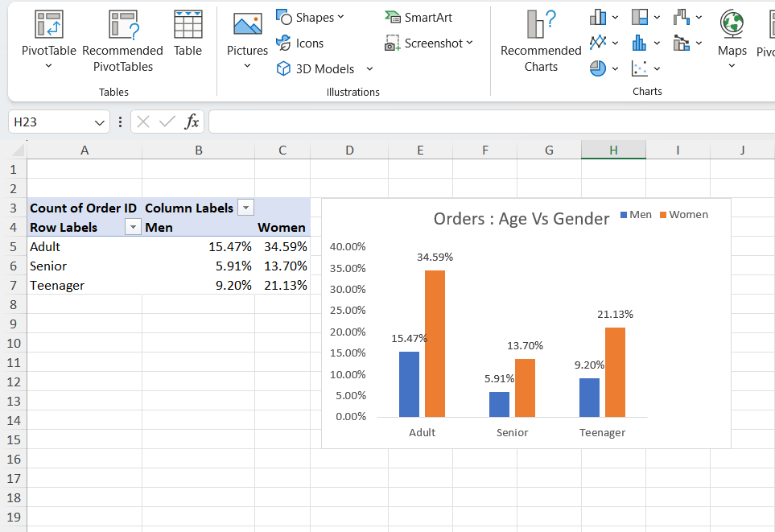

1. Pivot Table6: Channels Vs Order ID

Pivot Chart: 3–D Pie

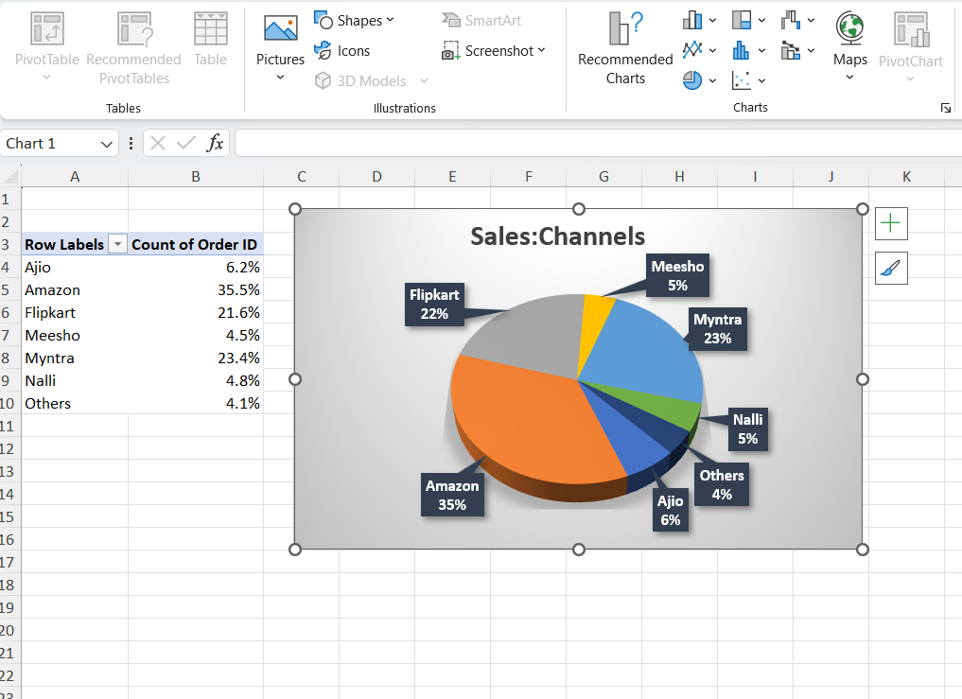

1. **Interactive Dashboard:**
2. Create a new sheet in the Excel file for Dashboard and Copy Paste every Pivot Chart created to this sheet.
3. Go to PivotChart Analyze tab in ribbon and insert slicers for the following fields.

* Month
* Channel
* Category

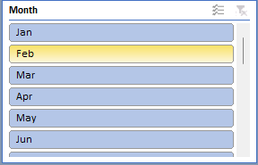 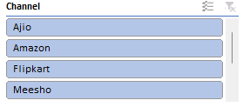 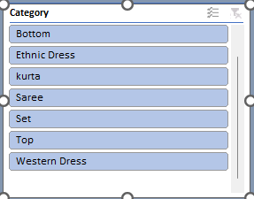

1. Right click on each slicer and select report connections and tick on every pivot table available.

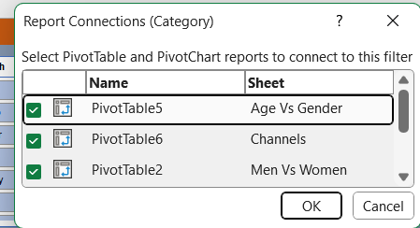

1. Final Dashboard:

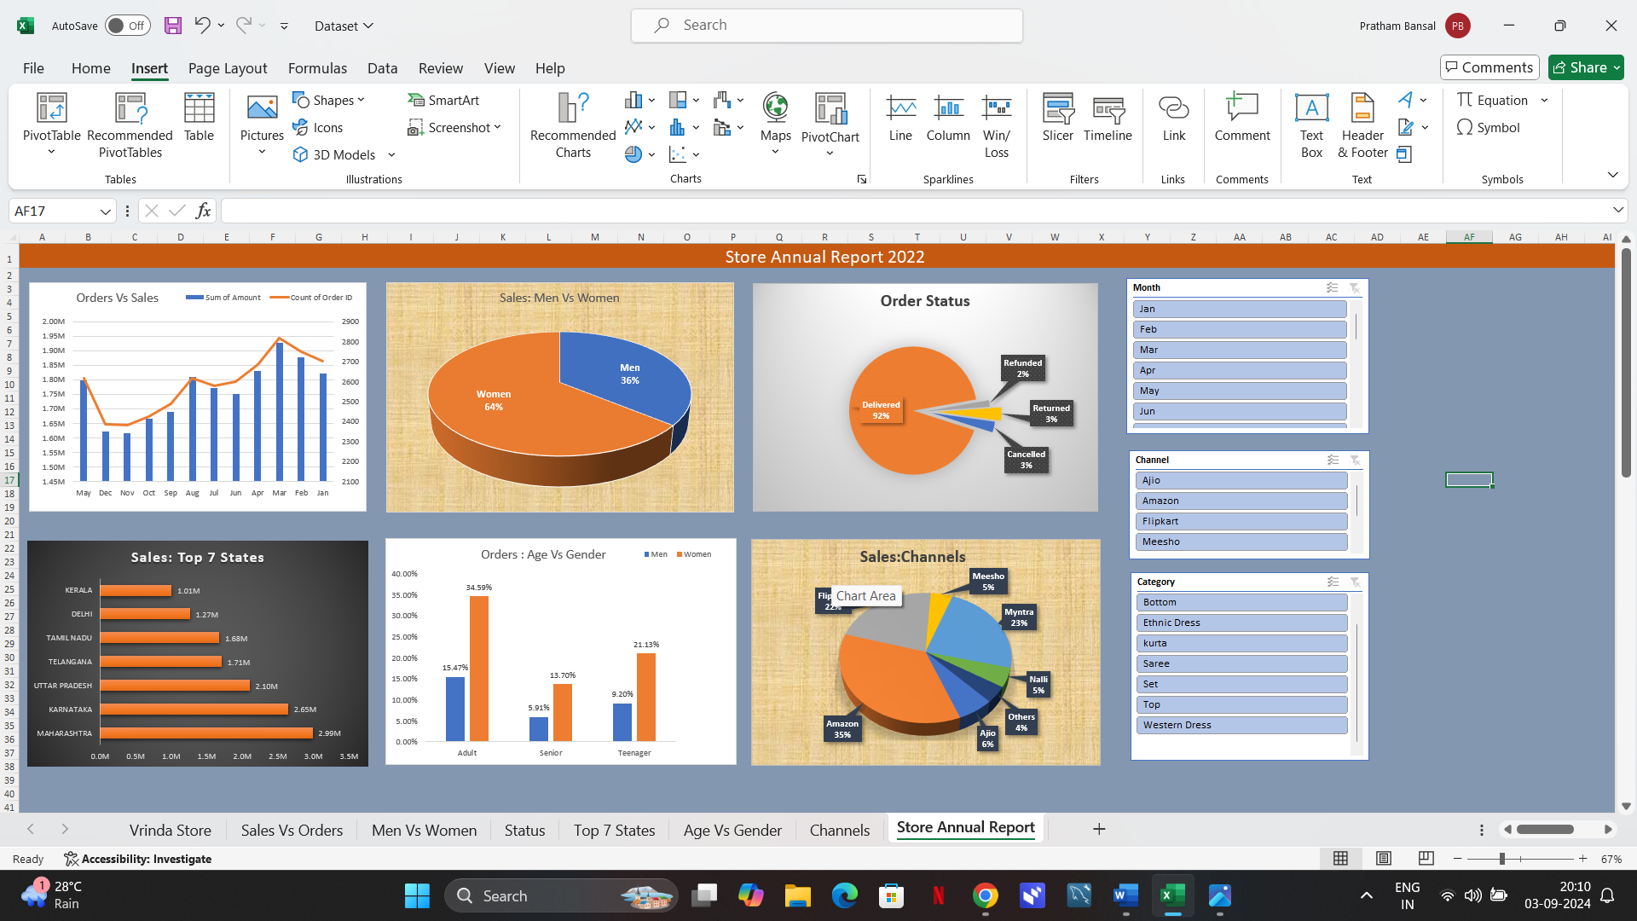

1. **Insights:**

* Women are more likely to buy compared to men (~65%)
* Maharashtra, Karnataka and Uttar Pradesh are the top 3 states (~35%)
* Adult age group (30-49 yrs) is max contributing (~50%)
* Amazon, Flipkart and Myntra channels are max contributing (~80%)

1. **Final Conclusion:** To improve Store sales:

Target women customers of age group(30-49 yrs) living in Maharashtra, Karnataka and Uttar Pradesh by showing ads/offers/coupons available on Amazon, Flipkart and Myntra.

1. **Links:**

* Excel Dashboard: https://docs.google.com/spreadsheets/d/1wJXbUkh93414oKAxk_FvRjv4LyvhQ3Ik/edit?usp=sharing&ouid=100715138493493277860&rtpof=true&sd=true
* Power BI: <https://drive.google.com/file/d/1JMD3Rr-rNFmBOpTAowG0CB-TID4Mlr9z/view?usp=sharing>