**TECHNICAL NANNY PRO**

**AKA**

**SMART BABY MONITORING SYSTEM**

1. **Structure :**

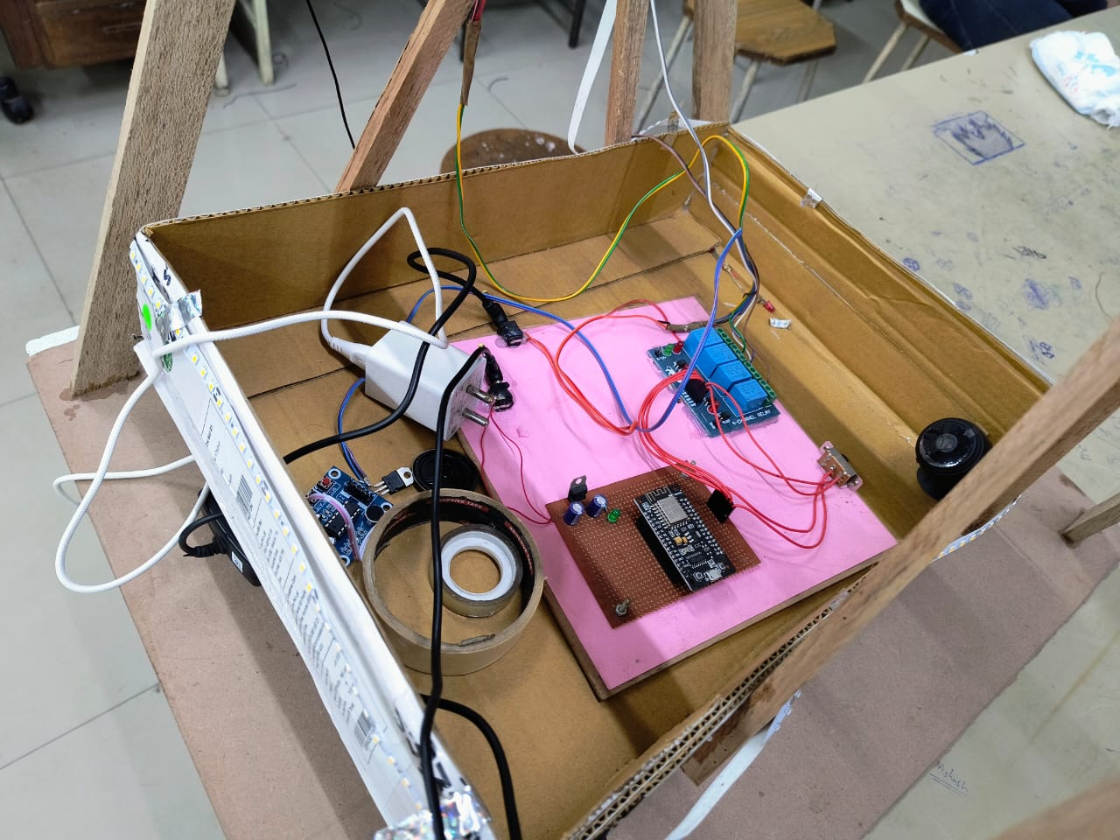

1. **Voice Communication Module :**

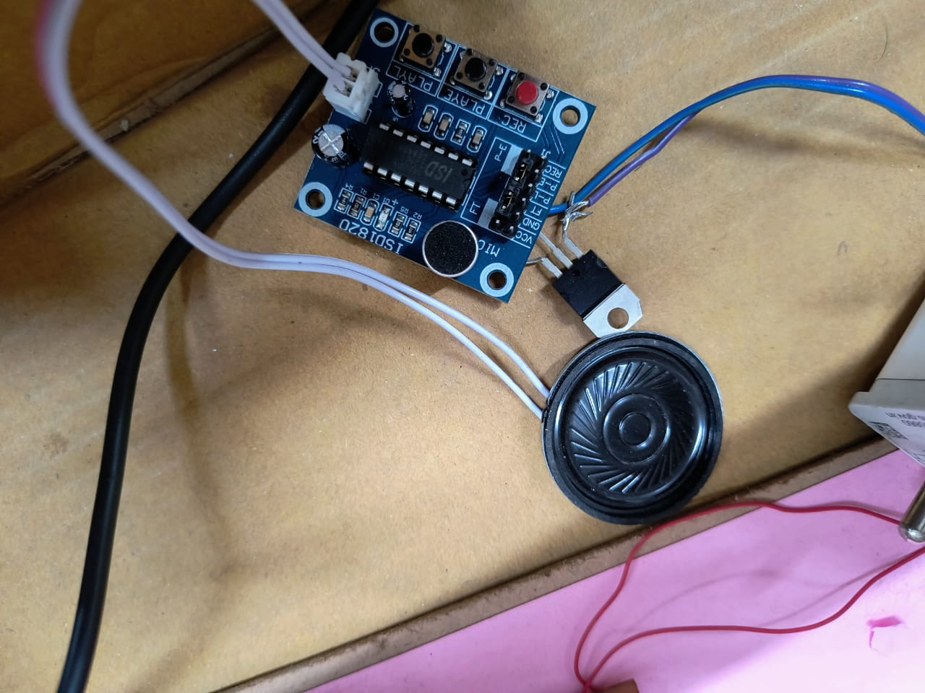

1. **Mechanical Structure :**

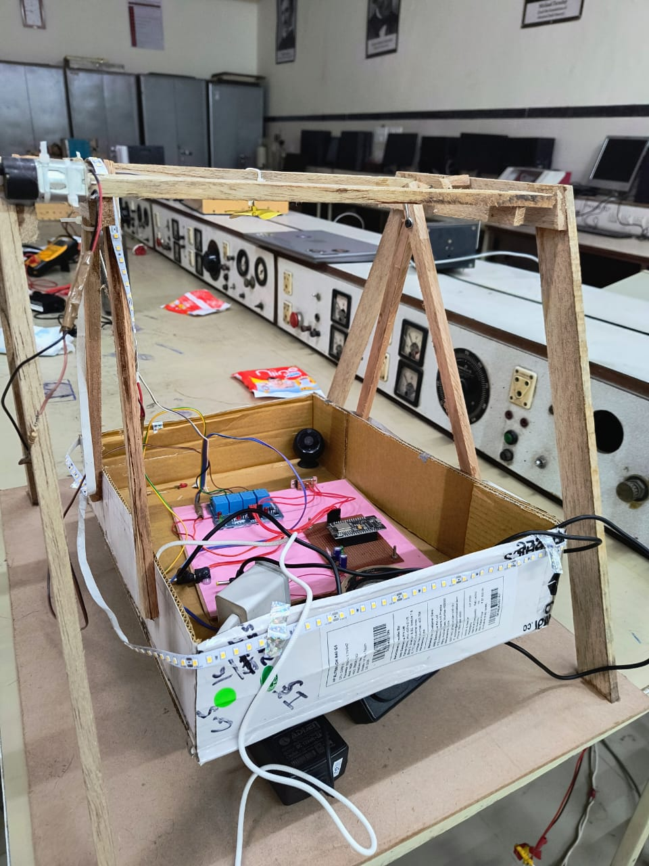

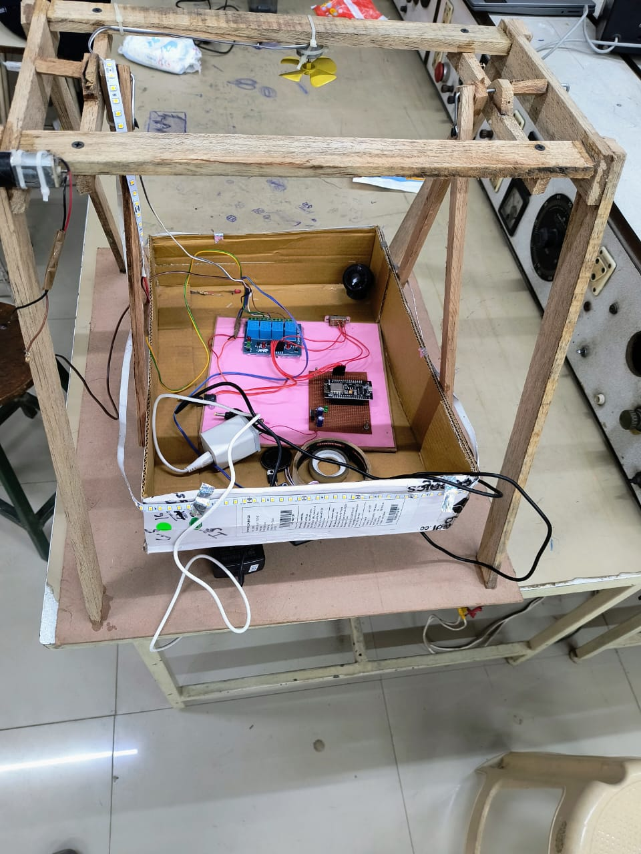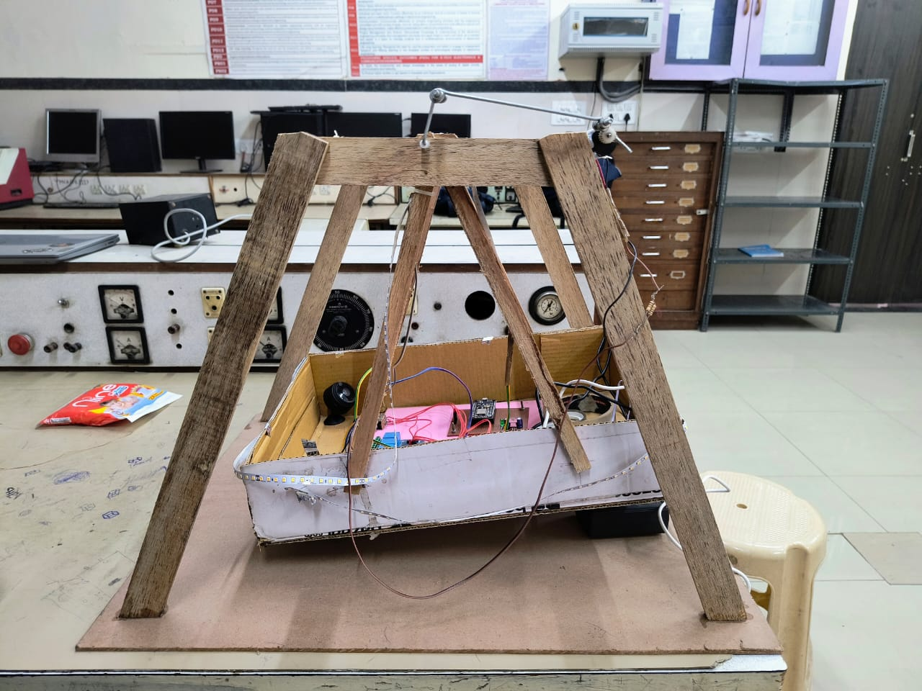

1. **Security Camera 24x7 Live Telecast :**

Transmission of Baby’s voice to parents

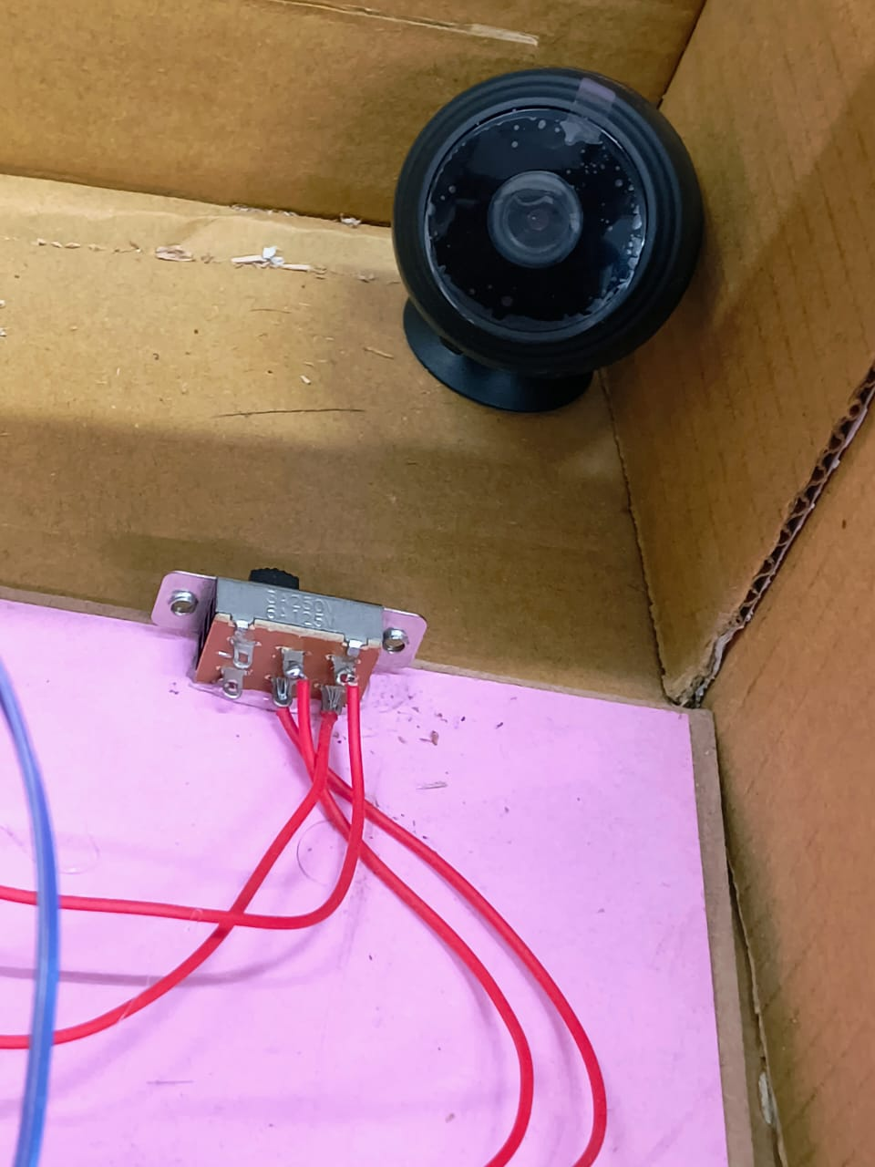

1. **4 Channel Relay Module to control environment :**

Lights, Fan, cradle

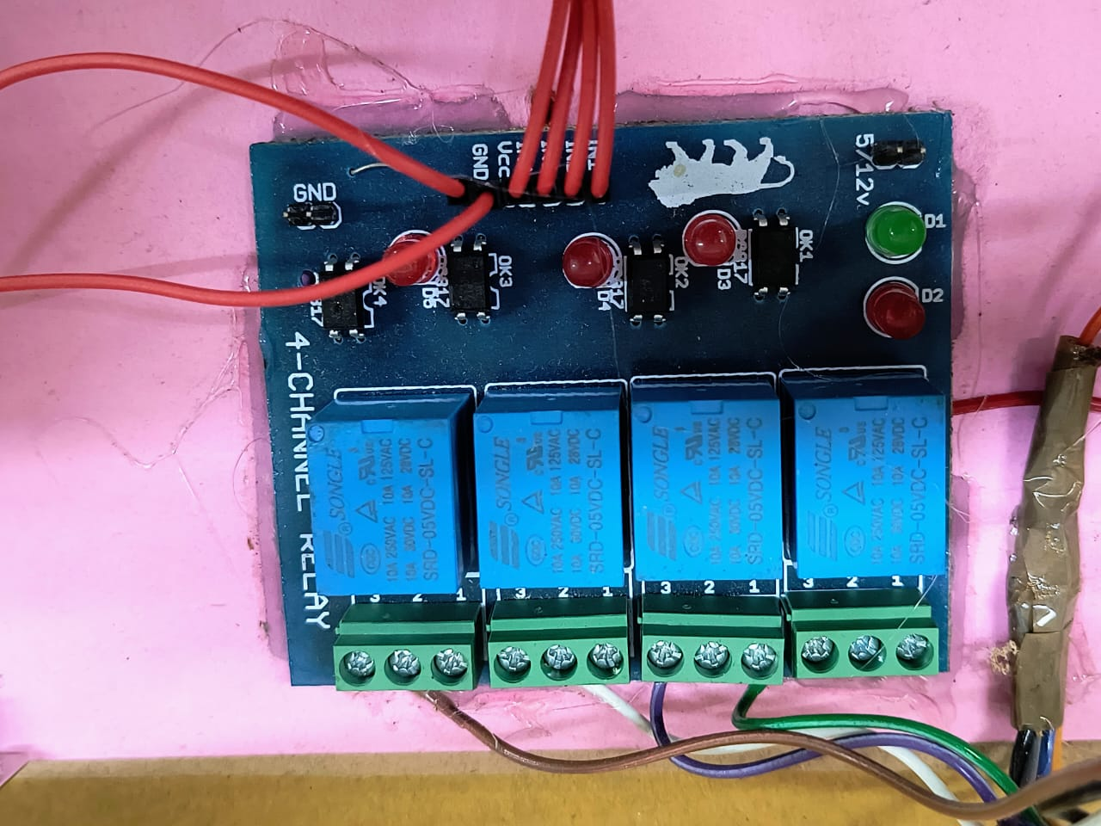

1. **NodeMCU to control remotely :**

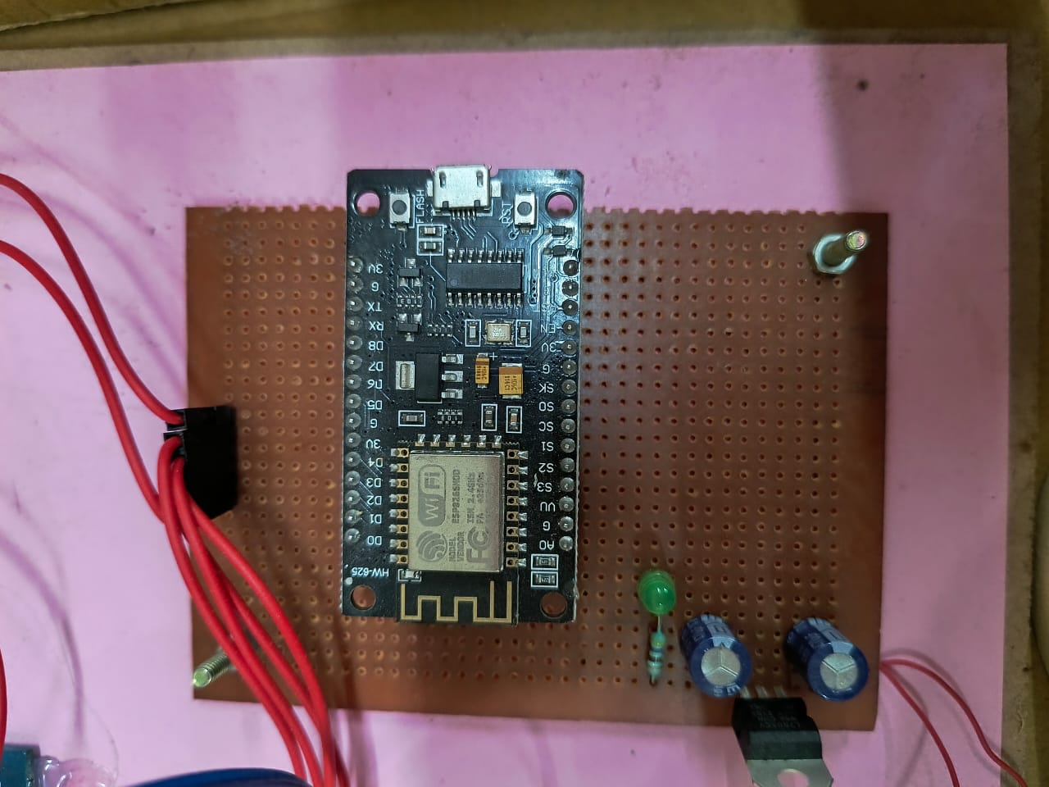

1. **Smart Diaper :**

To detect Wetness and prevent Rashes

