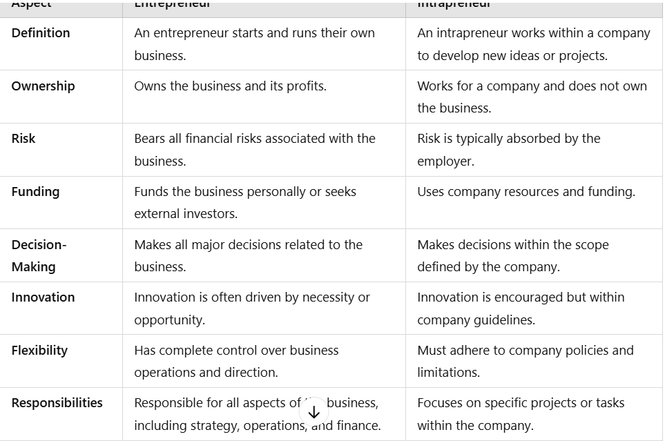

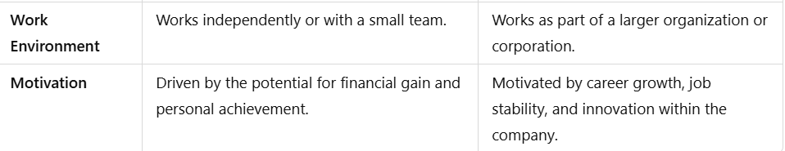

Stages from idea generation t idea implementation-

1. idea generation – basic idea created and described

2. idea screening – the cost ,profits and potential sales of the offering are calculated at price levels and its competitive strategy.

3. feature specification – specifications for the product are developed .It’s features and pricing

4. Development – actual product /service is designed .

5.Testing – product/service process is tested in the market with real customers .

6.Launch – product/service made available to customers

7. Evaluation – whether product /service is delivering the appropriate value to customers as well as meeting firm’s business goals .

5Q models-

What pain of customer are you solving?

How are you going to do it?

How many customers are there that are willing to buy from you ?

Why only you can solve the problem?

How can you defend against others?

How will we start business –

Business/lean modle-

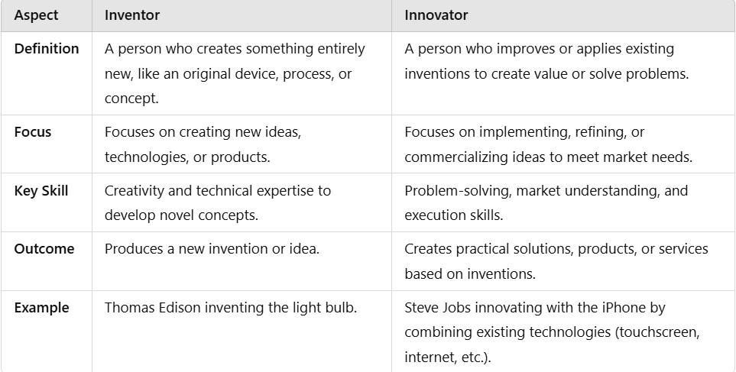

**Creativity** refers to the ability to generate new ideas, solutions, or concepts by combining existing knowledge in novel ways.