Game Design Document

Fill up the following document

1. Write the title of your project.

Space Shooter

1. What is the goal of the game?

Destroy as many asteroids as possible and stop them from hitting Earth.

1. Write a brief story of your game.

Multiple asteroids are coming to crash onto Earth. You have to stop them before they cause any damage. You have to use your spaceship and shoot at the asteroids to stop them.

1. Which are the playing characters of this game?

* Playing characters are the ones who respond to the user based on the input from the user.
* Cars, monkeys, dinos, wizards, etc., are the playing characters in the game.

|  |  |  |
| --- | --- | --- |
| Number | Character Name | What can this character do? |
| 1 | Spaceship | Move left and right and can also shoot. |
| 2 |  |  |
| 3 |  |  |
| 4 |  |  |
| 5 |  |  |
| 6 |  |  |
| 7 |  |  |
| 8 |  |  |

1. Which are the Non-Playing Characters of this game?

* Non-Playing characters are the ones that don't have an action or behavior when the user interacts with the game.
* Hurdles, stones, bananas, coins, etc., are non-playing characters in the game.

|  |  |  |
| --- | --- | --- |
| Number | Character Name | What can this character do? |
| 1 | Asteroids | It moves closer to the spaceship. It is an obstacle. |
| 2 | Missiles | The spaceship shoots these to break the asteroids. |
| 3 |  |  |
| 4 |  |  |
| 5 |  |  |
| 6 |  |  |
| 7 |  |  |
| 8 |  |  |

Draw your imagination of this game. What does this game look like?

* Draw the game either on your computer or on paper.
* Add images of the game scenes to show each of the playing and non-playing characters at least once.

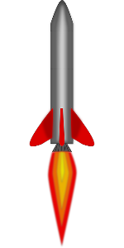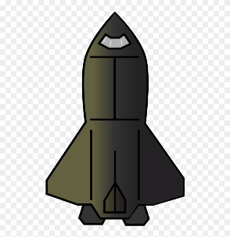

How do you plan to make your game engaging?

I would add adaptivity by increasing the game difficulty as the game goes on to keep the player interested.