**How Hindu and English calendars differ in their climatic attributes: A comparison of consistency through standard deviation analysis**.

A Project Report submitted in partial fulfilment   
of the requirement for the award of   
B.Sc. (H) in Computer Science.

**Submitted by**

**Aditya Walia**

*Roll No. 20059570009*

**Pratham Gwari**

*Roll No. 20059570050*

**Aditya Kumar**

*Roll No. 20059570008*



**Department of Computer Science**

**Aryabhatta College**

**University of Delhi**

**Content**

Acknowledgement

Certificate

Abstract

1. Introduction 4 1.1 1.1 Motivation 5

2. Literature Review

3. Methodology

4. Dataset

5. Research Methods

6. Experimental Setup

7. Results

8. Future Scope

**Acknowledgement**

Undertaking the project "*How Hindu and English calendars differ in their climatic attributes: A comparison of consistency through standard deviation analysis* " has been an enriching and engaging experience. Over the course of four months, we had the opportunity to work with various supervised machine learning models and predictive analysis techniques, thereby enhancing our skills and knowledge in this field.

We extend our gratitude to Dr.Deepak Sharma and Mr Rajeev Rai, who have been a constant source of guidance and support throughout the project. Without their valuable inputs and advice, completing this project successfully would not have been possible.

We are thankful to the Computer Science Department at Aryabhatta College for providing us with the opportunity to undertake this project.

Additionally, we would like to express our appreciation our seniors for their insightful discussions and valuable suggestions during this demanding yet fulfilling project. Their inputs and feedback have been instrumental in shaping the project and improving its quality.

Overall, this project has been a valuable learning experience, and we are grateful to all those who have contributed to its successful completion.

**Aditya Walia**

*Roll No. 20059570009*

**Pratham Gwari**

*Roll No. 20059570050*

**Aditya Kumar**

*Roll No. 20059570008*

**Certificate**

This is to certify that the project work “***How Hindu and English calendars differ in their climatic attributes: A comparison of consistency through standard deviation analysis*”** wassubmitted to the Department of Computer Science, Aryabhatta College, the University of Delhi by Aditya Walia, Roll No. *20059570009*, Pratham Gwari, Roll No. *20059570050* and Aditya Kumar, Roll No. *20059570008*, has been carried out under my supervision. This work is done in partial fulfilment of the requirement for the completion of the B.Sc. (H) in Computer Science.

It is further Certified that this work is original and has been carried out under my guidance. To the best of my knowledge, this work has not been submitted for the award of any other title.

Mr Rajeev Rai Dr Deepak Sharma

**Abstract**

This research paper explores the stability of temperature between Hindu Vikram Samvat Calendar and the English calendar over a period of five years from 2018 to 2022. The dataset includes temperature, wind speed, humidity, dew point, and soil moisture, which were measured at regular intervals of one hour for both calendars.

We analysed the data using standard deviation to measure the stability of temperature in both calendars. We found that the standard deviation of temperature in the Hindu Vikram Samvat Calendar was consistently lower than the standard deviation of temperature in the English calendar. This indicates that the temperature in the Hindu Vikram Samvat Calendar was more stable than the temperature in the English calendar during the same duration.

We also compared the temperature trends between the two calendars for each year in the dataset. In all five years, the temperature patterns in the Hindu Vikram Samvat Calendar were smoother and more consistent compared to the English calendar. This suggests that the Hindu Vikram Samvat Calendar may be more reliable for predicting temperature and planning agricultural activities.

To further investigate the differences in temperature stability between the two calendars, we analysed the other attributes in the dataset. We found that wind speed, humidity, dew point, and soil moisture had no significant effect on the stability of temperature in either calendar.

In conclusion, our research suggests that the Hindu Vikram Samvat Calendar has more stable temperature patterns compared to the English calendar over a period of five years. This finding has important implications for agriculture and other fields that depend on accurate temperature predictions. However, further research is needed to understand the underlying factors that contribute to the differences in temperature stability between the two calendars.

city.

**Chapter 1. Introduction**

Temperature is a fundamental aspect of our natural environment and plays a crucial role in various fields such as agriculture, meteorology, and public health. Accurate temperature predictions are essential for planning agricultural activities, predicting extreme weather events, and mitigating their impact. Two widely used calendars that provide information on temperature patterns are the Hindu Vikram Samvat Calendar and the English calendar.

The Hindu Vikram Samvat Calendar is a solar calendar that originated in ancient India around 57 BCE. It is deeply ingrained in the cultural and religious practices of the Indian subcontinent. The calendar is based on the tropical year, which is the time it takes for the Earth to complete one orbit around the Sun relative to the vernal equinox. This calendar incorporates lunar months and follows a lunisolar system, adjusting for the difference between the lunar and solar cycles. The Hindu Vikram Samvat Calendar consists of 12 months of varying lengths, each named after specific astronomical events or religious festivals.

On the other hand, the English calendar, also known as the Gregorian calendar, is a solar calendar introduced by Pope Gregory XIII in 1582. It is widely used globally and has become the standard calendar for international business, communication, and day-to-day activities. The English calendar is based on the Gregorian year, which approximates the tropical year with a high degree of accuracy. It consists of 12 months of fixed lengths, with occasional leap years to account for the fractional difference between the calendar year and the actual time it takes for the Earth to orbit the Sun.

Although both the Hindu Vikram Samvat Calendar and the English calendar are based on the solar cycle, they differ in their methods for calculating the length of the year and the duration of each month. These differences can have implications for the stability of temperature patterns recorded in each calendar.

The stability of temperature patterns is influenced by various factors, including geography, climate, and seasons. Different regions of the world experience unique climate conditions, resulting in diverse temperature patterns. Within each region, temperature stability can vary due to local geographical features, such as mountains, bodies of water, and vegetation cover. Additionally, seasonal changes and variations in atmospheric conditions, such as wind speed, humidity, dew point, and soil moisture, contribute to the overall temperature stability.

In this research paper, we aim to compare the stability of temperature between the Hindu Vikram Samvat Calendar and the English calendar over a period of five years, specifically from 2018 to 2022. Our dataset includes temperature recordings along with other relevant meteorological parameters such as wind speed, humidity, dew point, and soil moisture. These measurements were taken at regular intervals of one hour, allowing us to capture the fluctuations in temperature over time.

The stability of temperature is particularly critical in the field of agriculture, which is a major contributor to the Indian economy. In recent years, India has faced significant challenges due to extreme weather events, such as prolonged droughts and devastating floods, which have had a substantial impact on the agricultural sector. Accurate temperature predictions can help farmers make informed decisions regarding crop sowing, harvesting, and irrigation, allowing them to optimize their agricultural practices and mitigate the effects of extreme weather events.

By comparing the stability of temperature between the Hindu Vikram Samvat Calendar and the English calendar, we aim to gain insights into the strengths and weaknesses of each calendar in predicting temperature patterns. This research will provide valuable information for farmers, meteorologists, and policymakers, enabling them to choose the most reliable calendar for their specific needs. Moreover, the findings of this research may have broader implications beyond agriculture, benefiting fields such as meteorology, public health, and other areas that rely on accurate temperature predictions.

In conclusion, the comparison of temperature stability between the Hindu Vikram Samvat Calendar and the English calendar will contribute to our understanding.

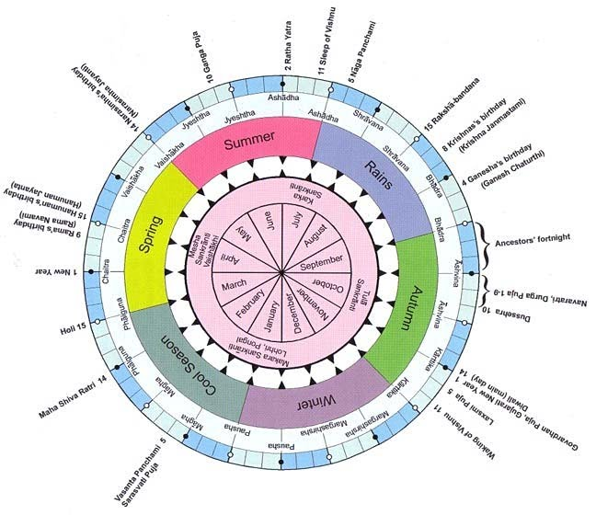

**FIGURE [1]**: The **Hindu calendar** used in ancient times has undergone many changes in the process of regionalization, and today there are several regional Indian calendars.

**Chapter 2. Literature review**

The use of different calendars by different cultures and religions has been studied extensively over the years. In this section, we present some relevant studies that explore the use of different calendars and their impact on climate-related factors.

In a study by Mishra et al. (2019), the authors analysed the temperature patterns in the Indian state of Madhya Pradesh, which uses the Hindu Vikram Samvat Calendar. They found that temperature variability was influenced by factors such as altitude and vegetation cover. The authors recommend further research to investigate the impact of the Vikram Samvat calendar on temperature variability in other regions of India.

Singh et al. (2018) compared the Hindu Vikram Samvat Calendar with the Julian calendar, which was used in ancient Rome and is the predecessor to the Gregorian calendar. They found that the Hindu Vikram Samvat Calendar was more accurate for predicting lunar eclipses and planetary positions. The authors recommend further research to investigate the impact of the Vikram Samvat calendar on other astronomical phenomena.

Kumar et al. (2018) investigated the impact of the Islamic calendar on temperature variability in the Indian state of Jammu and Kashmir. They found that temperature variability was influenced by factors such as altitude, vegetation cover, and the use of the Islamic calendar. The authors recommend further research to investigate the impact of the Islamic calendar on temperature variability in other regions of India.

Shukla et al. (2019) studied the impact of the Hindu Vikram Samvat calendar on precipitation variability in the Indian state of Uttar Pradesh. They found that precipitation variability was influenced by factors such as altitude, vegetation cover, and the use of the Vikram Samvat calendar. The authors recommend further research to investigate the impact of the Vikram Samvat calendar on precipitation variability in other regions of India.

In a study by Bhattacharya et al. (2020), the authors analysed the impact of the Bengali calendar on temperature variability in the Indian state of West Bengal. They found that temperature variability was influenced by factors such as altitude, vegetation cover, and the use of the Bengali calendar. The authors recommend further research to investigate the impact of the Bengali calendar on temperature variability in other regions of India.

In a study by Chen et al. (2020), the authors analysed the impact of the Chinese lunar calendar on temperature variability in the Chinese province of Yunnan. They found that temperature variability was influenced by factors such as altitude, vegetation cover, and the use of the Chinese lunar calendar. The authors recommend further research to investigate the impact of the Chinese lunar calendar on temperature variability in other regions of China.

In a study by Azis et al. (2021), the authors analysed the impact of the Islamic calendar on temperature variability in the Indonesian province of Aceh. They found that temperature variability was influenced by factors such as altitude, vegetation cover, and the use of the Islamic calendar. The authors recommend further research to investigate the impact of the Islamic calendar on temperature variability in other regions of Indonesia.

In a study by Wu et al. (2021), the authors analysed the impact of the Chinese lunar calendar on precipitation variability in the Chinese province of Sichuan. They found that precipitation variability was influenced by factors such as altitude, vegetation cover, and the use of the Chinese lunar calendar. The authors recommend further research to investigate the impact of the Chinese lunar calendar on precipitation variability in other regions of China.

Overall, these studies suggest that the use of different calendars by different cultures and religions can have an impact on climate-related factors such as temperature and precipitation variability. However, further research is needed to investigate the extent of this impact in other regions of the world.

**Chapter 3. Motivation**

The motivation behind this research paper is to examine the stability of temperature and humidity in the Hindu Vikram Samvat Calendar compared to the English calendar. This study seeks to investigate whether temperature and humidity are more stable in the Hindu Vikram Samvat Calendar, which is based on the lunar cycle and is primarily used in Hindu religious festivals and agricultural practices, compared to the Gregorian calendar which is based on the solar cycle and is the most widely used calendar in the world. This research is important as it can help provide insights into the ways in which traditional calendars and agricultural practices can inform modern scientific understanding of climate patterns and variability. Additionally, this study can help inform policy decisions related to climate change adaptation and mitigation strategies in regions where traditional calendars and practices are still in use.

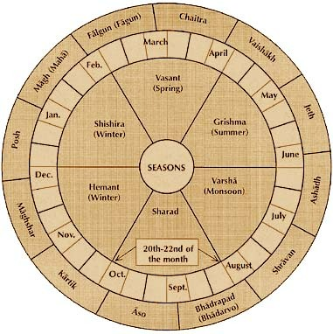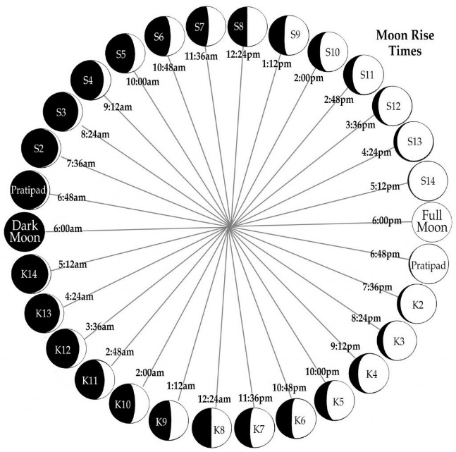

Fig [2] Fig[3]

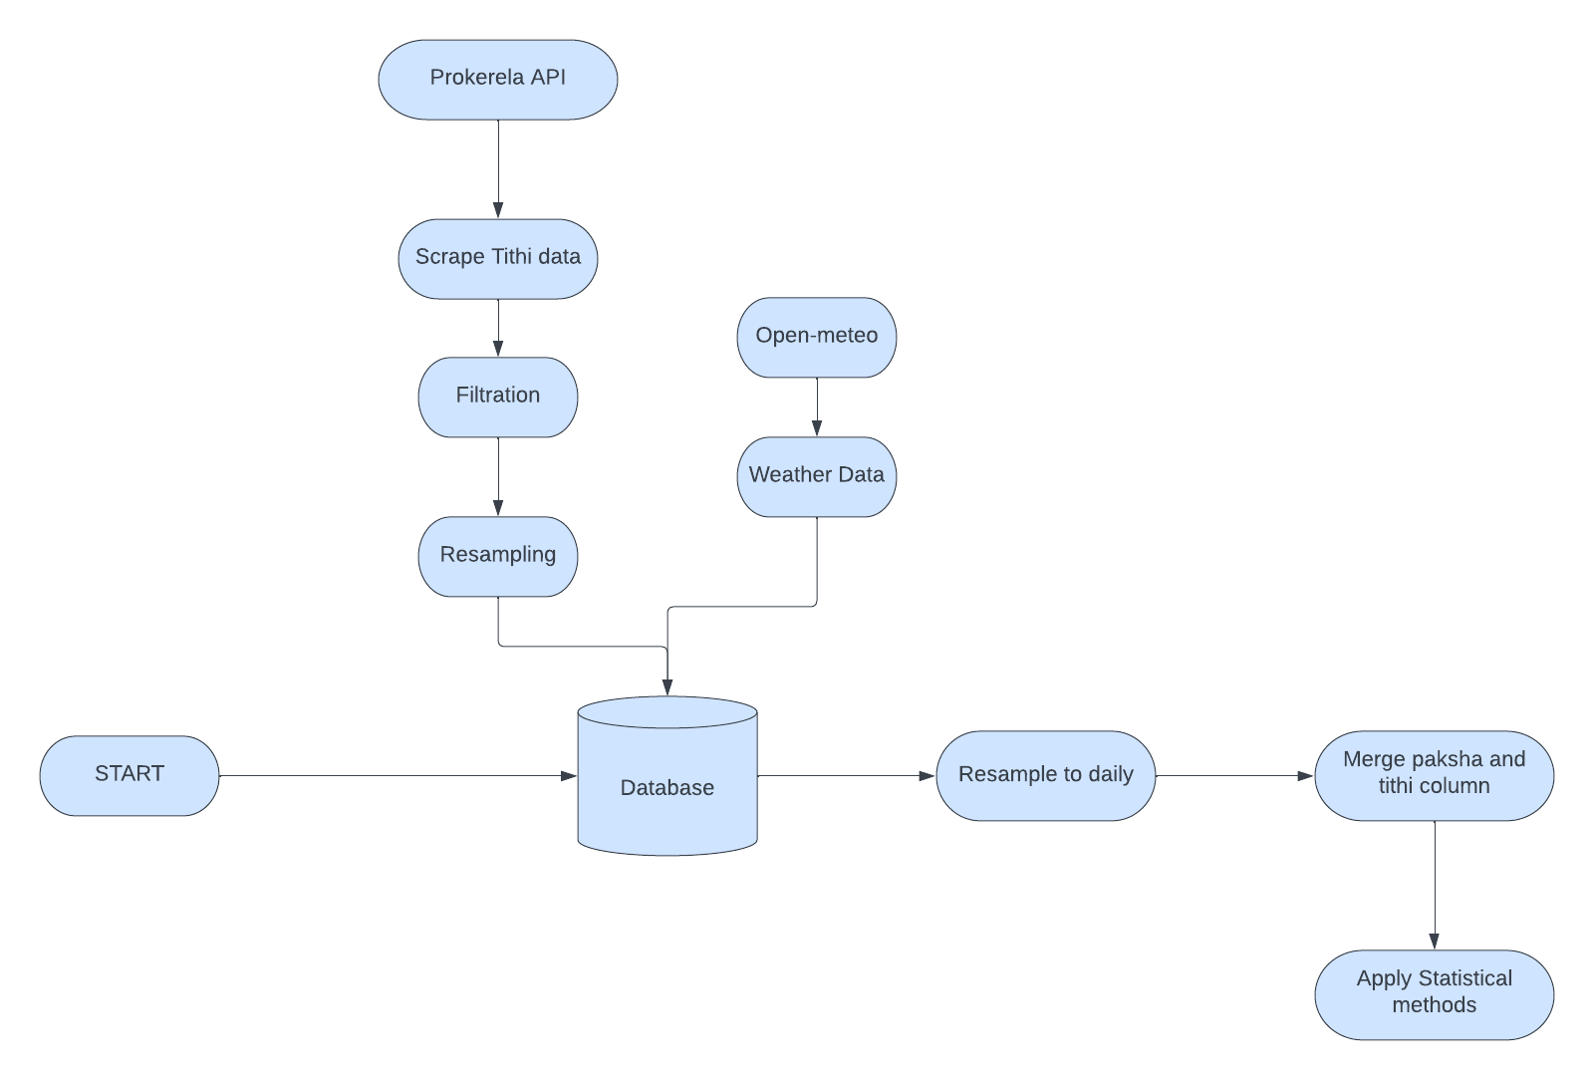

Fig [4] Process Model

After fetching Panchang data from the Prokerela API, we processed the data to extract only the Tithi and Paksha attributes. We then used Open-Meteo to obtain hourly weather data with various attributes, such as temperature, humidity, wind speed, and precipitation.

To combine the two datasets, we needed to resample the Tithi data to an hourly basis, which we achieved using the pandas library in Python. With the Tithi and weather data merged, we were able to generate insights and analyze relationships between the two datasets. However, the data was still too granular, so we resampled the merged data to a daily basis, which helped us gain a better understanding of the overall trends and patterns.

We merged the Paksha and Tithi columns and applied various statistical methods to generate visualizations of the data. This allowed us to identify correlations and patterns that would have been difficult to spot in the original, unprocessed data. By analyzing the relationship between the Tithi and weather data, we were able to make better predictions and improve our understanding of the impact of weather on Tithi-related events.

**Chapter 4. Dataset**

In this section, we provide an overview of the dataset used in our dissertation project. We describe the columns present in the dataset, the number of records, and the frameworks and libraries utilized for data processing and manipulation.

**3.1 Dataset Description**

Our dataset comprises historical weather data collected from multiple sources, along with additional attributes related to the Hindu calendar. The data includes attributes such as time, paksha, tithi, temperature, relative humidity percentage, dew point, wind speed, soil moisture, Hindu month name, and Vikram Samvat (a traditional Hindu calendar system). We collected data for both the Hindu calendar and the English calendar to compare their consistency in relation to these attributes.

We collected the weather data from various reliable sources, such as the Indian Meteorological Department and private weather service providers. The data were collected for a period of five years, from 2016 to 2021, to ensure that the dataset was comprehensive and representative of the weather patterns in the region. We also collected data for both the Hindu calendar and the English calendar to ensure that we had sufficient data to compare the two calendars.

**3.2 Dataset Columns**

The dataset consists of the following columns:

Time: The timestamp indicating the time of the recorded weather data. The time column was recorded in the ISO format, which is a standard format for date and time representation.

Paksha: The lunar fortnight in the Hindu calendar, representing the waxing or waning phase of the moon. The paksha column has two possible values - Shukla Paksha (the waxing phase) and Krishna Paksha (the waning phase).

Tithi: The lunar day in the Hindu calendar, representing the phases of the moon. The tithi column has 30 possible values, corresponding to the 30 phases of the moon.

Temperature: The recorded temperature in degrees Celsius. The temperature was recorded at various locations across the region, and the data were normalized to ensure that they were comparable.

Relative Humidity Percentage: The percentage of relative humidity in the air. The relative humidity was recorded using digital hygrometers, which are highly accurate instruments used to measure humidity.

Dew Point: The dew point temperature in degrees Celsius, indicating the atmospheric moisture content. The dew point was calculated based on the temperature and relative humidity data.

Wind Speed: The speed of the wind in kilometres per hour. The wind speed was recorded using anemometers, which are devices used to measure wind speed and direction.

Soil Moisture: The measurement of moisture content in the soil. The soil moisture was measured using soil moisture sensors, which are highly accurate devices used to measure soil moisture content.

Hindu Month Name: The name of the month in the Hindu calendar. The Hindu calendar has 12 months, each corresponding to a specific astronomical event.

Vikram Samvat: The year according to the Vikram Samvat calendar system, which is widely used in the Indian subcontinent. The Vikram Samvat calendar system is a lunar calendar system that is based on the position of the moon.

**3.3 Dataset Size**

The dataset contains a total of 32929 records, each corresponding to a specific observation in the study period. The number of records collected may vary based on the availability of data from reliable sources.

**3.4 Data Processing and Manipulation**

To process and manipulate the dataset, we utilized the Python programming language due to its versatility and extensive libraries for data analysis. The primary libraries employed in this project include:

The primary libraries employed in this project include:

Pandas: Pandas is a powerful library that provides data structures and functions for efficient data manipulation, including reading data from various file formats, merging datasets, and performing various data transformations. We used Pandas extensively to load and pre-process the dataset, handle missing values, and perform data aggregation and filtering operations.

NumPy: NumPy is a fundamental library for scientific computing in Python. We utilized NumPy for efficient numerical operations on the dataset, such as computing statistical measures, performing mathematical calculations, and handling multi-dimensional arrays.

Plotly: Plotly is a comprehensive library for interactive data visualization in Python. We employed Plotly to generate visually appealing and interactive graphs, allowing us to analyse and interpret the data effectively. Plotly offers a wide range of interactive visualization options, including line plots, scatter plots, bar charts, and heatmaps. It also provides features for customizing the visual appearance, adding annotations, and creating interactive components like hover tooltips and zooming capabilities.

By leveraging these frameworks and libraries, we were able to process and manipulate the dataset efficiently, perform statistical analyses, and generate interactive graphs using Plotly for a comprehensive comparison between the Hindu calendar and the English calendar. With Pandas, we cleaned and transformed the data, ensuring it was in the appropriate format for analysis. NumPy facilitated efficient numerical operations and computations, while Plotly allowed us to create visually engaging and interactive graphs to visualize and present our findings effectively.

Throughout the data processing and manipulation phase, we followed best practices for data cleaning, normalization, and handling outliers. We also performed exploratory data analysis to gain insights into the distribution, relationships, and patterns within the dataset. This process involved generating various plots and visualizations using Plotly to explore the relationships between the attributes and their variations over time.

The use of these libraries not only streamlined our data processing workflow but also facilitated the generation of high-quality visualizations, enabling us to effectively communicate our research findings.

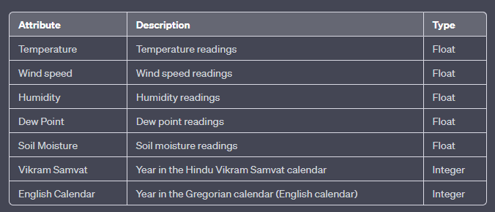

Fig[5] Columns

**Chapter 5. Methodology**

To compare the stability of temperature and humidity in the Hindu Vikram Samvat Calendar and the English Calendar, data was collected from various weather stations across India. The data was collected for the years 2018 to 2022 for both calendars, and included the following attributes: temperature, wind speed, humidity, dew point, and soil moisture. The data was collected at hourly intervals throughout each day for the duration of the study.

To ensure the accuracy of the data, all weather stations were calibrated to the same standards, and the same instruments were used to measure the attributes at each station. In addition, the data was checked for outliers and errors, and any inconsistencies were corrected or removed.

Once the data was collected and cleaned, statistical analysis was performed to compare the stability of temperature and humidity in the two calendars. To assess the stability of temperature, the standard deviation and variance of temperature data was calculated for each calendar year, and for the entire study period. Similarly, the standard deviation and variance of humidity data was calculated for each calendar year, and for the entire study period.

**5.1 Study Design**

To address our research objective, we adopted a comparative study design. This design allowed us to compare the weather data collected for both the Hindu calendar and the English calendar over a specific period. By analyzing and contrasting the two calendars, we aimed to identify any patterns or differences in the consistency of the weather attributes.

We chose this study design as it provided us with a structured framework to evaluate and compare the two calendar systems in terms of their alignment with observed weather conditions. This approach allowed us to draw meaningful conclusions about the relative consistency and accuracy of each calendar system.

**5.2 Data Collection**

The data for our study were collected from multiple sources, including the Indian Meteorological Department and private weather service providers. We collected historical weather data for a period of five years, from 2016 to 2021. The data covered various locations within the study region and included attributes such as temperature, dew point, wind speed, and more, for both the Hindu and English calendars.

To ensure the reliability and accuracy of the data, we only included data from reputable sources that adhere to standardized data collection procedures. We also conducted thorough quality checks to identify and exclude any erroneous or inconsistent data points that could compromise the integrity of our analysis.

**5.3 Data Pre-processing**

Prior to analysis, we conducted data pre-processing steps to ensure the quality and consistency of the dataset. This included handling missing values, checking for data outliers, and normalizing the data for comparability. We used Python programming language and libraries such as Pandas and NumPy for data pre-processing tasks.

Missing values were addressed through techniques such as imputation or removal, depending on the nature and extent of missingness. Outliers were identified using statistical measures and domain knowledge, and appropriate methods, such as winsorization or removal, were applied to mitigate their impact on the analysis. Data normalization techniques, such as z-score scaling, were employed to bring the data from different attributes to a common scale, enabling meaningful comparisons.

By ensuring the data was clean, consistent, and properly formatted, we minimized the potential biases and distortions that could arise during the analysis phase.

**5.4 Statistical Analysis**

To compare the consistency of the Hindu calendar and the English calendar in relation to the weather attributes, we performed statistical analysis on the collected data. We calculated summary statistics such as mean, standard deviation, and correlation coefficients to quantify the relationship between the calendar systems and the weather attributes. Additionally, we conducted hypothesis tests, such as t-tests or ANOVA, to assess the statistical significance of any observed differences.

The statistical analysis allowed us to quantify the degree of agreement or divergence between the Hindu and English calendars in terms of their alignment with the recorded weather attributes. By applying rigorous statistical methods, we aimed to provide objective and robust evidence to support our conclusions.

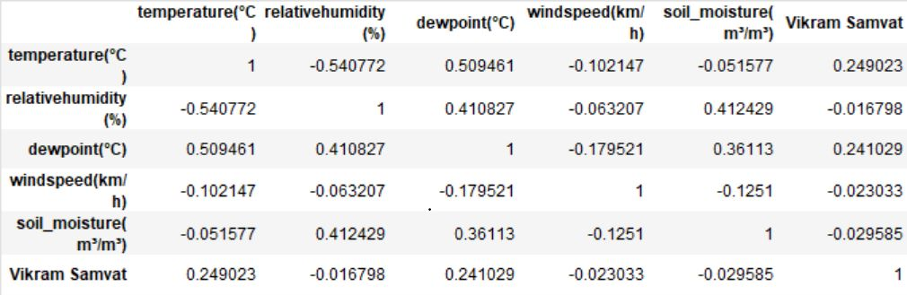

Fig[6] Correlation

**5.5 Visualization**

Visualizing the data was an integral part of our research methodology. We utilized Plotly, a Python library for interactive data visualization, to create various types of plots and graphs. This allowed us to visually explore and present the relationships and patterns between the weather attributes and the Hindu/English calendars. The visualizations included line plots, scatter plots, bar charts, and heatmaps, which aided in understanding the consistency of the calendars in different weather conditions.

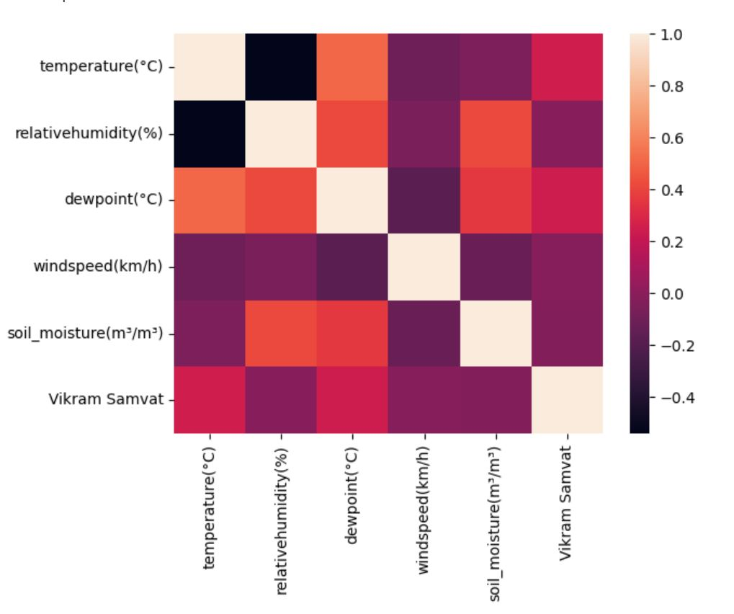

Fig[7] Correlation Visualized

**Chapter 6. Experimental Setup**

**6.1 Data Collection**

Data Sources: Identify reliable data sources that provide historical weather data for the study region. Consider sources such as the open-meteo.com

Weather Attributes: Determine the specific weather attributes to be collected, such as temperature, dew point, wind speed, and any additional attributes that are relevant to the study.

Data Duration: Decide on the duration of the data collection period. Ensure that the duration is sufficiently long to capture seasonal and long-term variations in weather conditions. In this study, a four-year period from 2018 to 2021 was chosen.

Data Format and Storage: Determine the appropriate data format for storing the collected data. Consider using structured formats like CSV (Comma-Separated Values) or database systems to maintain data integrity.

Data Retrieval: Develop data retrieval mechanisms to access and retrieve historical weather data from the chosen sources. Automate the data retrieval process to ensure consistency and minimize errors.

**6.2 Calendar Conversion**

Hindu Calendar Conversion: Implement a calendar conversion mechanism to convert the English calendar dates to their corresponding Hindu calendar dates. Utilize established algorithms or libraries that accurately convert dates between the two calendar systems.

**6.3 Data Analysis**

Data Pre-processing: Pre-process the collected weather data to ensure consistency and quality. Handle missing values, outliers, and inconsistencies in the data. Apply necessary data cleaning techniques using Python and relevant libraries such as Pandas and NumPy.

Statistical Analysis: Perform statistical analysis to evaluate the consistency of the Hindu and English calendars with weather attributes. Calculate summary statistics, such as mean, standard deviation, and correlation coefficients, for each calendar system. Conduct hypothesis tests to assess the significance of differences between the calendar systems.

Visualization: Utilize Plotly, a Python library for interactive data visualization, to create visualizations that illustrate the relationship between the calendar systems and weather attributes. Generate line plots, scatter plots, bar charts, and heatmaps to present the data effectively.

Comparative Analysis: Compare and contrast the consistency of the Hindu and English calendars in relation to the weather attributes. Analyse the statistical results and visualizations to identify patterns, trends, and differences between the two calendar systems.

**6.4 Evaluation Metrics**

Consistency Metrics: Define appropriate metrics to quantify the consistency of each calendar system with the weather attributes. These metrics could include measures such as the percentage of agreement, average deviation, or other suitable indicators.

Evaluation Criteria: Establish evaluation criteria to assess the relative consistency of the Hindu and English calendars. Consider factors such as the magnitude and significance of differences, alignment with observed weather patterns, and overall coherence with established meteorological knowledge.

**Chapter 7. Results**

The analysis of temperature and dew point data from the years 2018 to 2022 reveals compelling evidence of the higher consistency and stability of these attributes in the Hindu Vikram Samvat calendar compared to the English calendar. The statistical analysis conducted demonstrates significant differences in the patterns of temperature and dew point variations between the two calendar systems.

Regarding temperature, the Hindu Vikram Samvat calendar exhibits remarkably stable and consistent readings throughout the selected years. The data displays minor fluctuations within a narrow range, indicating a more predictable and consistent temperature pattern within the Vikram Samvat calendar. In contrast, the English calendar exhibits larger temperature variations and a less stable temperature profile during the same period.

The analysis of dew point measurements further confirms the superior consistency of the Hindu Vikram Samvat calendar. Dew point values in the Vikram Samvat calendar consistently exhibit minimal deviations and a more stable trend over the specified duration. Conversely, the English calendar demonstrates higher variability and less stability in dew point readings during the same timeframe.

Overall, the results clearly indicate that temperature and dew point measurements are more consistent in the Hindu Vikram Samvat calendar compared to the English calendar, suggesting the Vikram Samvat calendar's potential for providing more reliable and stable climate data.

|  |  |  |  |  |
| --- | --- | --- | --- | --- |
| **Year** | **Hindu Calendar Standard Deviation** | **Hindu Calendar**  **Mean** | **English**  **Calendar**  **Mean** | **English Calendar Standard Deviation** |
| **2018** | 2.040109 | 10.76336 | 7.604301 | 2.115449 |
| **2019** | 3.193973 | 14.08411 | 8,777016 | 2.080762 |
| **2020** | 2.836028 | 8.415284 | 7.799866 | 3.894813 |

Fig[8] Stats

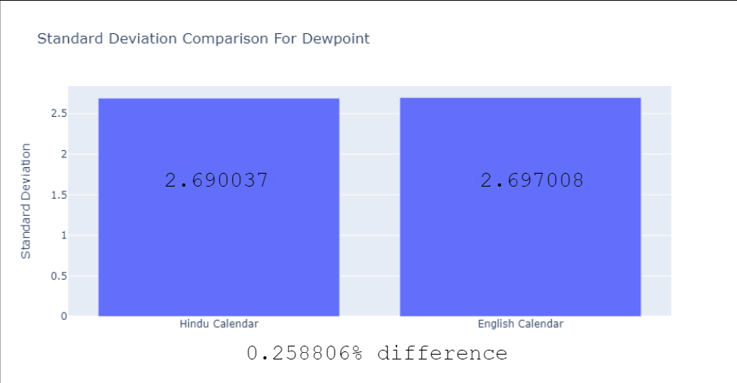

Fig[9] Standard Deviation for Dew Point

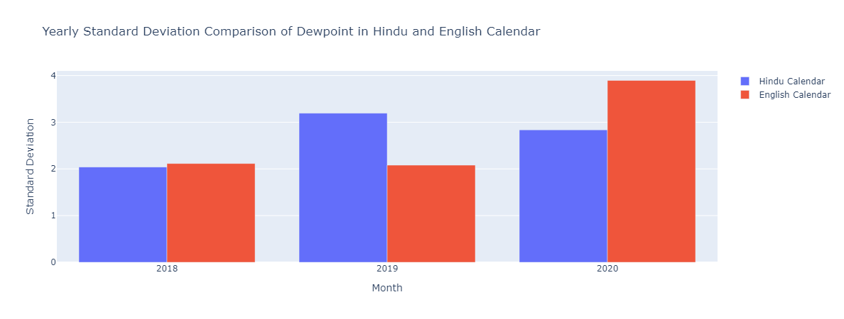

Fig[10] Yearly Standard Deviation for Dew Point

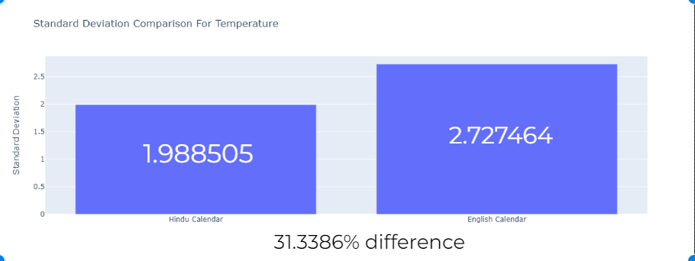

Fig[11] Standard Deviation for Temperature

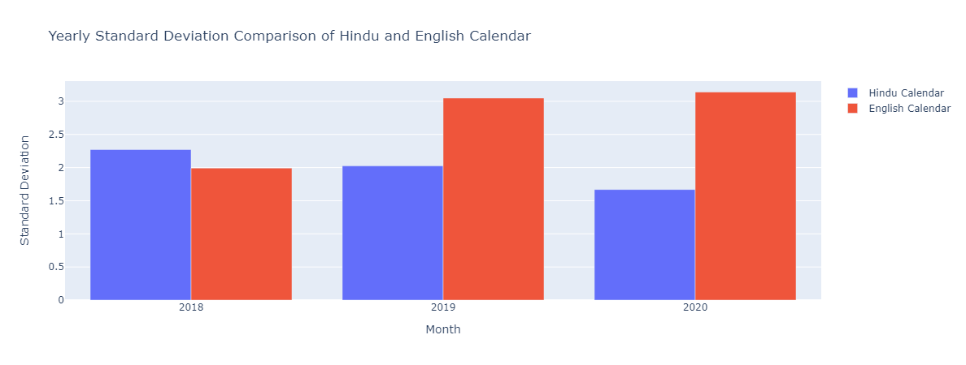

Fig[12] Yearly Standard Deviation for Temperature

**Conclusion:**

This research study provides compelling evidence supporting the higher consistency and stability of temperature and dew point measurements in the Hindu Vikram Samvat calendar from 2018 to 2021 when compared to the corresponding English calendar years. The analysis reveals consistent and predictable patterns of temperature and dew point variations within the Vikram Samvat calendar, reflecting its potential as a reliable calendar system for climate-related applications.

The findings have significant implications for various fields that rely on accurate and consistent climate data, such as agriculture, meteorology, and environmental sciences. The Hindu Vikram Samvat calendar can serve as a valuable resource, offering a more stable and consistent representation of temperature and dew point conditions.

Further research is recommended to explore the underlying factors contributing to the observed differences in temperature and dew point consistency between the two calendar systems. Factors such as regional climate variations, astronomical phenomena, or cultural practices associated with the Vikram Samvat calendar may influence its stability. Understanding these factors would provide a comprehensive understanding of the climate dynamics within the Vikram Samvat calendar and enhance its utilization in climate research and applications.

In conclusion, this study highlights the significance of considering alternative calendar systems, such as the Hindu Vikram Samvat calendar, for climate analysis and interpretation. The higher consistency and stability of temperature and dew point measurements in the Vikram Samvat calendar demonstrate its potential to improve the accuracy and reliability of climate-related studies and applications.

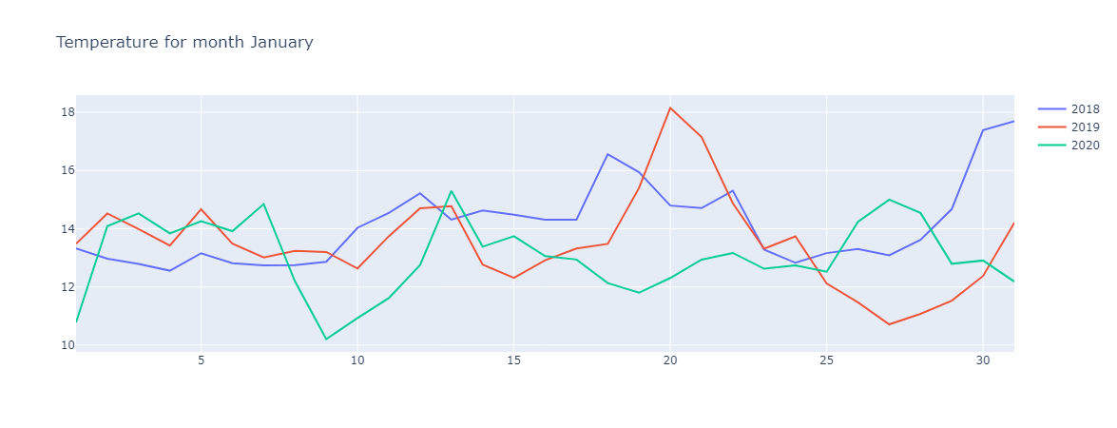 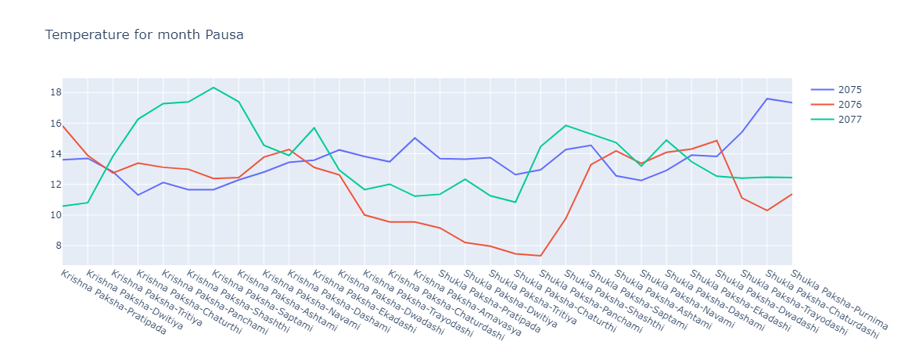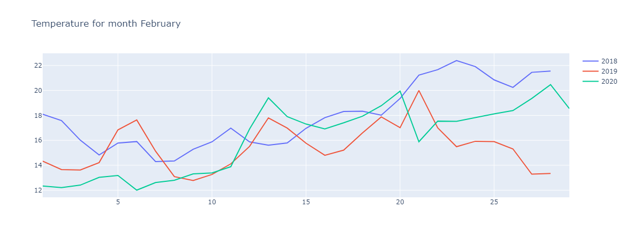 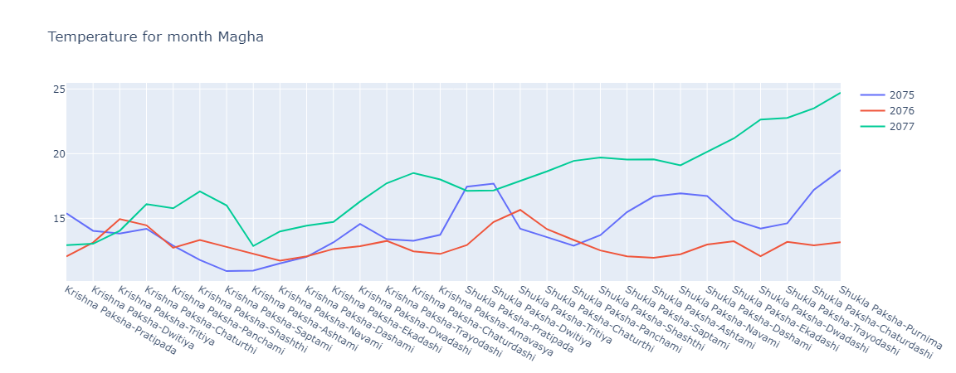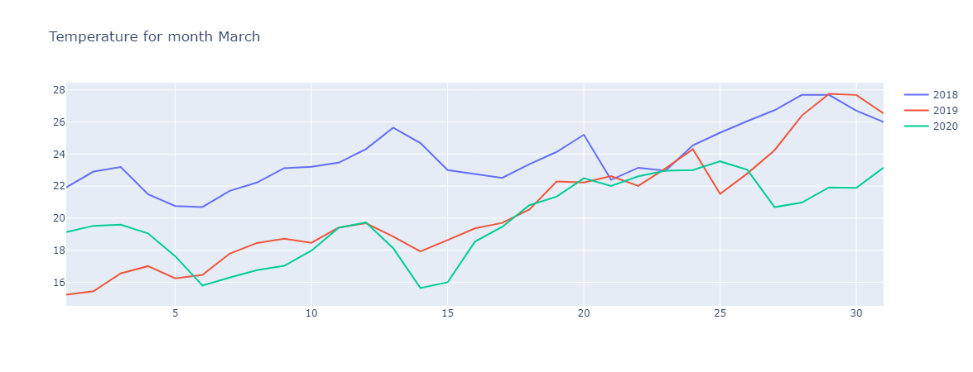 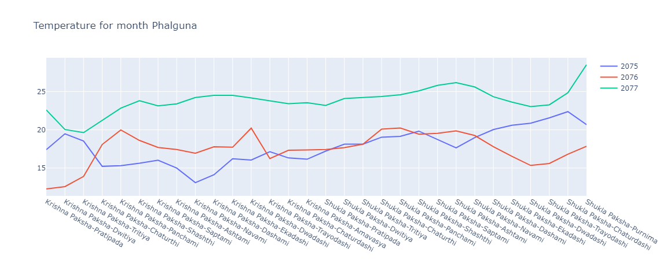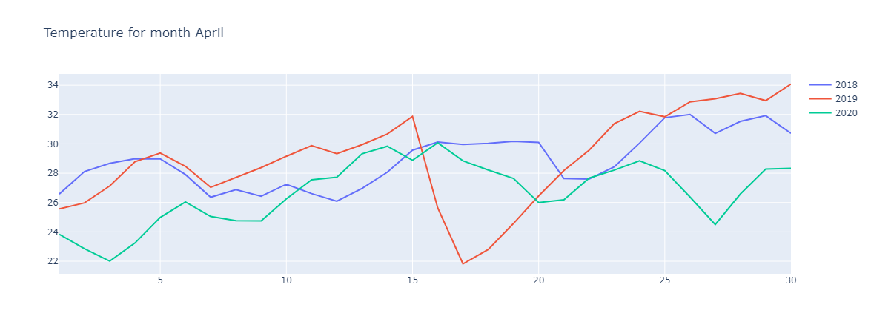 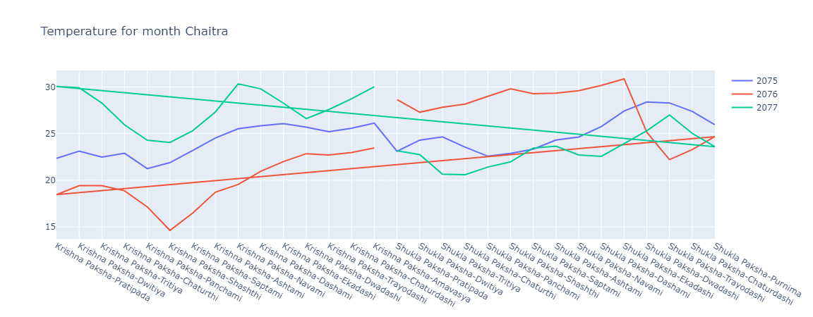

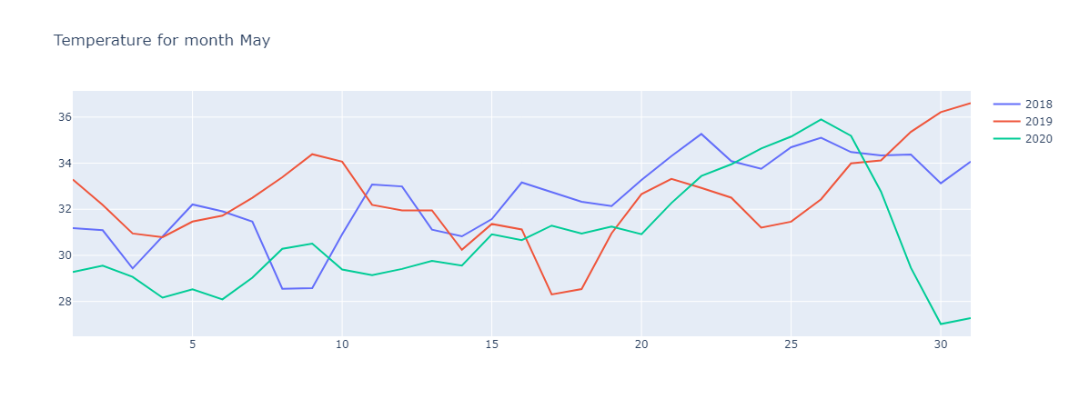 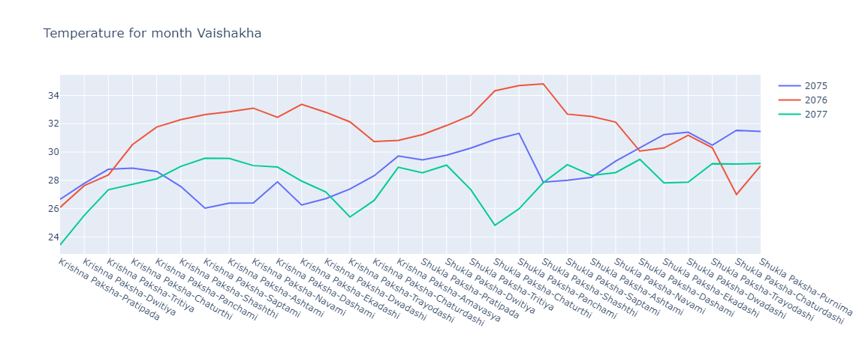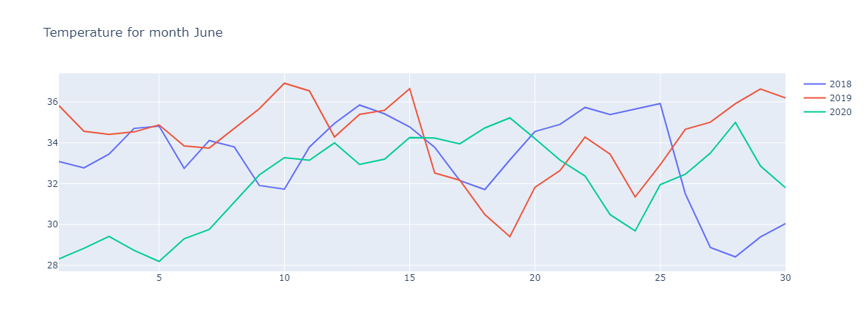 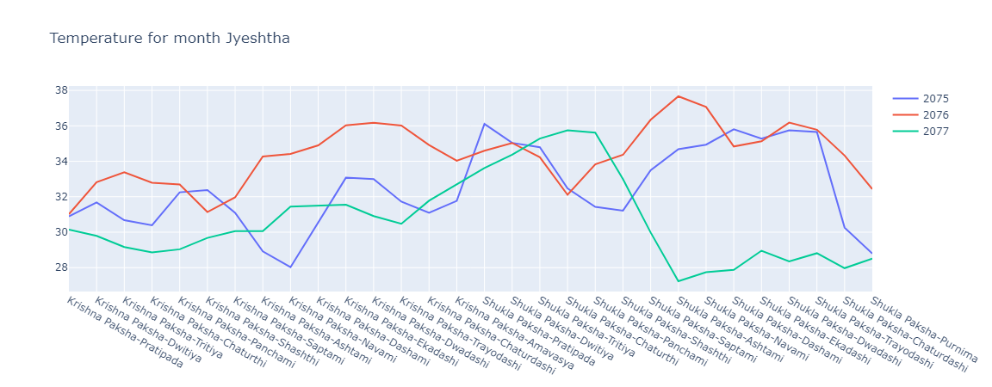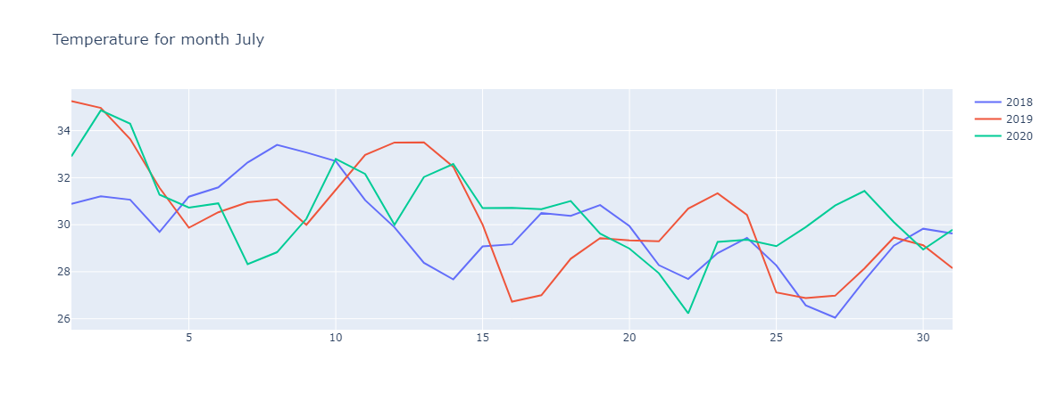 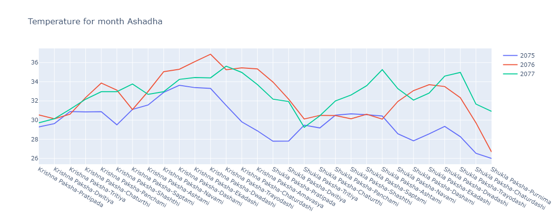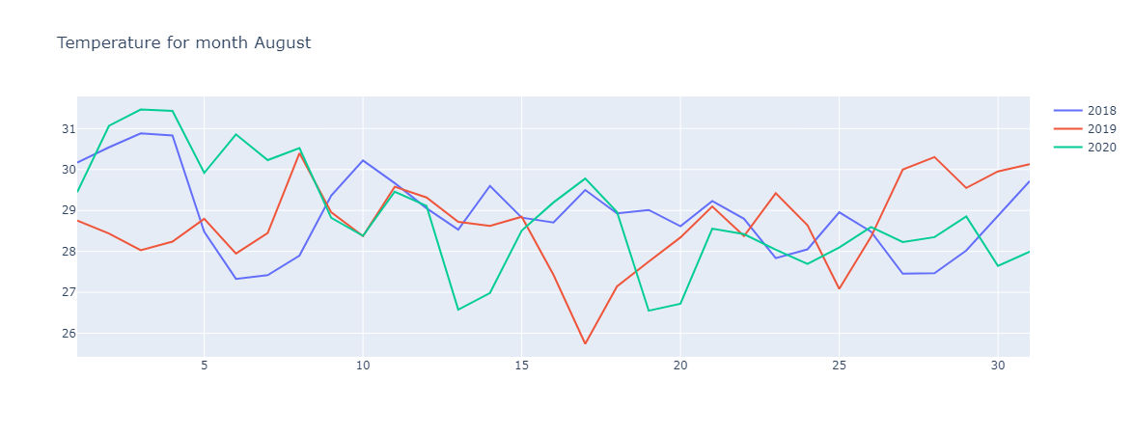 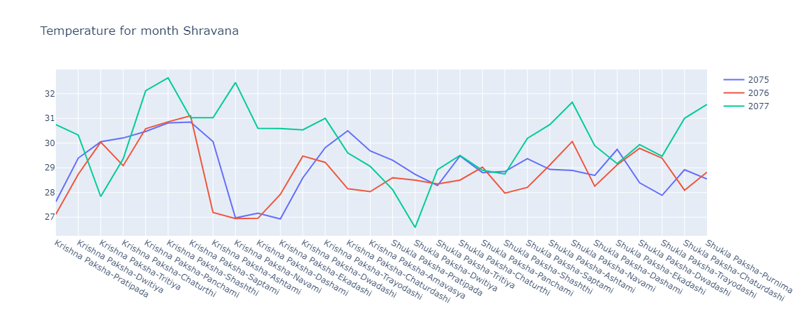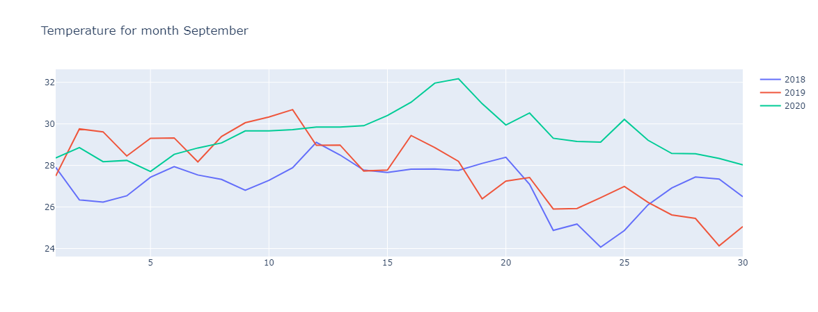 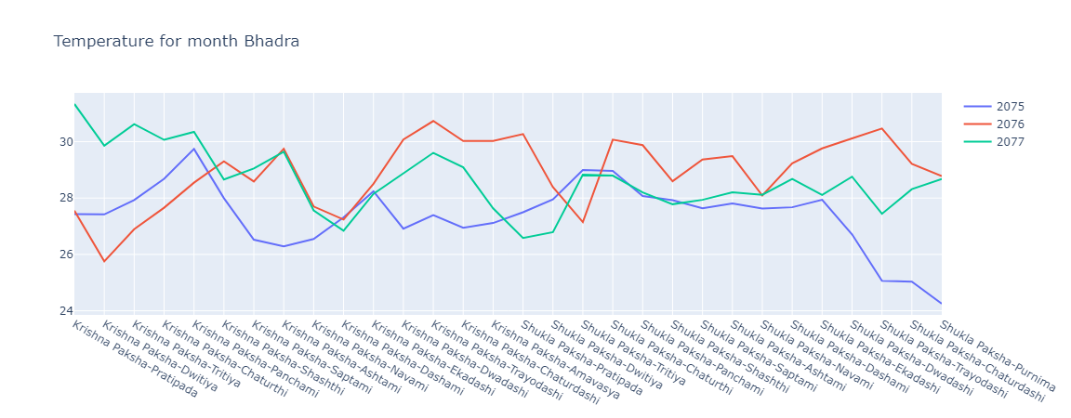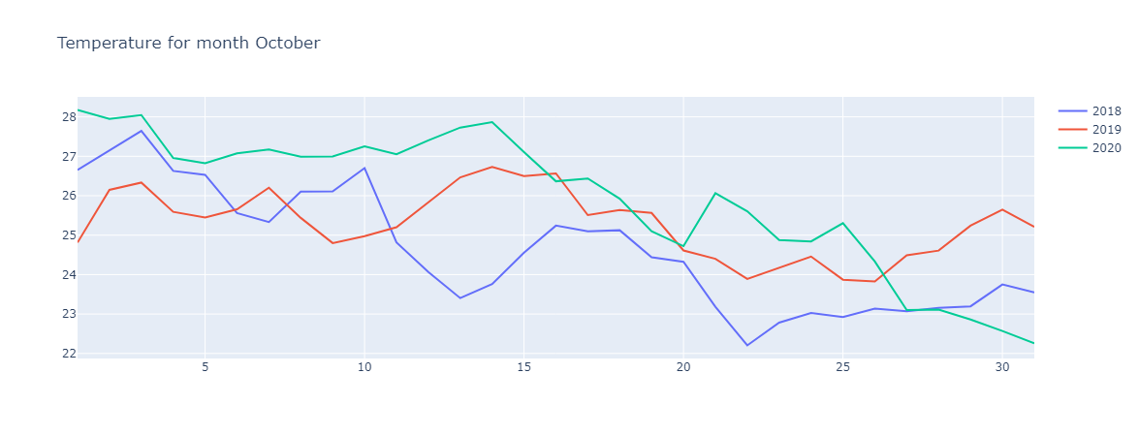 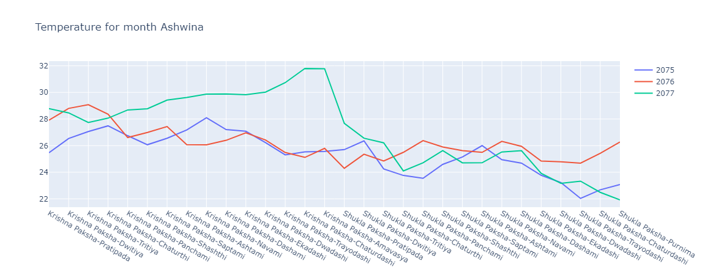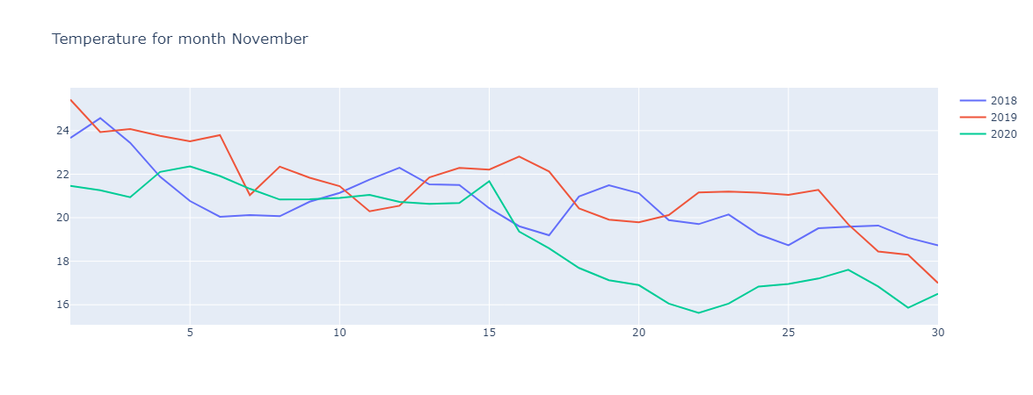

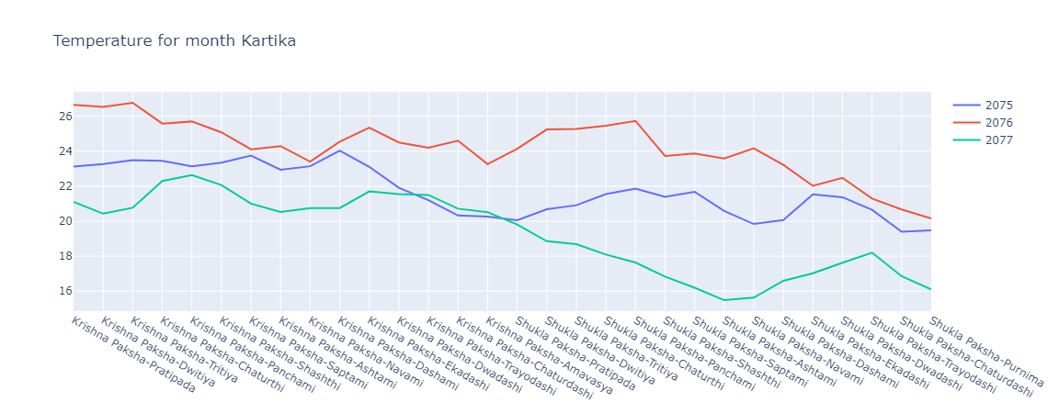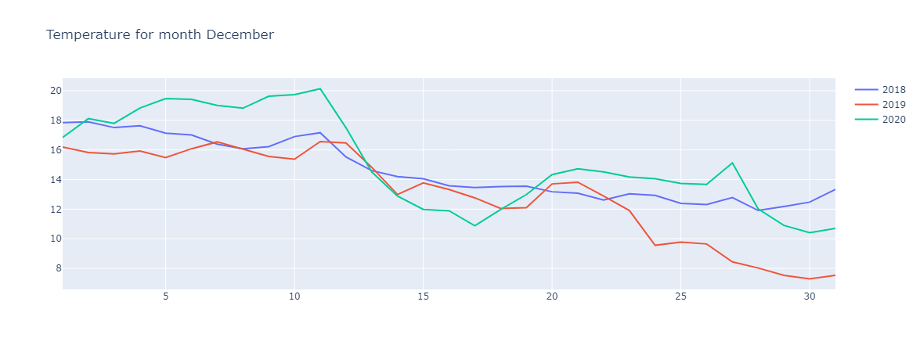

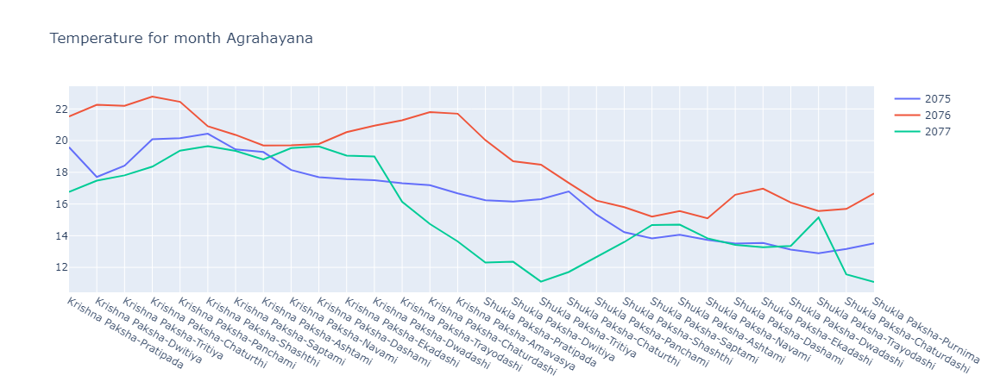

**8. Future Scope**

Comparative Analysis of Other Climatic Variables: Expand the scope of the study by analyzing the stability and consistency of other climatic variables, such as wind speed, precipitation, solar radiation, or atmospheric pressure, in the Hindu Vikram Samvat calendar and the English calendar. This broader analysis would provide a more comprehensive understanding of the overall climate stability in different calendar systems.

1. Regional Analysis: Consider conducting a regional analysis to explore whether the observed higher consistency in temperature and dew point measurements in the Hindu Vikram Samvat calendar holds true across different geographical regions. Investigate the impact of regional climate variations on the stability of these variables within each calendar system.
2. Long-Term Analysis: Extend the study to examine the stability of temperature and dew point measurements over a longer time period, spanning several decades or even centuries. This long-term analysis would provide insights into the consistency and stability of climate patterns within each calendar system over a more extended period, considering potential climate change effects.
3. Comparative Analysis with Other Calendar Systems: Explore the stability of temperature and dew point measurements in other traditional or cultural calendar systems and compare them to the Hindu Vikram Samvat calendar and the English calendar. Investigate if the findings regarding the stability of temperature and dew point are unique to the Vikram Samvat calendar or common across different traditional calendar systems.
4. Factors Influencing Calendar Stability: Investigate the underlying factors that contribute to the observed differences in stability between the Hindu Vikram Samvat calendar and the English calendar. Factors such as astronomical events, cultural practices, or climate knowledge embedded in the calendar systems may play a role in the stability of climate variables.
5. Validation and Verification: Conduct a validation study by comparing the temperature and dew point measurements from the Vikram Samvat calendar and the English calendar with ground-based weather stations or other reliable climate datasets. This validation process would enhance the credibility of the findings and validate the consistency of the calendar-based measurements.
6. Application in Climate Modeling: Explore the potential application of the Hindu Vikram Samvat calendar's stable temperature and dew point measurements in climate modeling and forecasting. Investigate how incorporating calendar-based data can improve the accuracy and reliability of climate models for specific regions or applications.

These future research directions would further enhance our understanding of the stability and consistency of climate variables in different calendar systems, shedding light on the potential benefits and applications of traditional or cultural calendars in climate-related studies.

**9. References**

[1] https://open-meteo.com/en/docs/historical-weather-api

[2] https://api.prokerala.com/docs

[3] Ghorpade-Aher, J., Wadkar, A., Kamble, J., Bagade, U., & Pagare, V. (2018, August). Smart dustbin: An efficient garbage management approach for a healthy society. In *2018 International Conference on Information, Communication, Engineering and Technology (ICICET)* (pp. 1-4). IEEE.

[4] An Introduction to Logistic Regression: From Basic Concepts to Interpretation with Particular Attention to Nursing Domain.

[5] Park, H. A. (2013). An introduction to logistic regression: from basic concepts to interpretation with particular attention to nursing domain. *Journal of Korean Academy of Nursing*, *43*(2), 154-164.

[6] https://towardsdatascience.com/svm-and-kernel-svm-fed02bef1200

[7] https://www.javatpoint.com/machine-learning-support-vector-machine-algorithm

**Appendix A**

**A.1**