Guardrailed Agentic MLOps for Self-Adaptive Energy Forecasting in Renewable-Integrated Smart Grids
Project Report submitted in the partial fulfilment of
Research Methodology
by
Pratham Kapoor
Saransh Naruka
Ritesh Pandey
Moinuddin Shaikh
Javin Sharma
Under the Guidance of
Dr. Meenal Mategaonkar
SVKM’s NMIMS University
(Deemed-to-be University)

Vile Parle (W), Mumbai – 56
Guardrailed Agentic MLOps for Self-Adaptive Energy Forecasting in Renewable-Integrated Smart Grids
Pratham Kapoor, Saransh Naruka, Ritesh Pandey, Moinuddin Shaikh, Javin Sharma
Mukesh Patel School of Technology Management & Engineering
SVKM’s NMIMS University, Mumbai, India

Abstract
Prediction of load, wind generation and PV generation in the renewable-integrated smart grid is not a single modelling problem. Once deployed, operating conditions evolve and measurements/timings of the lifecycle around the model execution need to be tracked and controlled for accuracy to be maintained. Most of the published research is only up to offline accuracy, one question remains: How can an agent participate in lifecycle decisions without becoming a final decision maker on high impact decisions? Addressing it, we developed an agentic machine-learning operations (MLOps) framework comprising two components: evidence collection and evidence-synthesis via an agent recommending only. The deterministic governance layer approves or rejects each retrain, promotion, or rollback, as well as creates or adds an audit trail record of the decision. The framework is built on top of the RTS-GMLC dataset, helps loading a wind and PV target at a primary work H24 and secondary work H1, has a staged and reproducible development protocol, experiment tracking, a model registry and drift-aware monitoring. Based on the key quantitative findings listed below, we conclude that [main conclusion to be inserted, once results have been confirmed]. The contribution is a reusable reference design in which help from agents and life cycle authority are separated.
Keywords: smart grid; energy forecasting; MLOps; agentic AI; concept drift; AI governance

Introduction
A new reality is that is power systems with renewable integration more difficult to run. The reality is that power systems with renewable energy are more complicated to run. Wind output and PV output is subject to the weather; load is a different story and depends according to its temporal and behavioural pattern. All three are thus possible to predict by AI techniques, which is an ongoing research area [1]. But a forecasting model isn’t ready for use when training completes. Changes in consumption behaviour, variations in weather patterns, mix changes in the generation fleet and distributions of inputs gradually cease to correspond to the data fed to the model. This mismatch is addressed through a problem called concept drift [2]. A model is only a singular component of a long-term production-based machine learning solution; the infrastructure on which it sits and the monitoring and updating processes account for much of the cost of the latter [3]. Therefore, machine learning operations (MLOps) comes into the picture to unify experiment tracking, model registry, deployment, monitoring and retraining and provide a managed lifecycle of machine learning.
The literature on forecasting has moved away from statistical and classical machine-learning techniques to deep architectures. A long short-term memory (LSTM) network was found to perform better than a back-propagation network with a MAPE of 44.06% compared to 49.49% for individual residential loads [5, 6]. A CNN–LSTM model performed better than the LSTM in all of 9 input–output configurations tested, and included as part of the hybrid [6]. In longer testing time horizons, a Transformer that has been fine-tuned for load & calendar performance achieved a mean MAPE of 10.18% compared to 11.40% for Seq2Seq [7]. A one-layer linear model “DLinear” was later demonstrated to be superior on an electricity benchmark, a reminder not to expect more performance from deep models, in this case variants of Transformers. Probabilistic deep learning models, which provide prediction intervals rather than point estimates, reduced the RMSE value in a household dataset from 0.081 to 0.025 with the price of quite high training and deployment cost [9].
We found 5 gaps were consistent for all 44 sources we looked at. The evidence is from one winter, one utility or one fixed benchmark and is not yet robust across seasons or regions. The point forecast is the main concern, and interval quality is little, if perhaps even never, used. There is an under reporting on Runtime, memory, compute cost. Model training and testing is done offline, so there remains an underexplored challenge with drift detection and safe updates. Monitoring, rollback, failure handling and oversight are missing from the picture as well, with test accuracy being the endpoint. This paper focuses on the two latter circumstances. Degraded forecast investigation could be aided by the reasoning over evidence and by using tools, in addition to drafting recommendations, in an agentic AI system. Nevertheless, the authority to train, promote or rollback creates another operational danger in giving it a role in such operations. An open question that remains is how agentic reasoning can participate in the machine learning lifecycle (without being the last decisionmaker of high impact actions).
In this research, it is intended that a forecasting foundation is constructed for load, wind and PV on RTS-GMLC, that it is embedded in an experiment tracking- this lets experiments be copied, stored and monitored- model registry- this allows the capacity to store models and have access to them when needed, without sacrificing their deterministic nature, deployment, monitoring and drift detection- this is provided to give a productive life to the model, allowing for deployment and monitoring while maintaining its deterministic nature, and guardrailed agent, who will be restricted to recommending trends and placed under deterministic governance- this will mean that experiments still carry the same deterministic capability even in the presence of a guardrailed agent. We hypothesize that one of such agents can bring investigatory value without ever stopping the decision authority of the governance layer.

Methodology
The study was carried out in a four stages pipeline as indicated in Figure 1. The research gap was identified and the scope was set through a survey of 44 unique sources, 5 of which were studied in detail. This then proceeded through a forecasting foundation, controlled model development, an MLOps lifecycle and agentic governance, before being evaluated together. The audited lifecycle actions make the adopted model re-enter into the deployment and monitoring lifecycle.
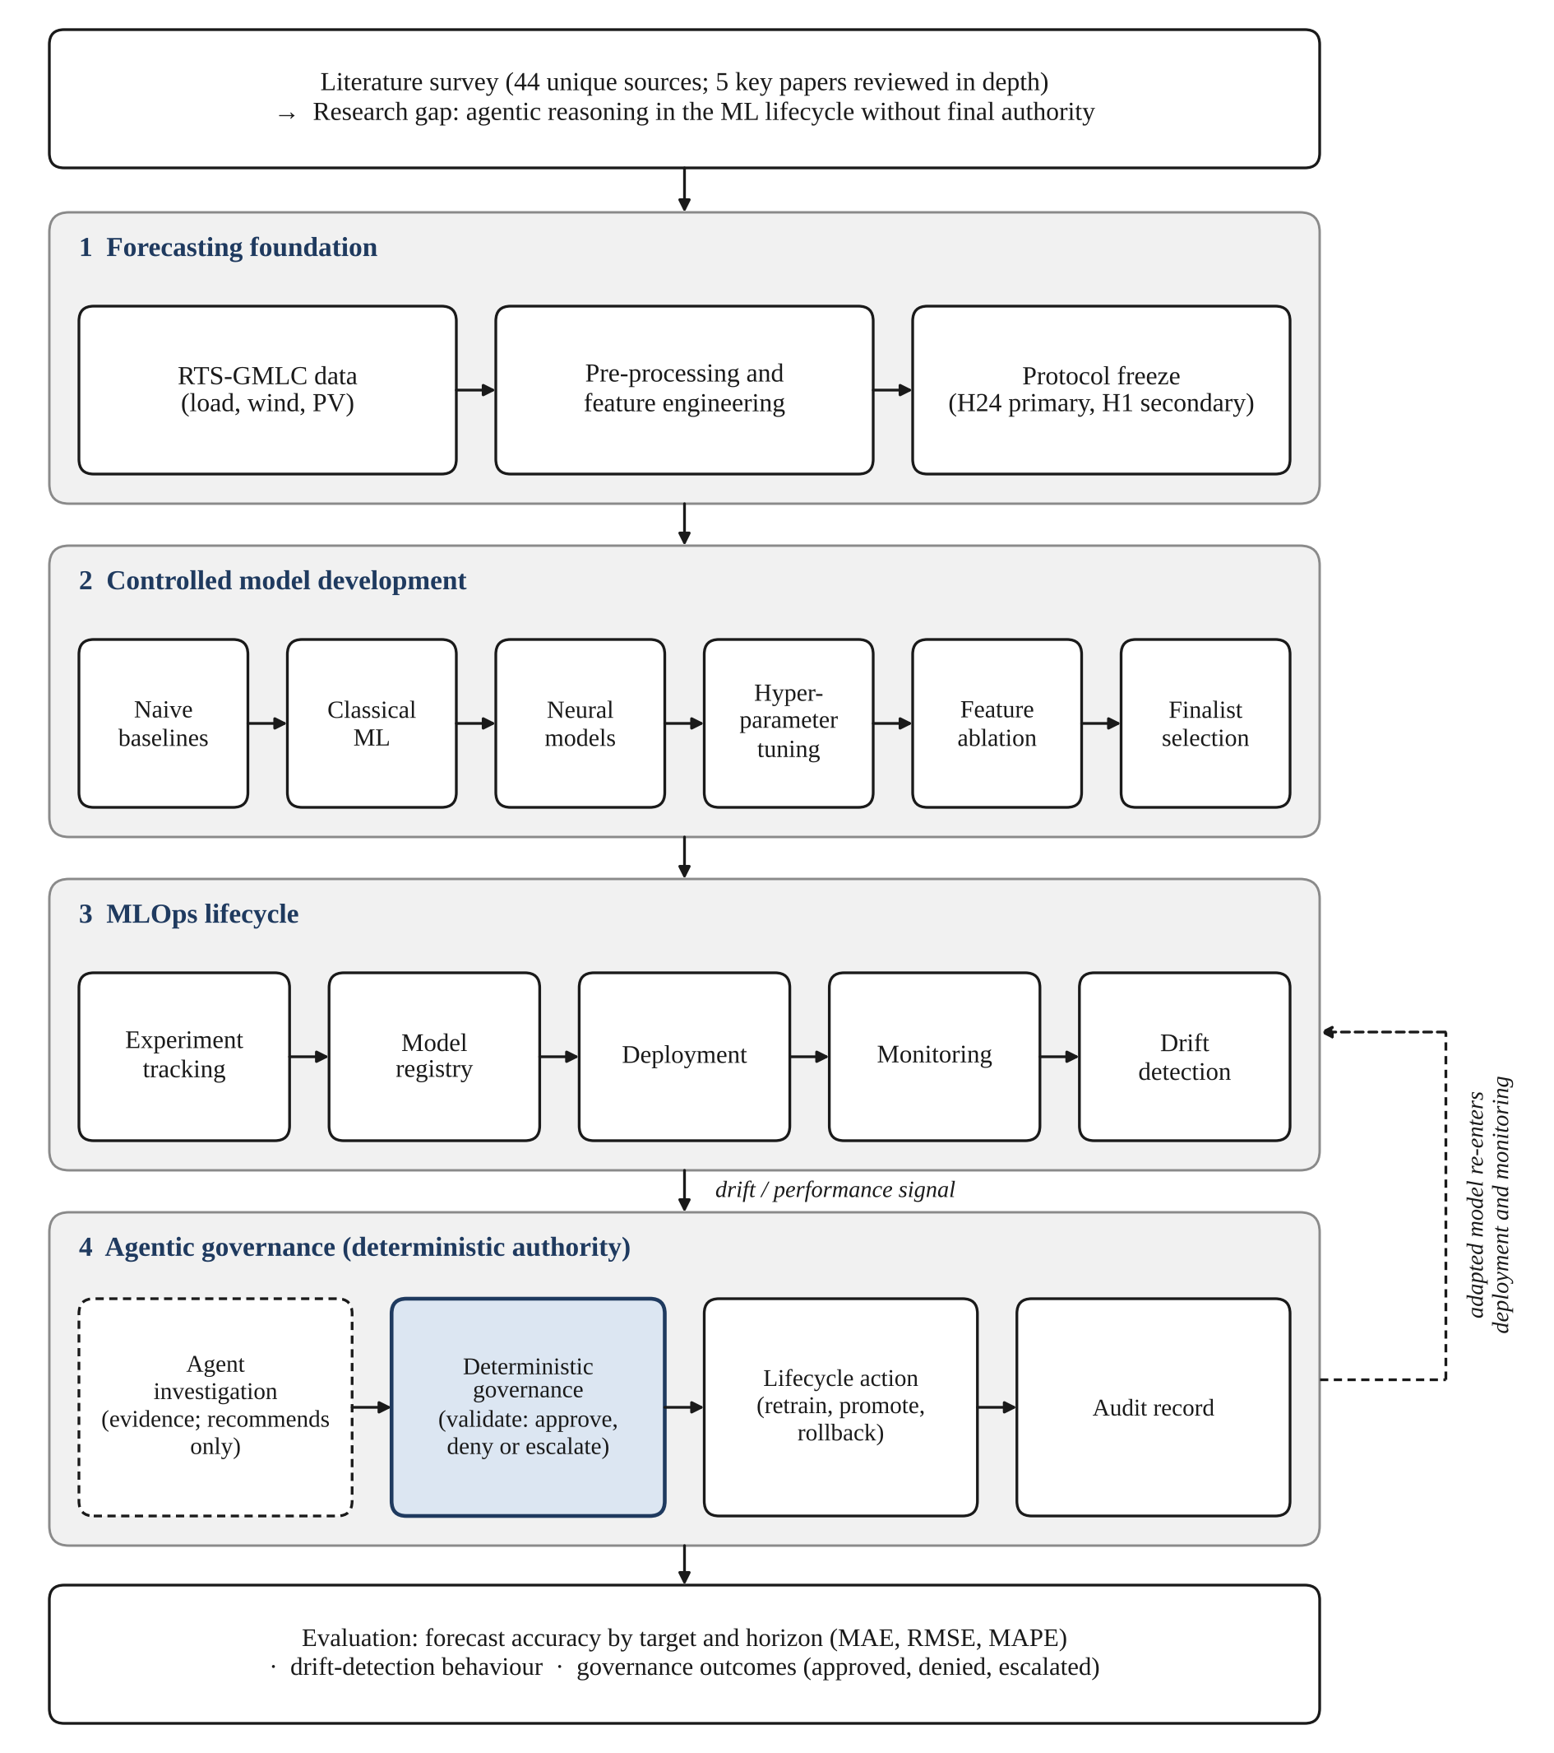
Figure 1. Flowchart of the guardrailed agentic MLOps framework mentioned in the research process.
Data are obtained from public dataset RTS-GMLC [10] that contains the load, wind and PV time series of a reference power system. There are three targets of which each is predicted at two horizons: primary H24 and secondary H1. There are 8,784 matched hourly observations for each target in the series with hourly resolution and applicable to calendar year 2020. Partitioning is always chronological and happens before each experiment, and is frozen. The scheme for model development is development/ training/ validation data; the final-test (sealed)/ 31 December 2020 – 1 November is a 1464 hours period. The feature set consists of just based on past observation: Lag blocks at 1, 24 and 168 hours; Calendar encodings; Rolling statistics. The scaling done on just the training period data is fit in the training pipeline. The published day ahead series is an external benchmark only, and is never used as a default feature of the model. The experimental protocol was finalized prior to the beginning of forecasting and thus all models were given the same data and splits.
The overall modeling process consisted of the following steps: naive baselines, classic machine-learning models, neural models, hyperparameter fine-tuning, feature ablation, and final model selection. A total of 20 runs were captured with MLflow; finalists were saved to a model registry with provenance and the best model was served on a monitored serving stage. There were signals of performance and drift monitored. If degradation was detected by the drift detector, adaptation might occur through retraining, promotion of a registered alternative or backtracking to a previous version.
The agent looks at evidence and provides back recommendations – they cannot make the decisions as the signal is raised. A deterministic governance layer validates data against fixed policy and approves, denies or escalates the data, and only 3 actions reach the lifecycle. Evaluation is based on the target and horizon (accuracy) and compares results: MAE, RMSE and MAPE and normalised variants (nMAE, nRMSE) in development, sMAPE. Sample size A sufficient sample size is required. [Statistical tests to be confirmed]

Case Studies
Case Study 1: Drift-triggered lifecycle episode.

Results and Discussion

Results
Results are presented in the Results Table 1 for each target and horizon for the held-out test period, using the accuracy resulting from the finalist model.
Table 1. The percentage of target and horizon accuracy for those that advanced to the final round.
Target | Horizon | Finalist model | MAE | RMSE | MAPE (%)
Load | H24 | [ ] | [ ] | [ ] | [ ]
Load | H1 | [ ] | [ ] | [ ] | [ ]
Wind | H24 | [ ] | [ ] | [ ] | [ ]
Wind | H1 | [ ] | [ ] | [ ] | [ ]
PV | H24 | [ ] | [ ] | [ ] | [ ]
PV | H1 | [ ] | [ ] | [ ] | [ ]
Table 2 collects the monitoring and drift-detection outcomes for the deployed model of each target.
Table 2. Drift detection and Adaptation outcomes.
Target | Drift events detected | Detection lag | Error before action | Error after action
Load | [ ] | [ ] | [ ] | [ ]
Wind | [ ] | [ ] | [ ] | [ ]
PV | [ ] | [ ] | [ ] | [ ]
The governance actions corresponding to the Target Drift events are shown in Table 3; the aggregated error over time is shown in Figure 2.
Table 3. Governance decisions relating to agent recommendations.
Lifecycle action | Recommended | Approved | Denied | Escalated
Retrain | [ ] | [ ] | [ ] | [ ]
Promote | [ ] | [ ] | [ ] | [ ]
Rollback | [ ] | [ ] | [ ] | [ ]
Total | [ ] | [ ] | [ ] | [ ]
The rolling forecast error per target will be colour coded and lifecycle action flags will be shown, as in Figure 2.

[Insert Figure 2: rolling forecast error per target, with drift flags and lifecycle actions marked]
Figure 2. Tracked forecasted error and bared drift flags/lifecycle actions.

Discussion
Compared to the literature, these are compared to the improvement achieved by other hybrid and attention-based architectures over LSTM baselines [6], [7] and to the one-layer linear model that does not outperform Transformers, [8]. These results relate to the offline-evaluation gap that was identified in the Introduction, favouring more complex models or appreciating the advantage of simple models (offline evaluation gap being motivated to either increase complexity or appreciate advantage of simple models), and [explain why offline evaluation gap is motivated to either increase complexity or appreciate advantage of simple models.]
Under the question is whether the agent added something useful to the investigation given deterministic lifecycle authority, and whether there was a cost trade-off that is comparable to the one reported for probabilistic models [9]; that is, what it has revealed about the usefulness of the agent, either in terms of usefulness or lack thereof.

Limitations
This study is based on only one publicly available benchmark. The first gap identified above is the status of generalisation across seasons, regions and types of consumers; the latter is not mentioned in RTS-GMLC. Only three targets and two horizons were studied, and the candidate models are not the entire literature, but cover the families implemented in our protocol.
The agent was evaluated under one governance policy and [agent configuration… to be specified], as a recommender only, in cases where it occurred naturally in the data, or have been introduced. The results do thus not imply anything about the behavior of the agent when he has the power to execute or the effects of alternative policies. The literature survey (44 sources) may still have overlooked the relevant literature.

Conclusion
In this paper, a guardrailed agentic MLOps lifecycle framework for self-adaptive forecasting of load, wind and PV in renewable-integrated smart grids is presented. The agent investigates and recommends: deterministic governance maintains a control on retrain, promotion and rollback decisions. [Major findings: summarise forecast accuracy, drift and adaptation, governance outcomes, key figures from the Results.] The framework provides an audit trail for operators that establishes a pattern for ensuring that all LCO lifecycle actions can be traced to evidence and a governance decision. For operators that implement assistive agents, our advice is to maintain life-cycle decisions that are under deterministic, an auditable control. Future work should involve further evaluation with other datasets, seasons, regions and uncertainty-aware forecasts, and also to computational cost.

Acknowledgements

References
[1] J. Arifin, A. Aziz, and S. Akhter, “AI-based energy forecasting for smart grids with renewable integration,” J. Comput. Sci. Technol. Stud., vol. 7, no. 4, pp. 461–480, 2025, doi: 10.32996/jcsts.2025.7.4.55.
[2] J. Gama et al., “A survey on concept drift adaptation,” ACM Comput. Surv., vol. 46, no. 4, 2014, doi: 10.1145/2523813.
[3] D. Sculley et al., “Hidden technical debt in machine learning systems,” in Proc. Adv. Neural Inf. Process. Syst. (NeurIPS), 2015.
[4] D. Kreuzberger et al., “Machine learning operations (MLOps): Overview, definition, and architecture,” arXiv:2205.02302, 2022.
[5] W. Kong, Z. Y. Dong, Y. Jia, D. J. Hill, Y. Xu, and Y. Zhang, “Short-term residential load forecasting based on LSTM recurrent neural network,” IEEE Trans. Smart Grid, vol. 10, no. 1, pp. 841–851, 2019, doi: 10.1109/TSG.2017.2753802.
[6] M. Alhussein, K. Aurangzeb, and S. I. Haider, “Hybrid CNN-LSTM model for short-term individual household load forecasting,” IEEE Access, vol. 8, pp. 180544–180557, 2020, doi: 10.1109/ACCESS.2020.3028281.
[7] A. L’Heureux, K. Grolinger, and M. A. M. Capretz, “Transformer-based model for electrical load forecasting,” Energies, vol. 15, no. 14, p. 4993, 2022, doi: 10.3390/en15144993.
[8] A. Zeng, M. Chen, L. Zhang, and Q. Xu, “Are transformers effective for time series forecasting?,” in Proc. AAAI Conf. Artif. Intell., 2023, arXiv:2205.13504.
[9] D. Kaur et al., “Energy forecasting in smart grid systems: Recent advancements in probabilistic deep learning,” IET Gener. Transm. Distrib., vol. 16, pp. 4461–4479, 2022, doi: 10.1049/gtd2.12603.
[10] GridMod, “RTS-GMLC,” GitHub repository. [Online]. Available: https://github.com/GridMod/RTS-GMLC

