Guardrailed Agentic MLOps for Self-Adaptive Energy Forecasting in Renewable-Integrated Smart Grids
Project Report submitted in the partial fulfillment of
Research Methodology
by
Pratham Kapoor
Saransh Naruka
Ritesh Pandey
Moinuddin Shaikh
Javin Sharma
Under the Guidance of
Dr. Meenal Mategaonkar
SVKM’s NMIMS University
(Deemed-to-be University)

Vile Parle (W), Mumbai – 56
Guardrailed Agentic MLOps for Self-Adaptive Energy Forecasting in Renewable-Integrated Smart Grids
Pratham Kapoor, Saransh Naruka, Ritesh Pandey, Moinuddin Shaikh, Javin Sharma
Mukesh Patel School of Technology Management & Engineering
SVKM’s NMIMS University, Mumbai, India

Abstract
Prediction of load, wind and photovoltaic (PV) generation in a renewable-integrated smart grid is not a single modelling problem: once deployed, operating conditions evolve, and the lifecycle around a model must be monitored and controlled for accuracy to hold. Most published studies stop at offline accuracy, which leaves one question open: how can an agent take part in lifecycle decisions without becoming the final authority over high-impact actions? To answer it, we built a guardrailed agentic machine-learning operations (MLOps) framework in which an agent investigates monitoring evidence and issues recommendations only, while a deterministic governance layer approves, denies or escalates every retrain, promotion or rollback and records each decision in an audit trail. The framework was evaluated on the RTS-GMLC dataset for load, wind and PV at a primary H24 and a secondary H1 horizon, with a reproducible protocol, experiment tracking, a model registry and drift-aware monitoring. Only the PV finalist beat its benchmark on the sealed test (36.12 against 39.09 MW); governed retraining cut drifted-window load MAE from 609.85 to 423.79 MW but did not improve the clean-data counterfactual; and all 32 lifecycle requests were decided deterministically, 19 of them denied, with agent-assisted decisions matching deterministic decisions in all eight comparison scenarios. The contribution is a reusable reference design to ensure agentic assistance and lifecycle authority remain separate.
Keywords: smart grid; energy forecasting; MLOps; agentic AI; concept drift; AI governance

Introduction
Power systems are more challenging to operate with the integration of renewables: wind and PV output is dependent on the weather, while demand has its own temporal and behavioural patterns. The task is real; the reference system in this study generates 8,784 load, wind and PV hourly values for a single year, which all the system operators have to predict for balancing and scheduling (Arifin et al., 2025). However, when the training is complete, a forecasting model isn’t finished. This is called concept drift (Gama et al., 2014) when the consumption behaviour is changing, the weather regimes are changing, the generation mix is changing and the input distributions a model learned from, no longer match the data the model receives. Monitoring, updating and infrastructure surrounding the model is a significant fraction of the cost of a production machine-learning system (Sculley et al., 2015). The answer to this is machine learning operations (MLOps), designed to bring experiment tracking, model registries, deployment, monitoring and retraining under one roof (Kreuzberger et al., 2023).
Transition from statistical and classical machine-learning models towards deep architectures in forecasting methods. An LSTM network was used to enhance the short-term residential load forecasting, and compared with a back-propagation network, it was found to have a MAPE of 44.06% versus 49.49% for individual residential load forecasts (Kong et al., 2019). A hybrid CNN–LSTM was then proposed and compared with LSTM alone in all nine input–output settings, where it outperformed LSTM in all cases with the average error for a single home being close to 40% (Alhussein et al., 2020). In longer horizons a Transformer trained to load and calendar achieved a mean MAPE of 10.18% (L’Heureux et al., 2022) while Seq2Seq (L’Heureux et al., 2022) obtained a MAPE of 11.40%. Probabilistic deep learning, which produced prediction intervals rather than prediction values, reduced the RMSE for a dataset about households from 0.081 to 0.025, but at significantly higher cost for training and deployment (Kaur et al., 2022).
The evidence is less robust for renewable integrated systems, in particular. A one-layer linear model (DLinear) performed better than the variants of Transformer on an electricity benchmark, reminding us that it is not necessary to be deep to be good (Zeng et al., 2023). Five gaps we found were common across the 44 sources surveyed: evidence from one winter, with robustness across seasons and regions yet to be proven; point forecasts dominating while interval quality is not often considered; runtime and memory/compute cost under-reported with no evaluation of the quality of intervals; models trained and tested offline, leaving drift detection and safe updating under-explored; testing accuracy treated as the end game, with monitoring, rollback, failure handling, and oversight under-researched. This paper focuses on the latter two of these. An agentic AI system that reasons about evidence, utilises tools, and makes recommendations may be able to investigate degraded forecasts, but allowing the system to train, promote, or rollback is an unknown operational risk. The open question is how agentic reasoning can join the machine learning lifecycle without serving as the ultimate decision maker on high impact actions in the lifecycle.
In this research, it has been proposed to create a reproducible forecasting base for load, wind and PV on the RTS-GMLC set, provide it with an MLOps lifecycle with experiment tracking, model registry, deployment, monitoring, and drift detection, and assess if adding an agent with a guardrail, only allowed to provide recommendations, and placed under deterministic governance, would provide investigative value while maintaining deterministic governance. It is speculated that such an agent can be used for lifecycle work, but would not change the final governing control.

Methodology
The study was conducted in four stages as illustrated in Figure 1. A research gap was identified and scope was set by surveying 44 unique sources, five of which were studied in detail. The process then followed a common forecasting foundation, a controlled model development, a lifecycle of MLOps, and an agentic governance, ending up with a joint evaluation. All lifecycle actions are reviewed and an adapted model returns to deployment/monitoring.
The public RTS-GMLC data (GridMod, n.d.) was used for data, providing load, wind and PV time series for a reference power system. A primary horizon (day-ahead) and a secondary horizon (next hour) were both forecasted for each target. The series are at hourly resolution and span the calendar year 2020 yielding 8,784 matched hourly data per target. There was chronological partitioning before any experiment (1 January - 31 August 2020) and a frozen validation (1 September - 31 October 2020) and a sealed final-test partition (1 November - 31 December 2020, 1,464 hours). Training and validation data were used for development decisions, using a six-fold rolling-origin scheme and after the candidate configuration was frozen, the sealed test was read in an authorised final-evaluation mode. No features used information not available at the time of prediction — Only lag blocks at 1, 24, 168 hours, calendar encodings and rolling statistics were built. Only data collected during the training period was used to fit the scaling. The publication of the day-ahead series has been used as an external benchmark, and has never been used as a default model feature.
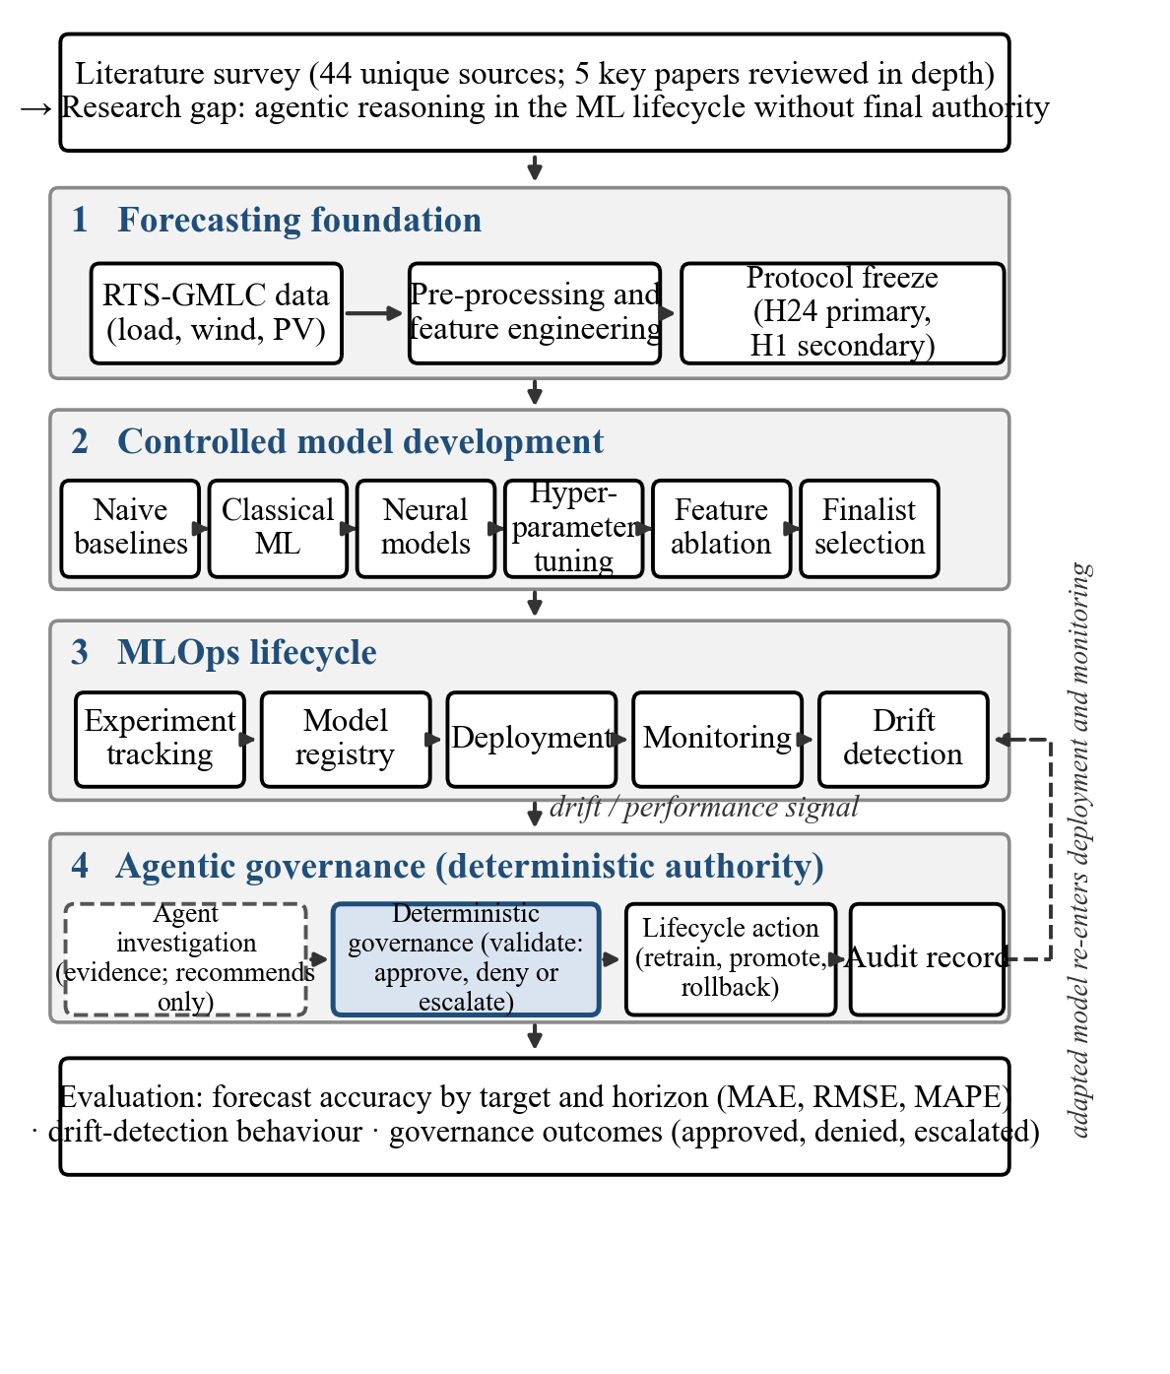
Figure 1. Flowchart of a guardrailed agentic MLOps design.
Model development proceeded from naive baselines to classical machine-learning models, neural models, hyperparameter tuning and feature ablation and finalist selection. The classical candidates were ridge regression, random forest, extra trees and histogram gradient boosting candidates, while the neural track trained models of MLP, LSTM and GRU on 168 hours of input sequences. The hyperparameters were taken from a frozen tuning protocol that had never been exposed to the test partition; the random seeds were set (42 for the classical models) and all runs were logged using MLflow — the frozen final evaluation yielded three official runs, one for each target. Finalists (random forest for load and PV, histogram gradient boosting for wind) were registered and deployed to a monitored serving stage with full provenance. For each weekly window with a stride of one day, compute a population stability index and a Wasserstein distance, normalised by a reference window, for each feature block, as well as a rolling MAE performance signal. Thresholds were based on the 99th percentile of reference-window statistics and were defined as NONE, WATCH, WARNING and CRITICAL in proportion to the number and intensity of monitors that were triggered. The monitoring was based on observation only, alerts were proofs for the agent and for humans, but not as triggers for the lifecycle.
A signal was raised and the agent examined the evidence and returned a recommendation, but was not empowered to do anything. Each request was checked against a set of rules and approved, denied or escalated by a deterministic governance layer, and only actions that were approved made it to the lifecycle. Five advisory recommendation types (investigate, summarise, explain, request human review, create report) were intercepted and audited by the agent, with seven lifecycle action types being intercepted and audited. The 12 gates in governance were ordered, and each had a fingerprint of the respective participants, including their registration fingerprint, lineage fingerprints, model fingerprints, feature fingerprints, protocol compatibility, evaluation, benchmark, statistical evidence and approval, and sealing. All decisions were sealed with a fingerprint using the hash function SHA-256. During development, the accuracy was assessed using target and horizon accuracy metrics: MAE, RMSE and sMAPE, in addition to variants of these metrics normalised by target or horizon: nMAE, nRMSE. The differences in forecasts were evaluated using paired Diebold–Mariano statistics (lag 23 Newey–West) and Holm–Bonferroni correction at the 0.05 level.

Case Studies
Case Study 1: Drift-triggered lifecycle episode (load, H24, scenario A15-01, HIGH severity). Injected feature drift raised a CRITICAL alert at the first monitored window (1–8 August 2020), triggered by all four detector families: feature, prediction, performance and error-distribution drift. The drift-analysis agent (v1.0.0, rule-based) examined the alert evidence and issued an advisory recommendation summarising the triggered detectors and signal values; it could not execute any action. The deterministic retraining policy (v15.0.0) validated the request against the frozen eligibility rules and returned ALLOW (RETRAINING_ALLOWED), after which retraining job RET-JOB-A15-01-HIGH-load completed with the frozen hyperparameters and seed. The retrained challenger was registered — never promoted — and on the 336-hour drifted evaluation window load MAE fell from 609.85 to 423.79 MW (30.5%); on the clean counterfactual window (15–29 August) it rose from 289.62 to 337.54 MW, a 16.5% stability loss.

Results and Discussion

Results
Table 1 reports finalist accuracy by target and horizon. H24 rows are the sealed final-test partition (n = 1,464); H1 rows are rolling-origin validation, because the sealed test was evaluated at the primary horizon only. Final-test conclusions below are therefore restricted to H24.
Table 1. Finalist forecast accuracy by target and horizon (MAE and RMSE in MW; sMAPE in %).
Target | Horizon | Finalist model | MAE (MW) | RMSE (MW) | sMAPE (%)
Load | H24 | Random forest (sealed test) | 174.26 | 231.27 | 4.72
Load | H1 | Random forest (validation) | 77.81 | 104.31 | 1.90
Wind | H24 | Hist. gradient boosting (sealed test) | 778.84 | 923.37 | 92.40
Wind | H1 | Hist. gradient boosting (validation) | 78.05 | 124.36 | 27.22
PV | H24 | Random forest (sealed test) | 36.12 | 82.08 | 117.73
PV | H1 | Random forest (validation) | 25.52 | 51.01 | 105.21
PV sMAPE counts zero-generation nights symmetrically, which inflates it; restricted to the 671 daylight hours with non-zero generation, the sealed-test PV sMAPE falls to 20.51%. Against the benchmarks, only the PV finalist passed on the sealed test (36.12 against 39.09 MW persistence, Diebold–Mariano p = 0.438); the load and wind finalists were significantly worse than the published day-ahead forecast (p < 10⁻⁹, Holm-corrected).
Table 2 collects the monitoring and drift-detection outcomes for the deployed model of each target, from the 30-scenario injection study (nine drift families at three severities, plus uncontaminated controls).
Table 2. Drift detection and adaptation outcomes (governed retraining episode A15-01, HIGH severity; MAE in MW on the 336-hour drifted evaluation window).
Target | Drift events detected | Detection lag | Error before action | Error after action
Load | 27 / 27 injected | 0 h | 609.85 MW | 423.79 MW
Wind | 27 / 27 injected | 0 h | 553.64 MW | 437.78 MW
PV | 27 / 27 injected | 0 h | 330.10 MW | 39.71 MW
The detection record needs its design stated plainly: the injected perturbations were calibrated against the frozen 99th-percentile thresholds, and detection was evaluated on the same weekly windows, so the 0-hour lag means the alert fired at the first window covering the injected period. These results bound the detector’s sensitivity; they are not a field detection rate. No control scenario (D00 or the natural development windows) produced a pre-onset alert, i.e. no false positives were recorded. The before-and-after values come from the same 336-hour drifted window, so the comparison is matched; the clean counterfactual window (15–29 August) is reported in Figure 2(b) alongside, because refitting to drift costs stability on clean data.
Table 3 counts the governance decisions on lifecycle action requests: 15 retraining requests under the frozen retraining policy, 15 promotion-path requests and 2 rollback interventions under the governance scenario suite.
Table 3. Governance decisions on lifecycle action requests.
Lifecycle action | Recommended | Approved | Denied | Escalated
Retrain | 15 | 4 | 7 | 4
Promote | 15 | 3 | 11 | 1
Rollback | 2 | 1 | 1 | 0
Total | 32 | 8 | 19 | 5
Figure 2 tracks the rolling error during the highest-severity episode behind Table 2 (A15-01-HIGH), with the drift alert and the governed retraining marked, and shows the adaptation outcome on the drifted and clean windows side by side.
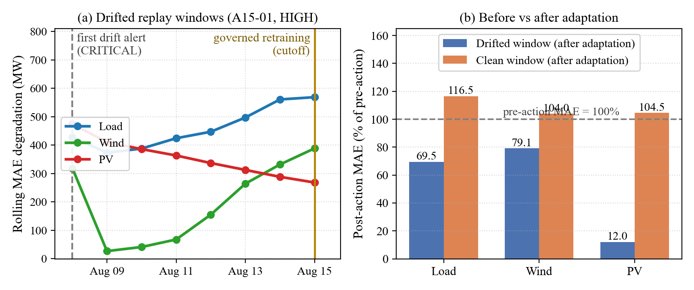
Figure 2. Scenario A15-01 (HIGH severity): (a) rolling MAE degradation with the first drift alert and the governed retraining marked; (b) post-adaptation MAE on the drifted and clean windows, relative to the pre-action model (100%).

Discussion
Table 1 confirms the benchmark-first discipline: on the sealed test the load and wind finalists lost to the published day-ahead forecast by 72% and 135% in MAE, while only the PV finalist beat persistence. Read against the literature, in which hybrid and attention-based architectures improved on LSTM baselines (Alhussein et al., 2020), (L’Heureux et al., 2022) and a one-layer linear model outperformed Transformer variants (Zeng et al., 2023), our results side with the second finding: the untuned neural track never approached the classical finalists on this dataset, and the LSTM and GRU sequence models were an order of magnitude worse. Complexity did not pay here, which matches the caution the DLinear result (Zeng et al., 2023) recommends.
Consider Table 2, which provides fast constructed detection, which means the informative quantity is the outcome of adaptation, and the cost. While Governed retraining did improve the drifted window for all three targets, the cost of the retraining is evident in the clean counterfactual - wind lost 4.0% and PV lost 4.5%, while the retrained load challenger was 16.5% poorer on clean data. Adaptation, therefore, should be evaluated on a regime-by-regime basis, rather than by simply looking at the headline improvements – in other words, the gap between the on- and off-line evaluations, as identified in the Introduction, is here being made visible in one framework.
Table 3 provides an answer to the central question. The governance layer blocked 19, allowed 8 and escalated 5 lifecycle requests across 32 lifecycle requests; no superior offline metric or agent recommendation overrode a block; and both rollback interventions showed a verified restoration and a blocked attempt. Results for the agent-versus-no agent comparison (Phase 18, eight scenarios) showed that agent-assisted decisions matched the deterministic-only decisions in all cases, and that the agent explanation workflows took about 5.0 s compared to 17.8 s for the deterministic-only ones (median 6.8 s), with complete and correct explanations and evidence references in both modes. The agent’s contribution was investigational; every high-impact decision remained under deterministic control.

Limitations
This study is based on a single public benchmark, from a single year. RTS-GMLC is a reference test system not an operational utility telemetry, and is not segmented and generalisation across seasons, regions and consumer types is untested. We studied only three targets and two horizons, with the H1 horizon only being assessed on validation data, and the candidate models are not the entire literature, but only those families implemented in our protocol. Table 2 contains the drift events, with perturbations applied to them so as to match the frozen thresholds; this doesn’t reflect the sensitivity of the detector, but rather its ability to detect the drift. The findings do not indicate that the agent has execution authority nor do they indicate whether other governance policies would have evaluated the agent as a recommender as well. Prediction-interval quality was not assessed, computational cost was tracked only for the logged runs, and the survey of the 44 sources may not have captured all the relevant work.

Conclusion
In conclusion, this paper introduced and assessed a guardrailed agentic MLOps lifecycle framework for self-adaptive forecasting of load, wind and PV in renewable-integrated smart grids. The agent investigated and recommended; deterministic governance retained authority over every retrain, promotion and rollback. On the sealed final test only the PV finalist beat its benchmark (36.12 against 39.09 MW), while the load and wind finalists lost to the published day-ahead forecast. Governed retraining cut drifted-window load MAE by 30.5% but cost 16.5% on clean data. Of 32 lifecycle requests, 19 were denied, 8 allowed and 5 escalated, and agent-assisted decisions matched deterministic decisions in all eight comparison scenarios while completing explanation workflows roughly three times faster. The contribution is a reusable reference design that keeps agentic assistance and lifecycle authority strictly apart, with an audit trail tracing every action to evidence and a governance decision. Our advice to operators adopting agentic assistance is to keep high-impact lifecycle decisions under deterministic, auditable control. Future work should extend the evaluation to other datasets, seasons and regions, to uncertainty-aware forecasts, to daytime-specific PV evaluation, and to the computational cost of the agent layer.

References
Alhussein, M., Aurangzeb, K., & Haider, S. I. (2020). Hybrid CNN-LSTM model for short-term individual household load forecasting. IEEE Access, 8, 180544–180557. https://doi.org/10.1109/ACCESS.2020.3028281
Arifin, J., Aziz, A., & Akhter, S. (2025). AI-based energy forecasting for smart grids with renewable integration. Journal of Computer Science and Technology Studies, 7(4), 461–480. https://doi.org/10.32996/jcsts.2025.7.4.55
Gama, J., Žliobaitė, I., Bifet, A., Pechenizkiy, M., & Bouchachia, A. (2014). A survey on concept drift adaptation. ACM Computing Surveys, 46(4), Article 44. https://doi.org/10.1145/2523813
GridMod. (n.d.). RTS-GMLC [GitHub repository]. https://github.com/GridMod/RTS-GMLC
Kaur, D., Islam, S. N., Mahmud, M. A., Haque, M. E., & Dong, Z. Y. (2022). Energy forecasting in smart grid systems: Recent advancements in probabilistic deep learning. IET Generation, Transmission & Distribution, 16, 4461–4479. https://doi.org/10.1049/gtd2.12603
Kong, W., Dong, Z. Y., Jia, Y., Hill, D. J., Xu, Y., & Zhang, Y. (2019). Short-term residential load forecasting based on LSTM recurrent neural network. IEEE Transactions on Smart Grid, 10(1), 841–851. https://doi.org/10.1109/TSG.2017.2753802
Kreuzberger, D., Kühl, N., & Hirschl, S. (2023). Machine learning operations (MLOps): Overview, definition, and architecture. IEEE Access, 11, 26791–26813. https://doi.org/10.1109/ACCESS.2023.3262138
L’Heureux, A., Grolinger, K., & Capretz, M. A. M. (2022). Transformer-based model for electrical load forecasting. Energies, 15(14), Article 4993. https://doi.org/10.3390/en15144993
Sculley, D., Holt, G., Golovin, D., Davydov, E., Phillips, T., Ebner, D., Chaudhary, V., Young, M., Crespo, J.-F., & Dennison, D. (2015). Hidden technical debt in machine learning systems. In Advances in Neural Information Processing Systems (Vol. 28, pp. 2503–2511). Curran Associates.
Zeng, A., Chen, M., Zhang, L., & Xu, Q. (2023). Are Transformers effective for time series forecasting? Proceedings of the AAAI Conference on Artificial Intelligence, 37(9), 11121–11128. https://doi.org/10.1609/aaai.v37i9.26317

